Supporting information for

**Identification of Dimethachlon Metabolites and** **Dissipation Behavior, Processing Factor and Risk Assessment of** **Dimethachlon in Rapeseed**

Lianhong Mou a, 1, Ling Wu a, 1, Ling Liu a, Yu Xiang a, Deyu Hu a and Yuping Zhang a*

State Key Laboratory of Green Pesticide, Key Laboratory of Green Pesticide and Agricultural Bioengineering, Ministry of Education, Center for R&D of Fine Chemicals, Guizhou University, Guiyang 550025, China

1 These authors contributed equally to this work.

* Correspondence: e-mail: zhangyupinggz@163.com (Yuping Zhang)

Tel.: (+86) 851 8829 2090; Fax: (+86)851 8829 2090.

**Table S1** **Instrumental Conditions for Metabolite Screening**

|  |  |  |  |  |
| --- | --- | --- | --- | --- |
| **Configuration** | **Item** | **Condition** | | |
| HPLC  parameters | Chromatographic column | Accucore aQ column C18  (150 mm × 2.1 mm; 2.6 μm) | | |
| Mobile phase  (A: water, B: methanol) | time (min)  0  5  12  14  14.1  16 | A (%)  98  98  2  2  98  98 | B (%)  2  2  98  98  2  2 |
| Flow | 0.3 mL/min | | |
| Injection volume | 5 *µ*L | | |
| Column temperature | 40 °C | | |
| Sample temperature | 20 °C | | |
| HRMS  Parameters  (ESI) | Scan mode | Full MS-dd/MS2 | | |
| Scan range | 70-1050 m/z | | |
| Resolution | 60000 | | |
| S-Lens RF Level | 70 | | |
| Sheath gas flow rate | 40 Arb | | |
| Aux gas flow rate | 10 Arb | | |
| heater temperature | 350℃ | | |
| capillary temperature | 320℃ | | |
| spray voltage (+) | 3500 V | | |
| Spray voltage (-) | -2500 V | | |
| AGC target for full mass | 3 × 106 | | |
| Maximum IT for full mass | 100 ms | | |
| Resolution for dd-MS2 | 15000 | | |
| AGC target for dd-MS2 | 1 × 105 | | |
| Maximum IT for dd-MS2 | 50 ms | | |
| Loop count | 5 | | |
| MSX count | 1 | | |
| Isolation window | 1.5 | | |
| Normalized collision energy | 20,40,60 (eV) | | |

**Table S2** **Instrument conditions for quantitative analysis of dimethachlon, DCBAA and 3,5-DCA**

|  |  |  |  |  |
| --- | --- | --- | --- | --- |
| **Configuration** | **Item** | **Condition** | | |
| HPLC  parameters | Chromatographic column | Hypersil GOLD ™ C18  (100 mm × 2.1 mm; 1.9 μm) | | |
| Mobile phase  (A: water, B: acetonitrile) | time (min)  6 | A (%)  50 | B (%)  50 |
| Flow | 0.2 mL/min | | |
| Injection volume | 5 µL | | |
| Column temperature | 40 °C | | |
| Sample temperature | 20 °C | | |
| HRMS  Parameters  (APCI) | Scan mode | T-sim | | |
| Scan range | 70-1050 m/z | | |
| Resolution | 70000 | | |
| S-Lens RF Level | 50 | | |
| Sheath gas flow rate | 30 Arb | | |
| Aux gas flow rate | 5 Arb | | |
| heater temperature | 300 ℃ | | |
| capillary temperature | 320 ℃ | | |
| spray voltage (+) | 2.5μA | | |
| Spray voltage (-) | -2.5μA | | |



**Figure S1 The structure of** **dimethachlon**



**Figure S2 The** **structures of dimethachlon metabolites produced in mammals**

天气

**Figure S3 The temperature during field experiments in Guiyang (April 18 to May 9, 2022) and Changsha (April 26 to May 17, 2022)**

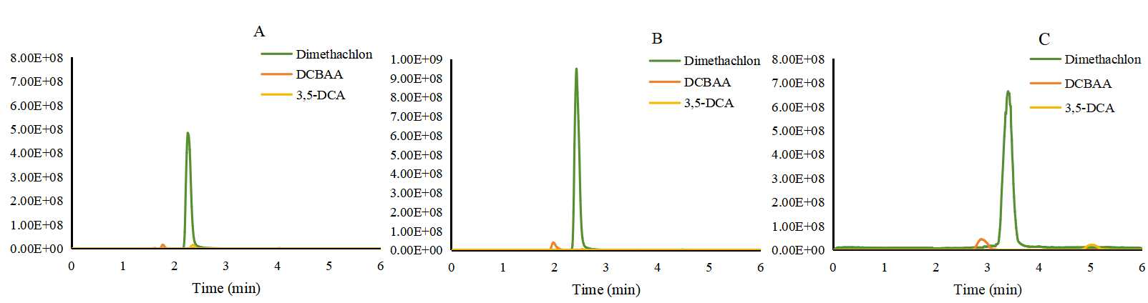

Figure S 4. The HPLC-HRMS chromatograms of three target analytes on a Hypersil GOLD ™ C18 column with different mobile phase

(flow rate: 0.2 mL/min; injection volume: 5μL; solvent standard solution: 1 μg/mL)

1. acetonitrile : water = 70:30
2. acetonitrile : 0.1% formic acid water = 70:30
3. acetonitrile : water = 50:50

ESI+APCIFigure S5. HPLC-HRMS chromatograms of three target analytes with different ion sources

(acetonitrile : water = 50:50; flow rate: 0.2 mL/min; injection volume: 5μL; solvent standard solution: 1 μg/mL, column: Hypersil GOLD ™ C18 )