**Supplementary Materials for**

**Electrochemical sensing of Gatifloxacin using Ag2S/RGO nanocomposite**

Chunxia Yao a, b, c, 1, Ying Liang d, 1, Sai Huang a, e, Chengbin Liu a, b, c, *, Wei Song a, b, c, *, Weiguo Song a, b, c, *

a The Institute of Agro-food Standards and Testing Technology, Shanghai Academy of Agricultural Sciences, Shanghai 201403, China

b Key Laboratory of Food Quality Safety and Nutrition (Co-construction by Ministry and Province), Ministry of Agriculture and Rural Affairs, Shanghai 201403, China

c Shanghai Engineering Research Center for Agri-product Quality and Safety, Shanghai 201403, China

d School of Pharmacy, Shanghai University of Medicine and Health Sciences, Shanghai 201318, China

e School of Materials Science and Engineering, Shanghai Institute of Technology, 100 Haiquan Road, Shanghai 201418, PR China

* Corresponding authors.

E-mail addresses: liuchengbin@saas.sh.cn (C.B. Liu); songwei890214@163.com (W. Song); songweiguo@saas.sh.cn (W.G. Song).

1 Chunxia Yao and Ying Liang: These authors contributed equally to the manuscript.



**Fig. S1.** XRD spectra of Ag2S standard card and the fabricated Ag2S.



**Fig. S2.** The energy-dispersive X-ray spectroscopy (EDS) of Ag2S within 10 min reaction time

**Table S1** SEM-EDS microanalysis of Ag2S within 10 min reaction time

|  |  |  |  |  |  |  |  |
| --- | --- | --- | --- | --- | --- | --- | --- |
| Element | C | O | Si | S | Ag | Sn | Weight |
| Weight（%） | 3.79 | 1.65 | 0.65 | 8.61 | 56.15 | 29.15 | 100.00 |
| Atom（%） | 21.38 | 6.97 | 1.56 | 18.19 | 35.26 | 16.64 | 100.00 |



**Fig. S3.** LSV of 150 µmol·L-1 gatifloxacin at Ag2S/GCE electrode with different reaction time.



**Fig. S4.** Effects of solution pH on (a) Ipa and (b) Epa of gatifloxacin

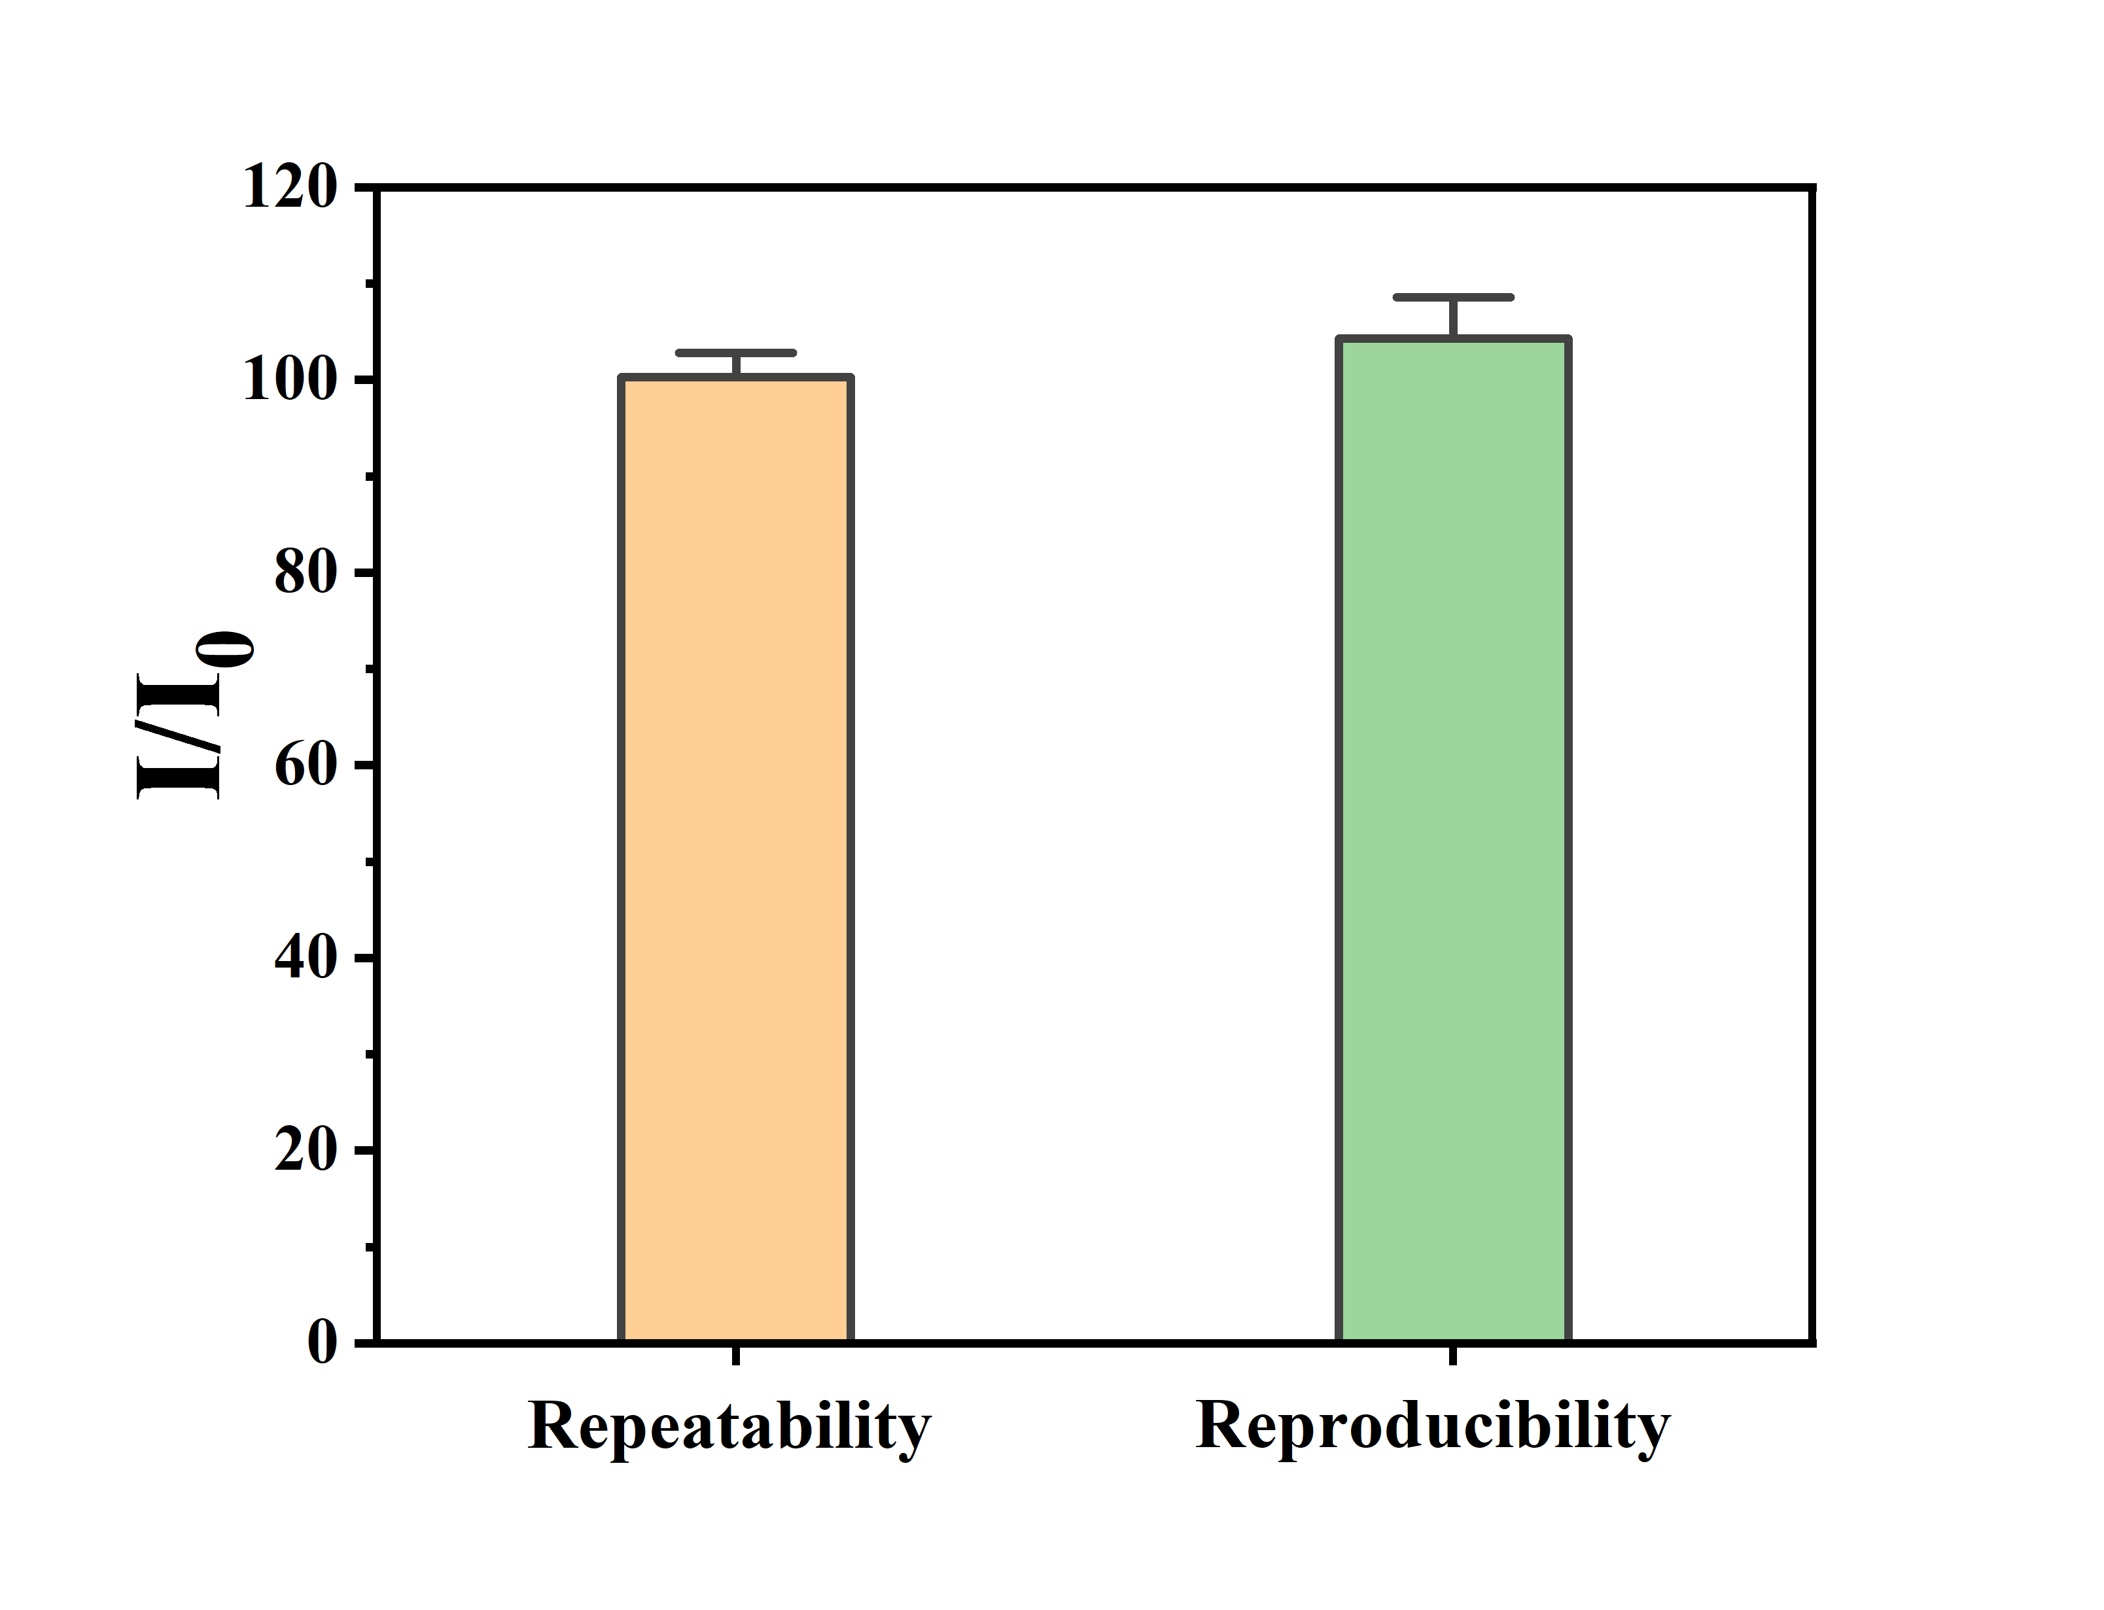

**Fig. S5.** Bar diagram for the repeatability and reproducibility of the sensor (n = 5).

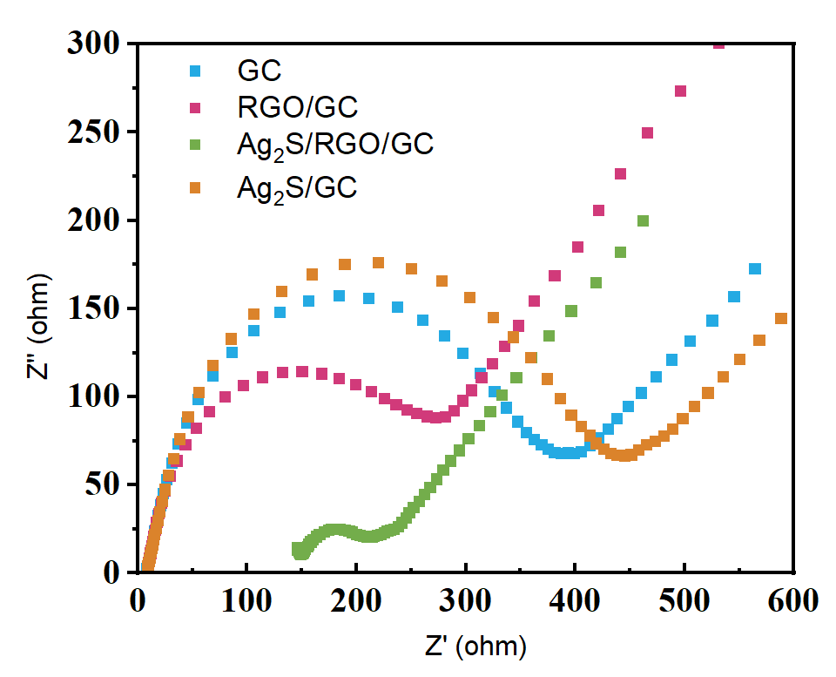

**Fig. S6.** EIS of different modified electrodes recorded in a 0.1 mol/L KCl solution containing 20 mmol/L [Fe(CN)6]3−/4−.