Supporting information

Ultrasonic-assisted DES extraction, characterization, antioxidant and in silico study of polysaccharides from Angelica dahurica Radix

Qian Li*, Ting Wang, Chenyue Wang, Xiaoqin Ding
College of Agronomy, State Key Laboratory of Aridland Crop Science, Gansu Agricultural University, Lanzhou 730070, China
*Corresponding author.
E-mail address: liqian1984@gsau.edu.cn(Qian Li)

Materials
Angelica dahurica Radix was bought from Qingshan Sulfur-free food Store in Suining city (Sichuan, China), which was identified as Angelica dahurica (Fisch.ex Hoffm.) Benth.et Hook.f.var.formosana (Boiss.) Shan et Yuan by Professor Yuan Chen, Gansu Agricultural University. A proper amount of the herbs were taken and baked for 12 h in the oven at 60℃. After being crushed and sifted through 40 mesh, the crude powder of RDA was prepared.
All chemicals used for the preparation of DES and for the determination were purchased from companies in several Chinese cities mentioned below. Choline chloride, glycerin, 1, 4-butanediol, urea and other analytical reagents were purchased from Shanghai Sinopharm Chemical Reagent Co., LTD. (Shanghai, China); Lactic acid was purchased from Yantai Shuangshuang Chemical Co., LTD. (Yantai, China). Anhydrous glucose was purchased from Beijing Solaibao Technology Co., LTD. (Beijing, China); Anhydrous ethanol was purchased from Tianjin Beichen Founder Reagent Factory (Tianjin, China); Concentrated sulfuric acid and phenol were purchased from Sinopharm Chemical Reagent Co., LTD. (Shanghai, China). The above reagents are analytically pure. Ultrapure water from Milli-Q Water Purification System - Bedford, USA.
2. Experimental

2.1. Preparation of DESs
It is crucial to carefully select the appropriate DES type for the extraction of the target compound from the sample. In this study, 12 sets of DES systems (refer to Table 1) were prepared using a simple heating method that requires minimal equipment. Each DES system was sealed in bottles, positioned on a constant-temperature magnetic stirrer, and stirred magnetically (typically for 120-180 min). The temperature was maintained between 80-95 °C until a homogeneous and transparent liquid was achieved. However, the direct synthesis by heating often faces challenges in producing ideal solvents due to the high viscosity and melting points observed in certain components. To address this issue, a specific amount of water was added to the DESs prior to heating to reduce viscosity.

2.2. Preparation of Standard Solution
A 10.00 mg glucose standard of constant weight was accurately measured and transferred to a 10 mL volumetric flask. Purified water was added for dissolution, and the volume was adjusted to the calibration mark. The solution was thoroughly dissolved using a vortex mixer to achieve a glucose standard solution with a concentration of 1 mg/mL. A series of polysaccharide standard solutions (1.00 mg/mL) were prepared by pipetting 0.20, 0.40, 0.60, 0.80, and 1.00 mL into separate test tubes. Purified water was added to dilute each solution to a total volume of 2.00 mL, followed by incubation. Subsequently, 1 mL of 5% phenol solution was added, mixed thoroughly, and then 4.00 mL of concentrated sulfuric acid was added. The mixture was shaken well, allowed to sit for 15 min, placed in a water bath at 40 ℃ for another 15 min, and then transferred to a beaker of cold water for 10 minutes to cool.

2.3. Preparation of Sample Solution

2.3.1. Polysaccharide solution preparation
Approximately 1.00 g of sieved A. dahurica powder was accurately weighed and transferred to a 150 mL conical flask. A pre-prepared DES was added using a liquid-solid ratio of 20:1 mL/g. The ultrasonic extraction conditions included a power setting of 300 W and frequency of 50 Hz, with an ultrasonic duration of 45 min at a temperature of 60 ℃ for the extraction of polysaccharides.

2.3.2. Crude polysaccharide preparation
The extract derived from section 2.4.1 underwent concentration to reduce to one-fifth of its initial volume through a rotary evaporator. Following this, the concentrated solution was diluted with anhydrous ethanol at a volume ratio of 1:4 and refrigerated at 4℃ overnight to induce precipitation. Subsequent centrifugation and drying processes yielded the crude polysaccharide product.

2.3.3. Traditional Extraction Method Comparison
To contrast ultrasound-assisted extraction with hot water extraction, polysaccharides were extracted using hot water in this study. The procedure involved extracting 5.00 g of pretreated sample powder with 150 mL of boiling water for 2 hours. After three rounds of extraction, the resultant extracts were combined and subjected to alcohol precipitation to isolate the crude polysaccharide.

2.4. Single factor experiment

2.4.1. Effect of Liquid-Solid Ratio
The impact of varying the liquid-solid ratio on the yield of ADRP was investigated under specific ultrasonic conditions: 300 W power, 50 Hz frequency, 45 min of ultrasonic time, and a temperature of 60 ℃. Various liquid-solid ratios of 10, 15, 20, 25, and 30 mL/g were employed for the extraction of A. dahurica, and the extraction efficiency of ADRP was subsequently determined.

2.4.2. Effect of Extraction Temperature
In this study, the liquid-solid ratio was maintained at 20:1 mL/g, with an ultrasonic power of 300 W at 50 Hz, and an ultrasonic time of 45 min. The impact of extraction temperature on the yield of ADRP was investigated across temperatures of 30, 40, 50, 60, and 70 ℃, followed by the calculation of the extraction efficiency of ADRP.

2.4.3. Effect of Extraction Time
In this experiment, the influence of extraction time duration on the yield of ADRP was examined under specified conditions: a liquid-solid ratio of 20:1 mL/g, a power of 300 W at 50 Hz, and an ultrasonic temperature of 60 ℃. Different extraction periods of 15, 25, 35, 45, and 55 min were applied for ADRP extraction to assess the extraction efficiency.

2.4.4. Effect of ultrasonic power
In this study, the liquid-to-solid ratio was defined as 20:1 mL/g, the ultrasonic extraction time was standardized at 45 min, and the ultrasonic temperature was maintained at 60 ℃. Varied ultrasonic power levels of 250 W, 300 W, 350 W, 400 W, and 450 W were chosen for ADRP extraction to investigate the impact of different ultrasonic powers on the polysaccharide yield.

2.5. Structural characterization

2.5.1. Fourier infrared spectroscopy
The PerkinElmer FT-IR Spectrum 3, furnished with universal ATR accessories such as ZnSe crystals and pressure pliers (PerkinElmer Corporation, Waltham, USA), was utilized for FT-IR analysis. Spectral data were acquired in the mid-infrared region spanning from 4000 to 400 cm⁻¹, with a spectral resolution set at 4 cm⁻¹. The analysis involved 32 scans, complemented by an additional 256 background scans to facilitate noise correction.

2.5.2. Monosaccharide composition
The sample (approx 5 mg) was hydrolyzed in a sealed tube with 2M trifluoroacetic acid at 121 °C for 2 h. Post-hydrolysis, the sample was dried under N₂ gas, methanol-washed, and blow-dried; this methanol washing process was reiterated 2-3 times. The resultant residue was dissolved in deionized water, filtered through a 0.22 μm microporous membrane, and analyzed. Monosaccharide types were identified using standard solutions.
The sample was then analyzed employing a CarboPac PA-20 anion exchange column (3×150 mm; Dionex) coupled with a pulsed amperometric detector (PAD; Dionex ICS 5000+). The analysis was performed at 0.5 mL/min, with an injection volume of 5μL. Three solvent systems were featured: A (ddH₂O), B (0.1M NaOH), and C (0.1M NaOH, 0.2M NaAc). The gradient program was as follows: 0 min - 95% A, 5% B, 0% C; 26 min - 85% A, 5% B, 10% C; 42 min - 85% A, 5% B, 10% C; 42.1 min - 60% A, 0% B, 40% C; 52 min - 60% A, 40% B, 0% C; 52.1 min - 95% A, 5% B, 0% C; with a hold to 60 min at 95% A, 5% B, 0% C.

2.5.3. Molecular weight distribution
The sample was dissolved in a 0.1M NaNO₃ aqueous solution containing 0.02% NaN₃ at a concentration of 1 mg/mL and filtered using a 0.45 μm pore filter. Gel chromatography with differential and multi-angle laser light scattering detection was employed. In this method, the U3000 liquid phase system (Thermo, USA) featured an Optilab T-rEX differential detector and a DAWN HELEOS II laser light scattering detector from Wyatt Technology, CA, USA. Gel filtration columns Ohpak SB-805 HQ (300×8mm) and Ohpak SB-803 HQ (300×8mm) were connected in series. The column was maintained at 45°C, with a 100 μL injection volume using mobile phase A (0.02% NaN₃, 0.1M NaNO₃), a flow rate of 0.6 mL/min, and a 75-min isocratic elution gradient.

2.6. Antioxidant activity test in vitro
The DPPH, ABTS and hydroxyl radical scavenging method were used to analyze the samples’ antioxidant properties in vitro. Extracts from two methods, traditional hot water and DES ultrasonic-assisted extraction, were compared. Each sample was prepared at maximum extraction concentration, and an ascorbic acid (VC) solution served as a control.
Scavenging activity on DPPH radical: Absorbance readings were taken at 517 nm, and the scavenging activity percentage was calculated by [1 - (A1 - A2)/A0] × 100%, where A0 is DPPH solution absorbance, A1 is sample absorbance in the DPPH mixture, and A2 is blank sample absorbance.
Scavenging activity on ABTS radical: Absorbance readings were taken at 734 nm, and the scavenging activity percentage was calculated by [1 - (A1 - A2)/A0] × 100%, where A0 was the absorbance of the sample blank (the sample was replaced by distilled water), A1 was the absorbance of the sample, and A2 was the absorbance of the reagent blank.
Scavenging activity on hydroxyl radical: Absorbance readings were taken at 510 nm, and the scavenging activity percentage was calculated by [1 - (A1 - A2)/A0] × 100%, where A0 was the absorbance of the sample blank (no sample in the mixed solution), A1 was the absorbance of the samples, and the A2 was the absorbance of the reagent blank.

2.7. Network pharmacology
The target proteins for five different sugars – trehalose, sorbitol, arabinose, lactose, and glucose – were predicted using the TCMSP (https://old.tcmsp-e.com/tcmsp.php), Swiss Target Prediction (http://swisstargetprediction.ch/), and BATMAN-TCM (http://bionet.ncpsb.org.cn/batman-tcm/index.php) databases. Subsequently, the nomenclature of the target proteins was standardized through UniProt (https://www.uniprot.org/). Disease target prediction utilizing the OMIM (https://www.omim.org/search/advanced/geneMap) and GeneCards databases (https://www.genecards.org/) involved keyword searches such as “oxidative,” “anti-oxidant,” “oxidative stress,” and “anti-oxidative stress.” The results were merged and duplicates eliminated to identify targets associated with antioxidant properties. Gene function enrichment analysis was conducted using the DAVID database (https://david.ncifcrf.gov/), and the visualization of enrichment results was completed on the Microbiota website (http://www.bioinformatics.com.cn/). The Microbiota website was also utilized to identify common targets pertaining to components and diseases. A Protein-Protein Interaction (PPI) network, with a confidence threshold of medium (0.4), was constructed utilizing the STRING database (https://cn.string-db.org/), and Cytoscape 3.7.2 software was employed for PPI network visualization.
2.8. Molecular docking

The protein structure files in PDB format were retrieved from the PDB database (https://www.rcsb.org) and processed using PyMOL (https://www.pymol.org) to remove water and ligands. The chemical compound’s SDF structure formula was obtained from PubChem (https://pubchem.ncbi.nlm.nih.gov) and converted from SDF to mol2 format through the utilization of OpenBabel software (v2.3.1). Subsequently, AutoDock Vina software (v1.1.2) was utilized for full-atom molecular docking to calculate the binding energy. The results of the docking analysis were visualized with PyMOL (3D, Version 2.2.0).

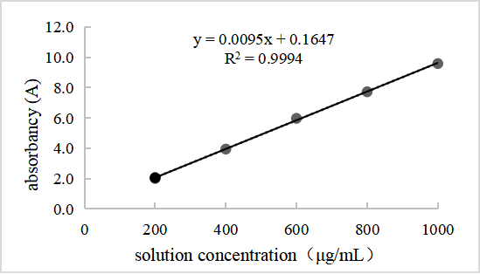
Fig. S1. Glucose standard curve

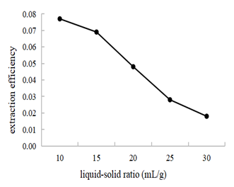
Fig.S2. Effect of liquid/solid ratio on the extraction rate of polysaccharides

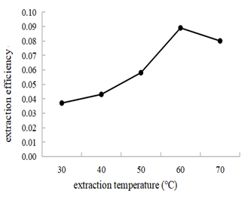
Fig. S3. Effect of ultrasonic temperature on the extraction rate of polysaccharides

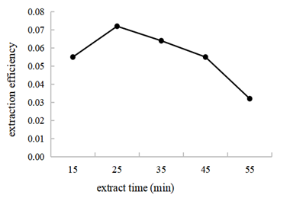
Fig S4. Effect of extraction time on the extraction rate of polysaccharides

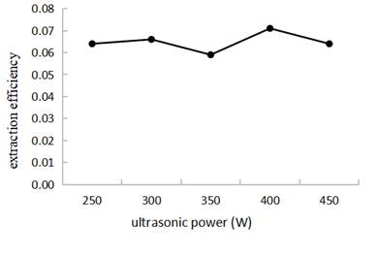
Fig S5. Effect of ultrasonic power on the extraction rate of polysaccharides

Fig. S6 Contour map (right) of the two independent variables interdependency: ultrasonic time and ultrasonic temperature (a), ultrasonic time and ultrasonic power (b) and ultrasonic temperature and ultrasonic power (c).

Fig. S7. Fourier transform infrared spectrum of A. dahurica polysaccharide

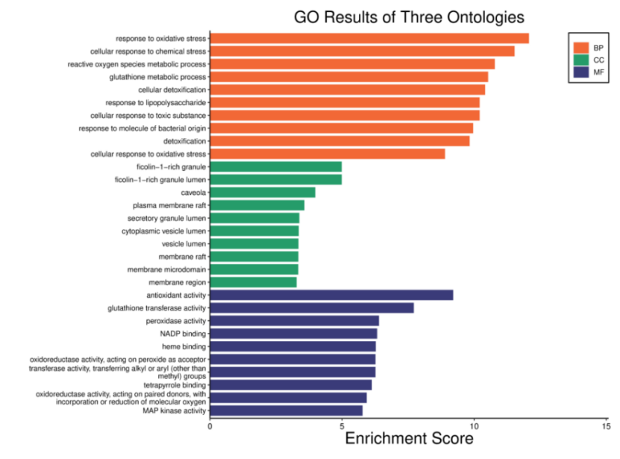
Fig S8. GO enrichment analysis for the intersection targets.

BP mainly includes: response to oxidative stress, cellular response to chemical stress, reactive oxygen species metabolic process, glutathione metabolic process. CC mainly includes: ficolin-1-rich granule, caveola, plasma membrane raft, secretory granule lumen, cytoplasmic vesicle lumen, vesicle lumen, membrane raft, membrane region. MF mainly includes: antioxidant activity, glutathione transferase activity, peroxidase activity. NADP binding, heme binding, oxidoreductase activity, tetrapyrrole binding, MAP kinase activity.

Fig. S9. Bar chart of KEGG enrichment analysis.

A total of 88 KEGG pathways were predicted for the 23 intersecting target genes. The top ten pathways by gene count include Pathways in cancer, Metabolic pathways, Fluid shear stress and atherosclerosis, Chemical carcinogenesis-reactive oxygen species, and Lipid and atherosclerosis.

