ARABJC-D-23-01668:
supplemental materials
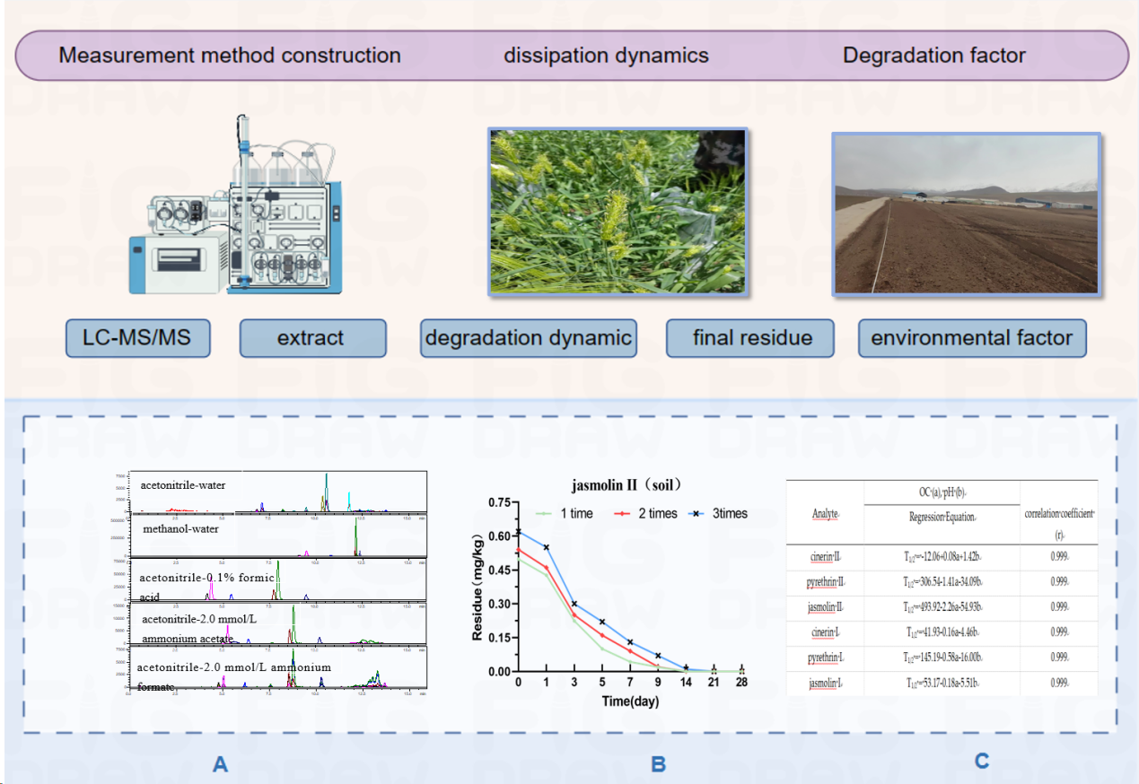
flow chart

Table 1 Pyrethrins component information
Component | Molecular Formular | Molecular weight
cinerin II | C₂₁H₂₈O₅ | 360.44
pyrethrin II | C₂₂H₂₈O₅ | 372.45
jasmolin II | C₂₂H₃₀O₅ | 374.47
cinerin I | C₂₀H₂₈O₃ | 316.44
pyrethrin I | C₂₁H₂₈O₃ | 328.45
jasmolin I | C₂₁H₃₀O₃ | 330.47

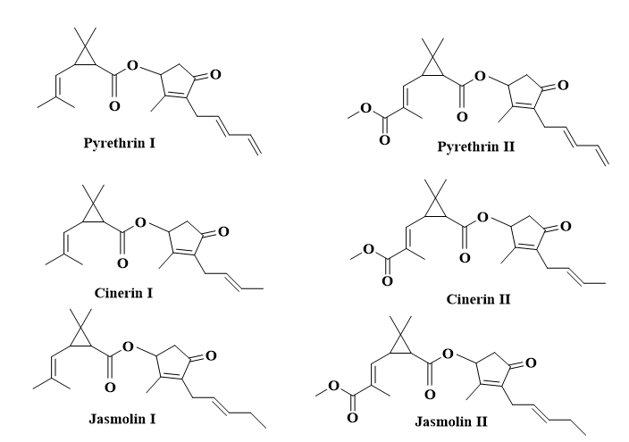
Figure 1 Chemical structure of pyrethrins

Table 2 Dynamic experimental design of pyrethrins digestion in barley plants in the field
Treatments |  | Dosage of  application  (g a.i./ha) | Time of  application  projects | Experimental project | Days after the  last application
Serial  number | Areas (m² )
1 | 25 ×3 | 54 | 1 | grains,stems | 2h,1,3,5,7,14,21,28days
2 | 25 ×3 | 54 | 2 | grains,stems
3 | 25 ×3 | 54 | 3 | grains,stems
CK | 25 ×3 | 0 |  |  | Before spraying ,in the middle period after spraying and at harvest

Table 3 Parameters of multiple response monitoring mode for pyrethrins diathesis spectrum
Compound | Retention time（min） | Ion source | Precursor (m/z) | Product (m/z) | Q1 Pre Bias (V) | CE  (eV) | Q3 Pre Bias (V)
cinerin II | 4.147 | EIS+ | 361.2 | 107* | -10 | -21 | -10
 |  |  |  | 77 | -24 | -54 | -12
pyrethrin II | 4.377 | EIS+ | 373.2 | 161* | -26 | -9 | -16
jasmolin II  cinerin I  pyrethrin I  jasmolin I | 5.468  7.769  7.997  9.509 | EIS+  EIS+  EIS+  EIS+ | 375. 2  317.2  329.2  331.2 | 133  163.1*  107  107*  77  161*  133  163.1*  107 | -14  -26  -14  -22  -22  -22  -22  -12  -22 | -20  -11  -27  -20  -53  -10  -19  -10  -24 | -24  -16  -16  -18  -12  -28  -12  -36  -38
* quantitative ion

Table 4 Effects of extractant dosage on pyrethrin recovery
extractant dosage (mL) | Average recovery (%)
 | Cinerin II | Pyrethrin II | Jasmolin II | Cinerin I | Pyrethrin I | Jasmolin I
10 | 90.94 | 91.47 | 87.49 | 88.59 | 91.81 | 88.25
20 | 90.71 | 88.21 | 85.65 | 86.52 | 90.63 | 88.73
30 | 90.25 | 85.86 | 85.35 | 85.53 | 90.28 | 87.52

Table 5 The correlation equations, correlation coefficients, quantification limits and matrix effects of pyrethrins in five matrices.
Compound | Matrices | Linear Regression Equation | Correlation Coefficient (R²) | Matrix Effects (% ME) | Linear range (mg/kg) | LOQ  (mg/kg)
cinerin II | acetonitrile | y = 82290x-472.98 | 0.9996 |  | 0.01~1.0  0.01~1.0  0.01~1.0  0.01~1.0  0.01~1.0 | 0.01  0.01  0.02  0.05  0.02
 | soil | y = 75365x-666.08 | 0.9990 | -8.4
 | grain | y = 76031x-403.05 | 0.9995 | -7.6
 | stem | y = 77130x-354.1 | 0.9995 | -6.3
 | root | y = 72085x-475.19 | 0.9996 | -12.4
pyrethrin II | acetonitrile | y = 263630x-335.86 | 0.9998 |  | 0.01~1.0 | 0.01
 | soil | y = 341557x-1976.8 | 0.9999 | 29.6 | 0.01~1.0  0.01~1.0 | 0.01  0.02
 | grain | y = 264853x-691.64 | 0.9999 | 0.5
 | stem | y = 270825x-199.58 | 0.9999 | 2.7 | 0.01~1.0 | 0.05
 | root | y = 319084x-2179.2 | 0.9993 | 21.0 | 0.01~1.0 | 0.02
jasmolin II | acetonitrile | y = 62171x-72.29 | 0.9993 |  | 0.01~1.0 | 0.01
 | soil | y = 79934x-618.03 | 0.9996 | 28.6 | 0.01~1.0 | 0.01
 | grain | y = 62127x-291.86 | 0.9995 | -0.1 | 0.01~1.0 | 0.02
 | stem | y = 61734x+144.45 | 0.9996 | -0.7 | 0.01~1.0 | 0.05
 | root | y = 80727x-653.01 | 0.9999 | 29.8 | 0.01~1.0 | 0.02
cinerin I | acetonitrile | y = 123779x+645.93 | 0.9992 |  | 0.01~1.0 | 0.01
 | soil | y = 170972x-1785.1 | 0.9996 | 38.1 | 0.01~1.0 | 0.01
 | grain | y = 115854x+573.08 | 0.9993 | -6.4 | 0.01~1.0 | 0.02
 | stem | y = 122824x+642.37 | 0.9993 | -0.8 | 0.01~1.0 | 0.05
 | root | y = 152765x-1137.5 | 0.9991 | 23.4 | 0.01~1.0 | 0.02
pyrethrin I | acetonitrile | y = 458189x+520.05 | 0.9999 |  | 0.01~1.0 | 0.01
 | soil | y = 626538x-5101.3 | 0.9992 | 36.7 | 0.01~1.0 | 0.01
 | grain | y = 476266x+722.9 | 0.9998 | 3.9 | 0.01~1.0 | 0.02
 | stem | y = 472265x+219.04 | 0.9998 | 3.1 | 0.01~1.0 | 0.05
 | root | y = 633808x-5364.8 | 0.9997 | 38.3 | 0.01~1.0 | 0.02
jasmolin I | acetonitrile | y = 67835x+55.849 | 0.9993 |  | 0.01~1.0 | 0.01
 | soil | y = 68698x-676.8 | 0.9996 | 1.3 | 0.01~1.0 | 0.01
 | grain | y = 56750x+178.43 | 0.9996 | -16.3 | 0.01~1.0 | 0.02
 | stem | y = 61499x+67.556 | 0.9992 | -9.3 | 0.01~1.0 | 0.05
 | root | y = 66554x-657.71 | 0.9996 | -1.9 | 0.01~1.0 | 0.02

Table 6 The average inter-day recoveries and relative standard deviations of pyrethrins on four substrates
Compound | Matrices | Additive level (mg/kg) | Addition Recovery (RSD)/% |  |  | Inter-Day Precisions (RSD)/%
 |  |  | The first day | The second day | The third day
cinerin II | soil | 0.01 | 93.78 (1.8) | 94.25 (4.1) | 97.16 (2.9) | 95.06 (1.9)
 |  | 0.02 | 95.22 (3.9) | 91.41 (2.4) | 92.58 (1.8) | 93.07 (2.1)
 |  | 0.5 | 93.49 (6.0) | 95.61 (3.4) | 97.21 (2.1) | 95.44 (2.0)
 | grain | 0.02 | 90.15 (2.2) | 89.36 (1.6) | 93.89 (1.9) | 91.13 (2.7)
 |  | 0.04 | 91.28 (4.1) | 93.68 (5.3) | 95.75 (2.8) | 93.57 (2.4)
 |  | 1.0 | 90.92 (5.2) | 97.12 (3.5) | 96.45 (3.3) | 94.83 (3.6)
 | stem | 0.05 | 88.35 (4.0) | 92.51 (2.3) | 94.02 (3.7) | 91.63 (3.2)
 |  | 0.1 | 93.51 (3.3) | 90.37 (4.7) | 92.66 (2.6) | 92.18 (1.8)
 |  | 1.0 | 90.77 (3.6) | 95.12 (1.7) | 95.92 (2.9) | 93.94 (3.0)
 | root | 0.02 | 90.22 (5.2) | 91.74 (2.0) | 94.63 (2.6) | 92.20 (2.4)
 |  | 0.04 | 91.61 (4.9) | 96.37 (5.0) | 97.42 (3.4) | 95.13 (3.3)
 |  | 1.0 | 93.88 (3.6) | 89.87 (3.1) | 95.23 (2.4) | 92.99 (3.0)
pyrethrin II | soil | 0.01 | 90.23 (3.8) | 95.33 (3.3) | 94.26 (3.1) | 93.27 (2.9)
 |  | 0.02 | 91.37 (4.7) | 90.87 (3.4) | 94.26 (4.0) | 92.17 (2.0)
 |  | 0.5 | 90.87 (5.1) | 92.65 (2.5) | 90.19 (2.0) | 91.24 (1.4)
 | grain | 0.02 | 88.49 (3.4) | 93.52 (2.6) | 90.11 (3.1) | 90.71 (2.8)
 |  | 0.04 | 89.50 (3.7) | 89.18 (1.9) | 92.15 (2.3) | 90.28 (1.8)
 |  | 1.0 | 91.55 (4.3) | 90.47 (2.4) | 95.14 (4.0) | 92.39 (2.6)
 | stem | 0.05 | 85.39 (5.3) | 90.03 (2.4) | 91.32 (3.3) | 88.91 (3.5)
 |  | 0.1 | 88.46 (3.7) | 88.79 (3.5) | 92.06 (5.0) | 89.77 (2.2)
 |  | 1.0 | 87.48 (2.8) | 90.78 (3.0) | 93.27 (4.2) | 90.51 (3.2)
 | root | 0.02 | 94.38 (2.2) | 95.18 (4.1) | 95.32 (1.7) | 94.96 (0.5)
 |  | 0.04 | 95.63 (2.5) | 97.51 (2.3) | 96.05 (0.9) | 96.40 (1.0)
 |  | 1.0 | 91.77 (3.4) | 98.37 (3.6) | 96.75 (3.0) | 95.63 (3.6)
jasmolin II | soil | 0.01 | 91.86 (3.2) | 97.53 (5.1) | 95.15 (2.9) | 94.85 (3.0)
 |  | 0.02 | 90.54 (4.5) | 96.81 (3.8) | 97.46 (5.0) | 94.94 (4.0)
 |  | 0.5 | 88.47 (4.8) | 94.57 (3.5) | 95.88 (3.4) | 92.97 (4.3)
 | grain | 0.02 | 88.20 (3.5) | 93.51 (3.7) | 90.23 (3.1) | 90.65 (3.0)
 |  | 0.04 | 86.71 (2.9) | 86.88 (4.1) | 92.10 (3.6) | 88.56 (3.5)
 |  | 1.0 | 87.12 (1.6) | 90.23 (2.9) | 89.55 (3.0) | 88.97 (1.8)
 | stem | 0.05 | 90.52 (4.3) | 89.09 (3.0) | 92.37 (2.7) | 90.66 (1.8)
 |  | 0.1 | 87.13 (5.1) | 90.12 (3.3) | 90.78 (2.9) | 89.34 (2.2)
 |  | 1.0 | 86.79 (2.2) | 88.45 (5.2) | 90.71 (3.1) | 88.65 (2.2)
 | root | 0.02 | 85.78 (7.2) | 95.79 (3.0) | 93.22 (4.2) | 91.60 (5.7)
 |  | 0.04 | 89.39 (4.3) | 88.85 (3.2) | 93.78 (3.6) | 90.67 (3.0)
 |  | 1.0 | 90.05 (4.0) | 97.57 (2.4) | 95.10 (2.8) | 94.24 (4.1)
cinerin I | soil | 0.01 | 94.61 (1.6) | 90.19 (2.2) | 91.78 (2.9) | 92.19 (2.4)
 |  | 0.02 | 95.11 (5.1) | 96.12 (3.2) | 91.99 (4.0) | 94.41 (2.3)
 |  | 0.5 | 91.42 (5.3) | 92.77 (3.6) | 98.23 (3.2) | 94.14 (3.8)
 | grain | 0.02 | 86.74 (4.0) | 85.29 (3.3) | 90.72 (3.1) | 87.58 (3.2)
 |  | 0.04 | 89.53 (3.6) | 92.03 (2.1) | 89.88 (2.8) | 90.48 (1.5)
 |  | 1.0 | 89.13 (4.0) | 89.55 (2.0) | 93.47 (2.5) | 90.72 (2.6)
 | stem | 0.05 | 87.18 (2.3) | 84.86 (3.3) | 91.11 (3.9) | 87.72 (3.6)
 |  | 0.1 | 90.31 (3.6) | 90.47 (2.6) | 89.79 (2.6) | 90.19 (0.4)
 |  | 1.0 | 91.14 (2.0) | 88.31 (1.0) | 87.12 (2.9) | 88.86 (2.3)
 | root | 0.02 | 89.26 (3.7) | 90.17 (2.6) | 93.07 (3.1) | 90.83 (2.2)
 |  | 0.04 | 91.59 (2.8) | 93.55 (3.4) | 93.28 (2.1) | 92.81 (1.1)
 |  | 1.0 | 93.70 (3.6) | 90.51 (3.5) | 89.03 (2.3) | 91.08 (2.6)
pyrethrin I | soil | 0.01 | 92.25 (4.1) | 95.33 (2.0) | 90.68 (2.3) | 92.75 (2.6)
 |  | 0.02 | 92.33 (5.1) | 90.76 (2.3) | 96.22 (1.9) | 93.10 (3.0)
 |  | 0.5 | 94.10 (6.1) | 97.23 (2.4) | 91.14 (1.0) | 94.16 (3.2)
 | grain | 0.02 | 90.10 (4.6) | 87.75 (3.0) | 92.34 (3.1) | 90.06 (2.5)
 |  | 0.04 | 91.29 (4.0) | 90.01 (3.4) | 88.31 (1.1) | 89.87 (1.7)
 |  | 1.0 | 91.67 (3.1) | 91.33 (1.5) | 88.35 (4.0) | 90.45 (2.0)
 | stem | 0.05 | 89.48 (2.6) | 88.14 (2.2) | 92.52 (3.3) | 90.05 (2.5)
 |  | 0.1 | 93.10 (3.3) | 90.19 (3.1) | 89.92 (2.0) | 91.07 (1.9)
 |  | 1.0 | 88.55 (3.7) | 92.13 (3.5) | 89.01 (2.0) | 89.90 (2.2)
 | root | 0.02 | 91.47 (3.9) | 92.87 (2.5) | 90.13 (2.5) | 91.49 (1.5)
 |  | 0.04 | 88.05 (4.6) | 89.32 (3.1) | 91.77 (4.0) | 89.71 (2.1)
 |  | 1.0 | 92.93 (4.1) | 90.43 (1.7) | 94.12 (3.2) | 92.49 (2.0)
jasmolin I | soil | 0.01 | 89.88 (4.3) | 88.11 (2.3) | 91.07 (1.5) | 89.69 (1.7)
 |  | 0.02 | 91.19 (3.9) | 88.19 (3.1) | 93.87 (2.0) | 91.08 (3.1)
 |  | 0.5 | 93.49 (3.3) | 90.56 (1.8) | 91.90 (3.6) | 91.98 (1.6)
 | grain | 0.02 | 85.30 (6.1) | 90.77 (3.2) | 88.09 (2.9) | 88.05 (3.1)
 |  | 0.04 | 89.44 (4.2) | 94.21 (2.2) | 92.01 (3.4) | 91.89 (2.6)
 |  | 1.0 | 88.56 (5.2) | 88.39 (1.9) | 93.27 (3.0) | 90.07 (3.1)
 | stem | 0.05 | 87.02 (2.7) | 90.34 (2.0) | 88.80 (4.7) | 88.72 (1.9)
 |  | 0.1 | 89.47 (4.9) | 90.37 (2.5) | 94.04 (2.6) | 91.29 (2.7)
 |  | 1.0 | 86.39 (5.6) | 87.91 (2.6) | 89.99 (3.1) | 88.10 (2.1)
 | root | 0.02 | 95.22 (3.1) | 90.13 (2.2) | 91.57 (4.5) | 92.31 (2.8)
 |  | 0.04 | 90.34 (4.0) | 89.06 (3.4) | 92.33 (3.0) | 90.58 (1.8)
 |  | 1.0 | 93.04 (4.3) | 91.32 (3.1) | 91.74 (2.1) | 92.03 (1.0)
Table 7 Regression equation, correlation coefficient and half-life of cinerin II in highland barley and soil
Samples | Application Times | Regression Equation | Correlation coefficient (r) | Half-life (d)
soil | 1 | C_{t} = 0.8494e^{-0.477t} | 0.9929 | 1.45
 | 2 | C_{t} = 0.7421e^{-0.4t} | 0.9972 | 1.73
 | 3 | C_{t} = 0.8975e^{-0.397t} | 0.9848 | 1.75
grain | 1 | C_{t} = 0.3045e^{-0.885t} | 0.9814 | 0.78
 | 2 | C_{t} = 0.3215e^{-0.863t} | 0.9739 | 0.80
 | 3 | C_{t} = 0.3518e^{-0.874t} | 0.9447 | 0.79
stem | 1 | - | - | -
 | 2 | - | - | -
 | 3 | C_{t} = 0.2628e^{-0.763t} | 0.9160 | 0.91

Table 8 Regression equation, correlation coefficient and half-life of pyrethrin II in highland barley and soil
Samples | Application Times | Regression Equation | Correlation coefficient (r) | Half-life (d)
soil | 1 | C_{t} = 0.8166e^{-0.424t} | 0.9948 | 1.63
 | 2 | C_{t} = 0.7545e^{-0.309t} | 0.9978 | 2.24
 | 3 | C_{t} = 1.0351e^{-0.272t} | 0.9924 | 2.55
grain | 1 | C_{t} = 0.308e^{-0.898t} | 0.9870 | 0.77
 | 2 | C_{t} = 0.3198e^{-0.875t} | 0.9865 | 0.79
 | 3 | C_{t} = 0.361e^{-0.839t} | 0.9727 | 0.83
stem | 1 | C_{t} = 0.2273e^{-0.718t} | 0.9646 | 0.97
 | 2 | C_{t} = 0.2319e^{-0.762t} | 0.9997 | 0.91
 | 3 | C_{t} = 0.2551e^{-0.795t} | 0.9981 | 0.87

Table 9 Regression equation, correlation coefficient and half-life of jasmolin II in highland barley and soil
Samples | Application Times | Regression Equation | Correlation coefficient (r) | Half-life (d)
soil | 1 | C_{t} = 0.5903e^{-0.372t} | 0.9921 | 1.86
 | 2 | C_{t} = 0.6636e^{-0.339t} | 0.9378 | 2.04
 | 3 | C_{t} = 0.7689e^{-0.289t} | 0.9770 | 2.40
grain | 1 | C_{t} = 0.2956e^{-0.822t} | 0.9722 | 0.84
 | 2 | C_{t} = 0.284e^{-0.766t} | 0.9795 | 0.90
 | 3 | C_{t} = 0.3144e^{-0.84t} | 0.9502 | 0.83
stem | 1 | - | - | -
 | 2 | - | - | -
 | 3 | C_{t} = 0.2142e^{-0.716t} | 0.9977 | 0.97

Table 10 Regression equation, correlation coefficient and half-life of cinerin I in highland barley and soil
Samples | Application Times | Regression Equation | Correlation coefficient (r) | Half-life (d)
soil | 1 | C_{t} = 0.8734e^{-0.315t} | 0.9857 | 2.20
 | 2 | C_{t} = 1.1927e^{-0.312t} | 0.9612 | 2.22
 | 3 | C_{t} = 1.1451e^{-0.27t} | 0.9734 | 2.57
grain | 1 | C_{t} = 0.2983e^{-0.811t} | 0.9682 | 0.85
 | 2 | C_{t} = 0.3243e^{-0.836t} | 0.9475 | 0.83
 | 3 | C_{t} = 0.3292e^{-0.815t} | 0.9478 | 0.85
stem | 1 | - | - | -
 | 2 | - | - | -
 | 3 | C_{t} = 0.2572e^{-0.803t} | 0.9963 | 0.86

Table 11 Regression equation, correlation coefficient and half-life of pyrethrin I in highland barley and soil
Samples | Application Times | Regression Equation | Correlation coefficient (r) | Half-life (d)
soil | 1 | C_{t} = 0.8801e^{-0.378t} | 0.9925 | 1.83
 | 2 | C_{t} = 0.9149e^{-0.311t} | 0.9917 | 2.23
 | 3 | C_{t} = 1.1275e^{-0.296t} | 0.9305 | 2.34
grain | 1 | C_{t} = 0.3442e^{-0.853t} | 0.9563 | 0.81
 | 2 | C_{t} = 0.3624e^{-0.876t} | 0.9734 | 0.79
 | 3 | C_{t} = 0.3651e^{-0.858t} | 0.9738 | 0.81
stem | 1 | C_{t} = 0.2628e^{-0.804t} | 0.9886 | 0.86
 | 2 | C_{t} = 0.2808e^{-0.814t} | 0.9740 | 0.85
 | 3 | C_{t} = 0.2963e^{-0.796t} | 0.9607 | 0.87

Table 12 Regression equation, correlation coefficient and half-life of jasmolin I in highland barley and soil
Samples | Application Times | Regression Equation | Correlation coefficient (r) | Half-life (d)
soil | 1 | C_{t} = 0.5849e^{-0.318t} | 0.9935 | 2.18
 | 2 | C_{t} = 0.7006e^{-0.288t} | 0.9869 | 2.41
 | 3 | C_{t} = 0.8635e^{-0.293t} | 0.9707 | 2.37
grain | 1 | C_{t} = 0.3139e^{-0.824t} | 0.9460 | 0.84
 | 2 | C_{t} = 0.3156e^{-0.847t} | 0.9575 | 0.82
 | 3 | C_{t} = 0.3254e^{-0.836t} | 0.9494 | 0.83
stem | 1 | - | - | -
 | 2 | - | - | -
 | 3 | C_{t} = 0.2091e^{-0.741t} | 0.9860 | 0.94

Table 13 Terminal residues of pyrethrins in soil
Samples | Spraying Dose  (g a.i./hm²) | Application Times | Interval Days | Residues of different analytes (mg/kg)
 |  |  |  | cinerin II | pyrethrin II | jasmolin  II | cinerin  I | pyrethrin  I | jasmolin  I
soil | 27 | 1 | 3 | 0.093 | 0.098 | 0.097 | 0.084 | 0.124 | 0.087
 |  |  | 5 | 0.032 | 0.033 | 0.029 | 0.030 | 0.029 | 0.025
 |  |  | 7 | <0.01 | <0.01 | <0.01 | <0.01 | <0.01 | <0.01
 |  | 2 | 3 | 0.101 | 0.095 | 0.099 | 0.088 | 0.107 | 0.089
 |  |  | 5 | 0.043 | 0.034 | 0.041 | 0.026 | 0.026 | 0.030
 |  |  | 7 | <0.01 | <0.01 | <0.01 | <0.01 | <0.01 | <0.01
 |  | 3 | 3 | 0.097 | 0.110 | 0.096 | 0.089 | 0.099 | 0.094
 |  |  | 5 | 0.033 | 0.032 | 0.035 | 0.027 | 0.031 | 0.029
 |  |  | 7 | <0.01 | <0.01 | <0.01 | <0.01 | <0.01 | <0.01
 | 54 | 1 | 3 | 0.243 | 0.250 | 0.224 | 0.367 | 0.302 | 0.248
 |  |  | 5 | 0.086 | 0.092 | 0.100 | 0.214 | 0.158 | 0.128
 |  |  | 7 | 0.028 | 0.045 | 0.043 | 0.098 | 0.057 | 0.065
 |  | 2 | 3 | 0.210 | 0.300 | 0.250 | 0.502 | 0.350 | 0.310
 |  |  | 5 | 0.104 | 0.140 | 0.161 | 0.330 | 0.220 | 0.190
 |  |  | 7 | 0.049 | 0.085 | 0.090 | 0.190 | 0.100 | 0.110
 |  | 3 | 3 | 0.300 | 0.480 | 0.301 | 0.500 | 0.430 | 0.380
 |  |  | 5 | 0.150 | 0.250 | 0.220 | 0.330 | 0.350 | 0.220
 |  |  | 7 | 0.063 | 0.181 | 0.130 | 0.190 | 0.200 | 0.150

Table 14 Terminal residues of pyrethrins in grain
Samples | Spraying Dose  (g a.i./hm²) | Application Times | Interval Days | Residues of different analytes (mg/kg)
 |  |  |  | cinerin II | pyrethrin II | jasmolin  II | cinerin  I | pyrethrin  I | jasmolin  I
grain | 27 | 1 | 1 | 0.054 | 0.058 | 0.057 | 0.062 | 0.063 | 0.055
 |  |  | 3 | <0.02 | <0.02 | <0.02 | <0.02 | <0.02 | <0.02
 |  |  | 5 | <0.02 | <0.02 | <0.02 | <0.02 | <0.02 | <0.02
 |  | 2 | 1 | 0.058 | 0.059 | 0.060 | 0.056 | 0.065 | 0.059
 |  |  | 3 | <0.02 | <0.02 | <0.02 | <0.02 | <0.02 | <0.02
 |  |  | 5 | <0.02 | <0.02 | <0.02 | <0.02 | <0.02 | <0.02
 |  | 3 | 1 | 0.055 | 0.061 | 0.061 | 0.055 | 0.071 | 0.058
 |  |  | 3 | <0.02 | <0.02 | <0.02 | <0.02 | <0.02 | <0.02
 |  |  | 5 | <0.02 | <0.02 | <0.02 | <0.02 | <0.02 | <0.02
 | 54 | 1 | 1 | 0.157 | 0.151 | 0.143 | 0.150 | 0.162 | 0.157
 |  |  | 3 | 0.020 | 0.021 | 0.021 | 0.022 | 0.021 | 0.021
 |  |  | 5 | <0.02 | <0.02 | <0.02 | <0.02 | <0.02 | <0.02
 |  | 2 | 1 | 0.167 | 0.161 | 0.131 | 0.170 | 0.169 | 0.151
 |  |  | 3 | 0.021 | 0.023 | 0.025 | 0.021 | 0.022 | 0.020
 |  |  | 5 | <0.02 | <0.02 | <0.02 | <0.02 | <0.02 | <0.02
 |  | 3 | 1 | 0.180 | 0.180 | 0.151 | 0.180 | 0.170 | 0.162
 |  |  | 3 | 0.020 | 0.025 | 0.020 | 0.023 | 0.024 | 0.021
 |  |  | 5 | <0.02 | <0.02 | <0.02 | <0.02 | <0.02 | <0.02

Table 15 Terminal residues of pyrethrins in stem
Samples | Spraying Dose  (g a.i./hm²) | Application Times | Interval Days | Residues of different analytes (mg/kg)
 |  |  |  | cinerin II | pyrethrin II | jasmolin  II | cinerin  I | pyrethrin  I | jasmolin  I
stem | 27 | 1 | 1 | <0.05 | <0.05 | <0.05 | <0.05 | <0.05 | <0.05
 |  |  | 3 | <0.05 | <0.05 | <0.05 | <0.05 | <0.05 | <0.05
 |  |  | 5 | <0.05 | <0.05 | <0.05 | <0.05 | <0.05 | <0.05
 |  | 2 | 1 | <0.05 | <0.05 | <0.05 | <0.05 | <0.05 | <0.05
 |  |  | 3 | <0.05 | <0.05 | <0.05 | <0.05 | <0.05 | <0.05
 |  |  | 5 | <0.05 | <0.05 | <0.05 | <0.05 | <0.05 | <0.05
 |  | 3 | 1 | 0.061 | 0.059 | 0.053 | 0.067 | 0.069 | 0.051
 |  |  | 3 | <0.05 | <0.05 | <0.05 | <0.05 | <0.05 | <0.05
 |  |  | 5 | <0.05 | <0.05 | <0.05 | <0.05 | <0.05 | <0.05
 | 54 | 1 | 1 | 0.060 | 0.130 | 0.051 | 0.061 | 0.130 | 0.059
 |  |  | 3 | <0.05 | <0.05 | <0.05 | <0.05 | <0.05 | <0.05
 |  |  | 5 | <0.05 | <0.05 | <0.05 | <0.05 | <0.05 | <0.05
 |  | 2 | 1 | 0.051 | 0.110 | 0.051 | 0.063 | 0.145 | 0.062
 |  |  | 3 | <0.05 | <0.05 | <0.05 | <0.05 | <0.05 | <0.05
 |  |  | 5 | <0.05 | <0.05 | <0.05 | <0.05 | <0.05 | <0.05
 |  | 3 | 1 | 0.160 | 0.120 | 0.109 | 0.122 | 0.161 | 0.090
 |  |  | 3 | <0.05 | <0.05 | <0.05 | <0.05 | <0.05 | <0.05
 |  |  | 5 | <0.05 | <0.05 | <0.05 | <0.05 | <0.05 | <0.05

Table 16 Physical and chemical properties of soil samples
Soil  Sample | TN（g/kg） | OC  （g/kg） | TP（g/kg） | TK（g/kg） | AN（mg/kg） | AK（mg/kg） | AP  （mg/kg） | pH
Haibei | 1.12 | 11.91 | 0.75 | 17.83 | 71.55 | 140 | 19.20 | 8.48
Haixi | 0.70 | 6.49 | 0.87 | 17.67 | 47.46 | 104 | 44.00 | 8.69
Haidong | 1.96 | 19.46 | 1.29 | 19.64 | 121.84 | 414 | 66.80 | 8.16

Table 17 Regression equation, correlation coefficient and half-life of cinerin II at three test sites
Sites | Analyte | Regression Equation | correlation coefficient (r) | Half-life (d)
Haibei soil | cinerin II | C_{t} = 1.484e^{-0.7293t} | 0.9999 | 0.95
Haibei sterilized soil | cinerin II | C_{t} = 2.000e^{-0.1257t} | 0.9737 | 5.51
Haixi soil | cinerin II | C_{t} = 1.707e^{-0.8708t} | 0.9992 | 0.80
Haixi sterilized soil | cinerin II | C_{t} = 2.214e^{-0.1353t} | 0.9465 | 5.13
Haidong soil | cinerin II | C_{t} = 1.504e^{-0.6188t} | 0.9960 | 1.12
Haidong sterilized soil | cinerin II | C_{t} = 2.031e^{-0.1182t} | 0.9537 | 5.87

Table 18 Regression equation, correlation coefficient and half-life of pyrethrin II at three test sites
Sites | Analyte | Regression Equation | correlation coefficient (r) | Half-life (d)
Haibei soil | pyrethrin II | C_{t} = 2.16e^{-1.078t} | 0.9996 | 0.64
Haibei sterilized soil | pyrethrin II | C_{t} = 3.689e^{-0.1589t} | 0.9666 | 4.36
Haixi soil | pyrethrin II | C_{t} = 2.612e^{-0.6078t} | 0.9990 | 1.14
Haixi sterilized soil | pyrethrin II | C_{t} = 4.071e^{-0.07287t} | 0.9692 | 9.51
Haidong soil | pyrethrin II | C_{t} = 1.945e^{-0.7906t} | 0.9931 | 0.88
Haidong sterilized soil | pyrethrin II | C_{t} = 3.198e^{-0.06351t} | 0.8949 | 10.91

Table 19 Regression equation, correlation coefficient and half-life of jasmolin II at three test sites
Sites | Analyte | Regression Equation | correlation coefficient (r) | Half-life (d)
Haibei soil | jasmolin II | C_{t} = 1.688e^{-0.5669t} | 0.9993 | 1.22
Haibei sterilized soil | jasmolin II | C_{t} = 2.592e^{-0.09273t} | 0.9445 | 7.48
Haixi soil | jasmolin II | C_{t} = 2.229e^{-0.3595t} | 0.9957 | 1.93
Haixi sterilized soil | jasmolin II | C_{t} = 2.972e^{-0.06272t} | 0.9669 | 11.05
Haidong soil | jasmolin II | C_{t} = 1.772e^{-0.3983t} | 0.9892 | 1.74
Haidong sterilized soil | jasmolin II | C_{t} = 2.773e^{-0.05615t} | 0.8332 | 12.34

Table 20 Regression equation, correlation coefficient and half-life of cinerin I at three test sites
Sites | Analyte | Regression Equation | correlation coefficient (r) | Half-life (d)
Haibei soil | cinerin I | C_{t} = 1.850e^{-0.3128t} | 0.9634 | 2.22
Haibei sterilized soil | cinerin I | C_{t} = 1.806e^{-0.1548t} | 0.9246 | 4.48
Haixi soil | cinerin I | C_{t} = 2.076e^{-0.3226t} | 0.9797 | 2.15
Haixi sterilized soil | cinerin I | C_{t} = 1.754e^{-0.1393t} | 0.9225 | 4.98
Haidong soil | cinerin I | C_{t} = 1.874e^{-0.2840t} | 0.9544 | 2.44
Haidong sterilized soil | cinerin I | C_{t} = 1.555e^{-0.1115t} | 0.9340 | 6.21

Table 21 Regression equation, correlation coefficient and half-life of pyrethrin I at three test sites
Sites | Analyte | Regression Equation | correlation coefficient (r) | Half-life (d)
Haibei soil | pyrethrin I | C_{t} = 2.826e^{-0.2657t} | 0.9818 | 2.61
Haibei sterilized soil | pyrethrin I | C_{t} = 4.504e^{-0.06393t} | 0.9337 | 10.84
Haixi soil | pyrethrin I | C_{t} = 3.417e^{-0.2915t} | 0.9937 | 2.38
Haixi sterilized soil | pyrethrin I | C_{t} = 4.680e^{-0.04648t} | 0.9572 | 14.91
Haidong soil | pyrethrin I | C_{t} = 3.092e^{-0.2055t} | 0.9970 | 3.37
Haidong sterilized soil | pyrethrin I | C_{t} = 3.620e^{-0.06195t} | 0.9257 | 11.19

Figure 3 Effect of anhydrous magnesium sulfate dosage on pyrethrins recovery (a); Effect of PSA dosage on the recovery rate of pyrethrins (b)

Figure 5 Highland barley grain purification

Figure 6 GCB+PSA combined purification

Figure 7 Dynamics of cinerin II dissipation in highland barley plants and soil.

Figure 8 Dynamics of pyrethrin II dissipation in highland barley plants and soil

Figure 9 Dynamics of jasmolin II dissipation in highland barley plants and soil

Figure 10 Dynamics of cinerin I dissipation in highland barley plants and soil

Figure 11 Dynamics of pyrethrin I dissipation in highland barley plants and soil

Figure 12 Dynamics of jasmolin I dissipation in highland barley plants and soil

Figure 13 Degradation curves of cinerin II soil at three test sites.(a: Haibei；b:Haixi ；c:Haidong)

Figure 14 Degradation curves of pyrethrin II soil at three test sites.(a: Haibei；b:Haixi ；c:Haidong)

Figure 15 Degradation curves of jasmolin II soil at three test sites.(a: Haibei；b:Haixi ；c:Haidong)

Figure 16 Degradation curves of cinerin I soil at three test sites.(a: Haibei；b:Haixi ；c:Haidong)

Figure 17 Degradation curves of pyrethrin I soil at three test sites.(a: Haibei；b:Haixi ；c:Haidong)

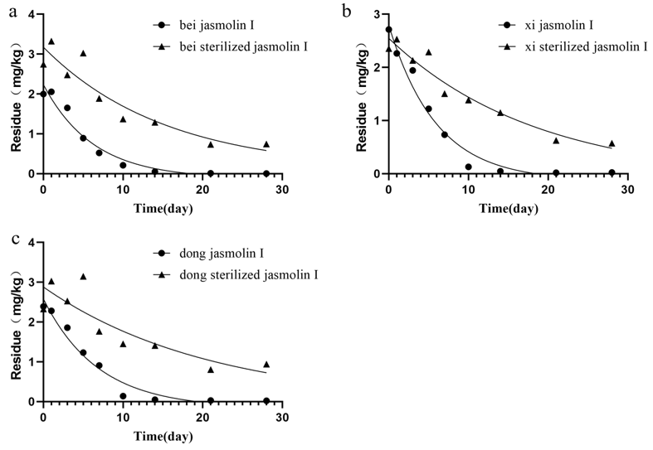
Figure 18 Degradation curves of jasmolin I soil at three test sites.(a: Haibei；b:Haixi ；c:Haidong)

