APPENDICES
APPENDIX A: RNA EXTRACTION

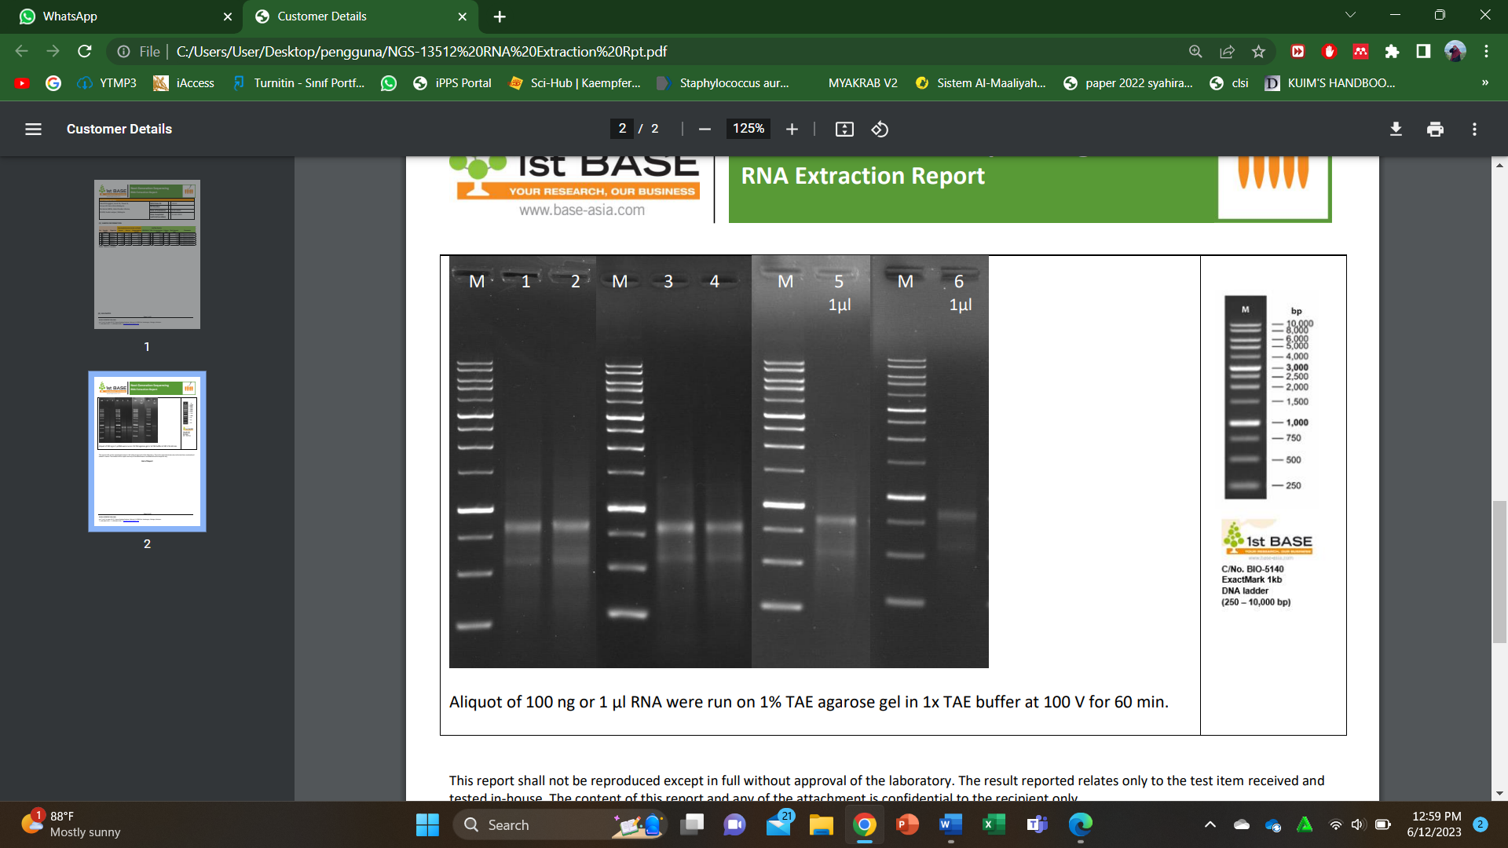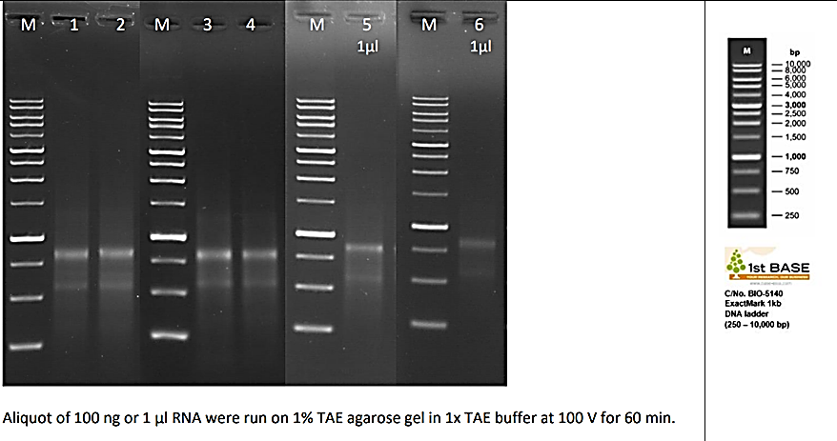
Figure A: Aliquot of 100 ng or 1µL RNA were run on 1% TAE agarose gel in 1×TAE buffer at 100 V for 60 minutes.

Table A: Nanodrop analysis RNA isolated from untreated (A1, A2 and A3) and MRSA treated with AgNPs-K (B1, B2, and B3). Absorption values 260/280 and 260/230 indicate nucleic acid purity.
Sample Name | Organism | Spectrophotometer (water as blank) |  |  | LabChip Results
 |  | A_{260/280} | A_{260/230} | Concentration (ng/uL) |  | rRNA Ratio | RIN | Concentration (ng/µL) | Volume (µL) | Total Amount (µg) | Comments
A1 | Bacteria | 2.120 | 2.243 | 114.84 |  | 0.4 | 4.0 | 197.00 | 55 | 10.48 | After DNase treatment
A2 | Bacteria | 2.095 | 2.209 | 56.72 |  | 2.0 | 7.0 | 198.00 | 55 | 10.89 | After DNase treatment
A3 | Bacteria | 2.135 | 2.223 | 112.48 |  | 4.1 | 6.0 | 108.00 | 55 | 5.94 | After DNase treatment
B1 | Bacteria | 2.144 | 2.037 | 57.12 |  | 4.1 | 5.0 | 108.00 | 55 | 5.94 | After DNase treatment
B2 | Bacteria | 2.154 | 2.157 | 64.36 |  | 2.5 | 6.0 | 132.00 | 45 | 5.94 | After DNase treatment
B3 | Bacteria | 2.098 | 0.351 | 34.16 |  | 6.9 | 6.0 | 79.00 | 35 | 2.77 | After DNase treatment
Note: RNA is in water

Appendix B: TRANCRIPTOMIC PROFILE ANALYSIS
Table B1: Log₂ fold change of downregulated gene of KEGG pathway of MRSA after treated with AgNPs-K (1.25 mg/mL).
Gene ID | log2FoldChange | pvalue | Gene name | Gene Description
IL357_RS11625 | -1.927298917 | 9.59E-27 | rpsD | 30S ribosomal protein S4 && PF01479:S4 domain|PF00163:Ribosomal protein S4/S9 N-terminal domain
IL357_RS03395 | -2.667732057 | 4.49E-26 | rplS | 50S ribosomal protein L19 && PF01245:Ribosomal protein L19
IL357_RS03380 | -1.503743875 | 4.38723E-21 | rpsP | 30S ribosomal protein S16 && -
IL357_RS05890 | -1.293566613 | 3.51346E-20 | rplW | 50S ribosomal protein L23 && -
IL357_RS05900 | -1.774910545 | 1.70069E-19 | rplC | 50S ribosomal protein L3 && PF00297:Ribosomal protein L3
IL357_RS05905 | -2.06872512 | 8.55452E-19 | rpsJ | 30S ribosomal protein S10 && PF00338:Ribosomal protein S10p/S20e

Table B2: Log₂ fold change of upregulated gene of KEGG pathway of MRSA after treated with AgNPs-K (1.25 mg/mL).
Gene ID | log2FoldChange | pvalue | Gene name | Gene Description
IL357_RS08075 | 3.441962718 | 4.47E-39 | manA | mannose-6-phosphate isomerase%2C class I && PF01238:Phosphomannose isomerase type I
IL357_RS00380 | 0.781577786 | 8.52E-11 | IL357_RS00380 | phosphomevalonate kinase && PF00288:GHMP kinases N terminal domain|PF08544:GHMP kinases C terminal
IL357_RS07545 | 0.992061481 | 1.16E-09 | IL357_RS07545 | NAD(P)/FAD-dependent oxidoreductase && PF01593:Flavin containing amine oxidoreductase
IL357_RS07540 | 0.973786197 | 1.87E-09 | crtQ | 4%2C4'-diaponeurosporenoate glycosyltransferase && PF00535:Glycosyl transferase family 2
IL357_RS10740 | 1.306997561 | 6.02E-09 | sph | sphingomyelin phosphodiesterase && PF03372:Endonuclease/Exonuclease/phosphatase family

Table B3: Log₂ fold change of downregulated genes in BP which involves primary metabolites process of MRSA after treated with AgNPs-K (1.25 mg/mL).
Gene_ID | Log2foldchange | Pvalue | Gene_Name | Gene_Description
IL357_RS03395 | -2.667732057 | 4.49E-26 | rplS | 50S ribosomal protein L19 && PF01245:Ribosomal protein L19
IL357_RS05175 | -1.557164395 | 6.60E-24 | IL357_RS05175 | 16S rRNA (uracil(1498)-N(3))-methyltransferase && PF04452:RNA methyltransferase
IL357_RS02025 | -1.663481435 | 1.42E-23 | clpB | ATP-dependent chaperone ClpB && PF07724:AAA domain (Cdc48 subfamily)|PF02861:Clp amino terminal domain, pathogenicity island component|PF10431:C-terminal, D2-small domain, of ClpB protein|PF00004:ATPase family associated with various cellular activities (AAA)
IL357_RS05900 | -1.774910545 | 1.70E-19 | rplC | 50S ribosomal protein L3 && PF00297:Ribosomal protein L3
IL357_RS10080 | -1.907325181 | 6.11E-18 | metE | 5-methyltetrahydropteroyltriglutamate--homocysteine S-methyltransferase && PF08267:Cobalamin-independent synthase, N-terminal domain|PF01717:Cobalamin-independent synthase, Catalytic domain
Novel00181 | -2.291513033 | 3.76E-13 | - | PF00239:Resolvase, N terminal domain|PF02796:Helix-turn-helix domain of resolvase

Table B4: Log₂ fold change of downregulated genes in CC which involves cellular component of MRSA after treated with AgNPs-K (1.25 mg/mL).
Gene_ID | Log2foldchange | Pvalue | Gene_Name | Gene_Description
IL357_RS09970 | -4.075431035 | 5.58E-88 | mepA | multidrug efflux MATE transporter MepA && PF01554:MatE
IL357_RS02970 | -2.444377553 | 2.51E-36 | efb | complement convertase inhibitor Efb && PF12199:Extracellular fibrinogen binding protein C terminal
IL357_RS11625 | -1.927298917 | 9.59E-27 | rpsD | 30S ribosomal protein S4 && PF01479:S4 domain|PF00163:Ribosomal protein S4/S9 N-terminal domain
IL357_RS02950 | -3.832990361 | 9.78E-27 | ecb | complement convertase inhibitor Ecb && PF12199:Extracellular fibrinogen binding protein C terminal
IL357_RS02600 | -2.07187928 | 4.17E-26 | IL357_RS02600 | cytochrome ubiquinol oxidase subunit I && PF01654:Cytochrome bd terminal oxidase subunit I
IL357_RS03395 | -2.667732057 | 4.49E-26 | rplS | 50S ribosomal protein L19 && PF01245:Ribosomal protein L19
IL357_RS13225 | -3.733772836 | 1.76E-22 | IL357_RS13225 | superantigen-like protein SSL11 && PF02876:Staphylococcal/Streptococcal toxin, beta-grasp domain|PF09199:Staphylococcal superantigen-like OB-fold domain
IL357_RS05900 | -1.774910545 | 1.70E-19 | rplC | 50S ribosomal protein L3 && PF00297:Ribosomal protein L3
IL357_RS02605 | -1.399053696 | 3.15E-16 | IL357_RS02605 | cytochrome d ubiquinol oxidase subunit II && PF02322:Cytochrome bd terminal oxidase subunit II
IL357_RS05875 | -1.077588284 | 1.94E-12 | rplV | 50S ribosomal protein L22 && PF00237:Ribosomal protein L22p/L17e

Table B5: Log₂ fold change of downregulated genes in MF which involves nucleic acid binding of MRSA after treated with AgNPs-K (1.25 mg/mL).
Gene_ID | Log2foldchange | Pvalue | Gene_Name | Gene_Description
IL357_RS11625 | -1.927298917 | 9.59E-27 | rpsD | 30S ribosomal protein S4 && PF01479:S4 domain|PF00163:Ribosomal protein S4/S9 N-terminal domain
IL357_RS02665 | -2.262550204 | 7.25E-22 | IL357_RS02665 | XRE family transcriptional regulator && PF12844:Helix-turn-helix domain|PF07883:Cupin domain
IL357_RS10130 | -1.373228625 | 5.54E-18 | ssb | single-stranded DNA-binding protein && PF00436:Single-strand binding protein family
IL357_RS07610 | -2.023636762 | 5.39E-15 | IL357_RS07610 | TetR/AcrR family transcriptional regulator && PF00440:Bacterial regulatory proteins, tetR family
Novel00181 | -2.291513033 | 3.76E-13 | - | PF00239:Resolvase, N terminal domain|PF02796:Helix-turn-helix domain of resolvase
IL357_RS11320 | -1.807383355 | 1.24E-12 | IL357_RS11320 | 3'-5' exonuclease && PF00929:Exonuclease
IL357_RS13595 | -2.037065754 | 1.67E-12 | infC | translation initiation factor IF-3 && PF00707:Translation initiation factor IF-3, C-terminal domain|PF05198:Translation initiation factor IF-3, N-terminal domain
IL357_RS03145 | -1.231772256 | 3.93E-12 | IL357_RS03145 | RNA-binding protein && PF01479:S4 domain
IL357_RS03735 | -1.759207471 | 6.68E-12 | IL357_RS03735 | MerR family transcriptional regulator && PF13411:MerR HTH family regulatory protein
IL357_RS12530 | -1.039240866 | 1.03E-11 | IL357_RS12530 | DEAD/DEAH box helicase && PF00270:DEAD/DEAH box helicase|PF00271:Helicase conserved C-terminal domain

