**Potential inhibition of SARS-CoV-2 infection and its mutation with the novel Geldanamycin analog: Ignaciomycin**

**Antony Stalina,#,*,** **Pachaiyappan Saravana Kumarb,#, Balakrishnan Senthamarai Kannanc, Rajamanikam Saravanand, Savarimuthu Ignacimuthub,*,** **Quan Zoua,\***

*aInstitute of Fundamental and Frontier Sciences, University of Electronic Science and Technology of China, Chengdu, 610 054 China.*

*bXavier Research Foundation, St. Xavier’s College, Affiliated to Manonmaniam Sundaranar University, Palayamkottai – 627 002, Tamil Nadu, India.*

*cDepartment of Chemistry, Tirunelveli Dakshinamara Nadar Sangam (T D M N S) College, Valliyur, Tirunelveli 627113, Tamil Nadu, India.*

*dDepartment of Physics, Meenakshi Chandrasekaran College of arts and science, Karambayam, Pattukkottai, Thanjavur, 614 626*

*Address correspondence to: Antony Stalin: [antonystalin@uestc.edu.cn](mailto:antonystalin@uestc.edu.cn); [a.staanlin@gmail.com](mailto:a.staanlin@gmail.com); Savarimuthu Ignacimuthu:[imuthus@hotmail.com](mailto:imuthus@hotmail.com); Quan Zou: [zouquan@nclab.net](mailto:zouquan@nclab.net)

# *These authors contributed equally to this work*

**Table S1.** Protein-Protein interaction analyses of the SARS-CoV-2-S glycoprotein and receptor ACE2 of the wild type

|  |  |  |  |  |  |  |  |  |
| --- | --- | --- | --- | --- | --- | --- | --- | --- |
| **Potential Hydrophobic Interactions** | | | | | | | | |
| ***ACE2*** | | | | **SARS-CoV-2-S RBD** | | | | **Distance Å** |
| **Res**  **Num** | **Res**  **Name** | **Chain-1** | **Atom**  **Name** | **Res**  **Num** | **Res**  **Name** | **Chain-2** | **Atom**  **Name** |
| 79 | LEU | A | CB | 486 | PHE | E | CB | 6.90 |
| **Potential Salt Bridges** | | | | | | | | |
| ***ACE2*** | | | | **SARS-CoV-2-S RBD** | | | | **Distance Å** |
| **Res**  **Num** | **Res**  **Name** | **Chain-1** | **Atom**  **Name** | **Res**  **Num** | **Res**  **Name** | **Chain-2** | **Atom**  **Name** |
| 30 | ASP | A | OD2 | 417 | LYS | E | NZ | 2.90 |
| **Potential Favorable Electrostatic Interactions** | | | | | | | | |
| ***ACE2*** | | | | **SARS-CoV-2-S RBD** | | | | **Distance Å** |
| **Res**  **Num** | **Res**  **Name** | **Chain-1** | **Atom**  **Name** | **Res**  **Num** | **Res**  **Name** | **Chain-2** | **Atom**  **Name** |
| 30 | ASP | A | CB | 417 | LYS | E | CB | 9.20 |
| 31 | LYS | A | CB | 484 | GLU | E | CB | 9.69 |
| **Potential Unfavorable Electrostatic Interactions** | | | | | | | | |
| ***ACE2*** | | | | **SARS-CoV-2-S RBD** | | | | **Distance Å** |
| **Res**  **Num** | **Res**  **Name** | **Chain-1** | **Atom**  **Name** | **Res**  **Num** | **Res**  **Name** | **Chain-2** | **Atom**  **Name** |
| 34 | HIS | A | CB | 417 | LYS | E | CB | 9.39 |
| 353 | LYS | A | CB | 403 | ARG | E | CB | 9.28 |
| **Potential Short Contacts** | | | | | | | | |
| ***ACE2*** | | | | **SARS-CoV-2-S RBD** | | | | **Distance Å** |
| **Res**  **Num** | **Res**  **Name** | **Chain-1** | **Atom**  **Name** | **Res**  **Num** | **Res**  **Name** | **Chain-2** | **Atom**  **Name** |
| 24 | GLN | A | OE1 | 487 | ASN | E | HD22 | 1.93 |
| 28 | PHE | A | CA | 489 | TYR | E | HH | 2.42 |
| 28 | PHE | A | HA | 489 | TYR | E | HH | 1.71 |
| 30 | ASP | A | OD2 | 417 | LYS | E | HZ1 | 1.93 |
| 31 | LYS | A | NZ | 493 | GLN | E | HE21 | 2.06 |
| 31 | LYS | A | HZ2 | 493 | GLN | E | HE21 | 1.82 |
| 31 | LYS | A | HZ3 | 493 | GLN | E | HE21 | 2.00 |
| 34 | HIS | A | HD2 | 453 | TYR | E | OH | 2.16 |
| 41 | TYR | A | OH | 500 | THR | E | HG1 | 1.82 |
| 41 | TYR | A | HH | 500 | THR | E | OG1 | 1.99 |
| 41 | TYR | A | HH | 500 | THR | E | HG1 | 1.31 |
| 42 | GLN | A | NE2 | 449 | TYR | E | HH | 2.16 |
| 42 | GLN | A | NE2 | 498 | GLN | E | HE22 | 2.24 |
| 42 | GLN | A | HE21 | 498 | GLN | E | NE2 | 2.17 |
| 42 | GLN | A | HE21 | 498 | GLN | E | HE22 | 1.39 |
| 42 | GLN | A | HE22 | 449 | TYR | E | HH | 1.74 |
| 353 | LYS | A | O | 502 | GLY | E | H | 1.77 |

"SS" in the **Potential Hydrogen Bonds** result represents Sidechain-Sidechain interaction, whereas "SB" represents Sidechain-Backbone interaction, and "BB" represents the Backbone-Backbone mode of interaction between the two interacting amino acids.

**Table S2.** Protein-Protein interaction analyses of the SARS-CoV-2-S glycoprotein and receptor ACE2 of the delta variant

**No Hydrophobic Interaction**

**No Salt Bridge Formation**

**No Unfavorable Electrostatic Interaction**

**Potential Favorable Electrostatic Interactions**

|  |  |  |  |  |  |  |  |  |  |  |  |  |  |  |  |  |  |  |  |  |  |  |  |  |
| --- | --- | --- | --- | --- | --- | --- | --- | --- | --- | --- | --- | --- | --- | --- | --- | --- | --- | --- | --- | --- | --- | --- | --- | --- |
| |  |  |  |  | | --- | --- | --- | --- | | ***ACE2*** | | | | | **Res Num** | **Res Name** | **Chain-1** | **Atom Name** | | | | | |  |  |  |  | | --- | --- | --- | --- | | **SARS-CoV-2-S RBD** | | | | | **Res Num** | **Res Name** | **Chain-2** | **Atom Name** | | | | | **Distance Å** |
| 30 | ASP | F | CB | 417 | LYS | A | CB | 9.05 |

**Potential Short Contacts**

|  |  |  |  |  |  |  |  |  |  |  |  |  |  |  |  |  |  |  |  |  |  |  |  |  |
| --- | --- | --- | --- | --- | --- | --- | --- | --- | --- | --- | --- | --- | --- | --- | --- | --- | --- | --- | --- | --- | --- | --- | --- | --- |
| |  |  |  |  | | --- | --- | --- | --- | | ***ACE2*** | | | | | **Res Num** | **Res Name** | **Chain-1** | **Atom Name** | | | | | |  |  |  |  | | --- | --- | --- | --- | | **SARS-CoV-2-S RBD** | | | | | **Res Num** | **Res Name** | **Chain-2** | **Atom Name** | | | | | **Distance Å** |
| 31 | LYS | F | HG3 | 489 | TYR | A | CE1 | 2.42 |
| 34 | HIS | F | HE2 | 493 | GLN | A | HB2 | 1.75 |
| 31 | LYS | F | HZ2 | 493 | GLN | A | HE21 | 1.99 |
| 353 | LYS | F | HZ2 | 496 | GLY | A | O | 2.19 |

**Table S3.** Protein-Protein interaction analyses of the SARS-CoV-2-S glycoprotein and receptor ACE2 of the omicron variant

**Potential Hydrophobic Interactions**

|  |  |  |  |  |  |  |  |  |  |  |  |  |  |  |  |  |  |  |  |  |  |  |  |  |
| --- | --- | --- | --- | --- | --- | --- | --- | --- | --- | --- | --- | --- | --- | --- | --- | --- | --- | --- | --- | --- | --- | --- | --- | --- |
| |  |  |  |  | | --- | --- | --- | --- | | ***ACE2*** | | | | | **Res Num** | **Res Name** | **Chain-1** | **Atom Name** | | | | | |  |  |  |  | | --- | --- | --- | --- | | **SARS-CoV-2-S RBD** | | | | | **Res Num** | **Res Name** | **Chain-2** | **Atom Name** | | | | | **Distance Å** |
| 79 | LEU | D | CB | 486 | PHE | A | CB | 6.69 |

**Potential Salt Bridges**

|  |  |  |  |  |  |  |  |  |  |  |  |  |  |  |  |  |  |  |  |  |  |  |  |  |
| --- | --- | --- | --- | --- | --- | --- | --- | --- | --- | --- | --- | --- | --- | --- | --- | --- | --- | --- | --- | --- | --- | --- | --- | --- |
| |  |  |  |  | | --- | --- | --- | --- | | ***ACE2*** | | | | | **Res Num** | **Res Name** | **Chain-1** | **Atom Name** | | | | | |  |  |  |  | | --- | --- | --- | --- | | **SARS-CoV-2-S RBD** | | | | | **Res Num** | **Res Name** | **Chain-2** | **Atom Name** | | | | | **Distance Å** |
| 35 | GLU | D | OE2 | 493 | ARG | A | NH1 | 2.69 |
| 35 | GLU | D | OE2 | 493 | ARG | A | NH2 | 3.80 |
| 38 | ASP | D | OD1 | 498 | ARG | A | NH1 | 3.17 |
| 38 | ASP | D | OD1 | 498 | ARG | A | NH2 | 3.75 |

**Potential Favorable Electrostatic Interactions**

|  |  |  |  |  |  |  |  |  |  |  |  |  |  |  |  |  |  |  |  |  |  |  |  |  |
| --- | --- | --- | --- | --- | --- | --- | --- | --- | --- | --- | --- | --- | --- | --- | --- | --- | --- | --- | --- | --- | --- | --- | --- | --- |
| |  |  |  |  | | --- | --- | --- | --- | | ***ACE2*** | | | | | **Res Num** | **Res Name** | **Chain-1** | **Atom Name** | | | | | |  |  |  |  | | --- | --- | --- | --- | | **SARS-CoV-2-S RBD** | | | | | **Res Num** | **Res Name** | **Chain-2** | **Atom Name** | | | | | **Distance Å** |
| 30 | ASP | D | CB | 493 | ARG | A | CB | 9.11 |
| 35 | GLU | D | CB | 493 | ARG | A | CB | 8.04 |
| 38 | ASP | D | CB | 493 | ARG | A | CB | 9.07 |
| 38 | ASP | D | CB | 498 | ARG | A | CB | 9.62 |
| 355 | ASP | D | CB | 498 | ARG | A | CB | 8.46 |
| 37 | GLU | D | CB | 505 | HIS | A | CB | 8.89 |
| 355 | ASP | D | CB | 505 | HIS | A | CB | 8.00 |

**Potential Unfavorable Electrostatic Interactions**

|  |  |  |  |  |  |  |  |  |  |  |  |  |  |  |  |  |  |  |  |  |  |  |  |  |
| --- | --- | --- | --- | --- | --- | --- | --- | --- | --- | --- | --- | --- | --- | --- | --- | --- | --- | --- | --- | --- | --- | --- | --- | --- |
| |  |  |  |  | | --- | --- | --- | --- | | ***ACE2*** | | | | | **Res Num** | **Res Name** | **Chain-1** | **Atom Name** | | | | | |  |  |  |  | | --- | --- | --- | --- | | **SARS-CoV-2-S RBD** | | | | | **Res Num** | **Res Name** | **Chain-2** | **Atom Name** | | | | | **Distance Å** |
| 353 | LYS | D | CB | 403 | ARG | A | CB | 9.21 |
| 31 | LYS | D | CB | 493 | ARG | A | CB | 7.58 |
| 34 | HIS | D | CB | 493 | ARG | A | CB | 5.18 |
| 353 | LYS | D | CB | 498 | ARG | A | CB | 7.26 |
| 353 | LYS | D | CB | 505 | HIS | A | CB | 4.30 |

**Potential Short Contacts**

|  |  |  |  |  |  |  |  |  |  |  |  |  |  |  |  |  |  |  |  |  |  |  |  |  |
| --- | --- | --- | --- | --- | --- | --- | --- | --- | --- | --- | --- | --- | --- | --- | --- | --- | --- | --- | --- | --- | --- | --- | --- | --- |
| |  |  |  |  | | --- | --- | --- | --- | | ***ACE2*** | | | | | **Res Num** | **Res Name** | **Chain-1** | **Atom Name** | | | | | |  |  |  |  | | --- | --- | --- | --- | | **SARS-CoV-2-S RBD** | | | | | **Res Num** | **Res Name** | **Chain-2** | **Atom Name** | | | | | **Distance Å** |
| 31 | LYS | D | HB3 | 456 | PHE | A | HZ | 1.89 |
| 24 | GLN | D | HE21 | 476 | GLY | A | HA3 | 1.95 |
| 27 | THR | D | HG1 | 489 | TYR | A | HE2 | 1.97 |
| 34 | HIS | D | CD2 | 493 | ARG | A | HD2 | 2.50 |
| 31 | LYS | D | HG2 | 493 | ARG | A | HH11 | 1.93 |
| 35 | GLU | D | OE2 | 493 | ARG | A | HH12 | 1.95 |
| 34 | HIS | D | HE1 | 494 | SER | A | O | 2.15 |
| 42 | GLN | D | HG3 | 498 | ARG | A | HH21 | 1.94 |
| 41 | TYR | D | OH | 500 | THR | A | OG1 | 2.40 |
| 41 | TYR | D | CE2 | 501 | TYR | A | HE1 | 2.49 |
| 353 | LYS | D | O | 502 | GLY | A | H | 1.99 |

**Table S4.** The physicochemical properties (ADME) of the novel compound Ignaciomycin

|  |  |  |  |  |  |  |  |  |  |  |  |
| --- | --- | --- | --- | --- | --- | --- | --- | --- | --- | --- | --- |
| Molecule name | Molecular Weight | cLogP | cLogS | HA | HD | Drug  likeness | Mutagenic | Tumorigenic | Reproductive Effective | Irritant | Drug  Score |
| Ignaciomycin | 548.587 | 1.4933 | -3.502 | 12 | 5 | 7.5912 | none | none | none | none | 0.60793 |
| Geldanamycin | 560.642 | 2.8712 | -3.929 | 11 | 3 | 7.0343 | none | none | none | none | 0.54728 |

cLogP: octanol/water partition coefficient; cLogS: water solubility; HA: Hydrogen bond Acceptor; HD: Hydrogen bond Donor.

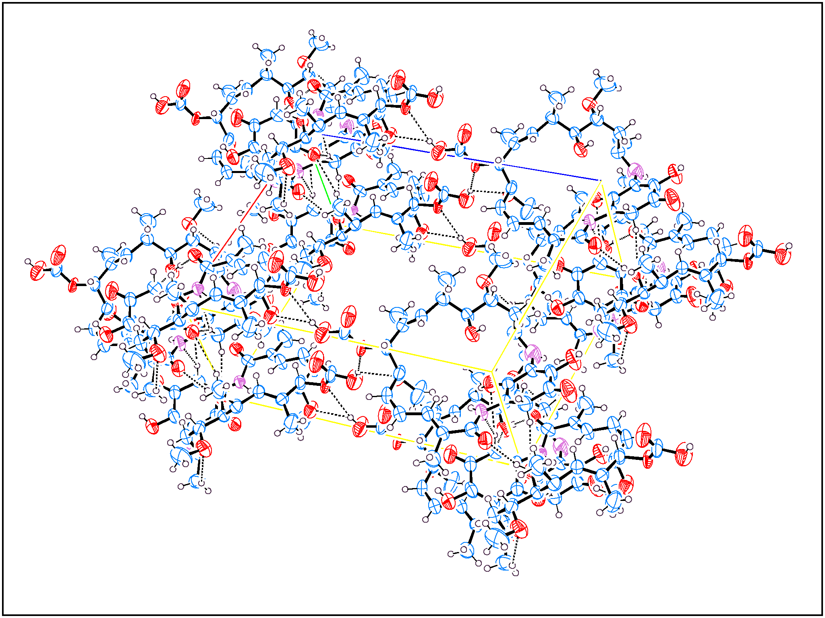

The crystal structure data of Ignaciomycin

Molecular formula : C27H36N2O10

SMILES information:

CO[C@@H]1C[C@H](C)NC2=C(O)C(=O)C=C(NC(=O)\C(C)=C\C=C/[C@@H](OC)[C@H](OC(O)=O)\C(C)=C\[C@H](C)[C@H]1O)C2=O

Molecular weight: 548.59

Space group Hall symbol : p 2yb

Space group H-M symbol: p 1 21 1

Crystal class : Monoclinic

International Tables : 4

Space group multiplicity: 2

Unit cell parameters: a = 13.964(2)Å , b = 7.8466(10)Å , c = 18.918(3)Å

*α* 90° *β* 90.760(5)° *γ* 90°P

**Figure S1.** ORTEP diagram for the intermolecular interactions of Ignaciomycin

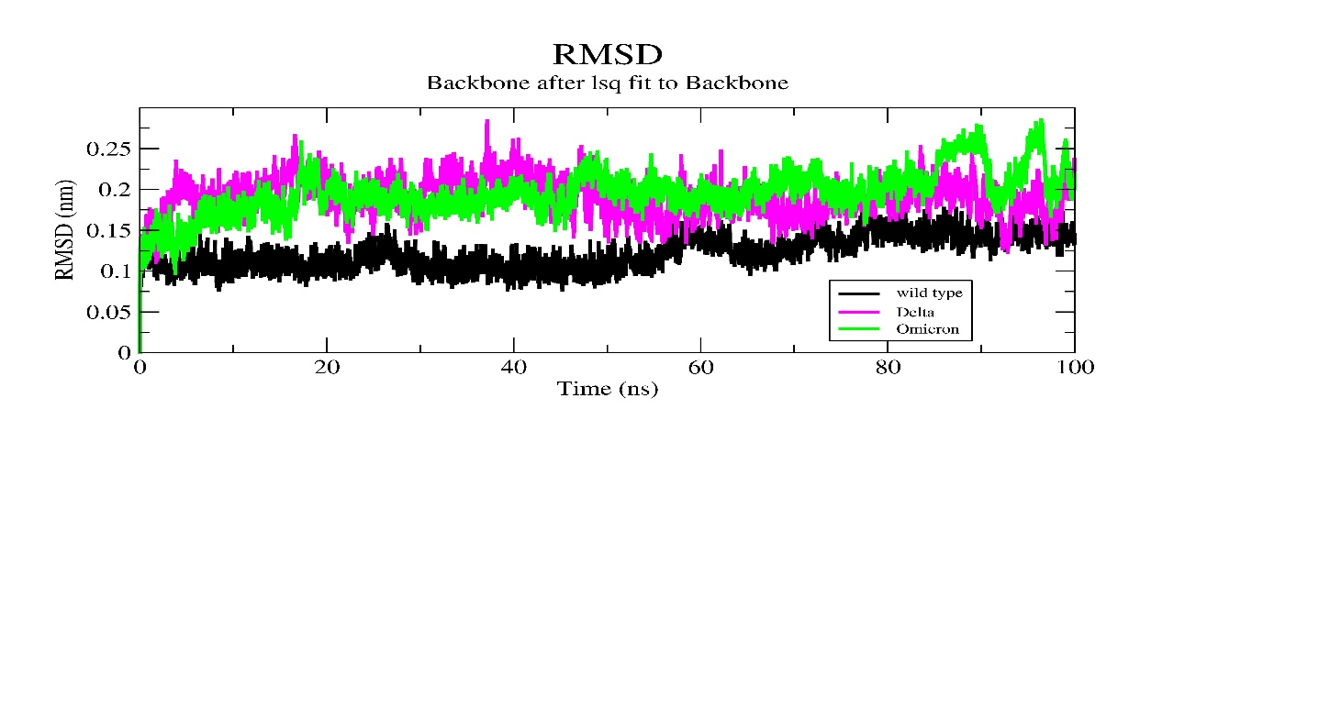

**Figure S2.** RMSD plot for the RBD of SARS-CoV-2 spike glycoprotein apo form of wild type, delta, and omicron variant

|  |  |
| --- | --- |
|  |  |

**Figure S3.** The interaction mode of Ignaciomycin with the RBD of SARS-CoV-2 spike glycoprotein of the wild-type complex after 100 ns dynamics simulation

|  |  |
| --- | --- |
|  |  |

**Figure S4.** The interaction mode of Ignaciomycin with the RBD of SARS-CoV-2 spike glycoprotein of the delta variant complex after 100 ns dynamics simulation

|  |  |
| --- | --- |
|  |  |

**Figure S5.** The interaction mode of Ignaciomycin with the RBD of SARS-CoV-2 spike glycoprotein of the omicron variant complex after 100 ns dynamics simulation

|  |  |
| --- | --- |
| A | B |

**Figure S6.** Secondary structure changes in the apo wild type (A) and Ignaciomycin–Wild type complex (B) after 100 ns simulation

|  |  |
| --- | --- |
| A | B |

**Figure S7.** Secondary structure changes in the apo delta variant (A) and Ignaciomycin– delta variant complex (B) after 100 ns simulation

|  |  |
| --- | --- |
| A | B |

**Figure S8.** Secondary structure changes in the apo omicron variant (A) and Ignaciomycin– omicron variant complex (B) after 100 ns simulation

|  |  |
| --- | --- |
| A | B |

**Figure S9.** The overall collective motions of the generated five eigenvectors with the RMSD (A) and RMSF (B) projection for the wild type and Ignaciomycin-wild type complex

|  |  |
| --- | --- |
| A | B |

**Figure S10.** The overall collective motions of the generated five eigenvectors with the RMSD (A) and RMSF (B) projection for the delta variant and Ignaciomycin-delta variant complex

|  |  |
| --- | --- |
| A | B |

**Figure S11.** The overall collective motions of the generated five eigenvectors with the RMSD (A) and RMSF (B) projection for the omicron variant and Ignaciomycin-omicron variant complex

|  |  |
| --- | --- |
| A | B |

**Figure S12.** The overall occupied area per residue (A) and solvent accessible (B) are calculated for the wild type and Ignaciomycin-wild type complex

|  |  |
| --- | --- |
| A | B |

**Figure S13.** The overall occupied area per residue (A) and solvent accessible (B) are calculated for the delta variant and Ignaciomycin-delta variant complex

|  |  |
| --- | --- |
| A | B |

**Figure S14.** The overall occupied area per residue (A) and solvent accessible (B) are calculated for the omicron variant and Ignaciomycin-omicron variant complex