**Supporting Information**

**Enhancing flame retardant and wrinkle-resistant performances of silk fabric with bio-based Maillard reaction products between glucose and poly(glutamic acid)**

Huiyu Jiang 1, 3,†, Ying Chen 1,†, Wen Zhang 1, 2, 3,*, Qing Li 1, 3,*

1 State Key Laboratory of New Textile Materials and Advanced Processing Technologies and School of Textile Science and Engineering, Wuhan Textile University, Wuhan 430200, Hubei, China

2 China National Textile and Apparel Council Key Laboratory of Flame Retardancy Finishing of Textile Materials, Soochow University, Suzhou 215123, China

3 Hubei Key Laboratory of Biomass Fibers and Eco-Dyeing & Finishing, College of Chemistry and Chemical Engineering, Wuhan Textile University, Wuhan 430200, China

† These authors contributed equally to this work

* Correspondence: zhangwen@wtu.edu.cn (W. Zhang), huiyujiang@wtu.edu.cn (H. Jiang)

**Contents of Supporting Information**

***5 pages, 3 tables and 4 figures***

**Section Page**

Table S1 S2

Table S2 S2

Figure S1 S3

Table S1 Parameters of untreated and treated silk fabrics on flammability

|  |  |  |  |
| --- | --- | --- | --- |
| Sample | Weight gain (%) | LOI value (%) | Damaged length (cm) |
| Untreated | 0 | 24.4 | 30 |
| Single PGA* | 0.83 | 24.7 | 30 |
| Single Glc* | 1.3 | 24.9 | 30 |
| MRPs-20** | 2.1 | 24.9 | 30 |
| MRPs-40** | 4.2 | 26.4 | 12.5 |
| MRPs-60** | 4.8 | 27 | 10.4 |
| Washing times-5*** | 4.3 | 26.5 | 10.4 |
| Washing times-10*** | 3.1 | 25.9 | 17.7 |
| Washing times-15*** | 2.4 | 25.1 | 30 |

* The silk fabric treated with 60 g/L single PGA or Glc was denoted as Single PGA and Single Glc, respectively. ** The silk fabric treated with 20/40/60 g/L MRPs were denoted respectively as MRPs-20/MRPs-40/MRPs-60. *** The 60 g/L MRPs treated silk fabric were subjected to 5/10/15 washing times were respectively denoted as Washing times-5/Washing times-10/Washing times-15.

Table S2 Flammability of the wool, polyamide, and cotton fabrics treated with MRPs

|  |  |  |  |
| --- | --- | --- | --- |
|  | LOI value (%) | Damaged length (cm) | Weight gain (%) |
| Untreated fabrics | | | |
| Wool | 24.4 | 30 |  |
| Polyamide | 24.7 | 22.3 |  |
| Cotton | 19.4 | 30 |  |
| MRPs treated fabrics | | | |
| Wool | 27.4 | 10.8 | 7.3 |
| Polyamide | 24.5 | 30 | 2.8 |
| Cotton | 20.1 | 30 | 0.2 |

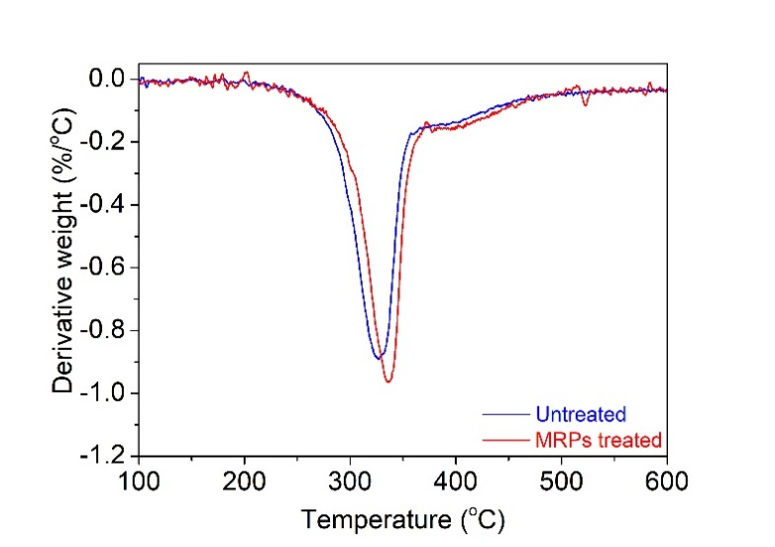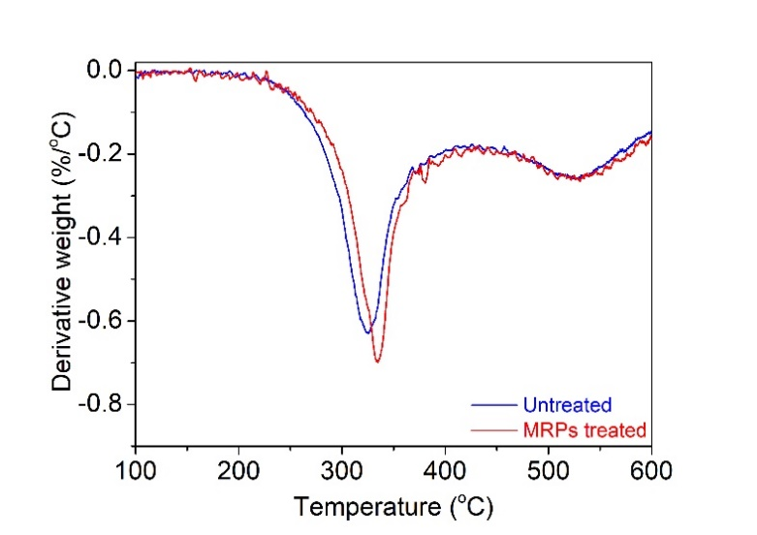

Figure S1. DTG curves of MRPs treated and untreated silk fabrics.