**Supplementary Information**

Sesquiterpenoids of *Dendrobium nobile* Lindl. Aqueous Extract for Inhibition Alcoholic Liver Injury through RTK/ELF4-regulated Inflammation in Mouse Hepatic Macrophages

Di Wu1, 2, Lin Qin1, 2, Chengcheng Feng1, Ligang Cao1, Ju Ye1, Xingdong Wu1, 2, Daopeng Tan*1, 2, and Yuqi He*1, 2.

1. Guizhou Engineering Research Center of Industrial Key-Technology for Dendrobium Nobile, Zunyi Medical University, Zunyi 563000, China
2. Joint International Research Laboratory of Ethnomedicine of Ministry of Education, Zunyi Medical University, Zunyi 563000, China

Di Wu: wudi@ zmu.edu.cn; * Correspondence: Daopeng Tan: tandp@zmu.edu.cn; Yuqi He: yqhe2016@zmu.edu.cn

Supplement Table 1. Primers used for RT-qPCR.

Supplement Table 2. Gradient elution conditions of mobile phase.

Supplement Table 3. The main metabolites of *D.nobile* *in vivo* analyzed by LC-MS/MS.

Supplement Table 4. Molecular docking results of the correlation between the active ingredients of *D.nobile* in blood and the ELF4-related pathway protein.

Supplementary Fig.1 The liver weight-to-body weight ratio.

Supplementary Fig.2. Extracted ion chromatogram (EIC) of the serum in mice administering with or without DNAE.

Supplementary Fig.3. Molecular docking of the RTK protein and Dendronobiloside C of DNAE.

Supplement Table 1. Primers used for RT-qPCR

|  |  |  |
| --- | --- | --- |
| Gene | Forward | Reverse |
| *IL-6* | CTGCAAGAGACTTCCATCCAG | AGTGGTATAGACAGGTCTGTTGG |
| *TNF-α* | CCCTCACACTCAGATCATCTTCT | GCTACGACGTGGGCTACAG |
| *ELF4* | TGCTGCGGAAGCTGTGTTT | AGCTCACGAAGCCTTCTCTCT |
| *S100A9* | ATACTCTAGGAAGGAAGGACACC | TCCATGATGTCATTTATGAGGGC |
| *ERK1* | TCAGTCCTTTTGAGCACCAG | TCATTTGCTCAATGGTTGG |
| *ERK2* | TCCATCGACATCTGGTCTGT | AGCTGGTCCAGGTAGTGCTT |
| *β-actin* | GTGGGCCGCTCTAGGCACCA | TGGCCTTAGGGTGCCAGGGGG |

Supplement Table 2. Gradient elution conditions of mobile phase

|  |  |  |
| --- | --- | --- |
| Time (min) | A phase-formic acid water (%) | B phase- acetonitrile (%) |
| 0 | 100 | 0 |
| 2 | 100 | 0 |
| 9 | 40 | 60 |
| 24 | 30 | 70 |
| 25 | 20 | 80 |
| 30 | 0 | 100 |
| 32 | 0 | 100 |
| 37 | 100 | 0 |
| 40 | 100 | 0 |

Supplement Table 3. The main metabolites of *D.nobile* *in vivo* analyzed by LC-MS/MS

|  |  |  |  |  |  |  |
| --- | --- | --- | --- | --- | --- | --- |
| Identification | RT  (min) | Add  ion | *m/z* | ppm | Formula | Major fragment ions |
| Nobilonine | 7.61 | [M+H]+ | 294.1708 | 2.71 | C16H24NO4 | 276.16, 250.18, 206.12, 180.14 |
| Mubironine | 7.21 | [M+H]+ | 250.1808 | 2.66 | C15H24NO2 | 323.17, 204.18, 175.15, 145.10, 133.10, 119.09, 105.07 |
| Dendramine | 7.51 | [M+H]+ | 280.1916 | 2.99 | C16H26NO3 | 263.19, 235.19, 220.13, 207.20, 164.14, 136.11 |
| Carboxymethyldendrobine | 7.37 | [M+H]+ | 322.2022 | 2.78 | C18H28NO4 | 262.18, 148.21, 136.11 |
| *N*-isopentenyl-dendrobine | 8.65 | [M+H]+ | 310.2016 | 0.92 | C17H28NO4 | 292.15, 264.16, 251.13, 176.03, 121.10, 85.03 |
| Dendrobine-*N*-oxide | 8.61 | [M+H]+ | 332.2589 | 1.48 | C21H34NO2 | 264.20, 145.05, 85.03 |
| Dendroterpene A | 7.91 | [M+H]+ | 264.1602 | 2.92 | C15H22NO3 | 236.16, 218.15, 193.04, 173.13, 159.12, 145.10 |
| Dendroterpene B | 6.97 | [M+H]+ | 280.1551 | 0.85 | C15H22NO4 | 262.14, 234.15, 216.14, 166.12 |
| Dendroxine | 8.91 | [M+H]+ | 292.1913 | 1.92 | C17H26NO3 | 274.18, 262.18, 248.20, 246.19 |
| 6-Hydroxy-dendroxine | 7.24 | [M+H]+ | 308.1864 | 2.58 | C17H26NO4 | 262.18, 248.16, 234.11 |
| *N*-isopentenyldendroxinium | 8.94 | [M+H]+ | 360.2541 | 2.22 | C22H34NO3 | 292.19, 274.18, 248.20, 231.16 |
| 9-Hydroxy-10-oxodendrobine | 7.62 | [M+H]+ | 294.1704 | 1.55 | C16H24NO4 | 276.16, 250.18, 248.16, 234.11, 230.15 |
| *N*-trans-feruloyl tyramine | 8.61 | [M+H]+ | 314.1397 | 3.17 | C18H20NO4 | 177.06, 145.03, 121.07, 117.03 |
| *N*-cis-feruloyl tyramine | 8.61 | [M+H]+ | 314.1397 | 3.17 | C18H20NO4 | 177.06, 145.03, 121.07, 117.03 |
| Dendronobilin C | 7.58 | [M-H]- | 297.1343 | -0.17 | C15H21O6 | 253.14, 235.13, 195.10, 177.09 |
| Dendronobilin F | 9.06 | [M-H]- | 281.1394 | -0.06 | C15H21O5 | 237.15, 219.14, 193.16, 165.09, 97.06 |
| Dendronobilin K | 10.72 | [M-H]- | 267.1602 | 0.03 | C15H23O4 | 223.17, 205.16, 129.97 |
| Dendroterpene C | 9.83 | [M-H]- | 263.1288 | -0.12 | C15H19O4 | 219.14, 189.09, 167.11 |
| Dendroterpene E | 8.17 | [M-H]- | 265.1445 | -2.34 | C15H21O4 | 203.14, 189.13 |
| Dendroside F | 7.31 | [M-H]- | 429.2131 | -0.06 | C21H33O9 | 157.01, 113.02, 85.03, 75.01, 71.01 |
| Dendrobiumane A | 13.31 | [M-H]- | 253.1808 | -0.58 | C15H25O3 | 207.17, 116.05 |
| Dendronobilin B | 9.68 | [M-H]- | 283.1551 | -0.13 | C15H23O5 | 239.16, 221.15, 186.02, 99.04 |
| Dendromoniliside D | 6.93 | [M-H]- | 445.2084 | 1.01 | C21H33O10 | 283.15, 265.15, 149.06, 113.02, 101.02, 85.03, 71.01 |
| Dendroside G | 7.22 | [M-H]- | 445.2084 | 1.17 | C21H33O10 | 401.22, 353.20, 259.35, 161.04, 113.02, 101.02, 85.03, 71.01 |
| Dendroside A | 8.83 | [M-H]- | 415.2341 | 0.72 | C21H35O8 | 355.21, 157.01, 129.02, 113.02, 85.03, 75.01, 71.01 |
| Dendroside C | 8.34 | [M-H]- | 415.2342 | 1.01 | C21H35O8 | 355.21, 157.01, 129.02, 113.02, 85.03, 75.01, 71.01 |
| Dendronobilin N | 10.74 | [M-H]- | 267.1603 | 2.42 | C15H23O4 | 249.15, 223.17, 205.16, 97.06 |
| Dendronobiloside C | 7.52 | [M-H]- | 559.2763 | 1.52 | C27H43O12 | 179.06, 119.03, 113.02, 101.02, 89.02, 85.03, 71.01, 59.01 |
| Dendronobiloside D | 7.69 | [M-H]- | 559.2763 | 1.54 | C27H43O12 | 337.02, 295.34, 253.36, 179.06, 161.04, 143.03, 113.02, 101.02, 89.02, 85.03, 71.01, 59.01 |
| Dendronobiloside A | 7.91 | [M-H]- | 563.3074 | 1.11 | C27H47O12 | 159.03, 113.02, 101.02, 95.01, 85.03, 71.01, 59.01 |
| Dendronobiloside E | 7.95 | [M-H]- | 413.2193 | 2.92 | C21H33O8 | 308.07, 167.09, 119.07, 113.02, 101.02, 89.02, 85.03, 71.01 |
| Dendronobilin G | 13.45 | [M-H]- | 253.1807 | -0.94 | C15H25O3 | 207.17, 123.10, 57.03 |

**alkaloids**

**sesquiterpenoids**

Supplement Table 4. Molecular docking results of the correlation between the active ingredients of *D.nobile* in blood and the ELF4-related pathway protein (binding energy < -7 kcal/mol)

|  |  |  |  |  |  |  |  |
| --- | --- | --- | --- | --- | --- | --- | --- |
| Comp ID | Compound | 结合能（kcal/mol） | | | | | |
| RTK | RAS | MEK | ERK | MAPK | NF-κB |
| comp_001 | 6-hydroxy-dendroxine | - | - | - | - | - | - |
| comp_002 | 9-hydroxy-10-oxodendrobine | -7.6 | - | - | - | - | - |
| comp_003 | Dendramine | -7.8 | - | - | - | - | - |
| comp_004 | Dendrobiumane A | -7.1 | - | -7.2 | - | - | - |
| comp_005 | Dendronobilin B | -7.7 | - | - | - | - | - |
| comp_006 | Dendronobilin C | - | - | - | - | - | - |
| comp_007 | Dendronobilin F | - | - | - | - | - | - |
| comp_008 | Carboxymethyldendrobine | -7.3 | - | - | - | - | - |
| comp_009 | Mubironine B | -8.1 | - | - | - | - | - |
| comp_010 | *N*-isopentenyl-dendrobine | -8.1 | -7.3 | -7.2 | -7.5 | -7.3 | - |
| comp_011 | *N*-isopentenyldendroxinium | -7.1 | - | -7.4 | -7.4 | -7.1 | - |
| comp_012 | *N*-trans-feruloyl tyramine | -8.7 | -8.6 | - | - | -7.5 | - |
| comp_013 | *N*-cis-feruloyl tyramine | -9.1 | -8.5 | - | -7.5 | - | - |
| comp_014 | Dendronobilin G | - | - | - | - | - | - |
| comp_015 | Dendronobilin K | -7.6 | - | - | - | - | - |
| comp_016 | Dendronobilin N | -7.7 | - | - | - | - | - |
| comp_017 | Dendronobiloside A | -8.2 | -7.8 | -7.5 | -8.2 | -8.2 | -7.6 |
| comp_018 | Dendronobiloside C | -9.1 | -8.4 | -7.3 | -8.1 | -8.4 | -7.3 |
| comp_019 | Dendronobiloside D | -8.6 | -7.9 | -7.3 | -7.6 | -7.9 | -7.7 |
| comp_020 | Dendronobiloside E | -8.1 | -7.1 | - | -8.0 | -7.2 | -7.3 |
| comp_021 | Dendroside F | -8.2 | -8.5 | -7.5 | -8.7 | -8.0 | - |
| comp_022 | Dendroside G | -8.2 | -8.0 | - | -7.8 | -7.3 | - |
| comp_023 | Dendroside A | -8.3 | -8.1 | -7.2 | -8.8 | -7.3 | -7.1 |
| comp_024 | Dendroside C | -8.0 | -7.8 | -7.3 | -7.7 | - | - |
| comp_025 | Dendrobine-*N*-oxide | - | - | - | -7.1 | - | - |
| comp_026 | Nobilonine | - | - | - | - | - | - |
| comp_027 | Dendroxine | -7.3 | - | - | - | - | - |
| comp_028 | Dendroterpene A | -7.3 | - | - | - | - | - |
| comp_029 | Dendroterpene B | -7.5 | - | - | - | - | - |
| comp_030 | Dendroterpene C | - | - | - | - | - | - |
| comp_031 | Dendroterpene E | -8.1 | - | - | - | - | - |
| comp_032 | Dendromoniliside D | -7.9 | -7.9 | -7.3 | -7.2 | -7.6 | - |

Supplementary Fig.1 The liver weight-to-body weight ratio. All data are means ± SD (n=6). * *vs.* NG. (\*\*\**p* < 0.001).

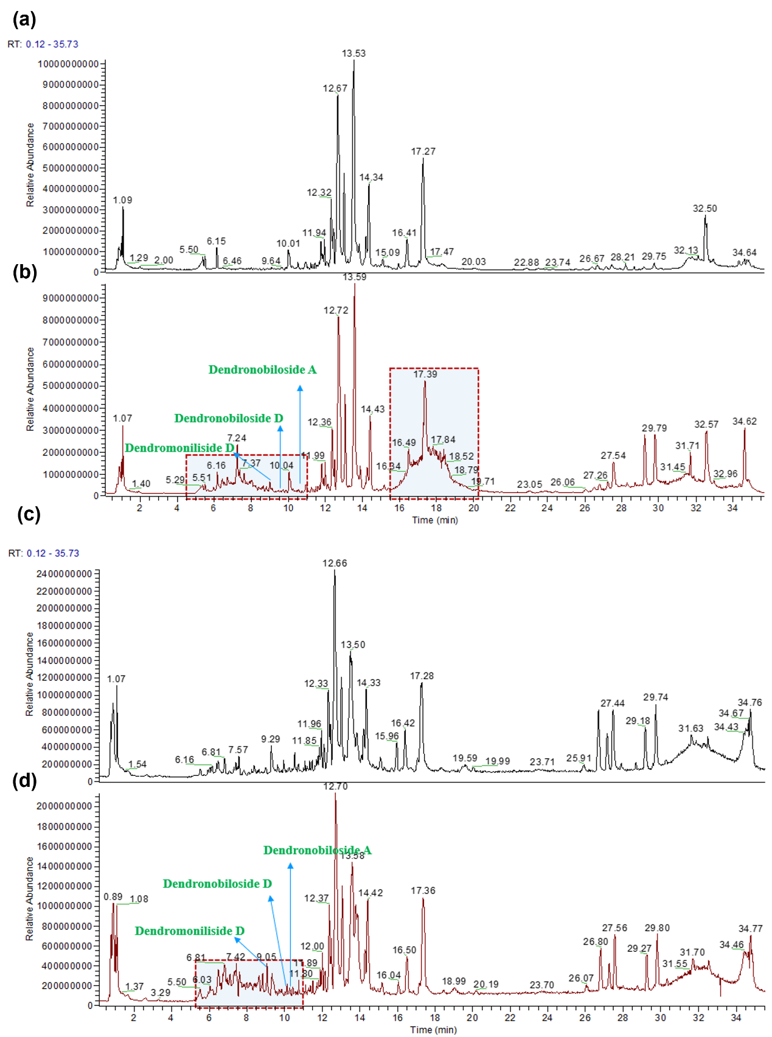

Supplementary Fig.2. Extracted ion chromatogram (EIC) of the serum in mice administering with or without DNAE. (a) EIC of blank serum in positive mode. (b) EIC of serum from gavaged DNAE mice in positive mode. (c) EIC of blank serum in negative mode. (d) EIC of serum from gavaged DNAE mice in negative mode.

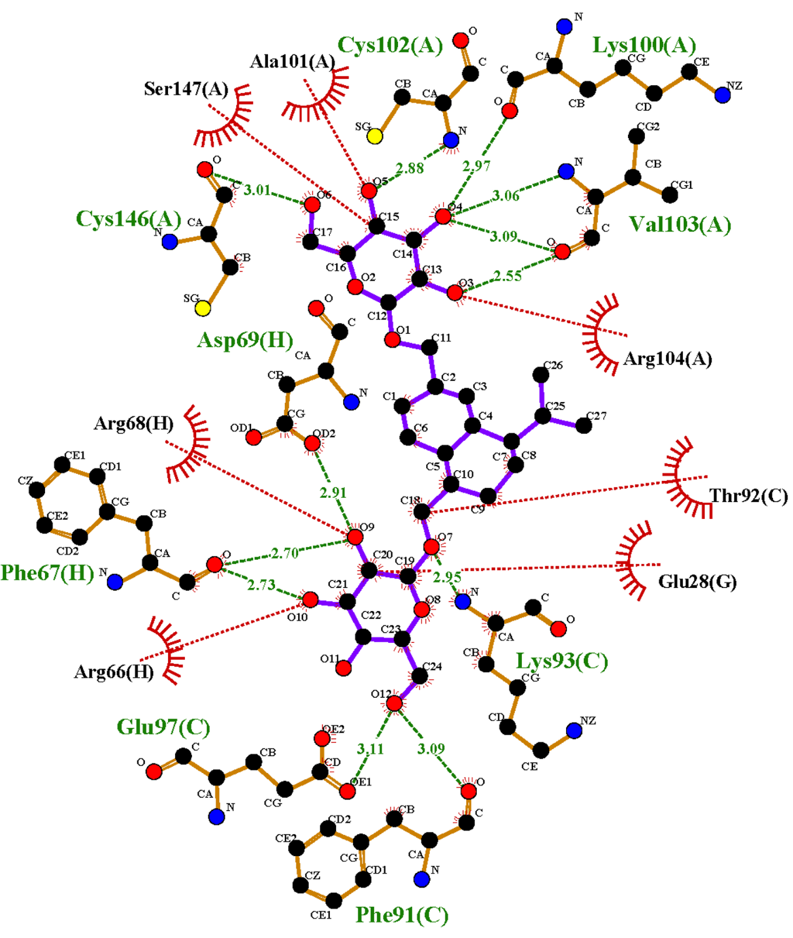 Supplementary Fig.3. Molecular docking of the RTK protein and Dendronobiloside C of DNAE. In 2D interactions, the purple ring structures represent the Dendronobiloside C, the orange chain structures represent the amino acids forming hydrogen bonds with Dendronobiloside C, the red arc structures represent the amino acids forming hydrophobic interaction with Dendronobiloside C, the green dashed lines represent the hydrogen bonds formed between the Dendronobiloside C and the protein.