**Figure S1.**

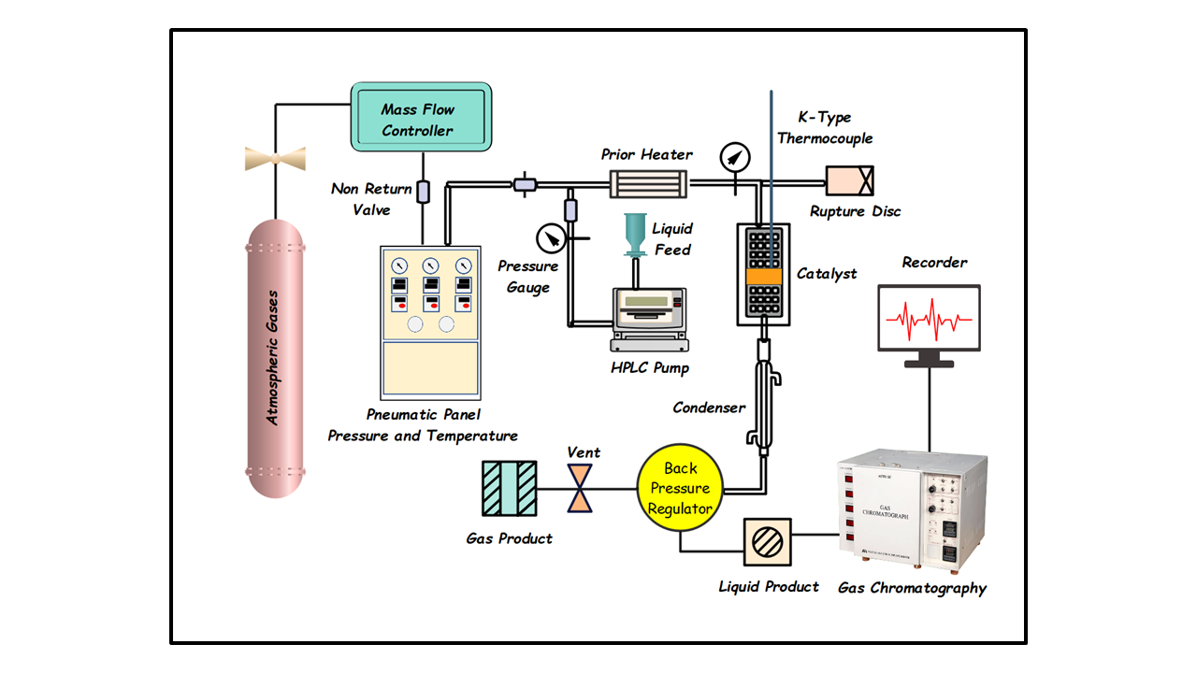

ddh

**Figure S1. A schematic flow diagram of high pressured fixed bed Continuous reactor.**