Fig. S1 Chromatograms of CM. raw products (S), honey-processed products (M), and stir-fried products (C)
Fig. S2. Morphologic photos of CM. (A) Raw CM;(B) Stir-fried CM;(C) Honey-processed CM
Tab. S1. Results of dynamic parameters of ZH andYH.
Honey type | Order of reaction | Zero order kinetic equation |  | First-order kinetic equation |  | Second-order kinetic equation
Indexes |  | K | R² | K | R² | K | R²
ZH | T | 1.087 | 0.6803 | 0.0202 | 0.8536 | 0.0007 | 0.3451
 | MC | -0.0418 | 0.9496 | -0.0027 | 0.9427 | 0.0002 | 0.9205
 | pH | -0.0011 | 0.5839 | -0.0002 | 0.5557 | 5.00E⁻⁰⁵ | 0.5851
 | Color | 0.0032 | 0.7629 | 0.0002 | 0.9171 | -0.0522 | 0.8725
 | Viscosity | 397.74 | 0.8448 | 0.0202 | 0.9729 | 2.00E⁻⁰⁶ | 0.9473
 | 5-HMF | 0.161 | 0.7878 | 0.0182 | 0.9685 | -0.0031 | 0.9673
 | TPC | 1.1763 | 0.9302 | 0.011 | 0.9756 | -1E⁻⁰⁵ | 0.9645
 | FRAR | 3.3396 | 0.9077 | 0.0154 | 0.9696 | -1E-04 | 0.9296
YH | T | 1.1676 | 0.7331 | 0.0185 | 0.8656 | -0.0004 | 0.4068
 | MC | -0.0276 | 0.9106 | -0.0017 | 0.9073 | 0.0001 | 0.8716
 | pH | -0.002 | 0.5657 | 0.0004 | 0.5663 | 0.0007 | 0.5667
 | Color | 0.0028 | 0.931 | 0.0124 | 0.9587 | -0.0598 | 0.931
 | Viscosity | 223.63 | 0.6395 | 0.0177 | 0.9549 | -1.0E⁻⁰⁶ | 0.9872
 | 5-HMF | 0.3141 | 0.8489 | 0.0175 | 0.9104 | -0.0016 | 0.8924
 | TPC | 1.0048 | 0.8442 | 0.0094 | 0.9366 | -0.0002 | 0.9296
 | FRAR | 0.4422 | 0.8442 | 0.0119 | 0.9271 | -0.0002 | 0.9147
Tab. S2. MC, TPC and 5-HMF of ZH measured at different temperature and time points (n=3)
T (℃) | Time (min) | MC (%) | TPC(mg GAE/100 g) | 5-HMF(mg/100 g)
125 ℃ | 0 | 17.65 | 56.61 | 2.67
 | 20 | 17.59 | 64.92 | 2.91
 | 40 | 17.25 | 72.22 | 3.87
 | 60 | 16.75 | 102.57 | 6.17
 | 80 | 15.55 | 148.70 | 10.66
80 ℃ | 100 | 14.64 | 180.22 | 18.58
 | 0 | 17.65 | 56.61 | 2.67
 | 20 | 17.12 | 72.10 | 3.26
 | 40 | 16.86 | 71.86 | 3.24
 | 60 | 16.57 | 71.80 | 3.37
 | 80 | 16.47 | 69.21 | 3.46
 | 100 | 16.11 | 70.92 | 3.54
Tab. S3. Kinetic reaction equations and related parameters of MC, TPC and 5-HMF in ZH at different temperatures
T(℃) | Indexes | Kinetic equation | R² | Order of reaction | K
125 ℃ | MC | y = -0.0015x | 0.9100 | First-order | 0.0015
 | TPC | y = 0.011x | 0.9776 | First-order | 0.0110
 | 5-HMF | y = 0.0169x | 0.9617 | First-order | 0.0169
80 ℃ | MC | y = -0.001x | 0.9852 | First-order | 0.0010
 | TPC | y = 0.0029x | 0.8817 | First-order | 0.0029
 | 5-HMF | y = 0.0034x | 0.9110 | First-order | 0.0034
Tab. S4. Compounds identified of chemical markers of CM.
No. | T/min | [M + H]- (m/z) | Formula | Error (ppm) | Identification | Proposed Structure
2 | 4.12 | - | C₆H₆O₃ | - | 5-Hydroxymethylfurfural | 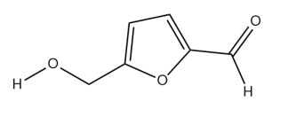
3 | 6.09 | 567.17 | C₂₆H₃₂O₁₄ | 2.27 | Mulberroside A | 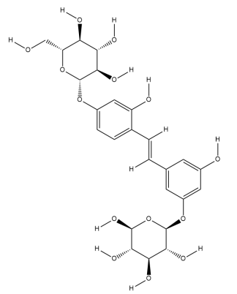
4 | 6.84 | 353.09 | C₁₆H₁₈O₉ | 3.87 | Chlorogenic acid | 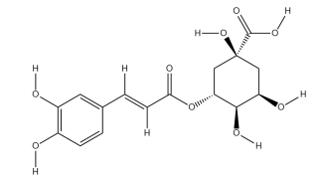
7 | 11.95 | 243.07 | C₁₄H₁₂O₄ | 4.58 | Oxyresveratrol | 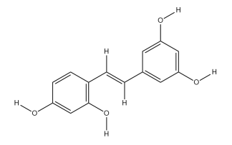
10 | 22.08 | 591.13 | C₃₄H₂₄O₁₀ | 3.76 | Mulberrofuran Q | 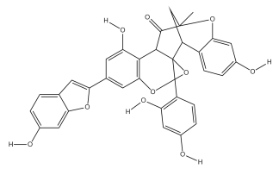
12 | 22.77 | 579.17 | C₃₄H₂₈O₉ | 3.62 | Mulberrofuran C | 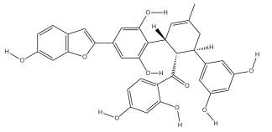
17 | 27.40 | 691.22 | C₄₀H₃₆O₁₁ | 2.94 | Kuwanon G | 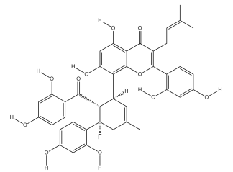
21 | 30.96 | 693.24 | C₄₀H₃₈O₁₁ | 3.78 | Kuwanon O | 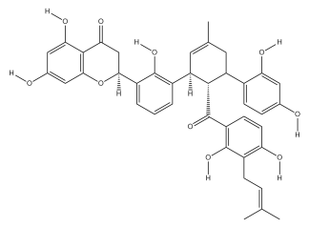
24 | 32.96 | 759.29 | C₄₅H₄₄O₁₁ | 3.35 | Sanggenon C | 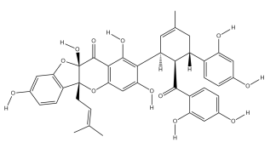
25 | 35.44 | 421.17 | C₂₅H₂₆O₆ | 4.03 | Cudraflavanone A | 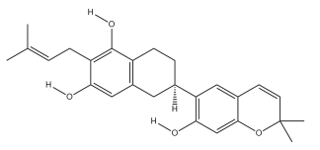
27 | 37.33 | 419.15 | C₂₅H₂₄O₆ | 3.96 | Cyclomulberrin | 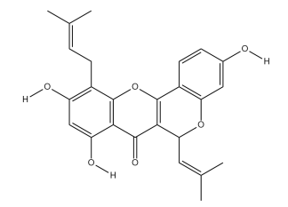
29 | 39.59 | 419.15 | C₂₅H₂₄O₆ | 4.03 | Morusin | 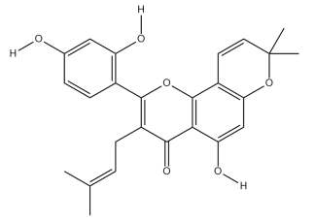
32 | 42.85 | 391.19 | C₂₅H₂₈O₄ | 4.09 | Mulberrofuran B | 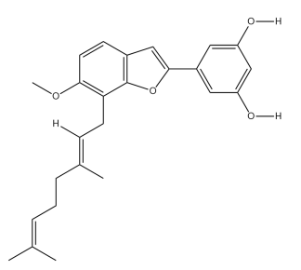
Tab. S5. Active ingredient gene targets of CM
Active ingredients | Targets
Oxyresveratrol | HCK、BACE1、ALB、MAPK14、ESR1、PTGS1、PTGS2、APP、CYP1A2、CYP2C9、CYP3A4、CYP2C19、PIK3CA、LCK、SYK、RELA、MAPT、ALOX5、TTR、AHR、CYP1A1、CYP19A1、EGFR、ABCB1、PTK2B、HMGCR
kuwanon G | MAPK10、MMP13、MAPK8、TTR、MAPK14、MMP3、BMP2、GSTP1、ESR1、BACE1、ALB、HCK、MAPK1、NQO1、KDR、HSP90AA1、SHBG、RELA
Morusin | ABCG2、PTGS2、BACE1、ADORA3、NFKB1、RELA、CYP1A1、CYP1A2、ALB、TTR、BMP2、KDR、MAPK10、GSTP1、CASP3、MAPK1、MAPK14、AR、F2、ESR1、MMP13、RORA

