*Supplementary materials for:*

Towards a better understanding on adsorption mechanism of various heavy metal with phosphorus rich hydrochar

Yi Wen, Dingxiang Chen, Yong Zhang, Huabin Wang (), Rui Xu ()

School of Energy and Environment Science, Yunnan Normal University, Kunming 650500, P. R. China;

Yunnan Key Laboratory of Rural Energy Engineering, Kunming 650500, P. R. China;

Corresponding author: Huabin Wang

Tel: +8613016418930

E–mailaddress: hbwang@ynnu.edu.cn

Corresponding author: Rui Xu

Tel: +86 27 65940928; Fax: +86 27 65940928

E–mailaddress: ecowatch_xr@163.com

**Table S1.** Basic elemental composition, specific surface area, and pore structure of CMHCC.

|  |  |
| --- | --- |
|  | CM400 |
| P (%) | 0.61 |
| S (%) | 1.69 |
| O/C | 1.48 |
| H/C | 0.18 |
| BET (m2·g−1) | 11.78 |
| Vtotal (m3·g−1) | 0.05 |
| Average pore size (Å) | 837.94 |

**Table S2.** Phosphorus release and adsorption effect of CMHCC in heavy metal solutions at different pH.

|  |  |  |  |  |  |
| --- | --- | --- | --- | --- | --- |
| pH | | | 2 | 4 | 6 |
| Pb(II) | *Qe* | mg·L−1 | 3.20 | 87.32 | 99.49 |
| mmoL·L−1 | 0.02 | 0.42 | 0.48 |
| Content of phosphorus | mg·L−1 | 5.61 | 0.40 | 0.03 |
| mmoL·L−1 | 0.18 | 0.01 | 0.00 |
| Content of phosphorus consumed | mg·L−1 | 0.00 | 4.31 | 4.38 |
| mmoL·L−1 | 0.00 | 0.13 | 0.14 |
| Cd(II) | *Qe* | mg·L−1 | 30.46 | 33.33 | 60.12 |
| mmoL·L−1 | 0.27 | 0.30 | 0.54 |
| Content of phosphorus | mg·L−1 | 5.27 | 4.50 | 2.93 |
| mmoL·L−1 | 0.16 | 0.14 | 0.09 |
| Content of phosphorus consumed | mg·L−1 | 0.23 | 0.20 | 1.48 |
| mmoL·L−1 | 0.01 | 0.01 | 0.05 |
| Hg(II) | *Qe* | mg·L−1 | 20.44 | 23.32 | 61.57 |
| mmoL·L−1 | 0.10 | 0.12 | 0.31 |
| Content of phosphorus | mg·L−1 | 4.71 | 4.66 | 3.76 |
| mmoL·L−1 | 0.15 | 0.15 | 0.12 |
| Content of phosphorus consumed | mg·L−1 | 0.79 | 0.04 | 0.65 |
| mmoL·L−1 | 0.02 | 0.00 | 0.02 |

**Table S3.** Summary table of adsorption capacity and adsorption mechanism of biochar for three kinds of heavy metal prepared from different raw materials.

|  |  |  |  |  |  |
| --- | --- | --- | --- | --- | --- |
| Heavy metal | Biomass | Phosphorus sources | Main adsorption mechanism | Adsorption capacity | Ref. |
| Pb(II) | Kitchen waste | K2HPO4 | Complexation (hydroxyl and phosphate groups) and precipitation (Pb5(PO4)3OH and PbHPO4) | 257.95 mg·g−1 | (Ning et al. 2022) |
| Swine manure | Endogenous phosphorus | Precipitation (Pb5(PO4)3OH) | 287.87 mg·g−1 | (Sun et al. 2022b) |
| Banana peel | K3PO4 | Precipitation (Pb5(PO4)3Cl), cationic bridging, complexation, and π−π electron−donor−acceptor interaction. | / | (Ge et al. 2022) |
| Sawdust | KH2PO4 | Precipitation (PbHPO4,Pb5(PO4)3(OH), and Pb3(CO3)2(OH)2), cation exchange, and complexation. | 6.36 mmol·g−1 | (Pei et al. 2021) |
| Bone char | Endogenous phosphorus | Complexation, ion exchange and precipitation (Ca2.5Pb7.5(PO4)6(OH)2). |  | (Mei et al. 2022) |
| Pig carcass | Endogenous phosphorus |  | / | (Chen et al. 2022) |
| *Camellia oleifera* shell | Ammonium polyphosphate | Chemisorption (Pb3(PO4)2 and Pb5(PO4)3OH) and complexation. | 723.6 mg·g−1 | (Fan et al. 2020) |
| Cd(II) | Banana peel | K3PO4 | Precipitation, complexation, and π−π electron−donor−acceptor interaction. | / | (Ge et al. 2022) |
|  | Bamboo | K3PO4 | Precipitation and complexation for the formation of Cd(OH)PO3·H2O and Cd(PO3)2. | / | (Zhang et al. 2020) |
|  | Peanut shell | Ammonium polyphosphate | Precipitation (Cd3(PO4)2). | 155 mg·g−1 | (Zhang et al. 2020) |
|  | Peanut shell | Phosphoric acid | Precipitation (Cd3(PO4)2). | 138 mg·g−1 | (Zhang et al. 2020) |
| Peanut shell | Ammonium dihydrogen phosphate | Precipitation (Cd3(PO4)2). | 99 mg·g−1 | (Zhang et al. 2020) |
|  | Apple tree branches | K3PO4 | Precipitation (Cd5(PO4)3Cl, Cd5(PO4)3OH, Cd3(PO4)2, Cd2P2O7, and Cd(PO3)2) and K+ exchange. |  | (Wang et al. 2022) |
|  | Chicken bone meal | Hydroxyapatite | Cation exchange (Cd(H2PO4)2 and Cd3(PO4)2), cation−π interaction, precipitation, and complexation. |  | (Liu et al. 2023) |
| Hg(II) | Bagasse | / | Complexation of Hg(II) with phenolic hydroxyl (CO−) and carboxylic (COO−) groups for the formation of (–O)2HgII and (–COO)2HgII. |  | (Xu et al. 2016) |
| Hickory chips | / | Complexation of Hg(II) with C=C and C=O via Hg−P binding to form Hg–π bonds. |  | (Xu et al. 2016) |
| Brazilian pepper | / | Complexation with phenolic hydroxyl and carboxylic groups. |  | (Liu et al. 2018) |
| Soybean Stalk | / | Ion exchange and physicochemical for the formation of Hg2Cl2 or Hg(OH)2. | 674.91 | (Kong et al. 2011) |
| Sawdust | / | Physicochemical for the formation of Hg2Cl2. | 0.18 mmol·g−1 | (Lloyd-Jones, Rangel-Mendez, and Streat 2004) |
| Oak wood | / | Complexation with S functional groups through the formation of Hg−S. | 99.5% | (Liu et al. 2018) |
| Apatite II™ | Hydroxyapatite | Precipitation (Hg3(PO4)2 and HgHPO4). |  | (Oliva et al. 2011) |

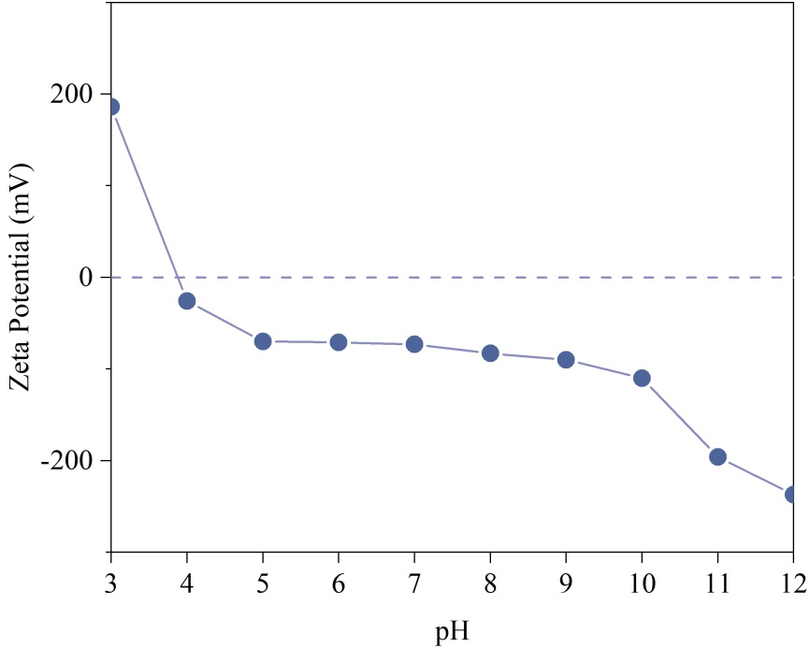

**Figure S1**. Zeta potential of CMHCC.