Table S1. Retention times and related mass spectrometry (MS) data of the target compounds.
No. | (tR)  (min) | [M+H]+ | [M−H]− | MRM | DP/V | CE/V | Name | Formula
No. | (tR)  (min) | m/z | m/z | (Precursor→Product)
1 | 10.43 |  | 120.92 | 120.5-76.9 | -56 | -16 | benzoic acid | C₆H₅COOH
2 | 9.79 |  | 447.81 | 447.2-299.8 | -145 | -35 | quercitrin | C₂₁H₂₀O₁₁
3 | 9.74 |  | 178.53 | 178.5-134.6 | -68 | -22 | caffeic acid | C₉H₈O₄
4 | 7.22 |  | 115.01 | 114.5-70.9 | -57 | -13 | fumaric acid | C₄H₄O₄
5 | 6.02 |  | 353.11 | 352.8-190.7 | -79 | -20 | chlorogenic acid | C₁₆H₁₈O₉
6 | 6.27 |  | 152.95 | 152.6-108.7 | -59 | -22 | protocatechuic acid | C₇H₆O₄
7 | 4.87 |  | 116.82 | 116.3-72.8 | -28 | -17 | succinic acid | C₄H₆O₄
8 | 5.47 |  | 190.52 | 190.5-85.0 | -60 | -27 | quinic acid | C₇H₁₂O₆
9 | 8.87 |  | 610.55 | 609.0-300.6 | -162 | -48 | rutin | C₂₇H₃₀O₁₆
10 | 6.82 |  | 190.32 | 190.3-74.8 | -202 | -25.9 | citrate | C₆H₈O₇
11 | 6.03 |  | 132.93 | 132.5-114.0 | -69 | -13 | malic acid | C₄H₆O₅
12 | 13.28 |  | 283.85 | 282.9-246.8 | -120 | -35 | kaempferol | C₁₅H₁₀O₆
13 | 10.89 | 457.37 |  | 457.3-411.2 | 116 | 40 | ursolic acid | C₃₀H₄₈O₃
14 | 6.45 | 458.41 |  | 458.3-163.0 | 50 | 20 | amygdalin | C₂₀H₂₇NO₁₁
15 | 12.76 | 274.59 |  | 274.0-87.9 | 79 | 32 | apigenin | C₁₅H₁₀O₅
16 | 6.66 | 109.0 |  | 109.0-53.0 | 87 | 21 | 5-hydroxymethyl furfural | C₆H₆O₃

Table S2. linear relationship of 16 chemical components
Name | Regression equation | Linear range (μg/mL) | R² | LoD | LOQ
benzoic acid | y=2.97×10⁵x-1.57×10⁵ | 0.12–12.24 | 0.9991 | 0.43 | 3.78
quercetin | y=2×10⁶x-870.64 | 0.0011–1.11 | 0.9993 | 0.11 | 1.11
caffeic acid | y=7.50×10⁵x-7×10⁵ | 1.21–121.75 | 0.9995 | 0.25 | 1.56
fumaric acid | y =5.32×10⁵x-2×10⁶ | 2.64–264.12 | 0.9991 | 0.49 | 2.41
chlorogenic acid | y=7.02×10⁵x-2×10⁷ | 0.065–130.23 | 0.9993 | 2.14 | 6.18
protocatechuic acid | y =8.03×10⁵x-3×10⁶ | 0.13–130.47 | 0.9994 | 0.15 | 3.76
succinic acid | y=1×10⁶x-4×10⁶ | 0.12–240 | 0.9992 | 0.69 | 1.63
quinic acid | y=6.94×10⁵x-2×10⁶ | 1.34-268.79 | 0.9996 | 2.16 | 10.81
rutin | y=5.55×10⁴x-6.26×10⁴ | 0.071–141.84 | 0.9990 | 0.39 | 12.38
citric acid | y = 2.66×105x - 2×10⁷ | 0.123–12300 | 0.9991 | 0.47 | 10.12
malic acid | y = 2.40×10⁵x-2×10⁶ | 0.015–600.45 | 0.9995 | 0.51 | 11.77
kaempferol | y = 3.21×10⁴x-1.23×10⁴ | 0.012-40.13 | 0.9996 | 0.91 | 9.87
ursolic acid | y = 1.43×10⁴x-6.26×10⁴ | 0.011-200.14 | 0.9994 | 0.37 | 1.23
amygdalin | y=1814.8x-1230.6 | 0.081–50.29 | 0.9995 | 0.17 | 9.75
apigenin | y=9.59×10⁵x-7.12×10⁵ | 0.012–121.23 | 0.9996 | 0.89 | 10.16
5-hydroxymethyl furfural | y = 3.38×10⁵x-1×10⁶ | 0.097–9.86 | 0.9990 | 0.78 | 9.43

Table S3. Samples content determination results(μg/g)
number | benzoic acid | quercetin | caffeic acid | fumaric acid | chlorogenic acid | protocatechuic acid | succinic acid | quinic acid | rutin | citric acid | malic acid | kaempferol | ursolic acid | amygdalin | apigenin | 5-hydroxymethyl furfural
S1 | 78.73 | 0.51 | 1020.69 | 2455.47 | 445.96 | 33.47 | 806.22 | 2417.45 | 32.96 | 132801.33 | 2586.03 | 527.57 | 742.24 | 736.17 | 1875.99 | 826.76
S2 | 77.32 | 0.36 | 1138.17 | 2585.65 | 440.04 | 30.06 | 1507.53 | 1703.43 | 44.32 | 168501.10 | 2533.81 | 590.96 | 680.72 | 579.89 | 2109.74 | 837.94
S3 | 95.53 | 0.87 | 1306.09 | 2652.43 | 356.77 | 30.29 | 1676.13 | 1804.79 | 51.76 | 154506.34 | 2867.88 | 502.80 | 701.83 | 611.83 | 2065.29 | 880.98
S4 | 75.92 | 0.71 | 1187.85 | 2355.88 | 431.16 | 28.36 | 1554.31 | 1588.73 | 46.14 | 144911.28 | 2464.21 | 506.93 | 832.53 | 699.75 | 2036.43 | 924.28
S5 | 82.12 | 0.76 | 1304.46 | 1984.59 | 398.47 | 28.97 | 1528.72 | 1447.33 | 49.00 | 149966.63 | 2852.02 | 530.10 | 987.67 | 451.50 | 1885.66 | 844.97
S6 | 81.74 | 0.69 | 1350.78 | 1839.89 | 399.61 | 31.64 | 1776.08 | 1415.06 | 49.45 | 153397.67 | 2975.33 | 549.95 | 694.70 | 691.18 | 2159.60 | 888.33
S7 | 61.32 | 0.56 | 1523.71 | 1938.34 | 381.73 | 29.41 | 1737.91 | 1570.79 | 34.02 | 159162.30 | 2740.95 | 420.62 | 811.08 | 493.52 | 1919.33 | 1371.17
S8 | 60.72 | 0.74 | 1627.90 | 1880.02 | 467.34 | 26.80 | 1501.24 | 1551.40 | 33.21 | 171467.41 | 2538.87 | 449.84 | 643.74 | 542.03 | 1373.68 | 1483.91
S9 | 72.14 | 0.69 | 1734.34 | 1872.87 | 465.23 | 27.12 | 1726.95 | 1585.62 | 37.08 | 163292.14 | 2746.75 | 427.73 | 965.72 | 627.20 | 2210.12 | 1532.85
S10 | 66.09 | 0.64 | 1503.01 | 2299.08 | 391.57 | 36.47 | 1698.30 | 1808.41 | 33.35 | 149753.31 | 2570.39 | 385.13 | 744.32 | 615.82 | 1337.29 | 1434.82
S11 | 65.83 | 0.68 | 1554.49 | 2325.70 | 403.51 | 38.04 | 1724.69 | 1842.59 | 34.94 | 139591.68 | 2621.11 | 407.66 | 937.44 | 558.29 | 2159.36 | 1420.13
S12 | 61.35 | 0.79 | 1472.42 | 2257.88 | 398.76 | 37.16 | 1648.64 | 1809.86 | 34.23 | 140152.12 | 2449.14 | 389.35 | 859.47 | 495.26 | 2906.70 | 1464.65

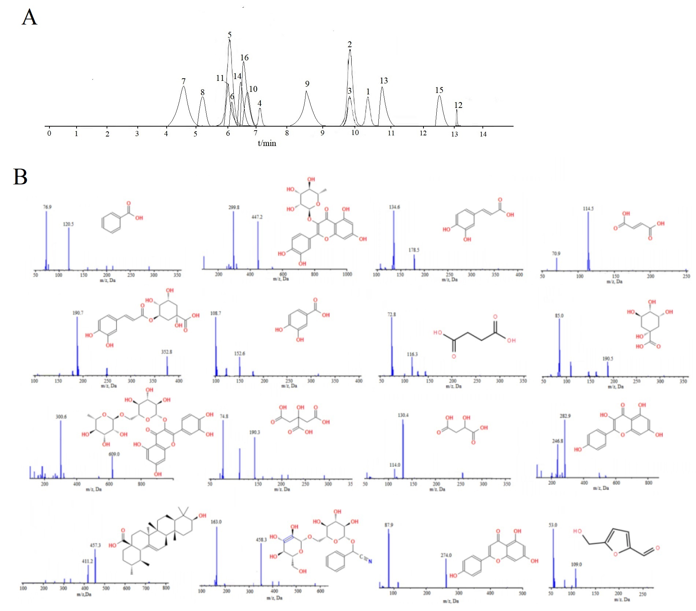
Fig.S1

