**Supplementary Data**

**Table S1. Design in single-factor experiment**

|  |  |  |  |  |
| --- | --- | --- | --- | --- |
| **Factors (units)** | **Levels** | | | |
| X1: molar ratio | 2:1 | 1:1 | 1:2 | 1:3 |
| X2: water addition in NADES (%, v/v) | 20 | 40 | 60 | 80 |
| X3: temperature (°C) | 30 | 40 | 50 | 60 |

**Table S2. Design in RSM study**

|  |  |  |  |
| --- | --- | --- | --- |
| **Factors (units)** | **Levels** | | |
| Low (-1) | Medium (0) | High (+1) |
| X1: molar ratio | 1:1 | 1:2 | 1:3 |
| X2: water addition in NADES (%, v/v) | 20 | 40 | 60 |
| X3: temperature (°C) | 30 | 45 | 60 |

**Table S3.** The pH and viscosity value of the NADES in this study.

|  |  |  |
| --- | --- | --- |
| **Sampels** | **pH** | **Viscosity (mPa.s)** |
| ChCl-U (1:2) | 9.29 | 7.90 |
| ChCl-Gly (1:2) | 3.02 | 18.42 |
| ChCl-CA (1:2) | 1.39 | 238.40 |
| ChCl-Sor (1:1) | 2.88 | 54.32 |
| ChCl-LA (1:1) | 1.40 | nd |
| ChCl-1,3 but (1:6) | 2.90 | 20.76 |
| ChCl-MA (1:1) | 1.55 | 39.41 |
| ChCl-Glu (1:1) | 2.55 | 86.69 |
| Glyc-LA (1:5) | 2.72 | 15.89 |
| Glyc-Gly(2:5) | 5.23 | 18.79 |
| Glu-CA (1:1) | 1.73 | nd |
| Glu-LA (1:5) | 1.23 | 23.80 |
| Gly-LA (1:1) | 1.85 | 14.98 |
| Gly-CA (1:1) | 1.67 | 132.20 |
| Gly-U (1:1) | 8.95 | 14.19 |
| Sor-CA (1:1) | 1.97 | nd |
| Sor-LA (1:1) | 1.90 | 81.56 |

Note: nd = not detected due to too high torque

**Table S4.** Box-Behnken design and experimental results from NADES-based ChCl-U extracts of PIL

|  |  |  |  |  |  |  |  |  |  |
| --- | --- | --- | --- | --- | --- | --- | --- | --- | --- |
| **Run** | **Variables** | | | **Response** | | | | | |
| **X1: Molar ratio** | **X2: Temp.**  **(°C)** | **X3: Water addition (%)** | **TPC  mg GAE/g DW** | **TFC  mg QE/g DW** | **DPPH  mmol QE/g DW** | **FRAP (mmol TE/g DW)** | **ABTS (mmol TE/g DW)** | **RP (mmol TE/g DW)** |
| 1 | 2 | 45 | 40 | 45.883±6.990 | 38.325±9.190 | 120.333±3.870 | 207.322±1.272 | 260.602±0.532 | 183.426±1.890 |
| 2 | 2 | 30 | 60 | 50.176±6.503 | 33.398±1.777 | 121.504±2.434 | 176.969±2.212 | 260.743±0.801 | 167.907±5.916 |
| 3 | 2 | 30 | 20 | 41.135±5.981 | 20.096±8.597 | 118.693±3.514 | 95.073±6.953 | 264.128±0.244 | 132.858±4.726 |
| 4 | 1 | 30 | 40 | 32.931±4.668 | 6.169±2.136 | 114.008±2.029 | 128.480±4.385 | 262.436±0.244 | 141.769±9.766 |
| 5 | 2 | 45 | 40 | 46.645±0.552 | 52.533±5.483 | 120.098±2.811 | 194.515±1.158 | 261.378±0.440 | 185.654±0.630 |
| 6 | 1 | 45 | 60 | 37.230±6.311 | 36.190±4.025 | 125.720±2.534 | 189.439±2.294 | 261.872±0.244 | 183.426±1.575 |
| 7 | 1 | 45 | 20 | 34.162±1.857 | 17.179±1.269 | 120.801±1.859 | 92.608±4.340 | 262.083±2.262 | 140.878±3.884 |
| 8 | 3 | 45 | 20 | 46.128±2.593 | 27.533±0.771 | 124.549±2.259 | 174.231±5.024 | 261.166±0.122 | 186.916±0.257 |
| 9 | 3 | 60 | 40 | 48.475±3.373 | 50.908±2.641 | 124.081±1.463 | 201.403±2.269 | 261.237±0.122 | 196.124±0.630 |
| 10 | 2 | 60 | 20 | 45.040±5.317 | 36.950±0.472 | 123.378±2.926 | 162.140±4.866 | 261.307±1.178 | 224.861±7.920 |
| 11 | 1 | 60 | 40 | 43.747±3.795 | 38.710±2.800 | 127.594±0.406 | 189.270±1.367 | 261.448±0.646 | 184.020±6.243 |
| 12 | 3 | 45 | 60 | 42.550±6.464 | 45.148±4.865 | 120.098±1.859 | 215.347±3.462 | 260.461±0.212 | 179.862±0.000 |
| 13 | 2 | 45 | 40 | 41.910±2.449 | 37.575±0.866 | 125.252±3.606 | 201.298±1.351 | 261.307±0.366 | 169.837±2.205 |
| 14 | 3 | 30 | 40 | 54.094±7.281 | 37.992±1.787 | 124.783±3.246 | 206.585±6.791 | 261.448±0.801 | 167.758±2.009 |
| 15 | 2 | 60 | 60 | 50.910±5.587 | 42.481±3.910 | 126.657±0.406 | 186.827±7.142 | 260.532±0.122 | 242.682±0.945 |

**Table S5.** ANOVA for respon surface from order polynominal model for investigated items.

| **Source** | **Sum of squares** | **df** | **Mean sequare** | **F value** | **p-value**  **(Prob > F)** |
| --- | --- | --- | --- | --- | --- |
| **TPC**  Model  A   B   C Residual  Lack of Fit Pure Error Cor Total | 271.05  233.03  12.10  25.92  232.73  219.80  12.93  503.78 | 3  1  1  1  11  9  2  14 | 90.35  233.03  12.10  25.92  21.16  24.42  6.46 | 4.27  11.01  0.57  1.23   3.78 | 0.0315 *(sig.)*  0.0068  0.4655  0.2919   0.2268 *(not sig.)* |
| **TFC**  Model  A  B  C Residual  Lack of Fit Pure Error Cor Total | 1522.98  501.38  637.14  384.46  670.35  528.29  142.06  2193.34 | 3  1  1  1  11  9  2  14 | 507.66  501.38  637.14  384.46  60.94  58.70  71.03 | 8.33  8.23  10.45  6.31   0.83 | 0.0036 *(sig.)*  0.0153  0.0080  0.0289   0.6576 *(not sig.)* |
| **DPPH**  Model  A B C AB AC BC  Residual  Lack of Fit Pure Error Cor Total | 146.59  3.63  64.54  5.38  51.04  21.95  0.055  33.99  17.05  16.94  180.58 | 6  1  1  1  1  1  1  8  6  2  14 | 24.43  3.63  64.54  5.38  51.04  21.95  0.055  4.25  2.84  8.47 | 5.75  0.85  15.19  1.27  12.01  5.17  0.013  0.34 | 0.0136 *(sig.)*  0.3824  0.0046  0.2932  0.0085  0.0527  0.9123  0.8737 *(not sig.)* |
| **FRAP**  Model  A  B  C  AB  AC  BC  A2  B2  C2  Residual  Lack of Fit Pure Error  Cor Total | 21202.14  4888.99  2195.62  7474.29  1088.06  776.00  818.22  44.67  960.91  3248.26  299.25  217.14  82.10  21501.38 | 9  1  1  1  1  1  1  1  1  1  5  3  2  14 | 2355.79  4888.99  2195.62  7474.29  1088.06  776.00  818.22  44.67  960.91  3248.26  59.85  72.38  41.05 | 39.36  81.69  36.69  124.89  18.18  12.97  13.67  0.75  16.06  54.27  1.76 | 0.0004 *(sig.)*  0.0003  0.0018  0.0001  0.0080  0.0155  0.0140  0.4271  0.0103  0.0007  0.3819 *(not sig.)* |
| **ABTS**  Model  A  B  C  Residual  Lack of Fit Pure Error  Cor Total | 7.01  1.55  2.24  3.22  4.91  4.54  0.37  11.92 | 3  1  1  1  11  9  2  14 | 2.34  1.55  2.24  3.22  0.45  0.50  0.18 | 5.24  3.48  5.01  7.22   2.74 | 0.0173 *(sig.)*  0.0889  0.0468  0.0211   0.2958 *(not sig.)* |
| **RP**  Model  A  B  C  Residual  Lack of Fit Pure Error  Cor Total | 8831.97  811.39  7044.56  976.03  3093.29  2946.70  146.59  11925.26 | 3  1  1  1  11  9  2  14 | 2943.99  811.39  7044.56  976.03  281.21  327.41  73.30 | 10.47  2.89  25.05  3.47   4.47 | 0.0015 *(sig.)*  0.1175  0.0004  0.0894   0.1963 *(not sig.)* |

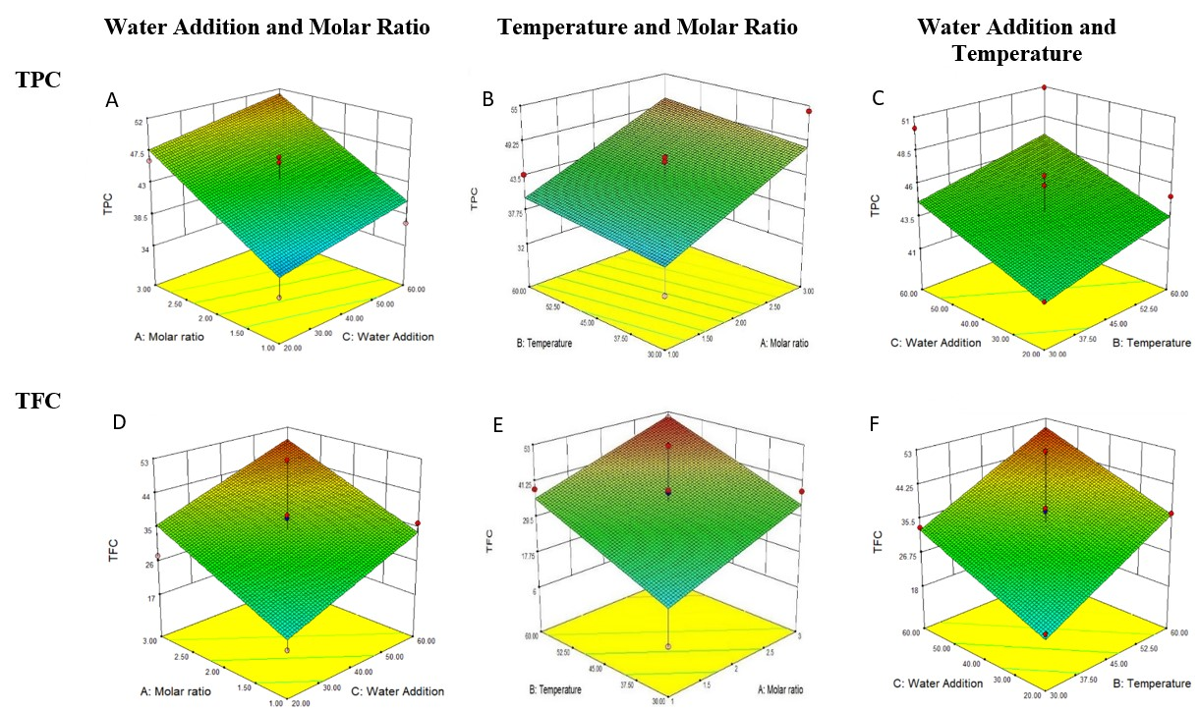

**Fig. S1.** 3D-surface of TPC and TFC shows the interaction between variables with each response

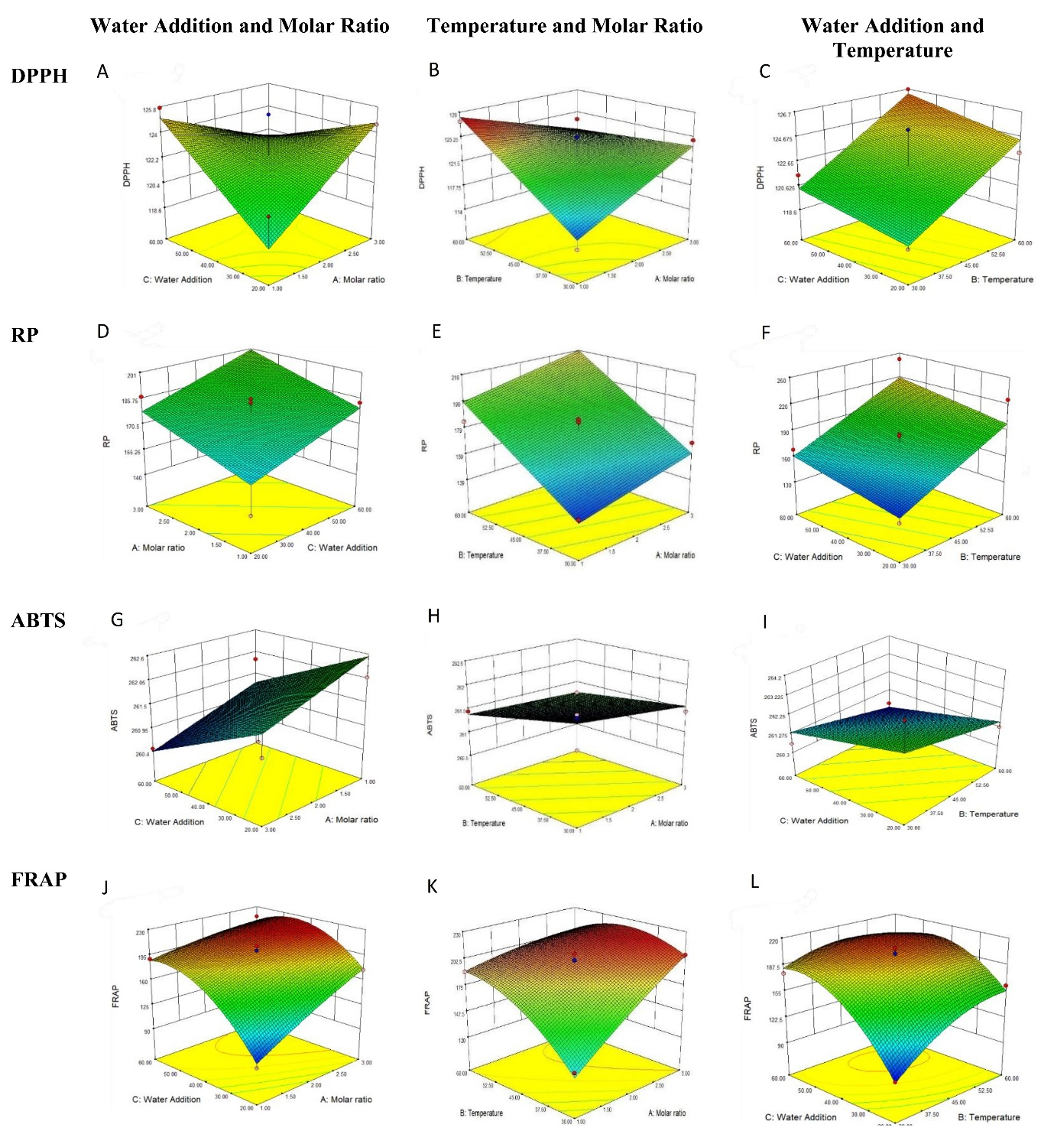

**Fig. S2.** 3D-surface of antioxidant activity shows the interaction between variables with each response