Supporting Information for
Insights into the photocatalytic role of glycine-assisted sol-gel auto-combustion synthesized (Co, Mn)(Co, Mn)₂O₄ nanostructures for efficient visible light-driven degradation of methyl orange
Ghazal Oroumiª, Foroozan Samimiª, Makarim A. Mahdi^{b}, Elmuez A. Dawi^{c}, Masoud Salavati-Niasariª*
ªInstitute of Nano Science and Nano Technology, University of Kashan, Kashan, P. O. Box. 87317-51167, I. R. Iran
^{b}Department of Chemistry, College of Education, University of Al-Qadisiyah, Diwaniyah, Iraq
^{c}Nonlinear Dynamic Research Center (NDRC), College of Humanities and Sciences, Ajman University, P.O. Box 346, Ajman, UAE
*Corresponding author. Tel.: +98 31 55912383; Fax: +98 31 55913201; E-mail address: salavati@kashanu.ac.ir (Masoud Salavati-Niasari)

S1. Supporting Figures
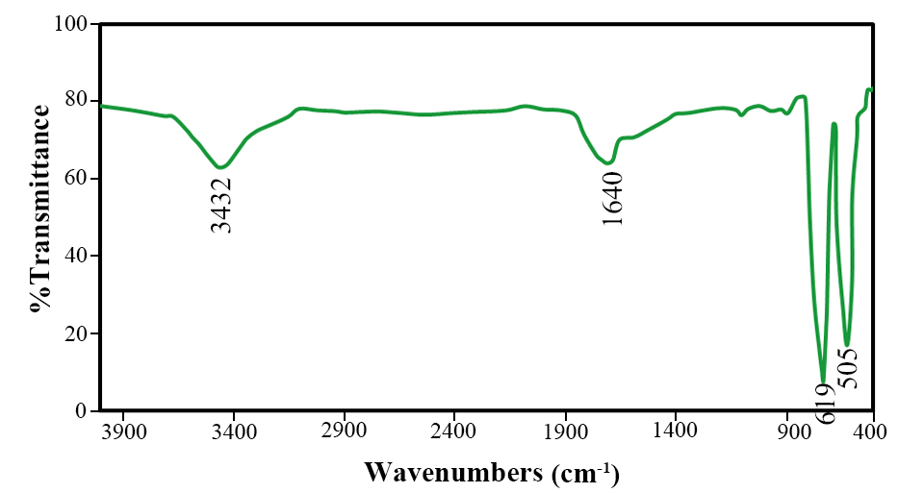
Figure S1. FT-IR spectrum of the (Co, Mn)(Co, Mn)₂O₄ nanoparticles (sample No. 2).

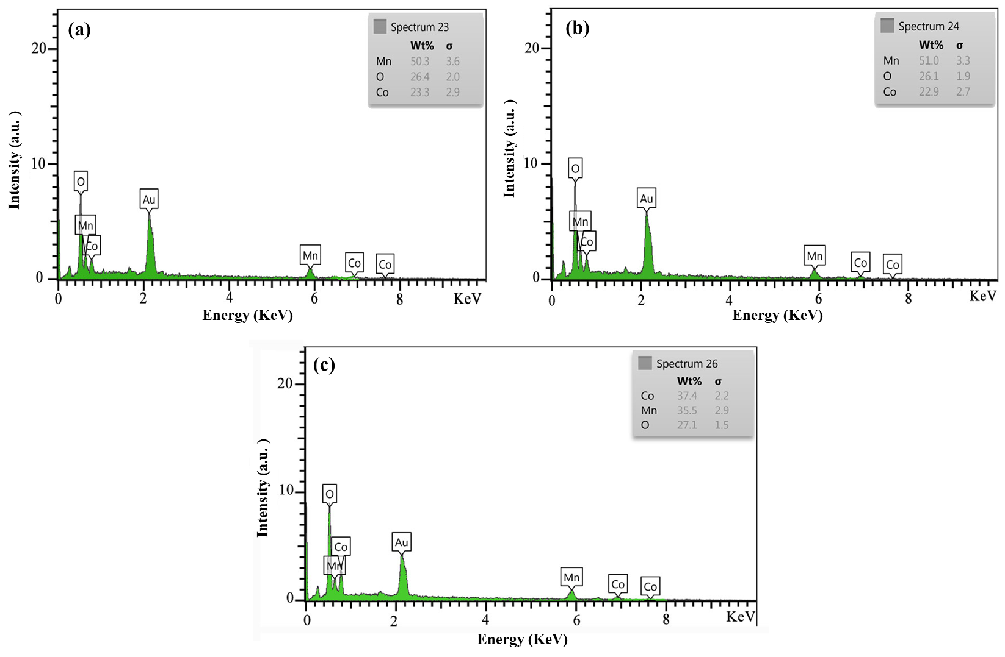
Figure S2. EDS spectra of the (Co, Mn)(Co, Mn)₂O₄ nanoparticles synthesized in the different ratios of precursors (Co: Mn) (a) 2:3, (b) 1:3, and (c) 3:3.

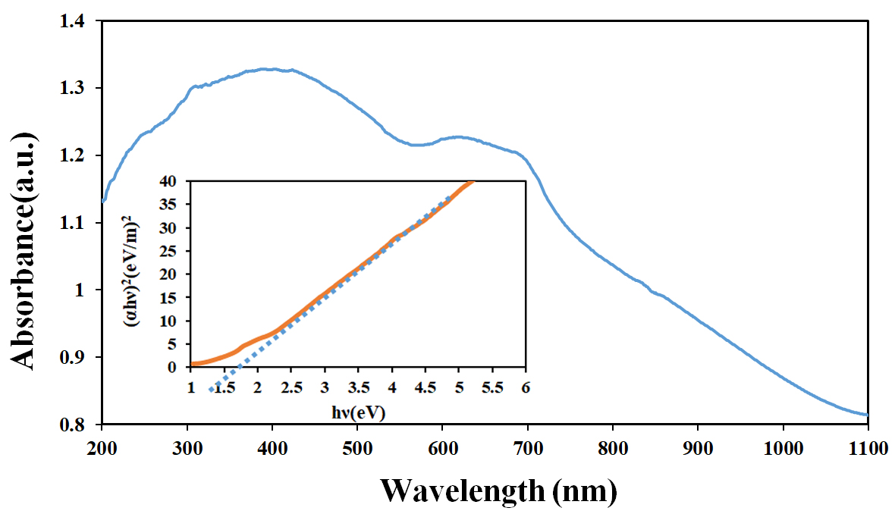
Figure S3. Results of DRS analysis, and the inset shows estimated band-gap of (Co, Mn)(Co, Mn)₂O₄ nanoparticles (sample No. 2).

