**Supporting information**

**Integrated serum, urine metabolomics and** **16S rRNA sequencing to investigate the modulatory effect of Ziziphi Spinosae Folium flavonoid on D-galactose****-induced aging of rats**

Yu Tao1,†, Cai Fu1,†, Huizhi Du1, Chenhui Du2*, Yan Yan 1*

1 Modern Research Center for Traditional Chinese Medicine, Shanxi University, Taiyuan 030006, China.

2 School of Traditional Chinese Materia Medica, Shanxi University of Chinese Medicine, Taiyuan 030619, China.

† These authors contributed equally to this work.

**Supplementary Flies**

1. ***Sample preparation of LZJSF***

The dried LZJS sample (500 g) was soaked for 3 h and extracted twice with 50% ethanol (1:12, *w/v*) at 80 ℃ for 30 min to obtain LZJS extract. Subsequently, the LZJS extract was chromatographed over on D101 macroporous resin at a concentration of 23.85 mg/mL, followed by the elution with distilled water at a flow rate of 0.5 BV/h, and 50% ethanol at a flow rate of 1 BV/h. The 50% ethanol eluent was collected, condensed and freeze-dried to powder (yield: 10%) to obtain LZJSF (Yan et al., 2020). Afterward, the relative contents of total flavonoids (41%) were determined using ultraviolet spectrophotometer.

1. ***Determination content of six compounds in LZJSF sample***
   1. Standard solution preparation

Stock solutions of quercetin*-3-O-*Rob, rutin, quercetin*-3-O-β-D-*Gal, quercetin*-3-O-β-D-*Glu, quercetin*-3-*Rha, and quercetin were prepared with 70% methanol at the concentration of 1 mg/mL, 1 mg/mL, 0.02 mg/mL, 0.02 mg/mL, 0.02 mg/mL, 0.02 mg/mL, respectively. The mixed stock solution containing each of the above six standard were prepared in the final concentration of quercetin*-3-O-*Rob for 50.0 μg/mL, rutin for 52.8 μg/mL, quercetin*-3-O-β-D-*Gal for 0.544 μg/mL, quercetin*-3-O-β-D-*Glu for 1.03 μg/mL, quercetin*-3-*Rha for 1.014 μg/mL and quercetin for 0.148 μg/mL.

* 1. Sample preparation

LZJSF extract powder of 10 mg was adding into 25 mL of 70% methanol, and then extracted ultrasonically for 20 min. The extract was cooled to ambient temperature, weighed, and compensated for the mass loss with solvent. After centrifugation (13,000 *g*, 5 min, 25 °C), the supernatant was injected for further analysis.

2.3 LC-MS-Q-Trap

UPLC-MS/MS analysis was performed according to our previous method (Yan et al., 2020). All chromatographic measurements were performed on a 3200 QTRAP (AB SCIEX, Biopolis, Singapore) equipped with a system controller (CBM-20A), column oven (CTO-20AC), autosampler (SIL-30AC), and two pumps (LC-30AD). Chromatographic separation was achieved on the column of Waters ACQUITY UPLC® HSS T3 (150 mm× 2.1 mm, 1.8 μm) maintained at 35 °C. The mobile phase consisted of water (A) - acetonitrile (B) (containing 0.1% formic acid) at flow rate of 0.3 mL/min, and the gradient elution was optimized as follows: 0-5 min, 15% B; 5-13 min, 15%-16% B; 13-17 min, 16% B; 17-20 min, 16%-16.5% B; 20-24 min, 16.5%-100 B. The injection volume was 2 μL.

Ion source parameters were set as follows: GS1, GS2, and CUR, 50, 50, and 40 psi, respectively; ion spray needle voltage, -4500 V; heater gas temperature, 550 °C; entrance potential (EP): -10 eV; and collision energy spread (CES): -45±15eV. Moreover, MRM mode also acted as survey experiments to trigger two separate EPI scans to generate MS2 spectra *via* an information dependent acquisition (IDA, also known as data-dependent acquisition) function with a threshold criterion as 500 cps. Mass Tolerance: 250 mDa. EPI parameters set to sweep range: 50-650 Da.

Negative and positive ionization polarities were applied simultaneously because Q-trap mass spectrometer enabled rapid polarity switching without sacrificing the data quality. Analyst Software package (Version 1.6.2, AB SCIEX, CA, USA) was utilized to synchronize the whole system, as well as for data acquisition and processing.

***3. Morris water maze (MWM) test***

The ability of rats to learn and remember the location of a hidden platform was determined by the MWM test, using previous method with protocol (Mifflin et al., 2021). In brief, the maze consisted of a large stainless steel circular pool (100 cm in diameter and 60 cm in height), which was filled with water (25 °C) to a depth of 30 cm. The pool was divided virtually into four equal quadrants, and a transparent platform (escape platform) was submerged 1.5 cm below the surface of the water in a fixed location. The spatial learning-memory test included a place navigation test and a probe test. In the place navigation test, each rat received 4 training trials with different starting positions each day for 5 consecutive days. After climbing onto the platform, the rat was permitted to remain there for 15 s. If the rat failed to reach the platform within 60 s, it was gently placed on the platform and allowed to remain there for 15 s. The time taken to reach the platform (escape latency) was recorded. On day 6, the probe test without the platform was conducted with a cutoff time of 60 s. The time spent in the target quadrant that previously contained the platform and the number of platform location crossings were recorded. Data acquisition was performed using a video camera.

***4.Processing of 1H-NMR spectra***

The 1H-NMR spectra were processed using the MestReNova software (version 8.0.1, Mestrelab Research, Spain). All spectra were manually corrected for phase and baseline distortions. The spectra of the serum were referenced internally to the chemical shift of creatinine at δ of 3.04 ppm, and were divided by the signal integral computed in 0.01 ppm intervals across the region of δ 0.80~8.60 ppm. The region of δ 4.68~5.20 ppm was removed to eliminate solvent peaks and the integration data were area-normalized. Meanwhile, the urine spectra were chemically corrected using TSP standard for displacement, and the δ 0.50~8.88 interval was integrated in sections at 0.01ppm intervals, of which δ 4.68~5.16 (residual water peak) were not integrated. Finally, the areas of the integral data were normalized.

**References**

Mifflin M. A., Winslow W., Surendra L., et al., 2021. Sex differences in the IntelliCage and the Morris water maze in the APP/PS1 mouse model of amyloidosis. Neurobiol. Aging. 101, 130-140. <https://doi.org/10.1016/j.neurobiolaging.2021.01.018>

Yan, Y., Fu C., Cui X., et al., 2020. Metabolic profile and underlying antioxidant improvement of Ziziphi Spinosae Folium by human intestinal bacteria. Food Chem. 320, 126651. <https://doi.org/10.1016/j.foodchem.2020.126651>

**Supplementary figures**

**Fig. S1.** Representative MRM chromatogram of quercetin*-3-O-*Rob, rutin, quercetin*-3-O-β-D-*Gal, quercetin*-3-O-β-D-*Glu, quercetin*-3-O-*Rha, quercetin. Left: Standard references; Right: LZJSF sample.

**Fig. S2.** 1H-NMR spectra of the serum (A) and the urine (B) in the Control group, D-gal group and HLZJSF group rats.

**Fig. S3.** The scores plot of the PLS-DA models performed by the variable sets selected through multi-factors.

**Fig. S4.** Multiple statistical analysis from 1H-NMR spectra of rat urine: (A) PLS-DA 3D score plots; (B) Permutation test; (C) OPLS-DA score plots; (D) Corresponding S-plot; (D) Changes of potential biomarkers in urine samples for each group (n=6).

**Fig. S5.** (A) Rarefaction analysis and Shannon index of the Control, D-gal and HLZJSF groups; (B) PLS-DA 3D score plots. (n=4)

**Fig. S6.** Effects of LZJSF on the gut microbiota of aging rats induced by D-gal: (A) Relative abundance of gut microbiota at the family level; (B) Relative quantitative analysis of major family; (n=4)

**Fig. S1.**

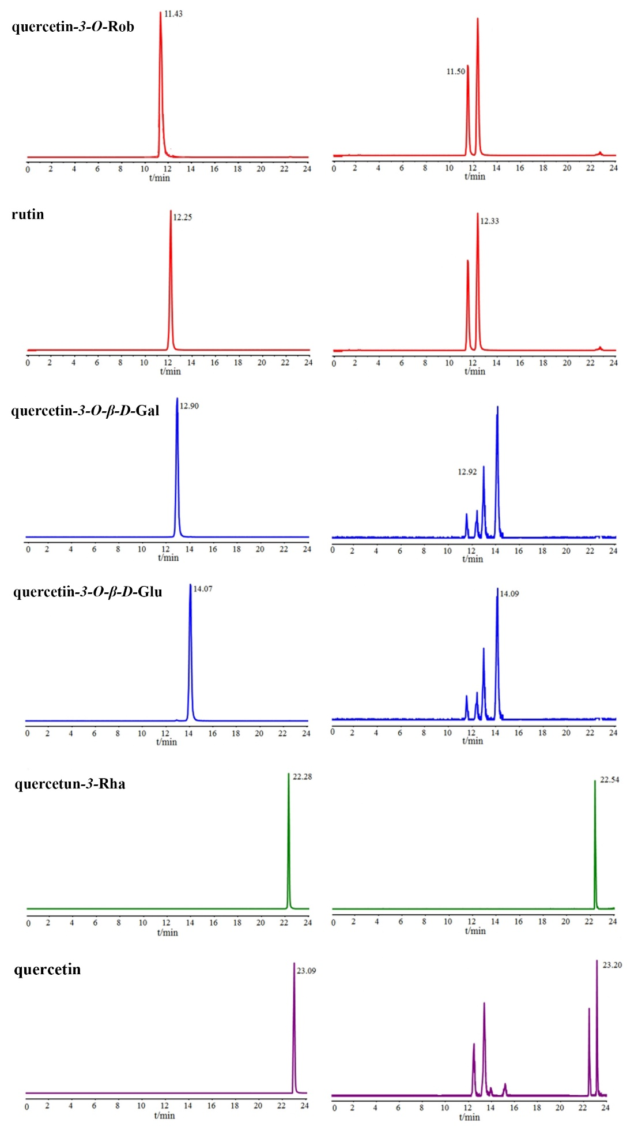

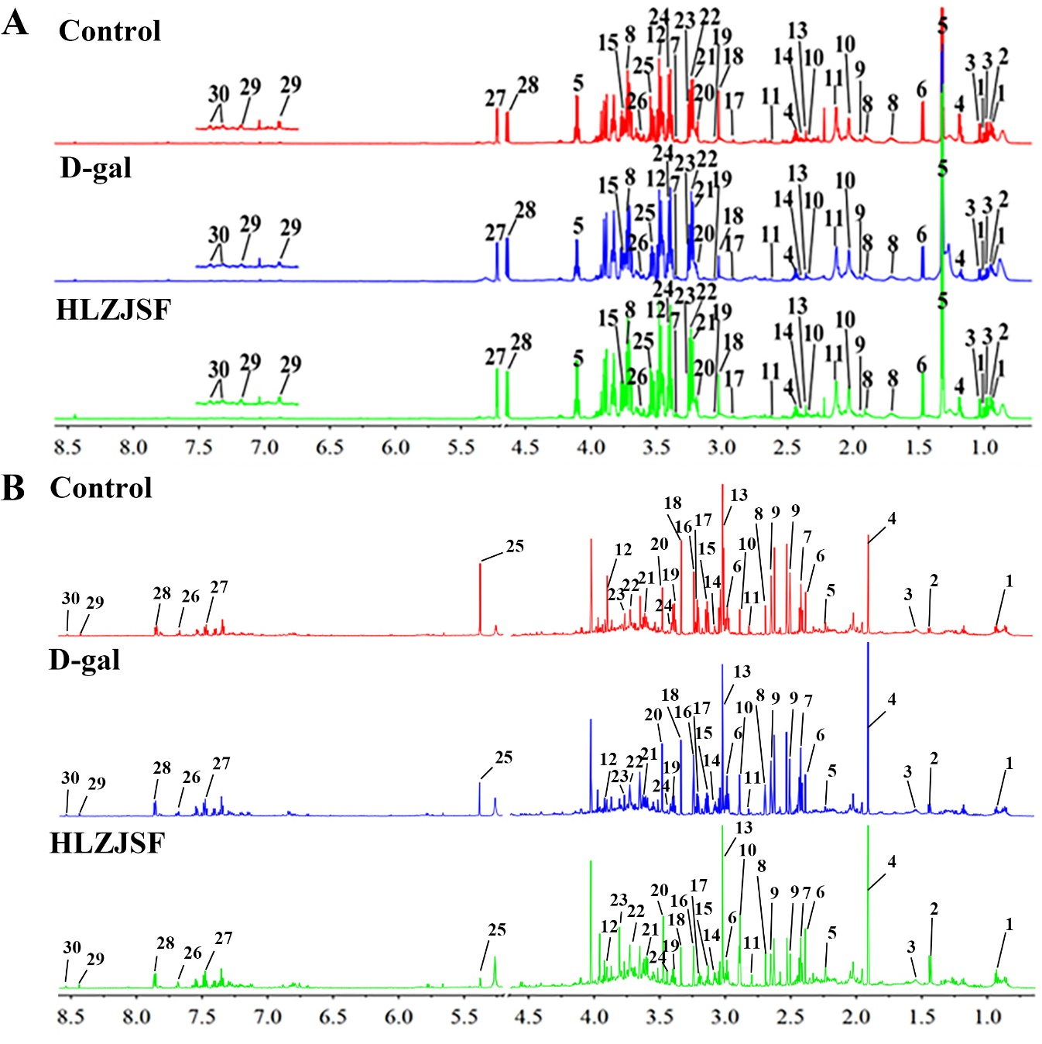**Fig. S2.**

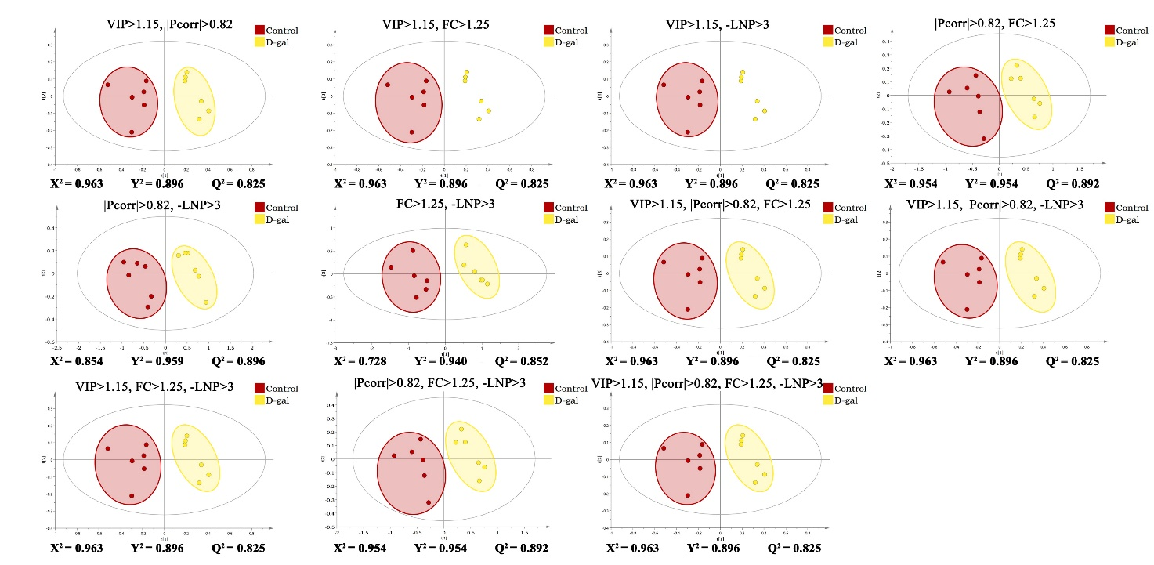**Fig. S3.**

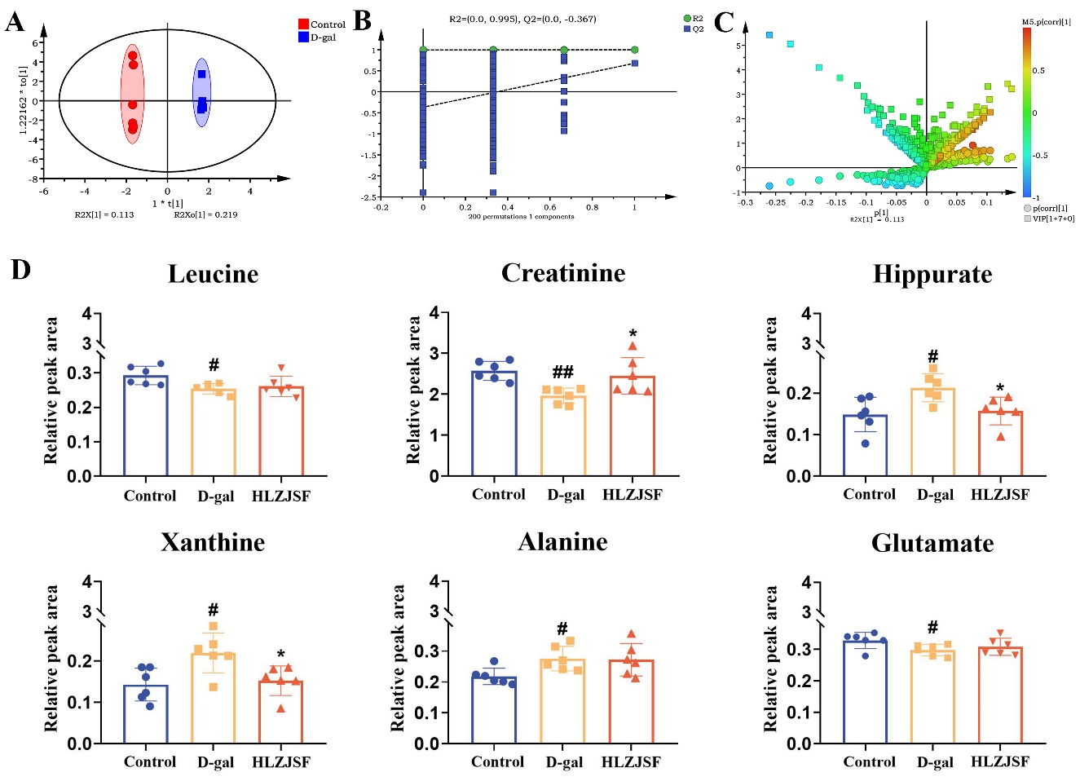**Fig. S4.**

**Fig. S5.**

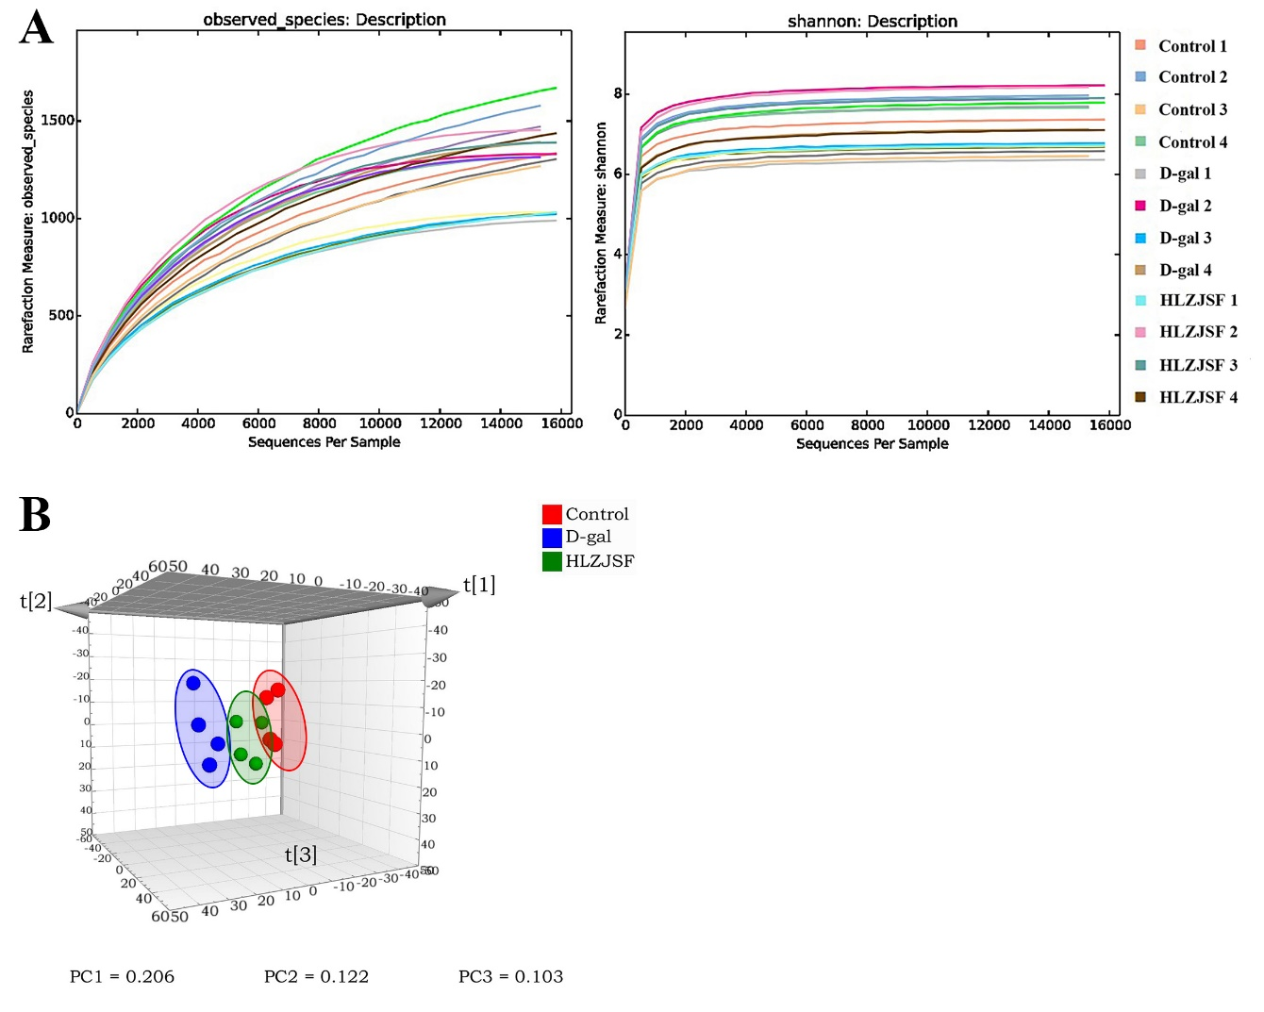

**Fig. S6.**

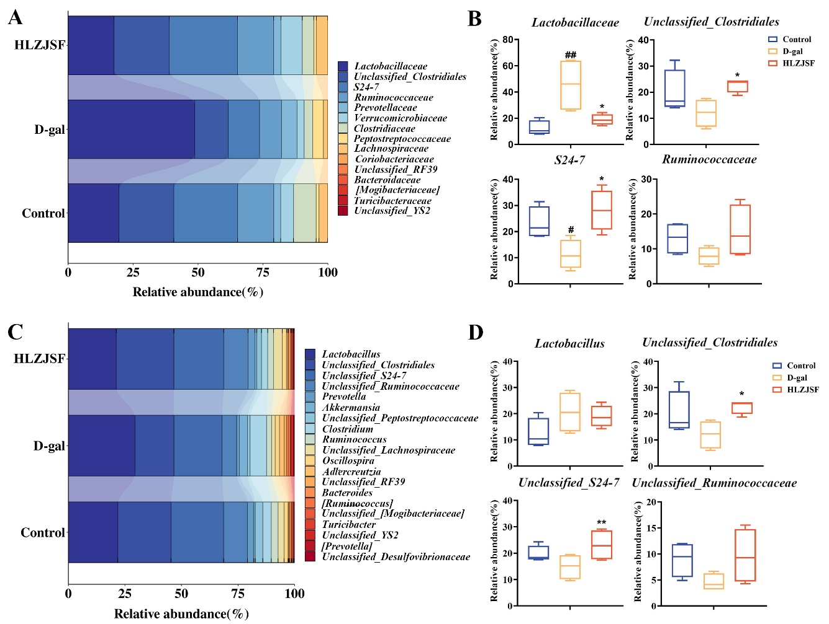

**Supplementary** **Tables**

Table S1 Peak assignment in the 1H-NMR spectra for endogenous metabolites in serum samples.

Table S2 Peak assignment in the 1H-NMR spectra for endogenous metabolites in urine samples.

Table S3 Identified metabolite markers in the serum samples.

Table S1

|  |  |  |
| --- | --- | --- |
| No. | Metabolite | *δ* H (*J* in Hz) |
| 1 | Isoleucine | 0.94(d, 7.2), 1.00(d, 7.2) |
| 2 | Leucine | 0.96(t, 6.0) |
| 3 | Valine | 0.98(d, 7.2), 1.03(d, 7.2) |
| 4 | *3*-*β*-Hydroxybutyrate | 1.20(d, 6.0), 2.30(dd, 13.8, 6.6) |
| 5 | Lactate | 1.31(d, 6.6), 4.11(d, 6.6) |
| 6 | Alanine | 1.47(d, 7.2) |
| 7 | Arginine | 1.72(m), 1.91(m),3.76(t, 5.4, 4.8), 3.24(t, 5.4, 4.8) |
| 8 | Lysine | 1.73(m), 1.90(m), 1.45(m) |
| 9 | Acetic acid | 1.92(s) |
| 10 | Glutamate | 2.05(m), 2.35(m) |
| 11 | Methionine | 2.13(s), 2.63(m) |
| 12 | Acetoacetate | 2.28(s) |
| 13 | Pyruvate | 2.36(s) |
| 14 | Succinate | 2.39(s) |
| 15 | Glutamine | 2.46(m), 3.77(t, 7.2) |
| 16 | Citrate | 2.52(d, 15.0) |
| 17 | dimethylglycine | 2.92(s) |
| 18 | Creatine | 3.04(s), 3.94(s) |
| 19 | Creatinine | 3.05(s) |
| 20 | Choline | 3.20(s) |
| 21 | Carnitine | 3.22(s) |
| 22 | Trimethylamine Oxide, TMAO | 3.25(s) |
| 23 | Betaine | 3.26(s) |
| 24 | Taurine | 3.42(s) |
| 25 | Glycine | 3.55(s) |
| 26 | Glycerol | 3.66(m) |
| 27 | *β*-glucose | 4.64(d, 7.8) |
| 28 | *α*-glucose | 5.24(d, 1.2) |
| 29 | Tyrosine | 6.88(d, 8.4) |
| 30 | Phenylalanine | 7.33(m), 7.38(m), 7.43(m) |

Table S2

|  |  |  |
| --- | --- | --- |
| No. | Metabolite | *δ* H (*J* in Hz) |
| 1 | Leucine | 0.94(t) |
| 2 | Alanine | 1.47(d) |
| 3 | Butyrate | 1.54(m) |
| 4 | Acetate | 1.92(s) |
| 5 | Acetoacetate | 2.26(s) |
| 6 | Succinate | 2.41(s) |
| 7 | *α*-ketoglutarate | 2.44(t), 3.01(t) |
| 8 | Dimethylamine | 2.72(s) |
| 9 | Citrate | 2.54(d), 2.66(d) |
| 10 | Trimethylglycine | 2.92(s) |
| 11 | Trimethylamine | 2.88(s) |
| 12 | Creatine | 3.04(s), 3.94(s) |
| 13 | Creatinine | 3.05(s) |
| 14 | Malonate | 3.16(s) |
| 15 | Choline | 3.20(s) |
| 16 | Betaine | 3.27(s), 3.90(s) |
| 17 | Trimethylamine Oxide (TMAO) | 3.26(s) |
| 18 | Scyllo-inositol | 3.37(s) |
| 19 | Taurine | 3.42(s) |
| 20 | Glycine | 3.55(s) |
| 21 | Phenylacetyglycine | 3.66(s) |
| 22 | Mannitol | 3.78(dd) |
| 23 | Guanidinoacetate | 3.80(s) |
| 24 | *p*-Hydroxyphenylacetate | 3.44(s) |
| 25 | Allantoin | 5.38(s) |
| 26 | Pyruvate | 7.69(s) |
| 27 | Hippurate | 7.49(t),7.88(d) |
| 28 | Xanthine | 7.88(s) |
| 29 | Formate | 8.46(s) |
| 30 | Trigonelline | 9.11(s) |

Table S3

|  |  |  |  |  |  |  |
| --- | --- | --- | --- | --- | --- | --- |
| No. | Metabolite | *δ* H (*J* in Hz) | Control *vs.* D-gal | D-gal *vs.* HLZJSF | Control *vs.* D-gal  metabolic pathway | D-gal *vs.* HLZJSF  metabolic pathway |
| 1 | Isoleucine | 0.94(d, 7.2), 1.00(d, 7.2) | **↑###** | **↓\*\*\*** | D-Glutamine and D-glutamate metabolism;  Alanine, aspartate and glutamate metabolism;  Arginine biosynthesis;  Arginine and proline metabolism | D-Glutamine and D-glutamate metabolism;  Alanine, aspartate and glutamate metabolism;  Arginine biosynthesis;  Arginine and proline metabolism |
| 2 | Leucine | 0.96(t, 6.0) | **↑###** | **↓\*\*\*** |
| 3 | Valine | 0.98(d, 7.2), 1.03(d, 7.2) | **↑###** | **↓\*\*\*** |
| 4 | Arginine | 1.72(m), 1.91(m),3.76(t, 5.4, 4.8), 3.24(t, 5.4, 4.8) | **↑###** | **↓\*\*\*** |
| 5 | Lysine | 1.73(m), 1.90(m), 1.45(m) | **↑###** | **↓\*\*\*** |
| 6 | Glutamate | 2.05(m), 2.35(m) | **↑###** | **↓\*\*** |