Supplementary Materials
Statistical Analysis of the Content of Metals in Blood Serum and in the Alternative Material in Head and Neck Carcinoma
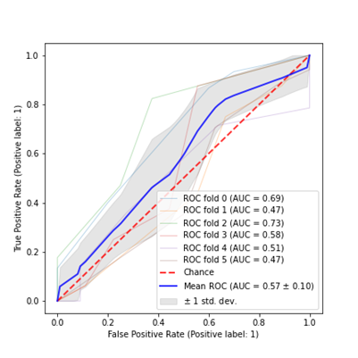 | 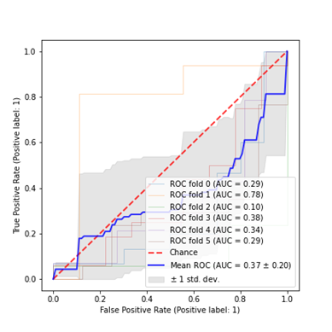
(a) | (b)
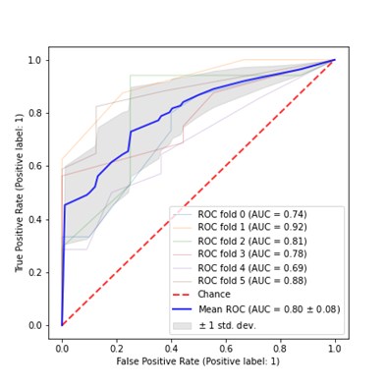 | 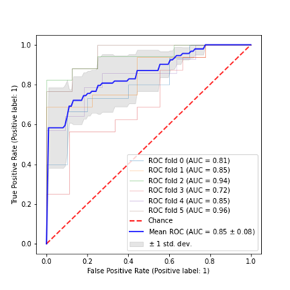
(c) | (d)
Figure S1. Cross-validation results (k = 6) of classification models for the serum data set, using the ROC curve and the AUC parameter: a) kNN, b) SVM, c) DT, d) RF.

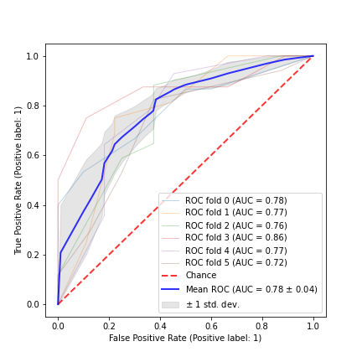 | 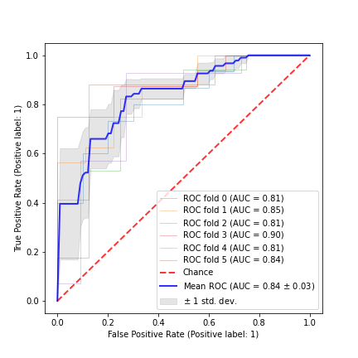
(a) | (b)
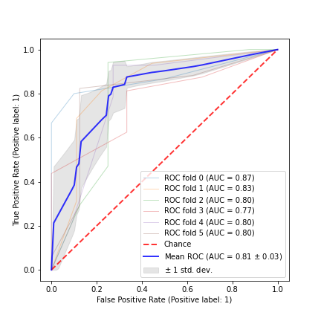 | 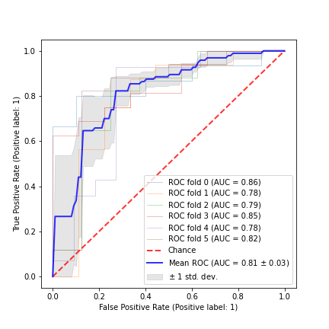
(c) | (d)
Figure S2. Cross-validation results (k = 6) of classification models for the hair data set obtained for hair, using the ROC curve and the AUC parameter: a) kNN, b) SVM, c) DT, d) RF.
(a) | (b)
(c) | (d)
Figure S3. Cross-validation results (k = 6) of classification models for data set obtained for nails using the ROC curve and the AUC parameter: a) kNN, b) SVM, c) DT, d) RF.

