**A Comprehensive study of facemask pyrolysis using Py-GC/MS, kinetic analysis**

**and ANN modeling**

**Imad A. Idrisa, Jurarat Nisamaneenatea, Duangduen Atongb, Viboon Sricharoenchaikula,c\***

*a Department of Environment Engineering, Faculty of Engineering, Chulalongkorn University, Bangkok 10330, Thailand*

*b National Metal and Materials Technology Center (MTEC), National Science and Technology Development Agency (NSTDA), Thailand Science Park, Pathum Thani 12120, Thailand*

*c Energy Research Institute, Chulalongkorn University, Bangkok 10330, Thailand*

*\* Corresponding author. Tel.: +662 218 6689; Fax: +662 218 6666; E-mail:* [*viboon.sr@chula.ac.th*](mailto:viboon.sr@chula.ac.th)

|  |  |  |
| --- | --- | --- |
| * Corresponding author: Dr. Viboon Sricharoenchaikul | E-Mail: [viboon.sr@chula.ac.th](mailto:viboon.sr@chula.ac.th) | |
| Tel.: +662 218 6689; Fax: +662 218 6666 | | |

**Supplementary Data**

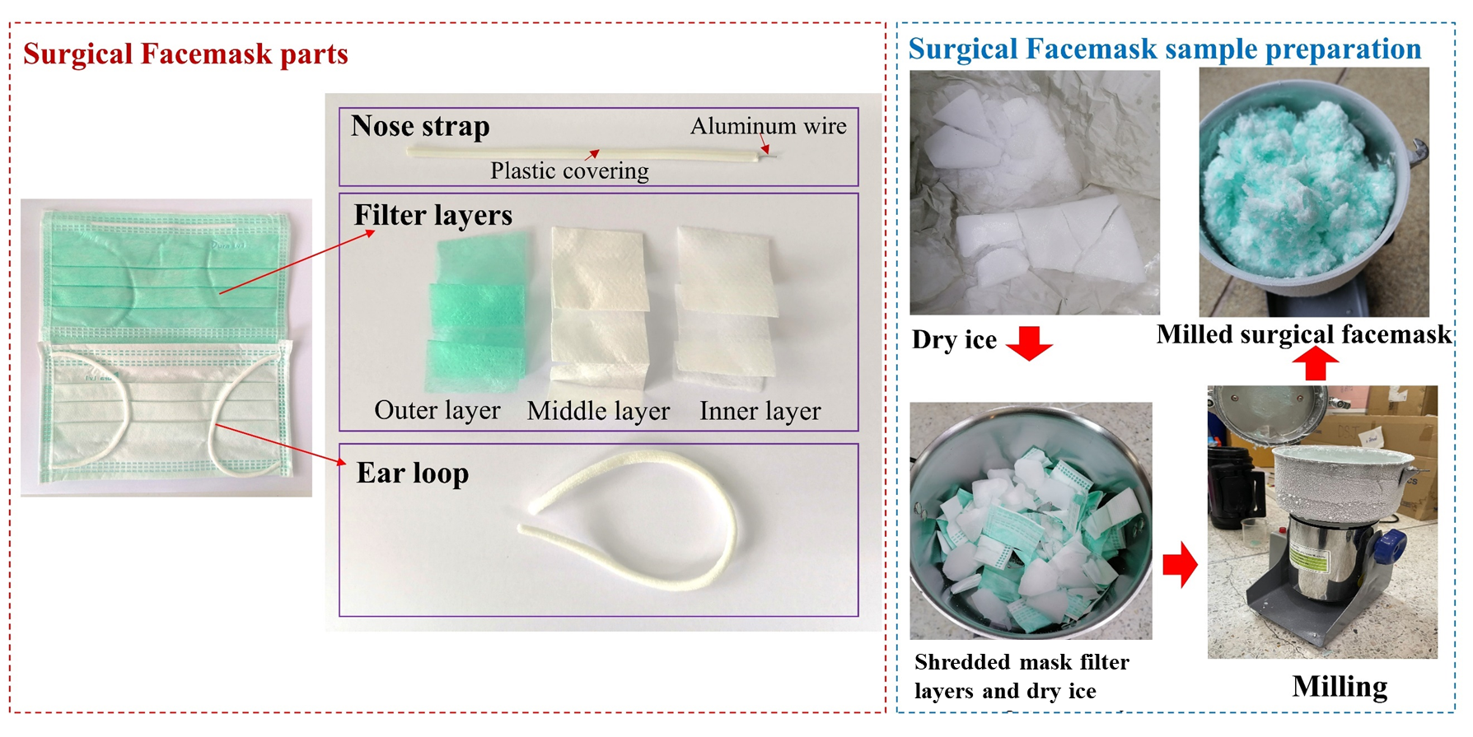

**Fig S1.** Milled facemask filters layers

|  |
| --- |
|  |

**Fig S2.** a) FT-IR results of surgical facemask filter layers and b) ear loop

**Fig S3.** Change of dα/dT and Tα with conversion (α)

**Py- GC/MS results of gaseous products**

|  |  |
| --- | --- |
| Table S1. Mean peak areas % of different compound families obtained in facemask pyrolysis at 550°C. | |
| **Compound** | **Area %** |
| **Alcohol** |  |
| (2,4,6-Trimethylcyclohexyl) methanol | 1.82 |
| 11-Methyldodecanol | 1.20 |
| 1-Heptanol, 2,4-diethyl- | 1.01 |
| 11-Methyldodecanol | 0.71 |
| (2,4,6-Trimethylcyclohexyl) methanol | 0.57 |
| 1-Heptanol, 2,4-diethyl- | 0.35 |
| 10-Dodecen-1-ol, 7,11-dimethyl- | 1.04 |
| **Aliphatic hydrocarbons** |  |
| **Lineal** |  |
| Propene | 8.44 |
| Pentane, 2-methyl- | 5.54 |
| 1-Pentene, 2-methyl- | 4.74 |
| 1-Pentene, 2,4-dimethyl- | 3.88 |
| 1,3-Pentadiene, 2,3-dimethyl- | 2.92 |
| 1-Hexene, 3,3-dimethyl- | 2.57 |
| Heptane, 4-methyl- | 2.33 |
| 1,5-Hexadiene, 2,5-dimethyl- | 2.27 |
| 1-Hexene, 3,3,5-trimethyl- | 2.26 |
| 2,4-Heptadiene, 2,6-dimethyl- | 3.72 |
| 2,4-Dimethyl-1-heptene | 1.89 |
| 1-Octene, 2-methyl- | 1.85 |
| Octane, 2,3,7-trimethyl- | 1.35 |
| Heptane, 3-ethyl-5-methyl- | 1.28 |
| Nonane, 2,6-dimethyl- | 2.46 |
| 1-Decene, 2,4-dimethyl- | 1.91 |
| 1-Undecene, 7-methyl- | 1.87 |
| Dodecane, 4,6-dimethyl- | 1.55 |
| Hexane, 1-(hexyloxy)-5-methyl- | 1.07 |
| **Cyclic** |  |
| Cyclohexane, 1,2,3,5-tetraisopropyl- | 4.24 |
| Cyclohexane, 1,3,5-trimethyl- | 3.94 |
| Cyclohexane, 2,4-diethyl-1-methyl- | 1.66 |
| Cyclooctane, 1-methyl-3-propyl- | 1.40 |
| Cyclopropane, 1-methyl-2-(1-methylpentyl)- | 1.59 |
| 1,1'-Bicyclohexyl | 1.68 |
| Cyclohexane, 1,2-diethyl-3-methyl- | 0.77 |
| **Ketones** |  |
| 2-Pentanone, 3-[(acetyloxy)methyl]-3,4-dimethyl- | 3.61 |
| Bicyclo[3.1.1]heptan-3-one, 6,6-dimethyl-2-(2-methylpropyl)- | 1.32 |
| **Ethers** |  |
| Dodecyl nonyl ether | 0.55 |
| Eicosyl octyl ether | 0.24 |
| Hexacosyl nonyl ether | 0.13 |
| **Esters** |  |
| Citronellyl butyrate | 1.00 |
| 6-Octenoic acid, 3,7-dimethyl-, 3,7-dimethyl-6-octenyl ester | 0.87 |
| 11,13-Dimethyl-12-tetradecen-1-ol acetate | 0.13 |
|  |  |

**Kinetic analysis**

|  |  |
| --- | --- |
|  |  |
|  |  |

**Fig S4**. Linear plots for calculation of *Ea* during the pyrolysis of facemask filters and ear loop blend using a) FR method, b) KAS method and c) FWO method

**Criado method**

The results obtained by the Criado method, also known as the master plots method, are demonstrated in Figs. S5 – S8.

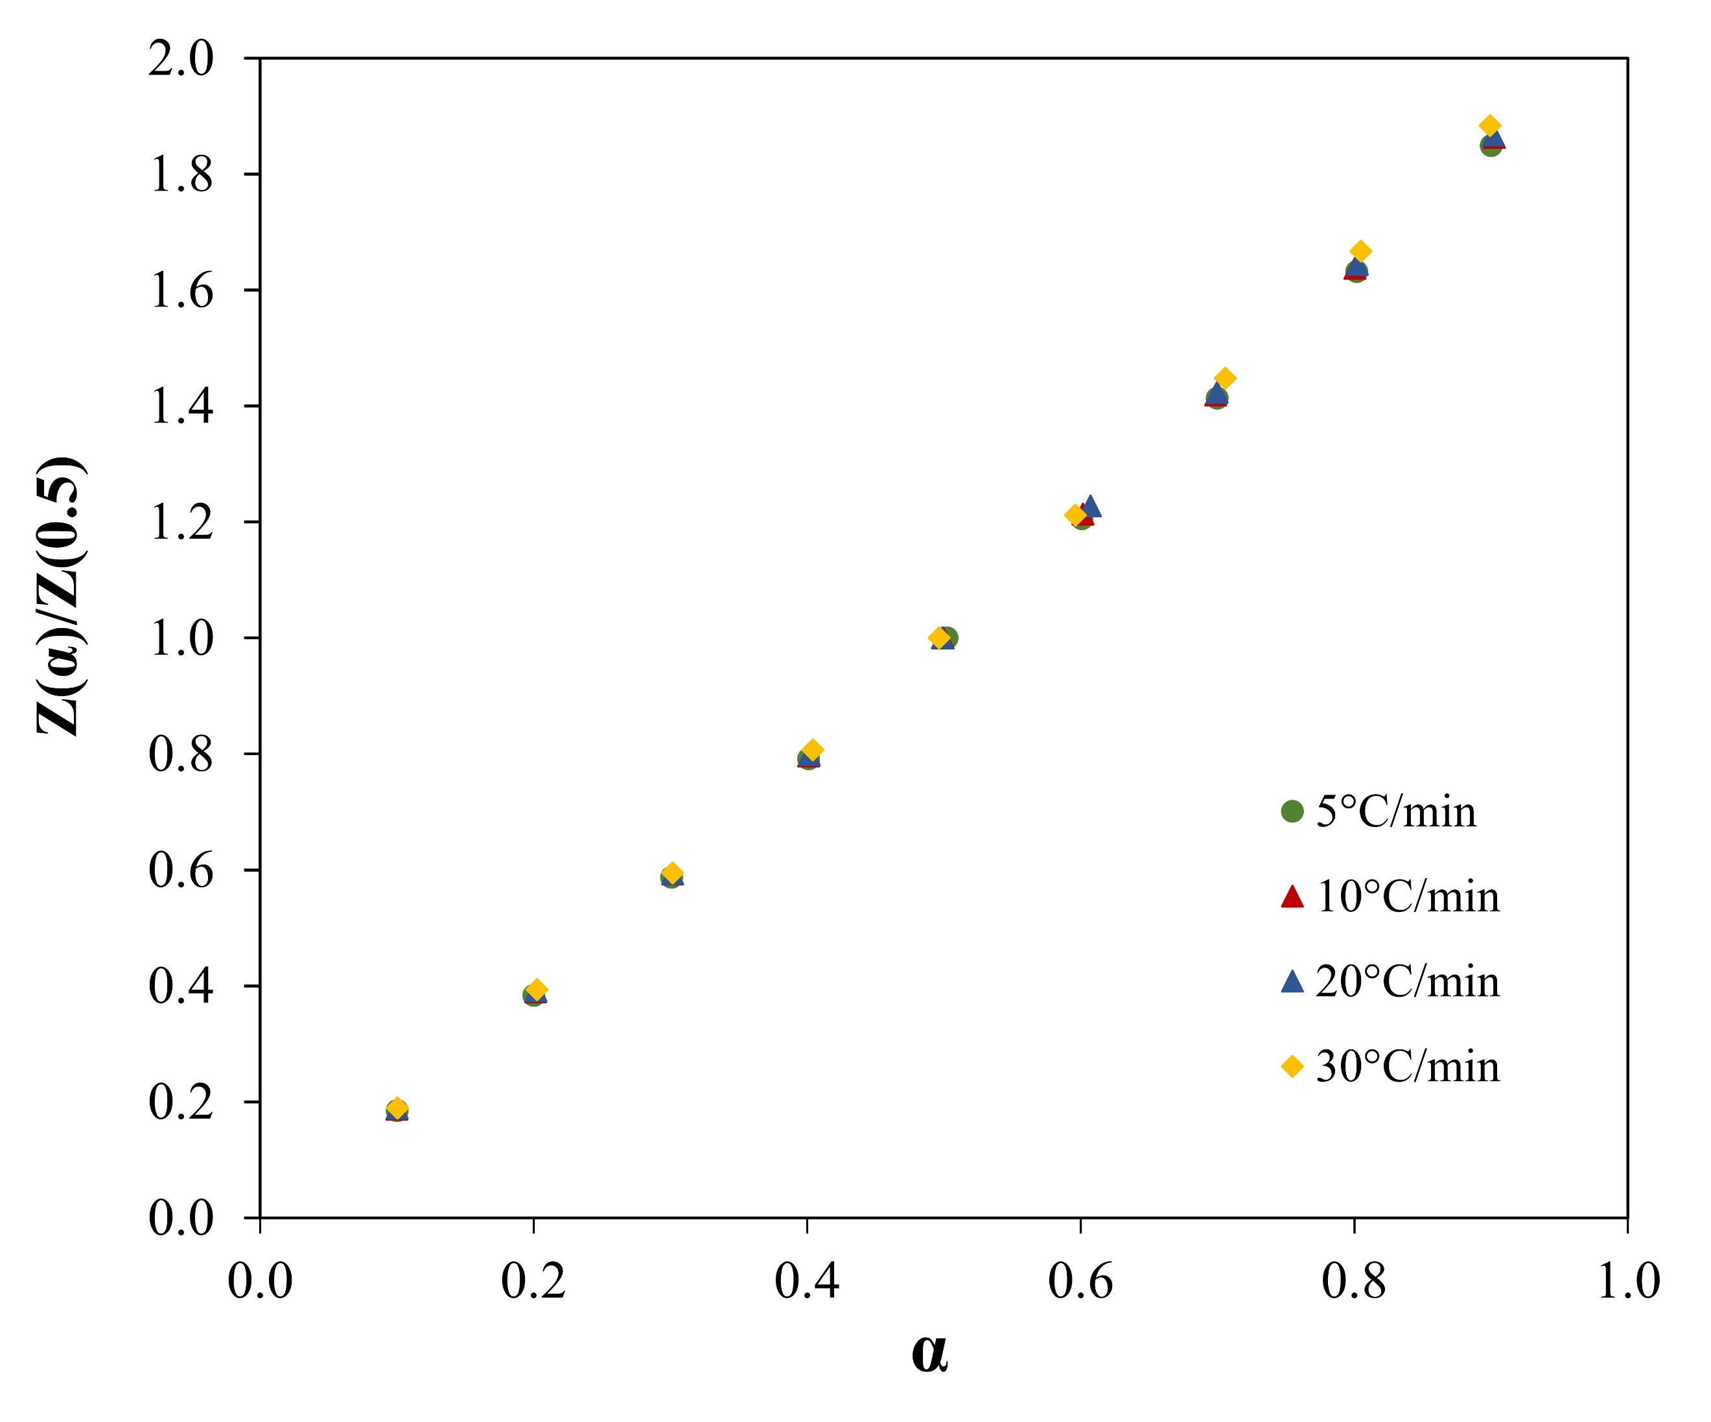

**Fig S5.** Master plots of experimental (TG) curves at different heating rates

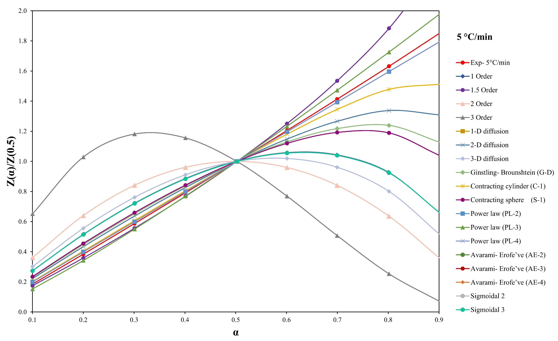

**Fig S6.** Master plots comparison of experimental and model predictions at a heating rate of 5°C/min

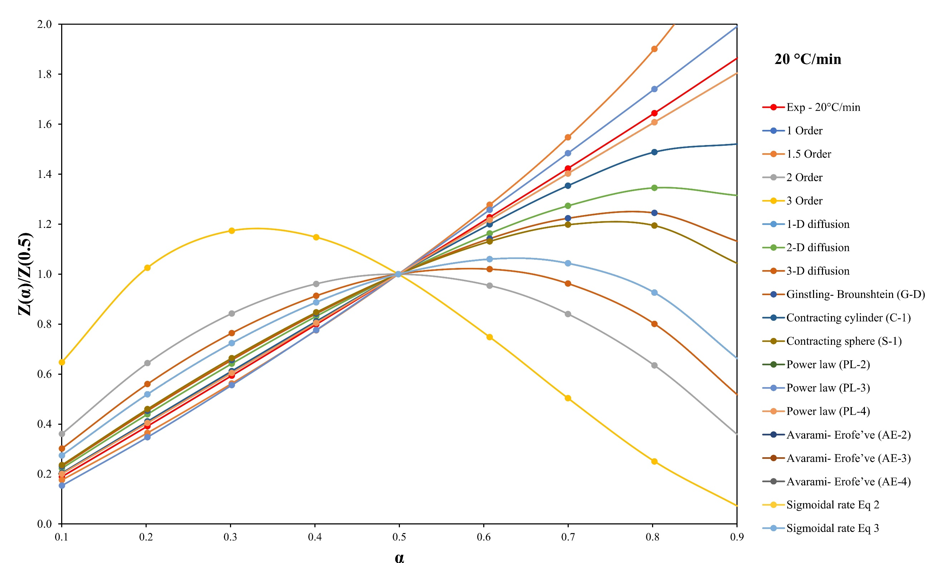

**Fig S7.** Master plots comparison of experimental and model predictions at a heating rate of 20°C/min

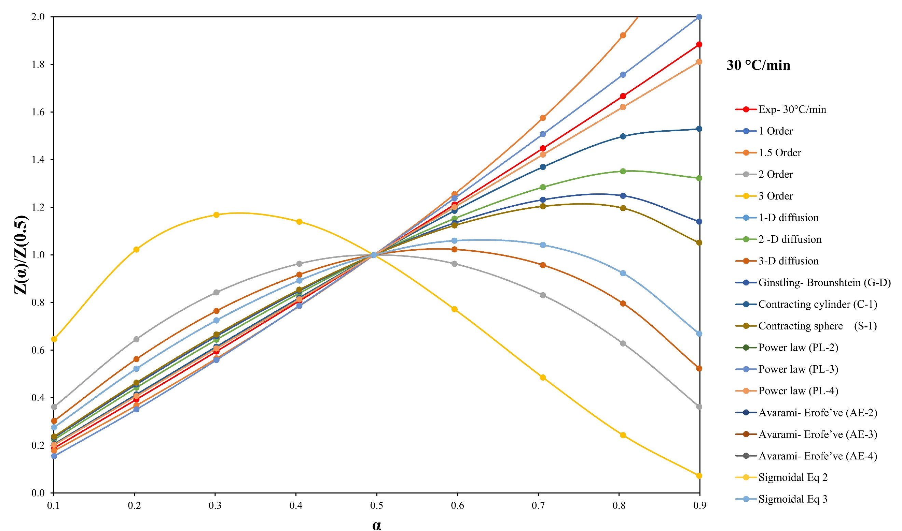

**Fig S8.** Master plots comparison of experimental and model predictions at a heating rate of 30°C/min

1. **ANN modeling**

Table S2. hyperparameters used to tune the ANN topology

|  |  |  |  |
| --- | --- | --- | --- |
| Number of hidden layers | Number of Neurons impeded in a layer | MSE | R2 |
| 1 | 10 | 92 | 0.95 |
| 2 | 8 | 6.08 | 0.966 |
| 2 | 10 | 0.8834 | 0.9995 |

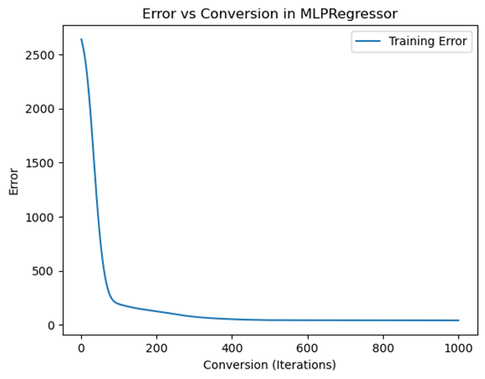

**Fig S9**. Error distribution vs conversion

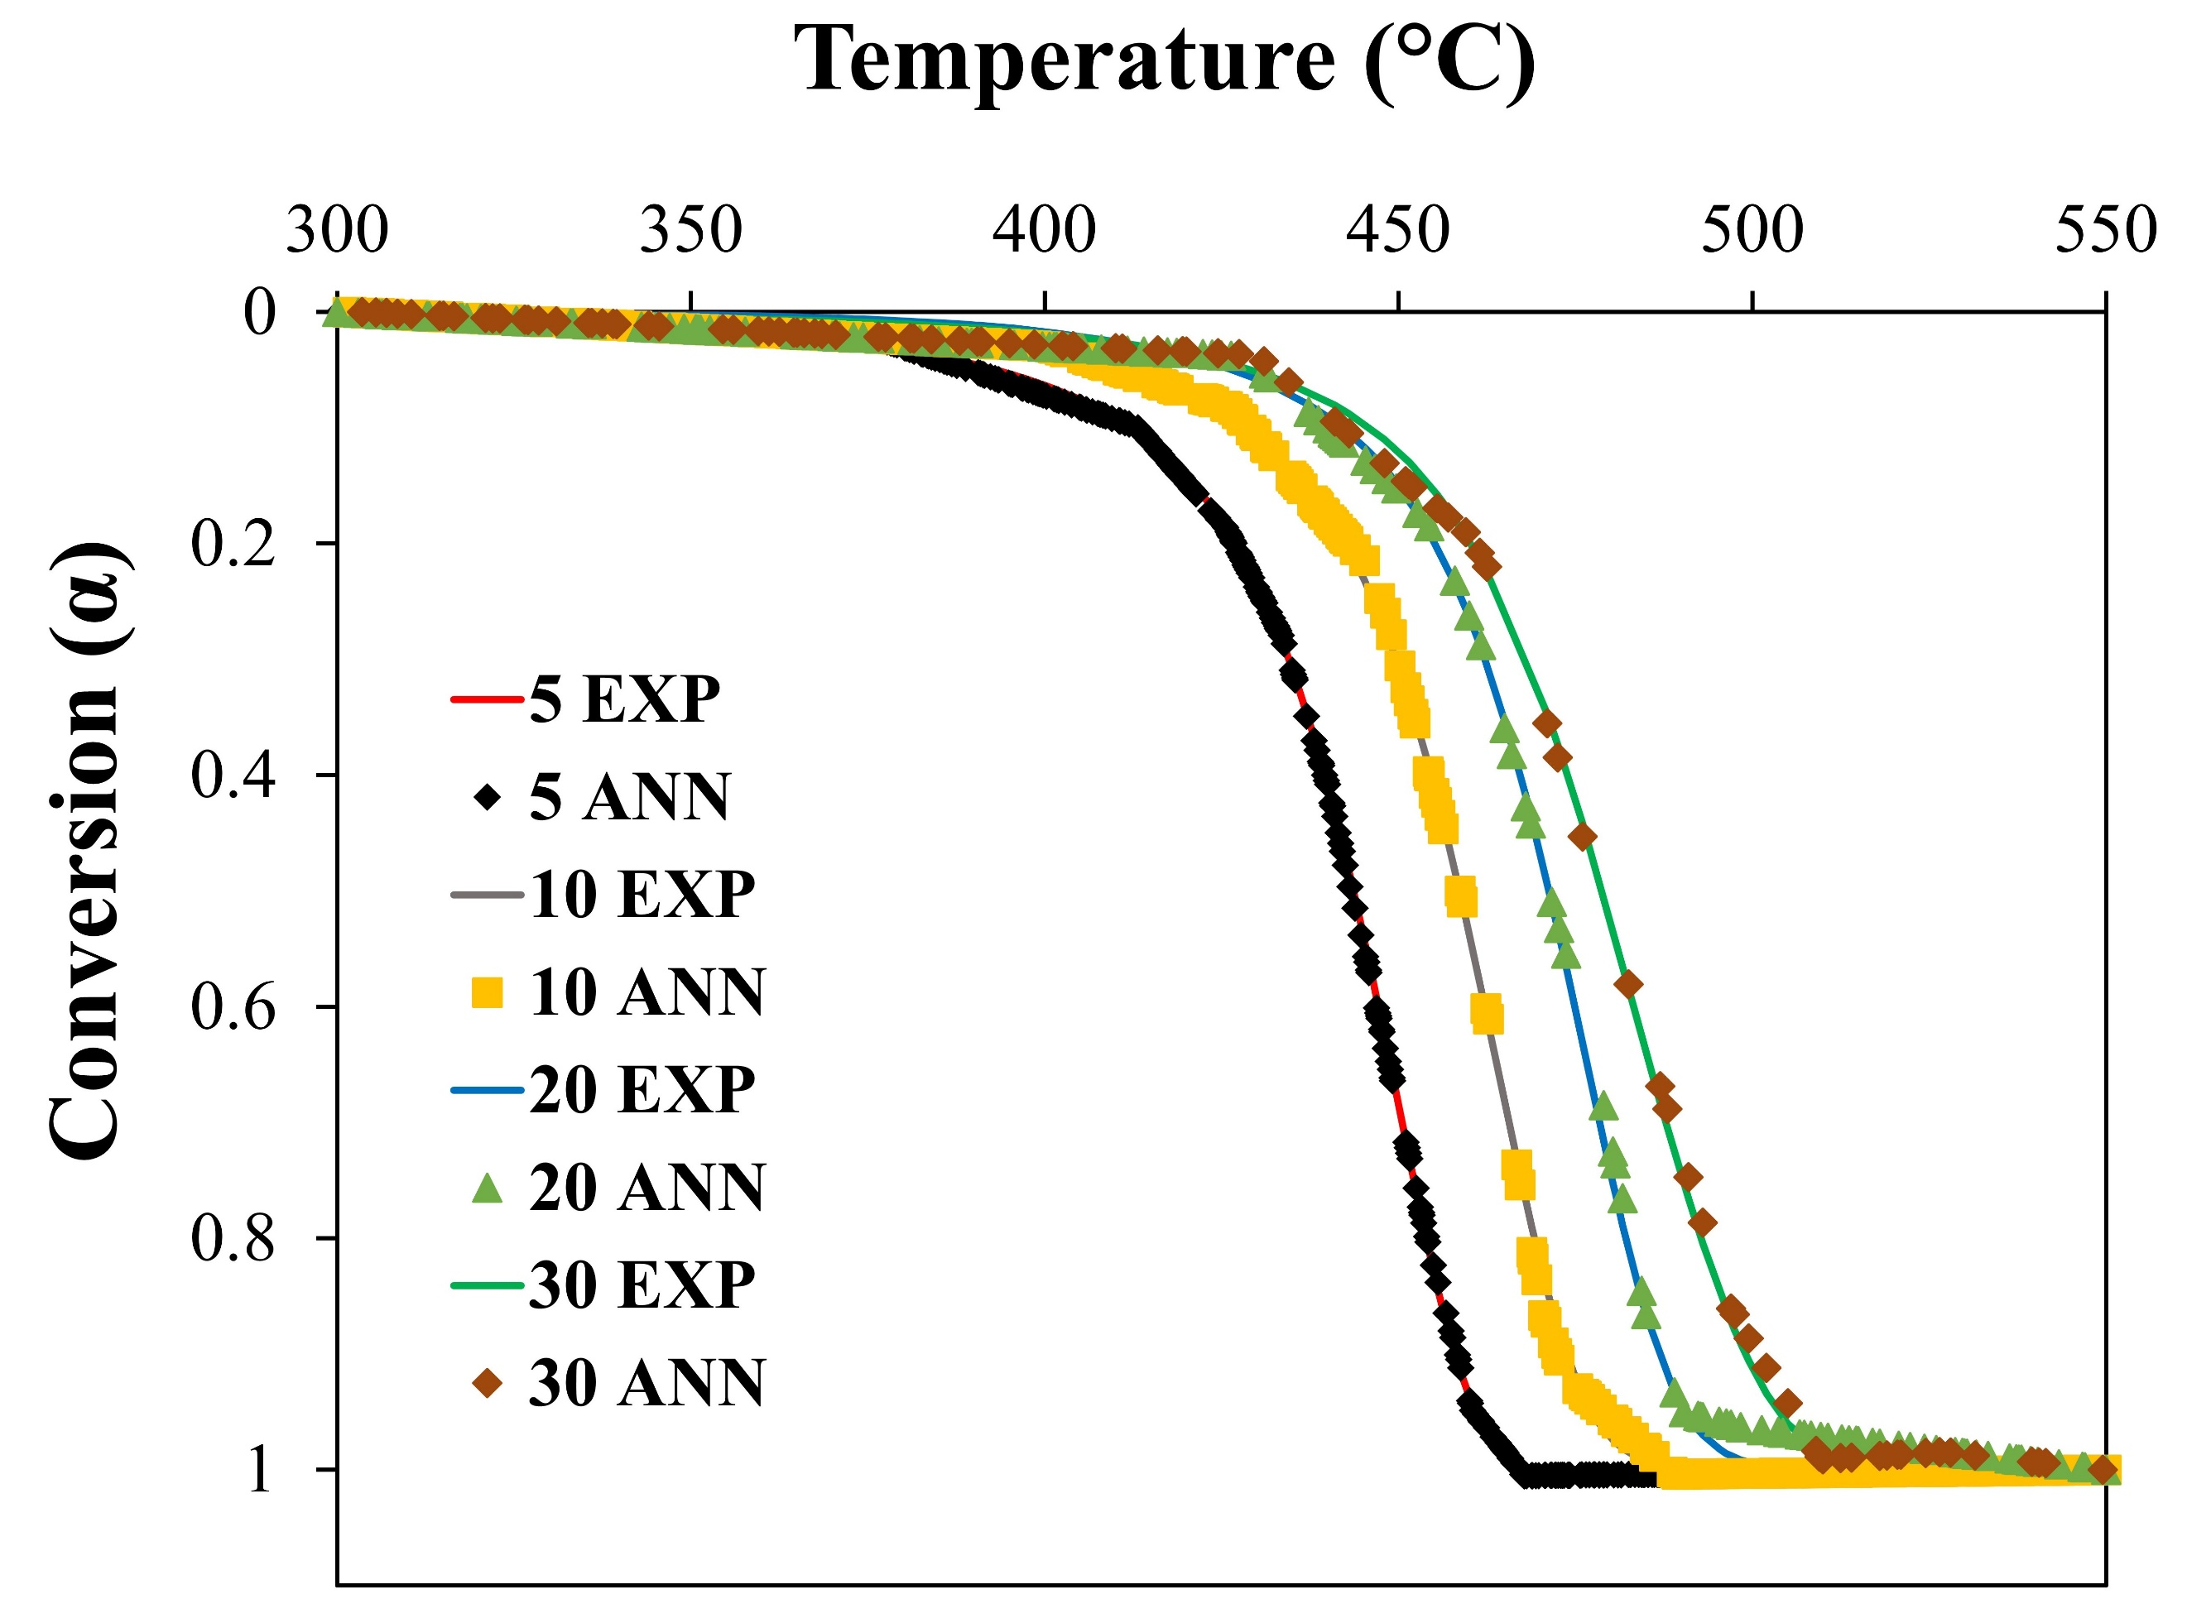

**Fig S10.** Experimental vs predicted α in the active zone (300 – 550 °C)

**Fig S11**. Error distribution between the experimental and predicted weight loss data in the active zone (300 – 550 °C)