Table S1 Predicted therapeutic targets of berberine treating psoriasis with skin tissue-specific gene expression.
Gene symbol | Target name
ESR1 | Estrogen receptor
CA2 | Carbonic anhydrase 2
STS | Steryl-sulfatase
ADAM17 | Disintegrin and metalloproteinase domain-containing protein 17
RXRA | Retinoic acid receptor RXR-alpha
CDK2 | Cell division protein kinase 2
NOS3 | Nitric oxide synthase, endothelial
GSR | Glutathione reductase, mitochondrial
PRKACA | cAMP-dependent protein kinase catalytic subunit alpha
SRC | Proto-oncogene tyrosine-protein kinase Src
PDE4D | cAMP-specific 3',5'-cyclic phosphodiesterase 4D
DPP4 | Dipeptidyl peptidase 4
MMP12 | Macrophage metalloelastase
AKR1C1 | Aldo-keto reductase family 1 member C1
PTPN1 | Tyrosine-protein phosphatase non-receptor type 1
AKR1C3 | Aldo-keto reductase family 1 member C3
FGFR2 | Fibroblast growth factor receptor 2
HSP90AA1 | Heat shock protein HSP 90-alpha
MMP8 | Neutrophil collagenase
PLA2G2A | Phospholipase A2, membrane associated
NR1H2 | Oxysterols receptor LXR-beta
GSK3B | Glycogen synthase kinase-3 beta
AURKA | Serine/threonine-protein kinase 6
DHODH | Dihydroorotate dehydrogenase (quinone), mitochondrial
XIAP | Baculoviral IAP repeat-containing protein 4
MMP3 | Stromelysin-1
PPARG | Peroxisome proliferator-activated receptor gamma
FKBP1A | Peptidyl-prolyl cis-trans isomerase FKBP1A
FGFR1 | Basic fibroblast growth factor receptor 1
MME | Neprilysin
REN | Renin
NR3C1 | Glucocorticoid receptor
RARA | Retinoic acid receptor alpha
GSTA1 | Glutathione S-transferase A1
IL2 | Interleukin-2
LCN2 | Neutrophil gelatinase-associated lipocalin
TGM3 | Protein-glutamine gamma-glutamyltransferase E
MAP2K1 | Dual specificity mitogen-activated protein kinase kinase 1
HMGCR | 3-hydroxy-3-methylglutaryl-coenzyme A reductase
RXRB | Retinoic acid receptor RXR-beta
CASP1 | Caspase-1
RAC1 | Ras-related C3 botulinum toxin substrate 1
CDC42 | Cell division control protein 42 homolog
RPS6KB1 | Ribosomal protein S6 kinase 1
AURKB | Serine/threonine-protein kinase Aurora-B
PIK3CA | Phosphatidylinositol 4,5-bisphosphate 3-kinase catalytic subunit alpha isoform
F3 | Tissue factor
ICAM1 | Intercellular adhesion molecule-1
PIK3CD | Phosphatidylinositol 4,5-bisphosphate 3-kinase catalytic subunit delta isoform
PIK3CB | Phosphatidylinositol 4,5-bisphosphate 3-kinase catalytic subunit beta isoform
MAPKAPK2 | MAP kinase-activated protein kinase 2
TGM2 | Protein-glutamine gamma-glutamyltransferase 2
XBP1 | X-box-binding protein 1
TYMS | Thymidylate synthase
DHFR | Dihydrofolate reductase
JAK1 | Tyrosine-protein kinase JAK1
KIT | Mast/stem cell growth factor receptor Kit
IKBKB | Inhibitor of nuclear factor kappa-B kinase subunit beta
MAPK14 | Mitogen-activated protein kinase 14
LRRK2 | Leucine-rich repeat serine/threonine-protein kinase 2
PLK1 | Serine/threonine-protein kinase PLK1
MAP4K4 | Mitogen-activated protein kinase kinase kinase kinase 4
PTGS2 | Prostaglandin G/H synthase 2
CDK4 | Cyclin-dependent kinase 4
QPCT | Glutaminyl-peptide cyclotransferase
CSF1R | Macrophage colony-stimulating factor 1 receptor
CYP1B1 | Cytochrome P450 1B1
P2RX7 | P2X purinoceptor 7

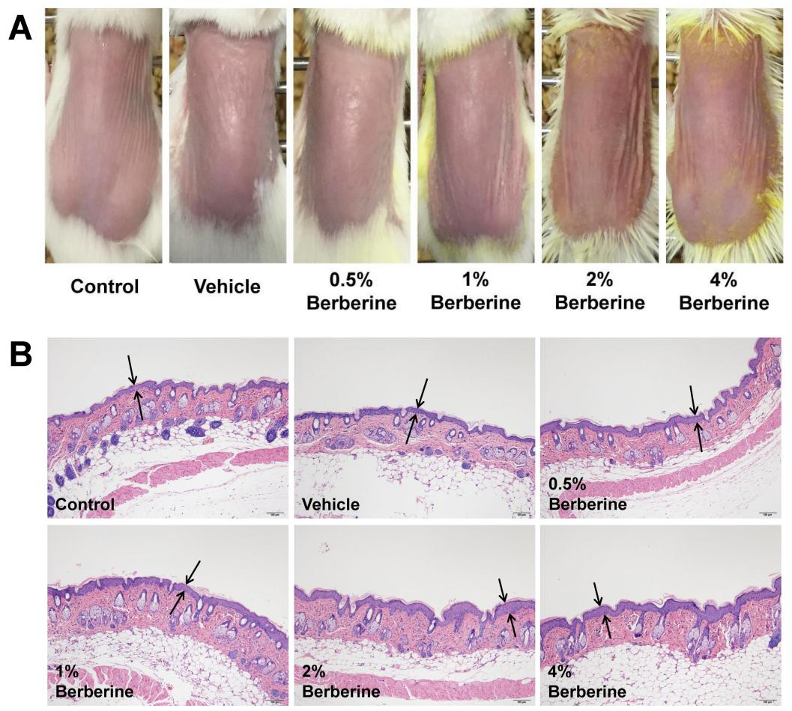
Fig. S1. Evaluation of the skin safety of Vehicle cream and 0.5%, 1%, 2%, 4% Berberine creams for topical administration of 6 days (n=8). (A) Representative pictures of dorsal skin in each group. (B) Histopathological observation of dorsal skin by HE staining (scale bar, 100 μm). Two opposite arrows indicated the epidermis.

