**A comprehensive strategy integrating** **metabolomics** **with** **DNA barcoding for** **discovery of** **combinatorial** **discriminatory quality markers: A case of** ***Cimicifuga foetida* and *Cimicifuga dahurica***

Qianqian Zhanga,b, Shujing Chena,b,c,1, Jiake Wena,b, Rui Wanga,b, Jin Lua,b, Abdulmumin Muhammad-Biua,b, Shaoxia Wanga, Kunze Dua,b*, Wei Weia,b,c, Xiaoxuan Tiana,b, Jin Lia,b, Yanxu Changa,b,c,*

aState Key Laboratory of Component-based Chinese Medicine, Tianjin University of Traditional Chinese Medicine, Tianjin, 301617, China

bTianjin Key Laboratory of Phytochemistry and Pharmaceutical Analysis, Tianjin University of Traditional Chinese Medicine, Tianjin, 301617, China

cHaihe Laboratory of Modern Chinese Medicine, Tianjin, 301617, China

*Corresponding author:

Yanxu Chang, State Key Laboratory of Component-based Chinese Medicine, Tianjin University of Traditional Chinese Medicine, Tianjin, 301617, China

1The author contributes equally to first author in this work

Tel.: +86-22-5959-6163; Fax: +86-22-5959-6163

E-mail: [Tcmcyx@tjutcm.edu.cn（Y.chang）and](mailto:Tcmcyx@tjutcm.edu.cn（Y.chang）and) [Dkztcm@tjutcm.edu.cn (K](mailto:Dkztcm@tjutcm.edu.cn%20(K). Du)

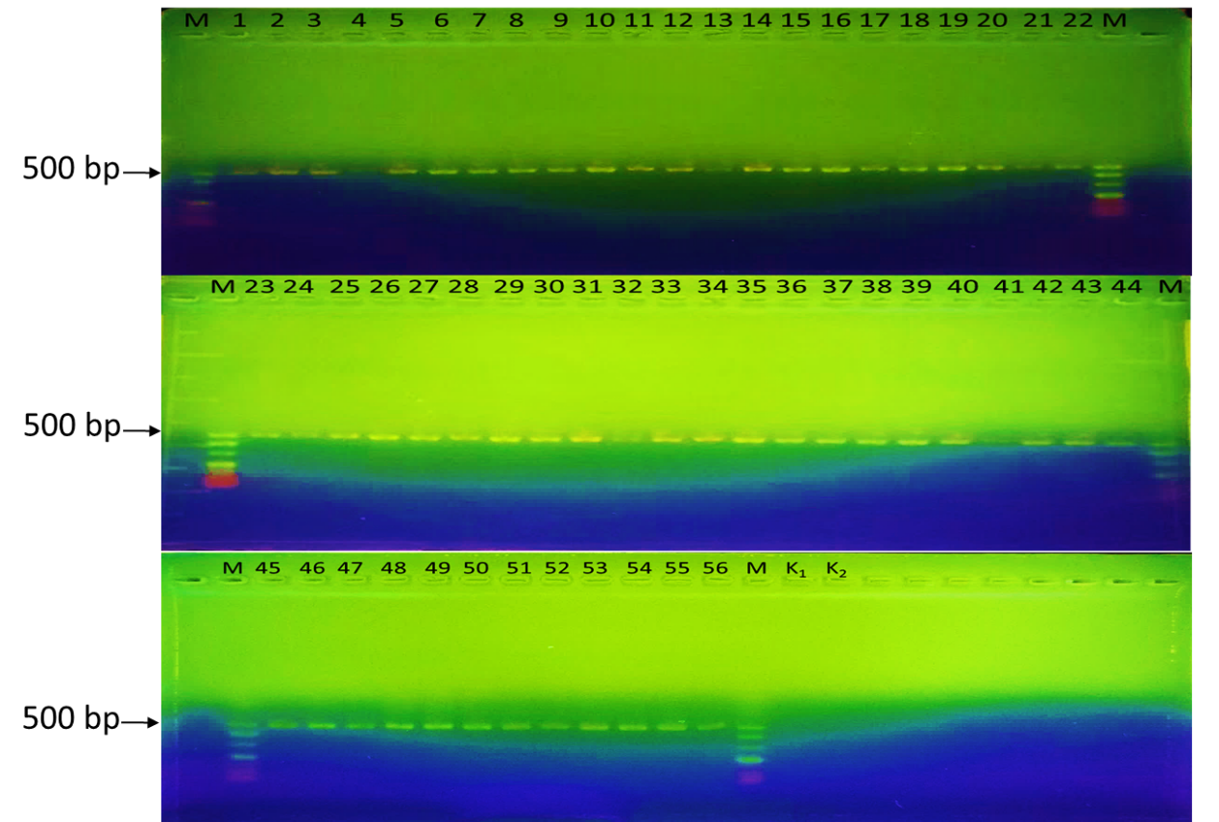

**Fig S1** Specific PCR assay of 56 batches CR by primers ITS2F/ITS3R.

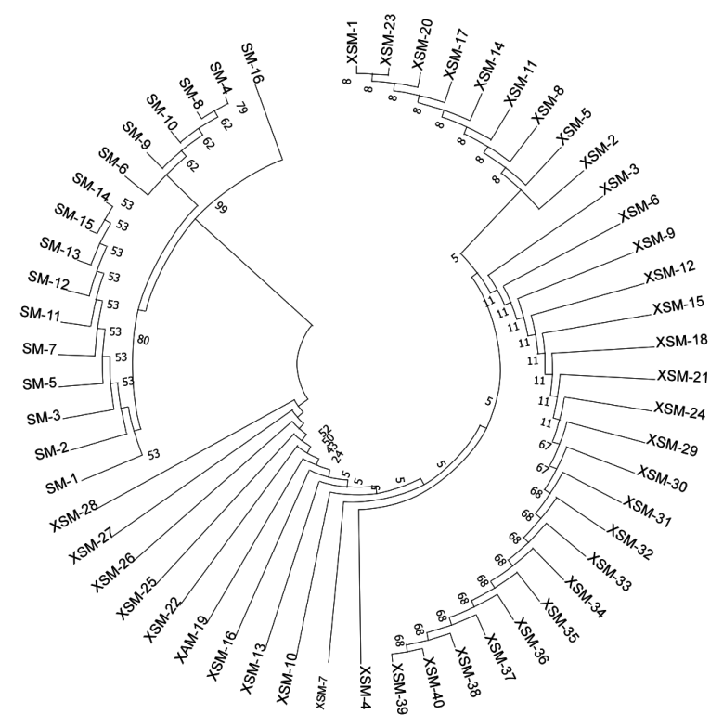

**Fig S2** Phylogenetic NJ tree of SM and XSM constructed with the ITS2 sequences

(1000 replicates).

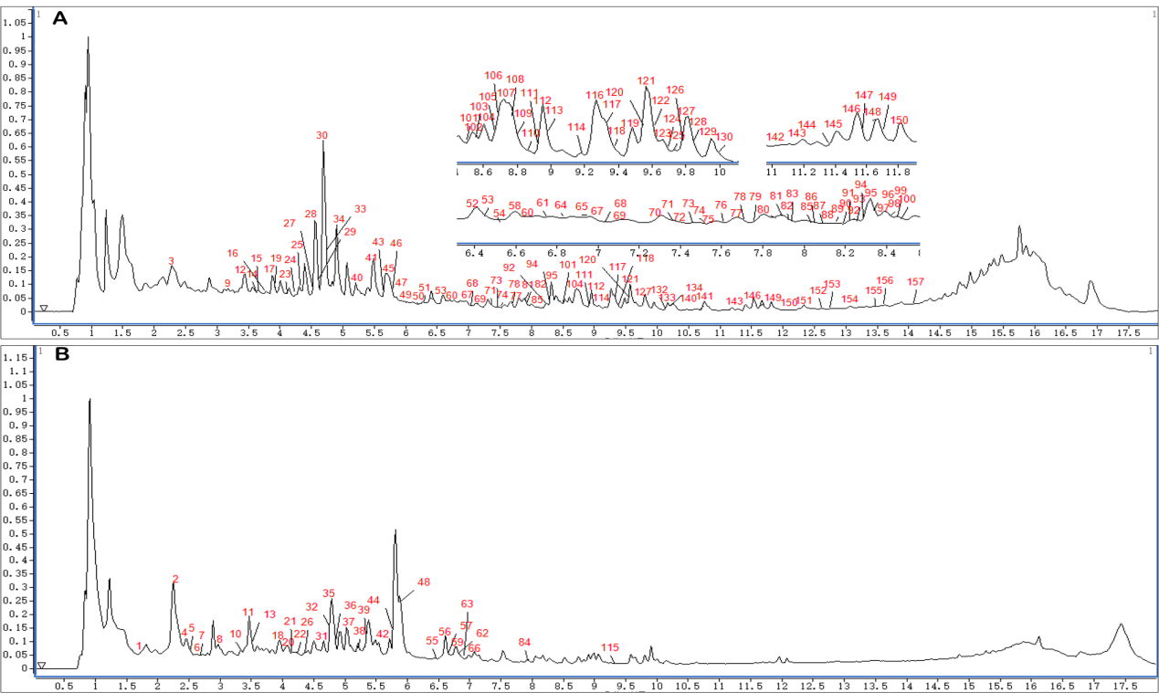

**Fig S3** The total ion chromatograms (TIC) of CR. (A) in positive ion mode and (B) in negative ion mode.

**Table S1** 56 batches sample information of CR collected from different origins.

|  |  |  |  |
| --- | --- | --- | --- |
| No. | Origin | No. | Origin |
| SM-1 | Hebei, China | XSM-13 | Inner Mongolia, China |
| SM-2 | Shanxi, China | XSM-14 | Inner Mongolia, China |
| SM-3 | Inner Mongolia, China | XSM-15 | Inner Mongolia, China |
| SM-4 | Jilin, China | XSM-16 | Heilongjiang, China |
| SM-5 | Jilin, China | XSM-17 | Heilongjiang, China |
| SM-6 | Jilin, China | XSM-18 | Heilongjiang, China |
| SM-7 | Liaoning, China | XSM-19 | Heilongjiang, China |
| SM-8 | Liaoning, China | XSM-20 | Heilongjiang, China |
| SM-9 | Liaoning, China | XSM-21 | Heilongjiang, China |
| SM-10 | Heilongjiang, China | XSM-22 | Heilongjiang, China |
| SM-11 | Heilongjiang, China | XSM-23 | Heilongjiang, China |
| SM-12 | Heilongjiang, China | XSM-24 | Heilongjiang, China |
| SM-13 | Heilongjiang, China | XSM-25 | Heilongjiang, China |
| SM-14 | Sichuan, China | XSM-26 | Heilongjiang, China |
| SM-15 | Sichuan, China | XSM-27 | Heilongjiang, China |
| SM-16 | Hubei, China | XSM-28 | Heilongjiang, China |
| XSM-1 | Anhui, China | XSM-29 | Heilongjiang, China |
| XSM-2 | Sichuan, China | XSM-30 | Heilongjiang, China |
| XSM-3 | Sichuan, China | XSM-31 | Heilongjiang, China |
| XSM-4 | Shannxi, China | XSM-32 | Heilongjiang, China |
| XSM-5 | Inner Mongolia, China | XSM-33 | Heilongjiang, China |
| XSM-6 | Inner Mongolia, China | XSM-34 | Heilongjiang, China |
| XSM-7 | Jilin, China | XSM-35 | Heilongjiang, China |
| XSM-8 | Liaoning, China | XSM-36 | Heilongjiang, China |
| XSM-9 | Liaoning, China | XSM-37 | Heilongjiang, China |
| XSM-10 | Liaoning, China | XSM-38 | Heilongjiang, China |
| XSM-11 | Inner Mongolia, China | XSM-39 | Heilongjiang, China |
| XSM-12 | Inner Mongolia, China | XSM-40 | Heilongjiang, China |

Abb: SM, *Cimicifuga foetida*; XSM, *Cimicifuga dahurica*

**Table S2** The precursor ion lists and static exclusion lists in different mass range.

|  |  |  |
| --- | --- | --- |
| Mass Range | Precursor ions lists | Static exclusion lists |
| (+)100-400 Da | 287.0555, 379.1002 | 121-122, 336-339, 288-288.5,316-316.5 |
| (+)400-600 Da | 487.3424, 509.3244, 525.3184, 527.3346, 529.3535 | 551-553, 526-526.5, 512.5-513, 465-465.5, 493-495 |
| (+)600-700 Da | 621.3989, 663.4103, 667.2476, 679.4058, 641.3664 | 628-628.5, 652-652.5, 673.5-674, 675.5-676, 610-610.5 |
| (+)700-800 Da | 701.3876, 703.4042,  787.4841 | 708.5-709, 776-776.5, 743-743.5 |
| (+)800-1200 Da | 803.4187, 805.4343, 865.4562 | **/** |
| (-)100-1500 Da | 461.1081, 609.1457,  635.3778 | 112-113, 116-117, 190-191, 307-308, 336.5-337, 416-416.5, 459-459.5, 601-602, 723.5-724, 965-966 |

**Table S3** The GC content, percent identify and genetic distance of ITS2 between *C. foetida* and *C. dahurica*.

|  |  |  |  |  |  |  |
| --- | --- | --- | --- | --- | --- | --- |
| No. | Species name | GC (%) | Percent identify | | | Genetic distance |
| *C. foetida* | *C. dahurica* | *C. heracleifolia* |
| F1 | *C. foetida* | 52.5% | 100% | 95.43% | 96.35% | ­— |
| F2 | *C. foetida* | 52.1% | 99.54% | 95.43% | 95.89% | 0.0046 |
| F3 | *C. foetida* | 51.8% | 99.09% | 95.89% | 96.80% | 0.0046 |
| F4 | *C. foetida* | 53.0% | 99.54% | 94.98% | 95.89% | 0.0046 |
| D1 | *C. dahurica* | 50.5% | 94.98% | 99.54% | 97.72% | 0.0475 |
| D2 | *C. dahurica* | 50.2% | 94.98% | 99.54% | 98.60% | 0.0522 |
| D3 | *C. dahurica* | 50.7% | 95.43% | 100% | 98.17% | 0.0472 |

Note: * it indicated the same base as the first row. Referring to *Molecular identification of DNA barcoding in traditional Chinese medicine*.

**Table S4** Chemical components identified or tentatively characterized in SM and XSM.

|  |  |  |  |  |  |  |  |  |  |
| --- | --- | --- | --- | --- | --- | --- | --- | --- | --- |
| No. | Adduct | tR  (min) | Formula | Mass | m/z | Error  (ppm) | MS/MS Fragments | Identification | Source |
| 1 | [M-H]- | 7.71 | C11H12O8 | 272.0532 | 271.0459 | 0.89 | 271.0457,191.0346,179.0346,  135.0453 | Fukiic acid | SM, XSM |
| 2 | [M-H]- | 8.45 | C8H8O4 | 168.0423 | 167.035 | 1.68 | 167.0348,152.0110,108.0211 | 2-methoxy-5-hydroxybenzoic acid | SM, XSM |
| 3 | [M-H]- | 8.60 | C11H12O7 | 256.0583 | 255.051 | 0.49 | 255.0509,211.0609,193.0504,  179.0348,165.0555 | Piscidic acid | SM, XSM |
| 4 | [M+Na]+ | 8.63 | C14H20O8 | 316.1158 | 339.105 | 0.44 | 339.1049,177.0537,149.0247 | Cimidaurinine | SM, XSM |
| 5 | [M-H]- | 8.74 | C14H20O8 | 316.1158 | 315.1085 | 0.76 | 315.1083,153.0553,123.0449 | Cimidahurine | SM, XSM |
| 6 | [M-H]- | 9.09 | C15H18O9 | 342.0951 | 341.0878 | 3.82 | 341.0865,179.0354,135.0467 | Caffeic acid 4-*O*-*β*-D-glucopyranoside | SM, XSM |
| 7 | [M-H]- | 9.52 | C10H10O4 | 194.0579 | 193.0506 | -2.41 | 193.0511,178.0277,134.0377 | Methyl caffeate | SM, XSM |
| 8 | [M-H]- | 9.55 | C16H20O9 | 356.1107 | 355.1035 | -0.4 | 355.1036,193.0509,149.0599 | trans-isoferulic acid 3-*O*-*β*-D-allopyranoside | SM |
| 9 | [M+H]+ | 10.23 | C22H28O11 | 468.1632 | 469.1704 | 0.72 | 469.1701,397.0211,307.1163,  261.1129 | Cimifugin-4'-*O*-*β*-D- glucopyranoside | SM |
| 10 | [M-H]- | 10.54 | C27H30O16 | 610.1534 | 609.1461 | 0.67 | 609.1457,253.0349,193.0507,  163.0398 | Shomaside A | SM, XSM |
| 11 | [M-H]- | 10.76 | C16H20O9 | 356.1107 | 355.1035 | -0.69 | 355.1037,193.0498,149.0263 | *trans*-isoferulic acid 3-*O*-*β*-D-glucopyranosude | SM |
| 12 | [M-H]- | 10.90 | C7H6O3 | 138.0317 | 137.0244 | 1.58 | 137.0242,93.0353,65.0391 | 4-hydroxybenzoic acid | XSM |
| 13 | [M+H]+ | 10.90 | C22H28O11 | 468.1632 | 469.1704 | -0.99 | 469.1709,397.1129,307.1175,  289.1068,261.1121 | Cimicifugoside | SM |
| 14 | [M-H]- | 11.28 | C27H30O15 | 594.1585 | 593.1512 | 1.17 | 593.1505,237.0403,193.0502,  165.0555 | Shomaside G | SM,XSM |
| 15 | [M+H]+ | 11.29 | C25H31NO10 | 505.1948 | 506.2021 | 0.94 | 506.2016,344.1493,177.0541 | Isocimicifugamide | XSM |
| 16 | [M+H]+ | 11.41 | C24H29NO10 | 491.1791 | 492.1864 | -0.36 | 492.1866,330.1068,177.0542,  137.0607 | Cimicifugamide A | XSM |
| 17 | [M-H]- | 11.81 | C27H30O15 | 594.1585 | 593.1512 | 1.67 | 593.1502,355.1040,237.0413,  165.0553 | Shomaside B | SM, XSM |
| 18 | [M+H]+ | 12.24 | C24H29NO9 | 475.1842 | 476.1915 | 3.17 | 476.1900,314.1388,177.0548 | *trans*-Feruloyl tyramine-4-*O*-*β*-D-glucopyranoside | XSM |

continued

|  |  |  |  |  |  |  |  |  |  |
| --- | --- | --- | --- | --- | --- | --- | --- | --- | --- |
| No. | Adduct | tR  (min) | Formula | Mass | m/z | Error  (ppm) | MS/MS Fragments | Identification | Source |
| 19 | [M-H]- | 12.28 | C9H8O4 | 180.0423 | 179.035 | 1.01 | 179.0348,135.0446 | Caffeic acid | SM, XSM |
| 20 | [M+H]+ | 12.35 | C21H26O11 | 454.1475 | 455.1548 | 0.63 | 455.1545,293.1018,275.0903 | Prim-*O*-glucosylangelicain | SM |
| 21 | [M+H]+ | 12.41 | C25H31NO10 | 505.1948 | 506.2021 | 0.74 | 506.2017,489.2515,344.1494,  177.0548,149.0611 | *trans*-Feruloyl-(3-*O*-methyl)-dopamine-4-*O*-*β*-D-allopyranoside | XSM |
| 22 | [M+H]+ | 12.67 | C16H18O6 | 306.1103 | 307.1176 | 0.05 | 307.1176,259.0598,235.0598,221.0441,177.0544 | Cimifugin | SM |
| 23 | [M-H]- | 12.91 | C20H18O10 | 418.09 | 417.0827 | 0.29 | 417.0826,237.0402,193.0505,  165.0555 | Cimicifugic acid C | SM, XSM |
| 24 | [M-H]- | 13.38 | C21H20O11 | 448.1006 | 447.0933 | -0.7 | 447.0936,253.0357,235.0251,  191.0352,165.056 | Cimicifugic acid A/B | SM, XSM |
| 25 | [M-H]- | 13.55 | C21H20O11 | 448.1006 | 447.0933 | 0.19 | 447.0932,253.0350,235.0244,  191.0346,181.0503 | Cimicifugic acid A/B | SM, XSM |
| 26 | [M-H]- | 14.26 | C22H22O11 | 462.1162 | 461.1089 | 1.59 | 461.1082,223.0607,193.0502,  165.0553 | 2-feruloyl fukinolic acid-1-metyl ester | XSM |
| 27 | [M-H]- | 14.45 | C21H20O10 | 432.1056 | 431.0984 | 1.78 | 431.0976,209.0451,193.0503,  178.0268,165.0554 | 2-feruloyl piscidic acid | SM, XSM |
| 28 | [M-H]- | 14.50 | C10H10O4 | 194.0579 | 193.0506 | 3.26 | 193.0500,178.0267,149.0604,  134.0370 | Ferulic acid | SM, XSM |
| 29 | [M-H]- | 14.61 | C21H20O10 | 432.1056 | 431.0984 | 1.32 | 431.0978,193.0503,165.0555,  149.0605 | Cimicifugic acid E/F | SM, XSM |
| 30 | [M-H]- | 14.71 | C10H10O4 | 194.0579 | 193.0506 | 2.74 | 193.0501,178.0272,149.0603,  134.0370 | Isoferulic acid | SM, XSM |
| 31 | [M+H]+ | 14.97 | C15H16O6 | 292.0947 | 293.102 | 1.25 | 293.1016,275.0912,233.0447,  221.0442 | Norcimifugin | SM |
| 32 | [M-H]- | 15.00 | C21H20O10 | 432.1056 | 431.0984 | 4.79 | 431.0963,209.0446,193.0503,  165.0552,149.0602 | Cimicifugic acid E/F | SM, XSM |
| 33 | [M-H]- | 15.32 | C18H16O7 | 344.0896 | 343.0823 | 1.24 | 343.0819,149.0603,134.0365 | 4'-methoxyl-3'-hydroxy-carboxybenzoyl isoferulic acid anhydride | SM, XSM |

continued

|  |  |  |  |  |  |  |  |  |  |
| --- | --- | --- | --- | --- | --- | --- | --- | --- | --- |
| No. | Adduct | tR  (min) | Formula | Mass | m/z | Error  (ppm) | MS/MS Fragments | Identification | Source |
| 34 | [M+H]+ | 15.53 | C18H19NO4 | 313.1314 | 314.1387 | 0.27 | 314.1386,177.0544,149.0597,  145.0281,117.0332 | Ferulyltyramine | SM, XSM |
| 35 | [M+H]+ | 16.13 | C32H48O9 | 576.3298 | 577.3371 | 1.06 | 577.3365,559.326,427.2839 | Cimicifugoside H-3 | SM |
| 36 | [M-H]- | 16.56 | C22H22O10 | 446.1213 | 445.114 | 2.96 | 445.1127,207.0657,193.0618,  165.0554,149.0604 | Cimicifugic acid L | XSM |
| 37 | [M-H]- | 16.56 | C37H58O11 | 678.3979 | 677.3906 | 0.2 | 677.3905,617.3685,485.3289,  59.0135 | 12*β*-acetylcimigenol-3-*O*-*β*-D-xylopyranoside | SM, XSM |
| 38 | [M+H]+ | 17.01 | C35H52O9 | 616.3611 | 617.3684 | 0.02 | 617.3684,467.3155,395.2592,  251.1801 | Cimicidanol-3-*O*-*α*-L-arabinoside | XSM |
| 39 | [M-H]- | 17.08 | C37H56O11 | 676.3823 | 675.375 | 1.01 | 675.3743,615.3565,579.3517,  541.2767,71.0133 | Cimiracemoside A | SM, XSM |
| 40 | [M-H]- | 17.09 | C37H58O11 | 678.3979 | 677.3906 | 1.23 | 677.3898,617.3681,599.3564,  559.3235,501.286 | 9,19-cyclocholest-7-en-16-one,23-(acetyloxy)-15,24,25-trihydroxy-4,4,14-trimethyl-3-(*β*-D-xylopyranoside) | XSM |
| 41 | [M-H]- | 17.44 | C35H54O10 | 634.3717 | 633.3644 | 0.35 | 633.3642,501.2848,369.2430 | Cimicifugoside H-2 | SM, XSM |
| 42 | [M-H]- | 17.65 | C19H18O7 | 358.1053 | 357.098 | 1.33 | 357.3975,193.0501 | Cimiracemate B | SM, XSM |
| 43 | [M-H]- | 17.65 | C19H18O7 | 358.1053 | 357.098 | 1.33 | 357.0975,193.0501,163.0397 | Cimiracemate A | SM, XSM |
| 44 | [M+H]+ | 17.72 | C37H54O10 | 658.3717 | 659.379 | 1.02 | 659.3783,599.3582,467.3177,  449.3052 | 26-dedoxycimifugoside | SM, XSM |
| 45 | [M-H]- | 17.90 | C37H56O10 | 660.3873 | 659.3801 | 1.77 | 659.3789,599.3592,581.3497,  559.3251，59.0135 | 23-*O*-aectyl-7,8-didehydroshengmanol 3-*O*-*α*-L-arabinopyranoside | XSM |
| 46 | [M+Na]+ | 17.90 | C30H48O5 | 488.3502 | 511.3394 | -4.72 | 511.3417,451.3205,433.3109,  379.2627 | Cimiacerin B | XSM |
| 47 | [M+H]+ | 18.18 | C30H44O5 | 484.3189 | 485.3262 | -0.31 | 485.3261,467.3156,449.3051,  431.2944,413.2691,395.2579 | Cimicidanol | SM, XSM |
| 48 | [M-H]- | 18.92 | C37H56O11 | 676.3823 | 675.375 | 1.01 | 675.3743,615.3538,543.2946,  131.0705,59.0136 | Actein | SM, XSM |

continued

|  |  |  |  |  |  |  |  |  |  |
| --- | --- | --- | --- | --- | --- | --- | --- | --- | --- |
| No. | Adduct | tR  (min) | Formula | Mass | m/z | Error  (ppm) | MS/MS Fragments | Identification | Source |
| 49 | [M+H]+ | 19.07 | C37H54O9 | 642.3768 | 643.3841 | 0.09 | 643.3840,583.363,451.3209,  73.0284 | Asiaticoside B | XSM |
| 50 | [M-H]- | 20.45 | C35H56O10 | 636.3873 | 635.3801 | 0.58 | 635.3797,577.3375,445.295 | 7*β*-hydroxycimigenol-3-*O*-*β*-D-xylopyranoside | SM, XSM |
| 51 | [M+H]+ | 20.45 | C35H52O8 | 600.3662 | 601.3735 | -0.34 | 601.3737,529.3167,451.3207,  397.2736,379.2631 | CimiracemosideⅠ | SM, XSM |
| 52 | [M-H]- | 20.71 | C35H56O10 | 636.3873 | 635.3801 | 0.43 | 635.3798,577.3386,445.2976 | 12*β*-hydroxycimigenol-3-*O*-*β*-D-xylopyranoside | SM, XSM |
| 53 | [M-H]- | 21.34 | C38H60O12 | 708.4085 | 707.4012 | -0.28 | 707.4014,647.4202,603.3539,  59.0139 | 24-*epi*-24-*O*-acetyl-7,8-didehydroshengmanol-3-*O*-*β*-D-galactopyranoside | SM |
| 54 | [M-H]- | 22.09 | C35H54O9 | 618.3768 | 617.3695 | 0.5 | 617.3692,599.3578,559.3270,  541.3163,467.2797 | 7,8-didehydrocimigenol 3-*O*-*β*-D-xyloside | SM, XSM |
| 55 | [M-H]- | 22.14 | C35H56O10 | 636.3873 | 635.3801 | 0.58 | 635.3797,577.3381,445.2970 | 7*β*-hydroxycimigenol-3-*O*-*α*-L-arabinopyranoside | XSM |
| 56 | [M-H]- | 22.32 | C35H56O10 | 636.3873 | 635.3801 | 0.58 | 635.3797,577.3379,445.2958 | (22R)-22*β*-hydroxycimigenol 3-*O*-*β*-D-xylopyranoside | SM, XSM |
| 57 | [M+H]+ | 22.40 | C37H54O10 | 658.3717 | 659.379 | 2.54 | 659.3773,641.3666,599.3580,  581.3475,467.3155,449.3048 | 26-deoxycimicifugoside | SM, XSM |
| 58 | [M-H]- | 22.72 | C35H56O10 | 636.3873 | 635.3801 | 1.84 | 635.3789,577.3377,445.2972 | 12*β*-hydroxycimigenol-3-*O*-*α*-L-arabinopyranoside | SM, XSM |
| 59 | [M-H]- | 22.78 | C35H54O9 | 618.3768 | 617.3695 | 0.33 | 617.3694,599.3474,559.3274,  541.3163 | 7,8-didehydroshengmanol-3-*O*-*β*-D-xylranoside | SM, XSM |
| 60 | [M+H]+ | 23.20 | C37H56O10 | 660.3873 | 661.3946 | -0.42 | 661.3949,529.3162,469.3303,  451.3209,397.2741,379.2641 | Cimiricaside A | XSM |
| 61 | [M-H]- | 23.35 | C37H60O11 | 680.4136 | 679.4063 | 2.63 | 679.4045,619.3850,601.3803,  487.3438 | 24-*epi*-*O*-acetylhydroshengmanol-3-*O*-*α*-L-arabinopyranoside | SM, XSM |

continued

|  |  |  |  |  |  |  |  |  |  |
| --- | --- | --- | --- | --- | --- | --- | --- | --- | --- |
| No. | Adduct | tR  (min) | Formula | Mass | m/z | Error  (ppm) | MS/MS Fragments | Identification | Source |
| 62 | [M+H]+ | 23.35 | C13H13NO | 199.0997 | 200.107 | -1.55 | 200.1073,158.0603,130.0654 | (*E*)/(*Z*)-3-(3'-methyl-2'-butenylidene)-2-indolinone | XSM |
| 63 | [M+H]+ | 23.67 | C35H54O8 | 602.3819 | 603.3891 | -0.42 | 603.3894,585.3791,471.3482,  453.3368,435.3268,73.0282 | 25-anhydrocimigenol 3-*O*-*α*-L-arabinopyranoside | XSM |
| 64 | [M-H]- | 23.99 | C37H56O10 | 660.3873 | 659.3801 | -0.19 | 659.3802,641.3697,509.2882,  59.0136 | 27-deoxyactein | SM, XSM |
| 65 | [M+Na]+ | 24.41 | C30H48O5 | 488.3502 | 511.3394 | -5.54 | 511.3421,451.3212,433.3103,  379.2632 | Cimigenol | XSM |
| 66 | [M-H]- | 25.47 | C37H58O10 | 662.403 | 661.3957 | 0.79 | 661.3952,601.3279,469.2872,  59.0135 | 25-*O*-acetylcimigenol-3-*O*-*α*-L-arabinoside | SM, XSM |
| 67 | [M+Na]+ | 25.72 | C35H56O9 | 620.3924 | 643.3817 | -2.81 | 643.3834,583.3633,451.3197,  379.265,361.2516 | Cimigenol-3-*O*-*α*-L-arabinoside | SM, XSM |
| 68 | [M+H]+ | 26.29 | C35H52O8 | 600.3662 | 601.3735 | -1.17 | 601.3742,583.3636,511.3073,  469.332,451.3209 | 7,8-didehydro-25-anhydrocimigenol-3-*O*-*β*-D-xyloside | SM, XSM |
| 69 | [M-H]- | 26.46 | C39H58O11 | 702.3979 | 701.3906 | -0.23 | 701.3908,641.3695,623.3593,  601.3384,583.3278 | Cimiricaside C | XSM |
| 70 | [M-H]- | 26.64 | C37H58O11 | 678.3979 | 677.3906 | -0.09 | 677.3907,617.3695,599.358,  485.255,71.0138 | 24-*O*-acetyl-7,8-didehydroshengmanol-3-*O*-*β*-D-xylopyranoside | SM, XSM |
| 71 | [M+Na]+ | 26.64 | C35H56O9 | 620.3924 | 643.3817 | -4.91 | 643.3847,583.3637,511.3423,  451.3211,433.3107 | Cimigenol-3-*O*-*β*-D-xylopyranoside | SM, XSM |
| 72 | [M+H]+ | 26.68 | C37H56O10 | 660.3873 | 661.3946 | -0.87 | 661.3952,643.3847,583.3636,  529.3163,469.3317,451.3210,  397.2741 | 25-*O*-aectyl-7,8-didehydroshengmanol 3-*O*-*α*-L-arabinopyranoside | SM, XSM |
| 73 | [M+Na]+ | 26.71 | C33H52O7 | 560.3713 | 583.3605 | -5.13 | 583.3634,565.3527,451.3216,  423.3106,415.2999 | 24-*O*-acetyl-25-*O*-methyl-7，8-didehydrohydro-shengmanol | SM, XSM |
| 74 | [M+H]+ | 26.85 | C37H56O10 | 660.3873 | 661.3946 | -1.48 | 661.3956,643.3849,583.3637,  529.3174,451.3209,397.2743 | 25-*O*-aectyl-7,8-didehydroshengmanol 3-*O*-*β*-D-xylranoside | SM, XSM |

continued

|  |  |  |  |  |  |  |  |  |  |
| --- | --- | --- | --- | --- | --- | --- | --- | --- | --- |
| No. | Adduct | tR  (min) | Formula | Mass | m/z | Error  (ppm) | MS/MS Fragments | Identification | Source |
| 75 | [M-H]- | 27.77 | C37H56O10 | 660.3873 | 659.3801 | -0.04 | 659.3801,599.3584,59.0136 | 23-*O*-aectyl-7,8-didehydroshengmanol 3-*O*-*β*-D-xylranoside | SM, XSM |
| 76 | [M+H]+ | 27.80 | C30H46O5 | 486.3345 | 487.3418 | -0.41 | 487.3420,451.3210,433.3096,  397.2738 | Cimigenol-3-one | XSM |
| 77 | [M+H]+ | 28.33 | C40H58O13 | 746.3877 | 747.395 | -0.51 | 747.3954,729.3852,669.3639,  651.3532,451.3208,397.2740 | 23-*O*-acetyl-7,8-didehydroshengmanol-3-*O*-(2'-*O*-malonyl)-xylopyranoside | XSM |
| 78 | [M+Na]+ | 28.55 | C30H48O5 | 488.3502 | 511.3394 | -5.95 | 511.3423,451.3213,433.3103,  379.2622 | 24-*epi*-cimigenol | XSM |
| 79 | [M-H]- | 30.36 | C39H58O11 | 702.3979 | 701.3906 | 0.05 | 701.3906,641.3696,623.3593,  583.3278,59.0137 | 15,23-*O*-diacetyl-7(8)-ene-shengmanol-3-*O*-*α*-L-arabinopyranoside | SM, XSM |
| 80 | [M-H]- | 31.21 | C30H48O6 | 504.3451 | 503.3378 | 0.42 | 503.3376,445.2960 | 11*β*-hydroxy-24-*epi*-cimigenol | SM, XSM |
| 81 | [M+H]+ | 31.72 | C32H48O6 | 528.3451 | 529.3524 | 3.72 | 529.3504,511.3407,469.3308,  451.3202 | 24-*O*-acetylshengmanol-7(8)-en-isodahurinol | SM |
| 82 | [M+H]+ | 32.27 | C32H48O6 | 528.3451 | 529.3524 | 3.72 | 529.3504,511.3416,493.3317,  469.3308,451.3203,397.2728 | 27-deoxyacetylacteol | SM |
| 83 | [M+H]+ | 32.66 | C32H48O6 | 528.3451 | 529.3524 | 5.8 | 529.3493,511.3393,451.3198,  379.2602 | 25-*O*-acetyl-7,8-didehydrocimigenol | SM |
| 84 | [M+Na]+ | 33.61 | C30H46O6 | 502.3294 | 525.3187 | 0.32 | 525.3185,469.3328,451.3201 | 25-*O*-methylisodahurinol | XSM |
| 85 | [M+Na]+ | 36.02 | C30H46O5 | 486.3345 | 509.3237 | -0.52 | 509.3240,451.3195 | 7,8-didehydrocimigenol | SM, XSM |
| 86 | [M+H]+ | 37.15 | C30H46O4 | 470.3396 | 471.3469 | 0.61 | 471.3466,453.3362,435.3251,  363.2676 | 25-dehydrocimigenol | SM |
| 87 | [M-H]- | 37.53 | C32H50O7 | 546.3557 | 545.3484 | -0.59 | 545.3487,485.3265,59.0136 | 12*β*-acetoxycimigenol | SM, XSM |
| 88 | [M+H]+ | 39.48 | C30H42O5 | 482.3032 | 483.3105 | -1.24 | 483.3111,467.3098,449.3051,  411.2536,395.2562 | (20R,24R)-24,25-epoxy-11*β*-hydroxy-7-en-9,19-cyclolanost-3,16,23-trione | XSM |

**Table S5** Regression formula, correlation coefficient, range of concentration, LOQ and recovery rate of the four markers.

|  |  |  |  |  |  |  |
| --- | --- | --- | --- | --- | --- | --- |
| Compounds | Regression formula | Coefficient | Range/(μg/mL) | LOQ  (μg/mL) | Recovery | RSD(%) |
| Caffeic acid | y=0.6451x+1.1813 | 0.9998 | 0.08-500 | 0.08 | 97.7% | 4.57% |
| Cimifugin | y=0.2493x+0.5499 | 0.9998 | 0.08-500 | 0.08 | 103% | 5.44% |
| Ferulic acid | y=0.6307x+0.6669 | 0.9998 | 0.048-300 | 0.048 | 103% | 3.70% |
| Isoferulic acid | y=0.6616x+2.4382 | 0.9998 | 0.16-1000 | 0.16 | 96.1% | 3.30% |

**Table S****6** The contents of four markers in all batches of samples.

|  |  |  |  |  |
| --- | --- | --- | --- | --- |
| No. | Caffeic acid  (mg/g) | Cimifugin  (mg/g) | Ferulic acid  (mg/g) | Isoferulic acid  (mg/g) |
| SM-1 | 0.298 | 1.607 | 0.311 | 0.557 |
| SM-2 | 0.381 | 2.206 | 0.197 | 0.050 |
| SM-3 | 0.176 | 1.611 | 0.231 | 0.287 |
| SM-4 | 0.134 | 3.648 | 0.157 | 0.519 |
| SM-5 | 0.173 | 3.611 | 0.169 | 0.582 |
| SM-6 | 0.291 | 2.811 | 0.276 | 0.294 |
| SM-7 | 0.182 | 4.227 | 0.178 | 0.656 |
| SM-8 | 0.160 | 3.375 | 0.173 | 0.625 |
| SM-9 | 0.209 | 4.234 | 0.196 | 0.695 |
| SM-10 | 0.227 | 2.003 | 0.257 | 0.046 |
| SM-11 | 0.281 | 2.590 | 0.275 | 5.105 |
| SM-12 | 0.405 | 2.225 | 0.377 | 4.569 |
| SM-13 | 0.648 | 2.521 | 0.296 | 4.011 |
| SM-14 | 0.311 | 3.000 | 0.689 | 1.910 |
| SM-15 | 0.197 | 0.007 | 0.296 | 1.397 |
| SM-16 | 0.153 | 0.065 | 0.111 | 1.252 |
| XSM-1 | 0.093 | 0.101 | 0.317 | 0.794 |
| XSM-2 | 0.058 | 0.257 | 0.242 | 1.223 |
| XSM-3 | 0.172 | 0.092 | 0.354 | 1.146 |
| XSM-4 | 0.023 | 0.012 | 0.158 | 1.122 |
| XSM-5 | 0.436 | 0.379 | 0.845 | 4.487 |
| XSM-6 | 0.086 | 0.046 | 0.195 | 0.992 |
| XSM-7 | 0.170 | 0.336 | 0.251 | 1.076 |
| XSM-8 | 0.090 | 0.090 | 0.257 | 1.401 |
| XSM-9 | 0.069 | 0.119 | 0.230 | 0.738 |
| XSM-10 | 0.035 | 0.038 | 0.291 | 1.571 |
| XSM-11 | 0.043 | 0.037 | 0.229 | 0.723 |
| XSM-12 | 0.038 | 0.046 | 0.235 | 0.616 |
| XSM-13 | 0.050 | 0.021 | 0.248 | 0.738 |
| XSM-14 | 0.062 | 0.042 | 0.152 | 0.537 |
| XSM-15 | 0.049 | 0.033 | 0.223 | 0.729 |
| XSM-16 | 0.007 | 0.001 | 0.157 | 0.648 |
| XSM-17 | 0.048 | 0.024 | 0.301 | 0.763 |
| XSM-18 | 0.034 | 0.004 | 0.251 | 0.895 |
| XSM-19 | 0.049 | 0.014 | 0.259 | 0.738 |
| XSM-20 | 0.048 | 0.015 | 0.225 | 0.746 |
| XSM-21 | 0.083 | 0.030 | 0.259 | 0.750 |
| XSM-22 | 0.086 | 0.045 | 0.359 | 1.035 |
| XSM-23 | 0.049 | 0.004 | 0.265 | 0.874 |
| XSM-24 | 0.038 | 0.059 | 0.279 | 0.914 |
| XSM-25 | 0.034 | 0.085 | 0.195 | 0.570 |
| XSM-26 | 0.119 | 0.480 | 0.224 | 1.155 |
| XSM-27 | 0.014 | 0.221 | 0.222 | 1.384 |
| XSM-28 | 0.039 | 0.180 | 0.323 | 1.053 |
| XSM-29 | 0.056 | 0.096 | 0.019 | 0.074 |
| XSM-30 | 0.065 | 0.195 | 0.154 | 0.696 |
| XSM-31 | 0.129 | 0.282 | 0.051 | 0.163 |
| XSM-32 | 0.085 | 0.277 | 0.108 | 0.228 |
| XSM-33 | 0.039 | 0.230 | 0.082 | 0.537 |
| XSM-34 | 0.060 | 0.209 | 0.091 | 0.185 |
| XSM-35 | 0.107 | 0.334 | 0.041 | 0.093 |
| XSM-36 | 0.093 | 0.244 | 0.020 | 0.085 |

continued

|  |  |  |  |  |
| --- | --- | --- | --- | --- |
| No. | Caffeic acid  (mg/g) | Cimifugin  (mg/g) | Ferulic acid  (mg/g) | Isoferulic acid  (mg/g) |
| XSM-37 | 0.108 | 0.407 | 0.044 | 0.087 |
| XSM-38 | 0.126 | 0.472 | 0.073 | 0.211 |
| XSM-39 | 0.082 | 0.282 | 0.097 | 0.364 |
| XSM-40 | 0.075 | 0.307 | 0.101 | 0.492 |