# Supporting information

**The preparation of LaOCl doped carbon-based catalysts and their oxygen reduction reaction performance**

Penghua Chen, Jingchun Jia*, Zhe Cheng, Ying Chang, Shaohong Guo, Meilin Jia**

*College of Chemistry and Environmental Science, Inner Mongolia Key Laboratory of Green Catalysis and Inner Mongolia Collaborative Innovation Center for Water Environment Safety, Inner Mongolia Normal University, Hohhot, 010022, China.*

*Corresponding author. E-mail: *jjc1983@126.com, jml@imnu.edu.cn*

*Figure*

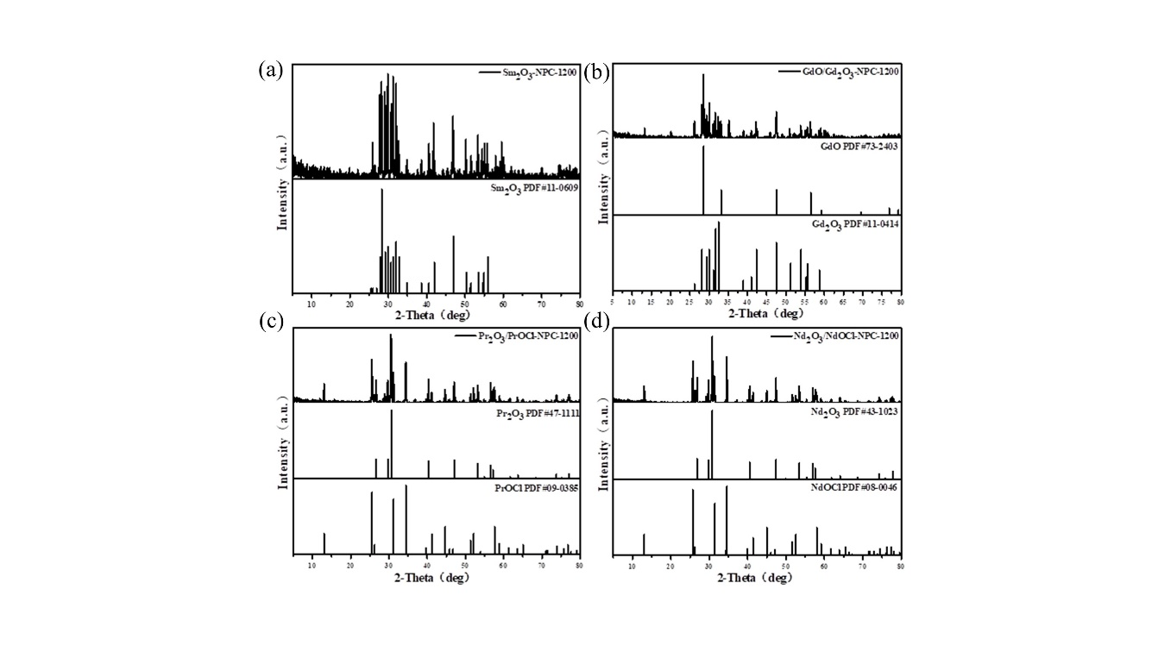

**Figure S1** (a-d)XRD Spectrum of catalyst SmOx-NPC, GdOx-NPC, PrOx-NPC, NdOx-NPC.

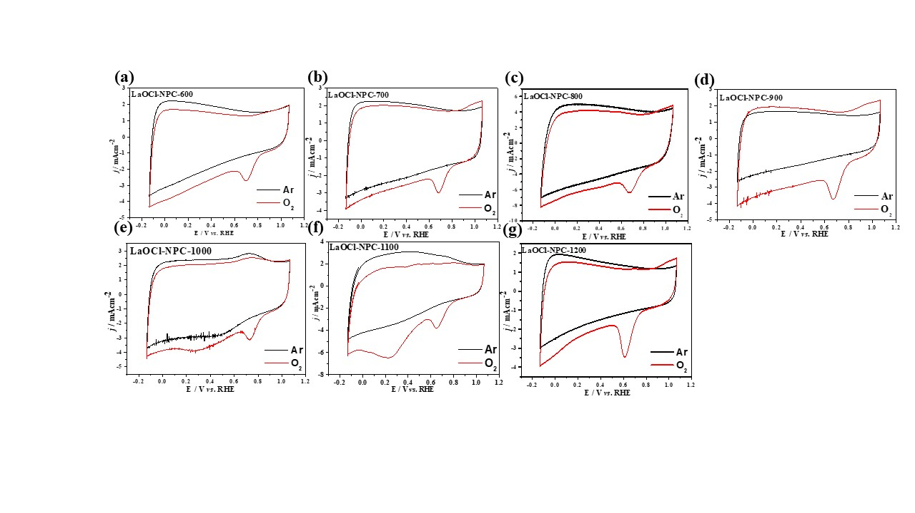

**Figure S2** CV curves of (a) LaOCl-NPC-600, (b) LaOCl-NPC-700, (c) LaOCl-NPC-800, (d) LaOCl-NPC-900, (e) LaOCl-NPC-1000, (f) LaOCl-NPC-1100, (g) LaOCl-NPC-1200.

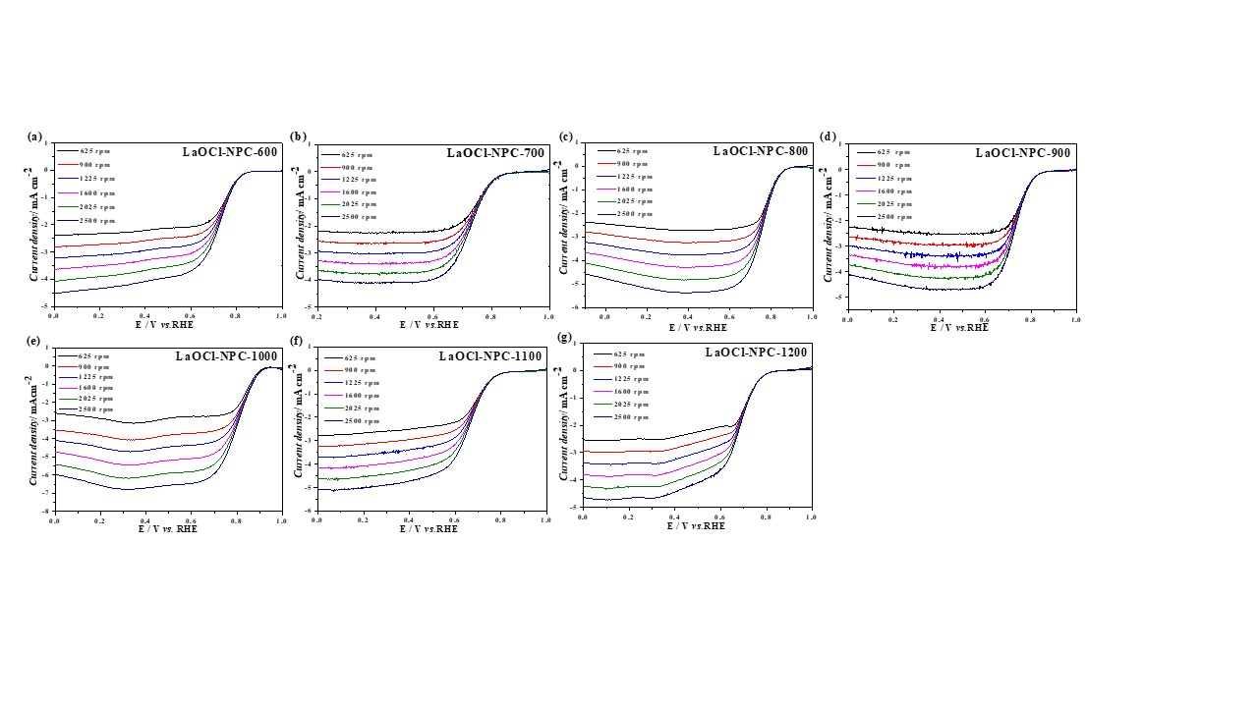**Figure S3** LSV curves of (a) LaOCl-NPC-600, (b) LaOCl-NPC-700, (c) LaOCl-NPC-800, (d) LaOCl-NPC-900,(e) LaOCl-NPC-1000, (f) LaOCl-NPC-1100, (g) LaOCl-NPC-1200.

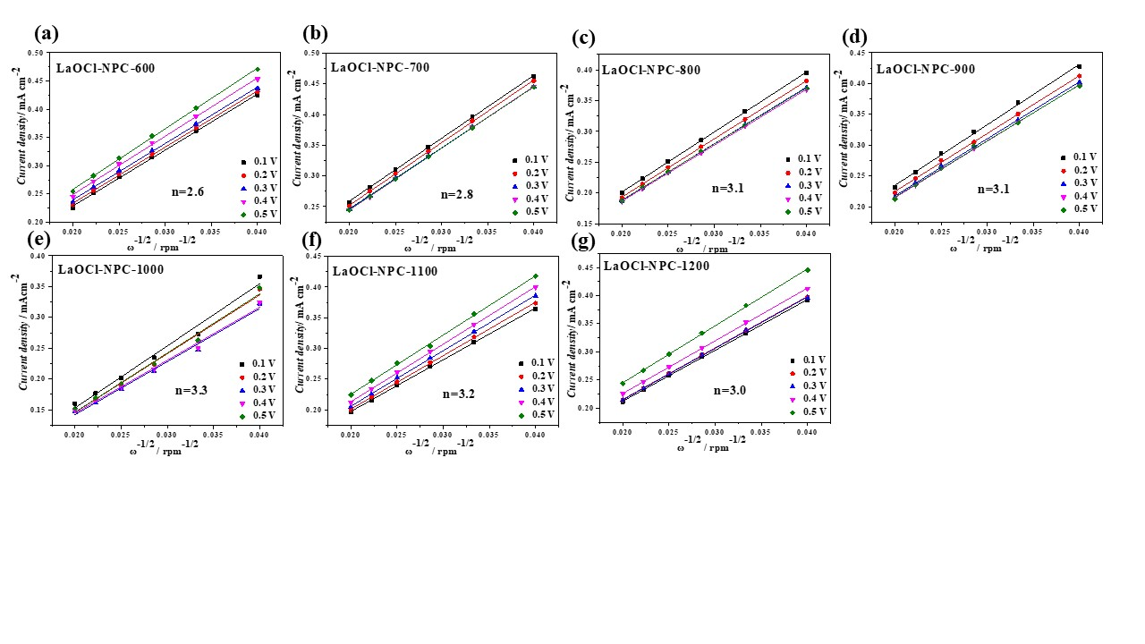

**Figure S4** K-L curves of (a) LaOCl-NPC-600, (b) LaOCl-NPC-700, (c) LaOCl-NPC-800, (d) LaOCl-NPC-900, (e) LaOCl-NPC-1000, (f) LaOCl-NPC-1100, (g) LaOCl-NPC-1200.

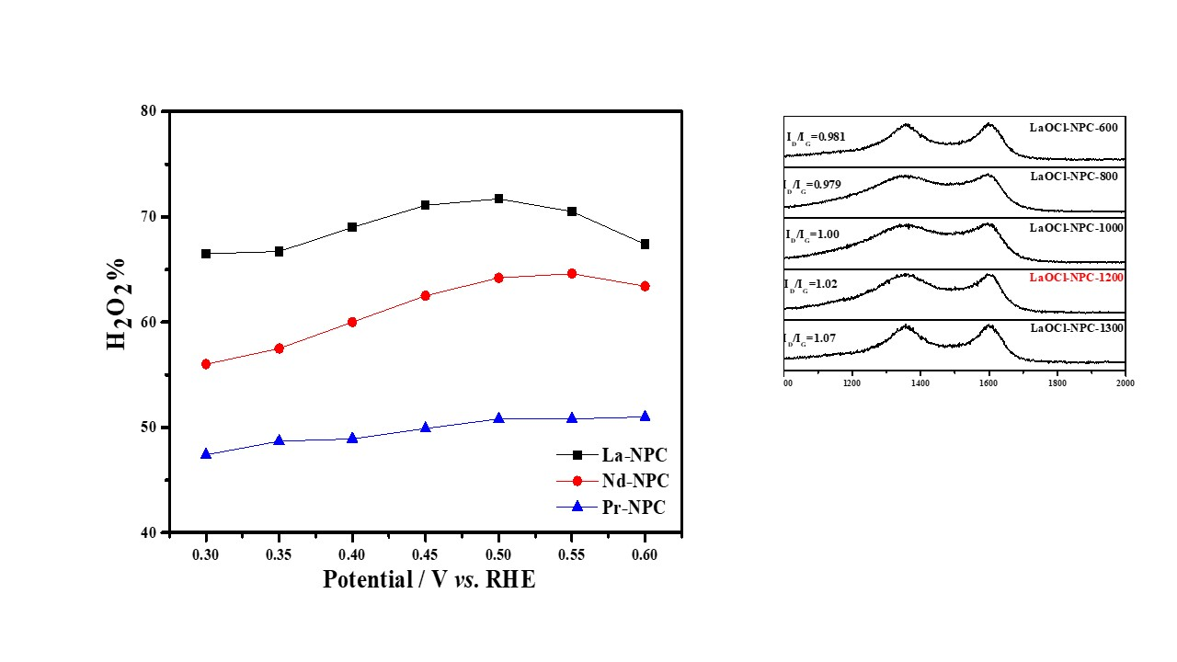

**Figure S5** hydrogen peroxide yields of catalyst La- NPC、Nd- NPC、Pr- NPC.

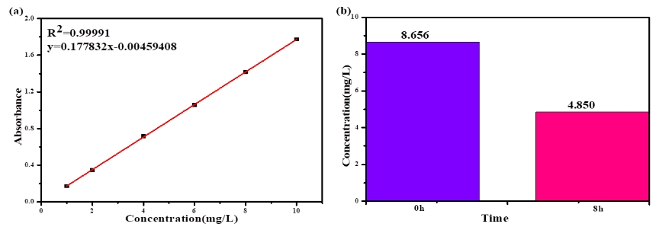

**Figure S6** (a) the curve of absorbance changing with rhodamine B concentration, and (b) the degradation diagram of catalyst LaOCl-NPC.

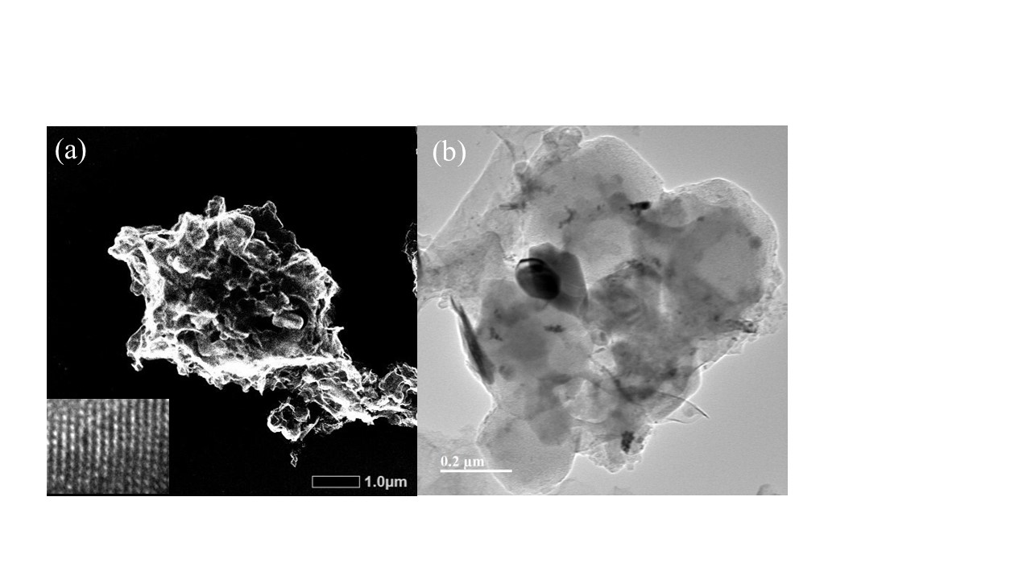

**Figure S7** (a) (b) TEM images of LaOCl-NPC-1200 after i-t test

**Table S1** Ratio of different elements.

|  |  |  |  |  |  |  |
| --- | --- | --- | --- | --- | --- | --- |
| **Temperature** | **Elements(%)** | | | | | |
| **C** | **O** | **La** | **N** | **P** | **Cl** |
| 600℃ | 75.6 | 8.08 | 1.59 | 4.09 | 6.72 | 3.92 |
| 900℃ | 79.37 | 8.45 | 1.44 | 3.90 | 5.76 | 1.08 |
| 1200℃ | 88.76 | 4.02 | 0.90 | 0.98 | 3.25 | 2.09 |

**Table S2.** BET Surface area, pore volume and average pore size of LaOCl-NPC.

|  |  |  |  |
| --- | --- | --- | --- |
| Sample | BET Surface Area  (m²/g) | Pore Volume  (cm3/g) | Pore Size  (nm) |
| LaOCl-NPC-1100 | 314.5 | 0.15 | 2.1 |
| LaOCl-NPC-1200 | 429.7 | 0.21 | 2.2 |
| LaOCl-NPC-1300 | 305.4 | 0.15 | 2.2 |