**Supplementary material**

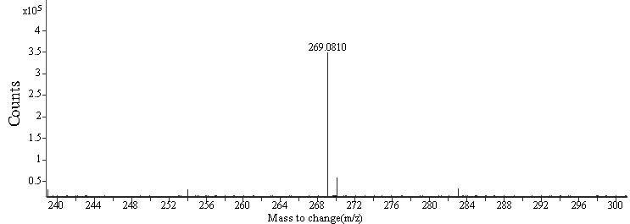

(A)

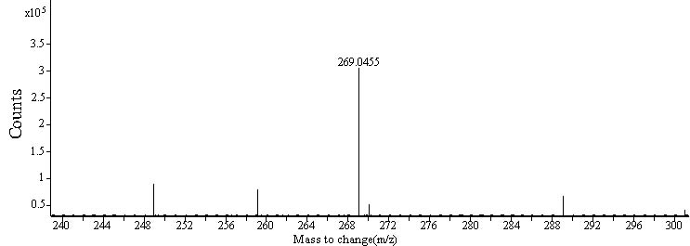

(B)

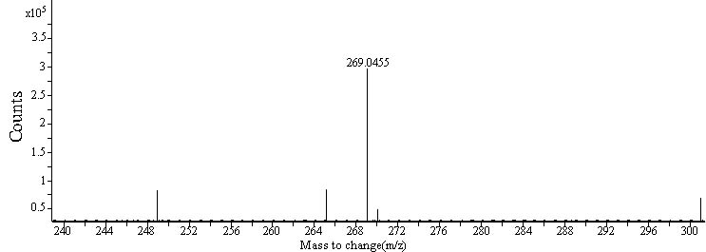

(C)

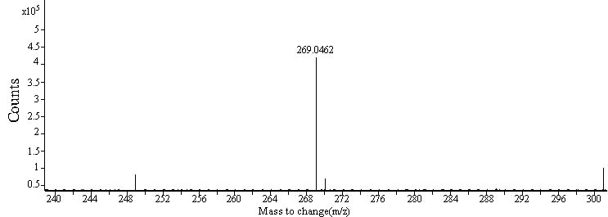

(D)

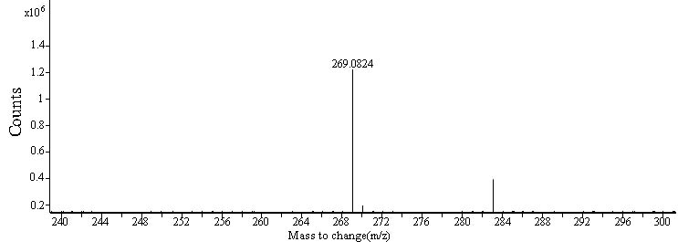

(E)

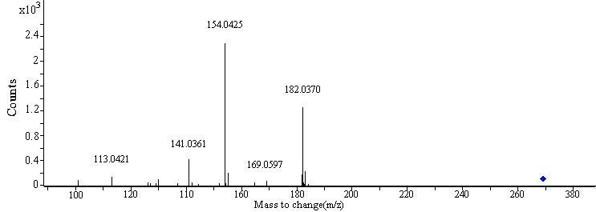

(F)

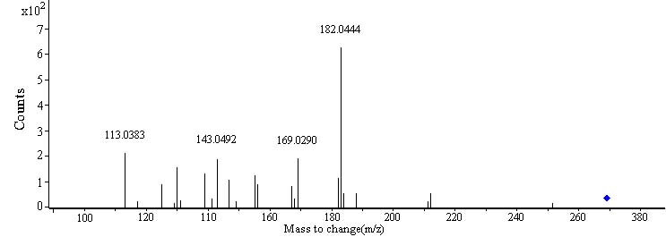

(G)

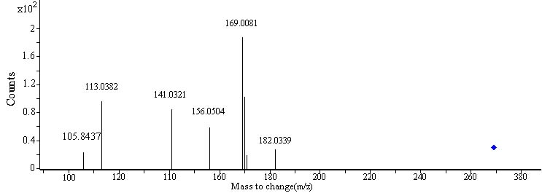

(H)

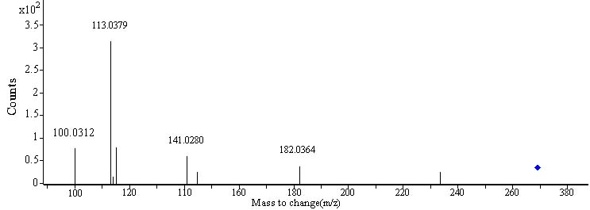

(I)

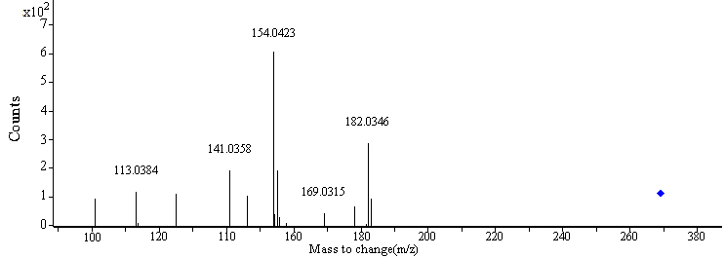

(J)

Fig. S1 MS and MS/MS spectra of standard NU (A, F) and possible NU from *D*.huoshanense (B,G), *D*. nobile (C, H), *D*. fimbriatum (D,I) and *D*. chrysotoxum (E, J) in EtOAcFs obtained by Q-TOF-MS analysis.

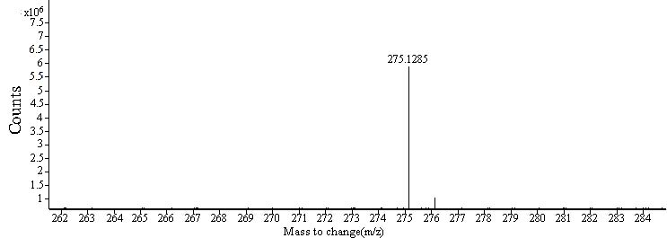

(A)

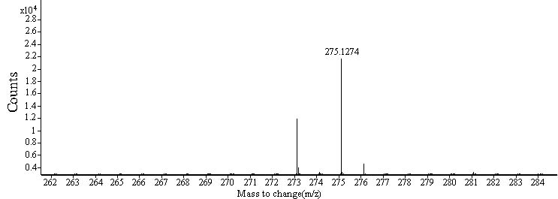

(B)

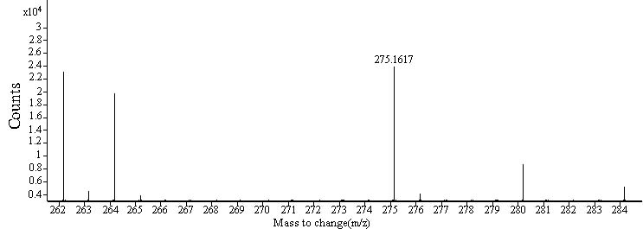

(C)

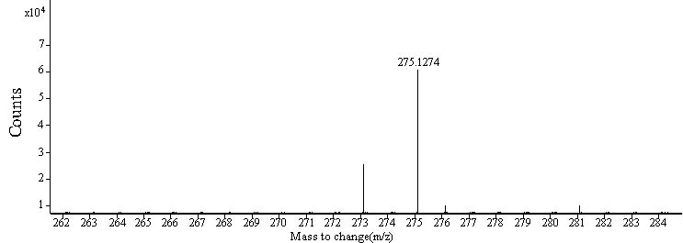

(D)

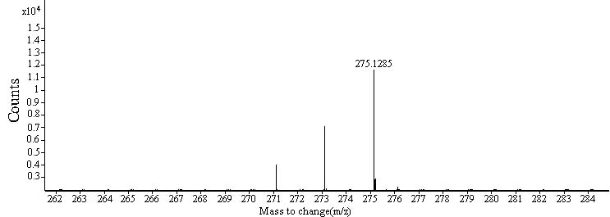

(E)

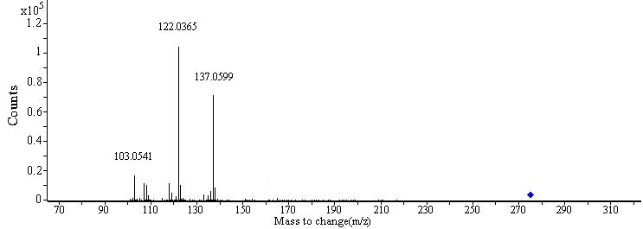

(F)

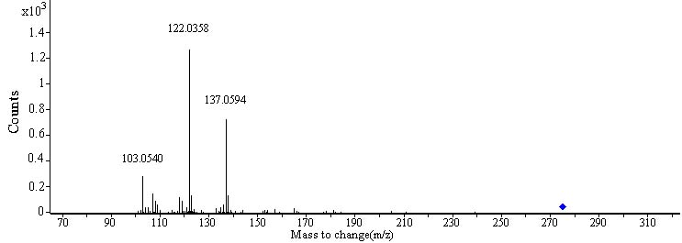

(G)

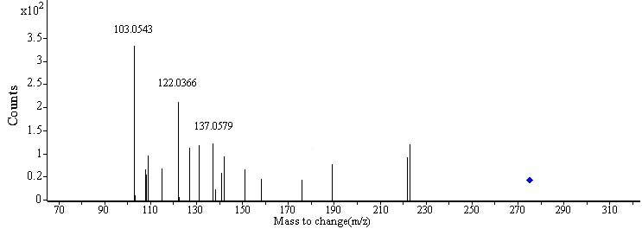

(H)

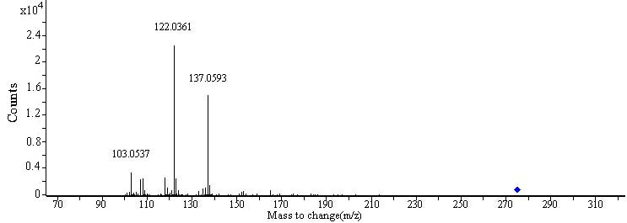

(I)

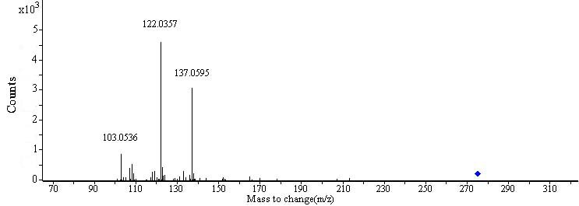

(J)

Fig. S2 MS and MS/MS spectra of standard GT (A, F) and possible GT from *D*.huoshanense (B,G), *D*. nobile (C, H), *D*. fimbriatum (D,I) and *D*. chrysotoxum (E, J) in EtOAcFs obtained by Q-TOF-MS analysis.

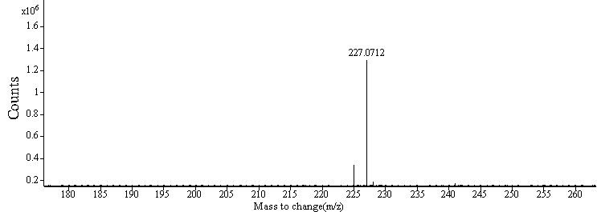

(A)

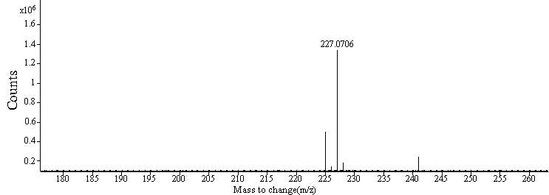

(B)

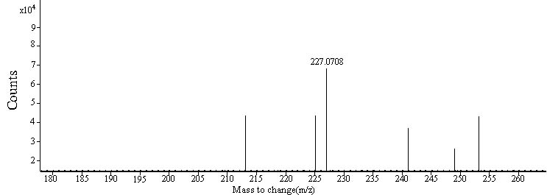

(C)

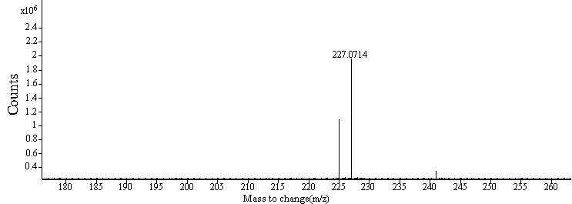

(D)

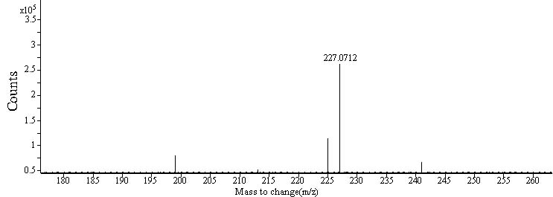

(E)

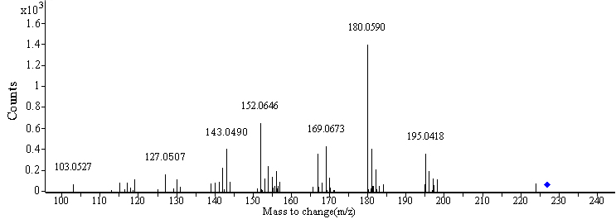

(F)

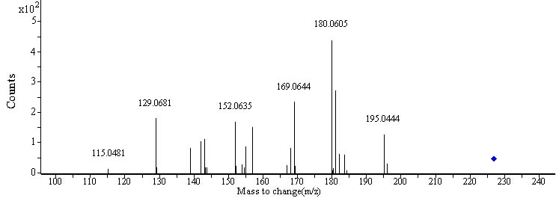

(G)

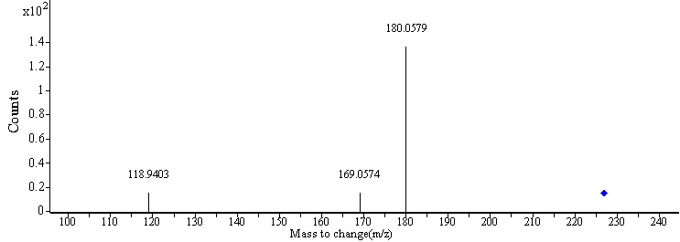

(H)

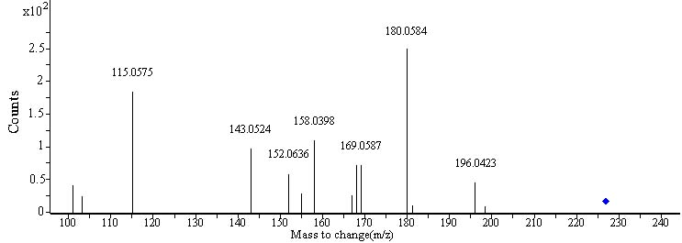

(I)

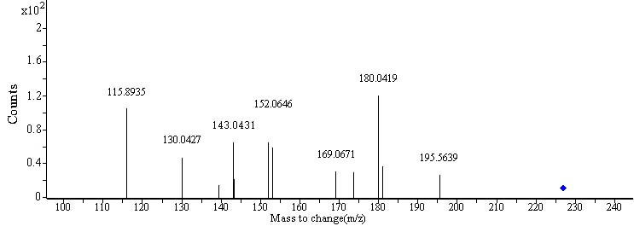

(J)

Fig. S3 MS and MS/MS spectra of standard TD (A, F) and possible TD from *D*.huoshanense (B, G), *D*. nobile (C, H), *D*. fimbriatum (D, I) and *D*. chrysotoxum (E, J) in EtOAcFs obtained by Q-TOF-MS analysis.

FIGS3

Fig. S4 Fluorescence emission spectra of α-glucosidase in the presence of GT(A), TD (C), and EtOAcF-DC (E) at various concentrations; Fluorescence emission spectra of inhibitors including GT(B), TD (D), and EtOAcF-DC (F) at various concentrations.

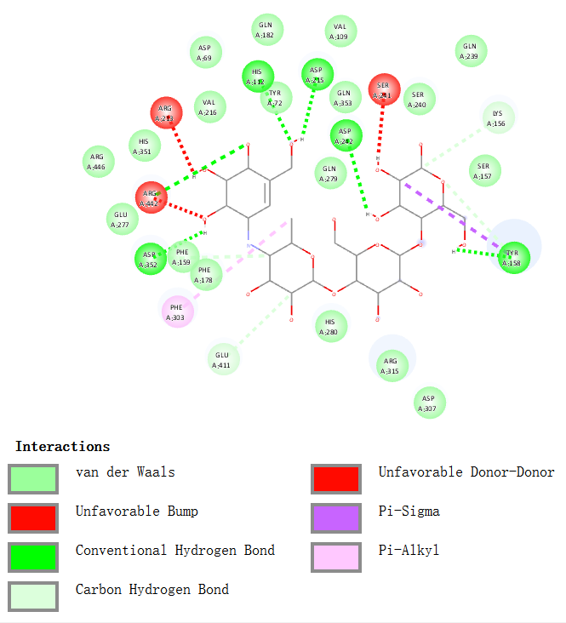

Fig. S5 2D diagram of interaction between α-glucosidase and acarbose.

Table S1 Binding site residues and docking scores of polyphenol compounds and acarbosein α-glucosidase

|  |  |  |  |  |
| --- | --- | --- | --- | --- |
| Compounds | Binding  energy (kcal/  mol) | Hydrogen bond interaction | van der Waals interaction | Other interaction |
| NU | − 8.3 | Ser241, Lys156, Asp242 | Ser311, Pro312, Arg315, Phe314, Leu313, Ser240, Ser157, Leu177 | Tyr158 (Pi-Pi T-shaped), Asp242(Pi-Anion), Lys156 (Pi-Alkyl), His280 (Pi-Alkyl), UNN0 (Unfavorable Acceptor-Acceptor) |
| GT | − 7.7 | Lys156, Asn415, Arg315, Glu411 | Ser240, Ser157, Tyr316, Gly160, Phe159, Leu313, Asp242, UNN0 | Phe314 (Pi-Pi T-shaped), Tyr158 (Pi-Pi T-shaped), His280 (Alkyl), Tyr158 (Alkyl), Arg315 (Alkyl), Lys156 (Pi-Alkyl) |
| TD1 | − 8.4 | Ser240 | Asp242, Arg315, Tyr 316, Phe314, Gly160 Ser157, UNN0 | Tyr158 (Pi-Pi Stacked), Tyr158 (Pi-Alkyl), Lys156 (Pi-Alkyl), Ser241 (Unfavorable, Donor-Donor), Asn415 (Unfavorable Donor-Donor) |
| TD2 | − 6.7 | Glu271  Ile272 | Trp15, Ala292, Ser298, Leu297, Asn259, Ile262, Arg263, Val266, Arg270 | Ile272 (Pi-Alkyl) |
| Acarbose | − 9.0 | Asp352, Arg442, Asp242, Asp215, His112, Tyr158, Glu411, Lys156 | Asp307, Arg315, His280, Phe178, Phe159, Glu277, Arg446, His351, Val216, Asp69, Gln182, Val109, Gln353, Gln279, Ser240, Gln239, Ser157 | Tyr158 (Pi-Sigma), Phe303 (Pi-Alkyl), Arg219 (Unfavorable Donor-Donor), Ser241 (Unfavorable Donor-Donor), Arg442 (Unfavorable Bump) |

1 Located in catalytic site.

2 Located in allosteric site.