Application of novel metal-organic frameworks containing sulfonic acid pendings in synthesis of chromeno[4,3-d]pyrimidines via back to back anomeric based oxidation
Fatemeh Jalili,ª Hassan Sepehrmansourie,ª Mahmoud Zarei,*^{b} Mohammad Ali Zolfigol,*ª Ardeshir Khazaei*ª and Mohammad Ali As’Habi ^{c}
ª Department of Organic Chemistry, Faculty of Chemistry, Bu-Ali-Sina University, 6517838965, Hamedan, Iran., E-mail: zolfi@basu.ac.ir, mzolfigol@yahoo.com (M. A. Zolfigol) or Khazaei_1326@yahoo.com (A. Khazaei).
^{b} Department of Chemistry, Faculty of Science, University of Qom, Qom, 37185-359, Iran. E-Mail: mahmoud8103@yahoo.com (M. Zarei).
^{c} Department of Phytochemistry, Medicinal Plant and Drugs research Institute, Shahid Beheshti University, Evin, Tehran, 1983963113, Iran.

FT-IR spectrum of 4-amino-2-phenyl-5H-chromeno[4,3-d]pyrimidin-5-one (1a) 7
¹H NMR spectrum of 4-amino-2-phenyl-5H-chromeno[4,3-d]pyrimidin-5-one (1a) 7
¹³C NMR spectrum of 4-amino-2-phenyl-5H-chromeno[4,3-d]pyrimidin-5-one (1a) 8
HR-Mass spectrum of 4-amino-2-phenyl-5H-chromeno[4,3-d]pyrimidin-5-one (1a) 8
FT-IR spectrum of 4-amino-2-(3-nitrophenyl)-5H-chromeno[4,3-d]pyrimidin-5-one (2a) 9
¹H NMR spectrum of 4-amino-2-(3-nitrophenyl)-5H-chromeno[4,3-d]pyrimidin-5-one (2a) 9
¹³C NMR spectrum of 4-amino-2-(3-nitrophenyl)-5H-chromeno[4,3-d]pyrimidin-5-one (2a) 10
HR-Mass spectrum of 4-amino-2-(3-nitrophenyl)-5H-chromeno[4,3-d]pyrimidin-5-one (2a) 10
HR-Mass expand spectrum of 4-amino-2-(3-nitrophenyl)-5H-chromeno[4,3-d]pyrimidin-5-one (2a) 11
FT-IR spectrum of 4-amino-2-(p-tolyl)-5H-chromeno[4,3-d]pyrimidin-5-one (3a) 11
¹H NMR spectrum of 4-amino-2-(p-tolyl)-5H-chromeno[4,3-d]pyrimidin-5-one (3a) 12
¹H NMR spectrum of 4-amino-2-(p-tolyl)-5H-chromeno[4,3-d]pyrimidin-5-one (D₂O exchange) (3a) 12
¹³C NMR spectrum of 4-amino-2-(p-tolyl)-5H-chromeno[4,3-d]pyrimidin-5-one (3a) 13
HR-Mass spectrum of 4-amino-2-(p-tolyl)-5H-chromeno[4,3-d]pyrimidin-5-one (3a) 13
FT-IR spectrum of 4-amino-2-(4-methoxyphenyl)-5H-chromeno[4,3-d]pyrimidin-5-one (4a) 14
¹H NMR spectrum of 4-amino-2-(4-methoxyphenyl)-5H-chromeno[4,3-d]pyrimidin-5-one (4a) 14
HR-Mass spectrum of 4-amino-2-(4-methoxyphenyl)-5H-chromeno[4,3-d]pyrimidin-5-one (4a) 15
FT-IR spectrum of 4-amino-2-(4-isopropylphenyl)-5H-chromeno[4,3-d]pyrimidin-5-one(5a) 15
¹H NMR spectrum of 4-amino-2-(4-isopropylphenyl)-5H-chromeno[4,3-d]pyrimidin-5-one (5a) 16
¹³C NMR spectrum of 4-amino-2-(4-isopropylphenyl)-5H-chromeno[4,3-d]pyrimidin-5-one (5a) 16
HR-Mass spectrum of 4-amino-2-(4-isopropylphenyl)-5H-chromeno[4,3-d]pyrimidin-5-one (5a) 17
FT-IR spectrum of 4-amino-2-(4-(dimethylamino)phenyl)-5H-chromeno[4,3-d]pyrimidin-5-one (6a) 17
¹H NMR spectrum of 4-amino-2-(4-(dimethylamino)phenyl)-5H-chromeno[4,3-d]pyrimidin-5-one (6a) 18
¹³C NMR spectrum of 4-amino-2-(4-(dimethylamino)phenyl)-5H-chromeno[4,3-d]pyrimidin-5-one (6a) 18
HR-Mass spectrum of 4-amino-2-(4-(dimethylamino)phenyl)-5H-chromeno[4,3-d]pyrimidin-5-one (6a) 19
FT-IR spectrum of 4-amino-2-(3-ethoxy-4-hydroxyphenyl)-5H-chromeno[4,3-d]pyrimidin-5-one (7a) 19
¹H NMR spectrum of 4-amino-2-(3-ethoxy-4-hydroxyphenyl)-5H-chromeno[4,3-d]pyrimidin-5-one (7a) 20
¹³C NMR spectrum of 4-amino-2-(3-ethoxy-4-hydroxyphenyl)-5H-chromeno[4,3-d]pyrimidin-5-one (7a) 20
HR-Mass spectrum of 4-amino-2-(3-ethoxy-4-hydroxyphenyl)-5H-chromeno[4,3-d]pyrimidin-5-one (7a) 21
FT-IR spectrum of 4-amino-2-(4-nitrophenyl)-5H-chromeno[4,3-d]pyrimidin-5-one (8a) 21
¹H NMR spectrum of 4-amino-2-(4-nitrophenyl)-5H-chromeno[4,3-d]pyrimidin-5-one (8a) 22
¹³C NMR spectrum of 4-amino-2-(4-nitrophenyl)-5H-chromeno[4,3-d]pyrimidin-5-one (8a) 22
HR-Mass spectrum of 4-amino-2-(4-nitrophenyl)-5H-chromeno[4,3-d]pyrimidin-5-one (8a) 23
FT-IR spectrum of 4-amino-2-(4-bromophenyl)-5H-chromeno[4,3-d]pyrimidin-5-one (9a) 23
¹H NMR spectrum of 4-amino-2-(4-bromophenyl)-5H-chromeno[4,3-d]pyrimidin-5-one (9a) 24
¹³C NMR spectrum of 4-amino-2-(4-bromophenyl)-5H-chromeno[4,3-d]pyrimidin-5-one (9a) 24
HR-Mass spectrum of 4-amino-2-(4-bromophenyl)-5H-chromeno[4,3-d]pyrimidin-5-one (9a) 25
FT-IR spectrum of 4-amino-2-(4-hydroxyphenyl)-5H-chromeno[4,3-d]pyrimidin-5-one (10a) 25
¹H NMR spectrum of 4-amino-2-(4-hydroxyphenyl)-5H-chromeno[4,3-d]pyrimidin-5-one (10a) 26
¹³C NMR spectrum of 4-amino-2-(4-hydroxyphenyl)-5H-chromeno[4,3-d]pyrimidin-5-one (10a) 27
HR-Mass spectrum of 4-amino-2-(4-hydroxyphenyl)-5H-chromeno[4,3-d]pyrimidin-5-one (10a) 27
FT-IR spectrum of 4-amino-2-(4-chlorophenyl)-5H-chromeno[4,3-d]pyrimidin-5-one (11a) 28
¹H NMR spectrum of 4-amino-2-(4-chlorophenyl)-5H-chromeno[4,3-d]pyrimidin-5-one (11a) 28
¹³C NMR spectrum of 4-amino-2-(4-chlorophenyl)-5H-chromeno[4,3-d]pyrimidin-5-one (11a) 29
HR-Mass spectrum of 4-amino-2-(4-chlorophenyl)-5H-chromeno[4,3-d]pyrimidin-5-one (11a) 29
FT-IR spectrum of 4-amino-2-(2,4-dichlorophenyl)-5H-chromeno[4,3-d]pyrimidin-5-one (12a) 30
¹H NMR spectrum of 4-amino-2-(2,4-dichlorophenyl)-5H-chromeno[4,3-d]pyrimidin-5-one (12a) 30
¹³C NMR spectrum of 4-amino-2-(2,4-dichlorophenyl)-5H-chromeno[4,3-d]pyrimidin-5-one (12a) 31
HR-Mass spectrum of 4-amino-2-(2,4-dichlorophenyl)-5H-chromeno[4,3-d]pyrimidin-5-one (12a) 31
FT-IR spectrum of 4-amino-2-(2-methoxyphenyl)-5H-chromeno[4,3-d]pyrimidin-5-one (13a) 32
¹H NMR spectrum of 4-amino-2-(2-methoxyphenyl)-5H-chromeno[4,3-d]pyrimidin-5-one (13a) 32
¹³C NMR spectrum of 4-amino-2-(2-methoxyphenyl)-5H-chromeno[4,3-d]pyrimidin-5-one (13a) 33
HR-Mass spectrum of 4-amino-2-(2-methoxyphenyl)-5H-chromeno[4,3-d]pyrimidin-5-one (13a) 33
FT-IR spectrum of 4-amino-2-(2-hydroxy-3-methoxyphenyl)-5H-chromeno[4,3-d]pyrimidin-5-one (14a) 34
¹H NMR spectrum of 4-amino-2-(2-hydroxy-3-methoxyphenyl)-5H-chromeno[4,3-d]pyrimidin-5-one (14a) 34
¹³C NMR spectrum of 4-amino-2-(2-hydroxy-3-methoxyphenyl)-5H-chromeno[4,3-d]pyrimidin-5-one (14a) 35
HR-Mass spectrum of 4-amino-2-(2-hydroxy-3-methoxyphenyl)-5H-chromeno[4,3-d]pyrimidin-5-one (14a) 35
FT-IR spectrum of 4-amino-2-(pyridin-4-yl)-5H-chromeno[4,3-d]pyrimidin-5-one (15a) 36
¹H NMR spectrum of 4-amino-2-(pyridin-4-yl)-5H-chromeno[4,3-d]pyrimidin-5-one (15a) 36
¹³C NMR spectrum of 4-amino-2-(pyridin-4-yl)-5H-chromeno[4,3-d]pyrimidin-5-one (15a) 37
HR-Mass spectrum of 4-amino-2-(pyridin-4-yl)-5H-chromeno[4,3-d]pyrimidin-5-one (15a) 37
HR-Mass expand spectrum of 4-amino-2-(pyridin-4-yl)-5H-chromeno[4,3-d]pyrimidin-5-one (15a) 38
FT-IR spectrum of 4-amino-2-(pyridin-3-yl)-5H-chromeno[4,3-d]pyrimidin-5-one (16a) 38
¹H NMR spectrum of 4-amino-2-(pyridin-3-yl)-5H-chromeno[4,3-d]pyrimidin-5-one (16a) 39
¹³C NMR spectrum of 4-amino-2-(pyridin-3-yl)-5H-chromeno[4,3-d]pyrimidin-5-one (16a) 39
HR-Mass spectrum of 4-amino-2-(pyridin-3-yl)-5H-chromeno[4,3-d]pyrimidin-5-one (16a) 40
FT-IR spectrum of 4-amino-2-(3-fluorophenyl)-5H-chromeno[4,3-d]pyrimidin-5-one (17a) 40
¹H NMR spectrum of 4-amino-2-(3-fluorophenyl)-5H-chromeno[4,3-d]pyrimidin-5-one (17a) 41
¹³C NMR spectrum of 4-amino-2-(3-fluorophenyl)-5H-chromeno[4,3-d]pyrimidin-5-one (17a) 42
HR-Mass spectrum of 4-amino-2-(3-fluorophenyl)-5H-chromeno[4,3-d]pyrimidin-5-one (17a) 42
FT-IR spectrum of 4-amino-2-(m-tolyl)-5H-chromeno[4,3-d]pyrimidin-5-one (18a) 43
¹H NMR spectrum of 4-amino-2-(m-tolyl)-5H-chromeno[4,3-d]pyrimidin-5-one (18a) 43
¹³C NMR spectrum of 4-amino-2-(m-tolyl)-5H-chromeno[4,3-d]pyrimidin-5-one (18a) 44
HR-Mass spectrum of 4-amino-2-(m-tolyl)-5H-chromeno[4,3-d]pyrimidin-5-one (18a) 44
FT-IR spectrum of 4-amino-2-(naphthalen-2-yl)-5H-chromeno[4,3-d]pyrimidin-5-one (19a) 45
¹H NMR spectrum of 4-amino-2-(naphthalen-2-yl)-5H-chromeno[4,3-d]pyrimidin-5-one (19a) 45
¹³C NMR spectrum of 4-amino-2-(naphthalen-2-yl)-5H-chromeno[4,3-d]pyrimidin-5-one (19a) 46
HR-Mass spectrum of 4-amino-2-(naphthalen-2-yl)-5H-chromeno[4,3-d]pyrimidin-5-one (19a) 46

Figure S1: Various kinds of stereoelectronic effects.

Figure S2: Synthesis a number of heterocyclic compounds via anomeric based oxidation.

4. Spectral data
4-Amino-2-phenyl-5H-chromeno[4,3-d]pyrimidin-5-one (1a)
Yellow solid; Mp: 265-268 °C; IR (KBr): υ (cm⁻¹)= 3480, 3367, 1705, 1615, 1102. ¹H NMR (499 MHz, DMSO-d₆) δ_{ppm} 8.55 (d, J = 7.2 Hz, 2H), 8.51 (d, J = 7.8 Hz, 2H), 8.19 (s, 1H), 7.72 (t, J = 7.7 Hz, 1H), 7.60 – 7.52 (m, 3H), 7.46 (d, J = 7.4 Hz, 1H), 7.42 (d, J = 8.5 Hz, 1H). Yellow solid; Mp: >300 °C; IR (KBr): υ (cm⁻¹)= ¹³C NMR (126 MHz, DMSO-d₆) δ_{ppm} 166.4, 163.6, 161.3, 159.5, 153.8, 137.2, 134.3, 132.2, 129.1, 128.9, 125.6, 125.2, 118.6, 117.3, 95.9. HR-MS (EI):m/z (M⁺ +1) calcd for C₁₇H₁₁N₃O₂: 289.0851, found: 290.0072.
4-Amino-2-(3-nitrophenyl)-5H-chromeno[4,3-d]pyrimidin-5-one (2a)
Yellow solid; Mp: 254 °C; IR (KBr): υ (cm⁻¹)= 3336, 3215, 3044, 1706, 1413, 1100, 617. ¹H NMR (400 MHz, DMSO-d₆) δ_{ppm} 9.66 (d, J = 2.3 Hz, 1H), 8.83–8.80 (m, 1H), 8.79 (dd, J = 4.8, 1.7 Hz, 1H), 8.75 (s, 1H), 8.65 (dd, J = 8.1, 1.6 Hz, 1H), 8.32 (s, 1H), 7.80–7.76 (m, 1H), 7.65 – 7.61 (m, 1H), 7.50 (d, J = 8.0 Hz, 2H). ¹³C NMR (101 MHz, DMSO-d₆) δ_{ppm} 164.5, 163.1, 159.2, 153.4, 152.2, 149.7, 135.9, 134.0, 132.2, 125.3, 124.9, 123.7, 117.9, 116.9. HR-MS (EI):m/z (M⁺ +1) calcd for C₁₇H₁₀N₄O₄: 334.0702, found: 335.0506.
4-Amino-2-(p-tolyl)-5H-chromeno[4,3-d]pyrimidin-5-one (3a)
Yellow solid; Mp: 278-280 °C; IR (KBr): υ (cm⁻¹)= 3424, 3326, 1697, 1612, 1539, 1116, 618. ¹H NMR (400 MHz, DMSO-d₆) δ_{ppm} δ 8.61 (dd, J = 7.9, 1.5 Hz, 1H), 8.59 (s, 1H), 8.46 (d, J = 8.2 Hz, 2H), 8.22 (d, J = 2.3 Hz, 1H), 7.79–7.74 (m, 1H), 7.52 – 7.47 (m, 2H), 7.39 (d, J = 8.0 Hz, 2H), 2.42 (s, 3H). ¹³C NMR (126 MHz, DMSO-d₆) δ_{ppm} 166.5, 163.6, 159.6, 153.8, 142.3, 134.3, 129.6, 129.1, 125.6, 125.2, 118.6, 117.3, 95.8, 21.6. HR-MS (EI):m/z (M⁺ +1) calcd for C₁₈H₁₃N₃O₂: 303.1008, found: 304.0157.
4-Amino-2-(4-methoxyphenyl)-5H-chromeno[4,3-d]pyrimidin-5-one (4a)
Yellow solid; Mp: 260-261 °C; IR (KBr): υ (cm⁻¹)= 3404, 3218, 2839, 1710, 1614, 1550, 1096, 616. ¹H NMR (400 MHz, DMSO-d₆) δ_{ppm} 9.17 (s, 1H), 8.55 – 8.48 (m, 2H), 8.22 (dd, J = 8.2, 1.5 Hz, 1H), 7.87 – 7.82 (m, 1H), 7.60 – 7.54 (m, 2H), 7.21 (dd, J = 8.0, 1.5 Hz, 1H), 6.96 (t, J = 8.0 Hz, 1H), 3.88 (s, 3H). HR-MS (EI):m/z (M⁺ +1) calcd for C₁₈H₁₃N₃O₃: 319.0957, found: 320.0047.
4-Amino-2-(4-isopropylphenyl)-5H-chromeno[4,3-d]pyrimidin-5-one (5a)
Yellow solid; Mp: 230-231 °C; IR (KBr): υ (cm⁻¹)= 3426, 3326, 1699, 1059. ¹H NMR (499 MHz, DMSO-d₆) δ_{ppm} 8.56 (d, J = 7.9 Hz, 2H), 8.45 (d, J = 7.9 Hz, 2H), 8.18 (s, 1H), 7.73 (t, J = 7.6 Hz, 1H), 7.51 – 7.39 (m, 5H), 2.99 (hept, J = 5.9 Hz, 1H), 1.26 (d, J = 6.8 Hz, 6H). ¹³C NMR (126 MHz, DMSO-d₆) δ_{ppm} 166.5, 163.6, 161.3, 159.5, 153.8, 152.9, 135.0, 134.2, 129.3, 126.9, 125.6, 125.2, 118.6, 117.3, 95.7, 33.9, 24.1. HR-MS (EI):m/z (M⁺ +1) calcd for C₂₀H₁₇N₃O₂: 331.1321, found: 332.0975.
4-Amino-2-(4-(dimethylamino)phenyl)-5H-chromeno[4,3-d]pyrimidin-5-one (6a)
Yellow solid; Mp: 254-256 °C; IR (KBr): υ (cm⁻¹)= 3426, 3177, 1703, 1598, 1175. ¹H NMR (499 MHz, DMSO-d₆) δ_{ppm} 8.55 (d, J = 7.8 Hz, 1H), 8.38 (d, J = 7.7 Hz, 2H), 8.32 (s, 1H), 8.07 (s, 1H), 7.72 (t, J = 7.7 Hz, 1H), 7.46 (t, J = 7.5 Hz, 1H), 7.42 (d, J = 8.3 Hz, 1H), 6.79 (d, J = 7.9 Hz, 2H), 3.03 (s, 6H). ¹³C NMR (126 MHz, DMSO-d₆) δ_{ppm} 166.8, 163.4, 161.4, 159.3, 153.8, 153.2, 134.0, 130.8, 125.5, 125.1, 123.9, 118.8, 117.3, 111.6, 111.5, 40.2. HR-MS (EI):m/z (M⁺ +1) calcd for C₁₉H₁₆N₄O₂: 332.1273, found: 333.0102.
4-Amino-2-(3-ethoxy-4-hydroxyphenyl)-5H-chromeno[4,3-d]pyrimidin-5-one (7a)
Yellow solid; Mp: 230-232 °C; IR (KBr): υ (cm⁻¹)= 3521, 3418, 3297, 3221, 1708, 1631, 1097. ¹H NMR (499 MHz, DMSO-d₆) δ_{ppm} 9.35 (s, 1H), 8.54 (d, J = 7.8 Hz, 1H), 8.44 (s, 1H), 8.12 (s, 1H), 8.08 – 8.04 (m, 2H), 7.71 (t, J = 7.1 Hz, 1H), 7.46 (t, J = 7.5 Hz, 1H), 7.42 (d, J = 8.2 Hz, 1H), 6.93 (d, J = 8.1 Hz, 1H), 4.13 (q, J = 6.9 Hz, 2H), 1.40 (t, J = 6.9 Hz, 3H). ¹³C NMR (126 MHz, DMSO-d₆) δ_{ppm} 167.2, 163.4, 161.1, 159.3, 153.8, 136.7, 135.4, 134.5, 133.2, 133.2, 130.3, 127.8, 125.6, 125.3, 118.2, 117.3, 96.0. HR-MS (EI):m/z (M⁺ +1) calcd for C₁₉H₁₅N₃O₄: 349.1063, found: 350.0347.
4-Amino-2-(4-nitrophenyl)-5H-chromeno[4,3-d]pyrimidin-5-one (8a)
Yellow solid; Mp: 250-251 °C; IR (KBr): υ (cm⁻¹)= 3453, 3338, 1706, 1627, 1557, 1353, 1138. ¹H NMR (499 MHz, DMSO-d₆) δ_{ppm} 9.06 (s, 1H), 8.80 (d, J = 7.6 Hz, 1H), 8.72 (s, 1H), 8.41 (d, J = 7.6 Hz, 1H), 8.35 (d, J = 7.8 Hz, 1H), 8.20 (s, 1H), 7.78 (t, J = 7.8 Hz, 1H), 7.70 (t, J = 7.5 Hz, 1H), 7.43 (t, J = 7.4 Hz, 1H), 7.36 (d, J = 8.2 Hz, 1H). ¹³C NMR (126 MHz, DMSO-d₆) δ_{ppm} 164.0, 163.5, 161.0, 159.5, 153.7, 148.4, 138.7, 134.9, 134.4, 130.6, 126.4, 125.4, 125.2, 123.1, 118.1, 117.2, 96.3. HR-MS (EI):m/z (M⁺ +1) calcd for C₁₇H₁₀N₄O₄: 334.0702, found: 335.0280.
4-Amino-2-(4-bromophenyl)-5H-chromeno[4,3-d]pyrimidin-5-one (9a)
Yellow solid; Mp: >300 °C; IR (KBr): υ (cm⁻¹)= 3217, 3044, 2834, 1710, 1555, 1415, 1093, 614. ¹H NMR (400 MHz, DMSO-d₆) δ_{ppm} 8.67 (s, 1H), 8.59 (dd, J = 7.8, 1.4 Hz, 1H), 8.46 (d, J = 8.6 Hz, 2H), 8.26 (s, 1H), 7.78 (d, J = 8.6 Hz, 2H), 7.77 – 7.74 (m, 1H), 7.52 – 7.47 (m, 2H). ¹³C NMR (126 MHz, DMSO-d₆) δ_{ppm} 165.5, 163.6, 161.2, 153.8, 136.4, 134.3, 132.0, 131.0, 126.2, 125.6, 125.2, 117.3. HR-MS (EI):m/z (M⁺ +1) calcd for C₁₇H₁₀BrN₃O₂: 366.9956, found: 367.9694.
4-Amino-2-(4-hydroxyphenyl)-5H-chromeno[4,3-d]pyrimidin-5-one (10a)
Yellow solid; Mp: >300 °C; IR (KBr): υ (cm⁻¹)= 3217, 3037, 2830, 1683, 1605, 1558, 1411, 1103, 616. ¹H NMR (400 MHz, DMSO-d₆) δ_{ppm} 10.27 (s, 1H), 8.65 – 8.60 (m, 1H), 8.51 (s, 1H), 8.46 (d, J = 8.7 Hz, 2H), 8.19 (s, 1H), 7.79 (t, J = 7.8 Hz, 1H), 7.55 – 7.49 (m, 2H), 6.95 (d, J = 8.7 Hz, 2H). 13C NMR (101 MHz, DMSO) δ_{ppm} 164.7, 164.1, 161.6, 160.2, 154.3, 149.1, 139.3, 135.6, 135.1, 131.3, 127.1, 126.1, 125.9, 123.7, 118.8, 117.9, 97.0. HR-MS (EI):m/z (M⁺ +1) calcd for C₁₇H₁₁N₃O₃: 305.0800, found: 305.9923.
4-Amino-2-(4-chlorophenyl)-5H-chromeno[4,3-d]pyrimidin-5-one (11a)
Yellow solid; Mp: >300 °C; IR (KBr): υ (cm⁻¹)= 3486, 3344, 3217, 1712, 1615, 1555, 1088, 615. ¹H NMR (400 MHz, DMSO-d₆) δ_{ppm} 8.72 (s, 1H), 8.64 (dd, J = 7.8, 1.4 Hz, 1H), 8.59 (d, J = 8.6 Hz, 2H), 8.31 (s, 1H), 7.83 – 7.82 (m, 1H), 7.69 (d, J = 8.6 Hz, 2H), 7.57 – 7.51 (m, 2H). 13C NMR (100 MHz, DMSO) δ_{ppm} 164.0, 153.4, 150.6, 147.4, 142.5, 134.1, 129.7, 128.9, 126.3, 124.9, 124.3, 124.0, 123.7, 122.7, 117.9, 116.9, 96.1. HR-MS (EI):m/z (M⁺ +1) calcd for C₁₇H₁₀ClN₃O₂: 323.0462, found: 324.0072.
4-Amino-2-(2,4-dichlorophenyl)-5H-chromeno[4,3-d]pyrimidin-5-one (12a)
Yellow solid; Mp: >300 °C; IR (KBr): υ (cm⁻¹)= 3479, 3351, 1708, 1617, 1100. ¹H NMR (499 MHz, DMSO-d₆) δ_{ppm} 8.74 (s, 1H), 8.35 (d, J = 7.8 Hz, 1H), 8.26 (s, 1H), 7.85 (d, J = 8.3 Hz, 1H), 7.74 (s, 1H), 7.71 (d, J = 7.7 Hz, 1H), 7.57 (d, J = 8.3 Hz, 1H), 7.45 – 7.42 (m, 2H). ¹³C NMR (126 MHz, DMSO-d₆) δ_{ppm} 167.2, 163.4, 161.1, 159.3, 153.8, 136.7, 135.4, 134.5, 133.2, 133.2, 130.3, 127.8, 125.6, 125.3, 118.2, 117.3, 96.0. HR-MS (EI):m/z (M⁺ +1) calcd for C₁₇H₉C_{l2}N₃O₂: 357.0072, found:357.9510.
4-Amino-2-(2-methoxyphenyl)-5H-chromeno[4,3-d]pyrimidin-5-one (13a)
Yellow solid; Mp: 281-283 °C; IR (KBr): υ (cm⁻¹)= 3402, 3139, 2847, 1710, 1614, 1399, 1109, 617. ¹H NMR (499 MHz, DMSO-d₆) δ_{ppm} 8.57 (s, 1H), 8.36 (d, J = 7.5 Hz, 1H), 8.15 (s, 1H), 7.73 – 7.69 (m, 1H), 7.60 (dd, J = 7.5, 2.0 Hz, 1H), 7.47 – 7.43 (m, 2H), 7.15 (d, J = 8.4 Hz, 1H), 7.05 (t, J = 7.5 Hz, 1H), 3.79 (s, 3H). ¹³C NMR (126 MHz, DMSO-d₆) δ_{ppm} 169.2, 163.4, 161.3, 159.2, 157.7, 153.8, 134.2, 131.5, 131.0, 129.1, 125.5, 125.2, 120.6, 118.5, 117.3, 112.9, 95.5, 56.3. HR-MS (EI):m/z (M⁺ +1) calcd for C₁₈H₁₃N₃O₃: 319.0957, found: 320.0079.
4-Amino-2-(2-hydroxy-3-methoxyphenyl)-5H-chromeno[4,3-d]pyrimidin-5-one (14a)
Yellow solid; Mp: 290-293 °C; IR (KBr): υ (cm⁻¹)= 3435, 3217, 3037, 2843, 1705, 1415, 1100, 615. ¹H NMR (400 MHz, DMSO-d₆) δ_{ppm} 9.17 (s, 1H), 8.55 – 8.48 (m, 2H), 8.22 (dd, J = 8.2, 1.5 Hz, 1H), 7.89 – 7.80 (m, 1H), 7.62 – 7.52 (m, 2H), 7.21 (dd, J = 8.0, 1.5 Hz, 1H), 6.96 (t, J = 8.0 Hz, 1H), 3.88 (s, 3H). 13C NMR (101 MHz, DMSO) δ_{ppm} 166.6, 161.4, 160.3, 158.3, 153.5, 151.7, 148.7, 134.4, 125.1, 125.0, 121.2, 117.9, 117.4, 117.1, 115.9, 95.2, 55.8. HR-MS (EI):m/z (M⁺ +1) calcd for C₁₈H₁₃N₃O₄: 335.0906, found: 336.0215.
4-Amino-2-(pyridin-4-yl)-5H-chromeno[4,3-d]pyrimidin-5-one (15a)
Yellow solid; Mp: >300 °C; IR (KBr): υ (cm⁻¹)= 3139, 1628, 1403, 1108, 618. ¹H NMR (400 MHz, DMSO-d₆) δ_{ppm} 9.08 (dd, J = 8.4, 1.5 Hz, 2H), 8.89 (s, 2H), 7.77 – 7.73 (m, 2H), 7.51 – 7.46 (m, 2H), 7.46 – 7.43 (m, 2H). 13C NMR (101 MHz, DMSO) δ 166.4, 159.7, 159.6, 151.8, 147.8, 133.6, 125.4, 124.2, 119.6, 117.5, 115.6, 86.3, 80.0. HR-MS (EI):m/z (M⁺ +1) calcd for C₁₆H₁₀N₄O₂: 290.0804, found: 291.9696.
4-Amino-2-(pyridin-3-yl)-5H-chromeno[4,3-d]pyrimidin-5-one (16a)
Yellow solid; Mp: >300 °C; IR (KBr): υ (cm⁻¹)= 3222, 3029, 1709, 1540, 1408, 1092, 614. ¹H NMR (400 MHz, DMSO-d₆) δ_{ppm} 9.18 (s, 1H), 8.92 (d, J = 7.8 Hz, 1H), 8.82 (s, 1H), 8.59 – 8.50 (m, 1H), 8.47 – 8.40 (m, 1H), 8.29 (s, 1H), 7.85 (t, J = 8.0 Hz, 1H), 7.79 – 7.73 (m, 1H), 7.50 (t, J = 7.6 Hz, 1H), 7.45 (d, J = 8.2 Hz, 1H). ¹³C NMR (101 MHz, DMSO-d₆) δ_{ppm} 163.7, 163.1, 160.6, 159.2, 153.3, 148.1, 138.3, 134.6, 134.1, 130.3, 126.1, 125.1, 124.9, 122.7, 117.8, 116.9, 96.0. HR-MS (EI):m/z (M⁺ +1) calcd for C₁₆H₁₀N₄O₂: 290.0804, found: 291.0152.
4-Amino-2-(3-fluorophenyl)-5H-chromeno[4,3-d]pyrimidin-5-one (17a)
Yellow solid; Mp: 295-297 °C; IR (KBr): υ (cm⁻¹)= 3476, 3365, 3213, 1703, 1408, 1104, 617. ¹H NMR (400 MHz, DMSO-d₆) δ_{ppm} 8.45 (d, J = 3.0 Hz, 1H), 8.40 (dd, J = 7.9, 1.7 Hz, 1H), 8.17–8.14 (m, 1H), 8.10 – 7.98 (m, 2H), 7.56 – 7.50 (m, 1H), 7.39–7.37 (m, 1H), 7.30 – 7.18 (m, 3H). ¹³C NMR (126 MHz, DMSO-d₆) δ_{ppm} 169.2, 163.4, 161.3, 159.3, 157.8, 153.8, 134.2, 131.5, 131.0, 129.1, 125.5, 125.2, 120.6, 118.5, 117.3, 112.9, 95.5, 56.3. HR-MS (EI):m/z (M⁺ +1) calcd for C₁₇H₁₀FN₃O₂: 307.0757, found: 308.0095.
4-Amino-2-(m-tolyl)-5H-chromeno[4,3-d]pyrimidin-5-one (18a)
Yellow solid; Mp: 290-292 °C; IR (KBr): υ (cm⁻¹)= 3405, 3285, 1719, 1638, 1108. ¹H NMR (499 MHz, DMSO-d₆) δ_{ppm} 8.56 (d, J = 6.8 Hz, 2H), 8.32 (d, J = 9.5 Hz, 2H), 8.18 (s, 1H), 7.73 (t, J = 7.6 Hz, 1H), 7.47 (t, J = 7.5 Hz, 1H), 7.43 (d, J = 7.6 Hz, 2H), 7.40 (t, J = 7.0 Hz, 1H), 2.42 (s, 3H). ¹³C NMR (126 MHz, DMSO-d₆) δ_{ppm} 166.5, 163.6, 161.3, 159.5, 153.8, 138.1, 137.2, 134.2, 132.8, 129.5, 128.8, 126.4, 125.6, 125.2, 118.6, 117.3, 95.9, 21.6. HR-MS (EI):m/z (M⁺+1) calcd for C₁₈H₁₃N₃O₂: 303.1008, found: 304.0000.
4-Amino-2-(naphthalen-2-yl)-5H-chromeno[4,3-d]pyrimidin-5-one (19a)
Yellow solid; Mp: 288-290 °C; IR (KBr): υ (cm⁻¹)= 3390, 3281, 1722, 1645, 1096. ¹H NMR (499 MHz, DMSO-d₆) δ_{ppm} 9.11 (s, 1H), 8.66 (d, J = 7.8 Hz, 1H), 8.62 (s, 1H), 8.59 (d, J = 8.6 Hz, 1H), 8.22 (s, 1H), 8.10 (d, J = 7.8 Hz, 1H), 8.04 (d, J = 8.6 Hz, 1H), 7.98 (d, J = 7.7 Hz, 1H), 7.74 (t, J = 7.8 Hz, 1H), 7.60 (p, J = 6.9 Hz, 2H), 7.50 (t, J = 7.5 Hz, 1H), 7.44 (d, J = 8.2 Hz, 1H). ¹³C NMR (126 MHz, DMSO-d₆) δ_{ppm} 166.4, 163.7, 161.3, 159.6, 153.9, 135.1, 134.6, 134.3, 133.0, 129.7, 129.6, 128.4, 128.2, 128.1, 127.1, 125.7, 125.6, 125.2, 118.6, 117.3, 95.9. HR-MS (EI):m/z (M⁺ +1) calcd for C₂₁H₁₃N₃O₂: 339.1008, found: 340.0478.

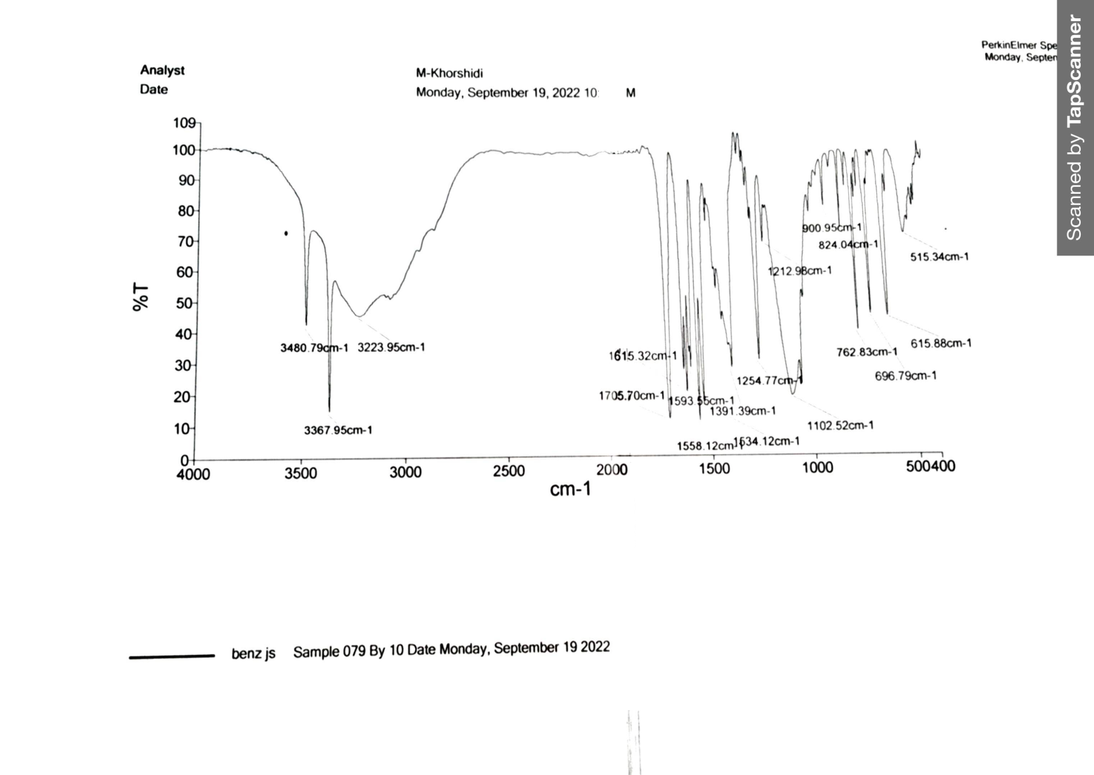

FT-IR spectrum of 4-amino-2-phenyl-5H-chromeno[4,3-d]pyrimidin-5-one (1a)
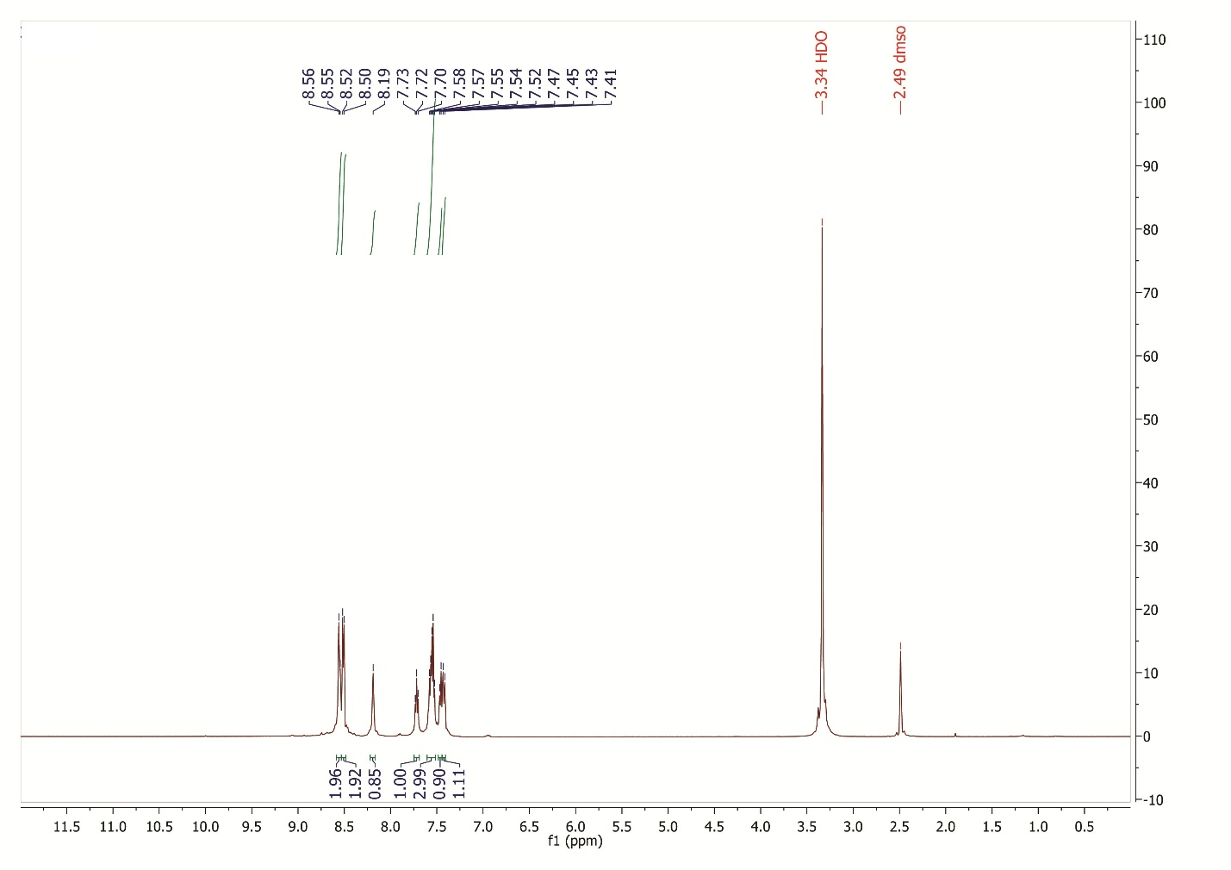

¹H NMR spectrum of 4-amino-2-phenyl-5H-chromeno[4,3-d]pyrimidin-5-one (1a)

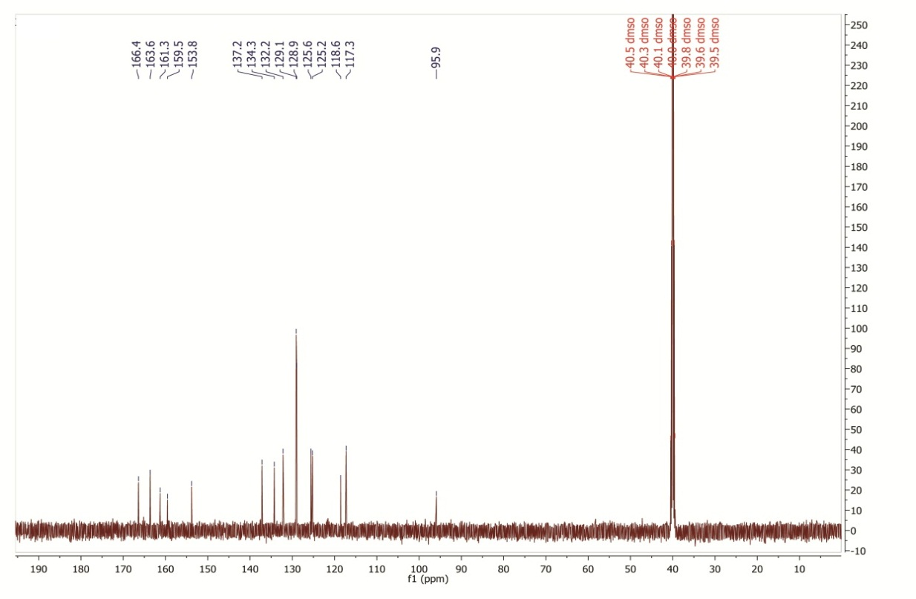

¹³C NMR spectrum of 4-amino-2-phenyl-5H-chromeno[4,3-d]pyrimidin-5-one (1a)
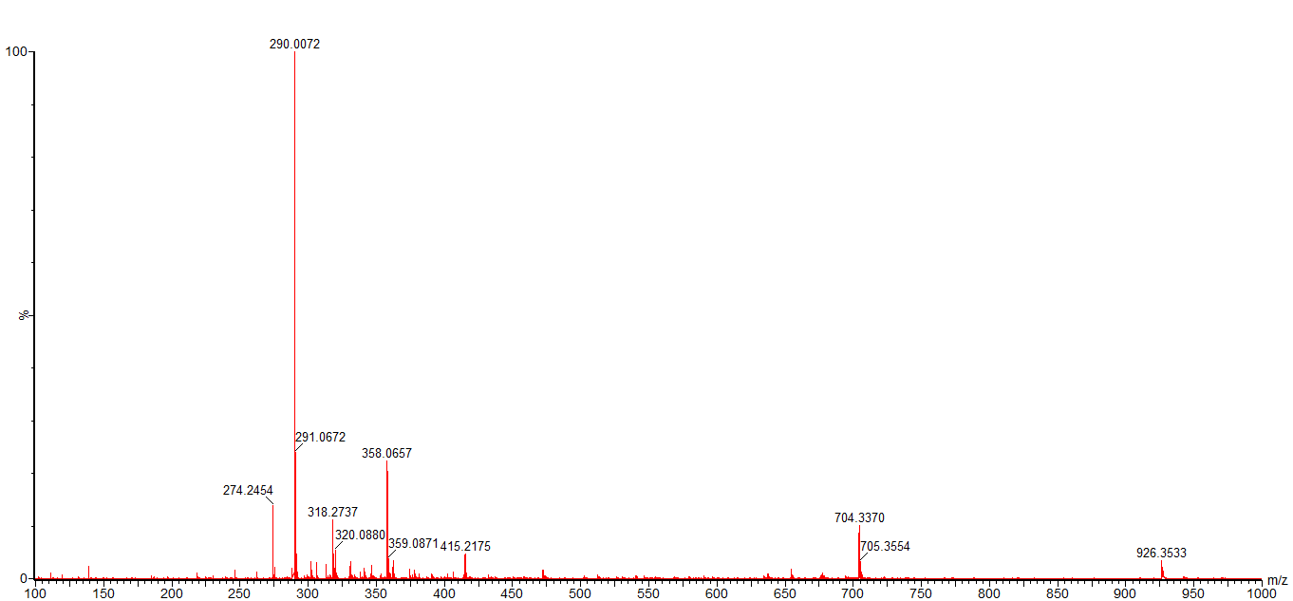

HR-Mass spectrum of 4-amino-2-phenyl-5H-chromeno[4,3-d]pyrimidin-5-one (1a)

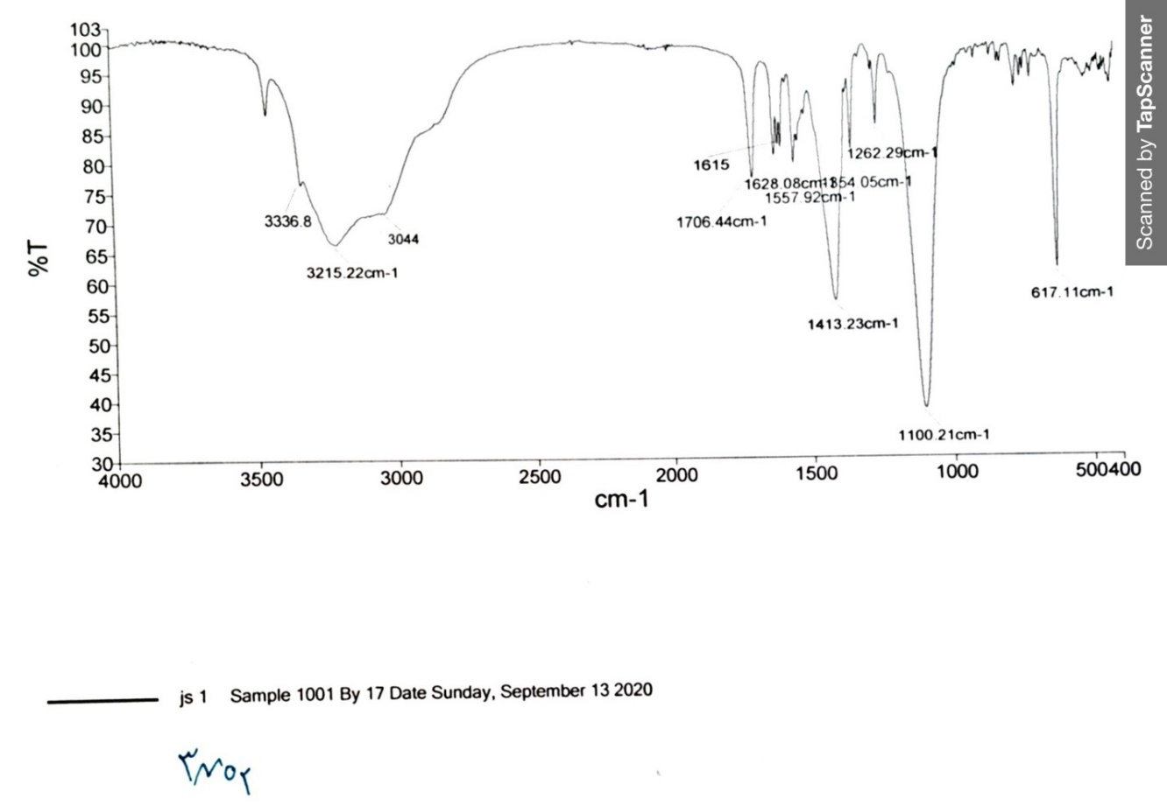

FT-IR spectrum of 4-amino-2-(3-nitrophenyl)-5H-chromeno[4,3-d]pyrimidin-5-one (2a)
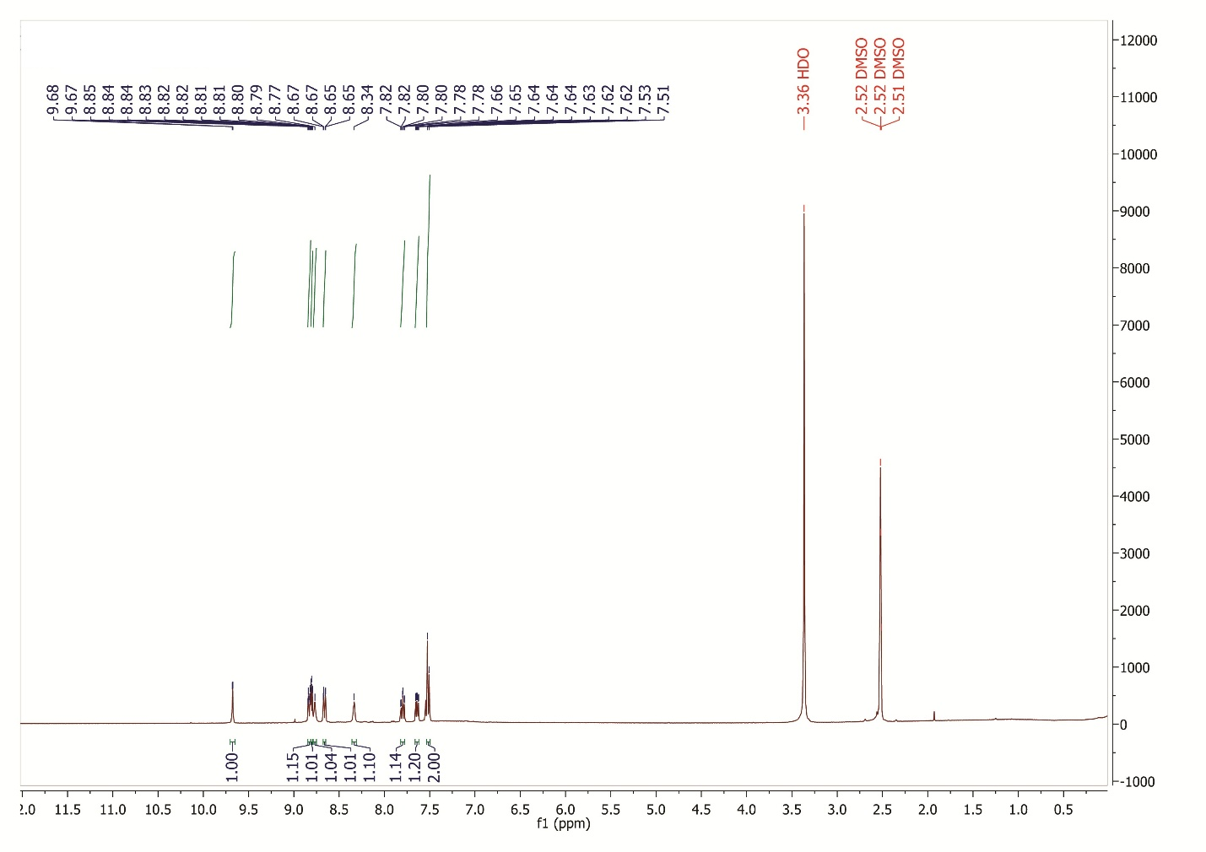

¹H NMR spectrum of 4-amino-2-(3-nitrophenyl)-5H-chromeno[4,3-d]pyrimidin-5-one (2a)

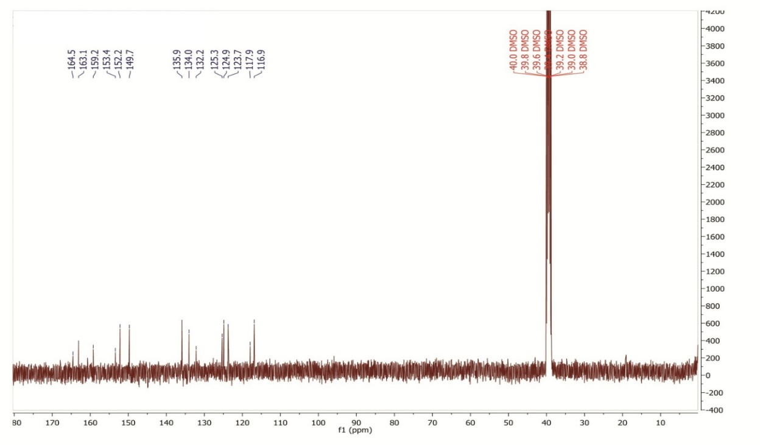

¹³C NMR spectrum of 4-amino-2-(3-nitrophenyl)-5H-chromeno[4,3-d]pyrimidin-5-one (2a)
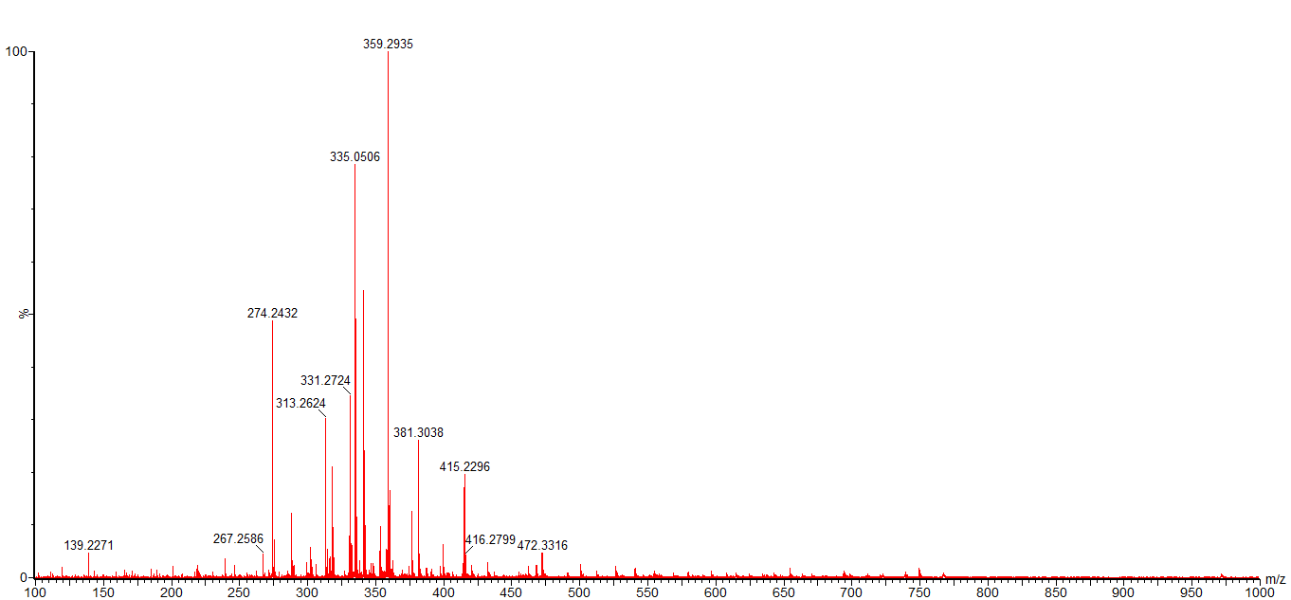

HR-Mass spectrum of 4-amino-2-(3-nitrophenyl)-5H-chromeno[4,3-d]pyrimidin-5-one (2a)

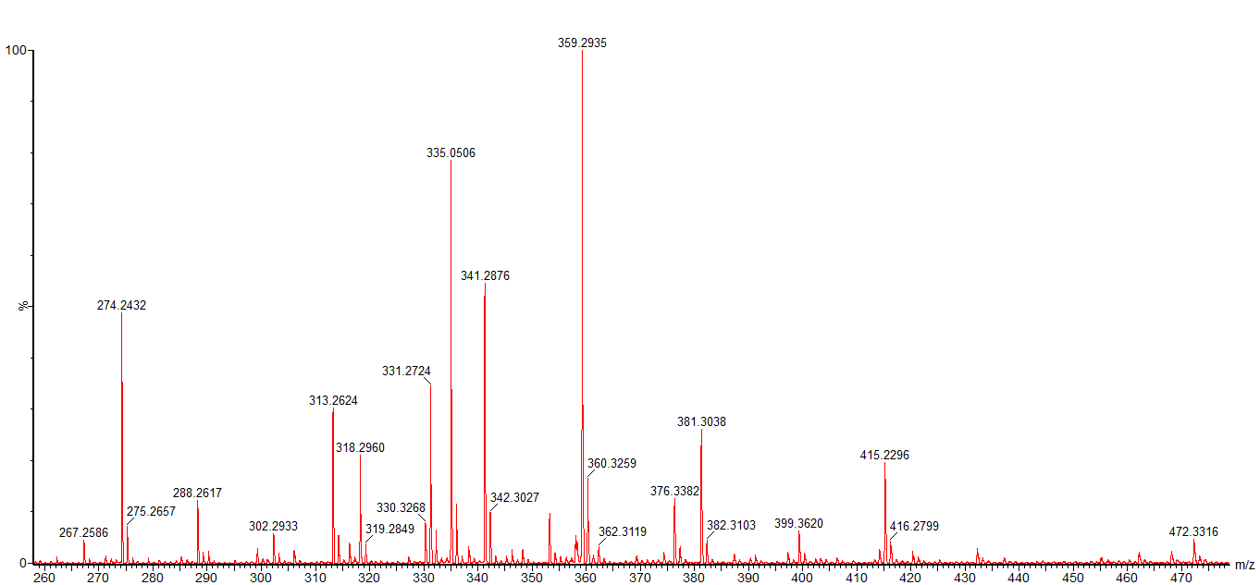

HR-Mass expand spectrum of 4-amino-2-(3-nitrophenyl)-5H-chromeno[4,3-d]pyrimidin-5-one (2a)

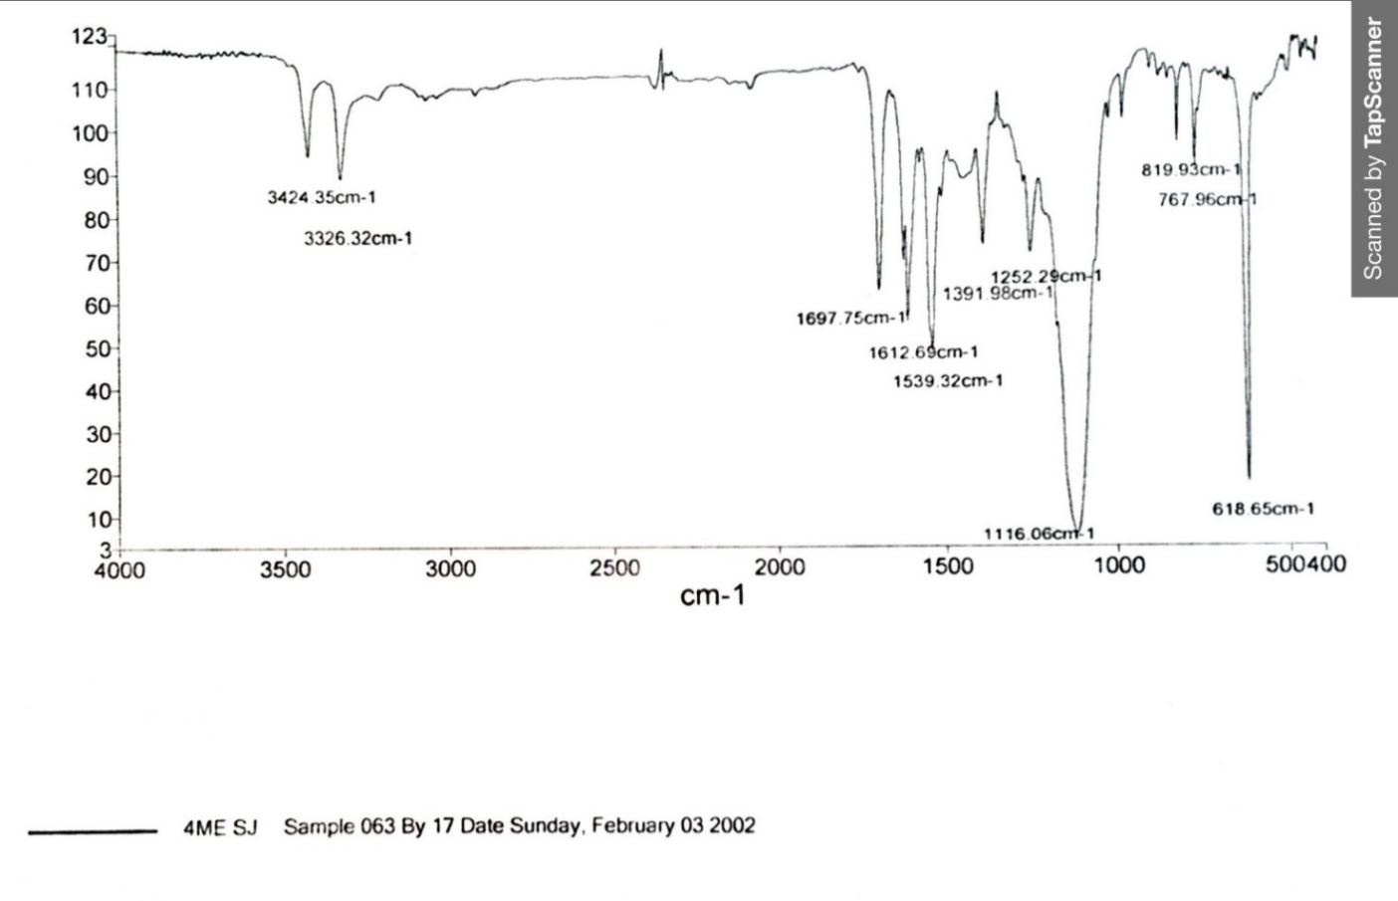

FT-IR spectrum of 4-amino-2-(p-tolyl)-5H-chromeno[4,3-d]pyrimidin-5-one (3a)

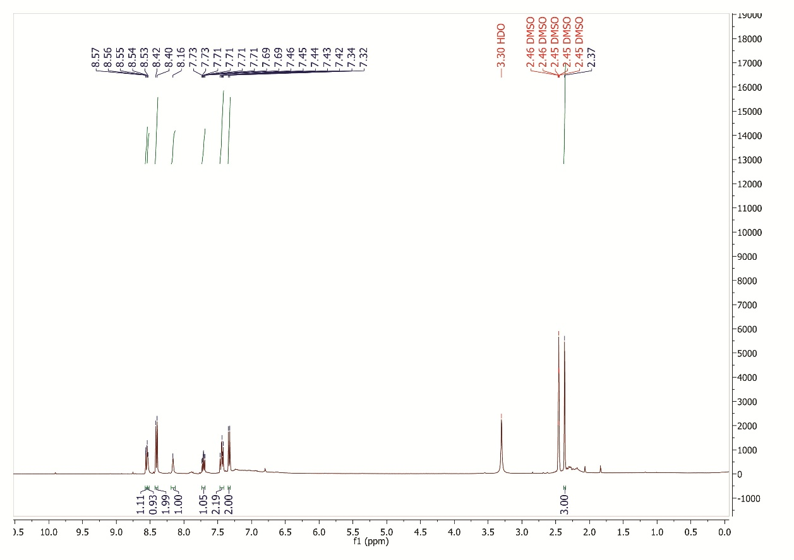

¹H NMR spectrum of 4-amino-2-(p-tolyl)-5H-chromeno[4,3-d]pyrimidin-5-one (3a)
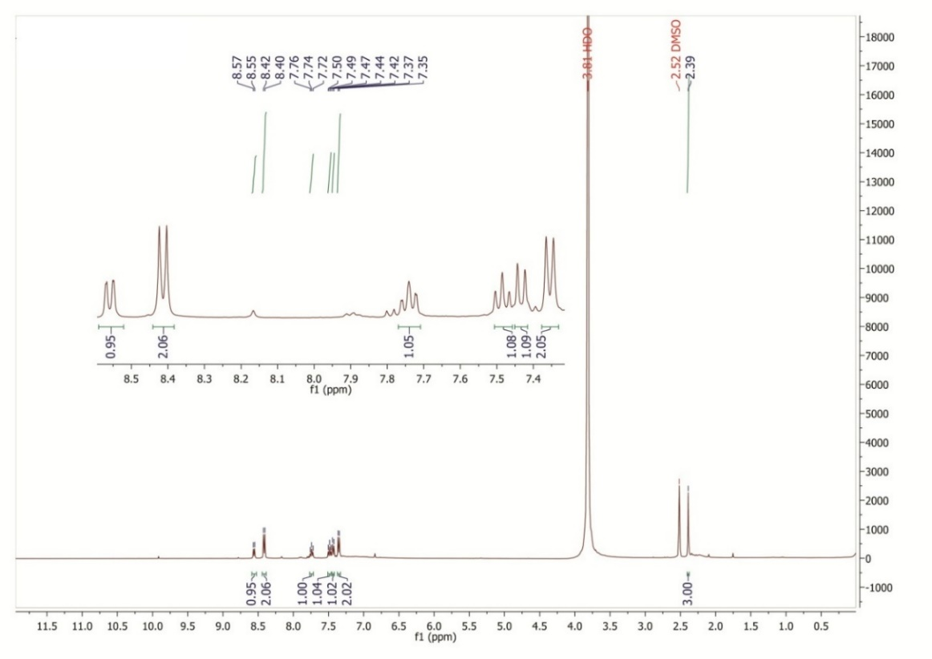

¹H NMR spectrum of 4-amino-2-(p-tolyl)-5H-chromeno[4,3-d]pyrimidin-5-one (D₂O exchange) (3a)

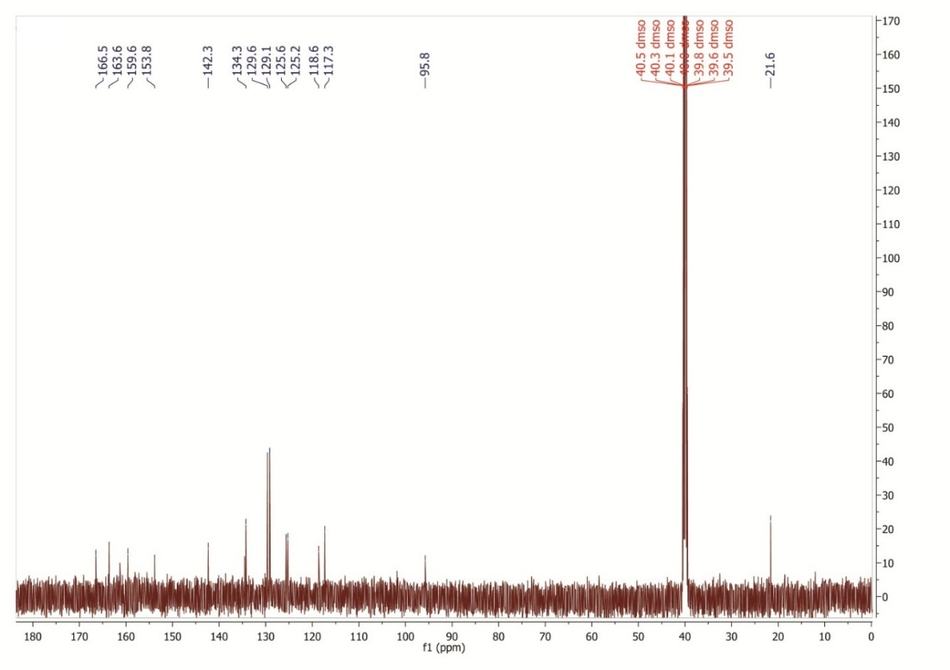

¹³C NMR spectrum of 4-amino-2-(p-tolyl)-5H-chromeno[4,3-d]pyrimidin-5-one (3a)
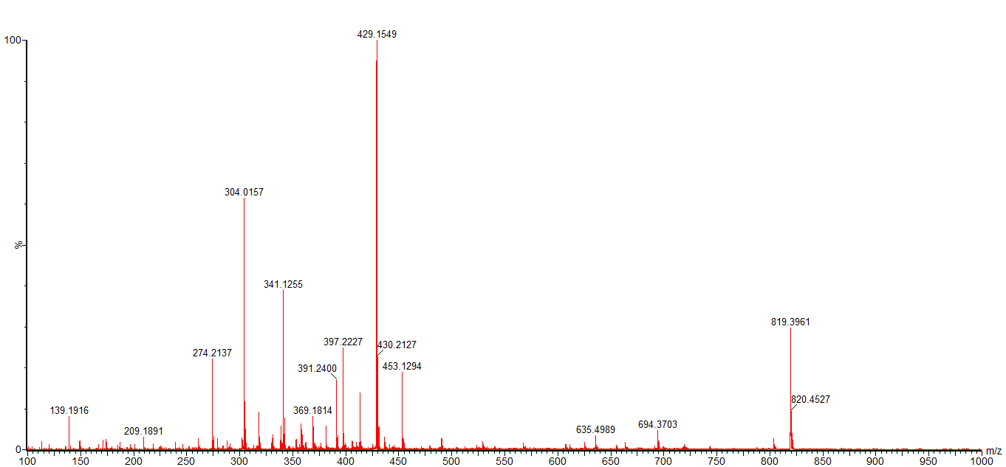

HR-Mass spectrum of 4-amino-2-(p-tolyl)-5H-chromeno[4,3-d]pyrimidin-5-one (3a)

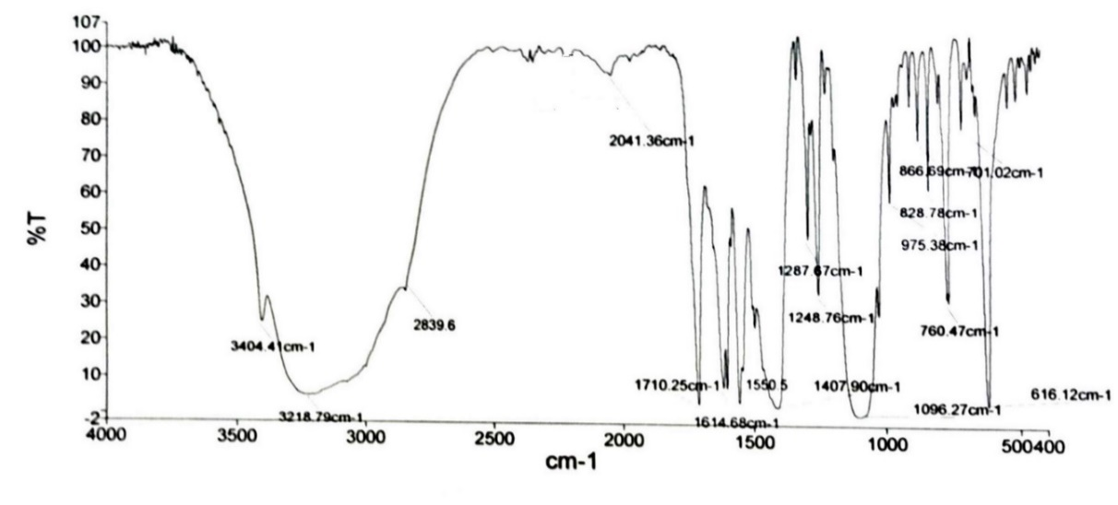

FT-IR spectrum of 4-amino-2-(4-methoxyphenyl)-5H-chromeno[4,3-d]pyrimidin-5-one (4a)

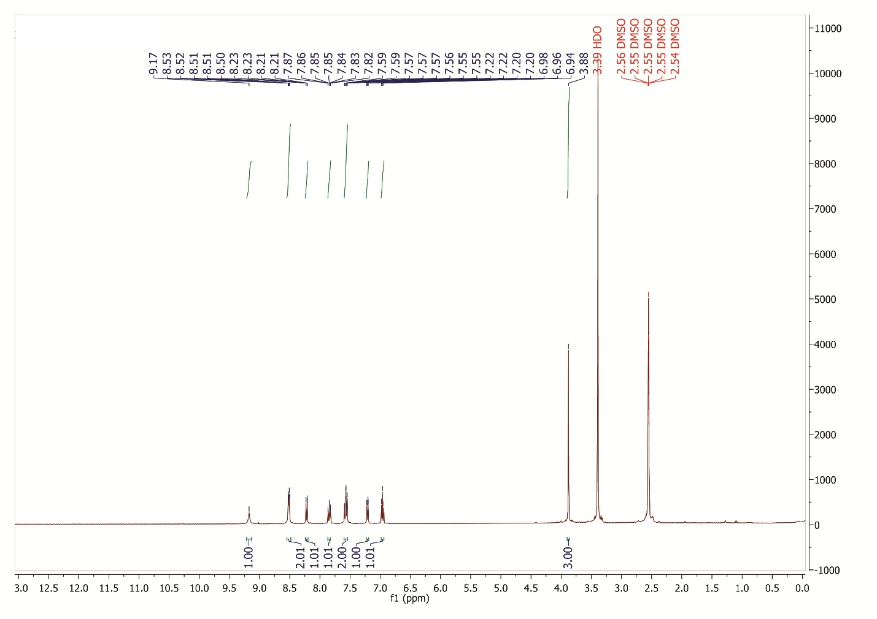

¹H NMR spectrum of 4-amino-2-(4-methoxyphenyl)-5H-chromeno[4,3-d]pyrimidin-5-one (4a)

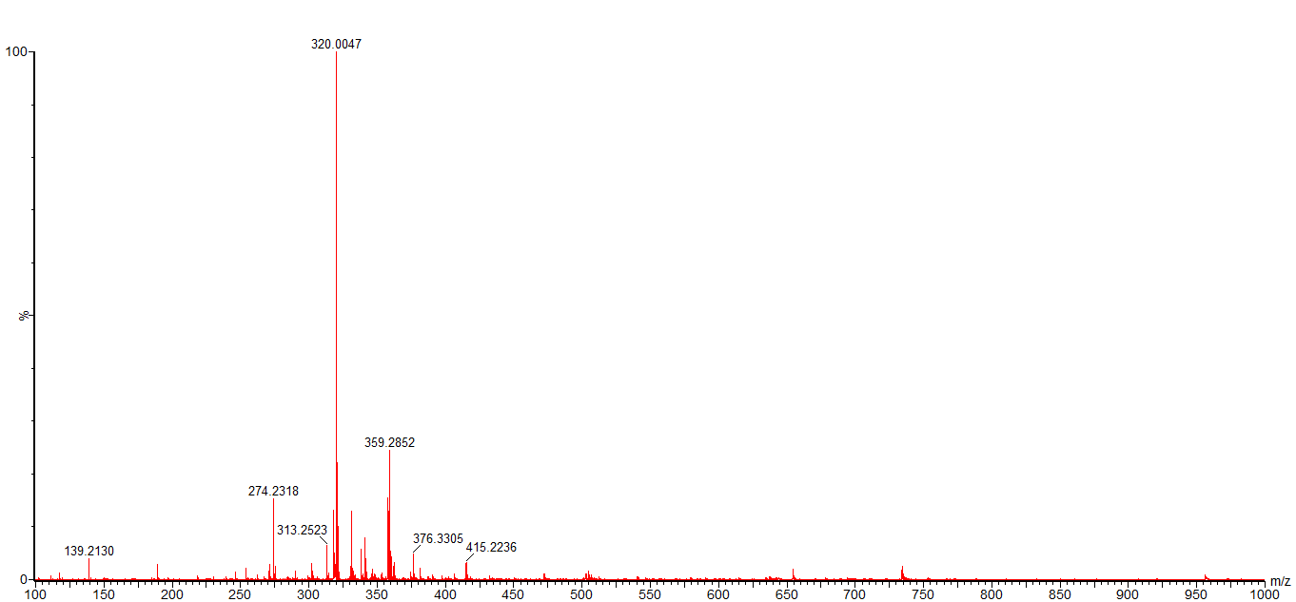

HR-Mass spectrum of 4-amino-2-(4-methoxyphenyl)-5H-chromeno[4,3-d]pyrimidin-5-one (4a)

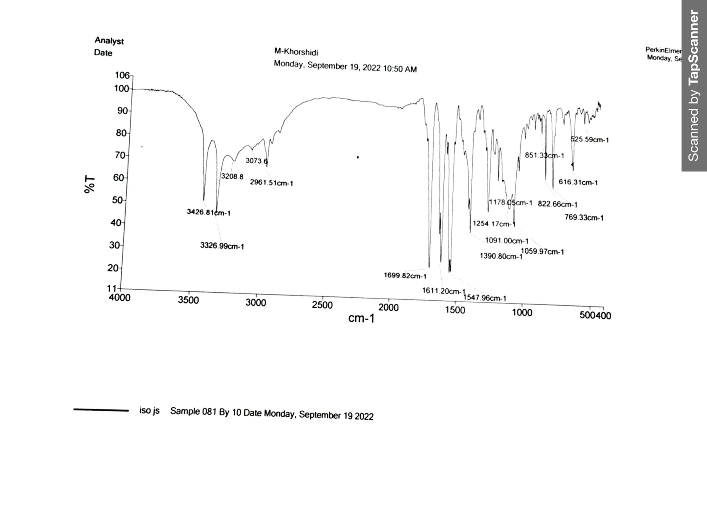

FT-IR spectrum of 4-amino-2-(4-isopropylphenyl)-5H-chromeno[4,3-d]pyrimidin-5-one(5a)

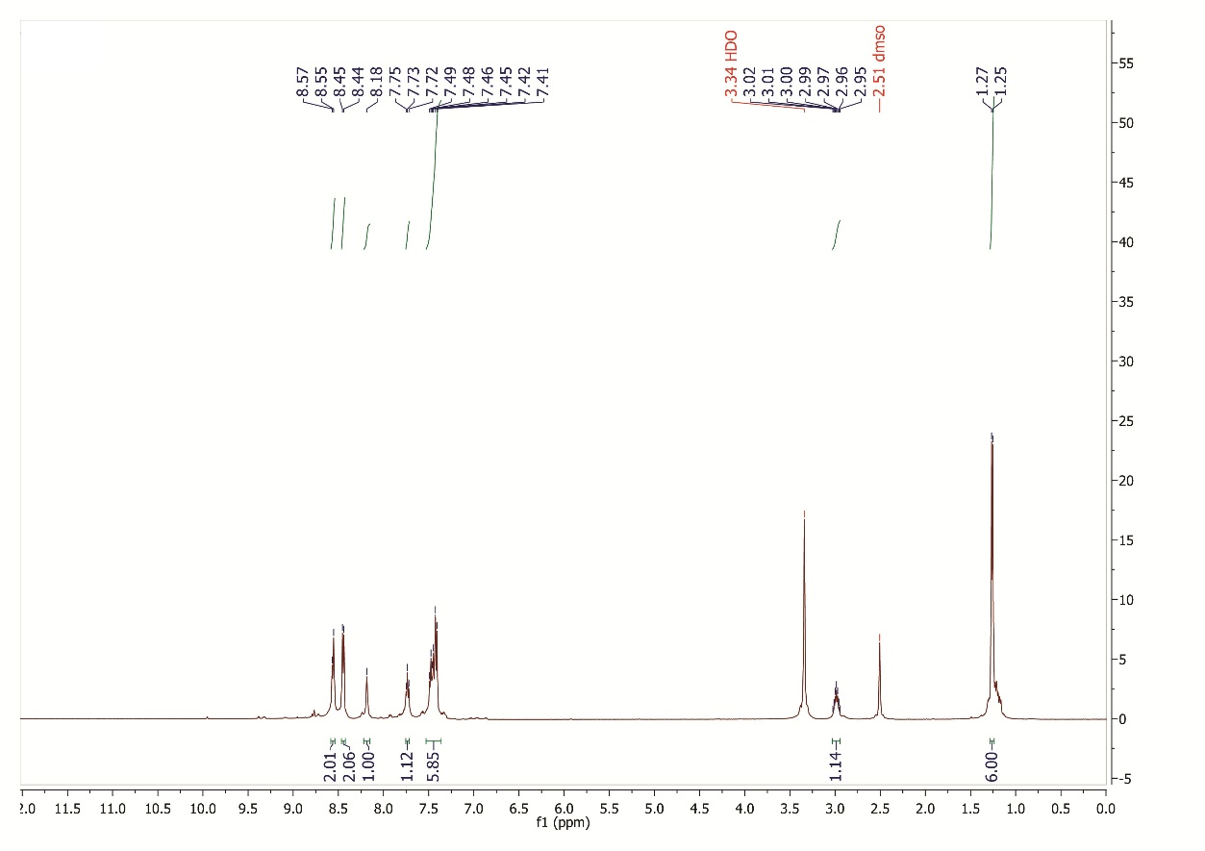

¹H NMR spectrum of 4-amino-2-(4-isopropylphenyl)-5H-chromeno[4,3-d]pyrimidin-5-one (5a)

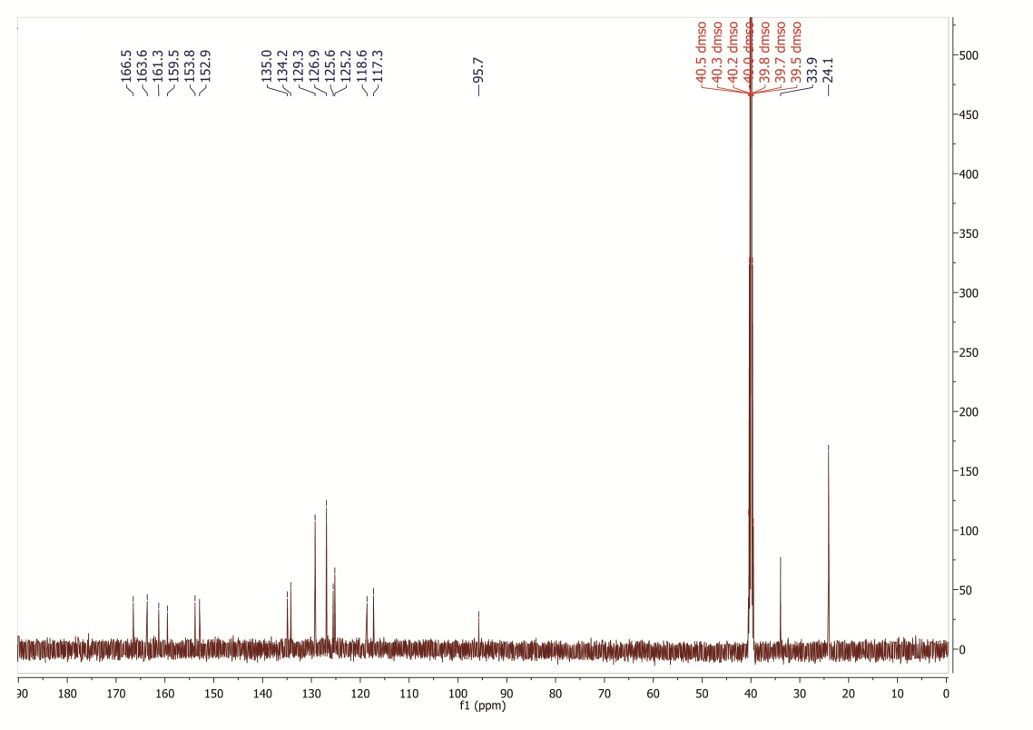

¹³C NMR spectrum of 4-amino-2-(4-isopropylphenyl)-5H-chromeno[4,3-d]pyrimidin-5-one (5a)

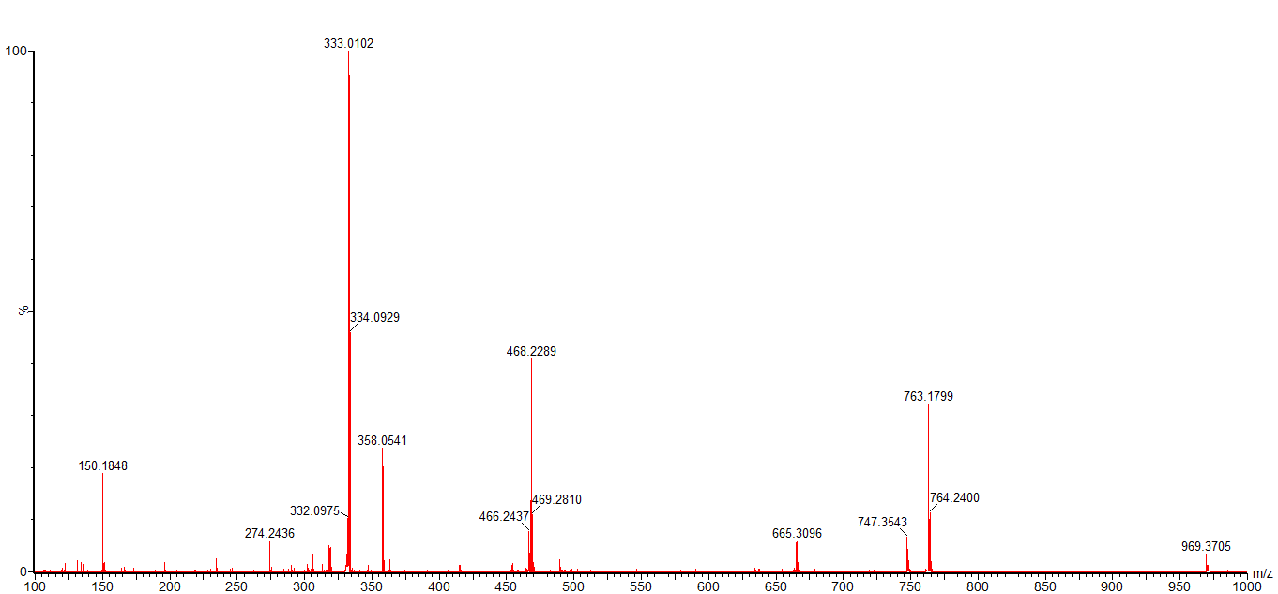

HR-Mass spectrum of 4-amino-2-(4-isopropylphenyl)-5H-chromeno[4,3-d]pyrimidin-5-one (5a)

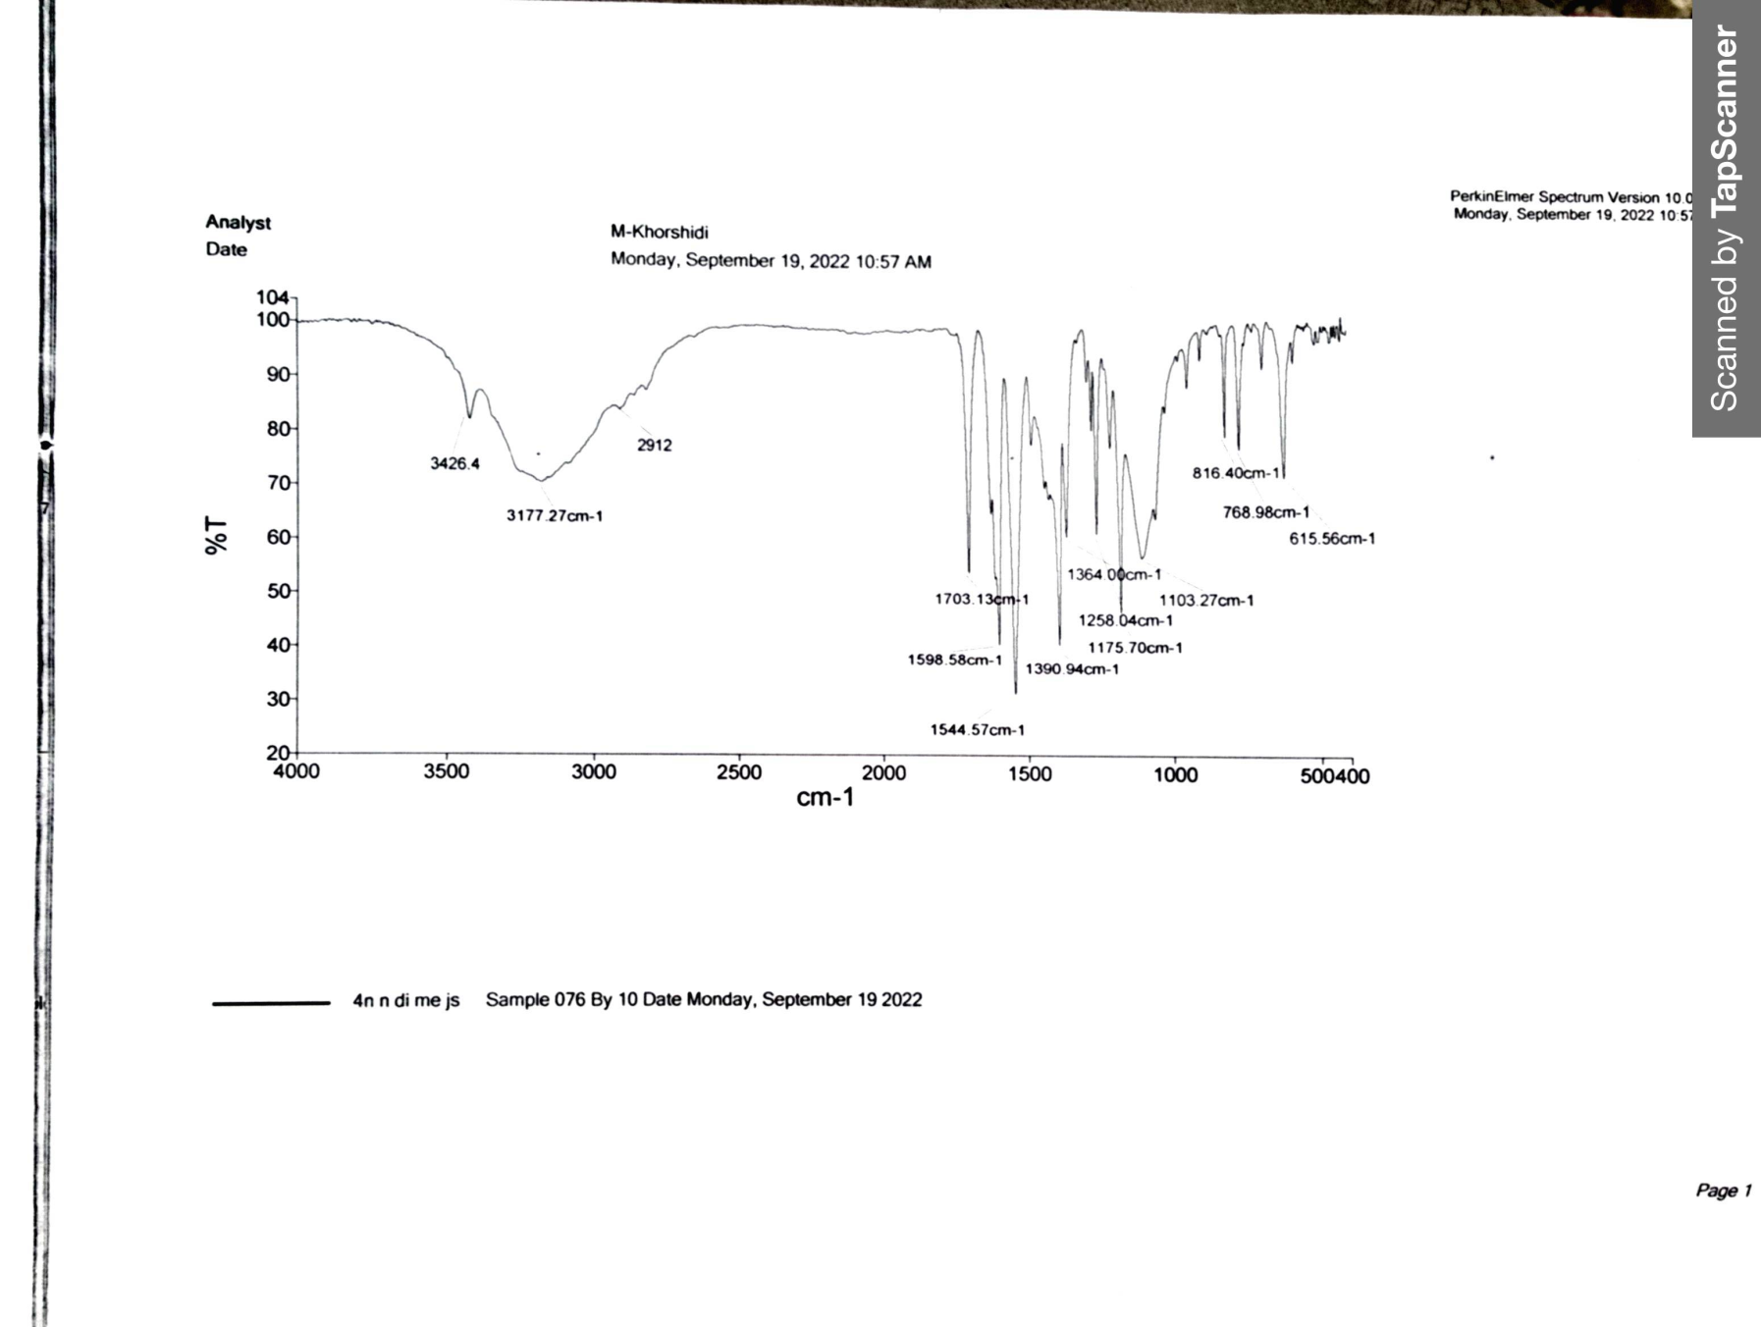

FT-IR spectrum of 4-amino-2-(4-(dimethylamino)phenyl)-5H-chromeno[4,3-d]pyrimidin-5-one (6a)

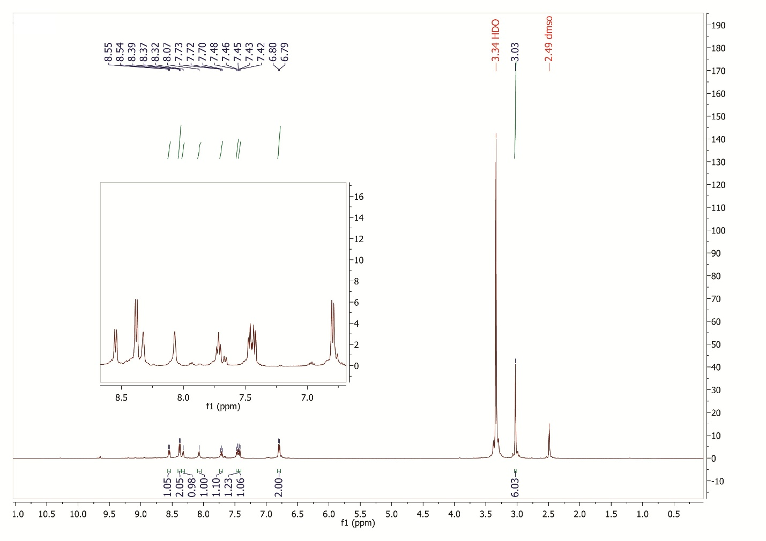

¹H NMR spectrum of 4-amino-2-(4-(dimethylamino)phenyl)-5H-chromeno[4,3-d]pyrimidin-5-one (6a)

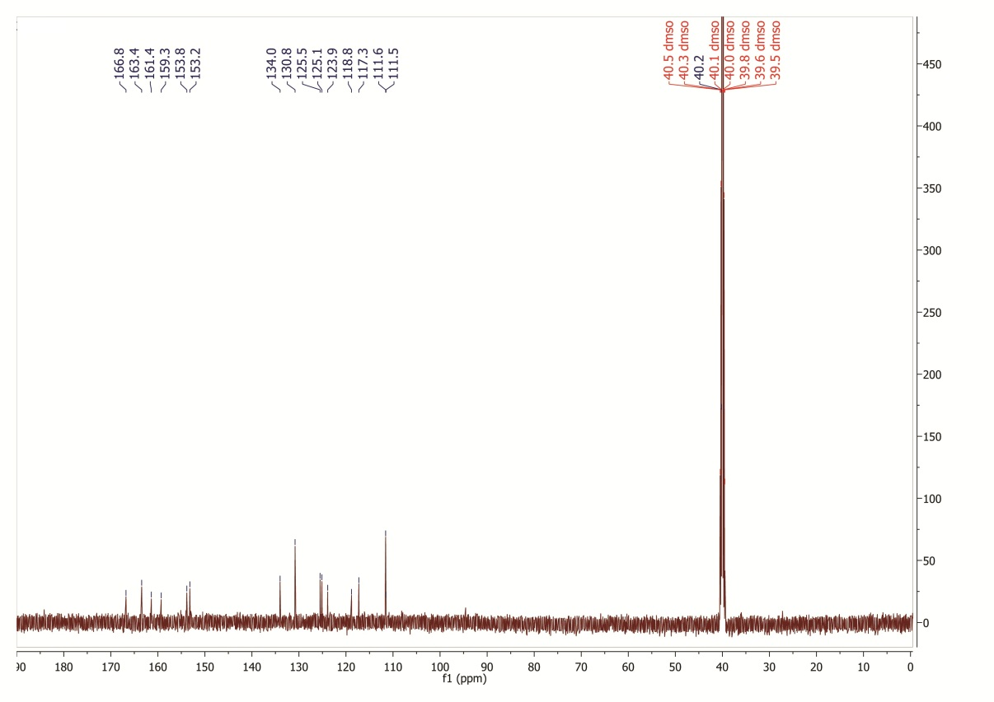

¹³C NMR spectrum of 4-amino-2-(4-(dimethylamino)phenyl)-5H-chromeno[4,3-d]pyrimidin-5-one (6a)

HR-Mass spectrum of 4-amino-2-(4-(dimethylamino)phenyl)-5H-chromeno[4,3-d]pyrimidin-5-one (6a)

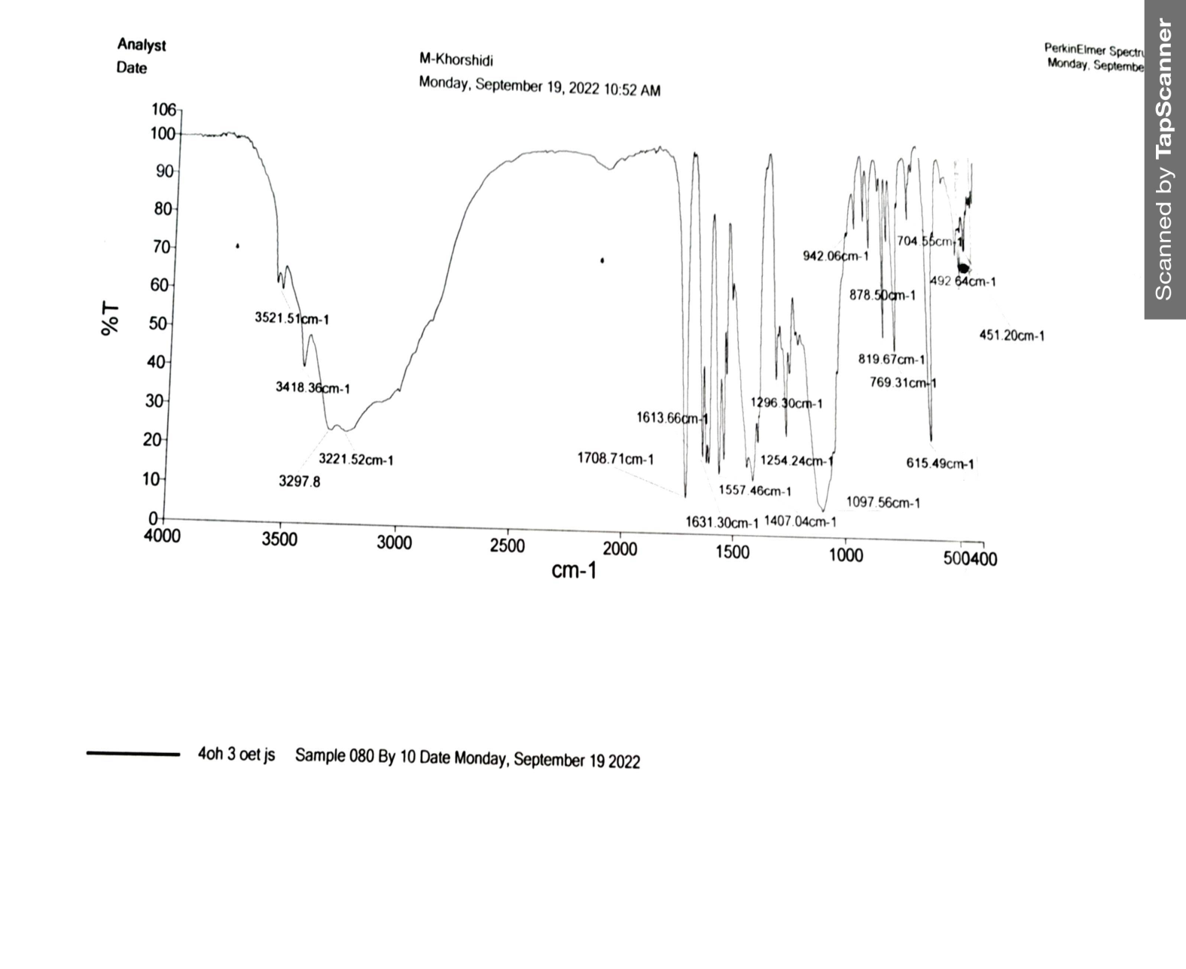

FT-IR spectrum of 4-amino-2-(3-ethoxy-4-hydroxyphenyl)-5H-chromeno[4,3-d]pyrimidin-5-one (7a)

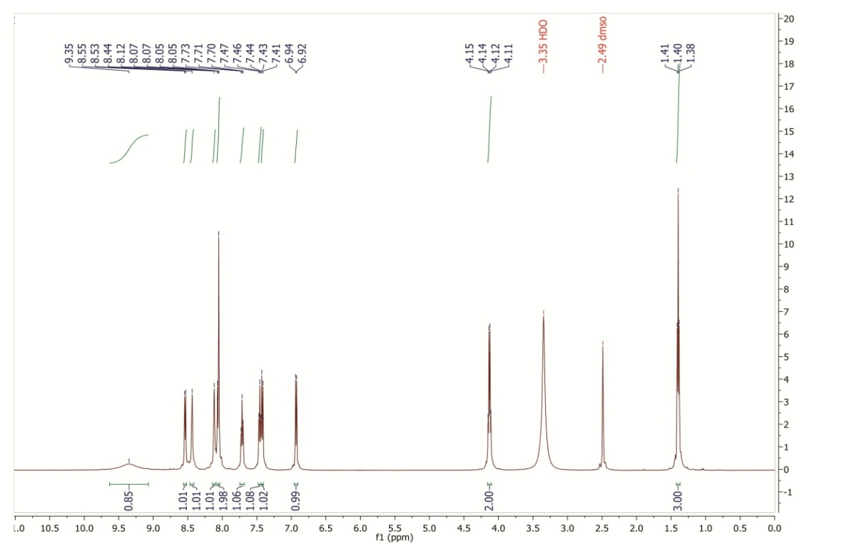

¹H NMR spectrum of 4-amino-2-(3-ethoxy-4-hydroxyphenyl)-5H-chromeno[4,3-d]pyrimidin-5-one (7a)

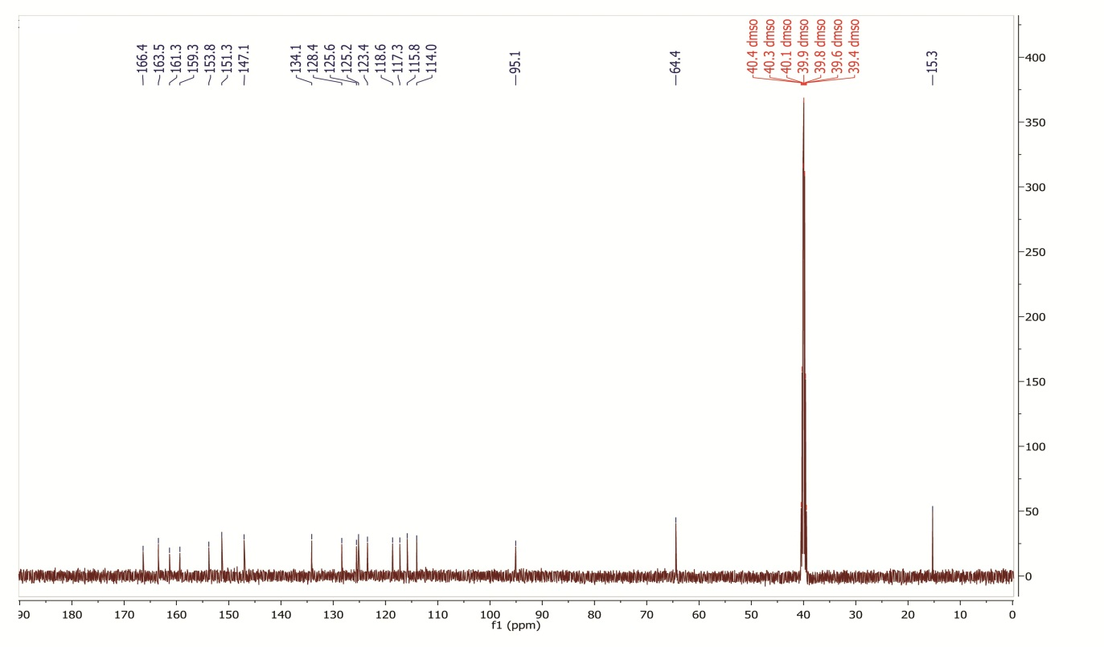

¹³C NMR spectrum of 4-amino-2-(3-ethoxy-4-hydroxyphenyl)-5H-chromeno[4,3-d]pyrimidin-5-one (7a)

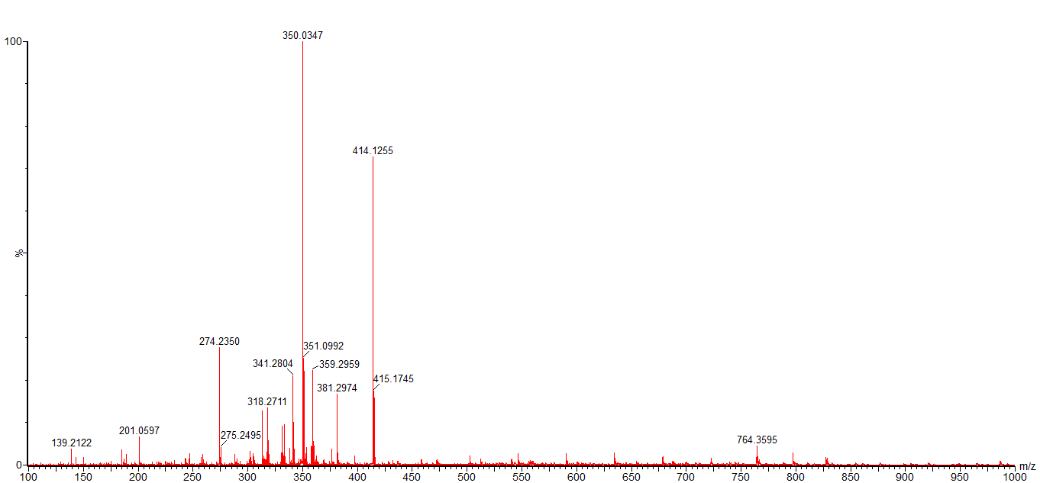

HR-Mass spectrum of 4-amino-2-(3-ethoxy-4-hydroxyphenyl)-5H-chromeno[4,3-d]pyrimidin-5-one (7a)

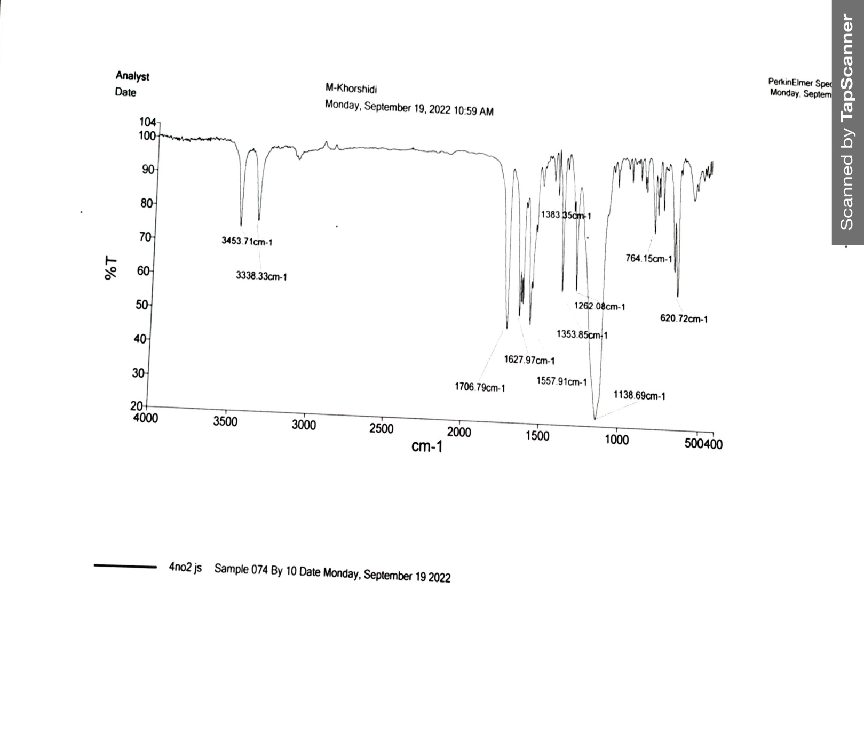

FT-IR spectrum of 4-amino-2-(4-nitrophenyl)-5H-chromeno[4,3-d]pyrimidin-5-one (8a)

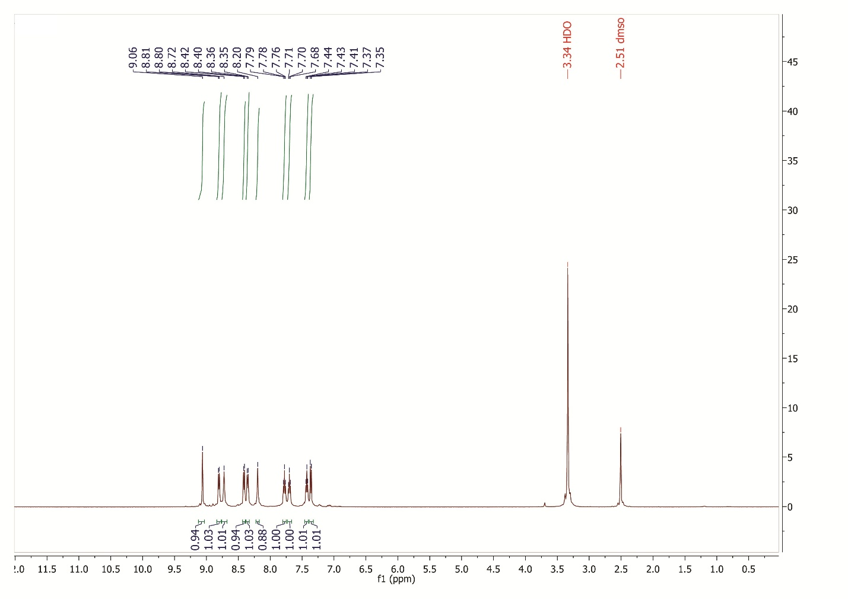

¹H NMR spectrum of 4-amino-2-(4-nitrophenyl)-5H-chromeno[4,3-d]pyrimidin-5-one (8a)
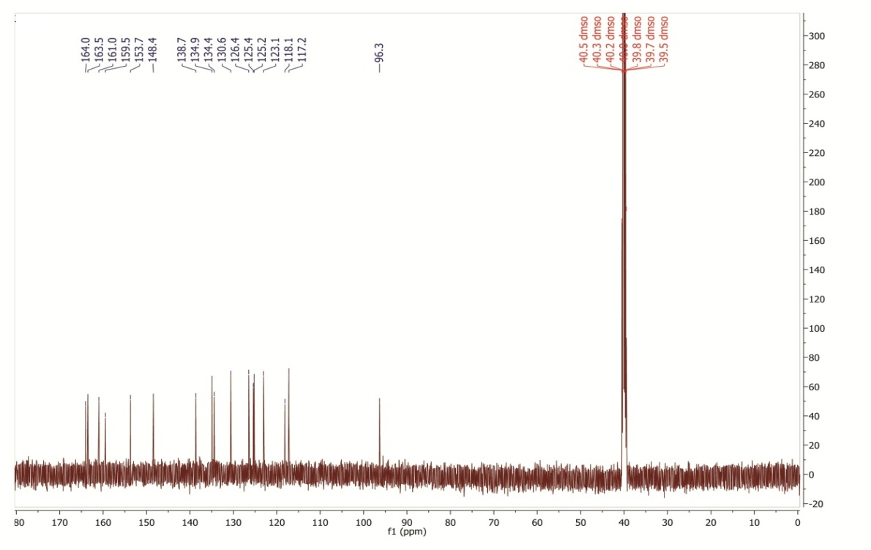

¹³C NMR spectrum of 4-amino-2-(4-nitrophenyl)-5H-chromeno[4,3-d]pyrimidin-5-one (8a)

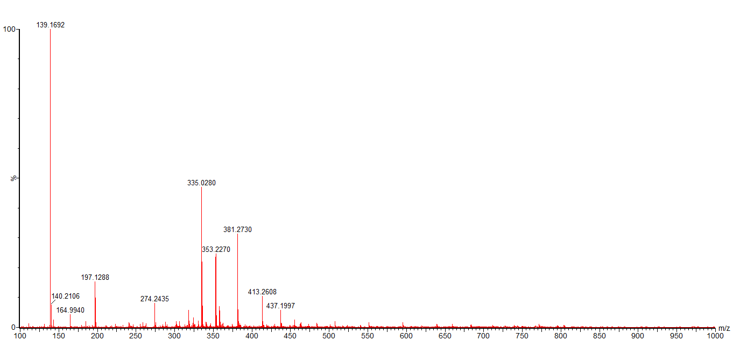

HR-Mass spectrum of 4-amino-2-(4-nitrophenyl)-5H-chromeno[4,3-d]pyrimidin-5-one (8a)

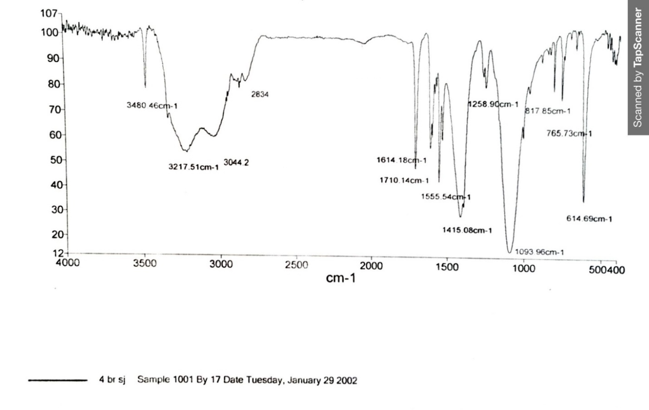

FT-IR spectrum of 4-amino-2-(4-bromophenyl)-5H-chromeno[4,3-d]pyrimidin-5-one (9a)

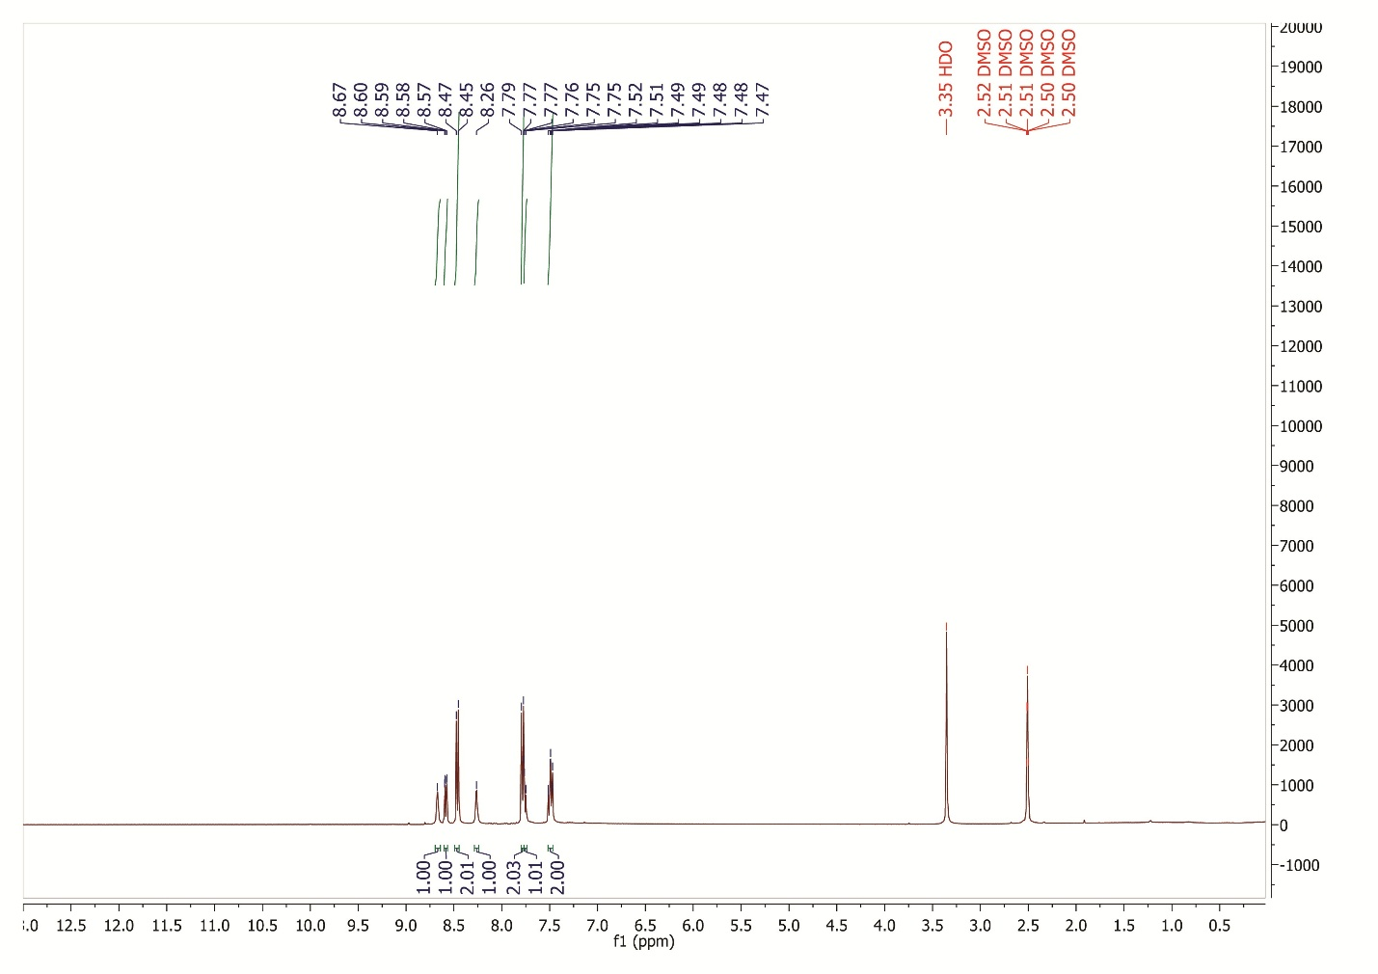

¹H NMR spectrum of 4-amino-2-(4-bromophenyl)-5H-chromeno[4,3-d]pyrimidin-5-one (9a)

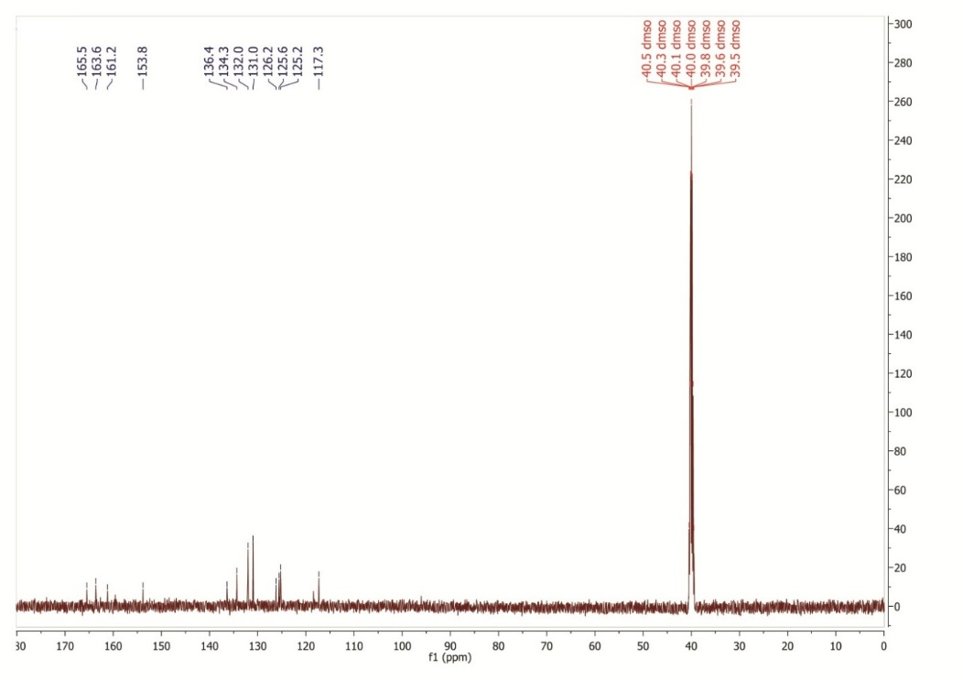

¹³C NMR spectrum of 4-amino-2-(4-bromophenyl)-5H-chromeno[4,3-d]pyrimidin-5-one (9a)

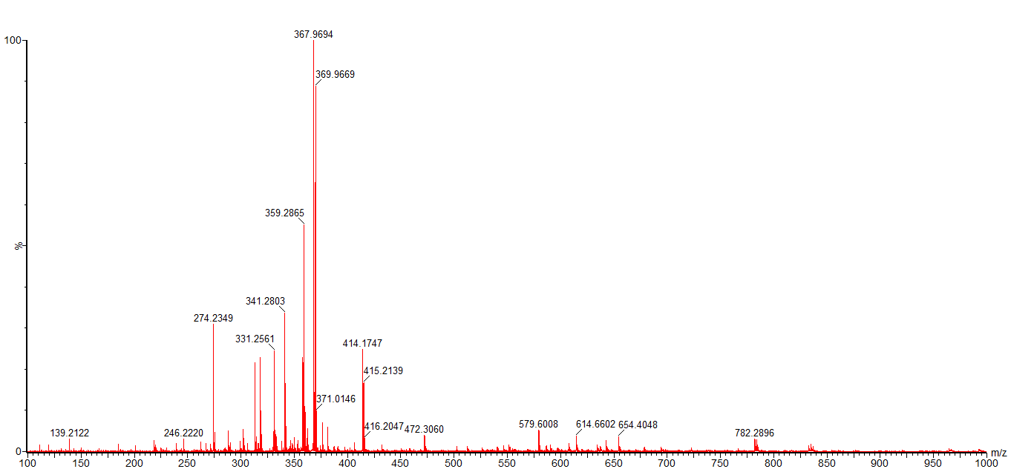

HR-Mass spectrum of 4-amino-2-(4-bromophenyl)-5H-chromeno[4,3-d]pyrimidin-5-one (9a)

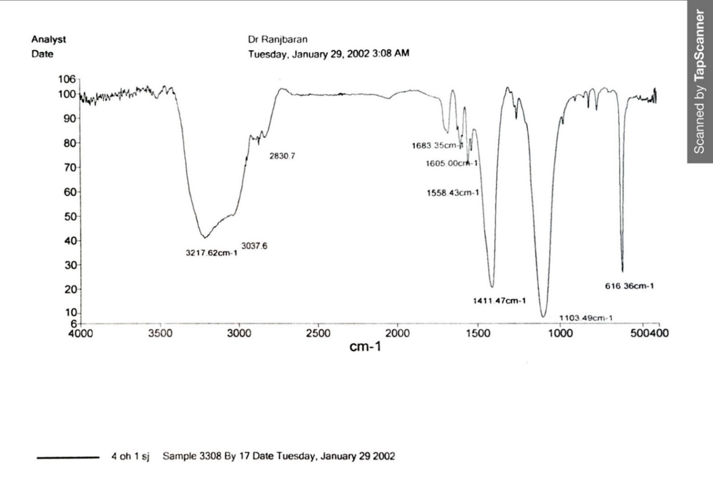

FT-IR spectrum of 4-amino-2-(4-hydroxyphenyl)-5H-chromeno[4,3-d]pyrimidin-5-one (10a)

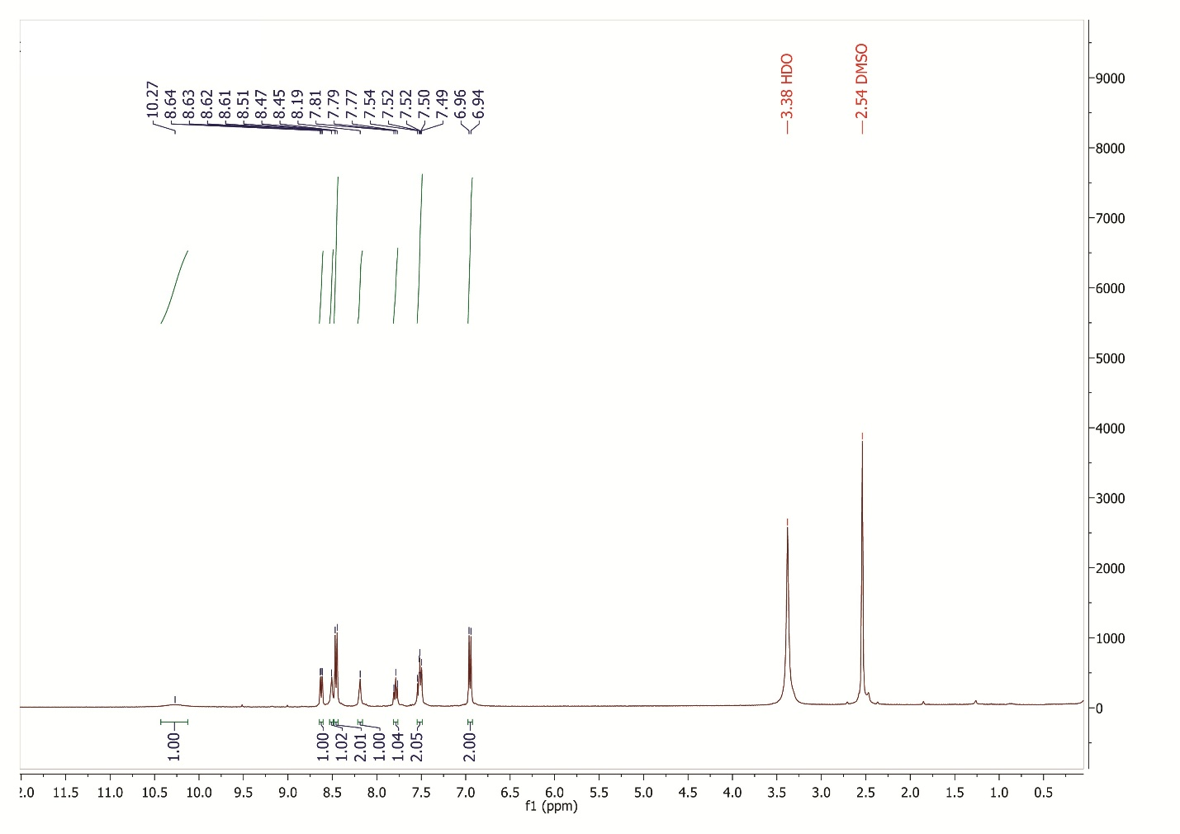

¹H NMR spectrum of 4-amino-2-(4-hydroxyphenyl)-5H-chromeno[4,3-d]pyrimidin-5-one (10a)

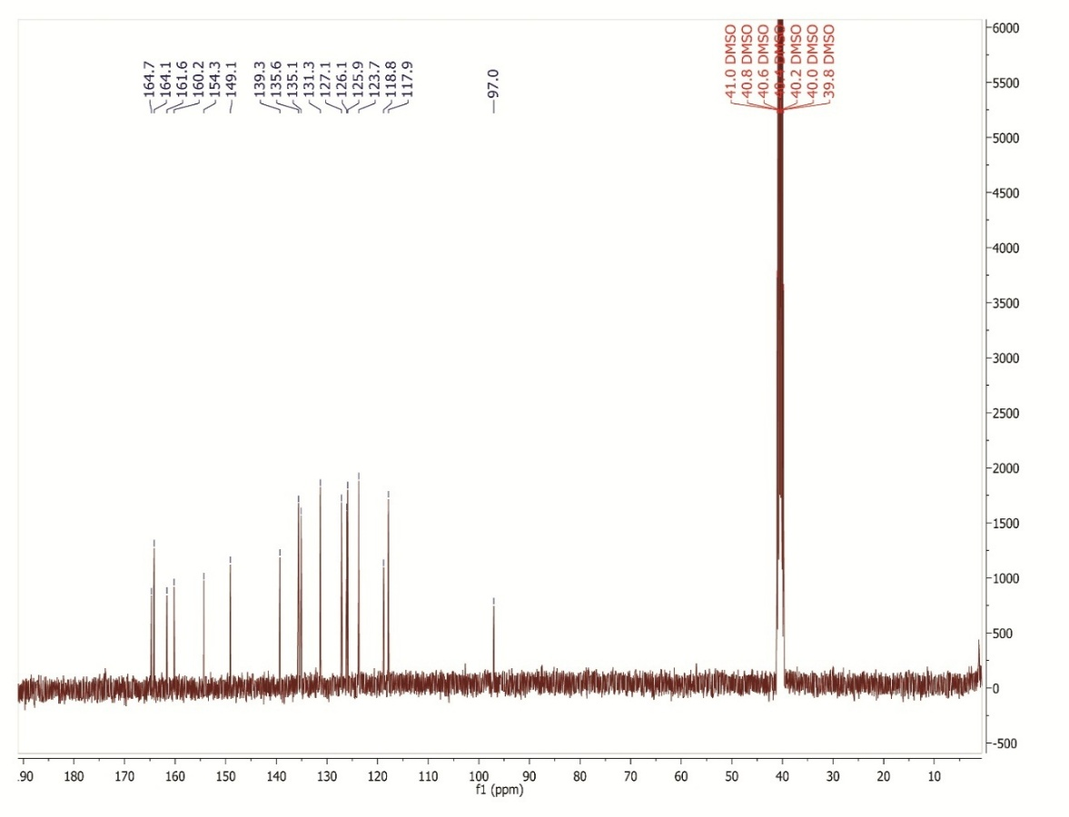

¹³C NMR spectrum of 4-amino-2-(4-hydroxyphenyl)-5H-chromeno[4,3-d]pyrimidin-5-one (10a)

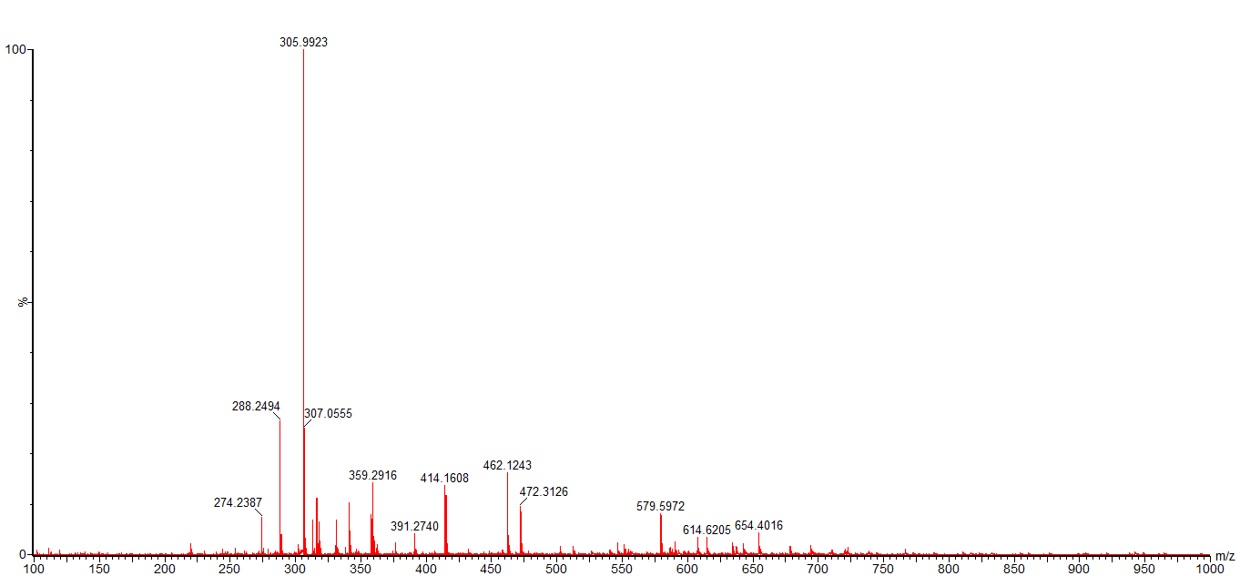

HR-Mass spectrum of 4-amino-2-(4-hydroxyphenyl)-5H-chromeno[4,3-d]pyrimidin-5-one (10a)

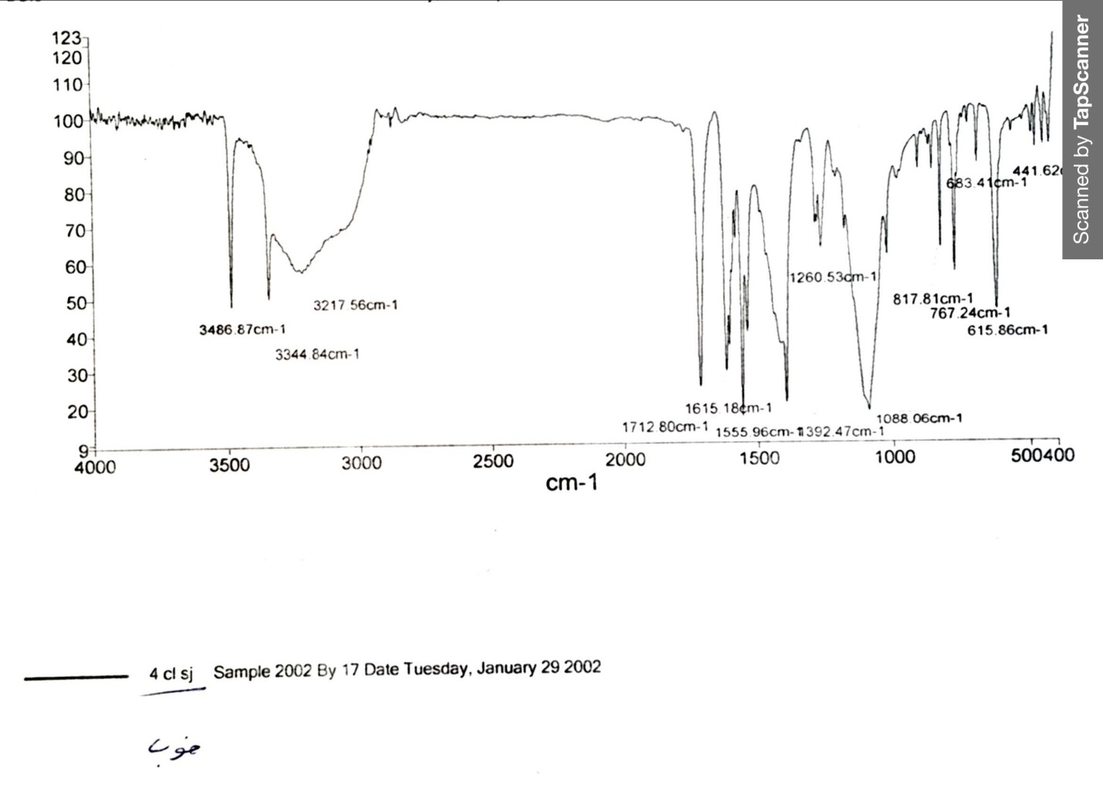

FT-IR spectrum of 4-amino-2-(4-chlorophenyl)-5H-chromeno[4,3-d]pyrimidin-5-one (11a)

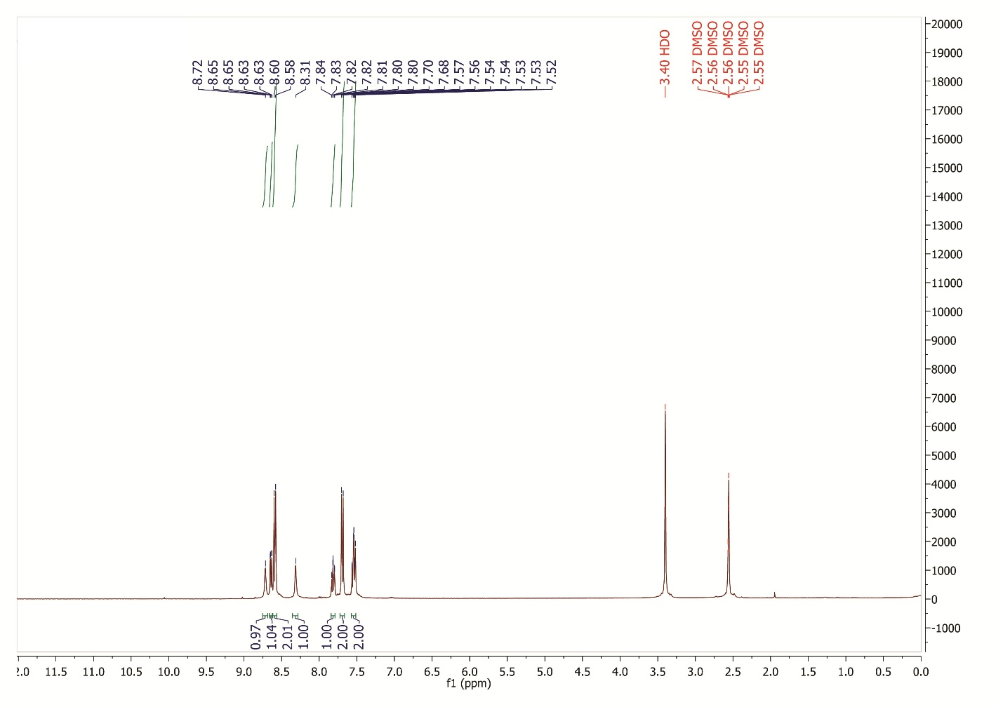

¹H NMR spectrum of 4-amino-2-(4-chlorophenyl)-5H-chromeno[4,3-d]pyrimidin-5-one (11a)

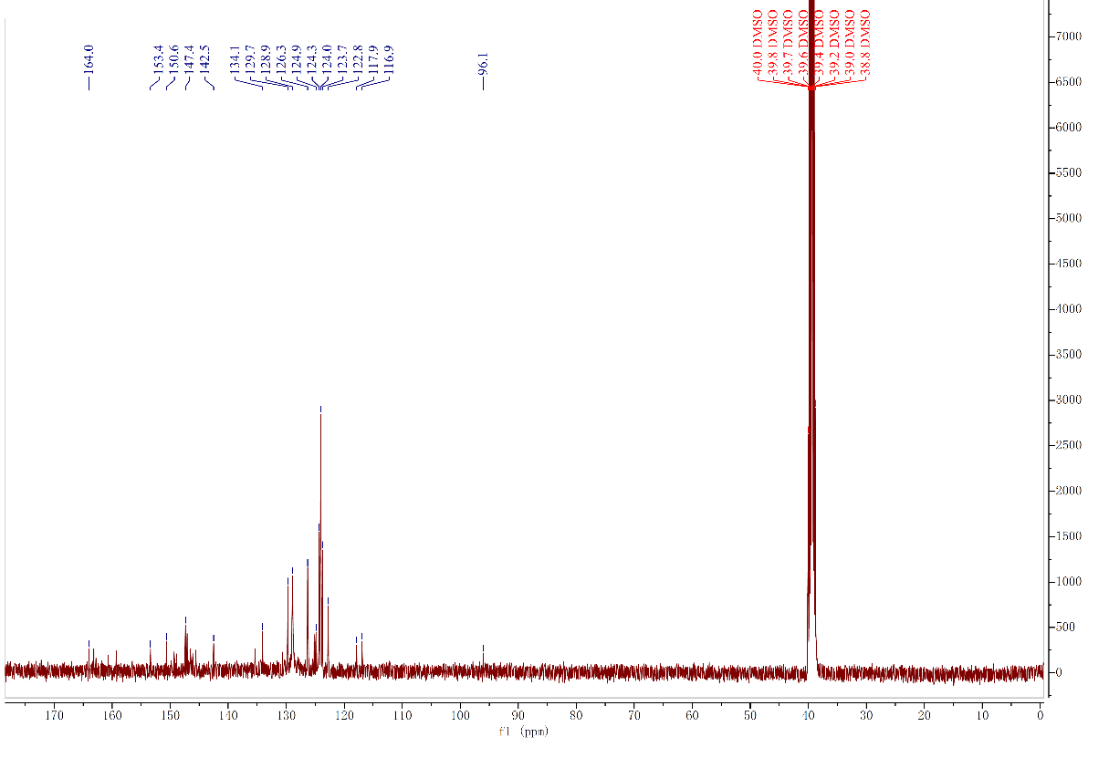

¹³C NMR spectrum of 4-amino-2-(4-chlorophenyl)-5H-chromeno[4,3-d]pyrimidin-5-one (11a)
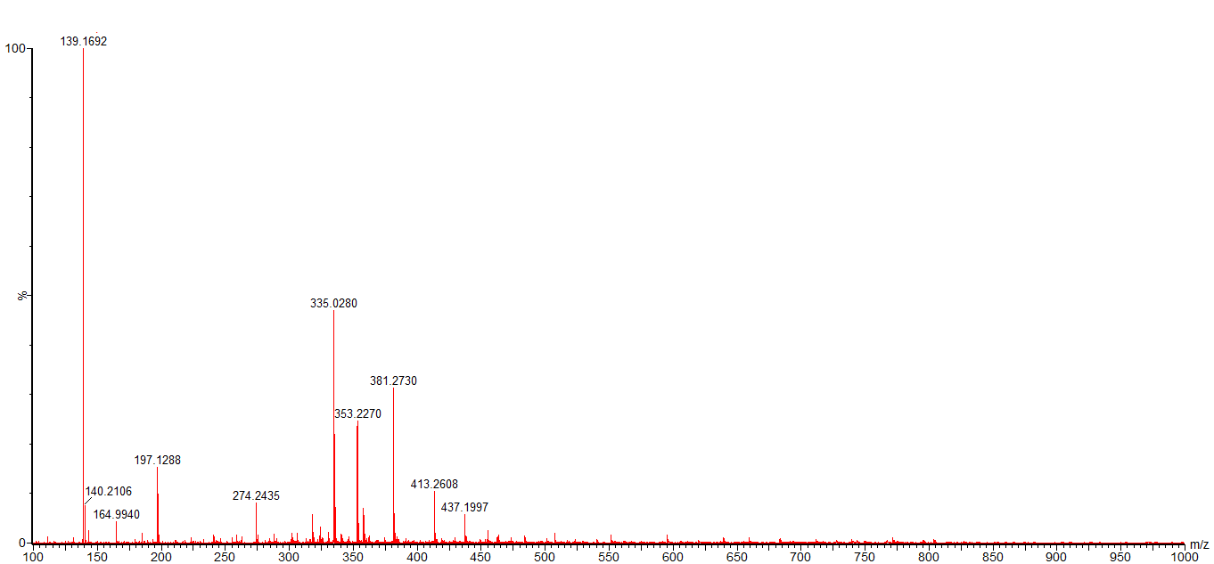

HR-Mass spectrum of 4-amino-2-(4-chlorophenyl)-5H-chromeno[4,3-d]pyrimidin-5-one (11a)

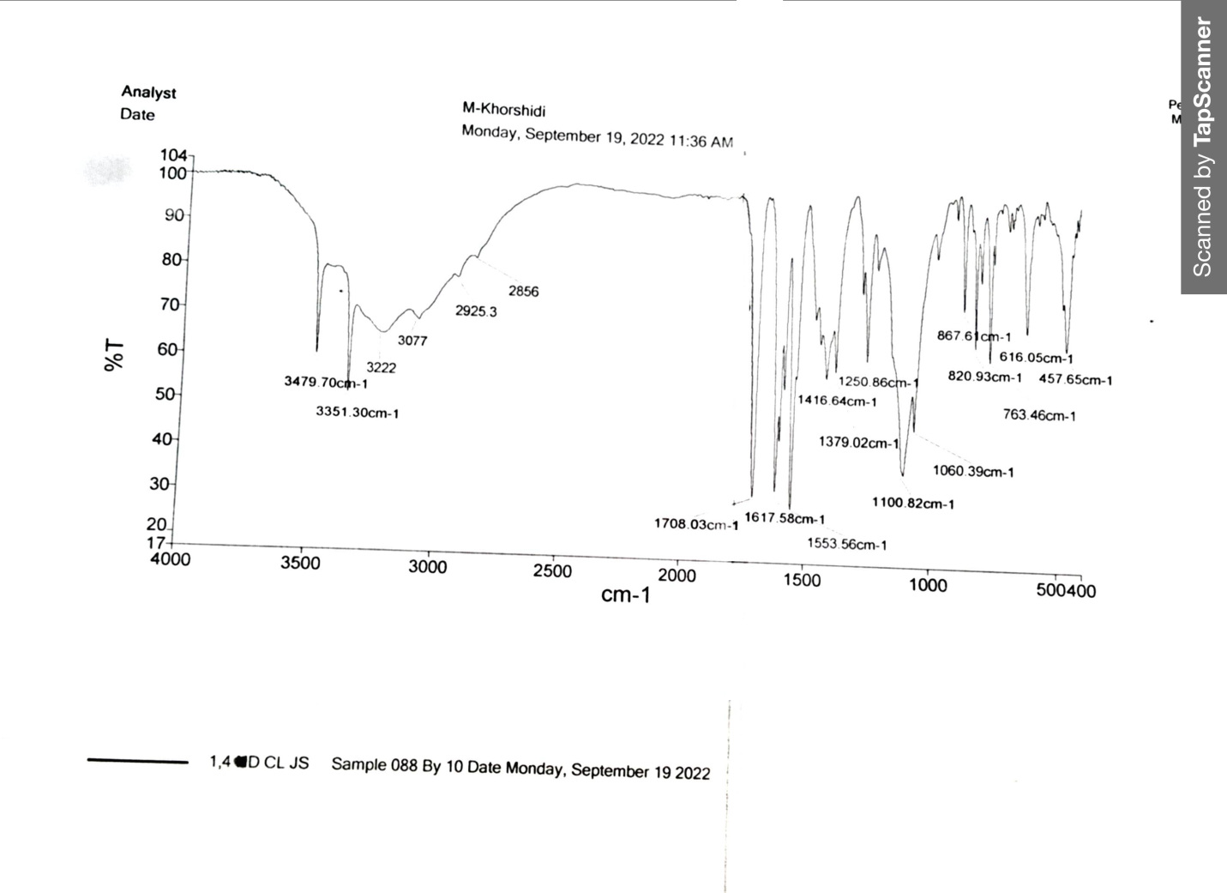

FT-IR spectrum of 4-amino-2-(2,4-dichlorophenyl)-5H-chromeno[4,3-d]pyrimidin-5-one (12a)
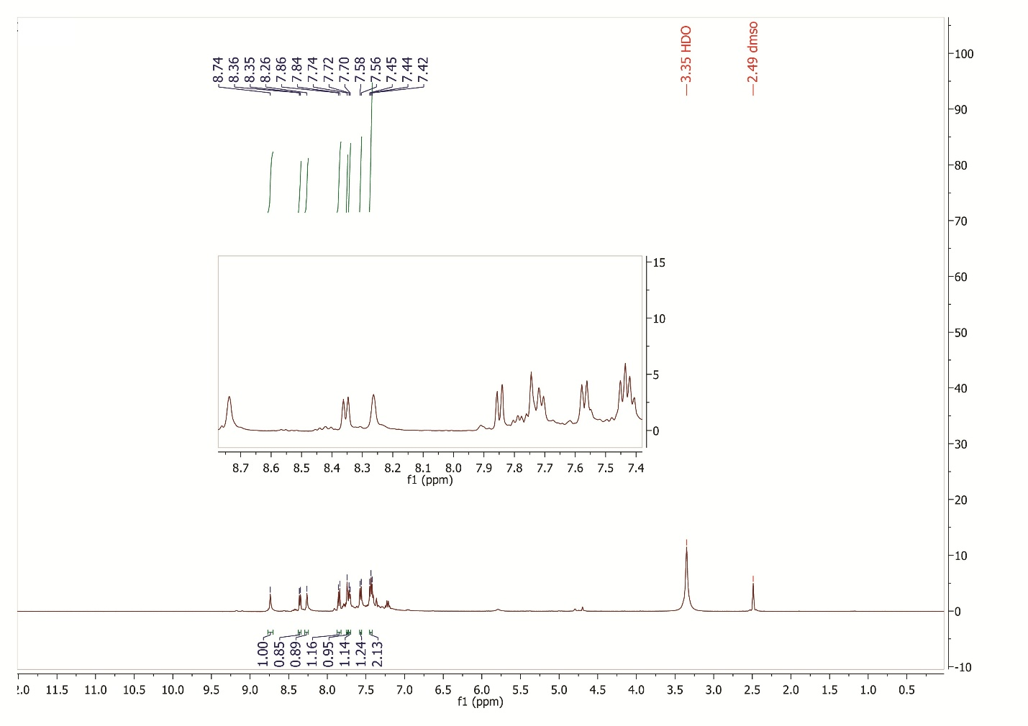

¹H NMR spectrum of 4-amino-2-(2,4-dichlorophenyl)-5H-chromeno[4,3-d]pyrimidin-5-one (12a)

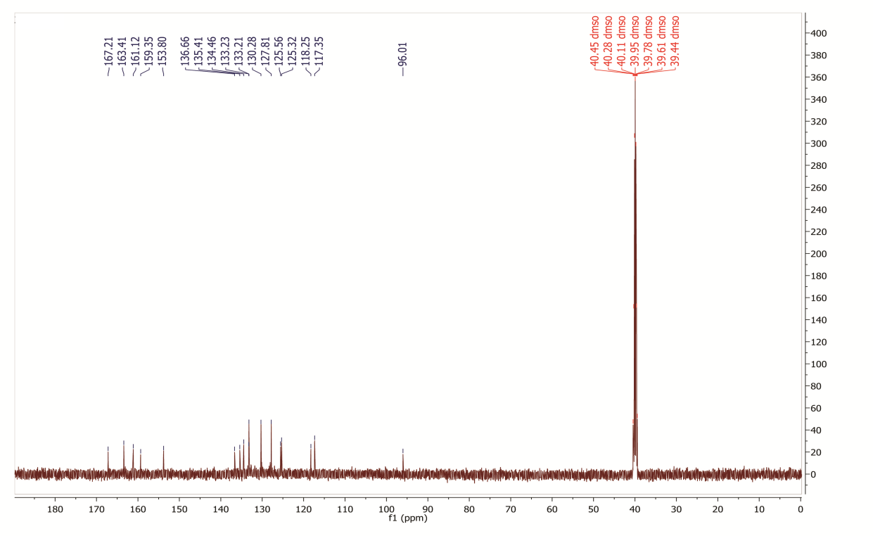

¹³C NMR spectrum of 4-amino-2-(2,4-dichlorophenyl)-5H-chromeno[4,3-d]pyrimidin-5-one (12a)
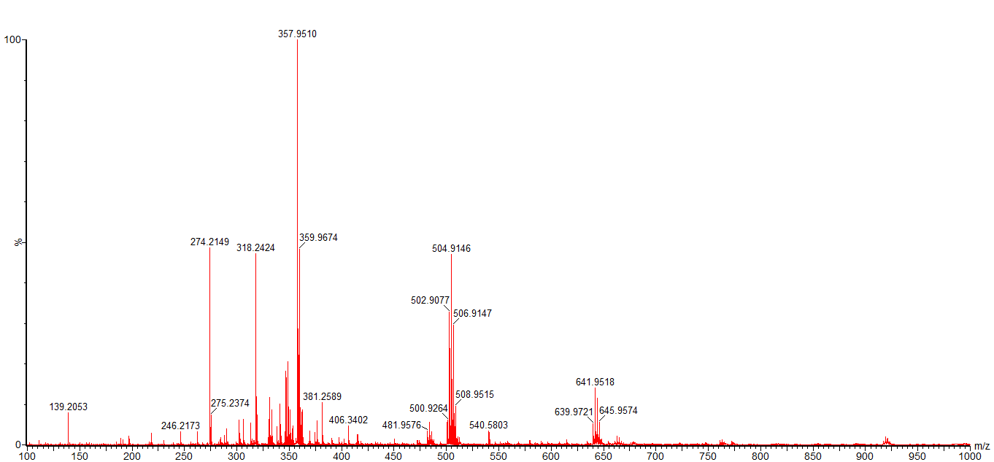

HR-Mass spectrum of 4-amino-2-(2,4-dichlorophenyl)-5H-chromeno[4,3-d]pyrimidin-5-one (12a)

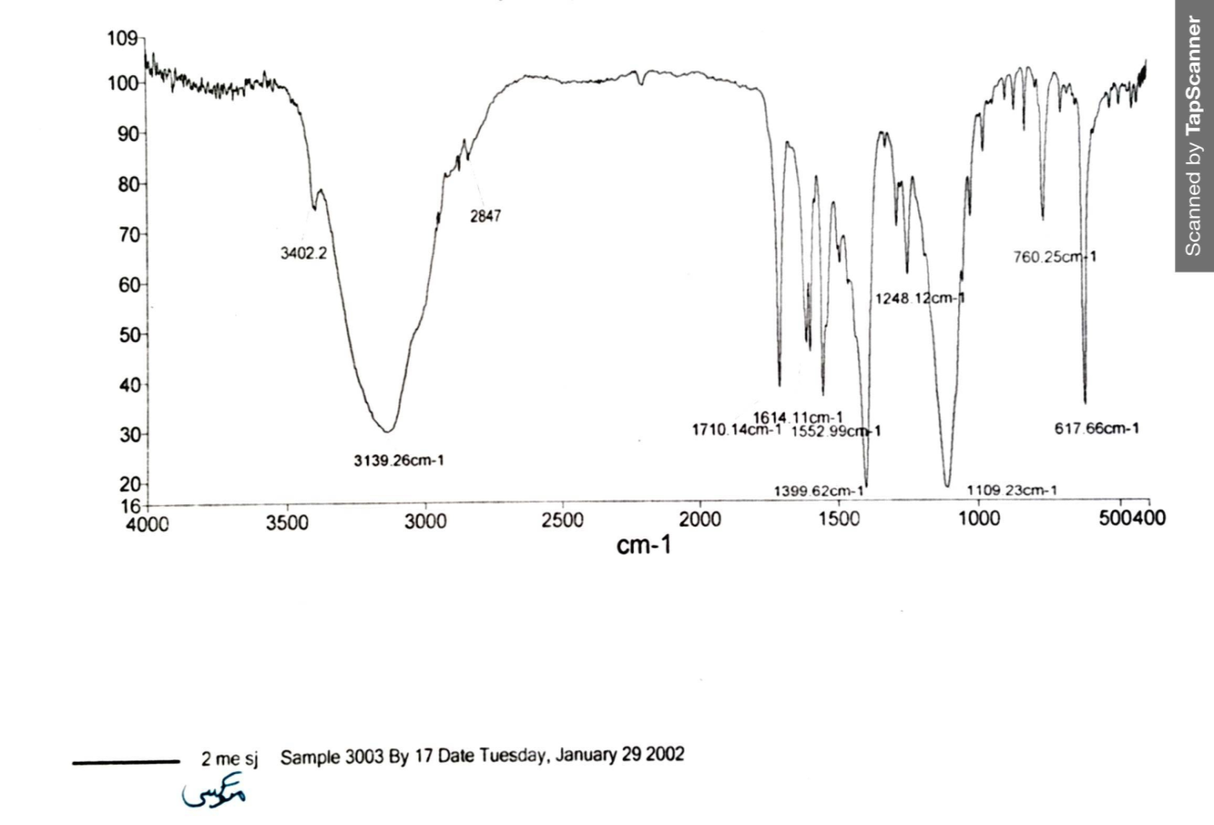

FT-IR spectrum of 4-amino-2-(2-methoxyphenyl)-5H-chromeno[4,3-d]pyrimidin-5-one (13a)

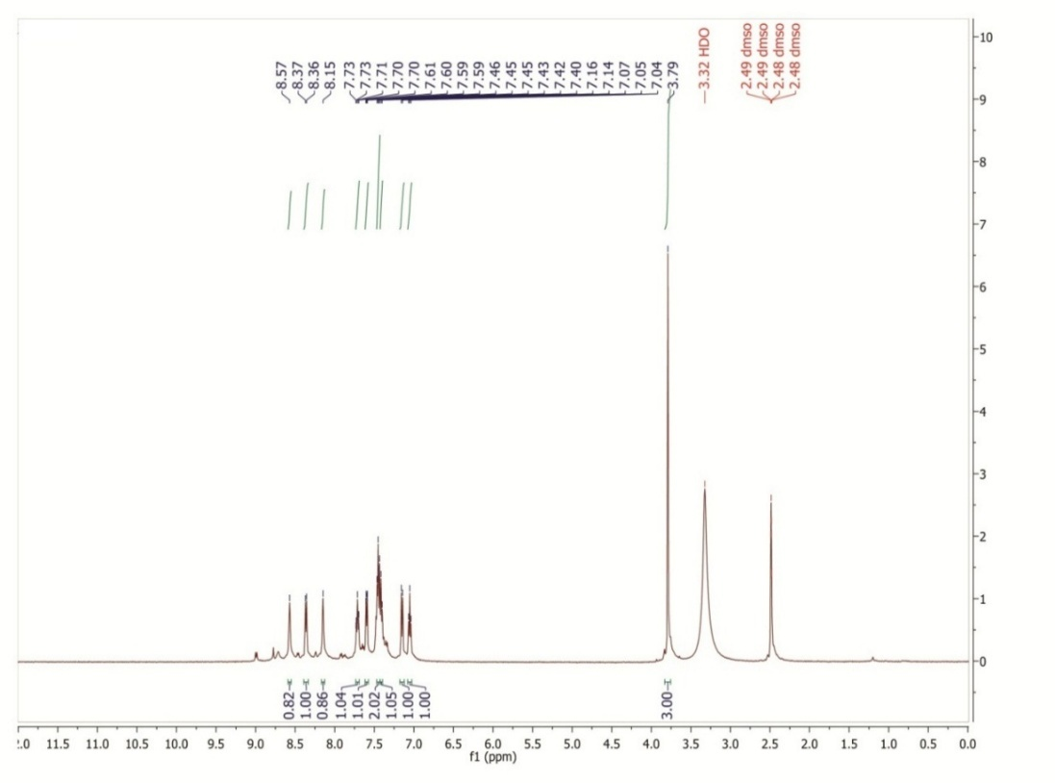

¹H NMR spectrum of 4-amino-2-(2-methoxyphenyl)-5H-chromeno[4,3-d]pyrimidin-5-one (13a)
\
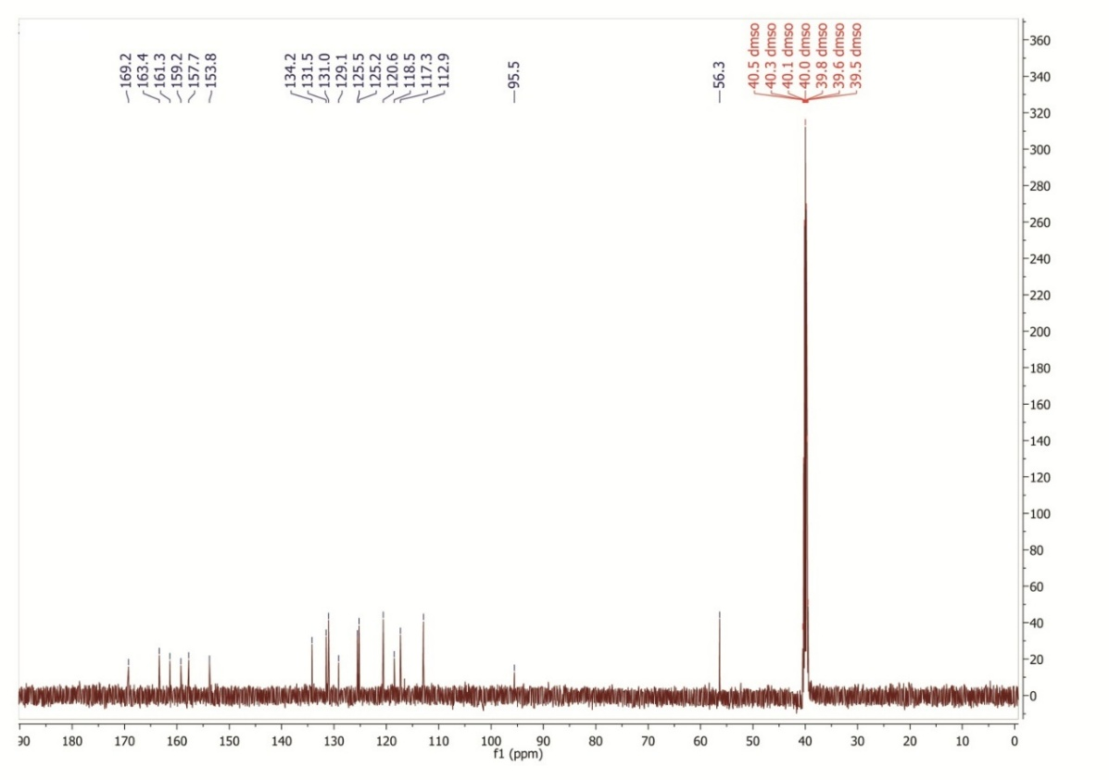

¹³C NMR spectrum of 4-amino-2-(2-methoxyphenyl)-5H-chromeno[4,3-d]pyrimidin-5-one (13a)

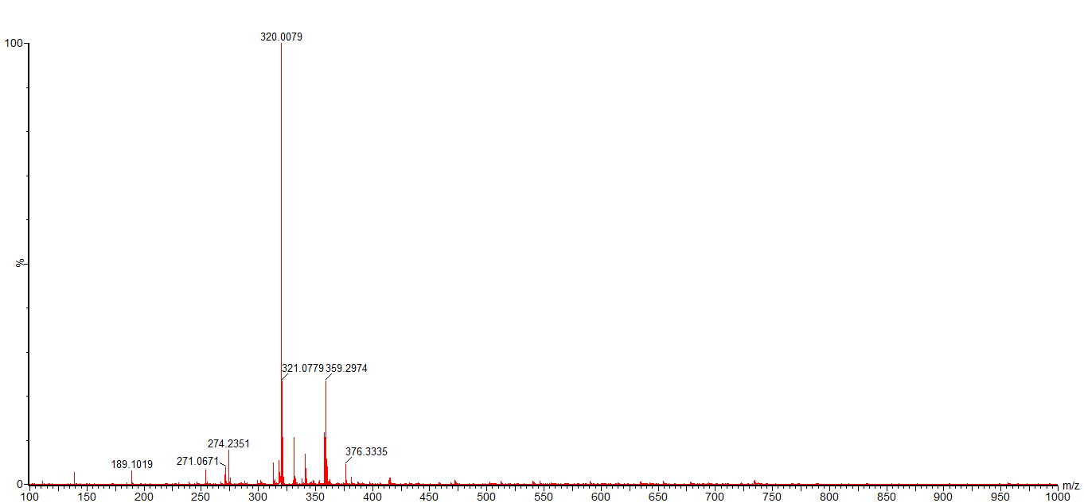

HR-Mass spectrum of 4-amino-2-(2-methoxyphenyl)-5H-chromeno[4,3-d]pyrimidin-5-one (13a)

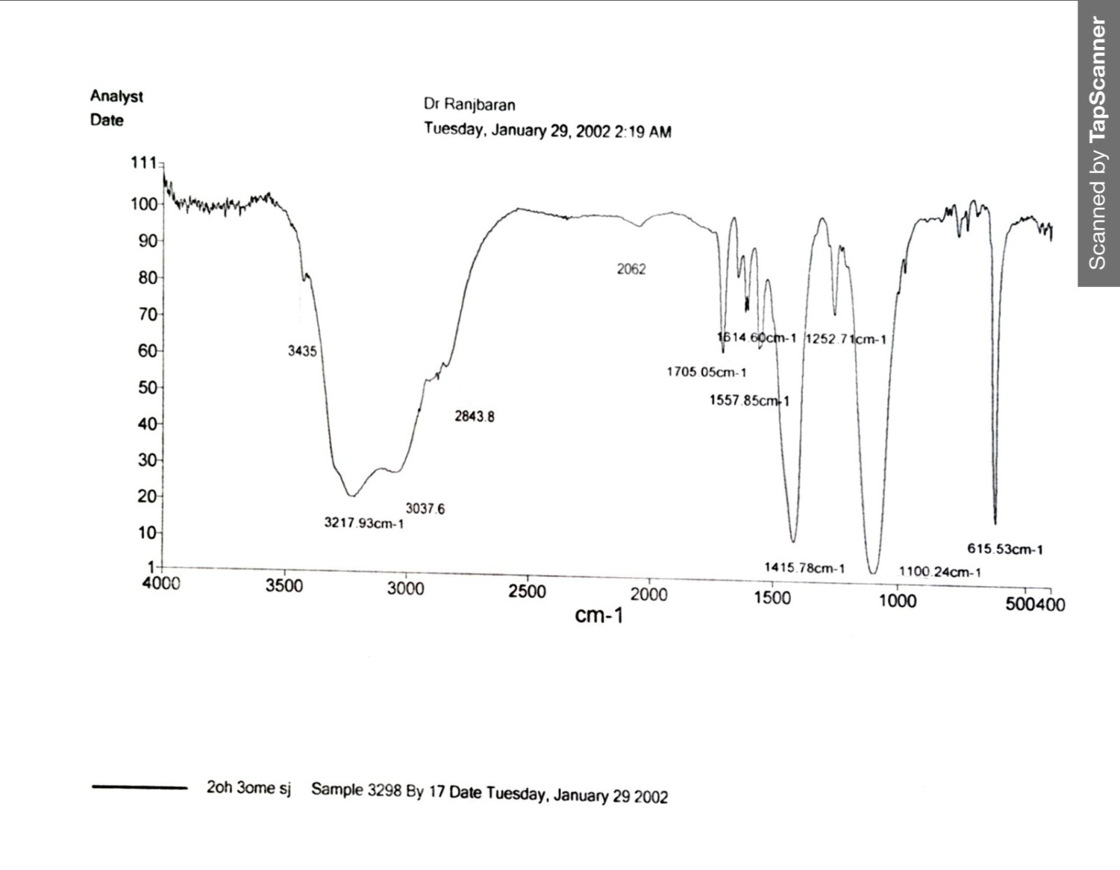

FT-IR spectrum of 4-amino-2-(2-hydroxy-3-methoxyphenyl)-5H-chromeno[4,3-d]pyrimidin-5-one (14a)

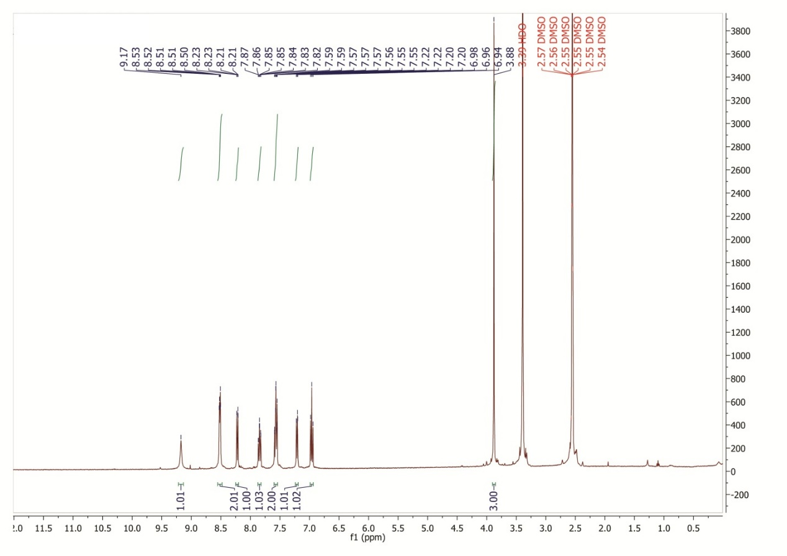

¹H NMR spectrum of 4-amino-2-(2-hydroxy-3-methoxyphenyl)-5H-chromeno[4,3-d]pyrimidin-5-one (14a)

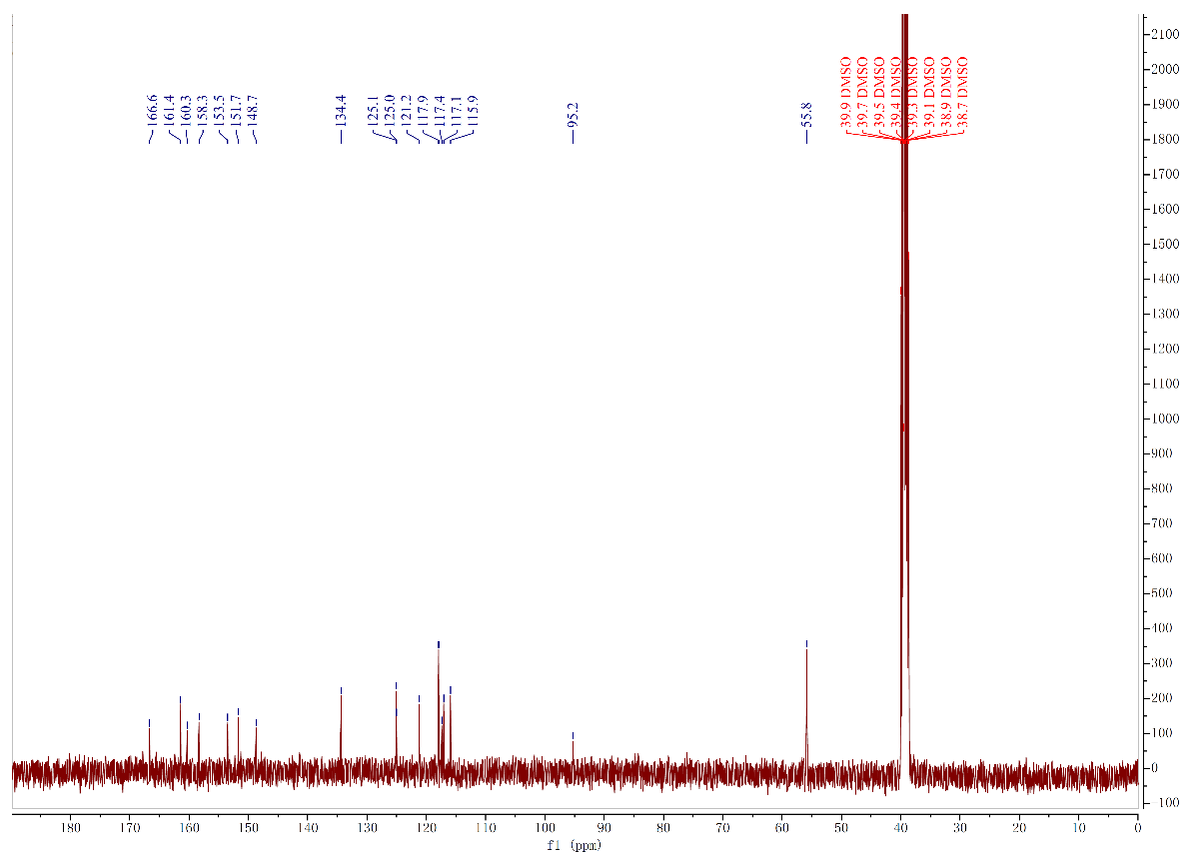

¹³C NMR spectrum of 4-amino-2-(2-hydroxy-3-methoxyphenyl)-5H-chromeno[4,3-d]pyrimidin-5-one (14a)

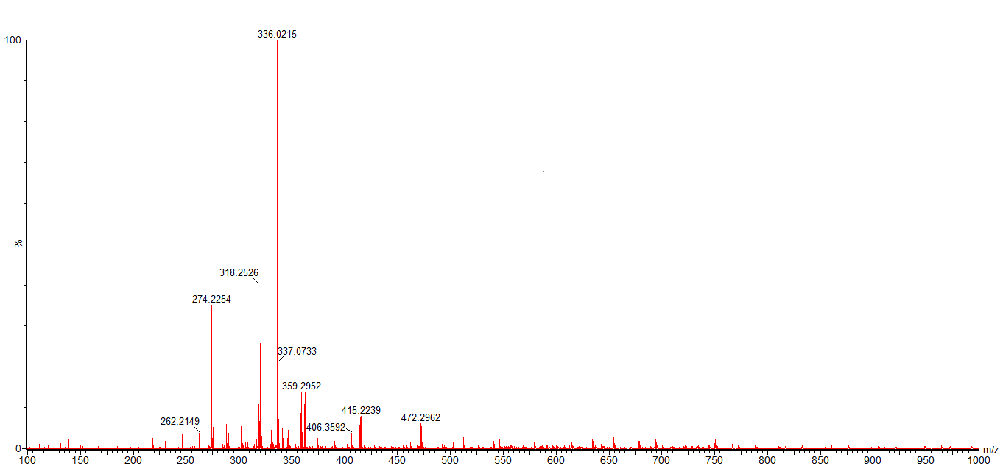

HR-Mass spectrum of 4-amino-2-(2-hydroxy-3-methoxyphenyl)-5H-chromeno[4,3-d]pyrimidin-5-one (14a)

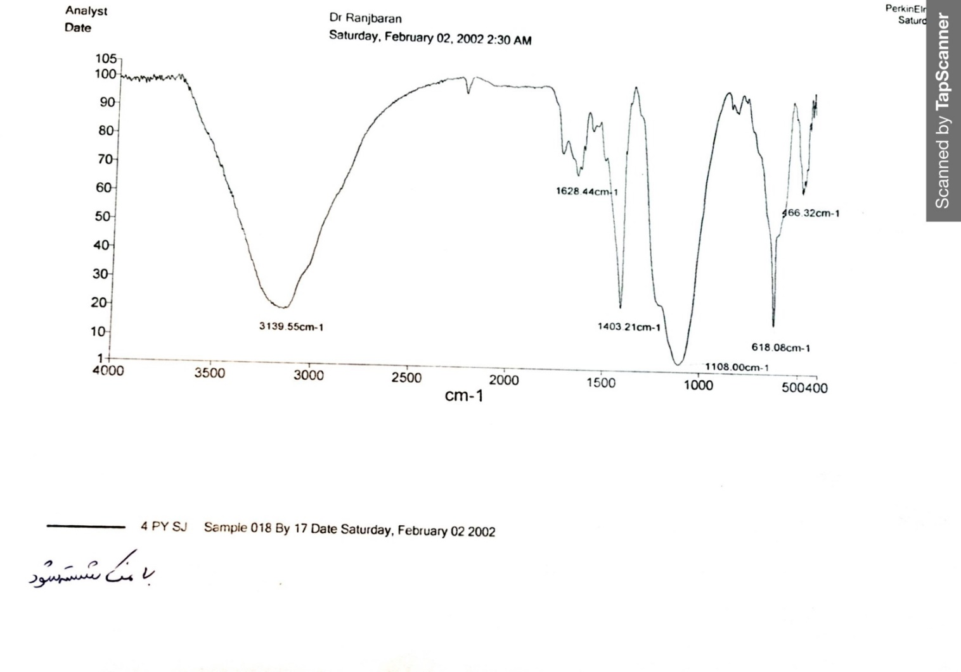

FT-IR spectrum of 4-amino-2-(pyridin-4-yl)-5H-chromeno[4,3-d]pyrimidin-5-one (15a)

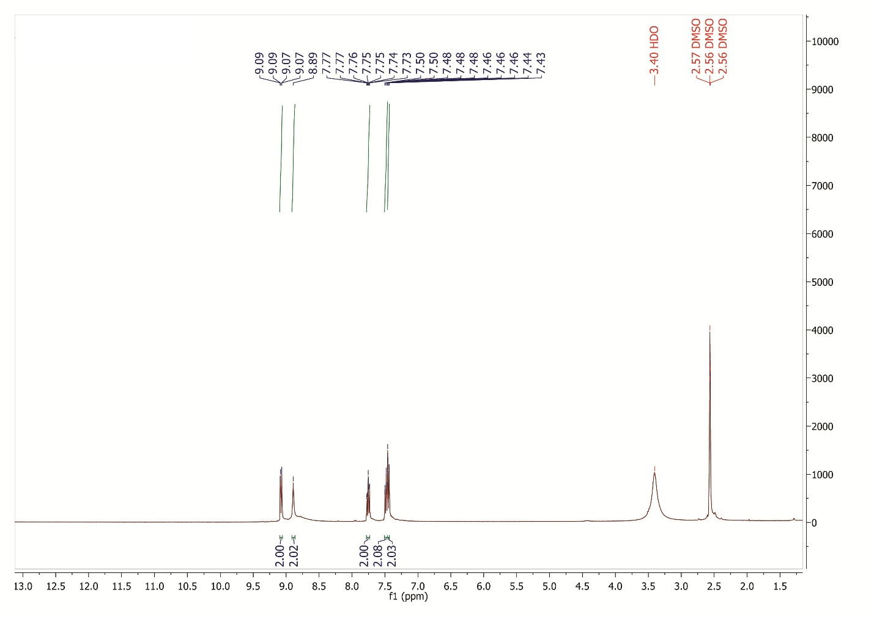

¹H NMR spectrum of 4-amino-2-(pyridin-4-yl)-5H-chromeno[4,3-d]pyrimidin-5-one (15a)

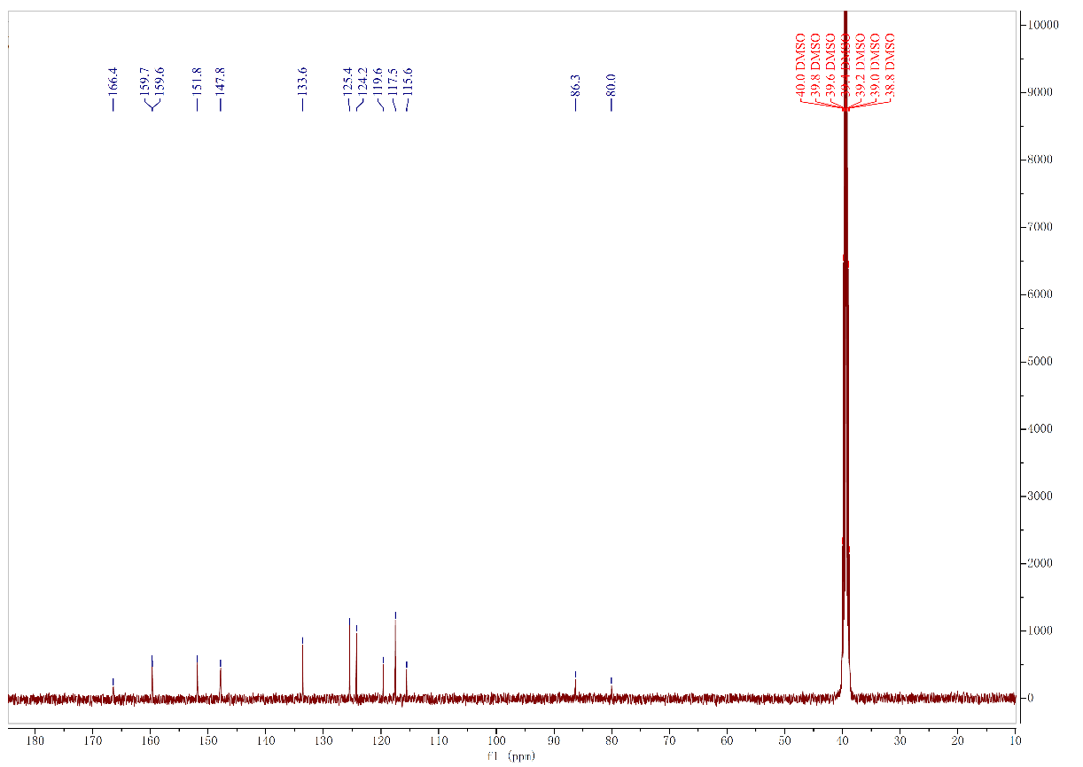

¹³C NMR spectrum of 4-amino-2-(pyridin-4-yl)-5H-chromeno[4,3-d]pyrimidin-5-one (15a)

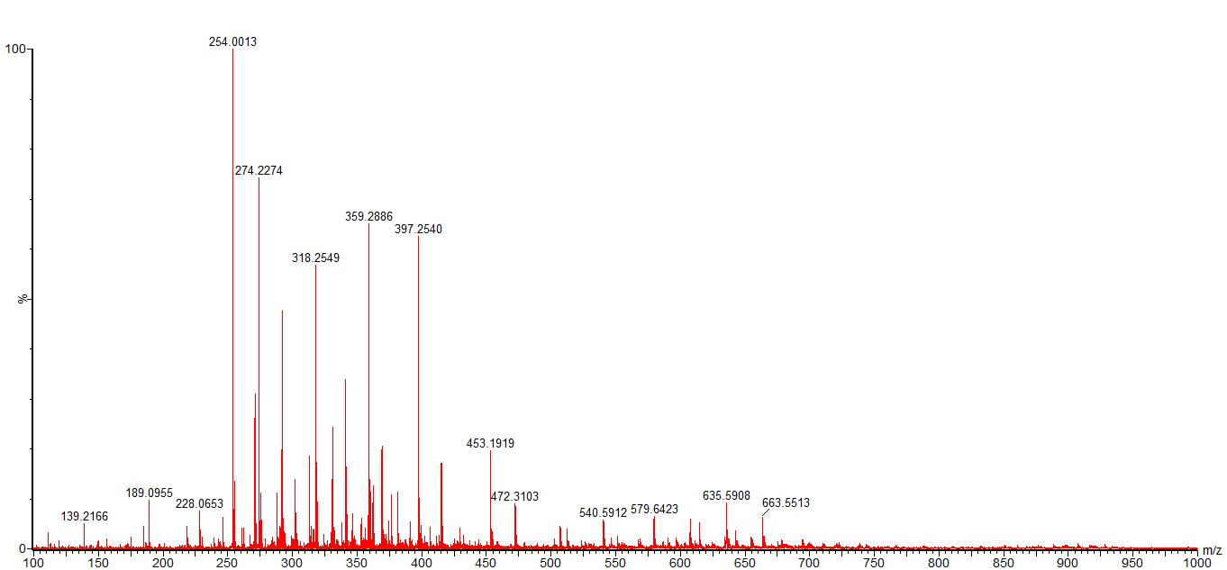

HR-Mass spectrum of 4-amino-2-(pyridin-4-yl)-5H-chromeno[4,3-d]pyrimidin-5-one (15a)

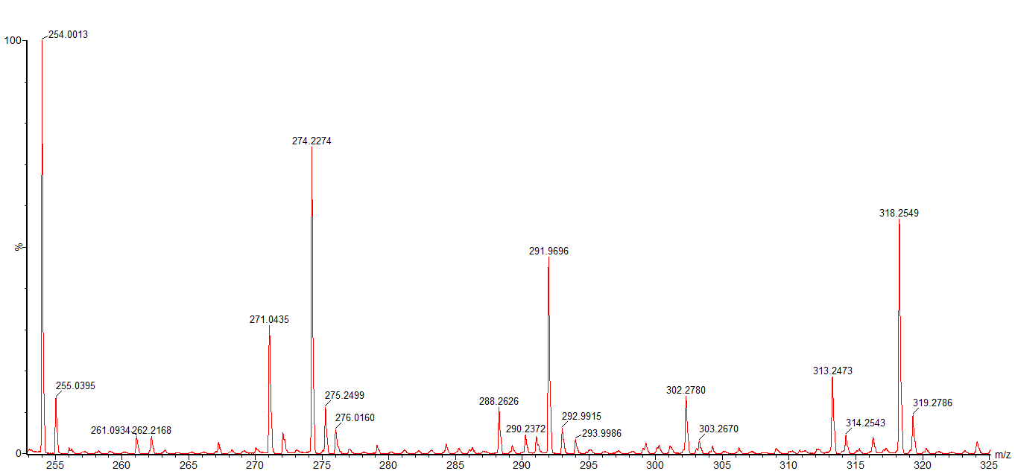

HR-Mass expand spectrum of 4-amino-2-(pyridin-4-yl)-5H-chromeno[4,3-d]pyrimidin-5-one (15a)

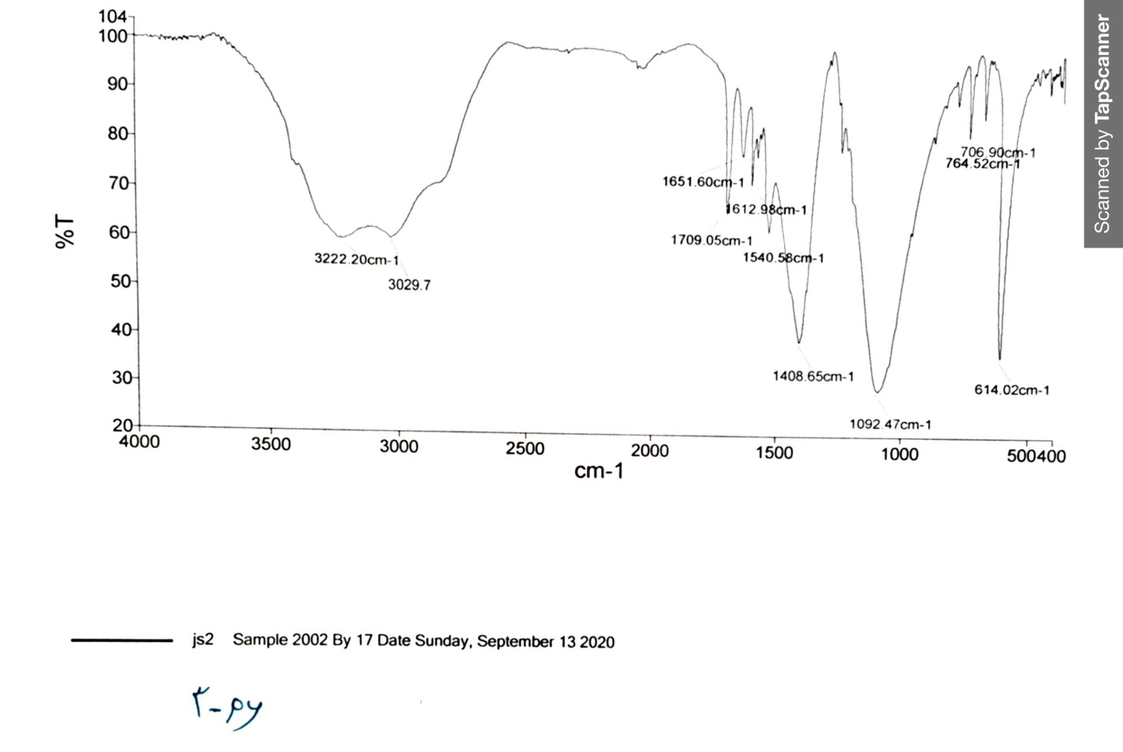

FT-IR spectrum of 4-amino-2-(pyridin-3-yl)-5H-chromeno[4,3-d]pyrimidin-5-one (16a)

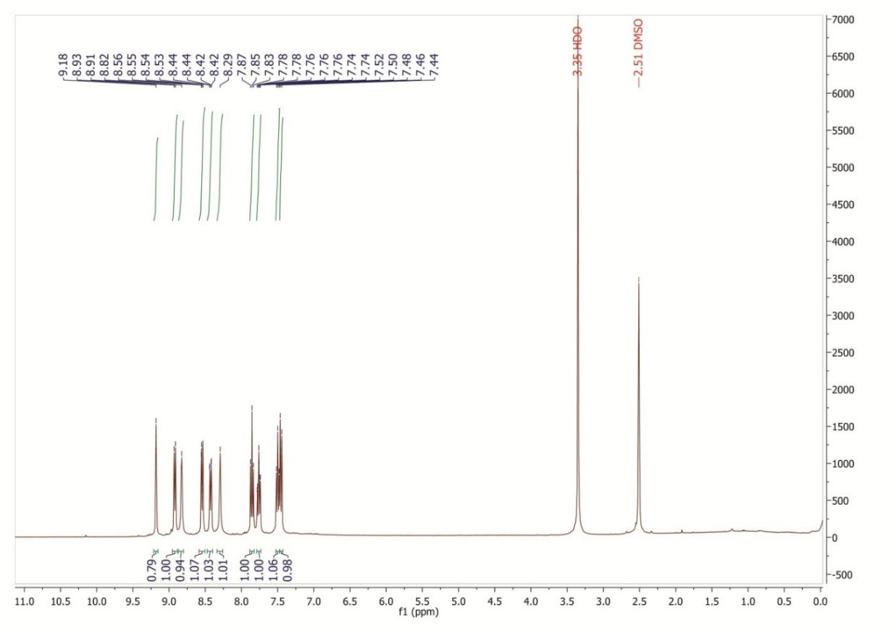

¹H NMR spectrum of 4-amino-2-(pyridin-3-yl)-5H-chromeno[4,3-d]pyrimidin-5-one (16a)

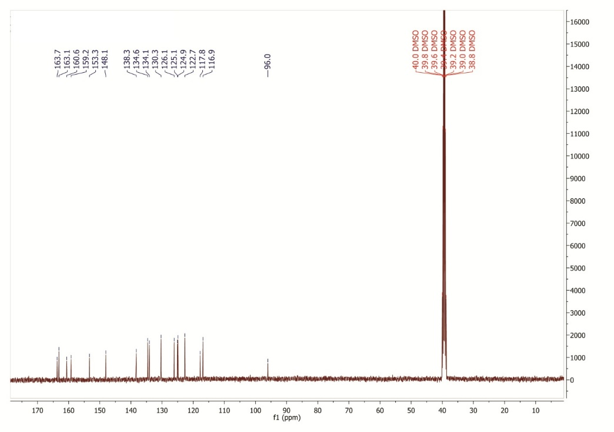

¹³C NMR spectrum of 4-amino-2-(pyridin-3-yl)-5H-chromeno[4,3-d]pyrimidin-5-one (16a)

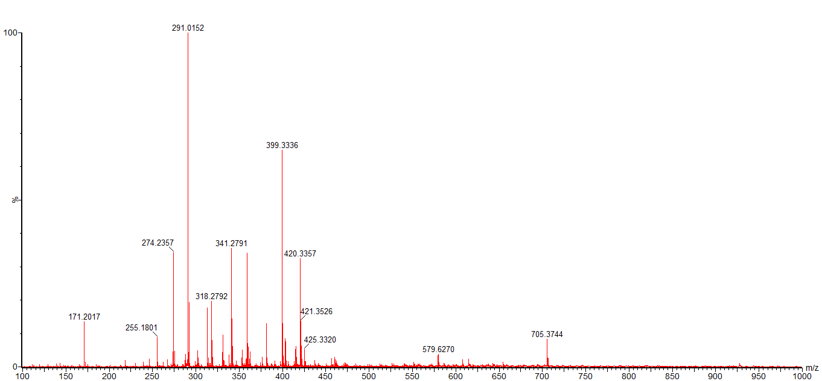

HR-Mass spectrum of 4-amino-2-(pyridin-3-yl)-5H-chromeno[4,3-d]pyrimidin-5-one (16a)

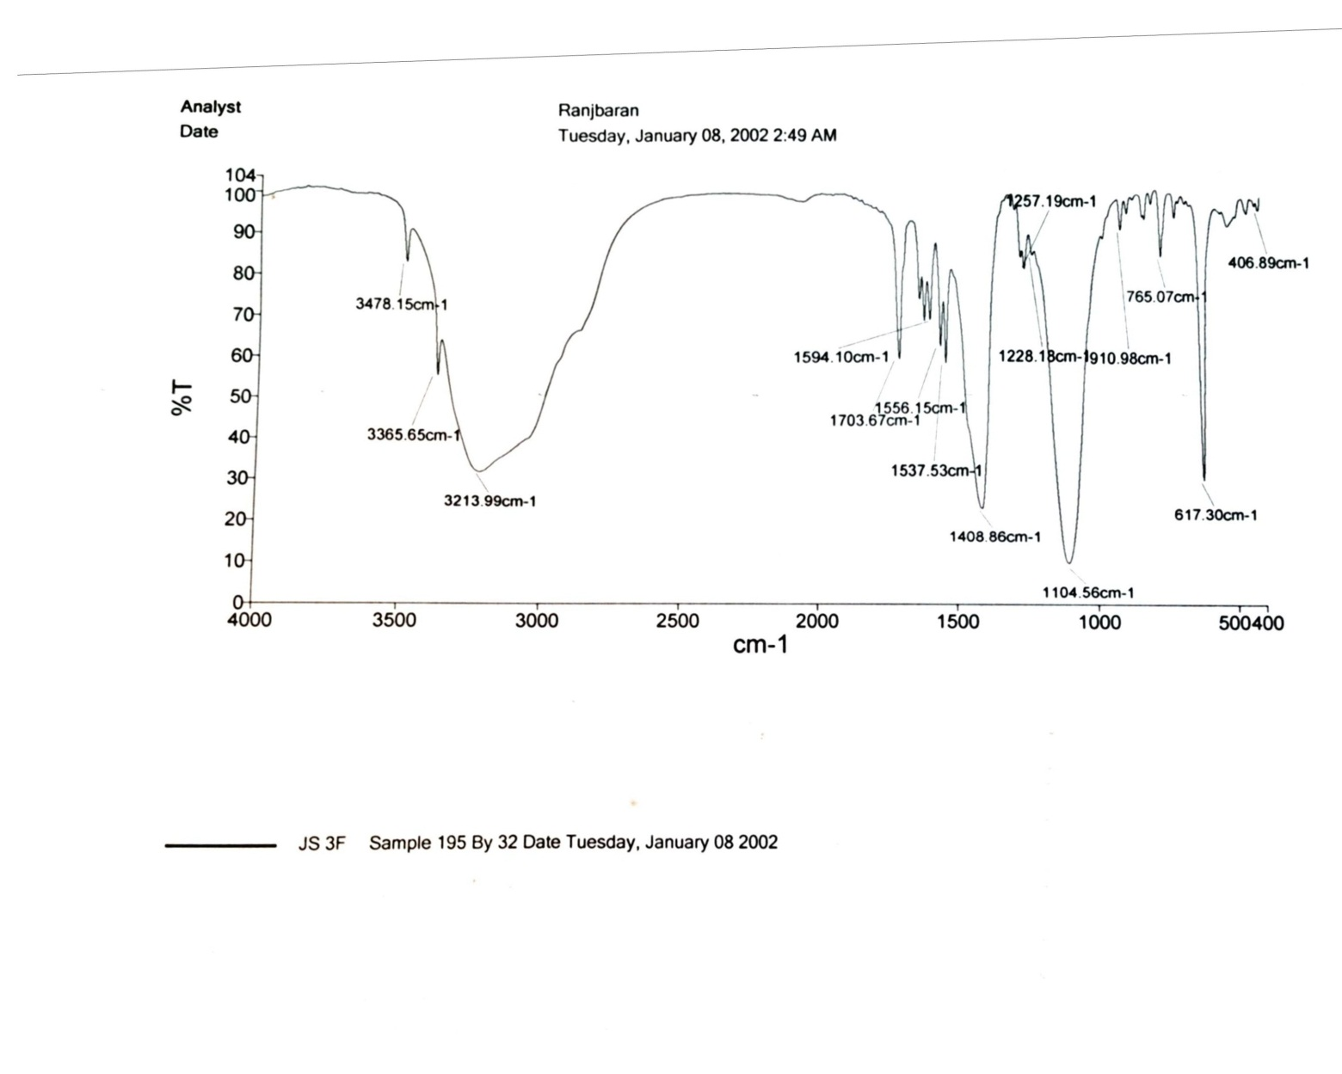

FT-IR spectrum of 4-amino-2-(3-fluorophenyl)-5H-chromeno[4,3-d]pyrimidin-5-one (17a)

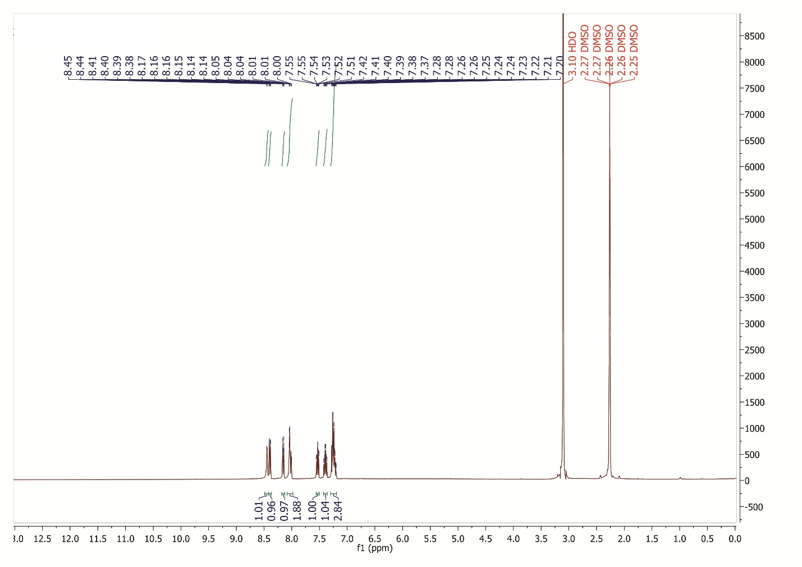

¹H NMR spectrum of 4-amino-2-(3-fluorophenyl)-5H-chromeno[4,3-d]pyrimidin-5-one (17a)

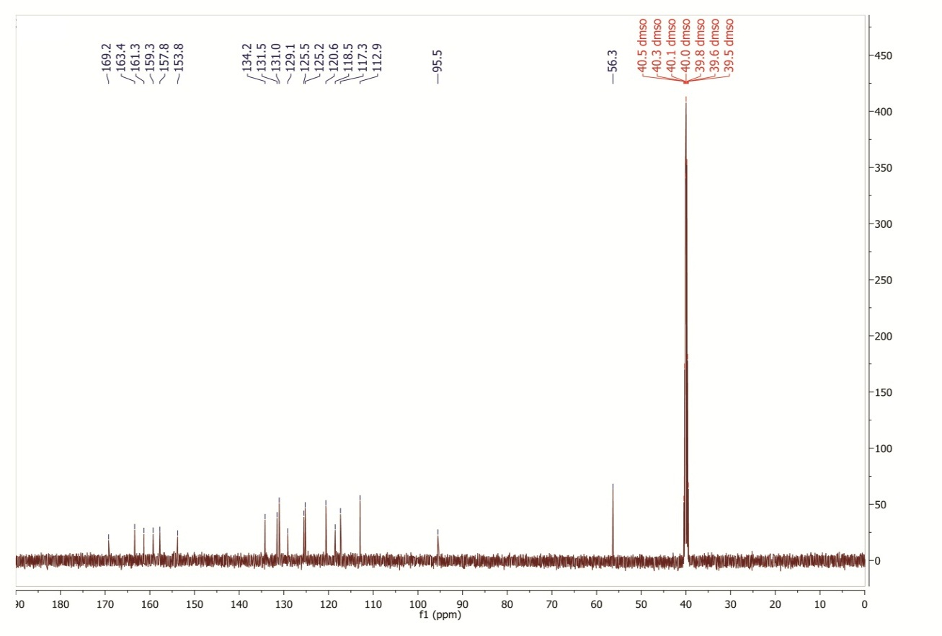

¹³C NMR spectrum of 4-amino-2-(3-fluorophenyl)-5H-chromeno[4,3-d]pyrimidin-5-one (17a)
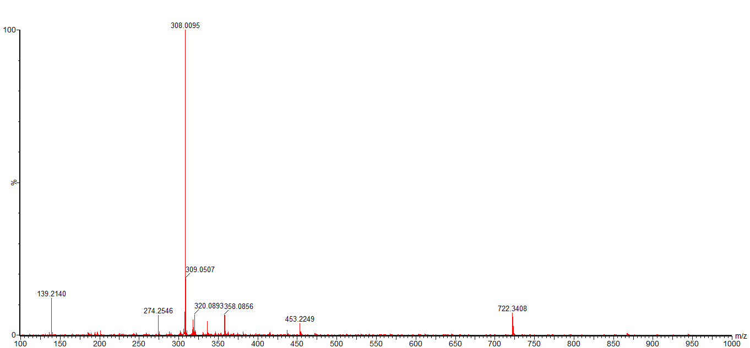

HR-Mass spectrum of 4-amino-2-(3-fluorophenyl)-5H-chromeno[4,3-d]pyrimidin-5-one (17a)

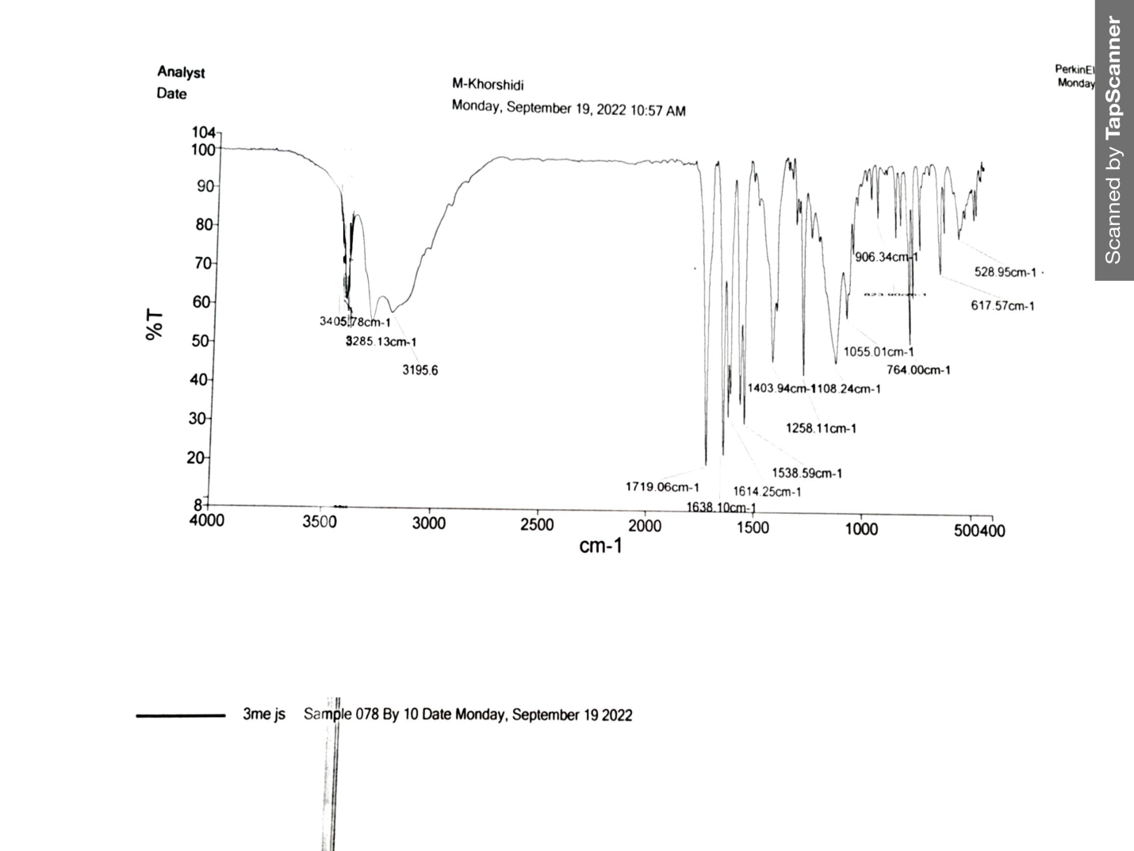

FT-IR spectrum of 4-amino-2-(m-tolyl)-5H-chromeno[4,3-d]pyrimidin-5-one (18a)
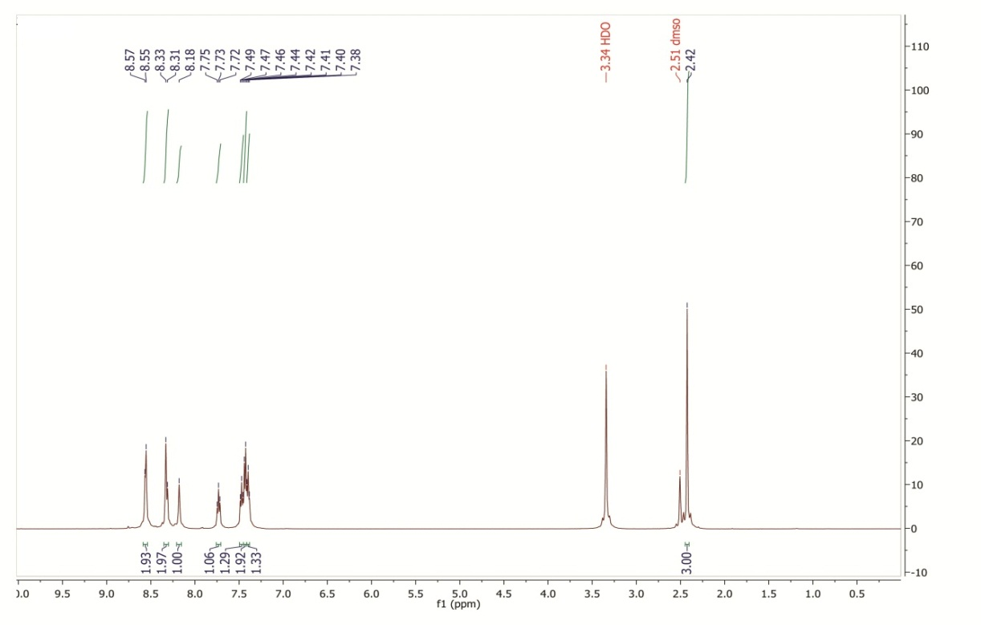

¹H NMR spectrum of 4-amino-2-(m-tolyl)-5H-chromeno[4,3-d]pyrimidin-5-one (18a)

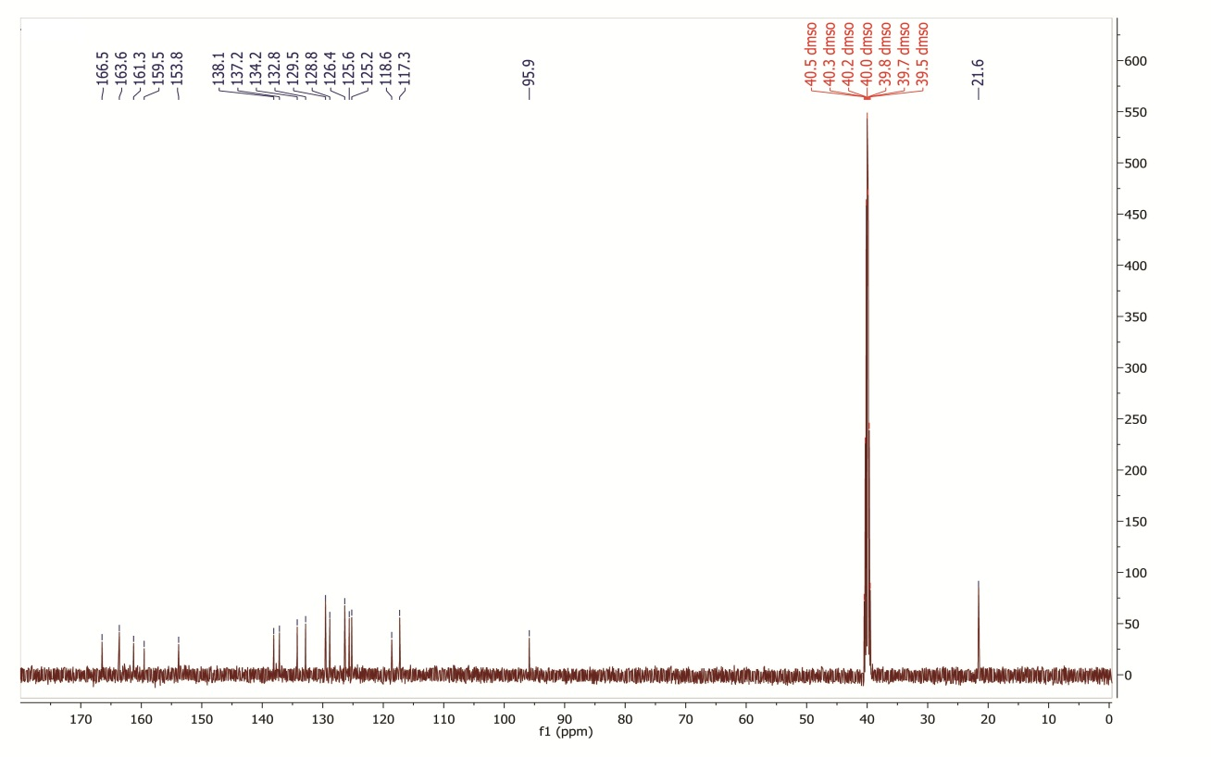

¹³C NMR spectrum of 4-amino-2-(m-tolyl)-5H-chromeno[4,3-d]pyrimidin-5-one (18a)
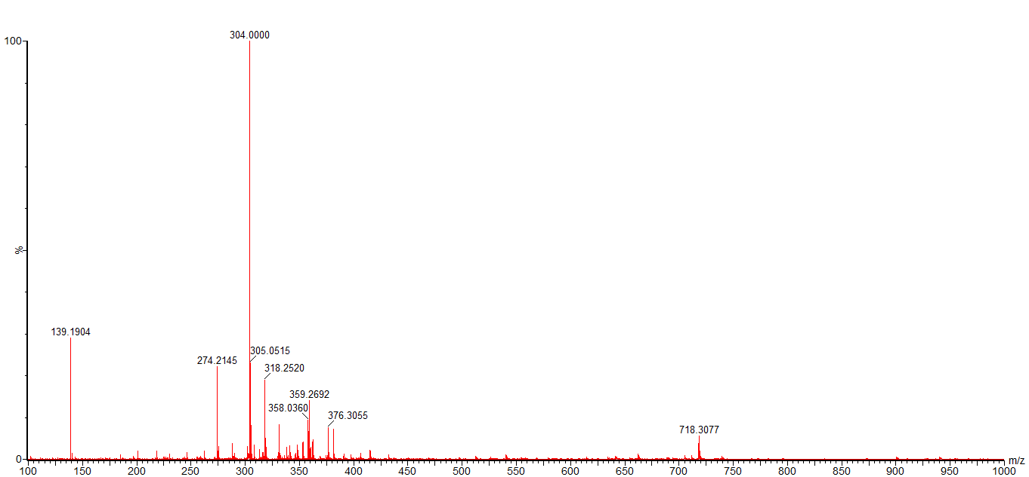

HR-Mass spectrum of 4-amino-2-(m-tolyl)-5H-chromeno[4,3-d]pyrimidin-5-one (18a)

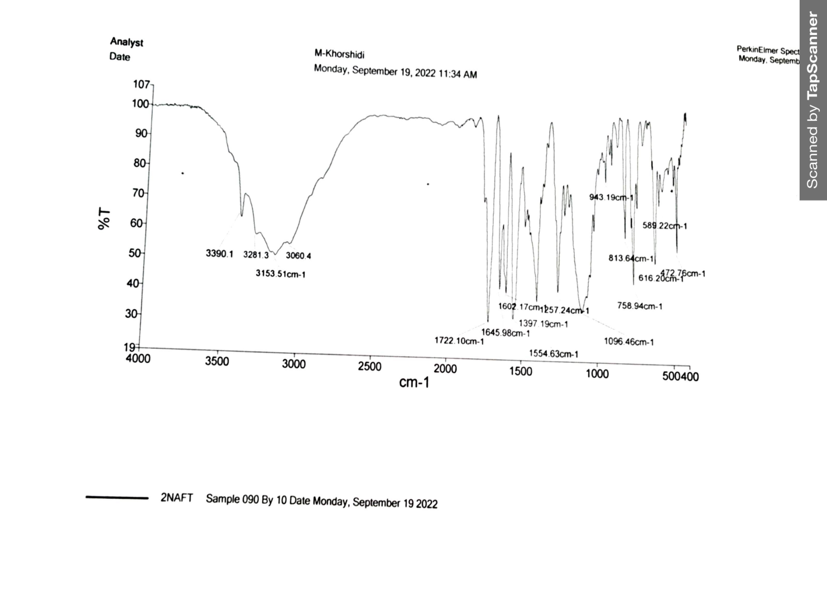

FT-IR spectrum of 4-amino-2-(naphthalen-2-yl)-5H-chromeno[4,3-d]pyrimidin-5-one (19a)
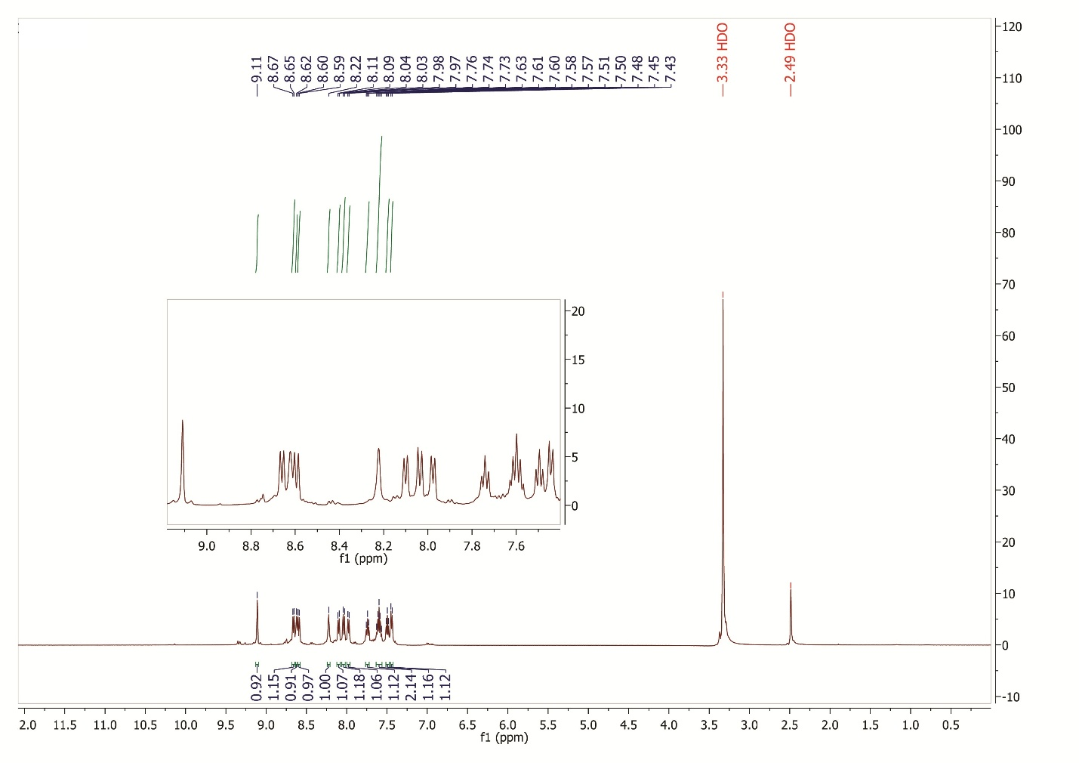

¹H NMR spectrum of 4-amino-2-(naphthalen-2-yl)-5H-chromeno[4,3-d]pyrimidin-5-one (19a)

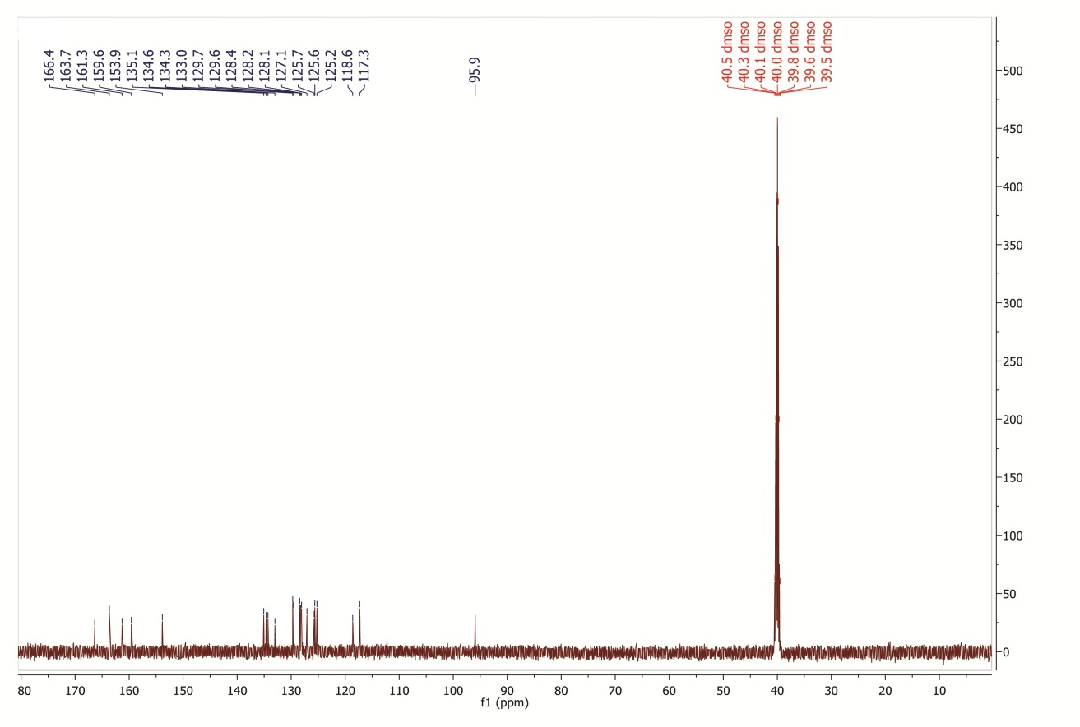

¹³C NMR spectrum of 4-amino-2-(naphthalen-2-yl)-5H-chromeno[4,3-d]pyrimidin-5-one (19a)
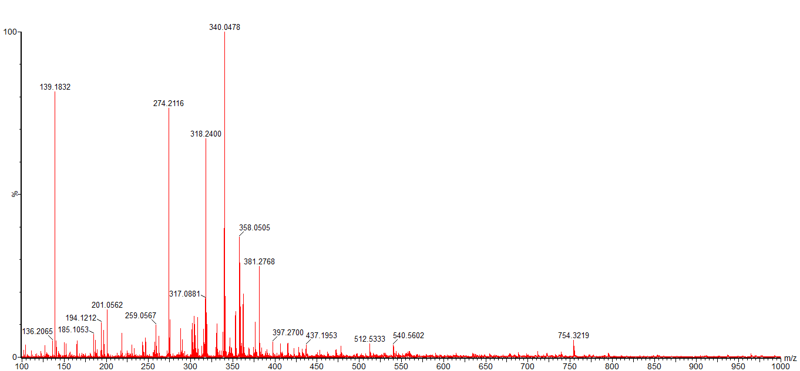

HR-Mass spectrum of 4-amino-2-(naphthalen-2-yl)-5H-chromeno[4,3-d]pyrimidin-5-one (19a)

