Supplementary Fig. S1 The size distribution of (a) Fe3O4 and (b) CaP/Fe3O4, (c) the effect of EDTA concentration on the morphology and size of prepared CaP particles, (d) the photographs of CaP and CaP/Fe3O4 dispersed in the water, and the isolation of CaP/Fe3O4 complex with different CaP/Fe3O4 mass ratio from the solution using external magnet.

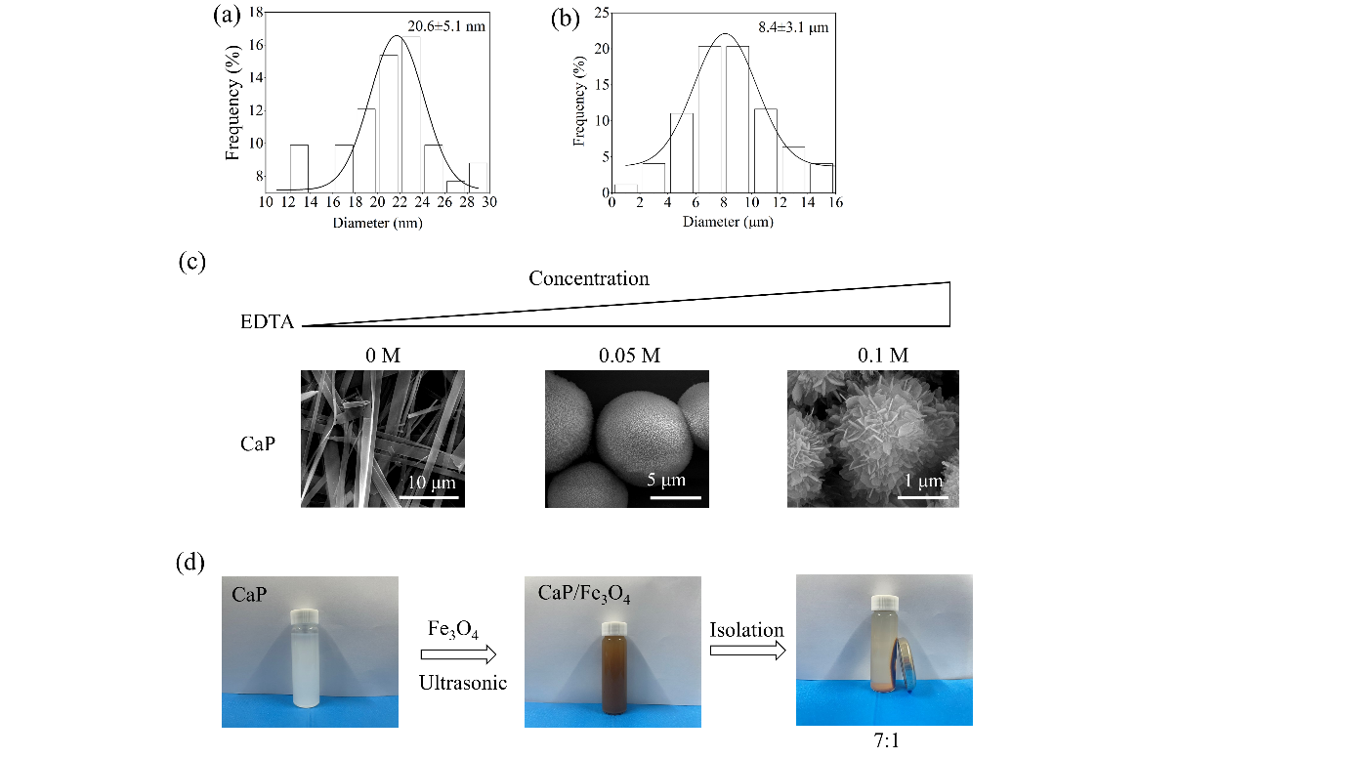

Supplementary Fig. S2 High-resolution TEM images showing the surface nanostructures of the microspheres consisted of HA nanorods and Fe3O4 nanoparticles.

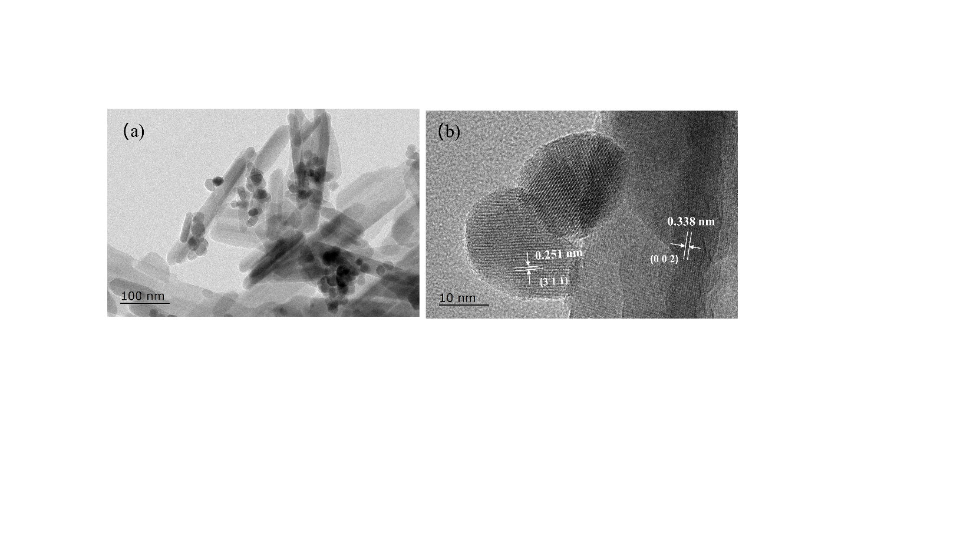

Supplementary Fig. S3 The cell proliferation when co-cultured with CaP and CaP/Fe3O4 particles at different mass ratios.

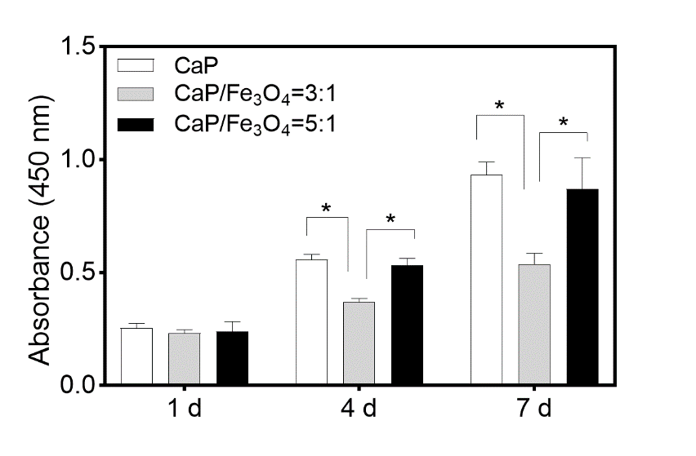

Supplementary Fig. S4 Biphosphate conjugated to GDF-5 using SPDP. First, the SPDP linker was reacted with NEM-treated GDF-5, followed by the coupling of thiolated biphosphate to achieve the PGDF-5.

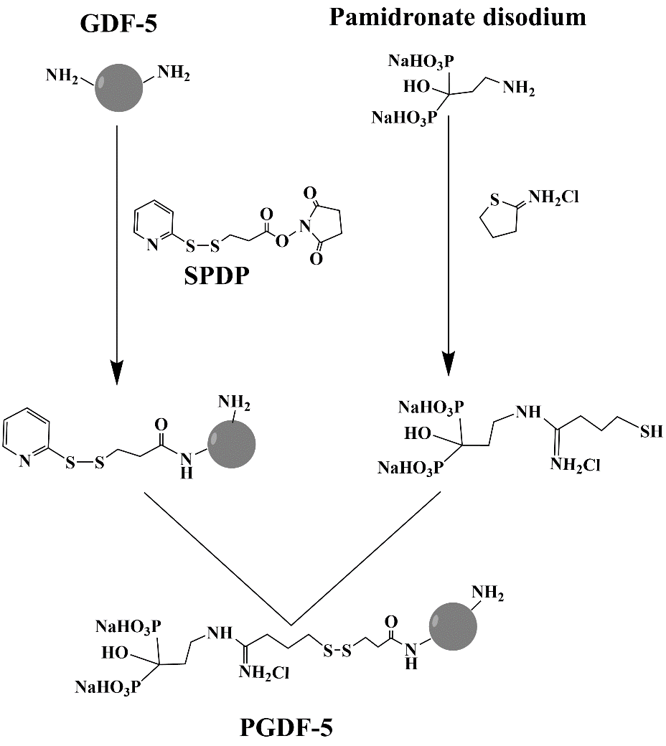

Supplementary Fig. S5 (a) The adsorption of GDF-5 and PGDF-5 on magnetic CaP particles, (b) the protein release amount from magnetic CaP particles in the Tris buffer containing 0 or 5 mM cysteine after 24 h, and (c) the PGDF-5 release curves from magnetic CaP particles in various solutions.

蛋白释放

Supplementary Fig. S6 Aggregation behavior of cells co-cultured with magnetic CaP microparticles for 3, 7 and 14 d at different (a) cell density and (b) particle density.

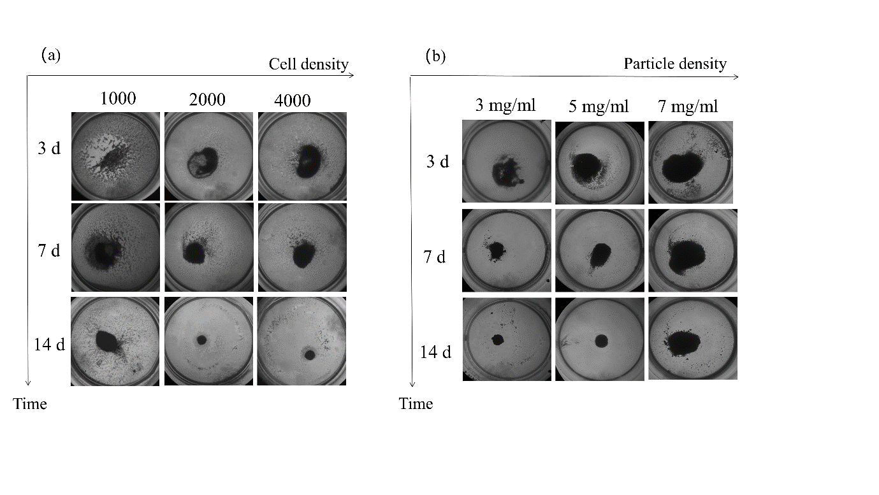

Supplementary Fig. S7 SEM images of cells co-cultured with various microcarriers (scale bar= 20 µm)

SEM

Supplementary Fig. S8 The semi-quantitative analysis of immunofluorescence staining including (a) OCN and (b) OPN. *** represents p < 0.001, **** represents p < 0.0001.

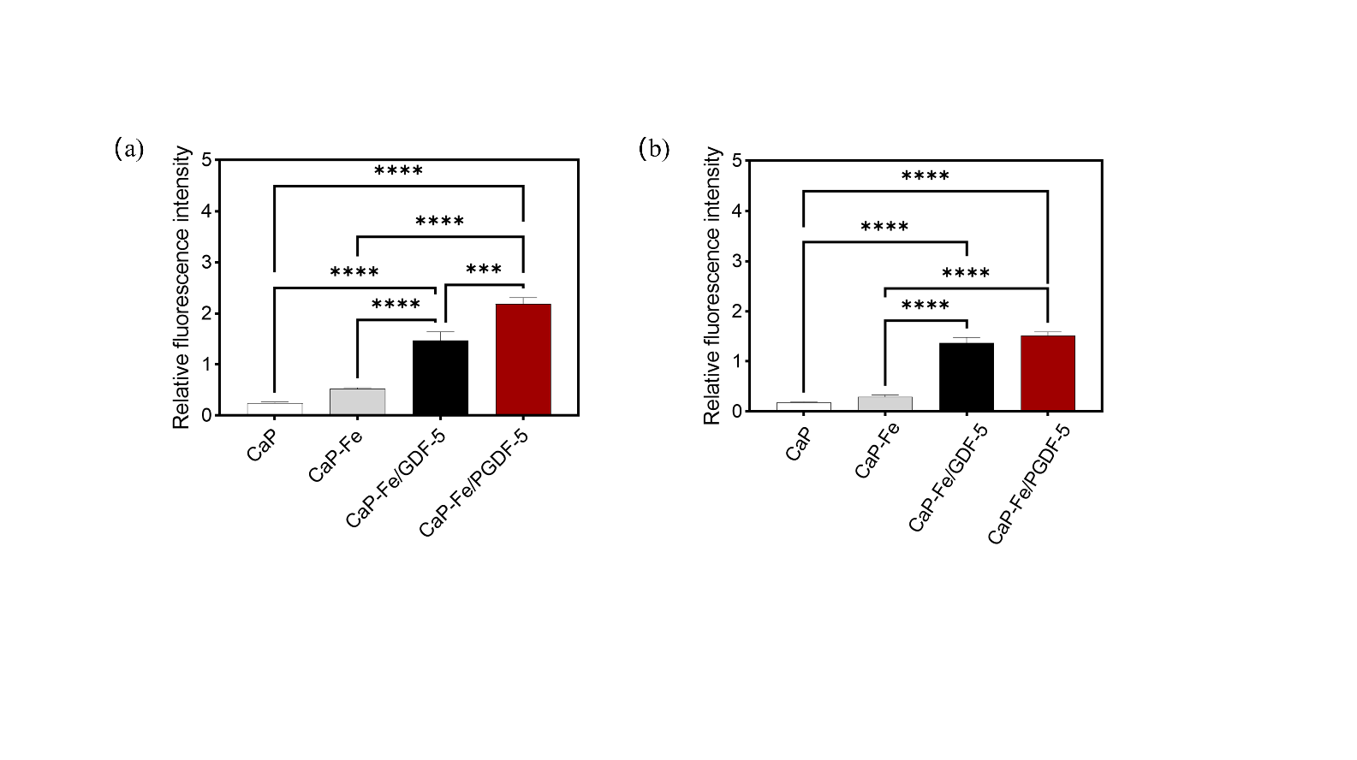

Supplementary Fig. S9 The isolated single CaP/Fe3O4 aggregates were fused into larger ones after culture of 10 d under the assistant of external magnetic field.

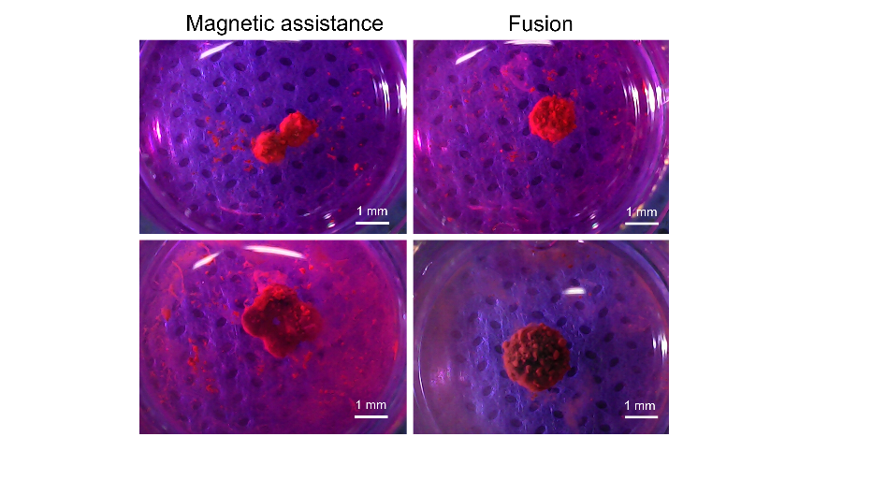

Table S1 The percentage of secondary structure calculated from CD spectra of GDF-5 and PGDF-5.

|  |  |  |  |  |
| --- | --- | --- | --- | --- |
|  | α-helix | β-sheet | β-turn | random coil |
| GDF-5 | 33.6% | 13.0% | 19.8% | 32.5% |
| PGDF-5 | 37.0% | 11.9% | 18.6% | 32.5% |