**Supplementary material**

**An Integrated Strategy to Discover the Quality Control Markers of Herbal Formulae of Danning Tablet with Anti-cholestasis Applications**

Jie-Jing Yu a, 1, Yu Wang a, 1, Xing Yan a, Xue Yan a, Yi Zhang a, Jiao-Jiao Wei a, Long-Chan Liu a, Li-Li Ding a, b *, Ai-Zhen Xiong a, b *, Lin-Shan Jiang a, Zheng-Tao Wang a, b, Li Yang a, b *

a*Shanghai Key Laboratory of Compound Chinese Medicine, The Ministry of Education (MOE) Key Laboratory for Standardization of Chinese Medicine, Institute of Chinese Materia Medica, Shanghai University of Traditional Chinese Medicine, 1200 Cailun Road, Shanghai 201203, China*

b *Shanghai R & D Center for Standardization of Traditional Chinese Medicines, Shanghai 201210, China*

* Corresponding authors at: Institute of Chinese Materia Medica, Shanghai University of Traditional Chinese Medicine, Shanghai 201203, China.

E-mail addresses: yl7@shutcm.edu.cn (L. Yang); aizhenxiong@shutcm.edu.cn (A. Xiong); nail8219@126.com (L. Ding)

1 Jie-jing Yu and Yu Wang contributed equally to this work and should be considered co-first authors.

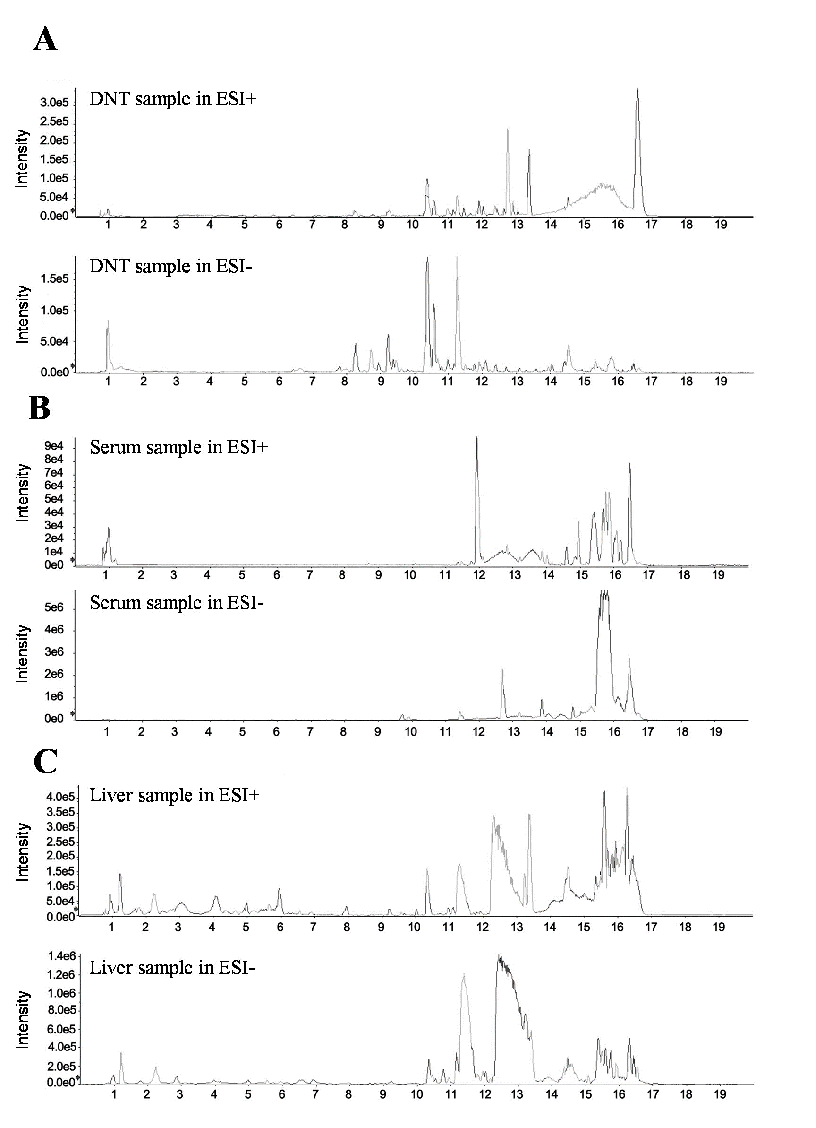

**Fig. S1** Typical UPLC-MS total ion chromatography of DNT sample (A), serum sample (B), and liver sample (C) in both of positive and negative ion modes.

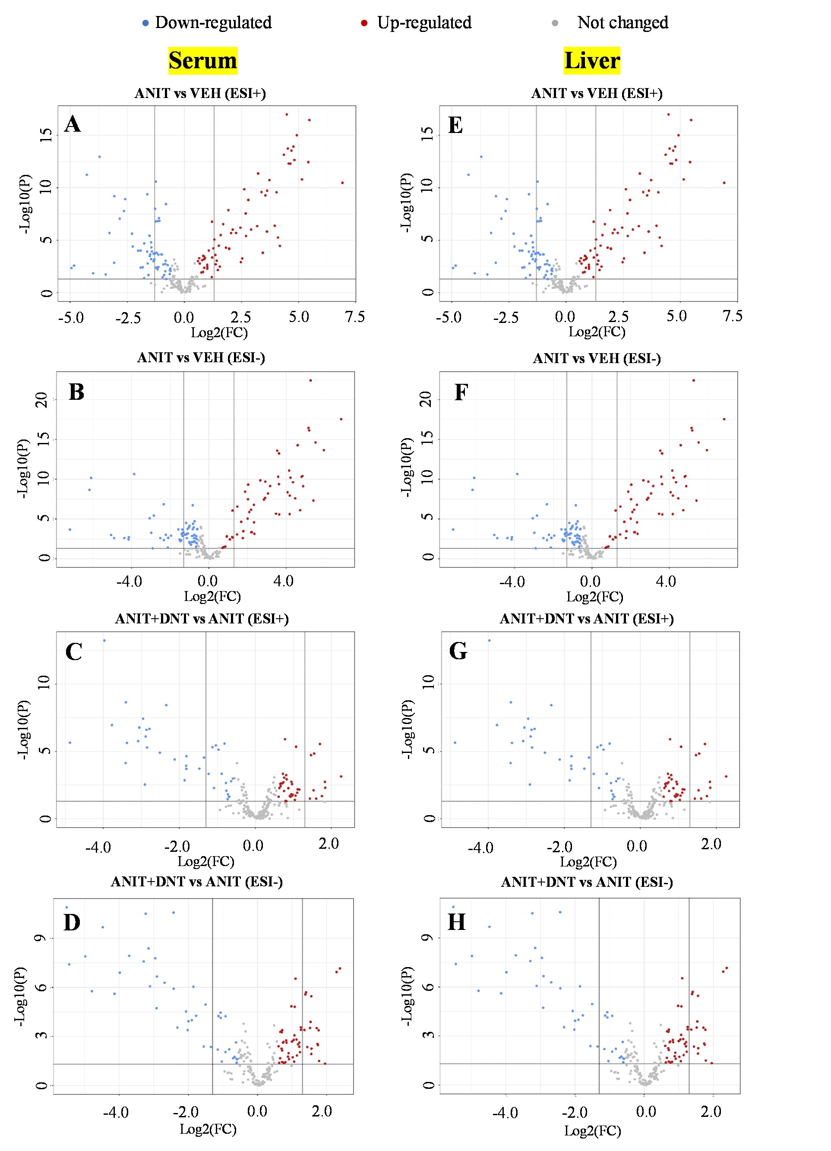

**Fig. S2** Volcano plots of endogenous compounds highlights differentially expressed endogenous components in serum and liver samples of mice. (A-D) Volcano plots between VEH and ANIT groups both in positive and negative ion modes. (E-H) Volcano plots between ANIT and ANIT+DNT groups both in positive and negative ion modes. Differentially expressed endogenous components between groups were screened by the selection criteria of P<0.05 and fold change＞1.5.



**Fig. S3** Hepatic mRNA expression of genes involved in bile acid biosynthesis and secretion in mice. Compared with the VEH (control) group, *P <0.05, **P <0.01, ***P <0.001; Compared with the ANIT (model) group, #P <0.05, ##P <0.01, ###P <0.001.

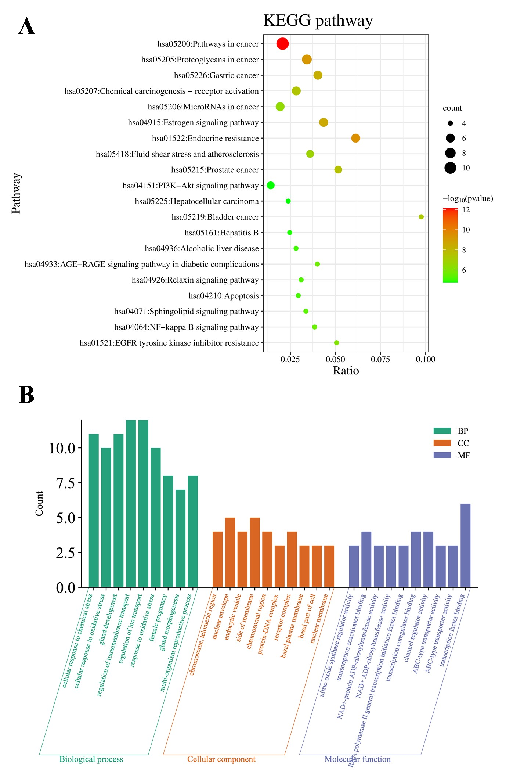

**Fig. S4** Possible mechanism for the anti-cholestatic effect of the DNT Q-markers. (A) KEGG pathway enrichment. The top 20 pathways are shown. (B) GO function enrichment analysis for BP, MF, CC. The top 10 significant terms (P < 0.05) are shown. X coordinate stands for enriched gene function, and Y coordinate stands for enriched gene number.

Table S1 Primers used for q-PCR.

|  |  |  |  |
| --- | --- | --- | --- |
| No. | Gene | Forward | Reverse |
|
| 1 | *Fxr* | ATGTACCAGCCTGAGAACCC | CTCAGCGTGGTGATGGTTGA |
| 2 | *Shp* | AACATTCCAGGCACCCTTCT | GGTCACCTCAGCAAAAGCAT |
| 3 | *Cyp27a1* | TGAACGAGTACCACACCAGG | CATCAGACTATGGCGCAGGT |
| 4 | *Cyp8b1* | CTGGACAAGGGTTTTGTGCC | CCCGCATCCCCTTCAAGAAT |
| 5 | *Bsep* | TCTGACTCAGTGATTCTTCGCA | CCCATAAACATCAGCCAGTTGT |
| 6 | *Ntcp* | CCAGCAGCTCTGGAAAAAGGTA | AGAGTTCAGGCCATTAGGGG |
| 7 | *Tnf* | CGGGCAGGTCTACTTTGGAG | ACCCTGAGCCATAATCCCCT |
| 8 | *Esr1* | CCAGGCTTTGGGGACTTGAAT | GCAAGTTAGGAGCAAACAGGAG |
| 9 | *Egfr* | GCAATGTTCCCATCGCTGTC | CAGGTGTCTTTGCATGTGGC |
| 10 | *Akt1* | TGTTTCTACTGTGGGCAGCA | TGGTCGCGTCAGTCCTTAAT |
| 11 | *Gapdh* | GGCCGAGAATGGGAAGCTTGT | ACATACTCAGCACCGGCCTCA |

Table S2 Characterization of xenobiotic chemicals derived from DNT in mice with ANIT-induced cholestasis.

| No. | Name | Formula | Source | Mass (Da) | RT (min) | Fragment ions (relative abundance%) |
| --- | --- | --- | --- | --- | --- | --- |
|  |  |  |  |  |  |  |
| 1 | eucomic acid | C11H12O6 | CF | 240.0634 | 7.3 | (ESI-)107.0490 (80%);133.0653 (40%);149.0599 (60%);177.0552 (80%);179.0344 (100%);195.0667 (20%);221.0451 (10%);239.0584 (100%) |
| 2 | isotachioside | C13H18O8 | PCRR | 302.1002 | 7.0 | (ESI-)101.0248 (65%);121.0275 (65%);139.0444 (35%);167.06 (65%);180.0623 (35%);195.0548 (65%);211.0862 (65%);223.0873 (35%);301.1246 (100%) |
| 3 | tachioside | C13H18O8 | PCRR | 302.1002 | 7.0 | (ESI-)101.0248 (65%);121.0275 (65%);139.0444 (35%);167.06 (65%);180.0623 (35%);195.0548 (65%);211.0862 (65%);223.0873 (35%);301.1246 (100%) |
| 4 | aloe emodin* | C15H10O5 | RRR | 270.0529 | 12.4 | (ESI+)115.0539 (10%);141.0697 (15%);169.0646 (15%);173.06 (5%);197.0592 (55%);201.055 (10%);225.0546 (45%);229.05 (25%);271.0599 (100%)  (ESI-)182.0384 (10%);197.0616 (20%);210.033 (10%);225.057 (80%);241.0522 (35%);269.0479 (100%) |
| 5 | apigenin* | C15H10O5 | PCRR | 270.0529 | 11.6 | (ESI+)115.0539 (10%);141.0697 (15%);169.0646 (15%);173.06 (5%);197.0592 (55%);201.055 (10%);225.0546 (45%);229.05 (25%);271.0599 (100%)  (ESI-)182.0384 (10%);197.0616 (20%);210.033 (10%);225.057 (80%);241.0522 (35%);269.0479 (100%) |
| 6 | emodin* | C15H10O5 | RRR PCRR | 270.0529 | 14.5 | (ESI+)115.0539 (10%);141.0697 (15%);169.0646 (15%);173.06 (5%);197.0592 (55%);201.055 (10%);225.0546 (45%);229.05 (25%);271.0599 (100%)  (ESI-)182.0384 (10%);197.0616 (20%);210.033 (10%);225.057 (80%);241.0522 (35%);269.0479 (100%) |
| 7 | citreorosein | C15H10O6 | RRR PCRR | 286.0478 | 12.1 | (ESI+)199.0381 (5%);213.0555 (15%);223.0397 (5%);240.0418 (5%);241.0498 (25%);251.0359 (5%);258.0513 (5%);269.0449 (5%);287.0551 (100%)  (ESI-)195.0485 (5%);211.0411 (20%);224.0492 (5%);241.0518 (20%);225.0311 (5%);257.0475 (15%);268.0394 (10%);285.0427 (100%) |
| 8 | kaempferol* | C15H10O6 | RRR PCRR CR CF | 286.0478 | 14.5 | (ESI+)199.0381 (5%);213.0555 (15%);223.0397 (5%);240.0418 (5%);241.0498 (25%);251.0359 (5%);258.0513 (5%);269.0449 (5%);287.0551 (100%)  (ESI-)195.0485 (5%);211.0411 (20%);224.0492 (5%);241.0518 (20%);225.0311 (5%);257.0475 (15%);268.0394 (10%);285.0427 (100%) |
| 9 | luteolin* | C15H10O6 | CR | 286.0478 | 11.0 | (ESI+)199.0381 (5%);213.0555 (15%);223.0397 (5%);240.0418 (5%);241.0498 (25%);251.0359 (5%);258.0513 (5%);269.0449 (5%);287.0551 (100%)  (ESI-)195.0485 (5%);211.0411 (20%);224.0492 (5%);241.0518 (20%);225.0311 (5%);257.0475 (15%);268.0394 (10%);285.0427 (100%) |
| 10 | 13-hydroxygermacrone | C15H22O2 | CR | 234.1621 | 14.0 | (ESI+)123.0435 (5%);179.1059 (60%);219.1410 (5%);235.1698 (100%) |
| 11 | curcumanolide A | C15H22O2 | CR | 234.1621 | 14.0 | (ESI+)123.0435 (5%);179.1059 (60%);219.1410 (5%);235.1698 (100%) |
| 12 | curcumanolide B | C15H22O2 | CR | 234.1621 | 14.0 | (ESI+)123.0435 (5%);179.1059 (60%);219.1410 (5%);235.1698 (100%) |
| 13 | curcumenol | C15H22O2 | CR | 234.1621 | 14.0 | (ESI+)123.0435 (5%);179.1059 (60%);219.1410 (5%);235.1698 (100%) |
| 14 | curcumenone | C15H22O2 | CR | 234.1621 | 14.0 | (ESI+)123.0435 (5%);179.1059 (60%);219.1410 (5%);235.1698 (100%) |
| 15 | gajutsulactone A | C15H22O2 | CR | 234.1621 | 14.0 | (ESI+)123.0435 (5%);179.1059 (60%);219.1410 (5%);235.1698 (100%) |
| 16 | gajutsulactone B | C15H22O2 | CR | 234.1621 | 14.0 | (ESI+)123.0435 (5%);179.1059 (60%);219.1410 (5%);235.1698 (100%) |
| 17 | procurcumenol | C15H22O2 | CR | 234.1621 | 14.0 | (ESI+)123.0435 (5%);179.1059 (60%);219.1410 (5%);235.1698 (100%) |
| 18 | 5-methoxyflavone | C16H12O3 | IR | 252.0787 | 12.2 | (ESI+)108.0204 (5%);136.0154 (5%);210.0678 (15%);237.0543 (15%);238.0625 (100%);253.0858 (30%) |
| 19 | 5,10-dihydroxy-2-methoxy-7-methylanthracene-1,4-dione | C16H12O5 | CR | 284.0685 | 11.9 | (ESI+)139.0533 (3%);168.0563 (15%);183.0793 (3%);196.0515 (15%);211.0746 (35%);224.0461 (5%);239.0698 (20%);242.0564 (35%);252.0441 (5%);285.074 (100%)  (ESI-)184.0543 (2%);212.0487 (5%);240.0449 (100%);268.0391 (2%);283.0635 (25%) |
| 20 | negletein | C16H12O5 | CRP | 284.0685 | 12.4 | (ESI+)139.0533 (3%);168.0563 (15%);183.0793 (3%);196.0515 (15%);211.0746 (35%);224.0461 (5%);239.0698 (20%);242.0564 (35%);252.0441 (5%);285.074 (100%)  (ESI-)184.0543 (2%);212.0487 (5%);240.0449 (100%);268.0391 (2%);283.0635 (25%) |
| 21 | physcion* | C16H12O5 | RRR PCRR | 284.0685 | 11.9 | (ESI+)139.0533 (3%);168.0563 (15%);183.0793 (3%);196.0515 (15%);211.0746 (35%);224.0461 (5%);239.0698 (20%);242.0564 (35%);252.0441 (5%);285.074 (100%)  (ESI-)184.0543 (2%);212.0487 (5%);240.0449 (100%);268.0391 (2%);283.0635 (25%) |
| 22 | questin | C16H12O5 | PCRR | 284.0685 | 16.1 | (ESI+)139.0533 (3%);168.0563 (15%);183.0793 (3%);196.0515 (15%);211.0746 (35%);224.0461 (5%);239.0698 (20%);242.0564 (35%);252.0441 (5%);285.074 (100%)  (ESI-)184.0543 (2%);212.0487 (5%);240.0449 (100%);268.0391 (2%);283.0635 (25%) |
| 23 | wogonin* | C16H12O5 | CR | 284.0685 | 11.9 | (ESI+)139.0533 (3%);168.0563 (15%);183.0793 (3%);196.0515 (15%);211.0746 (35%);224.0461 (5%);239.0698 (20%);242.0564 (35%);252.0441 (5%);285.074 (100%)  (ESI-)184.0543 (2%);212.0487 (5%);240.0449 (100%);268.0391 (2%);283.0635 (25%) |
| 24 | butyl phthalate | C16H22O4 | CR | 278.1519 | 14.3 | (ESI-)175.076 (50%);189.4915 (15%);191.1072 (75%);217.0864 (35%);235.1020 (34%);277.1453 (100%) |
| 25 | isobutyl phthalate | C16H22O4 | CR | 278.1519 | 14.3 | (ESI-)175.076 (50%);189.4915 (15%);191.1072 (75%);217.0864 (35%);235.1020 (34%);277.1453 (100%) |
| 26 | 3',4',5,7-tetramethoxyflavone | C19H18O6 | CRP CRPV | 342.1104 | 12.4 | (ESI+)153.0188 (3%);181.0129 (3%);285.0749 (25%);313.0690 (100%);328.0936 (15%);343.1158 (30%) |
| 27 | 3,5,7,4'-tetramethoxyflavone | C19H18O6 | CRP CRPV | 342.1104 | 12.4 | (ESI+)153.0188 (3%);181.0129 (3%);285.0749 (25%);313.0690 (100%);328.0936 (15%);343.1158 (30%) |
| 28 | 4',5,6,7-tetramethoxyflavone | C19H18O6 | CRP CRPV | 342.1104 | 12.4 | (ESI+)153.0188 (3%);181.0129 (3%);285.0749 (25%);313.0690 (100%);328.0936 (15%);343.1158 (30%) |
| 29 | demethyltangeretin | C19H18O7 | CRP CRPV | 358.1053 | 12.0 | (ESI+)257.0440 (3%);283.0599 (10%);311.0555 (10%);329.0653 (100%);344.0892 (20%);359.1117 (35%)  (ESI-)117.0343 (10%);176.9824 (5%);192.0073 (5%);207.031 (25%);241.0165 (5%);269.0119 (25%);284.0341 (15%);299.0591 (10%);312.0294 (25%);327.0541 (100%);342.0773 (20%);357.1007 (40%) |
| 30 | retusin | C19H18O7 | CRP | 358.1053 | 12.0 | (ESI+)257.0440 (3%);283.0599 (10%);311.0555 (10%);329.0653 (100%);344.0892 (20%);359.1117 (35%)  (ESI-)117.0343 (10%);176.9824 (5%);192.0073 (5%);207.031 (25%);241.0165 (5%);269.0119 (25%);284.0341 (15%);299.0591 (10%);312.0294 (25%);327.0541 (100%);342.0773 (20%);357.1007 (40%) |
| 31 | bonanzin | C19H18O8 | CRP | 374.1002 | 12.7 | (ESI+)197.0069 (5%);302.0412 (3%);327.0482 (35%);330.0353 (5%);345.0596 (100%);360.0844 (20%);375.1064 (90%)  (ESI-)185.0246 (5%);193.0156 (5%);201.0198 (5%);229.0145 (3%);241.0162 (5%);257.0114 (5%);285.0059 (10%);300.0294 (10%);313.0004 (15%);328.0247 (55%);343.0484 (100%);358.0702 (50%);373.095 (40%) |
| 32 | quercetagetin-3,5,6,3'-tetramethyl ether | C19H18O8 | IR | 374.1002 | 12.7 | (ESI+)197.0069 (5%);302.0412 (3%);327.0482 (35%);330.0353 (5%);345.0596 (100%);360.0844 (20%);375.1064 (90%)  (ESI-)185.0246 (5%);193.0156 (5%);201.0198 (5%);229.0145 (3%);241.0162 (5%);257.0114 (5%);285.0059 (10%);300.0294 (10%);313.0004 (15%);328.0247 (55%);343.0484 (100%);358.0702 (50%);373.095 (40%) |
| 33 | 5-demethylnobiletin | C20H20O8 | CRP CRPV | 388.1159 | 13.4 | (ESI+)197.0076 (5%);316.0588 (5%);328.0939 (5%);341.0647 (55%);343.0446 (3%);359.0742 (100%);374.099 (35%);389.1212 (70%) |
| 34 | 7-hydroxy-3,5,6,3',4'-pentamethoxyflavone | C20H20O8 | CRPV | 388.1159 | 13.4 | (ESI+)197.0076 (5%);316.0588 (5%);328.0939 (5%);341.0647 (55%);343.0446 (3%);359.0742 (100%);374.099 (35%);389.1212 (70%) |
| 35 | monohydroxy-pentamethoxyflavone | C20H20O8 | CRP | 388.1159 | 10.6 | (ESI+)197.0076 (5%);316.0588 (5%);328.0939 (5%);341.0647 (55%);343.0446 (3%);359.0742 (100%);374.099 (35%);389.1212 (70%) |
| 36 | 5,4'-dihydroxy-3,6,7,8,3'-pentamethoxyflavone | C20H20O9 | CRP | 404.1108 | 11.5 | (ESI-)148.0172 (3%);163.0391 (5%);200.0069 (3%);215.0334 (3%);231.0356 (5%);245.0987 (3%);270.0546 (5%);287.0259 (5%);299.9921 (5%);315.0167 (20%);330.0391 (20%);343.0116 (45%);358.0358 (90%);373.0582 (100%);388.0818 (80%);403.1 (85%) |
| 37 | graminones B | C21H22O8 | IR | 402.1315 | 12.8 | (ESI+)183.0283 (5%);211.0231 (10%);258.0519 (3%);301.0693 (10%);313.0707 (10%);327.0839 (25%);329.0632 (5%);330.0726 (25%);355.0789 (35%);373.089 (100%);403.1357 (40%) |
| 38 | nobiletin* | C21H22O8 | CRP CRPV | 402.1315 | 12.6 | (ESI+)183.0283 (5%);211.0231 (10%);258.0519 (3%);301.0693 (10%);313.0707 (10%);327.0839 (25%);329.0632 (5%);330.0726 (25%);355.0789 (35%);373.089 (100%);403.1357 (40%) |
| 39 | isovanilline | C8H8O3 | IR | 152.04734 | 7.8 | (ESI+)109.0272 (50%);110.0353 (100%);111.0777 (50%);125.0566 (100%);153.0477 (50%) |
| 40 | vanillin | C8H8O3 | CR | 152.04734 | 7.8 | (ESI+)109.0272 (50%);110.0353 (100%);111.0777 (50%);125.0566 (100%);153.0477 (50%) |
| 41 | ethyl 4-hydroxybenzoate | C9H10O3 | IR | 166.06299 | 12.9 | (ESI+)121.0273 (100%);123.0799 (3%);139.0376 (5%);149.0589 (20%);167.0699 (3%) |
| 42 | paeonol | C9H10O3 | CRPV CR | 166.06299 | 12.9 | (ESI+)121.0273 (100%);123.0799 (3%);139.0376 (5%);149.0589 (20%);167.0699 (3%) |
| 43 | 4-acetylbenzoic acid | C9H8O3 | CRP CRPV | 164.04734 | 12.7 | (ESI+)107.0474 (3%);109.0624 (15%);119.0489 (20%);123.044 (100%);137.0595 (20%);147.0452 (5%);165.0543 (20%) |
| 44 | 4-hydroxycinnamic acid | C9H8O3 | RRR CRP IR | 164.04734 | 12.7 | (ESI+)107.0474 (3%);109.0624 (15%);119.0489 (20%);123.044 (100%);137.0595 (20%);147.0452 (5%);165.0543 (20%) |
| 45 | luteolin-7-glucoside | C21H20O11 | PCRR | 448.38000 | 11.1 | (ESI-)206.0340;268.0378;285.0387;379.2104;447.0925 |

Note: * were confirmed with chemical standard references.

Table S3 The modeling and predictive abilities of OPLS-DA models.

|  |  |  |  |  |
| --- | --- | --- | --- | --- |
| Parameters | ESI+ data | | ESI- data | |
| ANIT vs Control | ANITESI+DNT vs ANIT | ANIT vs Control | ANITESI+DNT vs ANIT |
| Serum |  |  |  |  |
| R2Y | 0.993 | 0.990 | 0.992 | 0.997 |
| Q2 | 0.954 | 0.803 | 0.960 | 0.953 |
| Liver |  |  |  |  |
| R2Y | 0.997 | 0.988 | 0.997 | 0.993 |
| Q2 | 0.962 | 0.960 | 0.971 | 0.931 |

Table S4 The detailed endogenous metabolite identification information.

|  |  |  |  |  |  |  |
| --- | --- | --- | --- | --- | --- | --- |
| No. | | m/z (Da) | tR(min) | Metabolites | Formula | Class |
|  |
| ESI- | 1 | 145.1 | 0.8 | L-Glutamine | C5H10N2O3 | Amino acid |  |
| 2 | 172.1 | 8.2 | I-Acetyl-L-leucine | C8H15NO3 | Amino acid derivatives |  |
| 3 | 277.2 | 13.5 | Octadecatrienoic acid | C18H30O2 | Fatty acid |  |
| 4 | 279.2 | 15.6 | Linoleate | C18H32O2 | Fatty Acyls |  |
| 5 | 281.2 | 14.3 | (11E) -Octadecenoic acid | C18H34O2 | Fatty acid |  |
| 6 | 301.2 | 12.2 | Icosapentaenoic acid | C20H30O2 | Fatty acid |  |
| 7 | 303.2 | 15.5 | Arachidonate | C20H32O2 | Fatty acid |  |
| 8 | 307.3 | 16.1 | Icosadienoic acid | C20H36O2 | Fatty acid |  |
| 9 | 464.3 | 13.6 | Glycocholate | C26H43NO6 | Amino acid |  |
| 10 | 802.6 | 15.6 | PC (P-18:0) | C44H86NO9P | Phosphatidylcholine |  |
| 11 | 829.6 | 18.2 | SM(d20:1/PGF1alpha) | C45H87N2O9P | Sphingomyelin |  |
| 12 | 515.7 | 11.6 | Taurocholic acid | C26H45NO7S | Bile acid |  |
| 13 | 456.6 | 12.2 | Glycocholic acid | C26H43NO6 | Bile acid |  |
| 14 | 499.7 | 13.9 | Taurochenodeoxycholic acid | C26H45NO6S | Bile acid |  |
| ESI+ | 1 | 132.1 | 2.5 | L-Isoleucine | C6H13NO2 | Amino acid |  |
| 2 | 166.1 | 4.1 | L-Phenylalanine | C9H11NO2 | Amino acid |  |
| 3 | 169.0 | 1.8 | Urate | C5H4N4O3 | Purine |  |
| 4 | 188.1 | 5.9 | Tryptophan | C11H12N2O2 | Amino acid |  |
| 5 | 203.1 | 0.9 | Adipoylglycine | C8H13NO5 | Amino acid derivatives |  |
| 6 | 498.3 | 15.4 | Taurallocholic acid | C26H45NO7S | Bile acids |  |
| 7 | 524.4 | 15.6 | LysoPC (18:0) | C26H54NO7P | Phosphatidylcholine |  |
| 8 | 782.6 | 16.0 | PA (22:1(13Z)) | C45H83O8P | Phosphatidic acid |  |
| 9 | 782.6 | 16.1 | PE (P-18:1(9Z)) | C45H84NO7P | Phospholipids |  |
| 10 | 784.6 | 16.6 | PC (22:4(7Z,10Z,13Z,16Z)) | C48H86NO7P | Phosphatidylcholine |  |
| 11 | 784.6 | 16.5 | SM (d18:2(4E,14Z)) | C43H79N2O7P | Sphingomyelin |  |
| 12 | 785.6 | 14.9 | PA (20:2(11Z,14Z)) | C45H85O8P | Phosphatidic acid |  |

Table S5 Potential biomarkers in serum responsible for the protective effect of DNT against ANIT-induced injury in mice.

|  |  |  |  |  |  |
| --- | --- | --- | --- | --- | --- |
| No. | RT (min) | Identification | Mass accuracy (ppm) | Fold change | |
| ANIT/ Control | ANIT+DNT /ANIT |
| 1 | 11.6 | taurocholic acid | -3.6 | 24.98 ↑ | 0.45 ↓ |
| 2 | 12.2 | glycocholic acid | 0.2 | 4.01 ↑ | 0.62 ↓ |
| 3 | 13.9 | taurochenodeoxycholic acid | -1.1 | 5.31 ↑ | 0.51 ↓ |

↑ indicates up-regulated in mice while ↓ means down-regulated in mice.

Table S6 Potential biomarkers in liver responsible for the protective effect of DNT against ANIT-induced injury in mice.

|  |  |  |  |  |  |
| --- | --- | --- | --- | --- | --- |
| No. | RT (min) | Identification | Mass accuracy (ppm) | Fold change | |
| ANIT/ Control | ANIT+DNT /ANIT |
| 1 | 11.6 | taurocholic acid | 0.7 | 4.13 ↑ | 0.66 ↓ |
| 2 | 12.2 | glycocholic acid | -0.7 | 22.53 ↑ | 0.53 ↓ |
| 3 | 13.9 | taurochenodeoxycholic acid | 0.1 | 4.36 ↑ | 0.54 ↓ |

↑ indicates up-regulated in mice while ↓ means down-regulated in mice.