**The Enhanced adsorption of Layered Double Hydroxides modification from single to ternary metal for fluoride by TEA-assisted hydrothermal method**

Tian Huiyuana†, Li Yanga†, Xia Mengyana, Cui Baoyua, Liu Changa, Du Xiuhong c, Wang Zehua a, Duan Xianyingd,e1,Cui Jiehu a,b[1]

a School of Materials science and Engineering, Zhengzhou University of Aeronautics, Zhengzhou, P.R. China;

bHenan Engineering Research Center for Ceramic Materials Interface, Zhengzhou University of Aeronautics, Zhengzhou, P.R. China.

cClinical Laboratory Medicine, Henan Medical College, Zhengzhou, P.R. China

d School of Medicine, Huanghe Science and Technology University, Zhengzhou, P.R. China

eInstitute of Chemistry, Henan Academy of Sciences, Zhengzhou, Henan, 450002, PR China

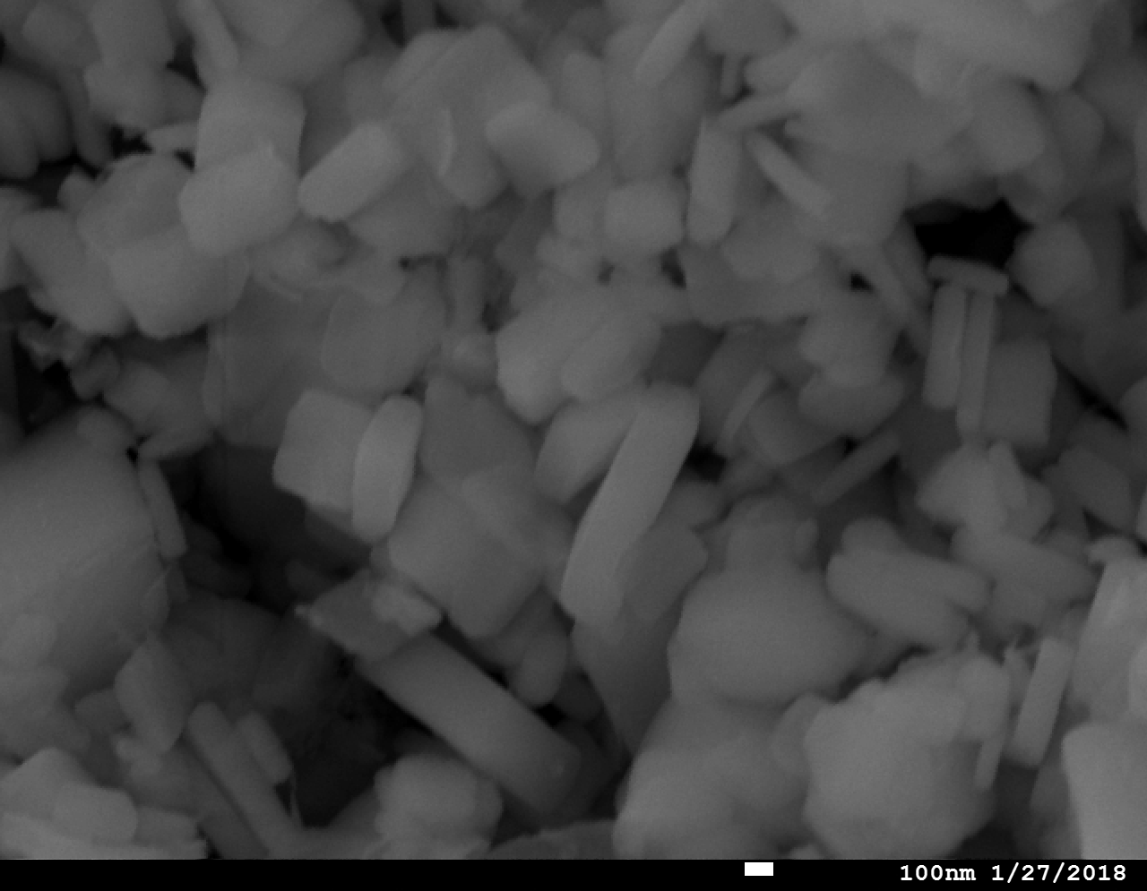

Zn-LDHs

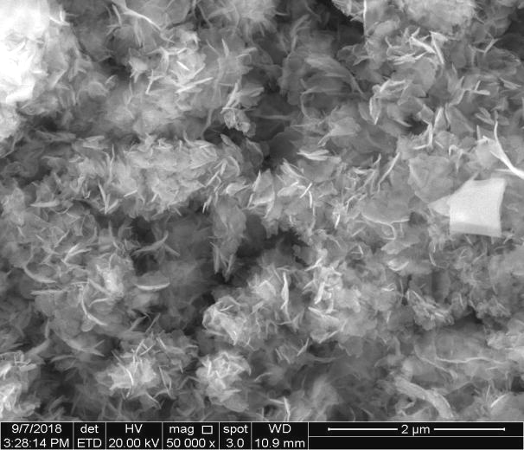

ZnCo-LDHs

Fig.S1 SEM of Zn-LDHs and ZnCo-LDHs

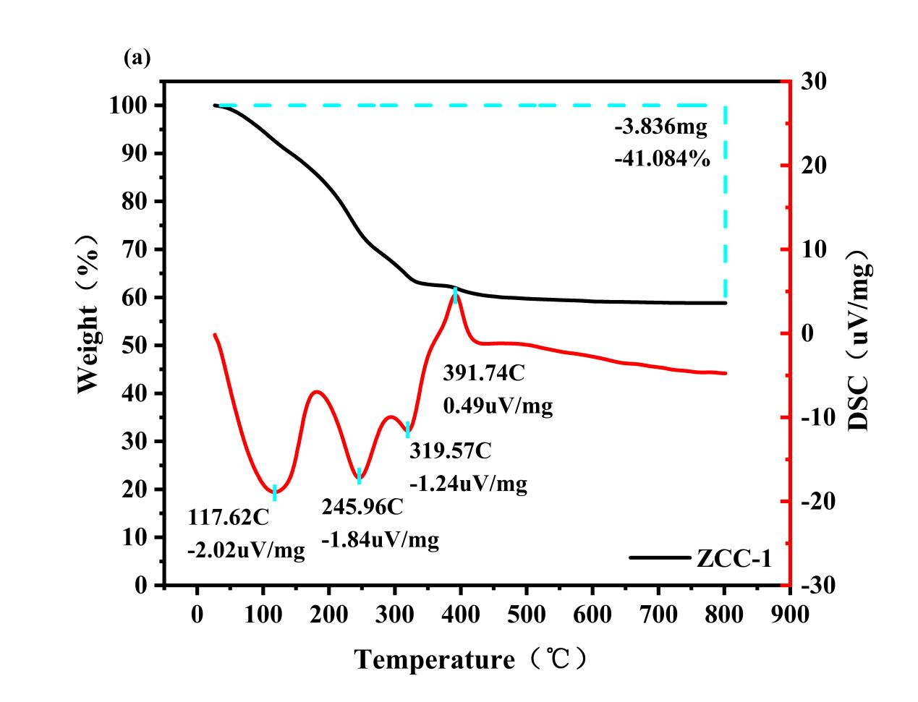

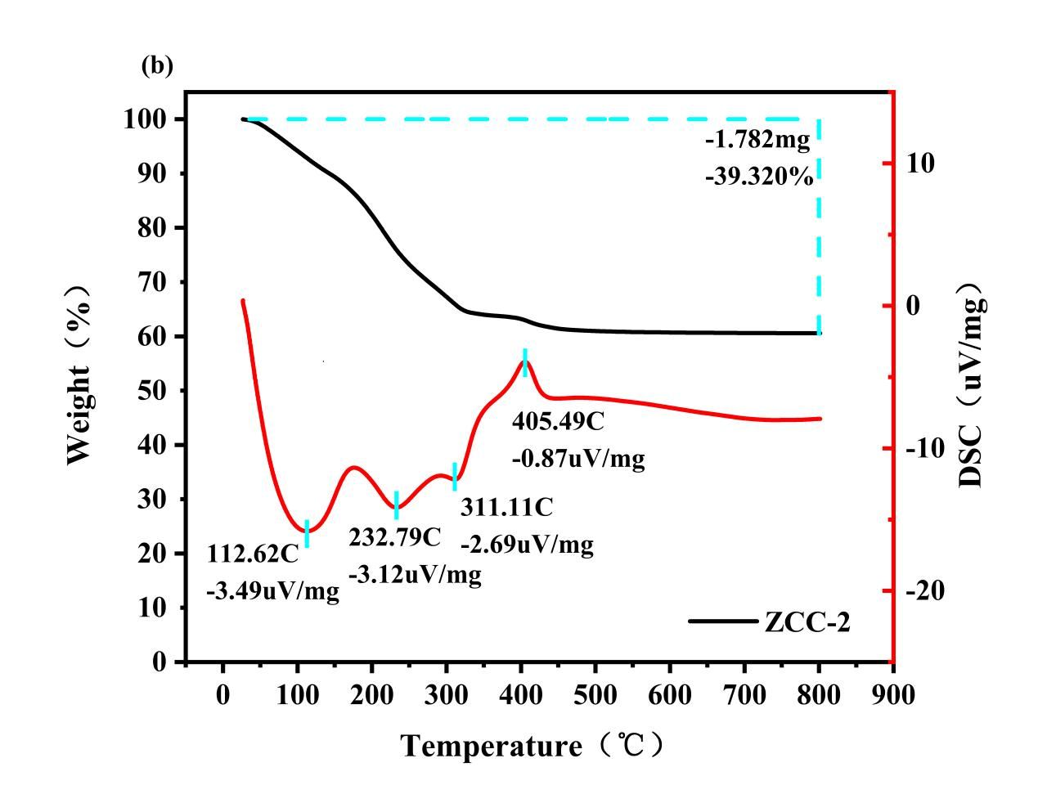

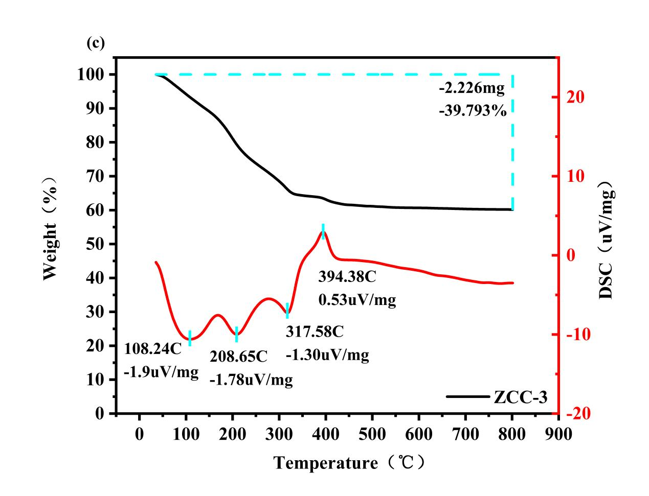

Fig.S2 TG-DSC of ZCC-1（a）、ZCC-2（b）and ZCC-3（c）

1. Corresponding author. Tel: +86 0371-61912901; Fax:+86 0371-61912901 *E-mail address*: *[cuijiehu@163.com](mailto:cuijiehu@163.com),[dxynumber@163.com](mailto:dxynumber@163.com)*

   †These authors contributed equally to this work