**1. Preparation of SJY**

Detailed information about the prescription was as following: Mori Folium (dried leaves of *Morous alba* L., Jiangsu, China, 7.5 g) and Chrysanthemi Flos (dry head of *Chrysanthemum morifolium* Ramat., Henan, China, 3 g) disperse the upper scorching wind heat, and Mori Folium can clear the lung heat and stop coughing, acting as the principal drug; Menthae Haplocalycis Herba (Dry aboveground part of *Mentha haplocalyx* Briq., Jiangsu, China, 2.5 g) is used to help Mori Folium and Chrysanthemi Flos disperse wind heat; Armeniacae Semen Amarum (dried mature seeds of *Prunus armeniaca* L., Hebei, China, 6 g) and Platycodonis Radix (dry root of *Platycodon grandiflorum* (Jacq.) A. DC., Heilongjiang, China, 6 g) can relieve cough by promoting lung qi; Forsythiae Fructus (dried fruit of *Forsythia suspensa* (Thunb.) Vahl, Shanxi, China, 5 g) can clear heat and detoxify the bitter cold, and Phragmitis (dry rhizome of *Phragmites communis* Trin., Hebei, China, 6 g) can clear heat and produce saliva and quench thirst, they are all adjuvants; Glycyrrhizae Radix Et Rhizoma (dried roots and rhizomes of *Glycyrrhiza uralensis* Fisch., Inner Mongolia, China, 2.5 g) was the conductant drug.

All herbs in SJY (7.5 g Mori Folium, 3 g Chrysanthemi Flos, 6 g Armeniacae Semen Amarum, 5 g Forsythiae Fructus, 2.5 g Menthae Haplocalycis Herba, 6 g Platycodonis Radix, 2.5 g Glycyrrhizae Radix et Rhizoma and 6 g Phragmitis) were purchased from Tong-Ren-Tang Pharmacy (Qiqihar, China).

The herbs were steeped in pure water for 30 min, then boiled (20 min, 1:8, twice) and filtered. The liquid from the decoction was collected twice and then the aqueous extract was concentrated by heat evaporation.

The authentication of herbal drugs was carried out by Associate Professor Wenbao Wang (Traditional Chinese Medicine Teaching and Research Office, Qiqihar Medical University, Qiqihar, China).

**2. UFLC-ESI-QTOF-MS condition of component analysis**

For *in vitro* component analysis, SJY was diluted by methanol (then centrifugated and filtered with 0.22 μm filter) as *in vitro* sample. On the aspect of *in vivo* sample, 1 mL plasma was mixed with 3 mL methanol, vortexed (3 min), then centrifugated (12,000 rpm, 4 ℃, 5 min). Supernatants were transferred and evaporated to dry under 30 ℃ N2, then 50 μL methanol was added, vortexed (3 min), ultrasound extracted (5 min), and centrifugated (12,000 rpm, 4 ℃, 5 min). All samples were analyzed through the following UFLC-ESI-QTOF-MS system.

Liquid phase condition: The column temperature was maintained at 30 °C and the flow rate was 0.4 mL·min-1. Mobile phase A was water containing 0.1% formic acid and mobile phase B was acetonitrile containing 0.1% formic acid. The elute gradient was set as follows: 0–2 min, 5% B; 2–15 min, B increased to 98%; 15–22.0 min, B was maintained at 98%; 22.0–22.1 min, B was declined linearly from 98% to 5%, 22.1–32 min, 5%.

Mass spectrum condition: A typical information dependent acquisition (IDA) was used to carry out the MS/MS experiment. The optimized MS parameters were listed in **Table** **S1**. Nitrogen was used as a nebulizer and auxiliary gas. Continuous recalibration was carried out every 2 h using an Auto Calibration Delivery System (CDS). Analyst software (version 1.7, Sciex) was used for operations.

Involved materials: UFLC grade formic acid was from Shandong Yuwang Industrial Co., Ltd. (Yucheng, China). Distilled water was obtained from Wahaha Co., Ltd. (Hangzhou, China). Both methanol and acetonitrile of UFLC grade were provided by Fisher Scientific (Fair Lawn, NJ, USA).

The components in SJY were identified by comparing MS/MS spectrum and accurate mass with authentic standards or relevant papers or public databases, for instance, Massbank (<http://www.massbank.jp>), HMDB (<http://www.hmdb.ca/>), mzCloud (<https://www.mzcloud.org/>) and GNPS (https://gnps.ucsd.edu/).

**Table S1** List of TOF/MS parameters, ionspray voltage floating (ISVF), the turbo spray temperature (TEM), declustering potential (DP), collision gas (CE), nebulizer gas (Gas 1), heater gas (Gas 2) and curtain gas for positive and negative ionization mode.

|  |  |  |
| --- | --- | --- |
| **Parameters** | **positive mode** | **negative mode** |
| ISVF | 5500 V | -4500 V |
| TEM | 550 °C | 550 °C |
| DP | 100 V | -80 V |
| CE | 30 eV | -10 eV |
| Gas 1 | 50 psi | 50 psi |
| Gas 2 | 50 psi | 50 psi |
| Curtain gas | 30 psi | 30 psi |

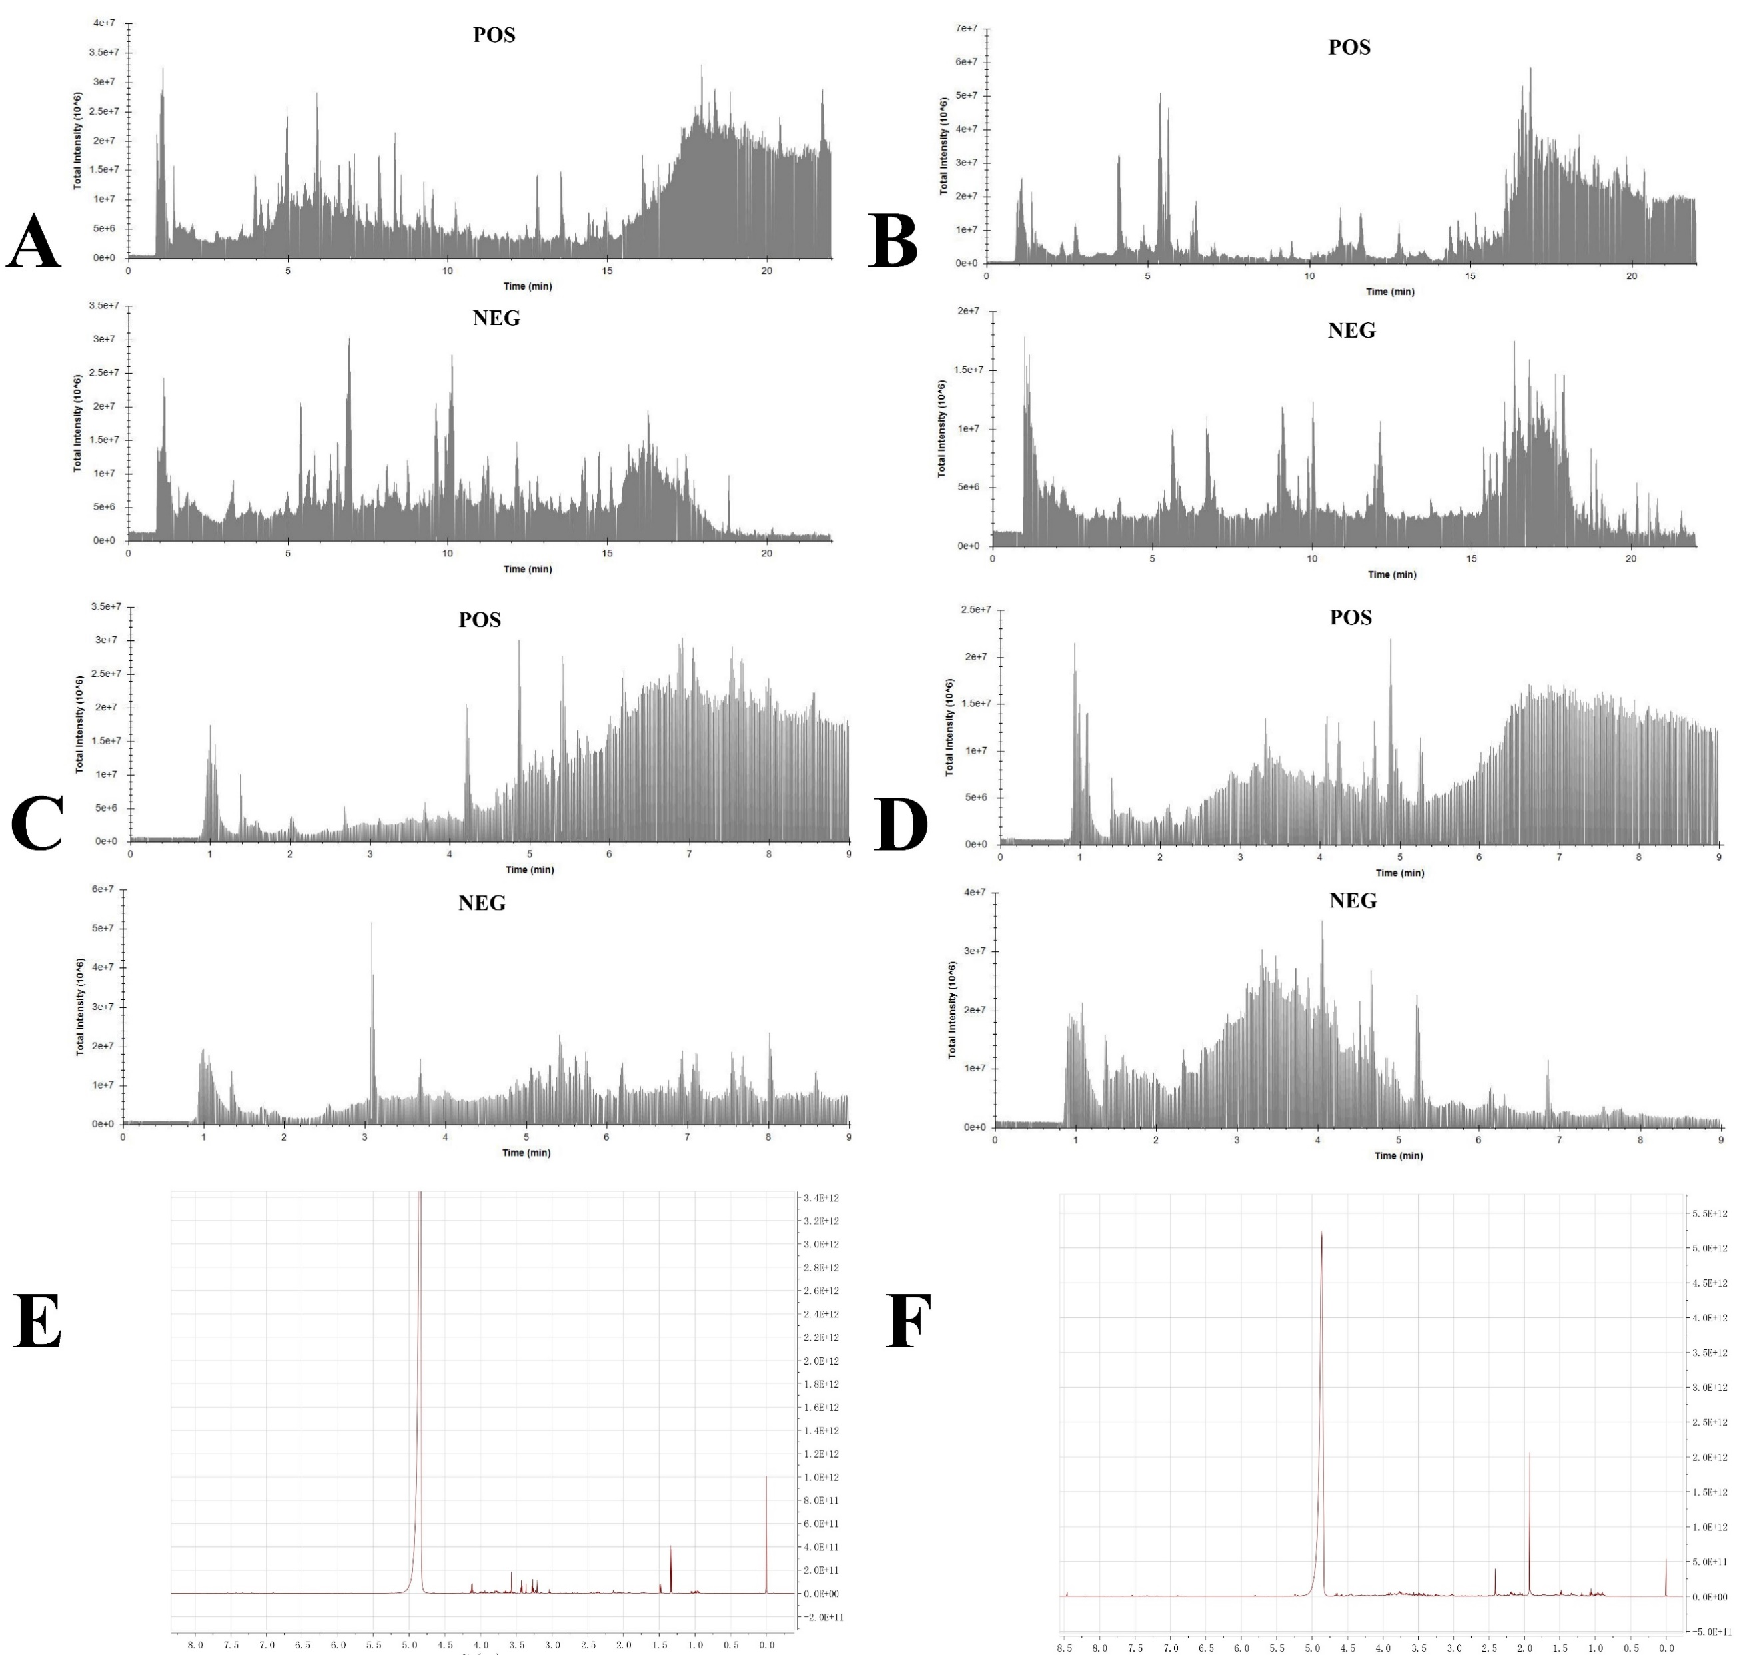

**Fig. S1**  Total ion chromatograms (TICs) of SJY *in vitro* (A) and *in vivo* analyses (B); representative TICs of pulmonary (C) and fecal (D) LC-MS metabolomic analyses; representative spectra of pulmonary (E) and fecal (F) 1H-NMR metabolomic analyses.

,

**Table S2** Characterization of ingredients in SJY by UFLC-ESI-QTOF-MS.

**\***: The absorptive ingredients in rat plasma; **#**: conﬁrmed by authentic standards.

|  |  |  |  |  |  |  |
| --- | --- | --- | --- | --- | --- | --- |
| **No.** | **Compound** | **Formula** | **Ion adduction** | **tR/ min** | **Error/ Δppm** | **Attribution** |
| 1 | Isoferulic Acid | C10H10O4 | [M+H]+ | 6.4 | 7.9 | 1,5 |
| 2 | Ferulic Acid**\*#** | C10H10O4 | [M+H-H2O]+ | 8.1 | 8.3 | 1,4,7 |
| 3 | Dimethyl phthalate | C10H10O4 | [M+H-CH4O]+ | 10.2 | 1.9 | 5,7 |
| 4 | Cyclic guanosine monophosphate | C10H12N5O7P | [M-H]- | 2.4 | 3.5 | 1,7 |
| 5 | Adenosine | C10H13N5O4 | [M+H]+ | 1.8 | 6.7 | 6,8 |
| 6 | PyroGlu-Pro | C10H14N2O4 | [M+H]+ | 3.3 | 4.8 | 1,7 |
| 7 | D-1-[(3-Carboxypropyl)amino]-1-deoxyfructose | C10H19NO7 | [M+H]+ | 1.1 | 7.6 | 1,2 |
| 8 | Thr-Leu | C10H20N2O4 | [M+H]+ | 3.4 | 1.3 | 1,7 |
| 9 | Fraxidin | C11H10O5 | [M+H]+ | 6.6 | 7.2 | 7,8 |
| 10 | N-Acetyl-L-phenylalanine | C11H13NO3 | [M-H]- | 9.1 | 8.2 | 1,5 |
| 11 | 4-Allyl-2,6-dimethoxyphenol | C11H14O3 | [M+H]+ | 7.6 | 8.7 | 1,6,7 |
| 12 | Sinapyl alcohol | C11H14O4 | [M+H-H2O]+ | 5.4 | 8.3 | 1,3 |
| 13 | 1-Methyladenosine | C11H15N5O4 | [M+H]+ | 3.2 | 6.1 | 6,8 |
| 14 | 5'-Deoxy-5'-(methylsulfinyl)adenosine | C11H15N5O4S | [M+H]+ | 1.6 | 4.8 | 6,8 |
| 15 | Loliolide**\*** | C11H16O3 | [M+H]+ | 6.9 | 7.1 | 2 |
| 16 | N-Fructosyl pyroglutamate | C11H17NO8 | [M-H]- | 1.2 | 5.1 | 5,7 |
| 17 | Undecanedioic acid | C11H20O4 | [M-H]- | 16.1 | 3.3 | 5 |
| 18 | Abrine | C12H14N2O2 | [M+H-CH3NH2]- | 4.2 | 0.6 | 1,2,7 |
| 19 | 12-Hydroxyjasmonic Acid | C12H18O4 | [M+H]+ | 5.7 | 8.4 | 1,2,7 |
| 20 | 12-Hydroxyjasmonate sulfate | C12H18O7S | [M-H]- | 7.4 | 3.9 | 1,2,7 |
| 21 | 4-Oxododecanedioic Acid | C12H20O5 | [M+NH4]+ | 8.1 | 3.0 | 7 |
| 22 | Sucrose | C12H22O11 | [M+H-H2O]+ | 1.2 | 6.5 | 1,2 |
| 23 | Lactulose | C12H22O11 | [M+NH4]+ | 1.2 | 7.5 | 3,7 |
| 24 | Trehalose | C12H22O11 | [M-H]- | 1.2 | 4.1 | 1,2,3,5,6,7 |
| 25 | Dodecanedioic acid | C12H22O4 | [M-H]- | 16.4 | 3.9 | 1,4,5,7 |
| 26 | 9-(2,3-dihydroxypropoxy)-9-oxononanoic acid | C12H22O6 | [M-H]- | 11.4 | 3.0 | 5,7 |
| 27 | Fructoselysine | C12H24N2O7 | [M+H]+ | 1.0 | 10.0 | 1,7 |
| 28 | 1,2,3,4-tetrahydroharmane-3-carboxylic acid | C13H14N2O2 | [M+H]+ | 5.1 | 1.7 | 1,8 |
| 29 | N-Acetyl-DL-tryptophan | C13H14N2O3 | [M-H]- | 10.2 | 1.6 | 1,7 |
| 30 | Dibenzylamine | C14H15N | [M+H]+ | 6.2 | 8.1 | 1 |
| 31 | Prunasin | C14H17NO6 | [M-H]- | 8.1 | 6.8 | 3 |
| 32 | Feruloyl putrescine | C14H20N2O3 | [M+H]+ | 4.7 | 2.1 | 1,2,7 |
| 33 | Phenylethyl Beta-D-Glucopyranoside**\*** | C14H20O6 | [M+NH4]+ | 5.8 | 7.0 | 1,2,5 |
| 34 | Salidroside | C14H20O7 | [M+NH4]+ | 4.4 | 3.5 | 4 |
| 35 | 2-Hydroxy-4-(2-Hydroxyethyl)Phenyl-Beta-D-Glucopyranoside | C14H20O8 | [M+H]+ | 2.0 | 6.5 | 1,2,5 |
| 36 | 2,4,7,9-Tetramethyl-5-decyne-4,7-diol | C14H26O2 | [M+H-2H2O]+ | 21.7 | 3.0 | 1,2,5 |
| 37 | Daidzein**\*** | C15H10O4 | [M+H]+ | 8.5 | 6.2 | 7 |
| 38 | 7,4'-Dihydroxyflavone**\*** | C15H10O4 | [M-H]- | 14.2 | 2.4 | 7 |
| 39 | Apigenin**\*#** | C15H10O5 | [M+H]+ | 10.5 | 7.3 | 1,2,3,5 |
| C15H10O5 | [M-H]- | 10.9 | 1.9 | 1,2,3,5 |
| 40 | Luteolin | C15H10O6 | [M-H]- | 15.5 | 2.0 | 1,2,3,4,5,6 |
| 41 | Kaempferol**#** | C15H10O6 | [M+H]+ | 7.2 | 4.9 | 1,2,3,4,5,6 |
| 42 | Quercetin**#** | C15H10O7 | [M+H]+ | 9.1 | 6.8 | 1,2,4,7,8 |
| 43 | Isoliquiritigenin**\*#** | C15H12O4 | [M+H]+ | 8.7 | 7.0 | 3,7 |
| 44 | Liquiritigenin**\*#** | C15H12O4 | [M+H]+ | 4.9 | 4.1 | 7 |
| 45 | Naringenin**\*#** | C15H12O5 | [M+H]+ | 7.8 | 5.8 | 2,5,7 |
| 46 | Naringenin chalcone**\*** | C15H12O5 | [M+H]+ | 6.8 | 0.7 | 7 |
| 47 | Achalensolide**\*** | C15H18O3 | [M+H]+ | 11.2 | 3.2 | 2 |
| 48 | 4-O-Beta-D-Glucosyl-4-Coumaric Acid**\*** | C15H18O8 | [M+NH4]+ | 4.9 | 7.0 | 7 |
| 49 | 10,12-dihydroxy-9-methyl-4,13-dimethylene-6-oxatricyclo[7.4.0.0<3,7>]tridecan- 5-one | C15H20O4 | [M+H-H2O]+ | 16.3 | 5.1 | 1,2,7 |
| 50 | Abscisic acid**\*** | C15H20O4 | [M-H]- | 14.9 | 2.1 | 7 |
| 51 | N-(1-Deoxy-1-fructosyl)phenylalanine | C15H21NO7 | [M+H]+ | 2.9 | 8.0 | 2,5,7 |
| 52 | 1-methyl-4-methylidene-7-(propan-2-yl)-1,2,3,3a,4,5,6,8a-octahydroazulen-1-ol | C15H24O | [M+H-H2O]- | 21.7 | 1.8 | 5 |
| 53 | 2,6-Di-tert-butyl-4-hydroxymethylphenol | C15H24O2 | [M+H-H2O]+ | 16.2 | 5.0 | 7 |
| 54 | 1-methyl-4-(6-methylhept-5-en-2-yl)-2,3-dioxabicyclo[2.2.2]oct-5-ene | C15H24O2 | [M+H-2H2O]+ | 8.8 | 9.9 | 8 |
| 55 | (-)-Isolongifolol | C15H26O | [M+H-H2O]+ | 12.1 | 8.8 | 8 |
| 56 | Formononetin**\*#** | C16H12O4 | [M+H]+ | 7.9 | 8.5 | 7 |
| C16H12O4 | [M-H]- | 8.5 | 3.0 | 7 |
| 57 | Acacetin**\*#** | C16H12O5 | [M+H]+ | 8.5 | 4.7 | 2,3,5,6 |
| C16H12O5 | [M-H]- | 7.7 | 3.2 | 2,3,5,6 |
| 58 | 3-(2,4-dihydroxyphenyl)-7-hydroxy-5-methoxychromen-4-one | C16H12O6 | [M+H]+ | 7.1 | 3.0 | 1,2,7 |
| 59 | Diosmetin | C16H12O6 | [M-H]- | 16.2 | 4.7 | 2,5 |
| 60 | Licochalcone B | C16H14O5 | [M-H]- | 14.7 | 0.0 | 3,7 |
| 61 | Hesperetin**#** | C16H14O6 | [M+H]+ | 11.1 | 4.8 | 2 |
| C16H14O6 | [M-H]- | 12.3 | 2.3 | 2 |
| 62 | Homoeriodictyol**\*** | C16H14O6 | [M+H]+ | 7.2 | 1.6 | 7 |
| 63 | Chlorogenic acid**\*#** | C16H18O9 | [M+H]- | 5.6 | 7.3 | 1,2 |
| C16H18O9 | [M-H]+ | 4.8 | 6.4 | 1,2 |
| 64 | (2S,3S,4S,5R,6R)-6-(3-benzoyloxy-2-hydroxypropoxy)-3,4,5-trihydroxyoxane-2-carboxylic acid | C16H20O10 | [M-H]- | 8.5 | 0.6 | 2,7 |
| 65 | Mussaenosidic Acid**\*** | C16H24O10 | [M-H]- | 5.4 | 6.1 | 1 |
| 66 | Pyrenophorol | C16H24O6 | [M-H]- | 20.3 | 5.6 | 1,2 |
| 67 | 7-methyl-1-[(2S,3R,4S,5S,6R)-3,4,5-trihydroxy-6-(hydroxymethyl)oxan-2-yl]oxy-1,4a,5,6,7,7a-hexahydrocyclopenta[c]pyran-4-carboxylic acid | C16H24O9 | [M-H]- | 9.4 | 7.5 | 5 |
| 68 | Palmitamide | C16H33NO | [M+H]+ | 18.2 | 0.4 | 1,7 |
| 69 | 3,6-Dimethoxyquercetagetin | C17H14O8 | [M+H]+ | 9.8 | 6.6 | 2 |
| 70 | 3-O-Feruloylquinic acid | C17H20O9 | [M-H]- | 8.5 | 2.5 | 7 |
| 71 | 1-Beta-D-Glucopyranosyl-L-Tryptophan | C17H22N2O7 | [M+H]+ | 4.0 | 4.7 | 1,7 |
| 72 | (1S)-1alpha-(beta-D-Glucopyranosyloxy)-1,4aalpha,5,6,7,7aalpha-hexahydrocyclopenta[c]pyran-4,7alpha-dicarboxylic acid 4-methyl ester | C17H24O11 | [M-H]- | 8.2 | 4.5 | 5 |
| 73 | cis-7-Hexadecenoic acid methyl ester | C17H32O2 | [M+H]+ | 21.7 | 8.3 | 2 |
| 74 | Jaceidin | C18H16O8 | [M-H]- | 16.5 | 5.0 | 2 |
| 75 | 5,8,4'-Trihydroxy-6,7,3'-Trimethoxyflavone | C18H16O8 | [M+H]+ | 10.9 | 2.3 | 1,2,7 |
| 76 | Rosmarinic acid | C18H16O8 | [M-H]- | 12.9 | 3.3 | 5 |
| 77 | N-Feruloyltyramine | C18H19NO4 | [M+H]+ | 8.4 | 8.9 | 7 |
| 78 | Licoagroside B | C18H24O12 | [M+H]+ | 6.6 | 8.8 | 7 |
| C18H24O12 | [M-H]- | 7.0 | 7.4 | 7 |
| 79 | 9-OxoOTrE | C18H28O3 | [M+H-H2O]+ | 10.7 | 5.4 | 1,2 |
| 80 | 13-Keto-9Z,11E-octadecadienoic acid | C18H30O3 | [M+H]+ | 17.1 | 1.7 | 3,7 |
| 81 | 13S-Hydroxy-9Z,11E,15Z-octadecatrienoic acid | C18H30O3 | [M+H-H2O]+ | 21.8 | 1.1 | 3,7 |
| 82 | 9-Oxo-10E,12Z-octadecadienoic acid | C18H30O3 | [M+H]+ | 16.6 | 3.3 | 3,7 |
| 83 | Raffinose | C18H32O16 | [M+Cl]- | 1.6 | 0.8 | 3 |
| 84 | 9(10)-EpOME | C18H32O3 | [M+H-H2O]+ | 17.0 | 4.3 | 3 |
| 85 | (10E,15E)-9,12,13-trihydroxyoctadeca-10,15-dienoic acid | C18H32O5 | [2M-H]- | 16.1 | 3.5 | 1,2,6 |
| 86 | cis,cis-9,12-Octadecadien-1-ol | C18H34O | [M+H]+ | 19.3 | 4.9 | 1 |
| 87 | 12,13-DiHOME | C18H34O4 | [M-H]- | 17.1 | 1.9 | 3 |
| 88 | 9-Octadecenamide | C18H35NO | [M+H]+ | 18.4 | 2.1 | 7 |
| 89 | Palmitoyl ethanolamide | C18H37NO2 | [M+H]+ | 17.9 | 1.6 | 3 |
| 90 | Sphingosine 1-Phosphate | C18H38NO5P | [M+H]+ | 16.1 | 7.1 | 3 |
| 91 | Tetradecyldiethanolamine | C18H39NO2 | [M+H]+ | 15.9 | 4.2 | 1,3 |
| 92 | 5,7,8-trimethoxy-2-methyl-3-phenylchromen-4-one | C19H18O5 | [M+H]+ | 15.0 | 3.9 | 1,2,7 |
| 93 | 5-Hydroxy-2',4',7,8-Tetramethoxyflavone | C19H18O7 | [M+H]+ | 15.8 | 2.5 | 1,2,7 |
| 94 | Bonanzin | C19H18O8 | [M+H]+ | 14.9 | 2.7 | 1,2,7 |
| 95 | [(4S,4aR,5S,8S,8aS)-4-acetyloxy-3,4a,5-trimethyl-9-oxo-4,5,6,7,8,8a-hexahydrobenzo[f][1]benzofuran-8-yl] acetate | C19H24O6 | [M+H-H2O]- | 8.1 | 6.1 | 1,7 |
| 96 | (2S,3R,4S,5R)-2-[(2R,3R,4S,5S,6R)-4,5-dihydroxy-6-(hydroxymethyl)-2-(2-phenylethoxy)oxan-3-yl]oxyoxane-3,4,5-triol | C19H28O10 | [M+NH4]+ | 5.7 | 2.1 | 4,7 |
| 97 | 3,5,5-Trimethyl-4-[3-(Beta-D-Glucopyranosyloxy)Butyl]-2-Cyclohexene-1-One | C19H32O7 | [M+H]+ | 6.6 | 8.5 | 4,7 |
| 98 | 1-Hexadecanoyl-sn-glycerol | C19H38O4 | [M+H]+ | 18.4 | 6.4 | 3 |
| 99 | Licoflavone A | C20H18O4 | [M+H]+ | 14.9 | 8.0 | 7 |
| 100 | 4-(8-prop-1-en-2-yl-3,4,8,9-tetrahydro-2H-furo[2,3-h]chromen-3-yl)benzene-1,3-diol | C20H20O4 | [M-H]- | 17.3 | 3.4 | 1,7 |
| 101 | 5-O-Demethylnobiletin | C20H20O8 | [M+H]+ | 16.2 | 8.0 | 1,2 |
| 102 | Matairesinol | C20H22O6 | [M+H]+ | 7.4 | 4.7 | 3,4 |
| 103 | Pinoresinol**\*** | C20H22O6 | [M+H-H2O]- | 9.5 | 5.5 | 4 |
| 104 | Lariciresinol | C20H24O6 | [M-H]- | 13.8 | 0.5 | 4 |
| 105 | Hydroquinidine**\*** | C20H26N2O2 | [M-H]- | 21.1 | 3.9 | 1,2 |
| 106 | 2,3-bis[(4-hydroxy-3-methoxyphenyl)methyl]butane-1,4-diol | C20H26O6 | [M+H-2H2O]+ | 9.6 | 7.0 | 3 |
| C20H26O6 | [M-H]- | 10.2 | 6.7 | 3 |
| 107 | Amygdalin**\*#** | C20H27NO11 | [M+Na]+ | 5.0 | 2.4 | 3 |
| C20H27NO11 | [M-H]- | 5.6 | 1.7 | 1,3 |
| 108 | 2-phenyl-2-[(2S,3R,4S,5S,6R)-3,4,5-trihydroxy-6-[[(2R,3R,4S,5S,6R)-3,4,5-trihydroxy-6-(hydroxymethyl)oxan-2-yl]oxymethyl]oxan-2-yl]oxyacetamide**\*** | C20H29NO12 | [M+H]+ | 4.9 | 4.5 | 5 |
| C20H29NO12 | [M+FA-H]- | 4.5 | 6.5 | 5 |
| 109 | Acetyl tributyl citrate | C20H34O8 | [M+H]+ | 17.8 | 3.9 | 1,2,7 |
| 110 | Apigenin 7-glucuronide**\*** | C21H18O11 | [M-H]- | 12.4 | 5.8 | 2,3,5 |
| 111 | Breviscapine**\*** | C21H18O12 | [M+H]+ | 6.2 | 5.2 | 2,7 |
| 112 | Luteolin 7-Glucuronide**\*** | C21H18O12 | [M-H]- | 10.5 | 5.4 | 2,3,4,5,6 |
| 113 | Quercetin 3-O-Glucuronide**\*** | C21H18O13 | [M+H]+ | 6.8 | 12.6 | 1,2,7 |
| C21H18O13 | [M-H]- | 6.1 | 4.4 | 1,2,7 |
| 114 | Apigetrin**\*** | C21H20O10 | [M+H]+ | 7.0 | 3.6 | 1,2,7 |
| 115 | Genistin | C21H20O10 | [M-H]- | 12.2 | 6.4 | 1,2,7 |
| 116 | Luteoloside | C21H20O11 | [M+H]+ | 6.8 | 1.7 | 2,3,5 |
| C21H20O11 | [M-H]- | 7.5 | 7.2 | 2,3,5 |
| 117 | Astragalin**\*#** | C21H20O11 | [M-H]- | 11.8 | 7.0 | 1,4,7 |
| 118 | Quercetin 3-O-Beta-D-Glucofuranoside | C21H20O12 | [M+H]+ | 6.2 | 2.8 | 1,2,4,7,8 |
| 119 | Isoquercitin**#** | C21H20O12 | [M-H]- | 10.4 | 5.6 | 1,2,3,4,7 |
| 120 | Prunin | C21H22O10 | [M-H]- | 12.1 | 3.5 | 5,7 |
| 121 | 3,5-dihydroxy-2-(4-hydroxyphenyl)-7-[3,4,5-trihydroxy-6-(hydroxymethyl)oxan-2-yl]oxy-2,3-dihydrochromen-4-one | C21H22O11 | [M-H]- | 8.0 | 5.3 | 7 |
| 122 | Eriodictyol-7-O-Glucoside | C21H22O11 | [M-H]- | 10.2 | 6.4 | 1 |
| 123 | Licochalcone A | C21H22O4 | [M+H]+ | 16.0 | 5.9 | 7 |
| 124 | Nobiletin | C21H22O8 | [M+H]+ | 15.0 | 6.2 | 2 |
| 125 | Liquiritin**\*#** | C21H22O9 | [M+H]+ | 6.2 | 7.9 | 3,7 |
| 126 | 2-(3,4-dimethoxyphenyl)-5-hydroxy-3,6,7,8-tetramethoxychromen-4-one | C21H22O9 | [M+H]+ | 15.8 | 0.9 | 1,2,4,5,7 |
| 127 | Neoliquiritin**#** | C21H22O9 | [M-H]- | 14.4 | 1.2 | 7 |
| 128 | Glyasperin C | C21H24O5 | [M+H]+ | 15.6 | 6.7 | 7 |
| 129 | Monolinolenin | C21H36O4 | [M+H]+ | 16.6 | 1.1 | 1 |
| 130 | 1-Palmitoyl-2-hydroxy-sn-glycero-3-phosphoethanolamine | C21H44NO7P | [M-H]- | 17.7 | 3.3 | 3 |
| 131 | Wogonoside**\*** | C22H20O11 | [M-H]- | 15.8 | 2.9 | 4 |
| 132 | 6-O-Methylscutellarin | C22H20O12 | [M-H]- | 13.1 | 0.4 | 1,2,7 |
| 133 | Calycosin-7-O-Beta-D-Glucoside | C22H22O10 | [M+H]+ | 6.0 | 2.0 | 1,7 |
| 134 | Acacetin 7-O-Beta-D-Galactopyranoside | C22H22O10 | [M+FA-H]- | 15.7 | 8.1 | 2,3,5,6 |
| 135 | Formononetin 7-O-Glucoside**\*** | C22H22O9 | [M+H]+ | 7.9 | 5.6 | 7 |
| 136 | Glyasperin D | C22H26O5 | [M+H]+ | 16.7 | 2.4 | 7 |
| 137 | (9S,14S)-10,13-Dimethylspiro[2,8,9,11,12,14,15,16-octahydro-1H-cyclopenta[a]phenanthrene-17,5'-oxolane]-2',3-dione**\*** | C22H28O3 | [M-H]- | 22.0 | 4.4 | 3 |
| 138 | [1,14-dihydroxy-8-(hydroxymethyl)-4,12,12,15-tetramethyl-5-oxo-13-tetracyclo[8.5.0.02,6.011,13]pentadeca-3,8-dienyl] acetate | C22H30O6 | [M+H+ACN]+ | 16.2 | 2.8 | 1,7 |
| 139 | p-Mentha-1-ene-8-yl 6-O-(alpha-L-rhamnopyranosyl)-beta-D-glucopyranoside | C22H38O10 | [M+FA-H]- | 14.7 | 9.3 | 5 |
| 140 | LPC(14:0) | C22H46NO7P | [M+H]+ | 16.2 | 5.5 | 1,3,7 |
| 141 | Quercetin-3-O-glucosyl-6''-acetate | C23H22O13 | [M+H]+ | 6.9 | 1.0 | 1,7 |
| C23H22O13 | [M-H]- | 7.2 | 7.9 | 1,7 |
| 142 | Calceolarioside A | C23H26O11 | [M-H]- | 10.8 | 2.9 | 4 |
| 143 | 3-oxo-3-[[(2R,3S,4S,5R,6S)-3,4,5-trihydroxy-6-[5-hydroxy-3-(4-hydroxyphenyl)-4-oxochromen-7-yl]oxyoxan-2-yl]methoxy]propanoic acid | C24H22O13 | [M+H]+ | 7.9 | 3.6 | 1 |
| 144 | 3-[[6-[2-(3,4-dihydroxyphenyl)-5-hydroxy-4-oxochromen-7-yl]oxy-3,4,5-trihydroxyoxan-2-yl]methoxy]-3-oxopropanoic acid | C24H22O14 | [M+H]+ | 7.4 | 8.8 | 1,2 |
| 145 | Quercetin 3-O-malonylglucoside | C24H22O15 | [M+H]+ | 6.5 | 1.9 | 1,2,4,7,8 |
| C24H22O15 | [M-H]- | 6.1 | 8.2 | 1,2,4,7,8 |
| 146 | Schizandrin A | C24H32O6 | [M+H]+ | 17.5 | 4.1 | 4,7 |
| 147 | 3,5,5-trimethyl-4-[3-[(2R,3R,4S,5S,6R)-3,4,5-trihydroxy-6-[[(2S,3R,4S,5R)-3,4,5-trihydroxyoxan-2-yl]oxymethyl]oxan-2-yl]oxybutyl]cyclohex-2-en-1-one | C24H40O11 | [M+FA-H]- | 11.5 | 1.8 | 5 |
| 148 | (2S,3R,4S,5R,6R)-2-[[(2R,3R,4S,5R,6S)-6-[[(2R,3S,4S,5R,6R)-6-[(2S,3S,4S,5R)-3,4-dihydroxy-2,5-bis(hydroxymethyl)oxolan-2-yl]oxy-3,4,5-trihydroxyoxan-2-yl]methoxy]-3,4,5-trihydroxyoxan-2-yl]methoxy]-6-(hydroxymethyl)oxane-3,4,5-triol | C24H42O21 | [M+FA-H]- | 1.7 | 7.3 | 4,7 |
| 149 | 1,3-Dicaffeoylquinic acid | C25H24O12 | [M+H]+ | 7.0 | 1.3 | 2 |
| 150 | 1,5-Dicaffeoylquinic acid | C25H24O12 | [M-H]- | 8.1 | 4.9 | 2 |
| 151 | 3,4-Dicaffeoylquinic acid | C25H24O12 | [M-H]- | 8.5 | 4.5 | 2 |
| 152 | 3,5-Dicaffeoylquinic acid | C25H24O12 | [M+H-H2O]- | 7.0 | 8.0 | 2 |
| 153 | 1-[2,4-Dihydroxy-5-(3-methylbut-2-enyl)phenyl]-3-hydroxy-3-[4-hydroxy-3-(3-methylbut-2-enyl)phenyl]prop-2-en-1-one | C25H28O5 | [M+H]+ | 16.7 | 1.4 | 3,5,6 |
| 154 | (1S,4aS,6S,7R,7aS)-6-[(E)-3-(4-hydroxyphenyl)prop-2-enoyl]oxy-7-methyl-1-[(2S,3R,4S,5S,6R)-3,4,5-trihydroxy-6-(hydroxymethyl)oxan-2-yl]oxy-1,4a,5,6,7,7a-hexahydrocyclopenta[c]pyran-4-carboxylic acid | C25H30O12 | [M+H]+ | 7.9 | 5.4 | 1,2 |
| 155 | Liquiritin apioside**\*#** | C26H30O13 | [M+NH4]+ | 6.0 | 7.7 | 7 |
| C26H30O13 | [M-H]- | 5.8 | 5.7 | 7 |
| 156 | 2-(hydroxymethyl)-6-[4-[(2S,3S)-3-(hydroxymethyl)-5-[(E)-3-hydroxyprop-1-enyl]-7-methoxy-2,3-dihydro-1-benzofuran-2-yl]-2-methoxyphenoxy]oxane-3,4,5-triol | C26H32O11 | [M+H-H2O]- | 6.8 | 1.4 | 1,7 |
| 157 | Tanegoside | C26H34O12 | [M+FA-H]- | 7.5 | 1.4 | 4,8 |
| 158 | (2R,3R,4S,5S,6R)-2-[3-hydroxy-1-(3-hydroxy-4-methoxyphenyl)-2-[4-[(E)-3-hydroxyprop-1-enyl]-2-methoxyphenoxy]propoxy]-6-(hydroxymethyl)oxane-3,4,5-triol | C26H34O12 | [M+H-H2O]- | 5.1 | 3.3 | 5,8 |
| 159 | 2-[3-[4-[1,3-dihydroxy-1-(4-hydroxy-3-methoxyphenyl)propan-2-yl]oxy-3-methoxyphenyl]propoxy]-6-(hydroxymethyl)oxane-3,4,5-triol | C26H36O12 | [M+NH4]+ | 5.2 | 4.7 | 4,8 |
| 160 | LPC(18:3) | C26H48NO7P | [M+H]+ | 16.3 | 4.0 | 1,2,7 |
| 161 | LPC(18:1) | C26H52NO7P | [M+H]+ | 17.1 | 5.0 | 1,2,7 |
| 162 | LPC(18:0) | C26H54NO7P | [M+H]+ | 17.6 | 6.3 | 1,2,7 |
| 163 | 7-[3-[(2R,3R,4R)-3,4-dihydroxy-4-(hydroxymethyl)oxolan-2-yl]oxy-4,5-dihydroxy-6-(hydroxymethyl)oxan-2-yl]oxy-3-(4-methoxyphenyl)chromen-4-one | C27H30O13 | [M+H]+ | 7.5 | 1.6 | 1,2,4,5,7 |
| 164 | 5-hydroxy-2-(4-hydroxyphenyl)-7-[[(2S,3S,4R,5S)-3,4,5-trihydroxy-6-[(2S,3R,4R,5R,6S)-3,4,5-trihydroxy-6-methyloxan-2-yl]oxyoxan-2-yl]methoxy]chromen-4-one | C27H30O14 | [M+H]+ | 6.6 | 2.1 | 1,2,4,5,7 |
| 165 | kaempferol-3-O-rutinoside | C27H30O15 | [M+H]+ | 6.5 | 6.6 | 1,2,4,7,8 |
| 166 | 5,7-Dihydroxy-3-(4-Hydroxyphenyl)-6,8-Bis[3,4,5-Trihydroxy-6-(Hydroxymethyl)Oxan-2-Yl]Chromen-4-One | C27H30O15 | [M+H]+ | 5.2 | 9.3 | 1,2,4,5,7 |
| 167 | Rutin**\*#** | C27H30O16 | [M-H]- | 6.0 | 3.4 | 1,2,4,5,7 |
| C27H30O16 | [M+H]+ | 5.9 | 5.9 | 1,2,4,5,7 |
| 168 | 7-[4,5-dihydroxy-6-(hydroxymethyl)-3-[(2S,3R,4R,5R,6S)-3,4,5-trihydroxy-6-methyloxan-2-yl]oxyoxan-2-yl]oxy-5-hydroxy-2-(4-hydroxyphenyl)-2,3-dihydrochromen-4-one | C27H32O14 | [M+FA-H]- | 11.9 | 4.2 | 1,8 |
| 169 | Phillyrin**\*#** | C27H34O11 | [M+FA-H]- | 15.1 | 5.7 | 4 |
| 170 | Linarin**\*** | C28H32O14 | [M+H]+ | 8.6 | 7.6 | 2,3,5 |
| C28H32O14 | [M+FA-H]- | 9.1 | 4.5 | 2,3,5 |
| 171 | Diosmin | C28H32O15 | [M+H]+ | 6.9 | 4.3 | 2,5 |
| 172 | Isosakuranetin 7-O-rutinoside | C28H34O14 | [M+H]+ | 8.8 | 0.3 | 1,2 |
| C28H34O14 | [M+FA-H]- | 8.4 | 6.3 | 1,2 |
| 173 | Hesperidin**\*#** | C28H34O15 | [M+H]+ | 7.2 | 5.3 | 2,5 |
| C28H34O15 | [M-H]- | 7.9 | 5.7 | 2,5 |
| 174 | Calceolarioside C | C28H34O15 | [M+NH4]+ | 5.7 | 2.8 | 4 |
| 175 | 2-[[7-hydroxy-1-(4-hydroxy-3,5-dimethoxyphenyl)-3-(hydroxymethyl)-6,8-dimethoxy-1,2,3,4-tetrahydronaphthalen-2-yl]methoxy]-6-(hydroxymethyl)oxane-3,4,5-triol | C28H38O13 | [M+NH4]+ | 5.7 | 1.1 | 4 |
| 176 | Forsythoside A**\*#** | C29H36O15 | [M+NH4]+ | 10.5 | 7.8 | 4 |
| C29H36O15 | [M-H]- | 9.4 | 1.2 | 4 |
| 177 | Alpha-Tocopherol**\*** | C29H50O2 | [M+H]+ | 19.8 | 6.2 | 7 |
| 178 | 3-oxo-3-[[3,4,5-trihydroxy-6-[5-hydroxy-2-(4-hydroxyphenyl)-4-oxo-7-[3,4,5-trihydroxy-6-(hydroxymethyl)oxan-2-yl]oxychromen-3-yl]oxyoxan-2-yl]methoxy]propanoic acid | C30H32O19 | [M+H]+ | 5.2 | 6.5 | 1 |
| 179 | Quercetin 3-O-(6"-malonyl-glucoside) 7-O-glucoside | C30H32O20 | [M-H]- | 7.2 | 1.2 | 2 |
| 180 | Glycyrrhetinic acid**\*#** | C30H46O4 | [M+H]+ | 14.6 | 0.6 | 7 |
| C30H46O4 | [M+H-H2O]+ | 14.9 | 0.2 | 7 |
| 181 | 3-Hydroxyolean-12-En-29-Oic Acid**\*** | C30H48O3 | [M+H-H2O]+ | 12.3 | 1.9 | 1,3 |
| 182 | 2-[4-[(3S,3aR,6S,6aR)-6-[3-methoxy-4-[3,4,5-trihydroxy-6-(hydroxymethyl)oxan-2-yl]oxyphenyl]-1,3,3a,4,6,6a-hexahydrofuro[3,4-c]furan-3-yl]-2-methoxyphenoxy]-6-(hydroxymethyl)oxane-3,4,5-triol | C32H42O16 | [M+NH4]+ | 5.3 | 8.5 | 1,2 |
| 183 | 6a-Acetoxy-17(21)-Hopene**\*** | C32H52O2 | [M+H]+ | 21.7 | 1.4 | 6 |
| 184 | 2-(3,4-dihydroxyphenyl)-3-[(2S,3R,4S,5S,6R)-4,5-dihydroxy-3-[(2R,3R,4R,5R,6S)-3,4,5-trihydroxy-6-methyloxan-2-yl]oxy-6-[[(2R,3R,4R,5R,6S)-3,4,5-trihydroxy-6-methyloxan-2-yl]oxymethyl]oxan-2-yl]oxy-5,7-dihydroxychromen-4-one | C33H40O20 | [M+H]+ | 5.4 | 4.6 | 1,2,4,5,7 |
| 185 | Quercetin 3-O-Sophoroside-7-O-Rhamnoside | C33H40O21 | [M+H]+ | 4.8 | 9.9 | 1,2 |
| 186 | [6-[2-(3,4-dihydroxyphenyl)ethoxy]-2-(hydroxymethyl)-4-(3,4,5-trihydroxy-6-methyloxan-2-yl)oxy-5-(3,4,5-trihydroxyoxan-2-yl)oxyoxan-3-yl] (E)-3-(3,4-dihydroxyphenyl)prop-2-enoate | C34H44O19 | [M+NH4]+ | 9.8 | 1.6 | 2,7 |
| C34H44O19 | [M-H]- | 9.2 | 1.9 | 2,7 |
| 187 | [(2R,3R,4S,5R,6R)-6-[2-(3,4-dihydroxyphenyl)ethoxy]-2-(hydroxymethyl)-5-[(2S,3R,4R,5R,6S)-3,4,5-trihydroxy-6-methyloxan-2-yl]oxy-4-[(3R,4R,5R,6S)-3,4,5-trihydroxy-6-methyloxan-2-yl]oxyoxan-3-yl] (E)-3-(3,4-dihydroxyphenyl)prop-2-enoate | C35H46O19 | [M+H]- | 10.5 | 1.4 | 6 |
| C35H46O19 | [M-H]- | 10.0 | 5.4 | 6 |
| 188 | 3-O-β-D-glucopyranosyl platycodigenin | C36H58O12 | [M+H]+ | 11.0 | 2.0 | 6 |
| 189 | 2-Propenoic acid | C3H4O2 | [M-H]- | 6.3 | 3.9 | 1,7 |
| 190 | PC(18:0/14:0) | C40H80NO8P | [M+H]+ | 16.3 | 3.2 | 1,3 |
| 191 | Glycyrrhizic acid**\*#** | C42H62O16 | [M+H]+ | 14.6 | 1.0 | 7 |
| C42H62O16 | [M-H]- | 15.4 | 7.7 | 7 |
| 192 | Licoricesaponin G2 | C42H62O17 | [M+H]+ | 13.4 | 1.3 | 7 |
| C42H62O17 | [M-H]- | 13.4 | 1.7 | 7 |
| 193 | PC(16:0/18:1(9Z)) | C42H82NO8P | [M+H]+ | 16.3 | 0.2 | 1,3 |
| 194 | 6-[2-[(9-acetyloxy-11-carboxy-4,4,6a,6b,8a,11,14b-heptamethyl-14-oxo-2,3,4a,5,6,7,8,9,10,12,12a,14a-dodecahydro-1H-picen-3-yl)oxy]-6-carboxy-4,5-dihydroxyoxan-3-yl]oxy-3,4,5-trihydroxyoxane-2-carboxylic acid | C44H64O18 | [M+H]+ | 10.9 | 5.7 | 6 |
| 195 | PC(18:1(9Z)/18:1(11Z)) | C44H84NO8P | [M+H]+ | 16.3 | 0.6 | 1,3 |
| 196 | D-Glucose | C6H12O6 | [M+NH4]+ | 1.3 | 0.0 | 1,2,4,5,6,7,8 |
| 197 | Gluconic acid | C6H12O7 | [M-H]- | 1.1 | 3.1 | 1,7 |
| 198 | Arginine | C6H14N4O2 | [M+H]+ | 1.0 | 8.5 | 1,5,6,7 |
| 199 | Sorbitol | C6H14O6 | [M-H]- | 1.1 | 11.5 | 1,2,3,7 |
| 200 | Citric acid | C6H8O7 | [M-H]- | 1.3 | 5.8 | 1,2,4,5,6,7,8 |
| 201 | N-Acetyl-DL-glutamic acid | C7H11NO5 | [M-H]- | 2.1 | 2.7 | 5 |
| 202 | D-(-)-QuinicAcid | C7H12O6 | [M-H]- | 6.6 | 6.8 | 2 |
| 203 | Trigonelline | C7H7NO2 | [M+H]+ | 1.1 | 3.6 | 1 |
| 204 | Suberic acid | C8H14O4 | [M-H]- | 9.4 | 5.1 | 3 |
| 205 | Syringic acid | C9H10O5 | [M+H]+ | 5.3 | 8.5 | 1,2 |
| 206 | Phenylalanine | C9H11NO2 | [M+H]+ | 2.7 | 1.8 | 5 |
| 207 | Tyrosine | C9H11NO3 | [M+H]+ | 1.6 | 0.0 | 1,2 |
| 208 | Uridine | C9H12N2O6 | [M+Cl]- | 2.2 | 2.4 | 1,2 |
| 209 | Azelaic acid | C9H16O4 | [M+H-H2O]+ | 7.3 | 1.5 | 3,5 |
| C9H16O4 | [M-H]- | 8.4 | 4.5 | 3,5 |
| 210 | Pantothenic acid**\*** | C9H17NO5 | [M+H]+ | 3.4 | 5.4 | 6,7 |
| C9H17NO5 | [M-H]- | 4.2 | 3.7 | 6,7 |
| 211 | Esculetin | C9H6O4 | [M+H]+ | 4.5 | 2.8 | 1,7 |
| C9H6O4 | [M+H]+ | 5.2 | 0.2 | 1,7 |
| 212 | Carbendazim | C9H9N3O2 | [M+H]+ | 4.6 | 1.4 | 1,2 |

Attribution of herbs: 1 stands for Mori Folium; 2 stands for Chrysanthemi Flos; 3 stands for Armeniacae Semen Amarum; 4 stands for Forsythiae Fructus; 5 stands for Menthae Haplocalycis Herba; 6 stands for Platycodonis Radix; 7 stands for Glycyrrhizae Radix et Rhizoma; 8 stands for Phragmitis Rhizoma.

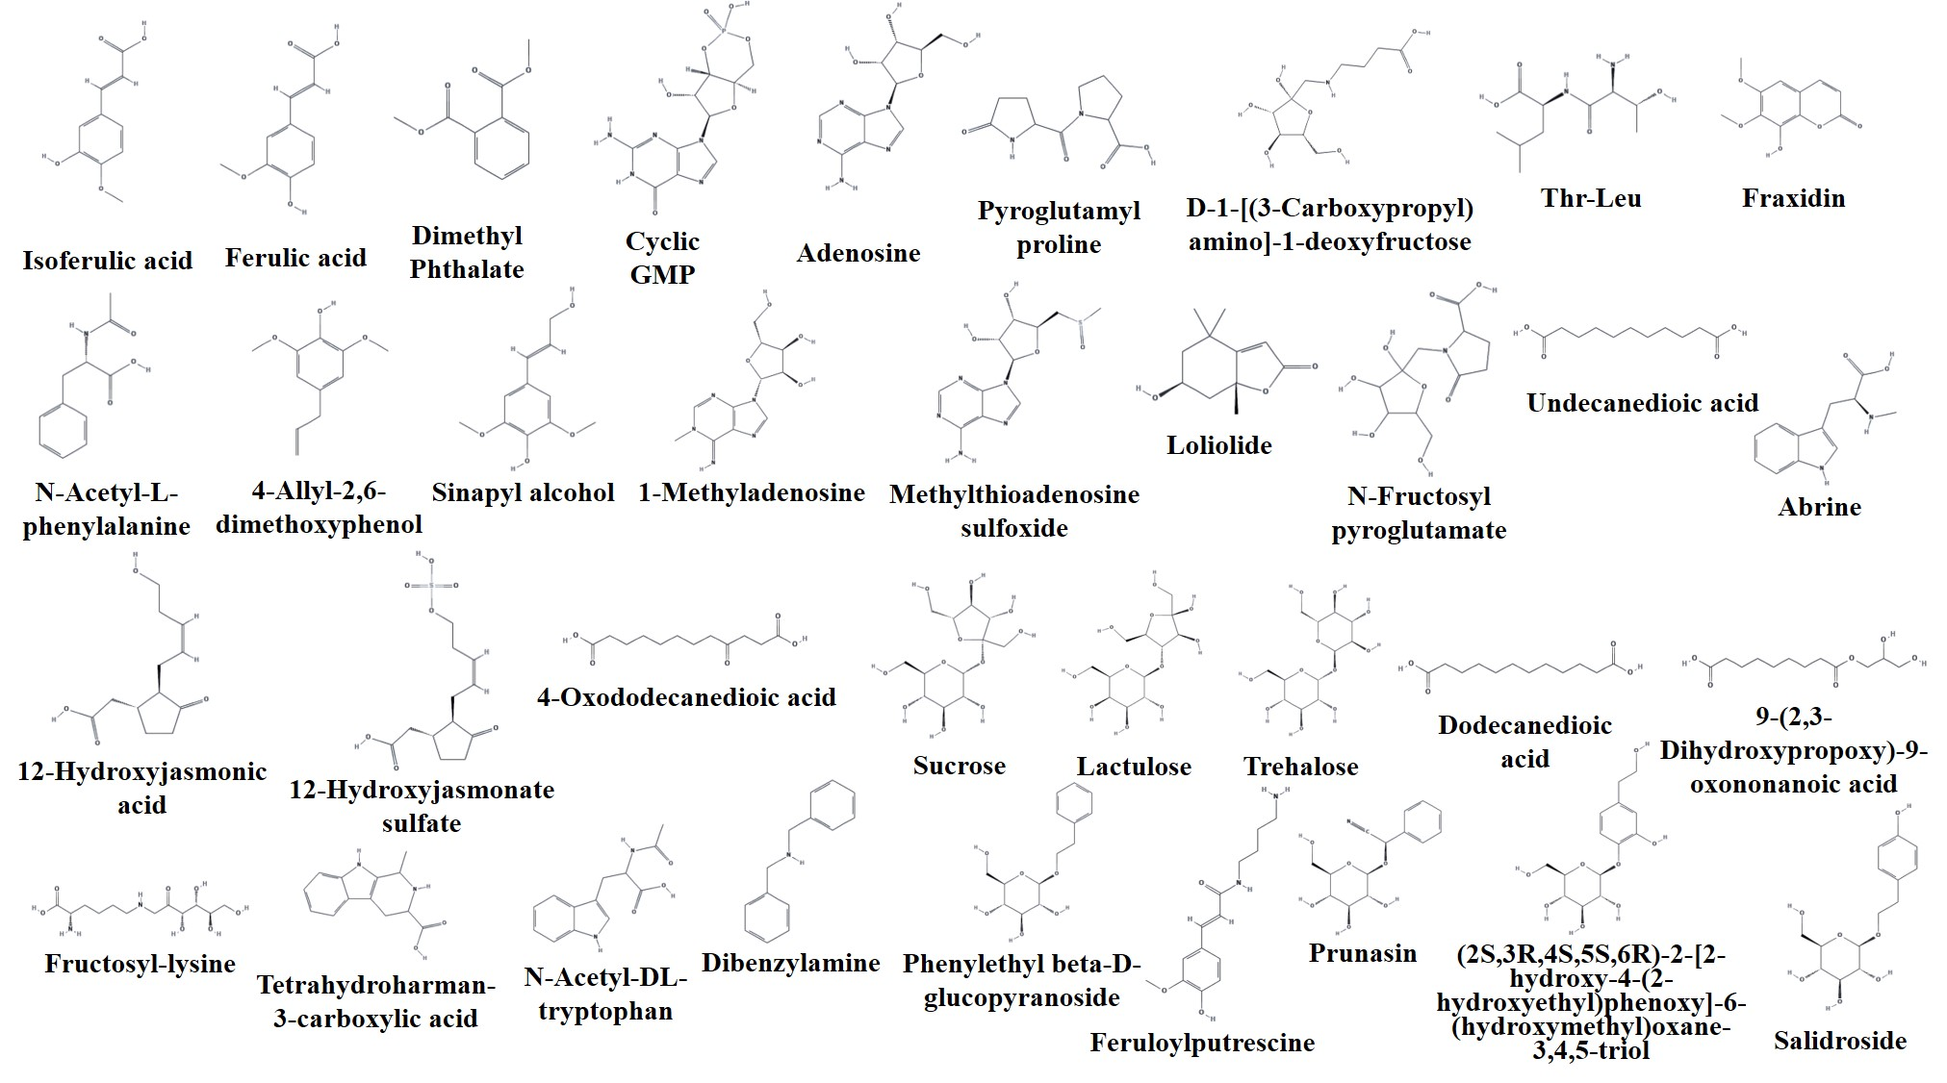

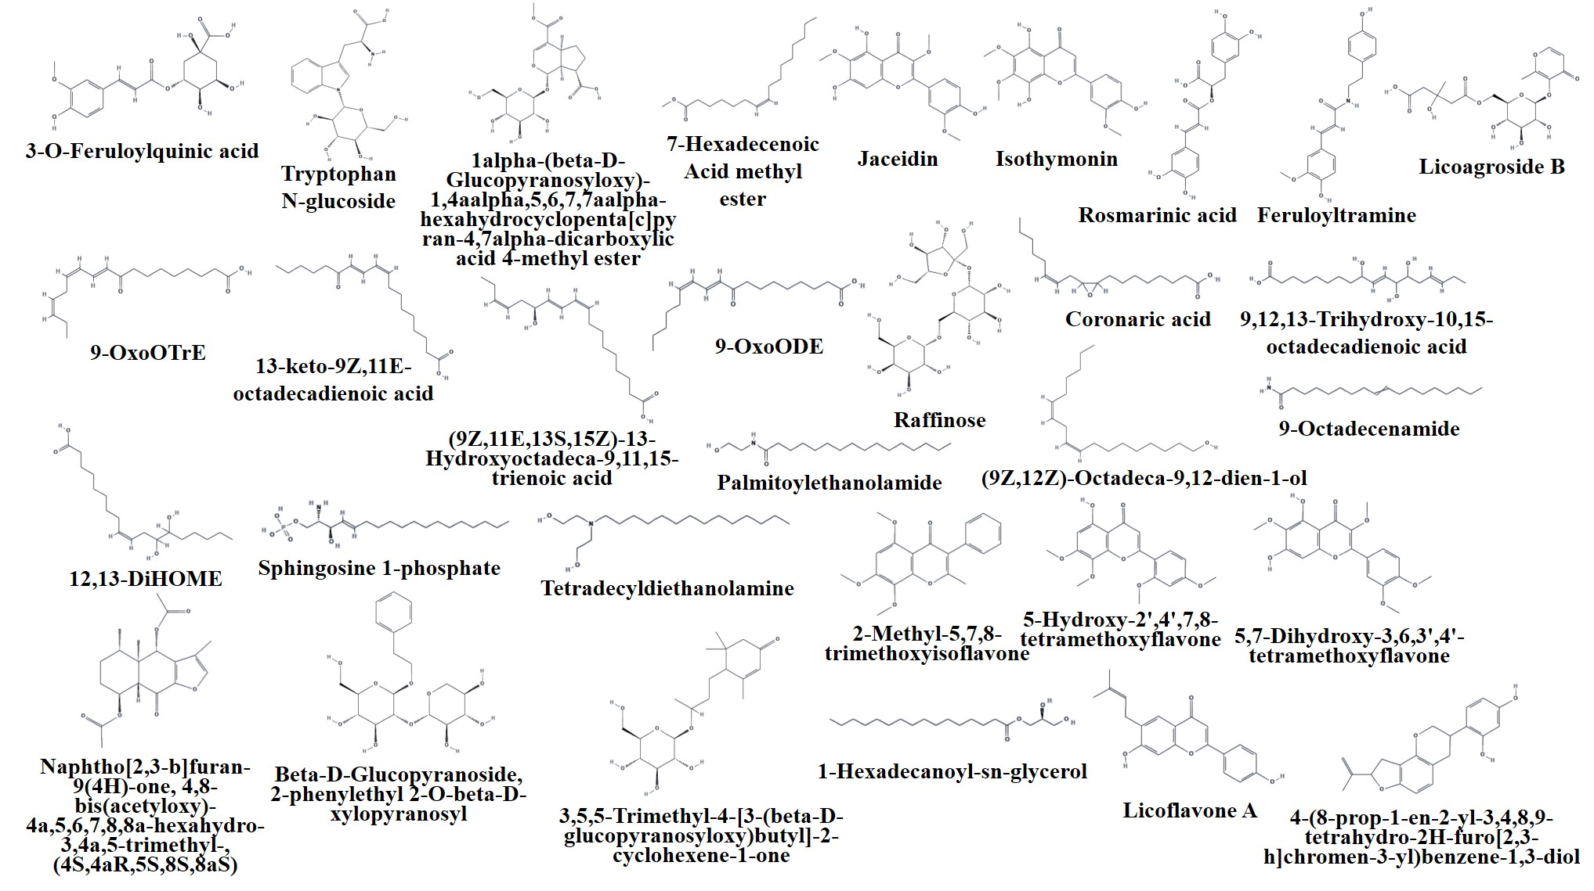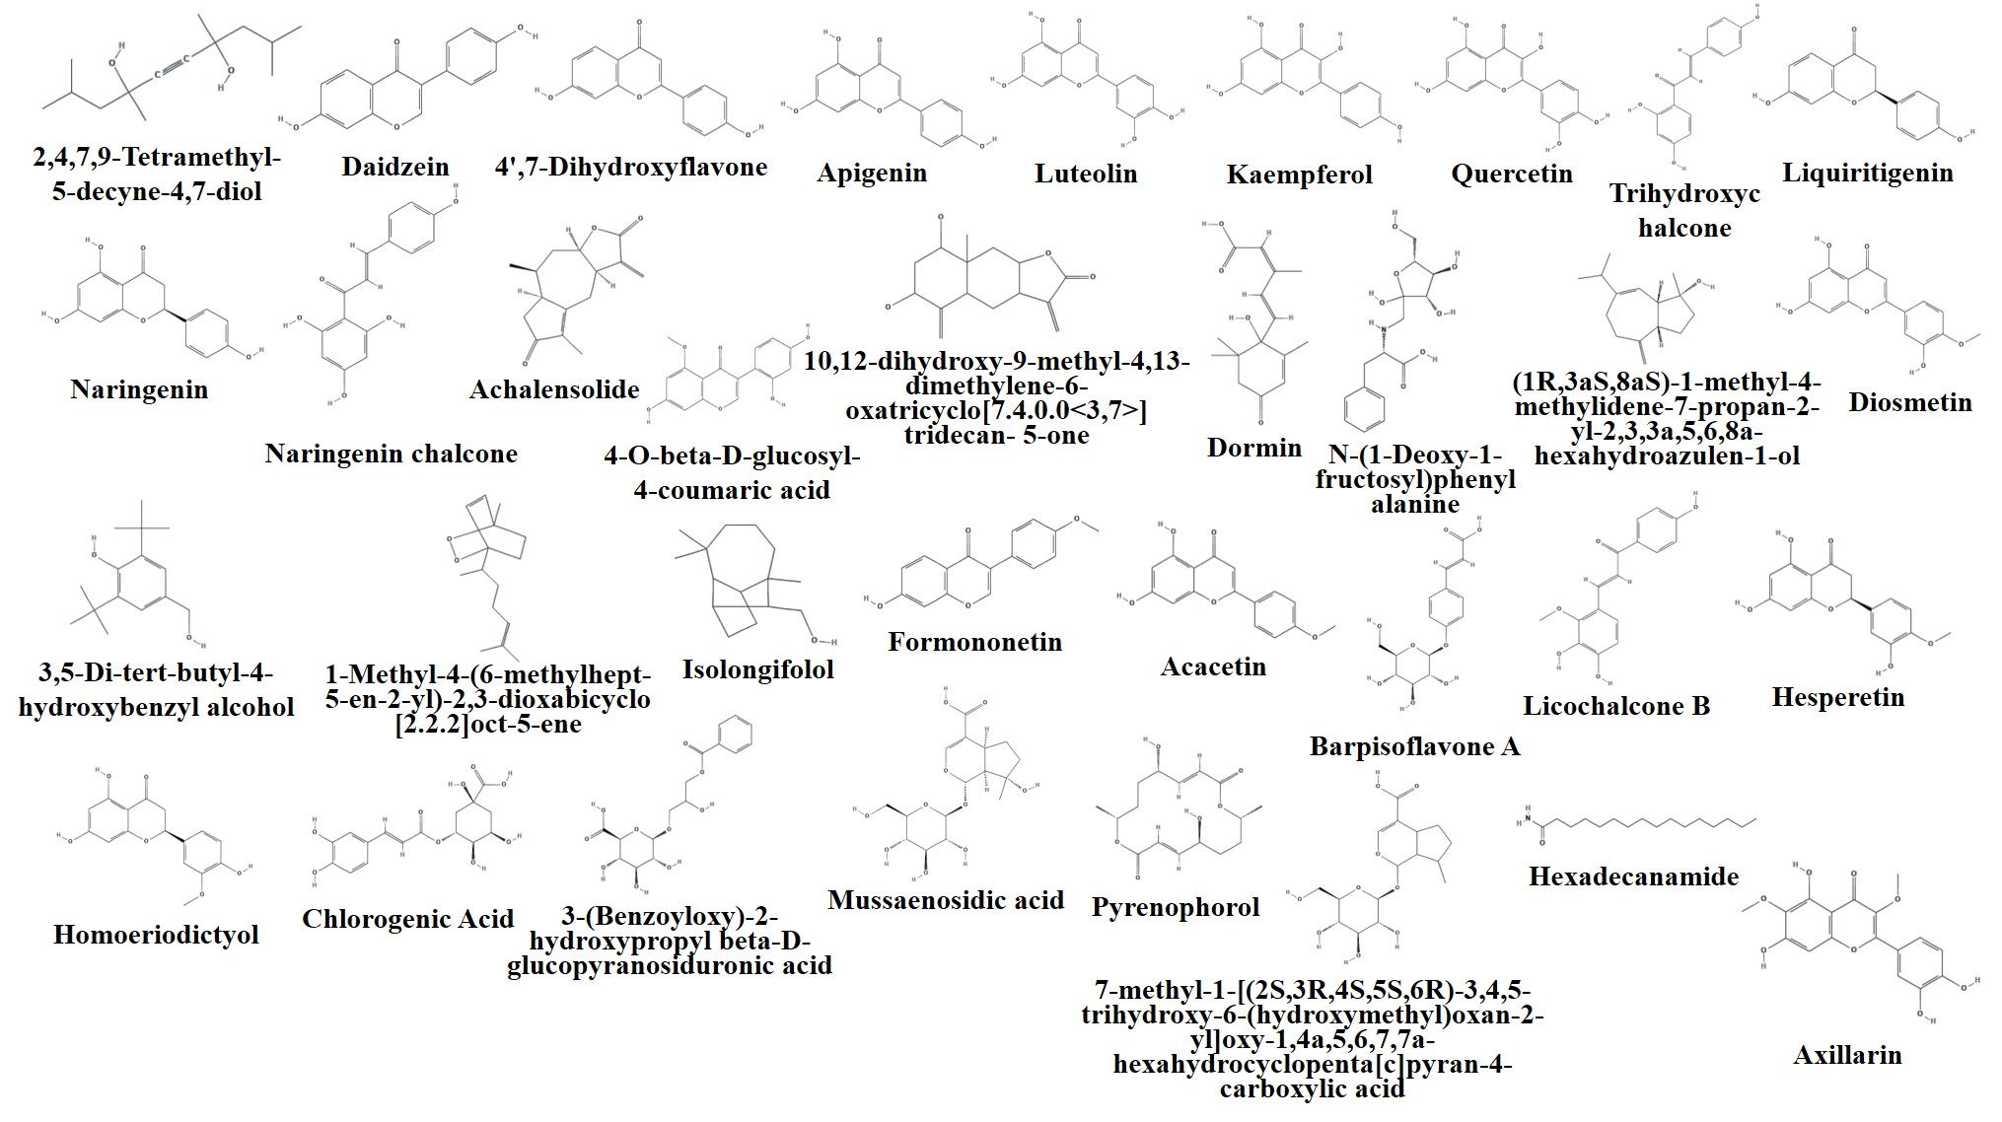

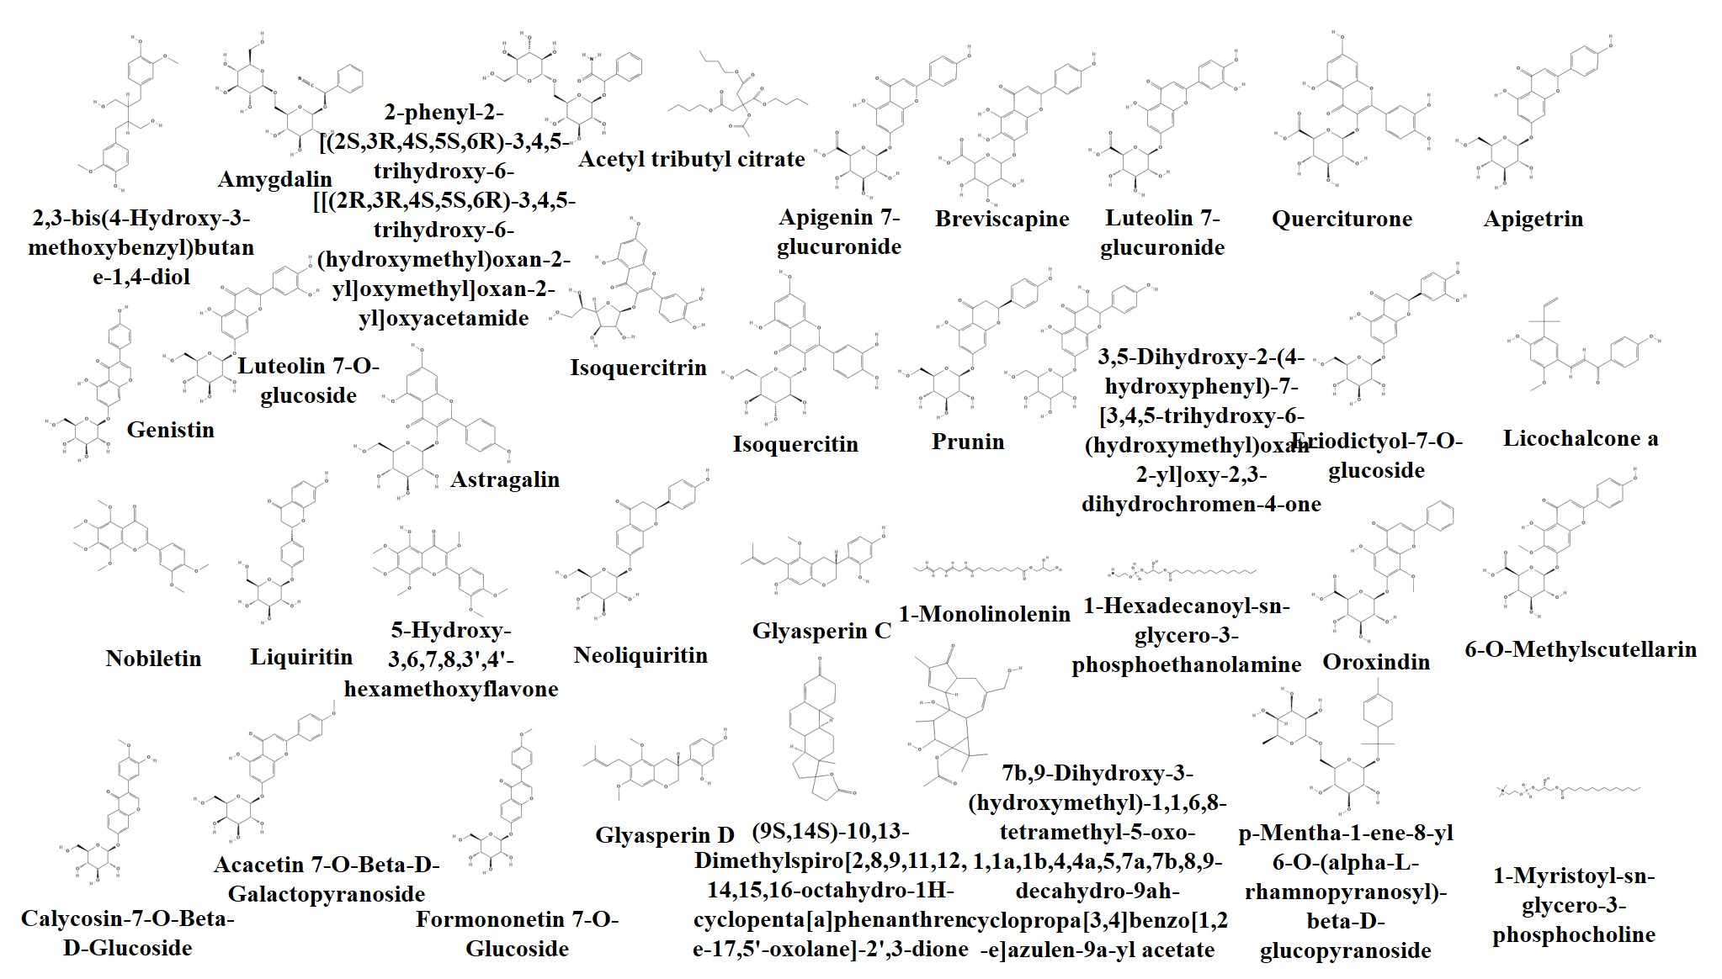

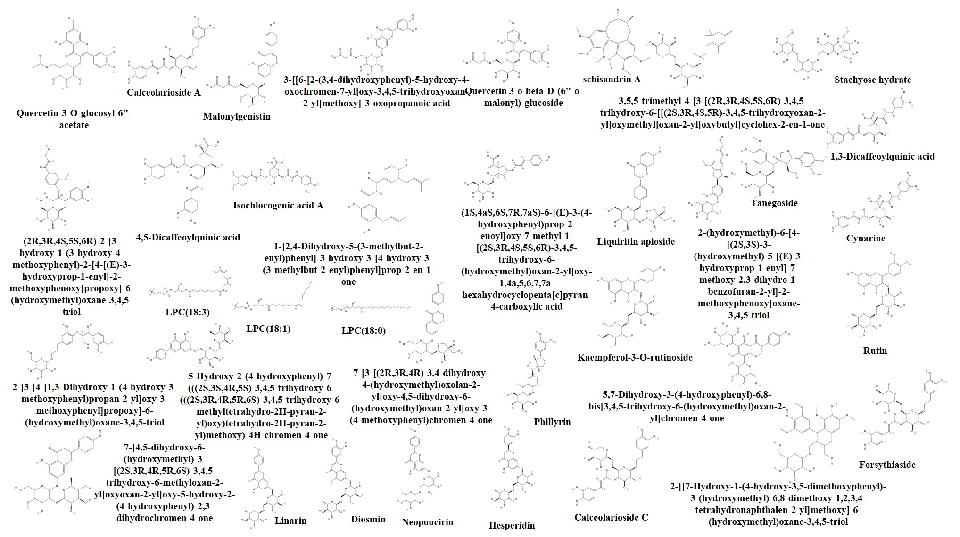

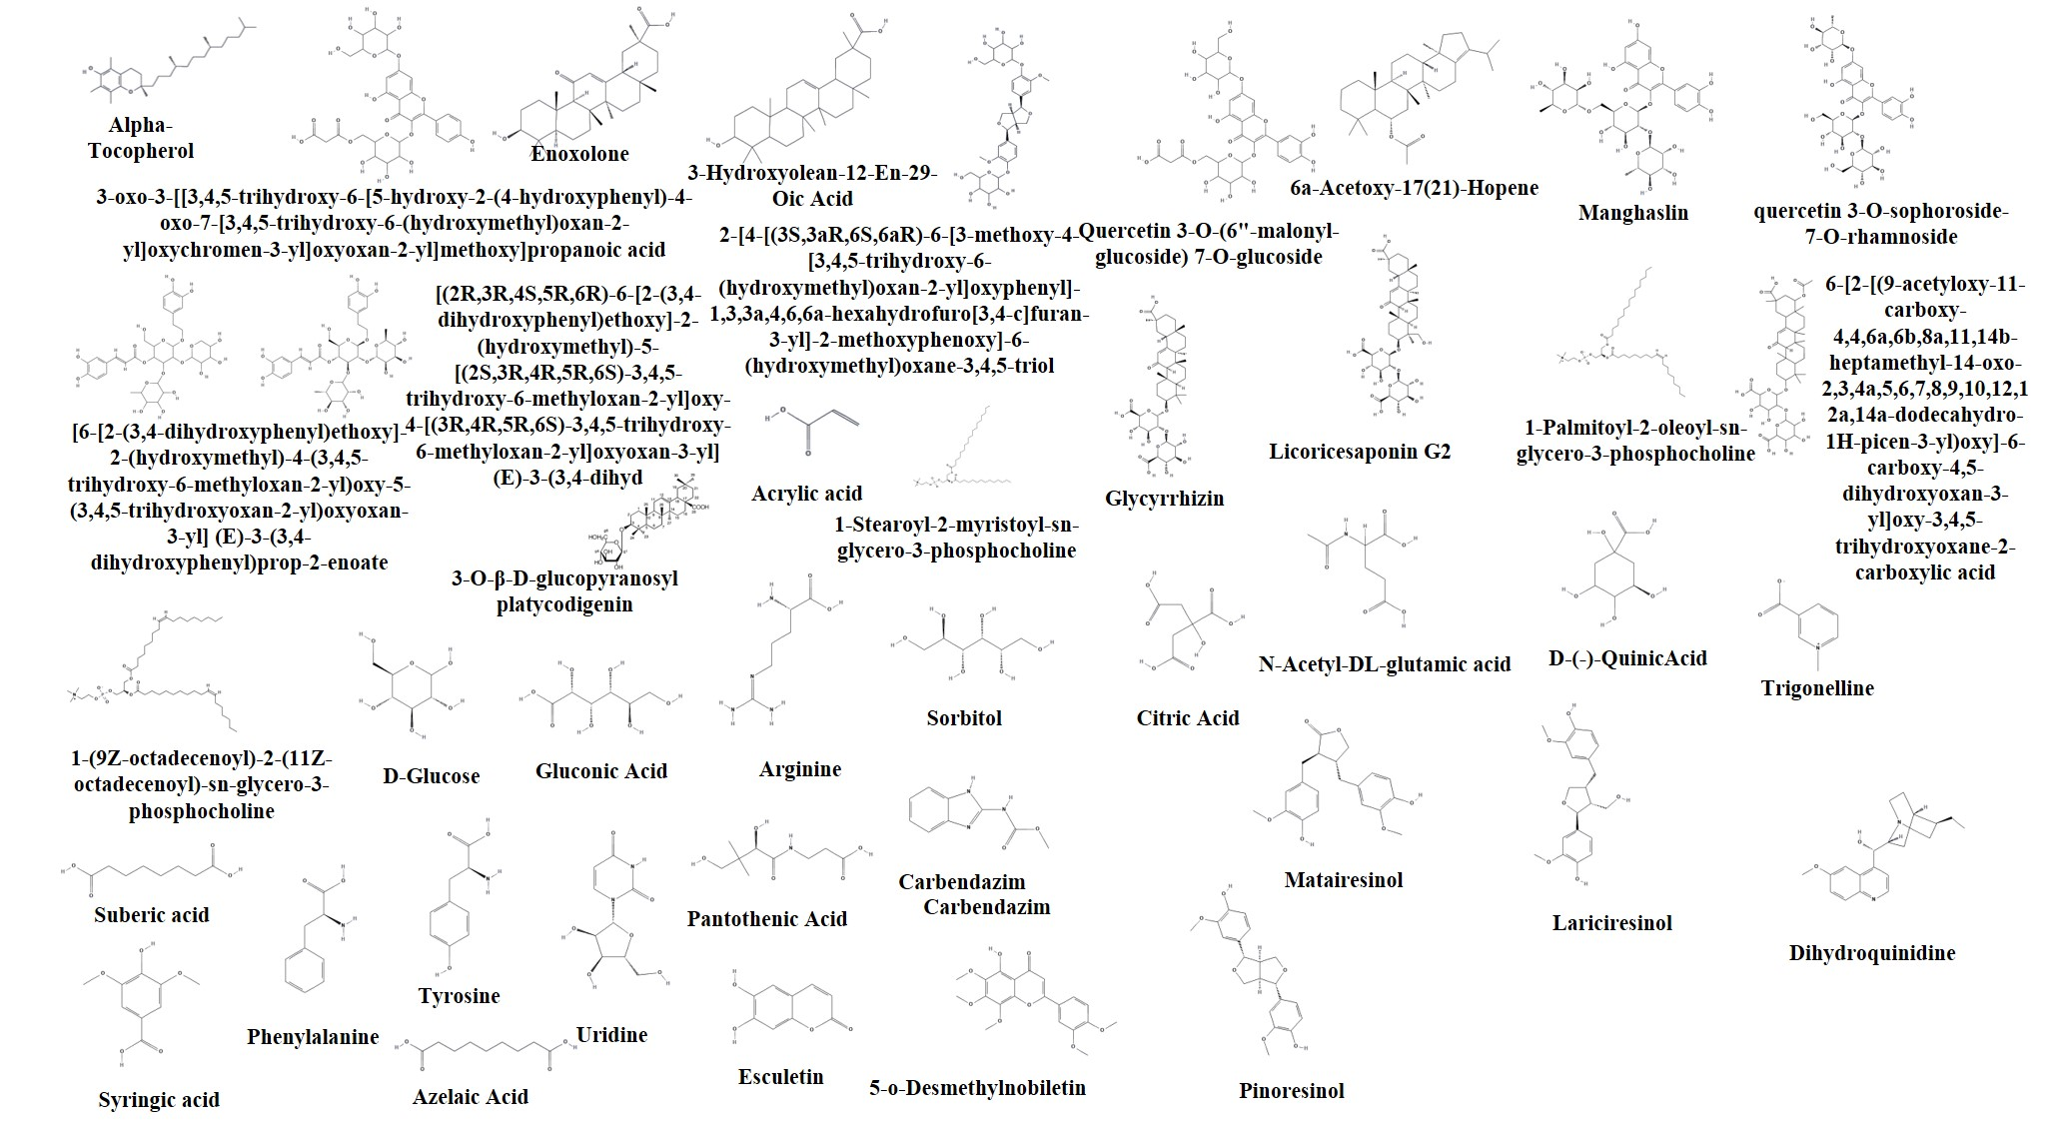

**Fig. S2** The structure of the identified compounds.

**3. BALF analysis for pulmonary injury**

**Protein concentration assay and white blood cell (WBC) count in BALF:** After collecting BALF sample, centrifugation (3000 rpm, 10 min, 4 °C) was conducted, and the supernatants were used for the protein concentration assay by bicinchoninic acid (BCA) method (Beyotime Biotechnology Co., Ltd, Nantong, China). On the other hand, the pelleted cells were resuspended for counting while blood cells utilizing the hemocytometer with Wright-Giemsa staining.

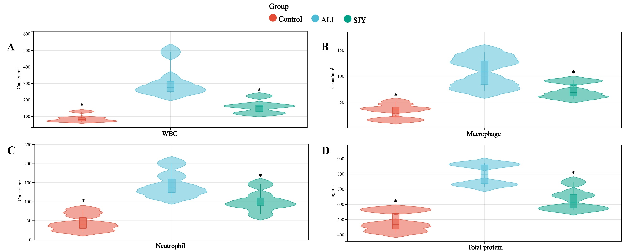

**Fig. S3**  BALF analysis of white blood cell count (A), macrophage count (B), neutrophil count (C) and protein concentration assay (D). *: Significant difference compared with model group (*p*<0.05).

**4. UFLC-ESI-QTOF-MS conditions and** **sample preparation of metabolomics**

Liquid phase condition:

The column temperature was maintained at 30 °C and the flow rate was 0.4 mL·min-1. Mobile phase A was water containing 0.1% formic acid and mobile phase B was acetonitrile containing 0.1% formic acid. The elute gradient was set as follow: 50–75% B from 0 to 2 min, 75–98% B from 2 to 5 min, kept 4 min then returned to 50% B and maintained to 12 min. Other mass spectrometry conditions were consistent with the composition analysis.

Sample preparation:

(1) The lung tissue was homogenized in 10 times the volume of saline and centrifuged (3,000 rpm, 20 min, 4 °C) to collect the supernatant. The mixture was obtained by mixing 1 mL lung homogenate with 3 mL methanol. Then the mixture was vortexed (3 min) and centrifugated (12,000 rpm, 4 °C, 10 min) to gather the supernatant, then dried (30 °C under N2). Next, 100 μL acetonitrile-deionized water (50:50, *v/v*) was added for reconstruction. After vortex (3 min), ultrasonic preparation (5 min), and centrifugation (12,000 rpm, 10 min, 4 °C), the final supernatant was assembled for instrumental analysis. Quality control (QC) samples were prepared by mixing different samples of equal volume.

(2) The stool samples were lyophilized for 48 h to stimulate homogenization. Freeze-dried powder of feces (100 mg) was spiked with deionized water (1 mL), followed by 3 min vortex and 3 min sonication, extracted with ethyl acetate (2.5 mL), then vortexed for 3 min and centrifuged at 12,000 rpm and 4 °C for 10 min, to keep the upper layer and extract the lower precipitate with 2.5 mL methanol-deionized water (80:20, *v/v*). Then, vortex for 3 min and centrifugation at 12,000 rpm and 4 °C for 10 min was conducted. Twice extracted supernatant were combined, filtrated and blown to dryness (30°C N2). Reconstitution was accomplished with 100 μL acetonitrile-deionized water (50:50, *v/v*). Further steps of vortex (3 min), ultrasound management (5 min) and centrifugation (12,000 rpm, 4 °C, 10 min) were successively conducted to obtain the supernatant for injection. QC samples were prepared by mixing different samples of equal volume.

**5.** **Method validation of metabolomics**

**Method validation of UFLC-ESI-QTOF-MS metabolomics:**

The method was validated for the precision of injection, repeatability and stability. At the beginning of the analytical batch, 6 QC samples were injected to balance the system. The precision of the injection was evaluated by 6 replicated analyses of the same QC sample. 6 QC samples prepared in parallel were used to appraised the repeatability. After a certain period of time for sample analysis (i.e. the time to complete four injections of samples), the QC sample was repeatedly injected to assess the stability of analytical workflow. Then selected ion chromatographic peaks, six ions from lung or feces samples respectively, were selected for method validation in positive and negative mode, and their retention times and peak areas were calculated to evaluate the system. The selected ions were distributed over the analysis mass range and time. The result indicated all RSD values were below 15%, implying the reliability of method (**Table S3** and **Table S4**).

**Table S3-1** The analytical performance of lung samples in positive mode.

|  |  |  |  |  |  |  |
| --- | --- | --- | --- | --- | --- | --- |
| m/z_RT | Precision (RSD %) | | Repeatability (RSD %) | | Stability (RSD %) | |
| RT | Intensity | RT | Intensity | RT | Intensity |
| 105.0913_1.01 | 1.23 | 10.89 | 1.22 | 10.71 | 1.43 | 10.83 |
| 226.2639_2.55 | 0.35 | 11.04 | 0.74 | 13.21 | 0.80 | 11.86 |
| 336.4669_3.36 | 0.28 | 11.92 | 0.35 | 10.40 | 0.75 | 10.91 |
| 425.5569_4.52 | 0.37 | 8.79 | 0.22 | 13.61 | 0.33 | 6.72 |
| 542.3612_5.41 | 0.44 | 4.31 | 0.36 | 4.57 | 0.46 | 6.69 |
| 691.9523_7.12 | 0.19 | 11.18 | 0.24 | 7.01 | 0.33 | 8.02 |

**Table S3-2** The analytical performance of lung samples in negative mode.

|  |  |  |  |  |  |  |
| --- | --- | --- | --- | --- | --- | --- |
| m/z_RT | Precision (RSD %) | | Repeatability (RSD %) | | Stability (RSD %) | |
| RT | Intensity | RT | Intensity | RT | Intensity |
| 103.2572_1.13 | 0.98 | 12.64 | 0.85 | 14.26 | 1.42 | 12.45 |
| 224.1638_2.66 | 0.26 | 7.01 | 0.36 | 8.54 | 0.40 | 7.63 |
| 331.1359_3.53 | 0.27 | 8.17 | 0.31 | 6.60 | 0.52 | 8.04 |
| 455.4556_4.88 | 0.14 | 9.03 | 0.17 | 11.92 | 0.28 | 9.00 |
| 571.2123_5.24 | 0.13 | 11.99 | 0.18 | 9.89 | 0.20 | 11.82 |
| 756.8503_6.77 | 0.11 | 12.46 | 0.14 | 11.76 | 0.15 | 13.18 |

**Table S4-1** The analytical performance of feces samples in positive mode.

|  |  |  |  |  |  |  |
| --- | --- | --- | --- | --- | --- | --- |
| m/z_RT | Precision (RSD %) | | Repeatability (RSD %) | | Stability (RSD %) | |
| RT | Intensity | RT | Intensity | RT | Intensity |
| 112.5342_1.15 | 1.12 | 10.79 | 1.46 | 10.62 | 1.50 | 10.65 |
| 236.1985_2.26 | 0.35 | 13.51 | 0.50 | 12.17 | 0.74 | 6.06 |
| 343.1534_3.98 | 0.38 | 9.23 | 0.51 | 12.45 | 0.90 | 13.42 |
| 469.9587_5.21 | 0.28 | 12.93 | 0.26 | 14.64 | 0.28 | 7.31 |
| 568.4737_6.29 | 0.40 | 4.72 | 0.34 | 4.17 | 0.50 | 7.48 |
| 703.7365_7.23 | 0.23 | 13.49 | 0.20 | 8.74 | 0.28 | 9.79 |

**Table S4-2** The analytical performance of feces samples in negative mode.

|  |  |  |  |  |  |  |
| --- | --- | --- | --- | --- | --- | --- |
| m/z_RT | Precision (RSD %) | | Repeatability (RSD %) | | Stability (RSD %) | |
| RT | Intensity | RT | Intensity | RT | Intensity |
| 115.6529_1.06 | 1.12 | 8.50 | 1.24 | 14.30 | 1.21 | 12.33 |
| 225.7145_2.56 | 0.64 | 5.56 | 0.93 | 11.90 | 0.81 | 7.35 |
| 341.1098_3.77 | 0.37 | 6.70 | 0.48 | 9.62 | 0.48 | 6.15 |
| 457.5126_4.89 | 0.30 | 8.88 | 0.28 | 6.05 | 0.33 | 7.17 |
| 531.6831_5.82 | 0.17 | 7.04 | 0.16 | 6.83 | 0.28 | 8.93 |
| 689.3623_7.02 | 0.14 | 11.60 | 0.19 | 9.29 | 0.25 | 7.67 |

**Method validation of 1H-NMR metabolomics:**

The performance of the method was actually validated by multiple injections of quality control (QC) samples obtained from a pool of 10 μl of all samples analyzed. QCs were analyzed at the beginning of the run, every 4 samples, and at the end of the run. RSD values were calculated for all identified metabolites, and all identified metabolites were detected with a RSD less than 20% in QC samples.

**6. Metabolomic analysis**

**Table S5** Biomarkers significantly regulated by SJY in lung and feces. Mass Error of candidates were not greater than 10 ppm in UFLC-ESI-QTOF-MS. #, *p*<0.05 *vs* ALI group.

|  |  |  |  |  |  |  |  |  |  |  |
| --- | --- | --- | --- | --- | --- | --- | --- | --- | --- | --- |
| **No.** | **Putative identification** | **Formula** | **Ion adduction** | **HMDB**  **ID** | **KEGG**  **ID** | **ALI/** | **SJY/** | **Source** | **NMR or LCMS** | **Fragment ions** |
| **Control** | **ALI** |
| 1 | dTMP | C10H15N2O8P | - | HMDB0001227 | C00364 | ↓ | - | Lung | NMR | — |
| 2 | L-Anserine | C10H16N4O3 | - | HMDB0000194 | C01262 | ↓ | - | Feces | NMR | — |
| 3 | Deoxyhypusine | C10H23N3O2 | [M+FA-H]- | HMDB0011150 | - | ↓ | ↑**#** | Feces | LCMS_NEG | 216.1717, 198.1614, 172.1821 |
| 4 | Spermine | C10H26N4 | - | HMDB0001256 | C00750 | ↑ | ↓**#** | Feces | NMR | — |
| 5 | N-Acetylneuraminic Acid | C11H19NO9 | - | HMDB0000230 | C19910 | ↓ | ↑ | Feces | NMR | — |
| 6 | Butyrylcarnitine | C11H21NO4 | [M+H]+ | HMDB0002013 | C02862 | ↓ | ↑ | Lung | LCMS_POS | 232.1553, 173.0815, 85.0289 |
| 7 | L-Asparaginyl-L-asparaginyl-L-asparagine | C12H20N6O7 | [M+C2H4O2-H]- | - | - | ↑ | ↓ | Lung | LCMS_NEG | 419.1391 |
| 8 | Psicoselysine N6-(D-Psicosyl)-L-lysine | C12H24N2O7 | [M-H]- | - | C21616 | ↑ | ↓ | Lung | LCMS_NEG | 307.1573 |
| 9 | Glutamylphenylalanine | C14H18N2O5 | [M-H]- | HMDB0029156 | - | ↑ | ↓ | Lung | LCMS_NEG | 293.1140, 275.1033, 164.0717 |
| 10 | Glycerol tributanoate | C15H26O6 | [M+FA-H]- | HMDB0031094 | C13870 | ↑ | ↓**#** | Lung | LCMS_NEG | 301.1658, 231.1241, 87.0448 |
| 11 | Asparagylprolylarginine | C15H27N7O5 | [M+FA-H]- | - | - | ↓ | ↑ | Lung | LCMS_NEG | 384.2065 |
| 12 | 6-(4-Sulfophenyl)decanoic acid | C16H24O5S | [M-H]- | - | - | ↑ | ↑ | Lung | LCMS_NEG | 327.1328 |
| 13 | Myristoylglycine | C16H31NO3 | [M-H]- | HMDB0013250 | - | ↑ | ↓ | Lung | LCMS_NEG | 284.2231, 266.2126 |
| 14 | 16-Hydroxyhexadecanoic acid | C16H32O3 | [M-H]- | HMDB0006294 | C18218 | ↓ | ↓ | Lung | LCMS_NEG | 271.2271, 253.2186 |
| 15 | N-(2-Hydroxydodecyl)-l-threonine | C16H33NO4 | [M+Na]+ | - | - | ↑ | ↓**#** | Feces | LCMS_POS | 326.2355 |
| 16 | 2-((2-Cyclohexylethyl)amino)adenosine | C18H28N6O4 | [M+FA-H]- | - | - | ↑ | ↑ | Lung | LCMS_NEG | 391.2147 |
| 17 | Stearidonic acid | C18H28O2 | [M+C2H4O2-H]- | HMDB0006547 | C16300 | ↑ | ↓ | Lung | LCMS_NEG | 257.2996, 231.2992 |
| 18 | (9S,10E,12Z,15Z)-9-Hydroxy-10,12,15-octadecatrienoic acid | C18H30O3 | [M+C2H4O2-H]- | HMDB0031934 | - | ↑ | ↓**#** | Lung | LCMS_NEG | 293.2119, 275.2008 |
| 19 | 2,3-dinor Prostaglandin E1 | C18H30O5 | [M+C2H4O2-H]- | - | - | ↑ | ↓**#** | Lung | LCMS_NEG | 325.2026 |
| 20 | 18-Oxooleate | C18H32O3 | [M+C2H4O2-H]- | - | C19617 | ↑ | ↓**#** | Lung | LCMS_NEG | 295.2332 |
| 21 | (10E,12Z)-9-HODE | C18H32O3 | [M-H]- | HMDB0062652 | - | ↓ | ↑**#** | Lung | LCMS_NEG | 295.2283, 277.2166, 187.1332 |
| 22 | Corchorifatty acid F | C18H32O5 | [M+C2H4O2-H]- | HMDB0035919 | - | ↑ | ↓ | Lung | LCMS_NEG | 327.2163, 291.1916, 229.1441 |
| 23 | Arginylhistidyllysine | C18H33N9O4 | [M+Cl]- | - | - | ↑ | ↓ | Lung | LCMS_NEG | 474.7452 |
| 24 | 10-Oxooctadecanoic acid | C18H34O3 | [M-H]- | HMDB0030980 | - | ↓ | ↑ | Lung | LCMS_NEG | 297.2438, 279.2332 |
| 25 | 9-Oxooctadecanoic acid | C18H34O3 | [M+C2H4O2-H]- | HMDB0030979 | - | ↑ | ↓ | Lung | LCMS_NEG | 297.2441, 279.2339 |
| 26 | Oleamide | C18H35NO | [M+H]+ | HMDB0002117 | C19670 | ↑ | ↓ | Lung | LCMS_POS | 282.2789, 265.2526, 247.2414 |
| 27 | 2-Hydroxystearic acid | C18H36O3 | [M-H]- | HMDB0062549 | C03045 | ↓ | ↑ | Lung | LCMS_NEG | 299.2592, 281.2479 |
| 28 | Palmitoylethanolamide | C18H37NO2 | [M+H]+ | HMDB0002100 | C16512 | ↑ | ↓**#** | Lung | LCMS_POS | 300.2892, 257.2466 |
| 29 | N-Palmitoyl Taurine | C18H37NO4S | [M-H]- | - | - | ↑ | ↓ | Lung | LCMS_NEG | 362.2375 |
| 30 | Phytosphingosine | C18H39NO3 | [M-H2O+H]+ | HMDB0004610 | C12144 | ↑ | ↓ | Lung | LCMS_POS | 264.1998, 262.2003 |
| 31 | Methyl linoleate | C19H34O2 | [M+H2O+H]+ | HMDB0034381 | - | ↑ | ↓ | Lung | LCMS_POS | 295.2627, 263.2369, 245.2270 |
| 32 | MG(16:0/0:0/0:0) | C19H38O4 | [M+C2H3N+H]+ | HMDB0011564 | - | ↑ | ↓ | Lung | LCMS_POS | 348.3111 |
| 33 | 1,2,4-Nonadecanetriol | C19H40O3 | [M+C2H3N+H]+ | HMDB0032112 | - | ↑ | ↓ | Feces | LCMS_POS | 317.3051, 299.2945, 281.2837 |
| 34 | Retinoic acid | C20H28O2 | [M+C2H4O2-H]- | HMDB0001852 | C00777 | ↑ | ↓ | Lung | LCMS_NEG | 299.1990, 255.2099, 119.0856 |
| 35 | (5Z,7E,9E,14Z,17Z)-Eicosapentaenoic acid; | C20H30O2 | [M+C2H4O2-H]- | - | C12083 | ↑ | ↓ | Lung | LCMS_NEG | 301.2198 |
| 36 | Eicosapentaenoic acid | C20H30O2 | [M-H]- | HMDB0001999 | C06428 | ↑ | ↓ | Lung | LCMS_NEG | 301.2165, 257.2271 |
| 37 | Eicosapentaenoic acid | C20H30O2 | [M-H2O+H]+ | HMDB0001999 | C06428 | ↑ | ↓**#** | Lung | LCMS_POS | 303.2320, 285.2212 |
| 38 | Arachidonic acid | C20H32O2 | [M-H]- | HMDB0001043 | C00219 | ↑ | ↓ | Lung | LCMS_NEG | 303.2339, 259.2434 |
| 39 | Arachidonic acid | C20H32O2 | [M+H]+ | HMDB0001043 | C00219 | ↑ | ↓**#** | Lung | LCMS_POS | 304.2366, 259.2431 |
| 40 | 11(R)-HETE | C20H32O3 | [M-H2O+H]+ | HMDB0004682 | C14780 | ↑ | ↓**#** | Lung | LCMS_POS | 321.2424, 303.2318, 285.2213 |
| 41 | 16(R)-HETE | C20H32O3 | [M+C2H4O2-H]- | HMDB0004680 | C14778 | ↑ | ↓ | Lung | LCMS_NEG | 319.2278, 301.2171 |
| 42 | 19(S)-HETE | C20H32O3 | [M+C2H4O2-H]- | HMDB0011136 | C14749 | ↑ | ↓ | Lung | LCMS_NEG | 319.2281, 301.2174 |
| 43 | 19(S)-HETE | C20H32O3 | [M+C2H3N+H]+ | HMDB0011136 | C14749 | ↑ | ↓**#** | Lung | LCMS_POS | 321.2420, 303.2322, 285.2215 |
| 44 | Lipoxin B4 | C20H32O5 | [M+FA-H]- | HMDB0005082 | C06315 | ↑ | ↓ | Lung | LCMS_NEG | 351.2178, 333.2072, 315.1966 |
| 45 | Prostaglandin D2 | C20H32O5 | [M-H]- | HMDB0001403 | C00696 | ↑ | ↓ | Lung | LCMS_NEG | 351.1003, 315.0010, 271.3002, 189.1005 |
| 46 | 6-Ketoprostaglandin E1 | C20H32O6 | [M-H]- | HMDB0004241 | C05962 | ↑ | ↓ | Lung | LCMS_NEG | 367.2162, 349.2022, 331.1917 |
| 47 | Dihomo-alpha-linolenic acid | C20H34O2 | [M+Na]+ | HMDB0060039 | C16522 | ↑ | ↓**#** | Lung | LCMS_POS | 307.2638, 289.2526, 271.2422 |
| 48 | Dihomo-gamma-linolenic acid | C20H34O2 | [M-H]- | HMDB0002925 | C03242 | ↑ | ↓ | Lung | LCMS_NEG | 305.3250, 287.3025, 261.2949 |
| 49 | 12(S)-HETrE | C20H34O3 | [M+C2H4O2-H]- | HMDB0062747 | - | ↑ | ↓ | Lung | LCMS_NEG | 321.2436, 303.2331 |
| 50 | 8Z,11Z-eicosadienoic acid | C20H36O2 | [M-H]- | HMDB0062432 | C21936 | ↓ | ↑ | Feces | LCMS_NEG | 307.2644, 289.2537 |
| 51 | 2-Hydroxyicos-14-ynoic acid | C20H36O3 | [M-H]- | - | - | ↑ | ↓**#** | Lung | LCMS_NEG | 323.2599 |
| 52 | Oleoylethanolamide | C20H39NO2 | [M+H]+ | HMDB0002088 | - | ↑ | ↓**#** | Lung | LCMS_POS | 326.3050, 309.2783, 62.0587 |
| 53 | N6-(1-Oxotetradecyl)-L-lysine | C20H40N2O3 | [M+Cl]- | - | - | ↑ | ↓ | Lung | LCMS_NEG | 391.7656 |
| 54 | Stearoylethanolamide | C20H41NO2 | [M+H]+ | HMDB0013078 | - | ↑ | ↓**#** | Lung | LCMS_POS | 328.3217, 267.2688, 62.0621 |
| 55 | N-Acetylsphinganine | C20H41NO3 | [M+Na]+ | - | - | ↑ | ↓ | Feces | LCMS_POS | 366.2836 |
| 56 | N-Stearoyl Taurine | C20H41NO4S | [M-H]- | - | - | ↑ | ↓ | Lung | LCMS_NEG | 390.2684 |
| 57 | 6,9,12,15,18-Heneicosapentaenoic acid | C21H32O2 | [M+C2H4O2-H]- | - | - | ↑ | ↓ | Lung | LCMS_NEG | 315.2389 |
| 58 | N-Oleoyl-L-Serine | C21H39NO4 | [M+C2H4O2-H]- | - | - | ↑ | ↓ | Lung | LCMS_NEG | 368.2865 |
| 59 | N-Palmitoyl-L-methionine | C21H41NO3S | [M-H]- | - | - | ↓ | ↓ | Lung | LCMS_NEG | 386.2786 |
| 60 | LPE(16:1) | C21H42NO7P | [M-H]- | HMDB0011504 | - | ↓ | ↑ | Lung | LCMS_NEG | 450.2623, 407.2204, 389.2102 |
| 61 | LPE(16:1) | C21H42NO7P | [M+H]+ | HMDB0011504 | - | ↓ | ↑ | Lung | LCMS_POS | 452.2772, 434.2655, 409.2352 |
| 62 | MG(18:0/0:0/0:0) | C21H42O4 | [M-H2O+H]+ | HMDB0011131 | - | ↑ | ↓**#** | Lung | LCMS_POS | 376.3422 |
| 63 | LPE(16:0) | C21H44NO7P | [M-H]- | HMDB0011503 | - | ↓ | ↑ | Lung | LCMS_NEG | 452.2788, 409.2363, 391.2189 |
| 64 | LPA(O-18:0) | C21H45O6P | [M+C2H3N+H]+ | HMDB0011144 | - | ↑ | ↓ | Lung | LCMS_POS | 425.3022, 327.3258 |
| 65 | Docosahexaenoic acid | C22H32O2 | [M-H]- | HMDB0002183 | C06429 | ↑ | ↑ | Lung | LCMS_NEG | 327.2321, 283.2433 |
| 66 | Neuroprotectin D1 | C22H32O4 | [M-H2O+H]+ | HMDB0003689 | - | ↑ | ↓**#** | Lung | LCMS_POS | 361.2377, 343.2266, 325.2153 |
| 67 | Docosapentaenoic acid(22n-3) | C22H34O2 | [M-H]- | HMDB0006528 | C16513 | ↑ | ↑ | Lung | LCMS_NEG | 329.2476, 311.2365 |
| 68 | Adrenic acid | C22H36O2 | [M-H]- | HMDB0002226 | C16527 | ↑ | ↓ | Lung | LCMS_NEG | 331.2486, 329.2495, 287.2684 |
| 69 | N-Arachidonoyl Taurine | C22H37NO4S | [M-H]- | - | - | ↑ | ↓ | Lung | LCMS_NEG | 410.2498 |
| 70 | N-(1-Oxoheptyl)-D-gamma-glutamyl-(6R)-6-carboxy-L-lysyl-D-alanine | C22H38N4O9 | [M+Br]- | - | - | ↑ | ↓**#** | Lung | LCMS_NEG | 501.2499 |
| 71 | LPS(16:1) | C22H42NO9P | [M-H]- | - | - | ↓ | ↑**#** | Lung | LCMS_NEG | 494.2524 |
| 72 | LPS(16:0) | C22H44NO9P | [M-H]- | - | - | ↑ | ↑ | Lung | LCMS_NEG | 496.2682 |
| 73 | LPC(14:0) | C22H46NO7P | [M+FA-H]- | HMDB0010379 | - | ↓ | ↑ | Lung | LCMS_NEG | 466.2942, 227.2018 |
| 74 | 10,11-Dihydro-12R-hydroxy-leukotriene E4 | C23H39NO6S | [M-H]- | HMDB0012501 | - | ↑ | ↓**#** | Lung | LCMS_NEG | 456.2425, 438.2321, 369.2122 |
| 75 | Unk-Abu-Pro-Leu-NH2 | C23H40N4O8 | [M+NH4]+ | - | - | ↑ | ↓**#** | Lung | LCMS_POS | 501.2746 |
| 76 | 3-hydroxyhexadecanoyl carnitine | C23H45NO5 | [M+H]+ | HMDB0061642 | - | ↑ | ↑ | Lung | LCMS_POS | 416.3376, 85.0288 |
| 77 | H-DL-Dab(OMe)-Leu-Ala-Ser-Lys-NH2 | C23H46N8O7 | [M+H]+ | - | - | ↑ | ↓**#** | Lung | LCMS_POS | 547.3621 |
| 78 | LPE(18:0) | C23H48NO7P | [M+Na]+ | HMDB0011130 | C21484 | ↑ | ↓ | Feces | LCMS_POS | 482.3241, 464.3133, 341.3045 |
| 79 | LPE(18:0) | C23H48NO7P | [M-H2O+H]+ | HMDB0011130 | - | ↑ | ↓ | Lung | LCMS_POS | 482.3229, 464.3132, 341.3038 |
| 80 | LPE(18:0) | C23H48NO7P | [M-H]- | HMDB0011130 | - | ↑ | ↓ | Lung | LCMS_NEG | 480.3096, 437.2665, 419.2552 |
| 81 | LPE(18:0) | C23H48NO7P | [M+Na]+ | HMDB0011130 | - | ↑ | ↓ | Lung | LCMS_POS | 482.3229, 341.3038 |
| 82 | 7-Ketodeoxycholic acid | C24H38O5 | [M+FA-H]- | HMDB0000391 | - | ↓ | ↑ | Lung | LCMS_NEG | 405.2629, 387.2544 |
| 83 | Tetracosatetraenoic acid(24:4n-6) | C24H40O2 | [M-H]- | HMDB0006246 | - | ↑ | ↓ | Lung | LCMS_NEG | 359.2951, 341.2878 |
| 84 | N-Oleoyl isoleucine | C24H45NO3 | [M-H]- | - | - | ↑ | ↓ | Lung | LCMS_NEG | 394.3387 |
| 85 | Nervonic acid | C24H46O2 | [M+C2H4O2-H]- | HMDB0002368 | C08323 | ↓ | ↑ | Feces | LCMS_NEG | 365.3384 |
| 86 | 1-Stearoylglycerophosphoserine | C24H48NO9P | [M-H]- | HMDB0061698 | - | ↑ | ↑ | Lung | LCMS_NEG | 524.2994, 437.2663, 152.9941 |
| 87 | Cerebronic acid | C24H48O3 | [M-H]- | HMDB0039540 | C17873 | ↑ | ↓ | Lung | LCMS_NEG | 383.3527, 365.3419 |
| 88 | N-Docosanoyl Taurine | C24H49NO4S | [M-H]- | - | - | ↑ | ↓ | Lung | LCMS_NEG | 446.3166 |
| 89 | LPC(16:0) | C24H50NO7P | [M+H]+ | HMDB0010382 | C04230 | ↑ | ↓ | Feces | LCMS_POS | 518.3211, 459.2495, 104.1103 |
| 90 | 1-O-Hexadecyl-lyso-sn-glycero-3-phosphocholine | C24H52NO6P | [M+H]+ | - | C13903 | ↑ | ↓ | Lung | LCMS_POS | 482.3578 |
| 91 | LPE(20:4) | C25H44NO7P | [M+FA-H]- | HMDB0011517 | - | ↑ | ↑ | Lung | LCMS_NEG | 500.2776, 457.2362 |
| 92 | Elaidic carnitine | C25H47NO4 | [M+H]+ | HMDB0005065 | - | ↑ | ↓ | Lung | LCMS_POS | 426.3554, 367.2835, 85.0284 |
| 93 | 3-Hydroxy-9Z-octadecenoylcarnitine | C25H47NO5 | [M+H]+ | HMDB0013340 | - | ↑ | ↑ | Lung | LCMS_POS | 442.3528, 383.2785, 85.0246 |
| 94 | LPE(20:1) | C25H50NO7P | [M+C2H4O2-H]- | HMDB0011512 | - | ↓ | ↑ | Lung | LCMS_NEG | 506.3246, 463.2833, 445.2717 |
| 95 | LPC(17:0) | C25H52NO7P | [M+C2H3N+H]+ | HMDB0012108 | C04230 | ↑ | ↓**#** | Lung | LCMS_POS | 512.3613, 510.3542 |
| 96 | LPC(18:2) | C26H50NO7P | [M+H]+ | HMDB0010386 | C04100 | ↑ | ↓ | Feces | LCMS_POS | 542.3211, 483.2476 |
| 97 | LPC(18:1) | C26H52NO7P | [M+H]+ | HMDB0002815 | - | ↑ | ↓ | Feces | LCMS_POS | 528.3629, 469.2896 |
| 98 | LPC(18:0) | C26H54NO7P | [M+H]+ | HMDB0010384 | C04230 | ↑ | ↓**#** | Feces | LCMS_POS | 526.3769, 524.3711 |
| 99 | LPC(18:0) | C26H54NO7P | [M+Na]+ | HMDB0010384 | C04230 | ↑ | ↓ | Lung | LCMS_POS | 526.3755, 524.3736 |
| 100 | LPC(18:0) | C26H54NO7P | [M+H]+ | HMDB0010384 | C04230 | ↑ | ↓ | Lung | LCMS_POS | 526.3762, 524.3722 |
| 101 | 7alpha-Hydroxy-3-oxo-4-cholestenoate | C27H42O4 | [M+FA-H]- | HMDB0012458 | C17337 | ↑ | ↓ | Feces | LCMS_NEG | 429.3007 |
| 102 | O-Arachidonoylcarnitine | C27H45NO4 | [M+H]+ | - | - | ↑ | ↑ | Lung | LCMS_POS | 448.3287 |
| 103 | 7α,27-Dihydroxycholesterol | C27H46O3 | [M+Na]+ | HMDB0006281 | C06341 | ↑ | ↓**#** | Feces | LCMS_POS | 419.3521, 401.3409, 383.3308 |
| 104 | (11Z,14Z)-Eicosadienoylcarnitine | C27H49NO4 | [M+Na]+ | - | - | ↑ | ↓ | Feces | LCMS_POS | 452.3598 |
| 105 | LPI(18:1) | C27H51O12P | [M+NH4]+ | HMDB0061693 | - | ↑ | ↓**#** | Lung | LCMS_POS | 599.3189, 581.3063, 265.2517 |
| 106 | Polyporusterone C | C28H44O6 | [M-H]- | HMDB0038497 | - | ↓ | ↑ | Lung | LCMS_NEG | 475.3058 |
| 107 | Brassicasterol | C28H46O | [M+Na]+ | HMDB0011181 | C08813 | ↑ | ↓ | Feces | LCMS_POS | 399.3622, 381.3508, 315.2677 |
| 108 | LPS(22:4) | C28H48NO9P | [M-H]- | - | - | ↓ | ↑**#** | Lung | LCMS_NEG | 572.2875 |
| 109 | 4-alpha-Methyl-5-alpha-cholest-7-en-3-beta-ol | C28H48O | [M+Na]+ | HMDB0011605 | C08825 | ↑ | ↓ | Feces | LCMS_POS | 401.3771, 383.3652 |
| 110 | LPC(20:4) | C28H50NO7P | [M+Na]+ | HMDB0010395 | C04230 | ↑ | ↓ | Feces | LCMS_POS | 566.3212, 507.2466 |
| 111 | 13-beta-D-Glucosyloxydocosanoate | C28H54O8 | [M+Br]- | - | C04103 | ↓ | ↑ | Lung | LCMS_NEG | 516.3674 |
| 112 | LPC(20:1) | C28H56NO7P | [M+H]+ | HMDB0010391 | C04230 | ↑ | ↓**#** | Lung | LCMS_POS | 550.3856, 532.3798, 184.0728 |
| 113 | Acetic acid | C2H4O2 | - | HMDB0000042 | C00033 | ↓ | - | Lung | NMR | — |
| 114 | Glycolic acid | C2H4O3 | - | HMDB0000115 | C03547 | ↑ | ↓ | Feces | NMR | — |
| 115 | Glycolic acid | C2H4O3 | - | HMDB0000115 | C03547 | ↓ | - | Lung | NMR | — |
| 116 | Dimethylsulfone | C2H6O2S | - | HMDB0004983 | C11142 | ↓ | ↑ | Lung | NMR | — |
| 117 | Taurine | C2H7NO3S | - | HMDB0000251 | C00245 | ↑ | ↑ | Lung | NMR | — |
| 118 | Cysteamine | C2H7NS | - | HMDB0002991 | C01678 | ↓ | - | Lung | NMR | — |
| 119 | 2-Aminoethylphosphonic acid | C2H8NO3P | - | HMDB0011747 | C03557 | ↓ | ↓ | Feces | NMR | — |
| 120 | Leukotriene C4 | C30H47N3O9S | [M-H]- | HMDB0001198 | C02166 | ↑ | ↓**#** | Lung | LCMS_NEG | 624.2698 |
| 121 | LPC(22:6) | C30H50NO7P | [M+H]+ | HMDB0010404 | C04230 | ↑ | ↓ | Feces | LCMS_POS | 568.3412, 550.3303, 184.0729 |
| 122 | Cer(d18:1/14:0) | C32H63NO3 | [M+FA-H]- | HMDB0011773 | C13916 | ↑ | ↓ | Lung | LCMS_NEG | 508.4733 |
| 123 | Cer(d18:0/14:0) | C32H65NO3 | [M+H]+ | HMDB0011759 | - | ↑ | ↓**#** | Lung | LCMS_POS | 512.5033, 494.4932 |
| 124 | N-[(4E,8E)-1,3-dihydroxyoctadeca-4,8-dien-2-yl]hexadecanamide | C34H65NO3 | [M+FA-H]- | HMDB0035480 | - | ↑ | ↓ | Lung | LCMS_NEG | 534.4899 |
| 125 | Cer(t18:0/16:0) | C34H69NO4 | [M+C2H4O2-H]- | HMDB0010697 | - | ↑ | ↓**#** | Feces | LCMS_NEG | 554.5146, 536.5051 |
| 126 | N-Acetyl-leu-leu-leu-leu-tyr-amide | C35H58N6O7 | [M-H2O-H]- | - | C11295 | ↑ | ↓ | Feces | LCMS_NEG | 673.4224 |
| 127 | Cer(d18:1/18:1) | C36H69NO3 | [M-H2O+H]+ | HMDB0004948 | C00195 | ↑ | ↓ | Feces | LCMS_POS | 570.5432 |
| 128 | GlcCer(d18:0/12:0) | C36H71NO8 | [M+FA-H]- | - | - | ↓ | ↑ | Lung | LCMS_NEG | 644.5036 |
| 129 | PE(14:1/18:1) | C37H70NO8P | [M-H]- | HMDB0008861 | - | ↓ | ↓ | Lung | LCMS_NEG | 686.4752, 281.2476, 225.1857 |
| 130 | DG(13:0/21:0/0:0) | C37H72O5 | [M-H2O+H]+ | HMDB0093277 | - | ↓ | ↑**#** | Feces | LCMS_POS | 614.5697 |
| 131 | N,N'-Ethylenebis(linoleic amide) | C38H68N2O2 | [M-H]- | - | - | ↑ | ↑ | Lung | LCMS_NEG | 583.5013 |
| 132 | PA(O-18:0/17:2) | C38H73O7P | [M+Cl]- | - | - | ↑ | ↓ | Lung | LCMS_NEG | 671.5026 |
| 133 | PE(P-16:0/18:2) | C39H74NO7P | [M-H]- | HMDB0011343 | - | ↑ | ↓ | Feces | LCMS_NEG | 698.5133, 655.4712, 78.9586 |
| 134 | PE(14:0/20:2) | C39H74NO8P | [M+C2H3N+H]+ | HMDB0008835 | - | ↓ | ↓ | Feces | LCMS_POS | 716.5219, 698.5101, 575.5029 |
| 135 | PE(P-16:0/18:1) | C39H76NO7P | [M+Na]+ | HMDB0011342 | - | ↓ | ↑**#** | Lung | LCMS_POS | 702.5437, 561.5239, 142.0252 |
| 136 | PE(16:0/18:1) | C39H76NO8P | [M-H]- | HMDB0008927 | - | ↑ | ↓**#** | Feces | LCMS_NEG | 716.0012, 281.0003 |
| 137 | PE(18:1/16:0) | C39H76NO8P | [M-H]- | HMDB0009055 | - | ↑ | ↓ | Feces | LCMS_NEG | 716.5227, 281.2478 |
| 138 | PE(16:0/18:1) | C39H76NO8P | [M+C2H3N+H]+ | HMDB0008927 | - | ↓ | ↑ | Lung | LCMS_POS | 718.5402, 577.5198 |
| 139 | DG(16:0/20:0/0:0) | C39H76O5 | [M-H2O+H]+ | HMDB0007107 | - | ↑ | ↑ | Feces | LCMS_POS | 625.5753, 607.5660, 295.2991 |
| 140 | PA(14:0/22:0) | C39H77O8P | [M+C2H3N+H]+ | HMDB0114788 | - | ↓ | ↓ | Feces | LCMS_POS | 705.5431, 687.5323 |
| 141 | Sarcosine | C3H7NO2 | - | HMDB0000271 | C00213 | ↓ | ↑**#** | Feces | NMR | — |
| 142 | Beta-Alanine | C3H7NO2 | - | HMDB0000056 | C00099 | ↑ | ↓ | Lung | NMR | — |
| 143 | Sarcosine | C3H7NO2 | - | HMDB0000271 | C00213 | ↓ | - | Lung | NMR | — |
| 144 | L-Cysteine | C3H7NO2S | - | HMDB0000574 | C00097 | ↑ | ↓**#** | Feces | NMR | — |
| 145 | L-Cysteine | C3H7NO2S | - | HMDB0000574 | C00097 | ↑ | ↓ | Lung | NMR | — |
| 146 | L-Serine | C3H7NO3 | - | HMDB0000187 | C00065 | ↑ | ↓**#** | Feces | NMR | — |
| 147 | L-Serine | C3H7NO3 | - | HMDB0000187 | C00065 | ↓ | ↑ | Lung | NMR | — |
| 148 | L-Cysteic Acid | C3H7NO5S | - | HMDB0002757 | C00506 | ↓ | - | Lung | NMR | — |
| 149 | D-(-)-3-Phosphoglyceric acid | C3H7O7P | - | HMDB0000807 | C00597 | ↓ | ↑ | Feces | NMR | — |
| 150 | D-(-)-3-Phosphoglyceric acid | C3H7O7P | - | HMDB0000807 | C00597 | ↓ | ↓ | Lung | NMR | — |
| 151 | 2-Propanol | C3H8O | - | HMDB0000863 | C01845 | ↑ | ↓**#** | Feces | NMR | — |
| 152 | PropyleneGlycol | C3H8O2 | - | HMDB0001881 | C00583 | ↓ | - | Feces | NMR | — |
| 153 | DL-alpha-Glycerol Phosphate | C3H9O6P | - | HMDB0000126 | C00093 | ↓ | ↑**#** | Feces | NMR | — |
| 154 | Araliacerebroside | C40H77NO10 | [M+FA-H]- | HMDB0033621 | - | ↓ | ↑ | Lung | LCMS_NEG | 730.5477, 712.5369, 476.3231 |
| 155 | PS(18:0/16:0) | C40H78NO10P | [M-H2O+H]+ | HMDB0012376 | - | ↓ | ↑ | Lung | LCMS_POS | 770.5521, 683.5207 |
| 156 | PC(O-16:1/16:1) | C40H78NO7P | [M+H2O+H]+ | HMDB0013411 | - | ↓ | ↓ | Feces | LCMS_POS | 716.5592 |
| 157 | PC(16:0/16:0) | C40H80NO8P | [M+H]+ | HMDB0000564 | C00157 | ↓ | ↑**#** | Lung | LCMS_POS | 734.0013, 184.0002 |
| 158 | PC(O-16:0/16:0) | C40H82NO7P | [M-H2O-H]- | - | - | ↑ | ↓**#** | Feces | LCMS_NEG | 704.5581, 255.2331 |
| 159 | 1-oleoyl-2-O-arachidonyl-sn-glycerol | C41H72O4 | [M-H2O-H]- | - | - | ↑ | ↑ | Feces | LCMS_NEG | 627.5289 |
| 160 | PE(P-16:0/20:4) | C41H74NO7P | [M-H]- | HMDB0011352 | - | ↑ | ↑ | Feces | LCMS_NEG | 722.5133, 679.4712, 78.9585 |
| 161 | PA(16:0/22:2) | C41H77O8P | [M+NH4]+ | HMDB0114845 | - | ↓ | ↑ | Lung | LCMS_POS | 729.5429, 711.5307 |
| 162 | PS(15:0/20:0) | C41H80NO10P | [M-H]- | HMDB0112327 | - | ↓ | ↑ | Lung | LCMS_NEG | 776.5451 |
| 163 | DG(18:2n6/0:0/20:2n6) | C42H74O5 | [M+NH4]+ | HMDB0056284 | - | ↑ | ↓ | Feces | LCMS_POS | 659.5615, 641.5503 |
| 164 | PS(18:0/18:1) | C42H80NO10P | [M-H]- | HMDB0010163 | - | ↑ | ↓ | Lung | LCMS_NEG | 788.5445 |
| 165 | PC(14:0/20:2) | C42H80NO8P | [M+H]+ | HMDB0007880 | C00157 | ↓ | ↑ | Lung | LCMS_POS | 758.5699 |
| 166 | PC(16:0/18:1) | C42H82NO8P | [M+H]+ | HMDB0007972 | C13875 | ↓ | ↑ | Lung | LCMS_POS | 760.5848 |
| 167 | PC(18:0/16:0) | C42H84NO8P | [M+Na]+ | HMDB0008034 | - | ↓ | ↑ | Lung | LCMS_POS | 768.6092 |
| 168 | PE(P-16:0/22:6) | C43H74NO7P | [M-H]- | HMDB0005780 | - | ↑ | ↑ | Feces | LCMS_NEG | 746.5131, 703.4709, 78.9593 |
| 169 | PE(P-18:1/20:5) | C43H74NO7P | [M-H]- | HMDB0011453 | - | ↑ | ↑ | Feces | LCMS_NEG | 746.5130, 703.4707, 78.9586 |
| 170 | PE(P-16:0/22:6) | C43H74NO7P | [M-H]- | HMDB0005780 | - | ↑ | ↓ | Lung | LCMS_NEG | 746.5137, 703.4707, 78.9591 |
| 171 | PE(P-16:0/22:5) | C43H76NO7P | [M-H]- | HMDB0011360 | - | ↓ | ↑ | Lung | LCMS_NEG | 748.5288, 705.4861, 78.9592 |
| 172 | PE(P-18:0/20:4) | C43H78NO7P | [M+H]+ | HMDB0005779 | C00350 | ↓ | ↑ | Lung | LCMS_POS | 752.5589, 611.5387 |
| 173 | PE(18:0/20:4) | C43H78NO8P | [M+H]+ | HMDB0009003 | C21480 | ↓ | ↑ | Lung | LCMS_POS | 768.5542, 750.5437, 627.5341 |
| 174 | PE(20:1/18:1) | C43H82NO8P | [M+H]+ | HMDB0009256 | - | ↓ | ↑ | Lung | LCMS_POS | 772.5856, 754.5739, 631.5652 |
| 175 | DG(18:2n6/0:0/22:6n3) | C44H70O5 | [M+FA-H]- | HMDB0056295 | - | ↑ | ↑ | Feces | LCMS_NEG | 677.5150, 659.5045, 57.0349 |
| 176 | PE-NMe(18:0/20:4) | C44H80NO8P | [M+C2H4O2-H]- | HMDB0113098 | - | ↑ | ↓ | Lung | LCMS_NEG | 780.5549, 723.4981, 78.9593 |
| 177 | PC(18:0/18:1) | C44H86NO8P | [M+Na]+ | HMDB0008037 | - | ↓ | ↓ | Feces | LCMS_POS | 794.6246 |
| 178 | PC(18:1/18:0) | C44H86NO8P | [M+Na]+ | HMDB0008069 | C00157 | ↓ | ↓ | Feces | LCMS_POS | 794.6247 |
| 179 | PE(24:1/15:0) | C44H86NO8P | [M+H]+ | HMDB0009747 | - | ↓ | ↓ | Feces | LCMS_POS | 810.5984, 669.5793 |
| 180 | PE-NMe(20:0/18:1) | C44H86NO8P | [M+H]+ | HMDB0113285 | - | ↓ | ↓ | Feces | LCMS_POS | 788.6163, 770.6062, 58.0655 |
| 181 | PE(15:0/24:1) | C44H86NO8P | [M+Na]+ | HMDB0008915 | - | ↓ | ↑ | Lung | LCMS_POS | 788.6164, 770.6052, 647.5982 |
| 182 | PC(14:0/22:0) | C44H88NO8P | [M+Na]+ | HMDB0007886 | C00157 | ↓ | ↓ | Feces | LCMS_POS | 796.6405 |
| 183 | PE(P-18:1/22:5) | C45H78NO7P | [M-H]- | HMDB0011459 | - | ↑ | ↑ | Feces | LCMS_NEG | 774.5441, 731.5027, 78.9592 |
| 184 | PE(P-18:1/22:5) | C45H78NO7P | [M-H]- | HMDB0011426 | - | ↑ | ↓ | Feces | LCMS_NEG | 774.5443, 731.5021, 78.9595 |
| 185 | PE(20:4/20:1) | C45H80NO8P | [M-H]- | HMDB0009428 | - | ↑ | ↑ | Lung | LCMS_NEG | 792.5552, 309.2781 |
| 186 | PC(17:0/12-HETE) | C45H82NO9P | [M-H2O-H]- | - | - | ↑ | ↓ | Feces | LCMS_NEG | 796.5581 |
| 187 | PC(22:6/16:1) | C46H78NO8P | [M+Na]+ | HMDB0008726 | - | ↑ | ↓**#** | Lung | LCMS_POS | 826.5357 |
| 188 | PC(24:0/14:1) | C46H90NO8P | [M+Na]+ | HMDB0008756 | - | ↓ | ↑ | Lung | LCMS_POS | 816.6476 |
| 189 | PC(20:0/18:0) | C46H92NO8P | [M+H2O+H]+ | HMDB0008267 | - | ↓ | ↓ | Feces | LCMS_POS | 818.6635 |
| 190 | DG(24:0/0:0/20:3n6) | C47H86O5 | [M-H2O-H]- | HMDB0056123 | - | ↑ | ↓ | Feces | LCMS_NEG | 729.6407, 711.6297, 305.2481 |
| 191 | PS(22:5/20:2) | C48H80NO10P | [M-H]- | HMDB0112852 | - | ↑ | ↑ | Feces | LCMS_NEG | 860.5451 |
| 192 | Erythritol | C4H10O4 | [M-H2O-H]- | HMDB0002994 | C00503 | ↑ | ↑ | Feces | LCMS_NEG | 83.0011, 73.1002 |
| 193 | 2-Oxobutyrate | C4H6O3 | - | HMDB0000005 | C00109 | ↓ | ↑ | Feces | NMR | — |
| 194 | Methylmalonic acid | C4H6O4 | - | HMDB0000202 | C02170 | ↑ | ↓ | Lung | NMR | — |
| 195 | 2-Hydroxybutyric acid | C4H8O3 | - | HMDB0000008 | C05984 | ↓ | ↓ | Feces | NMR | — |
| 196 | Dimethylglycine | C4H9NO2 | - | HMDB0000092 | C01026 | ↑ | ↑ | Lung | NMR | — |
| 197 | 2-amino-3-hydroxybutanoic acid | C4H9NO3 | - | HMDB0000167 | C00188 | ↑ | ↓**#** | Feces | NMR | — |
| 198 | TG(15:0/18:4/14:1) | C50H86O6 | [M+Br]- | HMDB0043662 | - | ↑ | ↓**#** | Feces | LCMS_NEG | 781.6251, 763.6245 |
| 199 | TG(15:0/O-18:0/20:4) | C56H102O5 | [M-H2O-H]- | HMDB0043825 | - | ↑ | ↓**#** | Feces | LCMS_NEG | 853.7657, 303.2336 |
| 200 | 4-Guanidinobutyric acid | C5H11N3O2 | - | HMDB0003464 | C01035 | ↑ | ↑ | Lung | NMR | — |
| 201 | L-Valine | C5H11NO2 | - | HMDB0000883 | C00183 | ↓ | - | Feces | NMR | — |
| 202 | Phosphocholine | C5H15NO4P | - | - | C00588 | ↓ | - | Lung | NMR | — |
| 203 | Dihydrothymine | C5H8N2O2 | - | HMDB0000079 | C00906 | ↑ | ↓**#** | Feces | NMR | — |
| 204 | 2-Oxoisovalerate | C5H8O3 | - | HMDB0000019 | C00141 | ↓ | ↑ | Feces | NMR | — |
| 205 | L-Proline | C5H9NO2 | - | HMDB0000162 | C00148 | ↑ | ↑ | Feces | NMR | — |
| 206 | L-Proline | C5H9NO2 | [M+H]+ | HMDB0000162 | C00148 | ↑ | ↓ | Lung | LCMS_POS | 115.9961, 70.1322 |
| 207 | Trans-4-Hydroxy-L-proline | C5H9NO3 | - | HMDB0000725 | C01157 | ↓ | ↑ | Feces | NMR | — |
| 208 | Fructose-thiosulfate | C6H10O9S2 | [M+Cl]- | - | - | ↑ | ↓ | Lung | LCMS_NEG | 288.7531 |
| 209 | D-Fructose | C6H12O6 | - | HMDB0000660 | C02336 | ↓ | ↑ | Lung | NMR | — |
| 210 | L-Leucine | C6H13NO2 | [M-H]- | HMDB0000687 | C00123 | ↑ | ↓ | Lung | LCMS_NEG | 130.1001 |
| 211 | Galactitol | C6H14O6 | - | HMDB0000107 | C01697 | ↑ | ↑ | Lung | NMR | — |
| 212 | 6-Hydroxynicotinic acid | C6H5NO3 | [M+H]+ | HMDB0002658 | C01020 | ↑ | ↓**#** | Feces | LCMS_POS | 140.1000, 76.2002, 50.2001 |
| 213 | Citrate | C6H8O7 | - | HMDB0000094 | C00158 | ↓ | ↑**#** | Lung | NMR | — |
| 214 | N-Acetyl-L-glutamic Acid | C7H11NO5 | - | HMDB0001138 | C00624 | ↓ | - | Lung | NMR | — |
| 215 | Acetylcholine | C7H16NO2 | - | HMDB0000895 | C01996 | ↓ | ↑ | Lung | NMR | — |
| 216 | p-Cresol sulfate | C7H8O4S | [M-H]- | HMDB0011635 | - | ↑ | ↓ | Feces | LCMS_NEG | 187.0052 |
| 217 | 4-EthylPhenol | C8H10O | - | HMDB0029306 | C13637 | ↑ | ↓ | Feces | NMR | — |
| 218 | N-Acetylgalactosamine 4-sulphate | C8H15NO9S | [M-H]- | HMDB0000781 | C16265 | ↓ | ↓ | Feces | LCMS_NEG | 300.0397, 270.0287, 254.0342 |
| 219 | Alpha-Lipoamide | C8H15NOS2 | - | HMDB0000962 | C00248 | ↓ | ↓ | Feces | NMR | — |
| 220 | L-Tyrosine | C9H11NO3 | [M+H]+ | HMDB0000158 | C00082 | ↑ | ↓ | Lung | LCMS_POS | 181.9062, 164.9070, 135.9472 |
| 221 | Acetyl-L-carnitine | C9H18NO4 | - | - | C02571 | ↓ | ↑ | Lung | NMR | — |

**7. Transcriptomic profile**

**Table S6** The information of representative DEGs. #, *p*<0.05 *vs* ALI group.

|  |  |  |
| --- | --- | --- |
| **Name** | **ALI/Control** | **SJY/ALI** |
| Marco | ↑ | ↓# |
| Clec4b2 | ↑ | ↓# |
| Slc13a3 | ↑ | ↓# |
| Fpr1 | ↑ | ↓# |
| Dsc3 | ↑ | ↓# |
| Ciart | ↓ | ↑# |
| Ltk | ↓ | ↑# |
| RGD1561327 | ↓ | ↑# |
| Per2 | ↓ | ↑# |
| C5 | ↓ | ↑# |

The lung tissue was used and Trizol, chloroform and isopropanol were added to extract total RNA. Total RNA was reverse-transcribed to a cDNA by EasyScript One-step gDNA Removal and cDNA Synthesis SuperMix (TransGen Biotech, AE311-03), DNA amplification was performed with TransStart Top Green qPCR SuperMix (TransGen Biotech, AQ131-02). The GAPDH (Rat GAPDH Endogenous Reference Genes Primers from Sangon Biotech, Order No. B662204) was used as an internal control, calculated the average value of Ct, was and quantitative analysis used relative quantitative, data analysis by 2 -△△Ct method.

**Table S7** Primers used for qRT-PCR analyses.

|  |  |  |
| --- | --- | --- |
| Gene | Forward (5′-3′) | Reverse (5′-3′) |
| *CXCR2* | GGTCCTCGTCTTCCTGCTCTG | TGTTAATCTCGTTCTGGCGTTCAC |
| *LCAT* | TGGCAAGACCTACTCTGTTGAATAC | CTCATCCCGCACATACCCATTG |
| *IL-10* | CTGCTATGTTGCCTGCTCTTACTG | GGGTCTGGCTGACTGGGAAG |
| *C5* | ATGCCCCACGGAGAAAATCT | CTTCGGGTGGGTTCTGTCTC |

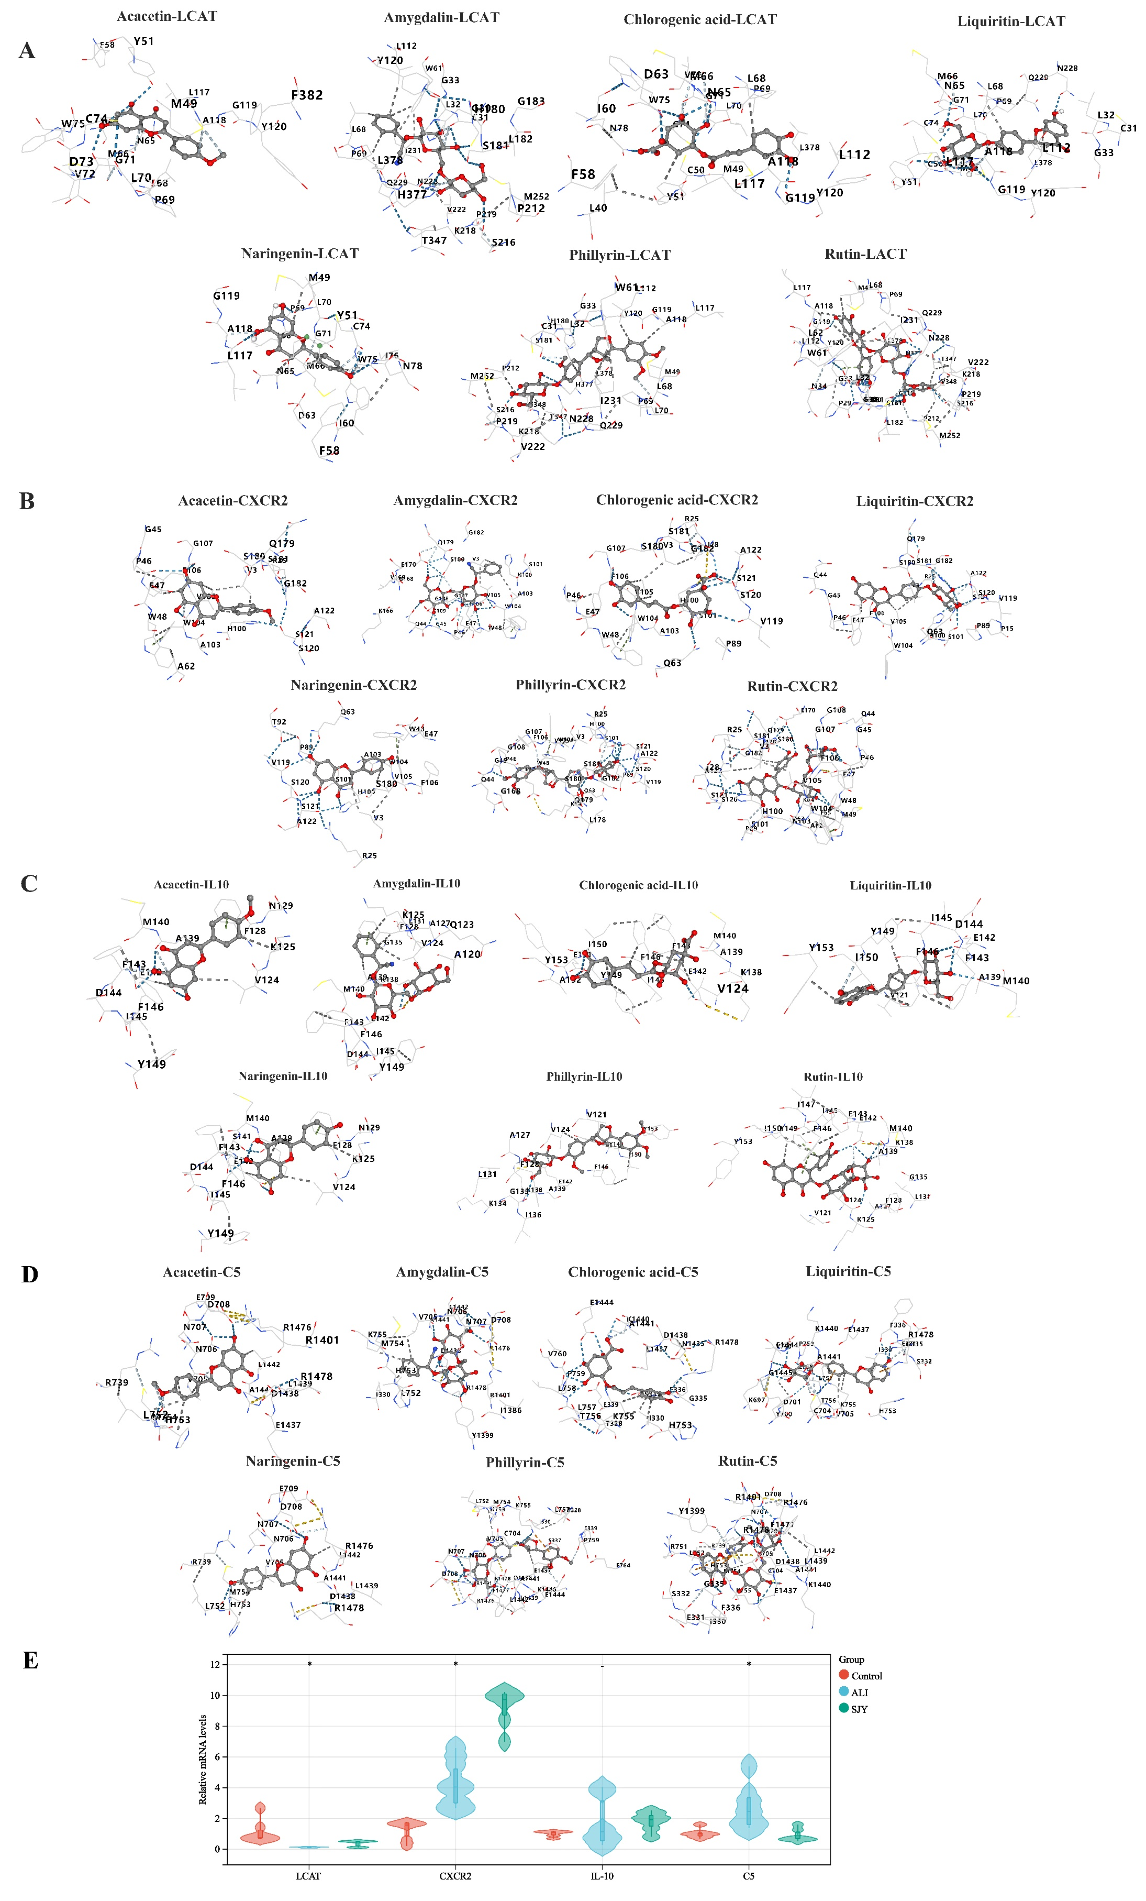

**Fig. S4** Verification of the key targets LCAT, CXCR2, IL-10 and C5 by molecular docking and qRT-PCR.

**Table S8** Molecular docking results of the interaction between SJY’s representative components and the key targets. The PDB ID of IL10, LCAT, C5 and CXCR2 were 2h24, 6mvd, 3cu7 and 6kva.

|  |  |  |  |  |  |  |
| --- | --- | --- | --- | --- | --- | --- |
| **Target** | **Compound** | **Score (kcal/mol)** | **Cavity volume** | **Center**  **(x, y, z)** | **Docking size**  **(x, y, z)** | **Contact residues** |
| **IL10** | liquiritin | -6.9 | 333 | 17, 14, -21 | 21, 21, 21 | Chain A: VAL121 VAL124 ALA139 MET140 GLU142 PHE143 ASP144 ILE145 PHE146 TYR149 ILE150 TYR153 |
|  | acacetin | -6.7 | 333 | 17, 14, -21 | 21, 21, 21 | Chain A: VAL124 LYS125 PHE128 ASN129 ALA139 MET140 GLU142 PHE143 ASP144 ILE145 PHE146 TYR149 |
|  | naringenin | -6.9 | 333 | 17, 14, -21 | 21, 21, 21 | Chain A: VAL124 LYS125 PHE128 ASN129 LYS138 ALA139 MET140 SER141 GLU142 PHE143 ASP144 ILE145 PHE146 TYR149 |
|  | phillyrin | -7 | 333 | 17, 14, -21 | 27, 27, 27 | Chain A: VAL121 VAL124 ALA127 PHE128 LEU131 LYS134 GLY135 ILE136 LYS138 ALA139 GLU142 PHE146 TYR149 ILE150 TYR153 |
|  | rutin | -8 | 333 | 17, 14, -21 | 22, 22, 22 | Chain A: VAL121 VAL124 LYS125 ALA127 PHE128 LEU131 GLY135 LYS138 ALA139 MET140 GLU142 PHE143 ILE145 PHE146 ILE147 TYR149 ILE150 TYR153 |
|  | amygdalin | -6.4 | 333 | 17, 14, -21 | 24, 24, 24 | Chain A: ALA120 GLN123 VAL124 LYS125 ALA127 PHE128 LEU131 GLY135 LYS138 ALA139 MET140 GLU142 PHE143 ASP144 ILE145 PHE146 TYR149 |
|  | chlorogenic acid | -6.5 | 333 | 17, 14, -21 | 23, 23, 23 | Chain A: VAL124 LYS138 ALA139 MET140 GLU142 PHE143 ILE145 PHE146 TYR149 ILE150 GLU151 ALA152 TYR153 |
| **LCAT** | liquiritin | -9.4 | 4255 | 103, 7, 114 | 33, 31, 25 | Chain A: CYS31 LEU32 GLY33 LEU112 LEU117 ALA118 GLY119 TYR120 ASN228 GLN229 LEU378 |
|  |  |  |  |  |  | Chain B: MET49 CYS50 TYR51 ASN65 MET66 LEU68 PRO69 LEU70 GLY71 CYS74 |
|  | acacetin | -8.4 | 4255 | 103, 7, 114 | 33, 31, 27 | Chain A: LEU117 ALA118 GLY119 TYR120 PHE382 |
|  |  |  |  |  |  | Chain B: MET49 TYR51 PHE58 ASP63 ASN65 MET66 LEU68 PRO69 LEU70 GLY71 VAL72 ASP73 CYS74 TRP75 |
|  | naringenin | -8.7 | 4255 | 103, 7, 114 | 33, 31, 27 | Chain A: LEU117 ALA118 GLY119 |
|  |  |  |  |  |  | Chain B: MET49 TYR51 PHE58 ILE60 ASP63 ASN65 MET66 LEU68 PRO69 LEU70 GLY71 CYS74 TRP75 ILE76 ASN78 |
|  | phillyrin | -9.3 | 4255 | 103, 7, 114 | 33, 27, 27 | Chain A: CYS31 LEU32 GLY33 TRP61 LEU112 LEU117 ALA118 GLY119 TYR120 HIS180 SER181 PRO212 SER216 LYS218 PRO219 VAL222 ASN228 GLN229 ILE231 MET252 THR347 VAL348 HIS377 LEU378 |
|  |  |  |  |  |  | Chain B: MET49 LEU68 PRO69 LEU70 |
|  | rutin | -9.4 | 4255 | 103, 7, 114 | 33, 31, 22 | Chain A: PRO29 GLY30 CYS31 LEU32 GLY33 ASN34 TRP61 LEU62 LEU112 LEU117 ALA118 GLY119 TYR120 HIS180 SER181 LEU182 GLY210 PRO212 SER216 LYS218 PRO219 VAL222 ASN228 GLN229 ILE231 MET252 THR347 VAL348 HIS377 LEU378 |
|  |  |  |  |  |  | Chain B: MET49 LEU68 PRO69 |
|  | amygdalin | -8.7 | 4255 | 103, 7, 114 | 33, 31, 24 | Chain A: GLY30 CYS31 LEU32 GLY33 TRP61 LEU112 TYR120 HIS180 SER181 LEU182 GLY183 PRO212 SER216 LYS218 PRO219 VAL222 ASN228 GLN229 ILE231 MET252 THR347 HIS377 LEU378 |
|  |  |  |  |  |  | Chain B: LEU68 PRO69 |
|  | chlorogenic acid | -8.6 | 4255 | 103, 7, 114 | 33, 31, 23 | Chain A: LEU112 LEU117 ALA118 GLY119 TYR120 LEU378 |
|  |  |  |  |  |  | Chain B: LEU40 MET49 CYS50 TYR51 PHE58 ILE60 ASP63 ASN65 MET66 LEU68 PRO69 LEU70 GLY71 VAL72 CYS74 TRP75 ASN78 |
| **C5** | liquiritin | -10 | 12283 | -20, 33, 64 | 35, 35, 25 | Chain B: ILE330 GLU331 SER332 GLY335 PHE336 LYS697 TYR700 ASP701 CYS704 VAL705 HIS753 LYS755 THR756 LEU757 LEU758 PRO759 VAL760 GLU1437 LYS1440 ALA1441 GLU1444 GLY1445 ARG1478 |
|  | acacetin | -8.3 | 12283 | -20, 33, 64 | 35, 35, 29 | Chain B: VAL705 ASN706 ASN707 ASP708 GLU709 ARG739 LEU752 HIS753 MET754 ARG1401 GLU1437 ASP1438 LEU1439 ALA1441 LEU1442 ARG1476 ARG1478 |
|  | naringenin | -7.9 | 12283 | -20, 33, 64 | 35, 35, 29 | Chain B: VAL705 ASN706 ASN707 ASP708 GLU709 ARG739 LEU752 HIS753 MET754 ASP1438 LEU1439 ALA1441 LEU1442 ARG1476 ARG1478 |
|  | phillyrin | -10.1 | 12283 | -20, 33, 64 | 35, 35, 27 | Chain B: THR328 ILE330 SER337 GLU339 CYS704 VAL705 ASN706 ASN707 ASP708 LEU752 HIS753 MET754 LYS755 LEU757 PRO759 GLU764 ARG1401 GLU1437 ASP1438 LEU1439 LYS1440 ALA1441 LEU1442 GLU1444 ARG1476 PHE1477 ARG1478 |
|  | rutin | -9.9 | 12283 | -20, 33, 64 | 35, 35, 29 | Chain B: ILE330 GLU331 SER332 GLY335 PHE336 CYS704 VAL705 ASN706 ASN707 ASP708 ARG739 ARG751 LEU752 HIS753 MET754 LYS755 TYR1399 ARG1401 GLU1437 ASP1438 LEU1439 LYS1440 ALA1441 LEU1442 ARG1476 PHE1477 ARG1478 |
|  | amygdalin | -8.8 | 12283 | -20, 33, 64 | 35, 35, 24 | Chain B: ILE330 VAL705 ASN706 ASN707 ASP708 LEU752 HIS753 MET754 LYS755 ILE1386 TYR1399 ARG1401 ASP1438 ALA1441 LEU1442 ARG1476 ARG1478 |
|  | chlorogenic acid | -8.2 | 12283 | -20, 33, 64 | 35, 35, 29 | Chain B: THR328 ILE330 GLY335 PHE336 SER337 GLU339 HIS753 LYS755 THR756 LEU757 LEU758 PRO759 VAL760 ASN1435 GLU1437 ASP1438 LYS1440 ALA1441 GLU1444 ARG1478 |
| **CXCR2** | liquiritin | -8.9 | 38101 | 41, 4, 61 | 35, 35, 35 | Chain H: GLN44 GLY45 PRO46 GLU47 GLN63 |
|  |  |  |  |  |  | Chain L: VAL3 ARG25 HIS100 SER101 TRP104 VAL105 PHE106 |
|  |  |  |  |  |  | Chain h: PRO15 PRO89 VAL119 SER120 SER121 ALA122 GLN179 SER180 SER181 GLY182 |
|  | acacetin | -7.8 | 38101 | 41, 4, 61 | 35, 35, 35 | Chain H: GLY45 PRO46 GLU47 TRP48 ALA62 |
|  |  |  |  |  |  | Chain L: VAL3 ARG25 HIS100 ALA103 TRP104 VAL105 PHE106 GLY107 |
|  |  |  |  |  |  | Chain h: SER120 SER121 ALA122 GLN179 SER180 SER181 GLY182 |
|  | naringenin | -7.9 | 38101 | 41, 4, 61 | 35, 35, 35 | Chain H: GLU47 TRP48 GLN63 |
|  |  |  |  |  |  | Chain L: VAL3 ARG25 HIS100 SER101 ALA103 TRP104 VAL105 PHE106 |
|  |  |  |  |  |  | Chain h: PRO89 THR92 VAL119 SER120 SER121 ALA122 SER180 |
|  | phillyrin | -9.3 | 38101 | 41, 4, 61 | 35, 35, 35 | Chain H: GLN44 GLY45 PRO46 GLU47 TRP48 GLN63 LYS64 |
|  |  |  |  |  |  | Chain L: VAL3 ARG25 HIS100 SER101 TRP104 VAL105 PHE106 GLY107 GLY108 |
|  |  |  |  |  |  | Chain h: PRO89 VAL119 SER120 SER121 ALA122 LEU178 GLN179 SER180 SER181 GLY182 |
|  |  |  |  |  |  | Chain l: GLY168 |
|  | rutin | -10.1 | 38101 | 41, 4, 61 | 35, 35, 35 | Chain H: GLN44 GLY45 PRO46 GLU47 TRP48 MET49 ALA62 GLN63 LYS64 PHE65 |
|  |  |  |  |  |  | Chain L: VAL3 ARG25 ILE28 HIS100 SER101 ALA103 TRP104 VAL105 PHE106 GLY107 GLY108 |
|  |  |  |  |  |  | Chain h: PRO89 SER120 SER121 ALA122 LEU178 GLN179 SER180 SER181 GLY182 |
|  |  |  |  |  |  | Chain l: GLU170 |
|  | amygdalin | -8.2 | 38101 | 41, 4, 61 | 35, 35, 35 | Chain H: GLN44 GLY45 PRO46 GLU47 TRP48 |
|  |  |  |  |  |  | Chain L: VAL3 HIS100 SER101 ALA103 TRP104 VAL105 PHE106 GLY107 GLY108 GLY109 |
|  |  |  |  |  |  | Chain h: GLN179 SER180 GLY182 |
|  |  |  |  |  |  | Chain l: LYS166 GLY168 VAL169 GLU170 |
|  | chlorogenic acid | -8 | 38101 | 41, 4, 61 | 35, 35, 35 | Chain H: PRO46 GLU47 TRP48 GLN63 |
|  |  |  |  |  |  | Chain L: VAL3 ARG25 ILE28 HIS100 SER101 ALA103 TRP104 VAL105 PHE106 GLY107 |
|  |  |  |  |  |  | Chain h: PRO89 VAL119 SER120 SER121 ALA122 SER180 SER181 GLY182 |

**8. Microbiome analysis**

**Table S9** Gut microflora intervened by SJY.

|  |  |  |
| --- | --- | --- |
| **Taxa** | **LDA score** | ***P* value** |
| d__*Bacteria*;p__*Firmicutes*;c__*Bacilli* | 3.77 | 8.65E-03 |
| d__*Bacteria*;p__*Firmicutes*;c__*Bacilli*;o__*Lactobacillales* | 3.76 | 1.33E-02 |
| d__*Bacteria*;p__*Firmicutes*;c__*Bacilli*;o__*Lactobacillales*;f__*Lactobacillaceae* | 3.67 | 2.07E-02 |
| d__*Bacteria*;p__*Firmicutes*;c__*Bacilli*;o__*Lactobacillales*;f__*Lactobacillaceae*;g__*Lactobacillus* | 3.67 | 2.07E-02 |
| d__*Bacteria*;p__*Proteobacteria*;c__*Alphaproteobacteria*;o__*Caulobacterales*;f__*Caulobacteraceae*;g__*Brevundimonas* | 3.28 | 4.28E-02 |
| d__*Bacteria*;p__*Firmicutes*;c__*Erysipelotrichia*;o__*Erysipelotrichales*;f__*Erysipelotrichaceae*;g__*Faecalibaculum* | 3.26 | 3.65E-02 |
| d__*Bacteria*;p__*Proteobacteria*;c__*Gammaproteobacteria*;o__*Enterobacteriales*;f__*Enterobacteriaceae*;g__*Escherichia-Shigella* | 3.24 | 1.85E-02 |
| d__*Bacteria*;p__*Firmicutes*;c__*Clostridia*;o__*Clostridiales*;f__*Lachnospiraceae*;g__*Blautia* | 3.11 | 4.54E-02 |
| d__*Bacteria*;p__*Proteobacteria*;c__*Gammaproteobacteria*;o__*Pasteurellales*;f__*Pasteurellaceae*;g__*Muribacter* | 3.09 | 8.04E-03 |
| d__*Bacteria*;p__*Firmicutes*;c__*Clostridia*;o__*Clostridiales*;f__*Ruminococcaceae*;g__*Ruminococcaceae*_UCG-011 | 3.09 | 1.08E-02 |
| d__*Bacteria*;p__*Firmicutes*;c__*Bacilli*;o__*Lactobacillales*;f__*Streptococcaceae*;g__*Streptococcus* | 3.03 | 1.18E-02 |
| d__*Bacteria*;p__*Firmicutes*;c__*Clostridia*;o__*Clostridiales*;f__*Lachnospiraceae*;g__*Agathobacter* | 3.03 | 1.18E-02 |
| d__*Bacteria*;p__*Bacteroidetes*;c__*Bacteroidia*;o__*Bacteroidales*;f__*Tannerellaceae* | 3.02 | 3.44E-02 |
| d__*Bacteria*;p__*Bacteroidetes*;c__*Bacteroidia*;o__*Bacteroidales*;f__*Tannerellaceae*;g__*Parabacteroides* | 3.02 | 3.44E-02 |
| d__*Bacteria*;p__*Firmicutes*;c__*Clostridia*;o__*Clostridiales*;f__*Peptostreptococcaceae* | 2.96 | 8.65E-03 |
| d__*Bacteria*;p__*Chloroflexi*;c__*Chloroflexia*;o__*Chloroflexales*;f__*Chloroflexaceae* | 2.92 | 1.58E-02 |
| d__*Bacteria*;p__*Proteobacteria*;c__*Gammaproteobacteria*;o__*Betaproteobacteriales*;f__*Burkholderiaceae*;g__*Limnohabitans* | 2.92 | 2.17E-02 |
| d__*Bacteria*;p__*Bacteroidetes*;c__*Bacteroidia*;o__*Bacteroidales*;f__*Marinifilaceae*;g__*Butyricimonas* | 2.92 | 2.33E-02 |
| d__*Bacteria*;p__*Firmicutes*;c__*Clostridia*;o__*Clostridiales*;f__*Ruminococcaceae*;g__*Faecalibacterium* | 2.90 | 6.46E-03 |
| d__*Bacteria*;p__*Firmicutes*;c__*Erysipelotrichia*;o__*Erysipelotrichales*;f__*Erysipelotrichaceae*;g__*Erysipelotrichaceae*_UCG-003 | 2.90 | 4.64E-02 |
| d__*Bacteria*;p__*Proteobacteria*;c__*Gammaproteobacteria*;o__*Pasteurellales*;f__*Pasteurellaceae* | 2.81 | 6.15E-03 |
| d__*Bacteria*;p__*Proteobacteria*;c__*Gammaproteobacteria*;o__*Pasteurellales* | 2.81 | 6.15E-03 |
| d__*Bacteria*;p__*Firmicutes*;c__*Erysipelotrichia*;o__*Erysipelotrichales*;f__*Erysipelotrichaceae*;g__*Erysipelatoclostridium* | 2.80 | 2.58E-02 |
| d__*Bacteria*;p__*Bacteroidetes*;c__*Bacteroidia*;o__*Bacteroidales*;f__*Marinifilaceae* | 2.76 | 4.84E-02 |