**Novel Synthesis and Characterization of Magnesium-doped CoFe2O4 Nanoparticles –SiO2 -3-Aminopropylethoxysilane -Gallic acid Magnetic Nanocomposite for Effective Removal of Cationic Dyes**

Shameran Jamal Salih1*, Layth Imad Abd Ali 2, Wali M. Mahmood3

1,2,3 Department of Chemistry, Faculty of Science and Health, Koya University, Koya KOY45, Kurdistan Region − F.R., Iraq

*Corresponding Author

Email: [shameran.jamal@koyauniversity.org](mailto:shameran.jamal@koyauniversity.org)

**Structure of dyes**

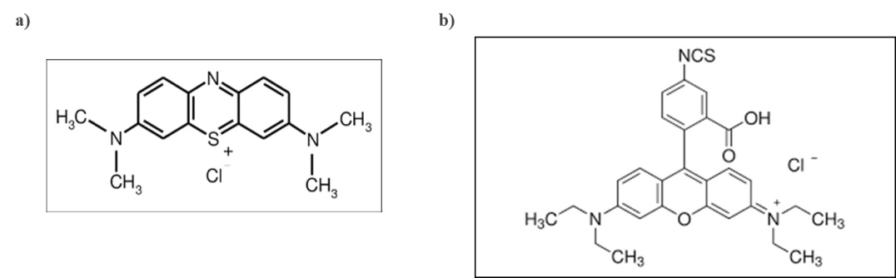

**Fig. S1:** Chemical structure of (a) Methylene Blue and (b) Rhodamine B.

**Thermal Gravimetric Analysis (TGA)**

Thermal Gravimetric Analysis (TGA) patterns, depicted in Fig. S1, were utilized to characterize the compound materials and evaluate the thermal stability of both MgCF and MgCF@SiO-NH-GA samples. The TGA analysis revealed a total weight reduction of 18.86% and 39.17% across a temperature range of 50-1000 °C, respectively. The TGA spectra demonstrate the stability of MgCF when subjected to heating in the temperature range of 50-600 °C. For MgCF@SiO-NH-GA, the TGA analysis reveals a total weight loss of 33.25%, occurring in distinct stages at temperatures of 120, 290, 550, and 1000 °C. This weight reduction can be attributed to the breakdown of various surface groups on the nanocomposite and the disappearance of hydroxyl ions from the particles. In addition, the weight loss at temperatures of 290, 550, and 1000 °C is associated with the decomposition of Gallic acid and residual functionalities. This is due to the elongation of the carbon chain and the increase in the molecular weight of the dendrimer shell (Sanna Angotzi et al., 2023). Furthermore, the weight loss percentage of 33.25% for MgCF@SiO-NH-GA confirms the presence of polyhydroxyl groups on the MgCF@SiO-NH-GA shell. The weight reduction observed before 290 °C corresponds to the removal of surface moisture.

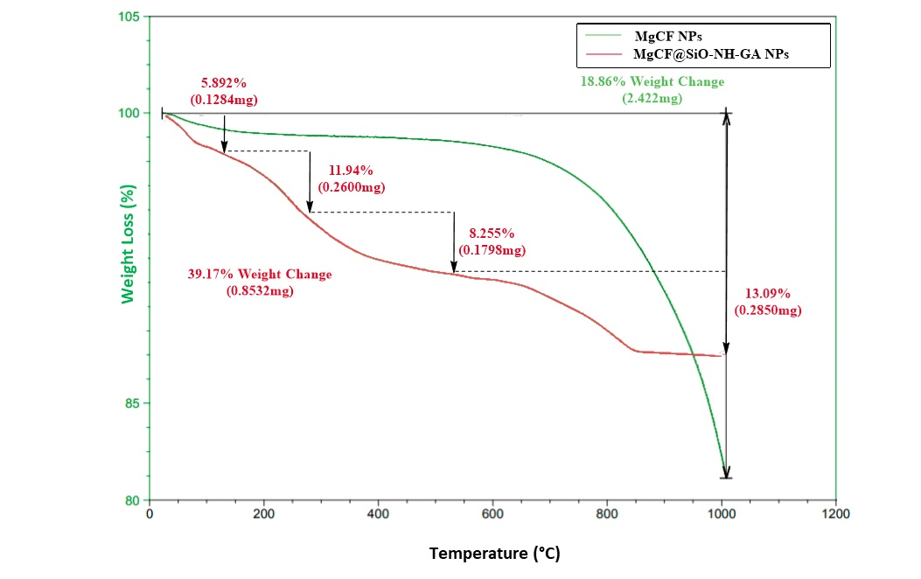

**Fig. S2:** TGA curves of MgCF and MgCF@SiO-NH-GA NPs.

**X-ray Diffraction**

The phase purity and crystallographic identity of both the unmodified and modified MgCF NPs samples were determined by analyzing their powder X-ray diffraction (XRD) patterns, as presented in Fig. S2.

C:\Users\Admin\Desktop\Fatima\Sal\xrd-e.tif

**Fig. S3.** X-ray diffraction patterns of MgCF and MgCF@SiO-NH-GA NPs.

The observed diffraction pattern closely matches the face-centered cubic (JCPDS 22-1086) arrangement and the typical cubic spinel structure of cobalt ferrite. Importantly, no additional crystalline phases were detected in the XRD patterns, affirming that the samples are phase-pure. This confirms that the analyzed samples exclusively consist of MgCF in their modified form, with no other crystalline phases. The XRD pattern of the as-synthesized nanoparticles revealed distinct diffraction peaks corresponding to the single spinel phase with the Fd3m space group. These peaks were accurately indexed with Miller indices: (111), (220), (311), (222), (440), (422), (511), (440), and (533), located at 2θ positions of 18.529°, 30.620°, 31.978°, 35.953°, 45.709°, 54.124°, 56.665°, 63.136°, and 75.5058°, respectively. Similarly, the Mg-CF@SiO-NH-G particles displayed distinct diffraction peaks at 18.645°, 30.500°, 35.894°, 37.510°, 43.436°, 53.958°, 57.399°, 63.108°, and 74.639°, indexed with the same Miller indices. Notably, additional minor peaks observed at approximately 18° and 25° indicate the incorporation of organic SiO2, 3-APTES, and Gallic acid groups, confirming the successful modification of the spinel MgCF nanoparticles (Hussein et al., 2023). Furthermore, the peak positions exhibit significant shifts in the modified form of the NPs. To determine the average sizes of the crystallites in both synthesized samples, Debye-Scherrer's equation was applied, specifically by analyzing the X-ray peak broadening of the (311) diffraction peak.

$D=\frac{Kℷ}{β\cos{θ}}$ (1)

The grain size (D) was determined using Debye-Scherrer's equation, with λ representing the wavelength (0.15406), β as the line width, θ being the peak position, and K as a constant (approximately 0.94). For the as-synthesized MgCF NPs, the calculated crystallite size was 6.6446 nm, while for the MgCF@SiO-NH-GA NPs, it was found to be 3.8653 nm.

Furthermore, the XRD patterns of the corresponding MgCF@SiO-NH-GA nanocomposites revealed a significant decrease in peak intensities across all XRD patterns of the nanodots following functionalization.

**Fourier Transform Infrared (FTIR) Spectroscopy**

Fig. S3 illustrates the FTIR spectra of both the as-synthesized and modified MgCF NPs within the frequency range of 4000-400 cm⁻¹. In the as-prepared MgCF NPs, a broad band at 3446 cm⁻¹ was observed, indicating the stretching vibration of H–O–H. This points to the presence of water molecules and hydroxyl groups on the surface.

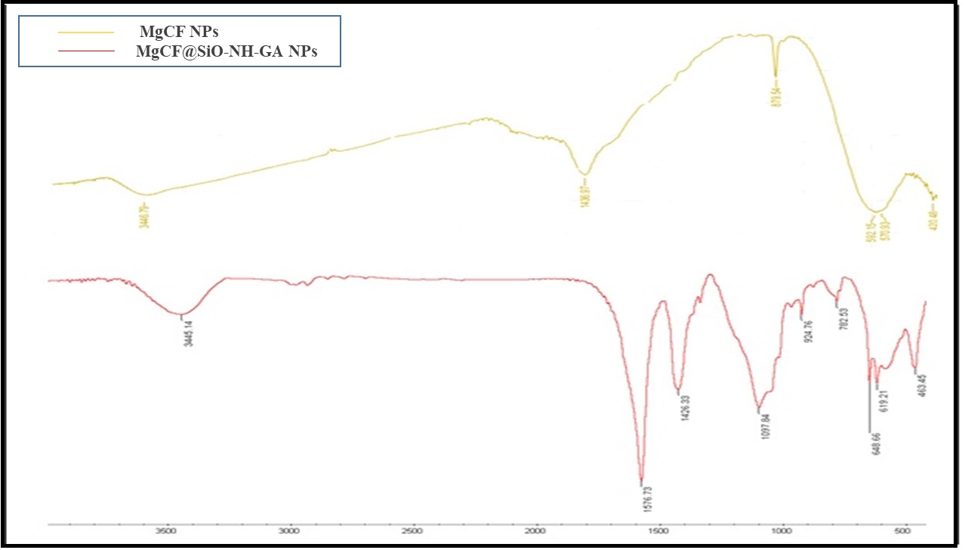

**Fig. S4.** FTIR spectra of MgCF and MgCF@SiO-NH-GA NPs.

Vibrational frequencies associated with M-O bonds in both octahedral and tetrahedral sites were detected around 400 and 600 cm⁻¹. For all samples, absorption bands at 420 and 436 cm⁻¹ (v₁) and 592 and 570 cm⁻¹ (v₂) were observed, confirming the spinel ferrite phase of both as-synthesized and modified MgCF NPs, respectively. These absorption bands align with inherent lattice vibrations in the compounds' octahedral and tetrahedral sites, with the difference between v₁ and v₂ frequencies attributed to the longer bond length of oxygen-metal ions in the tetrahedral positions. Vibrational frequencies are influenced by bonding forces, cation mass, and cation-oxygen distances (Refat et al., 2022).

Furthermore, a robust absorption at 1097 cm⁻¹ and 782 cm⁻¹ indicates the formation of a silica network due to the coating of the synthesized nanoparticles with SiO₂. Si-O-Fe vibrations are associated with a band at 924 cm⁻¹, pointing to an interaction between the nearby silica matrix and the highly isolated Fe³⁺ ions. A broad band observed at 3445 cm⁻¹ signifies Si–OH vibrations. The band around 924 cm⁻¹ indicates the absorption of Fe–O stretching in Fe–O–Si bonds, which has increased in intensity. These findings suggest the formation of fabricated NP clusters, accompanied by the rearrangement of the silica network and the strengthening of the Si–O–Fe bond between the CoFe₂O₄ clusters and the surrounding silica network (Kakde et al., 2021). In addition, the modification of functional groups, such as amino groups, plays a crucial role in enhancing the nanoparticles' ability to form covalent bonds or chemical interactions with various substances. The presence of these functional groups on the synthesized nanoparticles is confirmed by the observed FTIR peaks. The existence of amino groups is indicated by the presence of N–H bonding at 1426 and 1576 cm⁻¹, as well as O–H bonding at 3445 cm⁻¹ on the surface of the MNPs. Furthermore, the presence of APTES on the surface of MgCF@SiO2 NPs is confirmed by detecting bands at 1097 and 924 cm⁻¹, consistent with the Si–O stretching vibrations of APTES on the magnetic NPs' surface. Upon adding Gallic acid to the synthesized nanoparticles, a prominent and narrow peak at 1576 cm⁻¹ is observed, indicating the stretching vibration of the carbonyl group. The band at 3445 cm⁻¹ corresponds to the O-H group's stretching vibration, while a substantial absorption at 1097 cm⁻¹ confirms the presence of the C-O bond. Notably, the band at 744 cm⁻¹ aligns with the characteristic stretching vibration of the C-C bond within the aromatic ring of Gallic acid.

**Energy Dispersive Spectroscopy (EDS) analysis**

EDS was employed to investigate the elemental distribution of the as-prepared nanocomposite. In Fig. S4a–d, the elemental distribution spectra of the prepared nano-adsorbent reveal the presence of Fe, O, Co, and Mg elements. Notably, Fe and O are the predominant elements in the nanoparticles, as shown in (Fig. S4a). The coating of the nanoparticles with SiO2 during the initial stage results in a decrease in Fe, Co, and Mg elements, accompanied by an increase in the Oxygen element (Fig. S4b). This indicates a rearrangement of the elemental composition in the nanocomposite. The functionalization of the nanoparticles with NH2 group leads to an increase in N content (Fig. S4c). and functionalization with -COOH (Gallic acid) groups results in an increase in the C and O contents (Fig. S4d). This increase is attributed to the presence of NH2 and -COOH groups on the nanoparticle surface, resulting in higher O, C, and N elements. Subsequently, the as-synthesized nano-structure (MgCF@SiO-NH-GA) was further assessed in Fig. S4e–k, displaying elemental-mapping images that encompass cobalt, iron, oxygen, magnesium, silicon, nitrogen, carbon, and the combined nano-structure (Fig. S4k). These images confirm the uniform distribution of the elements and the high purity of the prepared sample, aligning with the crystalline phase data obtained from XRD analysis. These findings prove the successful synthesis and functionalization of the nano-adsorbent (MgCF@SiO2-NH-COOH).



**Fig. S5:** The elemental distribution EDS spectra of (a) the prepared MgCF, b) nanoparticles coated with SiO2, c) functionalization of the nanoparticles with NH2, b) functionalization of the nanoparticles -COOH (Gallic acid). The elemental-mapping images for d) cobalt, e) iron, f) oxygen, g) magnesium, h) silicon, i) nitrogen, j) carbon, and k) the combined nanostructure.

**Thermodynamic studies**

Batch experiments were conducted to investigate the influence of temperature on the adsorption and removal of cationic dyes (MB/RhB). The temperature of the sorption process plays a crucial role in the efficiency of adsorption by affecting the diffusion rate of the dye molecules on the surface active sites and within the pores of MgCF@SiO-NH-GA. By analyzing the temperature during the removal process, valuable insights can be gained regarding changes in enthalpy (ΔH°) and entropy (ΔS°). The adsorption of dyes exhibited a slight variation, ranging from 97.3% to 99.1%, within the temperature range of 298 ± 1K to 333 ± 1K, using an initial concentration of 40 ppm and a neutral pH solution (as illustrated in Fig. S6a).

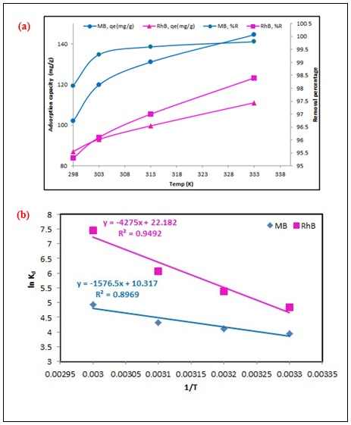

**Fig. S6:** The effect of temperature on a) adsorption capacity and b) rate constant of MgCF@SiO-NH-GA for MB and RhB.

Generally, increasing the temperature enhances the mobility and diffusion of the dye molecules due to the formation of surface monolayers. Additionally, higher temperatures reduce the intermolecular interactions between dye molecules and water, facilitating faster and easier diffusion into the nano-adsorbent scaffold. Given the insignificant difference in removal efficiencies between 298-333K, 298K was selected as the ideal temperature for this study. To examine the thermodynamic characteristics and gain insights into the adsorption of dyes (MB/RhB) onto the nano-adsorbent, several experiments were conducted at different temperatures ranging from 298 to 333 K. By utilizing the equations provided below, it is possible to estimate the enthalpy (ΔH°), entropy (ΔS°), and Gibbs free energy (ΔG°) associated with the adsorption process of dyes onto the nano-adsorbent (MgCF@SiO-NH-GA) at the state of equilibrium.

 (13)

 (14)

The equilibrium constant Kd, where Kd=qe/Ce, was used to determine the values of ΔH° and ΔS°. A linear plot of ln Kd vs. 1/T (as shown in Fig. S6b) was employed to define these values. The obtained values of ΔH° and ΔS° are recorded in (Table S1). The positive value of ΔH° suggests the endothermic nature of the dyes (MB/RhB) sorption onto the nano-adsorbent. An increase in temperature accelerates the adsorption rate and dye diffusion. The negative value of ΔG° indicates the spontaneity of dyes removal, making it favorable and preferred. As temperature increases, the value of ΔG° becomes more negative, suggesting that high temperature benefits the adsorption process.

**Table S1:** Summary of values for thermodynamics parameters for MB and RhB by MgCF@SiO-NH-GA.

|  |  |  |  |  |  |  |  |  |
| --- | --- | --- | --- | --- | --- | --- | --- | --- |
| **MB** | | | | | **RhB** | | | |
| **Temperature** (K) | **∆H**  (KJ.mol-1) | **∆S**  (J.mol-1.K-1) | **∆G**  (KJ.mol-1) | **R2** | **∆H**  (KJ.mol-1) | **∆S**  (J.mol-1.K-1) | **∆G**  (KJ.mol-1) | **R2** |
| **298** | 68.96 | 269.83 | -9.9 | 0.8969 | 27.93 | 121.74 | -8.9 | 0.9492 |
| **303** |  | | -13.7 |  |  | | -10.3 |  |
| **313** | -16.86 | -11.9 |
| **333** | -19.4 | -12.8 |

The adsorption of dyes onto the nano-adsorbent caused a random expansion at the MgCF@(SiO-NH-GA)-dye interface, as indicated by the positive value of ΔS°. This expansion may be attributed to the surface movement of adsorbed MB and RhB molecules on the adsorbent surface or changes in the nano-adsorbent surface.

**References**

Hussein, M. M., S. A. Saafan, H. Abosheiasha, et al., 2023. Crystal structure and peculiarities of microwave parameters of Co 1− x Ni x Fe 2 O 4 nano spinel ferrites. RSC advances. 13, 26879-26891.

Kakde, A., R. Belekar, G. Wakde, et al., 2021. Evidence of magnetic dilution due to unusual occupancy of zinc on B-site in NiFe2O4 spinel nano-ferrite. Journal of Solid State Chemistry. 300, 122279.

Refat, N. M., M. Y. Nassar and S. A. Sadeek, 2022. A controllable one-pot hydrothermal synthesis of spherical cobalt ferrite nanoparticles: synthesis, characterization, and optical properties. RSC advances. 12, 25081-25095.

Sanna Angotzi, M., V. Mameli, D. Zákutná, et al., 2023. Hard–Soft Core–Shell Architecture Formation from Cubic Cobalt Ferrite Nanoparticles. Nanomaterials. 13, 1679.