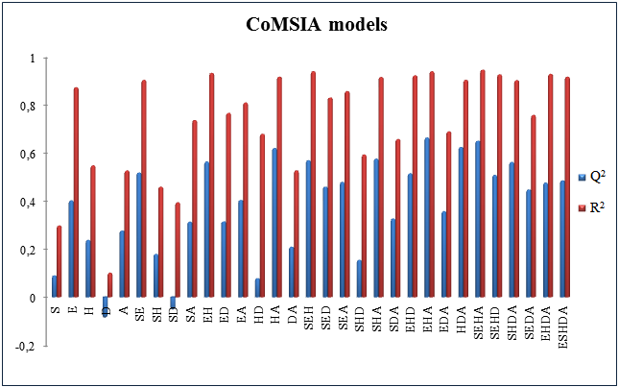

**Fig. 5 $Q^{2}$**  and $R^{2}$ values of the 31 potential combinations fields of CoMSIA model (S: steric, E: electrostatic, H: hydrophobic, D: H-bond donor, A: H-bond acceptor).

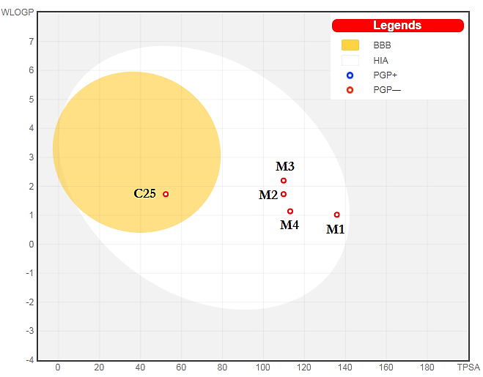

**Fig. 11** BOILED-Egg model.

**Table 18** Local properties of the molecule **C25** and **M1**.

|  |  |  |  |  |  |
| --- | --- | --- | --- | --- | --- |
| Compound | Atom | P- | P+ |  |  |
| **C25** | N1 | 0.260 | 0.083 | 0.226 | **0.593** |
| N2 | 0.395 | 0.209 | 0.570 | **0.900** |
| C3 | 0.040 | 0.025 | 0.068 | 0.091 |
| N4 | 0.187 | 0.042 | 0.115 | 0.426 |
| C5 | 0.035 | 0.054 | 0.147 | 0.080 |
| N6 | 0.122 | 0.277 | 0.755 | 0.278 |
| C7 | 0.130 | 0.435 | 1.186 | 0.296 |
| C8 | 0.160 | 1.461 | **3.984** | 0.365 |
| C9 | 0.054 | 1.665 | **4.540** | 0.123 |
| C10 | 0.018 | 0.212 | 0.578 | 0.041 |
| C11 | 0.064 | 0.009 | 0.025 | 0.146 |
| C12 | 0.144 | 0.032 | 0.087 | 0.382 |
| C13 | 0.092 | 0.240 | 0.654 | 0.207 |
| F14 | 0.053 | 0.073 | 0.199 | 0.121 |
| O15 | 0.056 | 0.216 | 0.589 | 0.128 |
| C17 | 0.066 | 0.185 | 0.504 | 0.150 |
| **M1** | N1 | -0.05 | 0.055 | 0.226 | 0.131 |
| N2 | -0.034 | 0.042 | 0.173 | 0.089 |
| C3 | -0.024 | 0.066 | 0.272 | 0.063 |
| N4 | -0.079 | 0.088 | 0.362 | 0.207 |
| C5 | 0.01 | 0.025 | 0.103 | 0.026 |
| N6 | 0.096 | 0.029 | 0.119 | 0.252 |
| C7 | 0.064 | 0.025 | 0.103 | 0.168 |
| C8 | -0.009 | 0.041 | 0.169 | 0.024 |
| C9 | 0.016 | 0.088 | 0.362 | 0.042 |
| C10 | 0.085 | 0.117 | 0.482 | 0.223 |
| C11 | 0.147 | 0.202 | **0.832** | 0.385 |
| C12 | 0.141 | 0.114 | 0.469 | 0.370 |
| C13 | 0.020 | 0.239 | **0.984** | 0.052 |
| N14 | 0.158 | 0.096 | 0.395 | **0.414** |
| O15 | 0.289 | 0.133 | 0.548 | **0.758** |
| C16 | 0.048 | 0.017 | 0.070 | 0.126 |
| O17 | 0.038 | 0.045 | 0.185 | 0.100 |
| O18 | 0.132 | 0.050 | 0.206 | 0.346 |
| Cl19 | 0.026 | 0.065 | 0.268 | 0.068 |
| N20 | 0.018 | 0.011 | 0.045 | 0.047 |