**Novel modified probiotic gold nanoparticles loaded with ginsenoside CK exerts an anti-inflammation effect *via* NF-κB/MAPK signaling pathways**

Seunghyun Kim a 1, Rongbo Wang a 1, Sanjeevram Dhandapani a,Kyungsu Kang b, Ik-Hyun Cho c *, Yeon-Ju Kim a *

*aGraduate School of Biotechnology, and College of Life Science, Kyung Hee University, Yongin 17104, Republic of Korea*

*bNatural Product Informatics Research Center, Korea Institute of Science and Technology, Gangneung, Gangwon-do 25451, Republic of Korea*

*cDepartment of Science in Korean Medicine and Brain Korea 21 Plus Program, Graduate School, Kyung Hee University, Seoul 02447, Republic of Korea*

Correspondence authors: Yeon-Ju Kim; Ik-Hyun Cho

Tel +82-31-201-5634; +82- 2-961-0749, Fax +82- 2-965-5969

Email: yeonjukim@khu.ac.kr (YJK); ihcho@khu.ac.kr (IHC)

1 Theseauthors contributed equally to the manuscript.

**Disclosure statement**

The authors declare that they have no conflict of interest regarding this publication.

**Supplementary Figures**

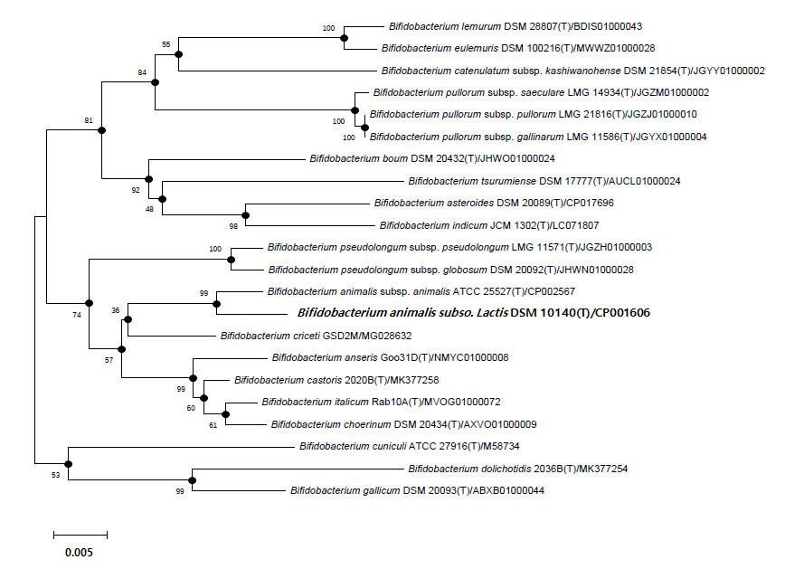

**Figure S1.** Neighbor-joining tree based on 16S rRNA sequences of *B. animalis* subsp. lactis and type strains of closely related species.Rooted neighbor-joining tree based on 16S rRNA gene sequences showing the phylogenetic positions of strain *B. animalis* subsp. *lactis* DSM 10140 and the other closest bacteria in the genus *Bifidobacterium* and some other related taxa. Filled circles show that the corresponding nodes were also recovered in the maximum-parsimony algorithm. Bootstrap values, expressed as percentages of 1000 replications, are shown at branch points. Bar, 0.005 substitutions per nucleotide position.

**Table S1.** List of primer sequences used in experiments

|  |  |  |
| --- | --- | --- |
| Gene name | Forward primer (5`-3`) | Reverse primer (5`-3`) |
| *GAPDH* | TGAAGGTCGGTGTGAACGGATTTTGGC | TGGTTCACACCCATCACAAACATGG |
| *iNOS* | AATGGCAACATCAGGTCGGCCATCACT | GCTGTGTGTCACAGAAGTCTCGAACTC |
| *COX-2* | TGCTGGTGGAAAAACCTCGT | AAAACCCACTTCGCCTCCAA |
| *TNF-α* | AGCCCACGTCGTAGCAAACCACCAA | AACACCCATTCCCTTCACAGAGCAAT |
| *IL-1β* | TGCAGAGTTCCCCAACTGGTACATC | GTGCTGCCTAATGTCCCCTTGAATC |
| *IL-6* | GTTCTCTGGGAAATCGTGGA | TGTACTCCAGGTAGCTATGG |
| *β-Actin* | CGGGAAATCGTGCGTGAC | AGCTCTTCTCCAGGGAGGA |

Table S2. Interpretation of FT-IR spectrum peaks

|  |  |  |
| --- | --- | --- |
| Compound K | Bifi-CKAuNPs | Peak of assignment |
| 1654.74 | 1640.46 | C=O stretch, C=C alkene |
|  | 1546.03 | N-H bending and C-H stretching (amide Ⅱ) |
| 1453.57 | 1455.02 | CH2 bend |
| 1387.02~1261.39 | 1384.74 | CH3 bend |
|  | 1234.41 | PO2-asymmetric stretching (amide Ⅲ) |
| 1199.87 |  | C-OH stretching |
| 1076.79 | 1075.98 | PO2- stretching |
|  | 1042.63 | P-O-C twisting |
| 911.95 |  | C-H alkene, C-O-C stretching |
| 903.88 |  | Aromatic C-H bend, C-H alkene, Monosubstituted alkene |
| 803.99 |  | Aromatic C-H bend, C-H alkene |
| 646.85 | 658.84 | C-H alkene |