**Supplementary Materials** for

**In situ flame-synthesis of nanostructured carbon materials via facile alcohol Bunsen burner**

Hao-Lin Hsu a, b, 1, *, Ta-Hui Lin c, d, Chao-Ming Huang a, e, Wei-Cheng Chiu a, f,

Wen-Chang Huang a, b, Shuhn-Shyurng Hou a, c, 1, [1]*

a *Green Energy Technology Research Center, Kun Shan University, Tainan, 710, Taiwan, R.O.C.*

b *Department of Electrical Engineering, Kun Shan University, Tainan 710, Taiwan, R.O.C.*

c *Research Center for Energy Technology and Strategy, National Cheng Kung University, Tainan 701, Taiwan, R.O.C.*

d *Department of Mechanical Engineering, National Cheng Kung University, Tainan 701, Taiwan, R.O.C.*

e *Department of Material Engineering, Kun Shan University, Tainan 710, Taiwan, R.O.C.*

f *Department of Mechanical Engineering, Kun Shan University, Tainan 710, Taiwan, R.O.C.*

This file includes Figs. S1–S2, as follows:

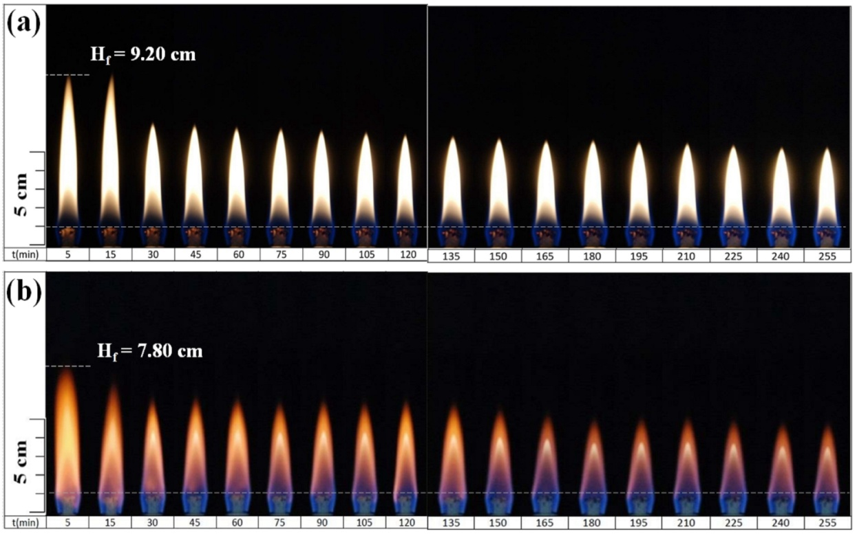

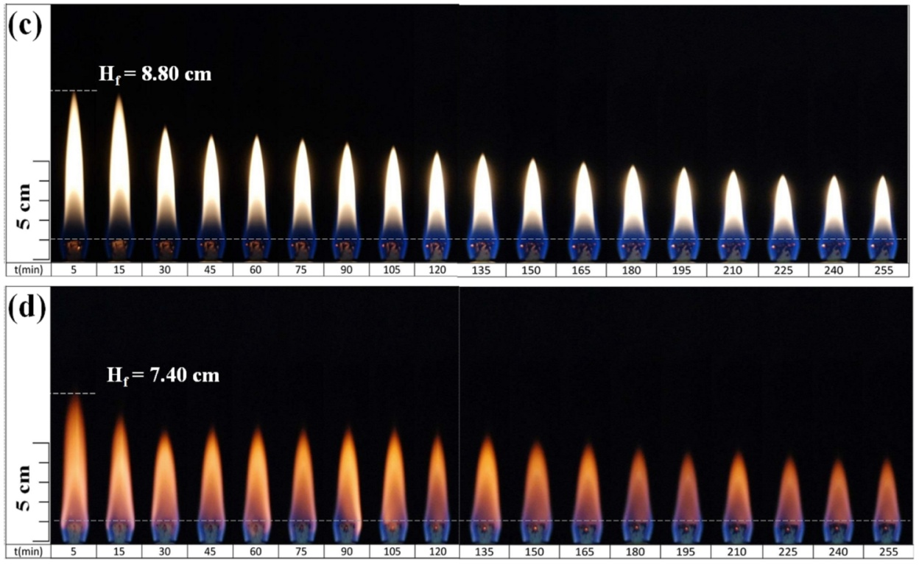

Fig. S1. Flame variation phenomena of alcohol Bunsen lamps (a) B90N10, (b) E90N10, (c) B80N20, and (d) E80N20 at different times.

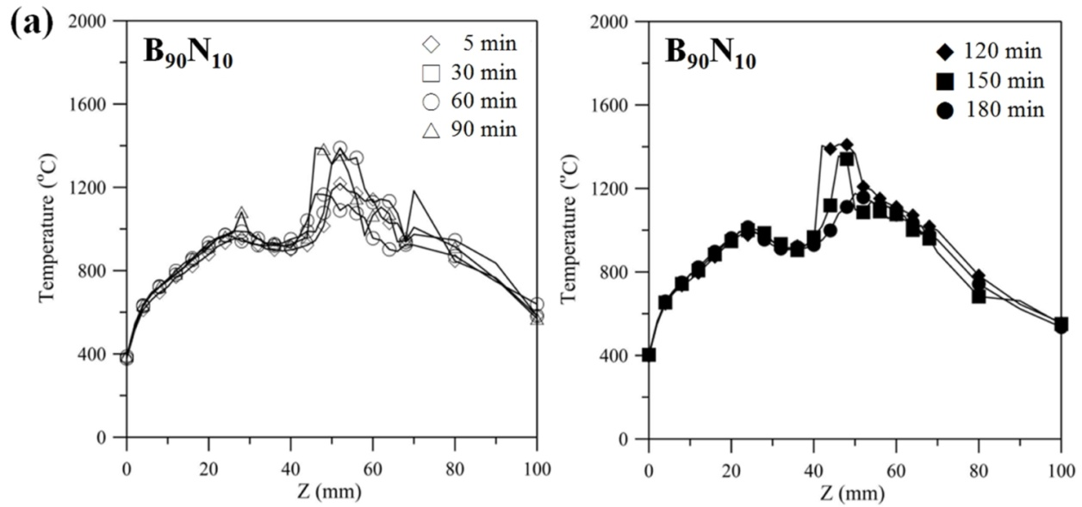

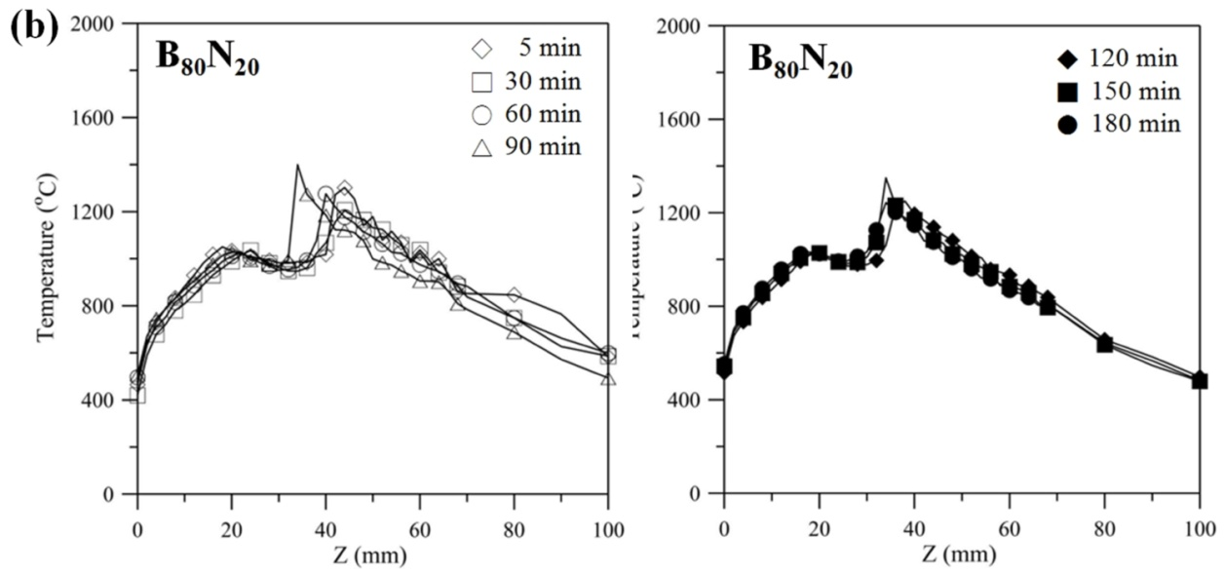

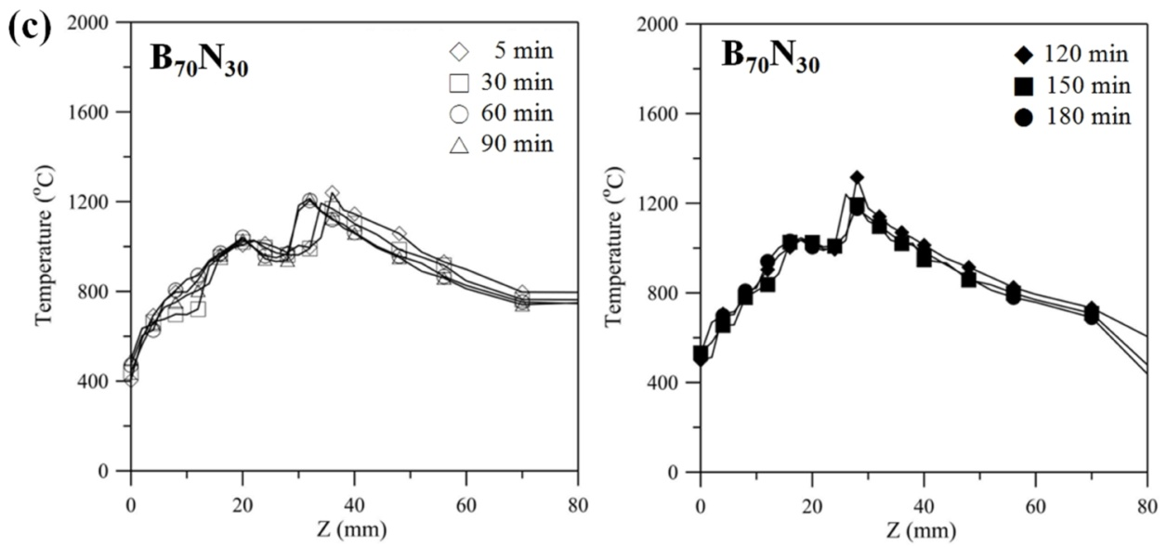

Fig. S2. The recorded temperatures of Bunsen lamp flames using fuels (a) B90N10, (b) B80N20, and (c) B70N30.

1. * Corresponding authors: Prof. Shuhn-Shyurng Hou & Asst. Prof. Hao-Lin Hsu

   E-mail address: sshou@mail.ksu.edu.tw (S.-S. Hou)

   Tel: +886 6 2050496; Fax: +886 6 2059422

   E-mail address: diago661228@gmail.com (H.-L. Hsu)

   Tel.: +886 983 673630; Fax: +886 6 2051825

   1 Corresponding authors contributed equally to this work.