**Appendix A**

Supporting information

Na-CDs as an eco-friendly and efficient corrosion inhibitor for Q235 in 1 M HCl

Liming Donga, Jingbao Wangb, Yuyue Mab, Yilei Ruana, Zhiyong Hua, Xuemei Maa[1]*

a: School of chemistry and Chemical Engineering, North University of China, Taiyuan 030051, China

b: School of Materials Science and Engineering, Beijing University of Chemical Technology, Beijing 100029, China

**Table S1**. Data from three weight loss measurements.

|  |  |  |  |  |  |  |  |  |  |  |  |
| --- | --- | --- | --- | --- | --- | --- | --- | --- | --- | --- | --- |
|  | **Content (mg/L)** | **Long (mm)** | **Wide (mm)** | **High (mm)** | ***Φ* (mm)** | **A (cm2)** | **W0(g)** | **W(g)** | **Corrosion rate**  **(g∙cm–2∙h–1)** | **η (%)** | **ΔW(g)** |
| 1 | 0 | 35.2000 | 27.7333 | 2.0000 | 4.0333 | 21.7882 | 15.7494 | 14.9014 | 0.1622 | 0.0000 | 0.8480 |
| 50 | 35.2333 | 27.9000 | 2.0333 | 4.0333 | 21.9700 | 15.7411 | 15.6619 | 0.0150 | 0.9074 | 0.0792 |
| 100 | 35.3667 | 27.7333 | 2.1000 | 4.1333 | 21.9942 | 15.8540 | 15.7935 | 0.0115 | 0.9293 | 0.0605 |
| 150 | 35.2333 | 27.8333 | 2.1000 | 4.0667 | 21.9937 | 15.8191 | 15.7841 | 0.0066 | 0.9591 | 0.0350 |
| 200 | 35.2333 | 27.8333 | 2.0000 | 4.0333 | 21.8825 | 15.5173 | 15.4402 | 0.0147 | 0.9095 | 0.0771 |
| 2 | 0 | 35.3667 | 27.7333 | 2.0333 | 4.0333 | 21.9251 | 15.6959 | 14.8413 | 0.1624 | 0.0000 | 0.8546 |
| 50 | 35.2000 | 27.7333 | 2.0333 | 4.1333 | 21.8195 | 15.7011 | 15.6148 | 0.0165 | 0.8985 | 0.0863 |
| 100 | 35.3667 | 27.7333 | 2.1000 | 4.0667 | 21.9986 | 15.8212 | 15.7490 | 0.0137 | 0.9158 | 0.0722 |
| 150 | 35.2333 | 27.9000 | 2.0333 | 4.0333 | 21.9700 | 15.7986 | 15.7521 | 0.0088 | 0.9457 | 0.0465 |
| 200 | 35.2000 | 27.8333 | 2.0000 | 4.0333 | 21.8626 | 15.4800 | 15.3947 | 0.0163 | 0.8999 | 0.0853 |
| 3 | 0 | 35.3667 | 27.7333 | 2.0333 | 4.1333 | 21.9187 | 15.7011 | 14.8413 | 0.1635 | 0.0000 | 0.8598 |
| 50 | 35.2333 | 27.9000 | 2.0333 | 4.0667 | 21.9678 | 15.7411 | 15.6680 | 0.0139 | 0.9153 | 0.0730 |
| 100 | 35.2000 | 27.7333 | 2.1000 | 4.0667 | 21.8992 | 15.7251 | 15.6692 | 0.0106 | 0.9349 | 0.0559 |
| 150 | 35.3667 | 27.8333 | 2.0000 | 4.0333 | 21.9620 | 15.8139 | 15.7800 | 0.0064 | 0.9607 | 0.0338 |
| 200 | 35.2000 | 27.8333 | 2.0000 | 4.0667 | 21.8605 | 15.7199 | 15.6377 | 0.0157 | 0.9041 | 0.0822 |

**Fig S1.** Freundlich isotherm equation.

**Table S2**. In the original state, EDS data were obtained by soaking 1M HCl for 24h and soaking 1M HCl containing 150mg/L Na-CDs for 24h.

|  |  |  |  |  |
| --- | --- | --- | --- | --- |
| condition | element | wt% | Wt % Sigma | At% |
| Original | C | 3.44 | 0.2 | 14.12 |
| O | 0.32 | 0.07 | 0.99 |
| Fe | 96.24 | 0.21 | 84.89 |
| 1 M HCl | C | 3.69 | 0.28 | 11.12 |
| O | 15.34 | 0.14 | 34.71 |
| Cl | 4.54 | 0.06 | 4.63 |
| Fe | 76.43 | 0.27 | 49.54 |
| 150mg/L Na-CDs | C | 5.72 | 0.26 | 20.68 |
| O | 2.84 | 0.08 | 7.69 |
| Na | 0 | 0.07 | 0 |
| Cl | 1.34 | 0.04 | 1.65 |
| Fe | 90.1 | 0.26 | 69.99 |

电脑屏幕的照片

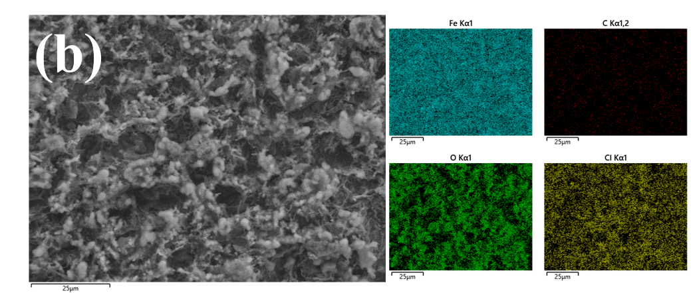

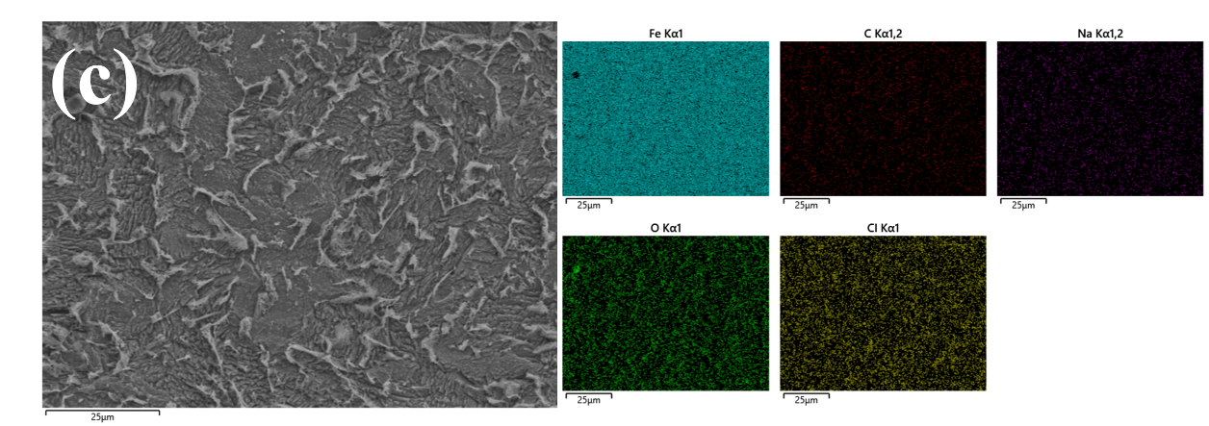

**Fig S2**. (a) In its original state, (b)1M HCl soaked for 24h, (c) Soak in 1M HCl containing 150mg/L Na-CDs for 24h.



**Fig S3**. Morphology of Q235 carbon steel soaked in 1 M HCl solution containing other concentrations of Na-CDs for 24h ：(a) and (a1) 200 mg/L, (b) and (b1) 100 mg/L, (c) and (c1) 50 mg/L.

**Fig S4.** Morphology of Q235 carbon steel soaked in 1 M HCl solution with 150mg/L concentration of Na-CDs for 24h without rinsing (a) (a1) and slowly rinsed with deionized water (b) (b1), as well as EDS data, (a2) without rinsing, (b2) slowly rinsed with deionized water.

1. * Corresponding author.

   E-mail: maxuemei@nuc.edu.cn