**Supplementary Files**

**Controlling Cisplatin Release by Synergistic Action of Silver-Cisplatin on Monodispersed Spherical Silica for Targeted Anticancer and Antibacterial Activities**

**Table S1**. Particle size and zeta potential of MSS, 1Ag/MSS, 4Ag/MSS and   
6Ag/MSS samples.

|  |  |  |
| --- | --- | --- |
| **Sample** | **Particle Size (nm)** | **Zeta potential (mV)** |
| Silica | 80 | -5 |
|  |  |  |
| 1wt%Ag/MSS | 90 | -24.7 |
|  | 103 | -23.5 |
|  | 82 | -21.8 |
|  |  |  |
| 4wt%Ag/MSS | 385 | -26.8 |
|  | 137 | -28.8 |
|  | 164 | -29.9 |
|  |  |  |
| 6wt%Ag/MSS | 196 | -24.2 |
|  | 109 | -24.5 |
|  | 112 | -23.5 |

**Table S2**: Fitting parameters for drug release using different formulations.

|  |  |  |  |  |  |  |
| --- | --- | --- | --- | --- | --- | --- |
| Name of models | Zero order | | First order | | Higuchi model | |
| Formulations/Parameters | k | R2 | k | R2 | k | R2 |
| 1Ag/MSS | 1.3943 | 0.7745 | 0.3158 | 0.9725 | 5.6315 | 0.9042 |
| 2Ag/MSS | 2.0013 | 0.7801 | 0.3049 | 0.9566 | 8.0606 | 0.9058 |
| 4Ag/MSS | 0.2570 | 0.9406 | 0.1569 | 0.7854 | 0.9129 | 0.8493 |
| 6Ag/MSS | 0.1681 | 0.8916 | 0.1288 | 0.9224 | 0.6269 | 0.8880 |
|  |  |  |  |  |  |  |
| 4Ag/SBA-16 | 1.2229 | 0.7451 | 0.4147 | 0.9824 | 1.8505 | 0.9774 |
| 4Ag/TiZSM-5 | 0.4808 | 0.9219 | 0.2564 | 0.9679 | 4.9887 | 0.8874 |
| 4Ag/Mesosilicalite | 0.4995 | 0.9452 | 0.2877 | 0.9865 | 1.9105 | 0.9896 |
| 4Ag/Halloysite | 0.3346 | 0.8709 | 0.1828 | 0.9540 | 1.3048 | 0.9475 |
| 4Ag/MSS | 0.2509 | 0.9230 | 0.1527 | 0.7581 | 0.8900 | 0.8310 |
| 4Ag/Silicalite | 0.0341 | 0.8861 | 0.1100 | 0.8350 | 0.1196 | 0.7789 |

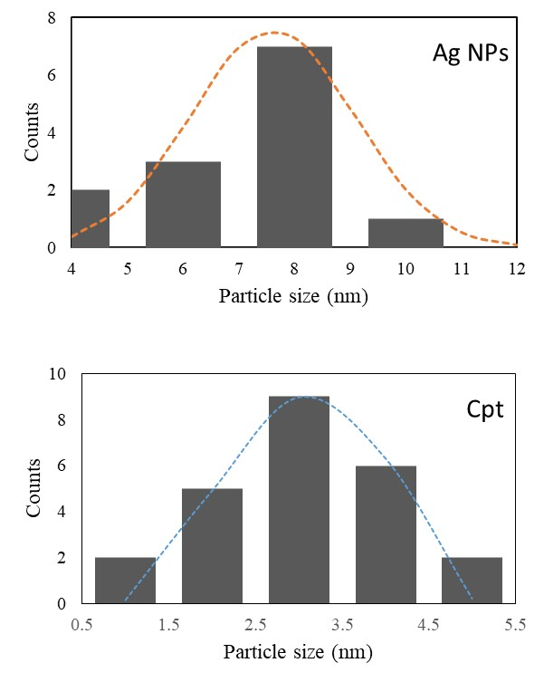

Fig. S1. Particle size histogram of 6wt% Ag/MSS/Cpt.



**Fig. S2**: Cell viability by using MTT Assay: It shows the impact of treatment of nanoparticles on HEK-293 cells post 48-hour treatment. * p < 0.05





Fig. S3. XPS spectrum of 1wt%Ag/MSS and 6wt%Ag/MSS.

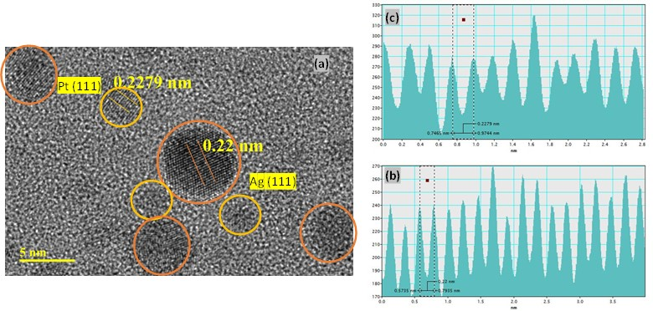

Fig. S4. TEM image of 6Ag/MSS/CPt and lattice fringes of (b) cisplatin and (c) Ag.