***Cassia fistula* leaves extract profiling and its emphasis on induced ulcerative colitis in male rats through inhibition of Caspase 3 and cyclooxygenase-2**

Nada A. Abdellatif1*, Enas E. Eltamany1*, Nahla S. El-Shenawy2, Mohamed S. Nafie3, Yasmin M. Hassan4,Rasha A. Al-Eisa5, Jihan M. Badr1*, Reda F.A. Abdelhameed1,6

1Department of Pharmacognosy, Faculty of Pharmacy, Suez Canal University, Ismailia 41522, Egypt; 2Department of Zoology, Faculty of Science, Suez Canal University, Ismailia 41522, Egypt;

3 Department of Chemistry (Biochemistry program), Faculty of Science, Suez Canal University, Ismailia 41522, Egypt; 4 Department of Botany and Microbiology, Faculty of Science, Suez Canal University, Ismailia 41522, Egypt; 5 Department of Biology, Collage of Science, Taif University, Taif 21944, Saudi Arabia;

6 Department of Pharmacognosy, Faculty of Pharmacy, Galala University, New Galala 43713, Egypt.

* Equal contribution

|  |  |
| --- | --- |
| **Supplement (S1)** | TIC of the negative mode of LC/MS/MS analysis of *C. fistula* leaves extract |
| **Supplement (S2)** | PBC of the negative mode of LC/MS/MS analysis of *C. fistula* leaves extract |
| **Supplement (S3)** | TIC of the positive mode of LC/MS/MS analysis of *C. fistula* leaves extract |
| **Supplement (S4)** | PBC of the positive mode of LC/MS/MS analysis of *C. fistula* leaves extract |

**S1. TIC of the negative mode of LC/MS/MS analysis of *C. fistula* leaves extract**

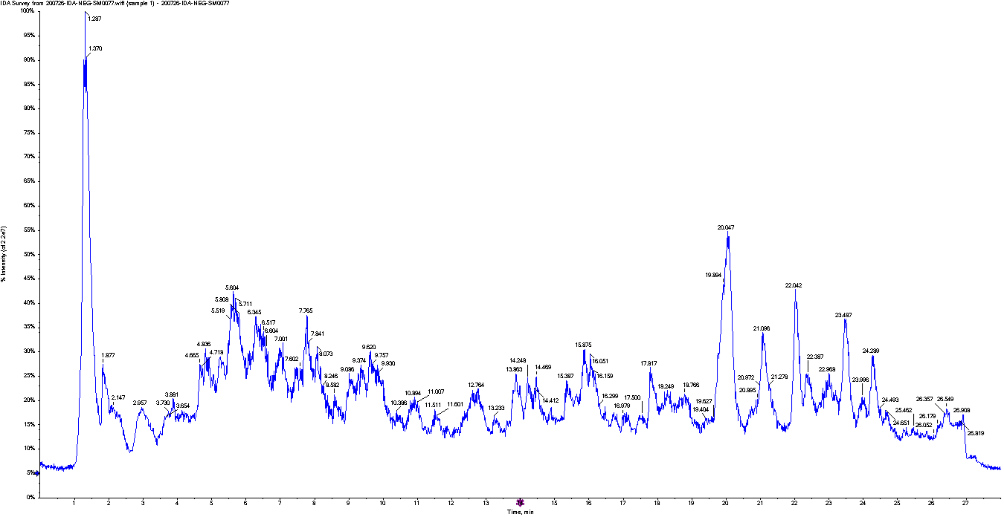

**S2. PBC of the negative mode of LC/MS/MS analysis of *C. fistula* leaves extract**





**S3. TIC of the positive mode of LC/MS/MS analysis of *C. fistula* leaves extract**

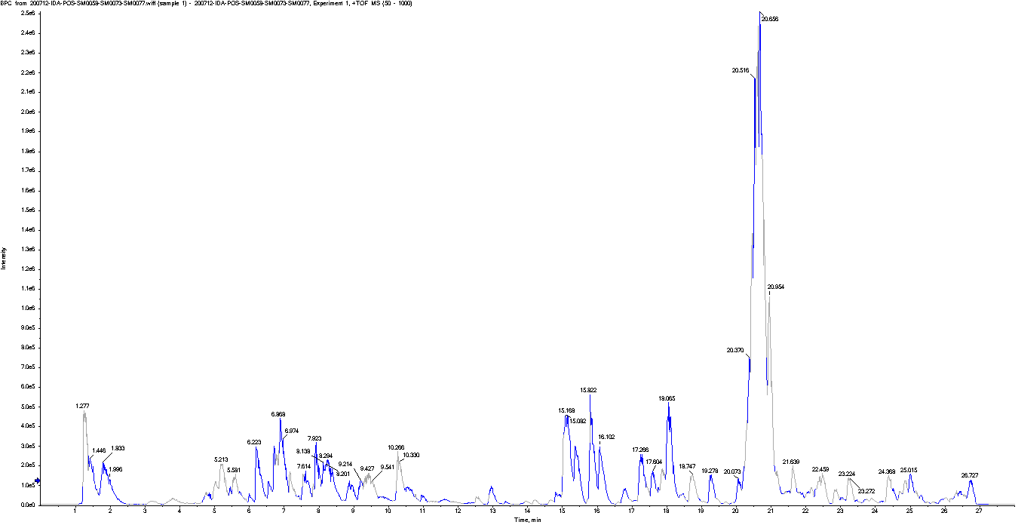

**S4. PBC of the positive mode of LC/MS/MS analysis of *C. fistula* leaves extract**