Supplementary Information
Spongisulfins A-C, three S-bridged angucycline dimers from Spongiactinospora rosea LHW63015 and their gut epithelium protective activity in Drosophila melanogaster
Weizhuo Tang^{a,b†}, Die Zhang^{b,c†}, Jing Xu^{b}, Shuping Wang^{b}, Bin Wei^{d}, Lei Li^{b∗}
ªCollege of Biological and Chemical Engineering, Changsha University, Changsha 410022, Hunan Province, China
^{b}Research Center for Marine Drugs, Department of Pharmacy, Ren Ji Hospital, School of Medicine, Shanghai Jiao Tong University, Shanghai 200127, China
^{c}Department of Pharmacy, Shanghai Children’s Medical Center, School of Medicine, Shanghai Jiao Tong University, Shanghai 200127, China
^{d}College of Pharmaceutical Science & Collaborative Innovation Center of Yangtze River Delta Region Green Pharmaceuticals, Zhejiang University of Technology, Hangzhou 310014, China
∗Corresponding author Tel: +86-21-68383346, Fax: +86-21-58732594
Email address: lilei2526@163.com
†Weizhuo Tang and Die Zhang contributed equally to this work.
Contents
Figure S1. Media screening for large-scale fermentation of S. rosea LHW63015. a Growth on agar plates at 30 °C for 8 days; the diameter of plates, 90 mm. b Centrifuged fermentation broth and blank media at 30 °C for 8 days. c TLC profiles of fermentation extracts; running system, MeOH-CH₂Cl₂ (1:10, v/v).
Figure S2. LCMS profiles of crude extracts of S. rosea LHW63015 in medium M2 (red) and blank medium (green) at 30 °C for 8 days. Eluent, MeCN-H₂O (1:9 to 10:0 in 20 min, v/v) at 1 mL min⁻¹ at room temperature.
Figure S3. HPLC analysis of S. rosea LHW63015 for different days in medium M2. The peak comprising target molecule (MW = 702 Da) was highlighted. Eluent, MeOH-H₂O (1:9 to 10:0 in 30 min, v/v) at 1 mL min⁻¹ at room temperature. Detection UV wavelength at 254 nm.
Figure S4. Phylogenetic status of spo (spongisulfin) in the GCF assigned by BiG-SCAPE.
Figure S5. Neighbour-joining (NJ) and maximum-likelihood (ML) phylogenetic trees based on CLF (KS_{β}) protein sequences from angucycline type PKSII biosynthetic gene clusters (BGC).
Figure S6. Comparing analysis of spo with closely related angucycline BGCs.
Figure S7. ¹H NMR (DMSO-d₆, 600 MHz) spectrum of 1.
Figure S8 ¹³C NMR (DMSO-d₆, 150 MHz) spectrum of 1.
Figure S9 DEPT135 NMR (DMSO-d₆, 150 MHz) spectrum of 1.
Figure S10 ¹H-¹H COSY NMR (DMSO-d₆, 600 MHz) spectrum of 1.
Figure S11 HSQC NMR (DMSO-d₆, 600 MHz) spectrum of 1.

Figure S12 HMBC NMR (DMSO-d₆, 600 MHz) spectrum of 1.

Figure S13 NOESY NMR (DMSO-d₆, 600 MHz) spectrum of 1.
Figure S14 HRESIMS (ES+) spectrum of 1.
Figure S15 UV and ECD (MeOH) spectra of 1.
Figure S16 ¹H NMR (DMSO-d₆, 600 MHz) spectrum of 2.
Figure S17 ¹³C NMR (DMSO-d₆, 150 MHz) spectrum of 2.
Figure S18 DEPT135 NMR (DMSO-d₆, 150 MHz) spectrum of 2.
Figure S19 ¹H-¹H COSY NMR (DMSO-d₆, 600 MHz) spectrum of 2.
Figure S20 HSQC NMR (DMSO-d₆, 600 MHz) spectrum of 2.
Figure S21 HMBC NMR (DMSO-d₆, 600 MHz) spectrum of 2.

Figure S22 NOESY NMR (DMSO-d₆, 600 MHz) spectrum of 2.
Figure S23 HRESIMS (ES+) spectrum of 2.
Figure S24 UV and ECD (MeOH) spectra of 2.
Figure S25 ¹H NMR (DMSO-d₆, 600 MHz) spectrum of 3.
Figure S26 ¹³C NMR (DMSO-d₆, 150 MHz) spectrum of 3.
Figure S27 DEPT135 NMR (DMSO-d₆, 150 MHz) spectrum of 3.
Figure S28 ¹H-¹H COSY NMR (DMSO-d₆, 600 MHz) spectrum of 3.
Figure S29 HSQC NMR (DMSO-d₆, 600 MHz) spectrum of 3.
Figure S30 HMBC NMR (DMSO-d₆, 600 MHz) spectrum of 3.
Figure S31 NOESY NMR (DMSO-d₆, 600 MHz) spectrum of 3.
Figure S32 HRESIMS (ES+) spectrum of 3.
Figure S33 UV and ECD (MeOH) spectra of 3, calcultaed ECD spectra of 3 and diastereomer 3'.
Figure S34 ¹H NMR (DMSO-d₆, 600 MHz) spectrum of 4.
Figure S35 ¹³C NMR (DMSO-d₆, 150 MHz) spectrum of 4.
Figure S36 DEPT135 NMR (DMSO-d₆, 150 MHz) spectrum of 4.
Figure S37 ¹H-¹H COSY NMR (DMSO-d₆, 600 MHz) spectrum of 4.
Figure S38 HSQC NMR (DMSO-d₆, 600 MHz) spectrum of 4.
Figure S39 HMBC NMR (DMSO-d₆, 600 MHz) spectrum of 4.
Figure S40 NOESY NMR (DMSO-d₆, 600 MHz) spectrum of 4.
Figure S41 HRESIMS (ES+) spectrum of 4 and oxidized product 6.
Figure S42 UV and ECD (MeOH) spectra of 4.
Figure S43 ¹H NMR (CDCl₃, 600 MHz) spectrum of 5.
Figure S44 ¹³C NMR (CDCl₃, 150 MHz) spectrum of 5.
Figure S45 DEPT135 NMR (CDCl₃, 150 MHz) spectrum of 5.
Figure S46 ESIMS (ES+) spectrum of 5.
Figure S47 ¹H NMR (CDCl₃, 600 MHz) spectrum of 6.
Figure S48 ¹³C NMR (CDCl₃, 150 MHz) spectrum of 6.
Figure S49 DEPT135 NMR (CDCl₃, 150 MHz) spectrum of 6.
Figure S50 ESIMS (ES+) spectrum of 6.
Figure S51 ¹H NMR (DMSO-d₆, 600 MHz) spectrum of 7.
Figure S52 ¹³C NMR (DMSO-d₆, 150 MHz) spectrum of 7.
Figure S53 DEPT135 NMR (DMSO-d₆, 150 MHz) spectrum of 7.
Figure S54 ESIMS (ES+) spectrum of 7.
Table S1 Formula of five selected media.
Table S2 Cartesian coordinates of the geometry of 1.
Table S3 Cartesian coordinates of the geometry of 3.
Table S4 Cartesian coordinates of the geometry of 3′.
Table S5 Secondary metabolites BGCs from S. resea LHW63015 predicted by antiSMASH.

Table S6 ¹H (600 MHz) and ¹³C (150 MHz) NMR Data for 5, 6 and 7.
Table S7 Analysis on CLF protein sequences from the potential T2PKS BGCs.
Table S8 Predicted functions of ORFs in the angucycline BGC (spo) and homologous in thioangucycline BGC (tac)
Table S9 Angucycline BGCs used in this work.

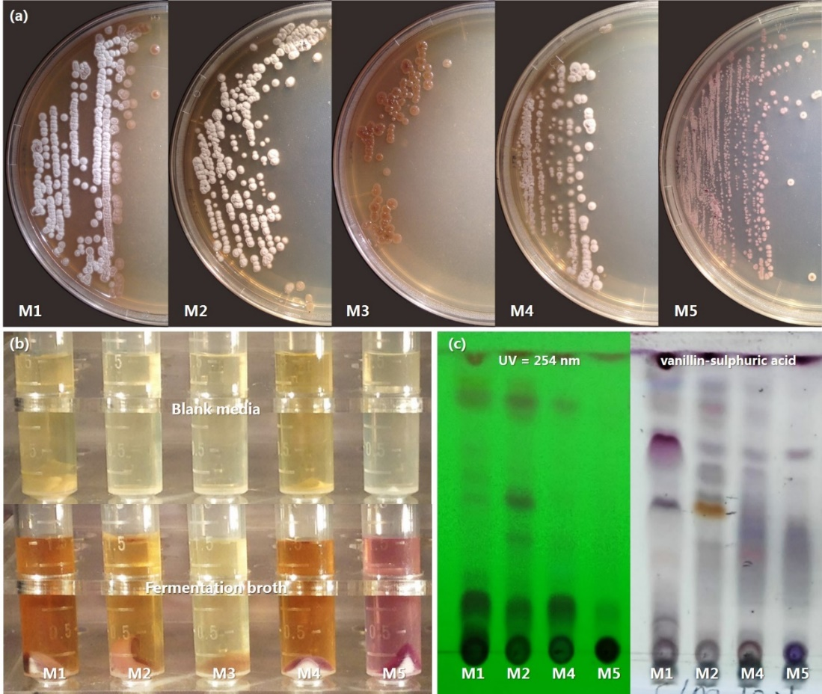
Figure S1 Media screening for large-scale fermentation of S. rosea LHW63015. a Growth on agar plates at 30 °C for 8 days; the diameter of plates, 90 mm. b Centrifuged fermentation broth and blank media at 30 °C for 8 days. c TLC profiles of fermentation extracts; running system, MeOH-CH₂Cl₂ (1:10, v/v).

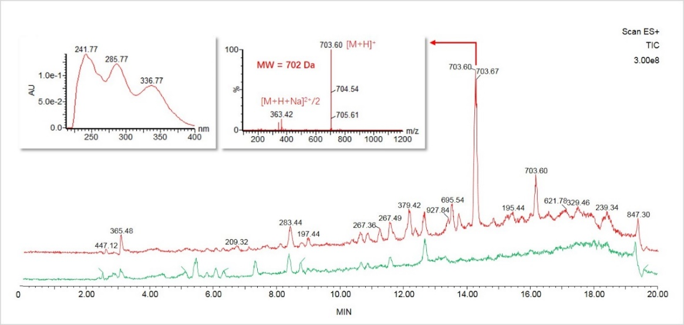
Figure S2 LCMS profiles of crude extracts of S. rosea LHW63015 in medium M2 (red) and blank medium (green) at 30 °C for 8 days. Eluent, MeCN-H₂O (1:9 to 10:0 in 20 min, v/v) at 1 mL min⁻¹ at room temperature.

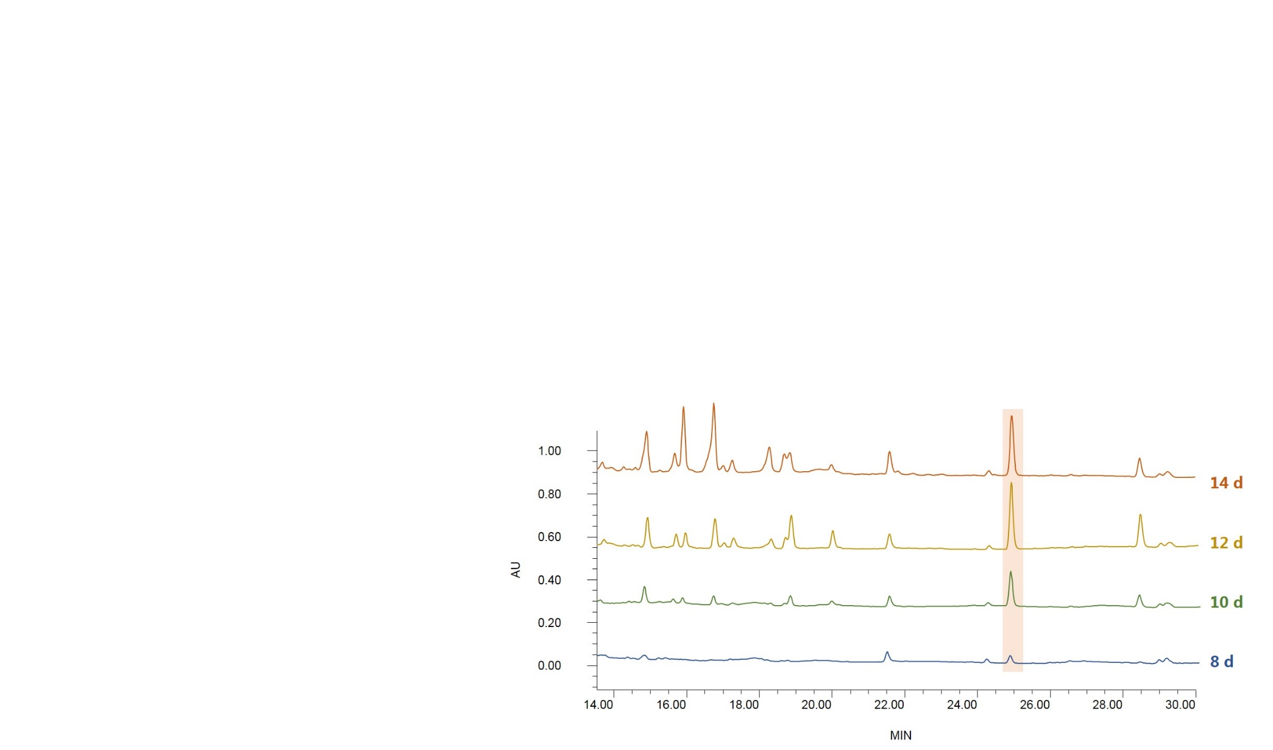
Figure S3 HPLC analysis of S. rosea LHW63015 for different days in medium M2. The peak comprising target molecule (MW = 702 Da) was highlighted. Eluent, MeOH-H₂O (1:9 to 10:0 in 30 min, v/v) at 1 mL min⁻¹ at room temperature. Detection UV wavelength at 254 nm.

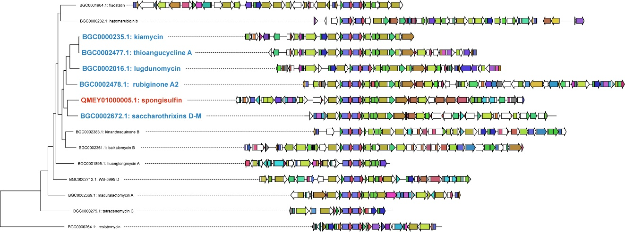
Figure S4 Phylogenetic status of spo (spongisulfin) in the GCF assigned by BiG-SCAPE.

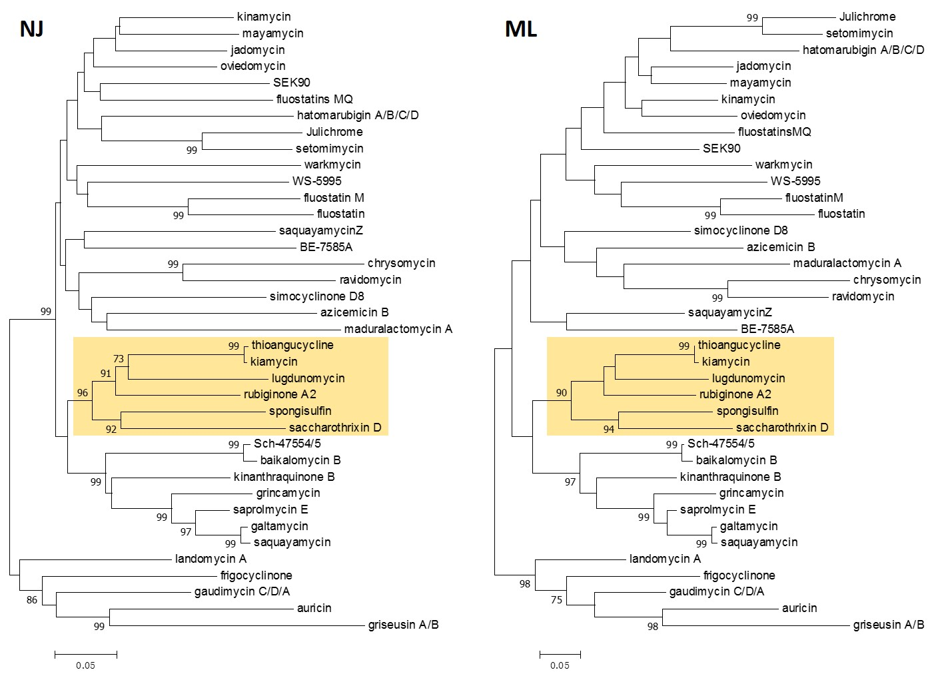
Figure S5 Neighbour-joining (NJ) and maximum-likelihood (ML) phylogenetic trees based on CLF (KS_{β}) protein sequences from angucycline type PKSII biosynthetic gene clusters (BGC).
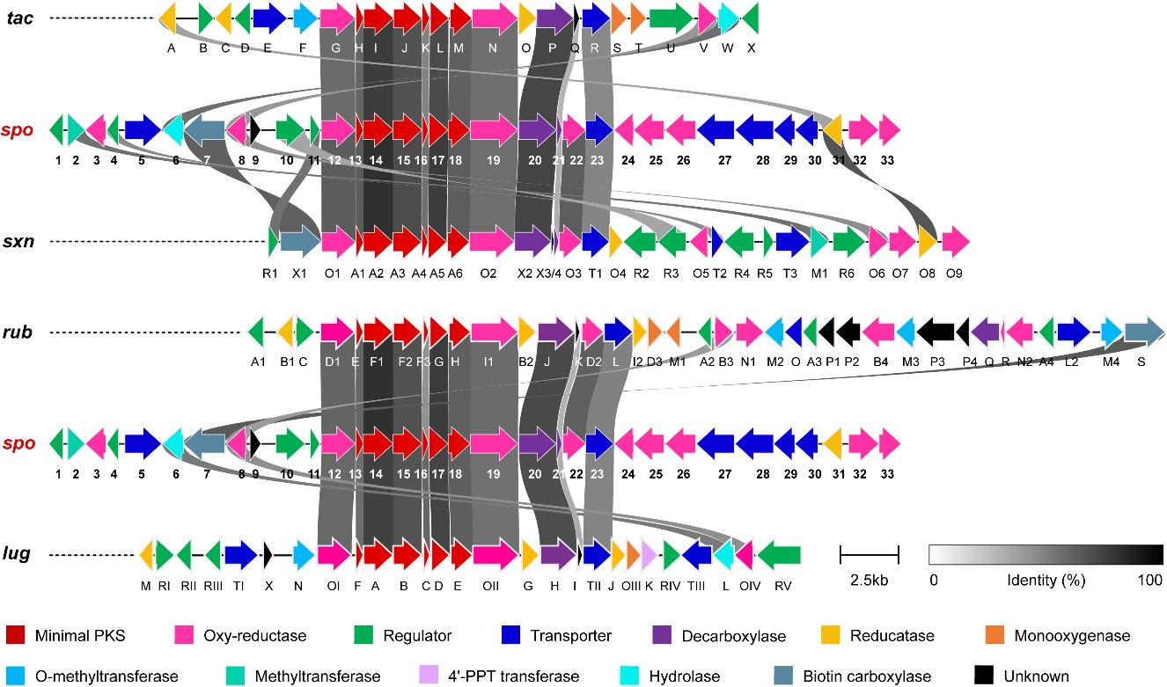
Spo | Tac | ID/SM [%] | Sxn | ID/SM [%] | Rub | ID/SM [%] | Lug | ID/SM [%]
2 |  |  | M1 | 63.22 /73.56
4 |  |  | T2 | 54.17 /70.83
6 | W | 64.50/75.24 |  |  |  |  | L | 60.39/68.83
7 |  |  | X1 | 69.44 /80.65 | S | 71.82/81.83
8 | V | 49.82/61.75 | O6 | 52.61 /68.64 | B3 | 48.59/63.03 | OIV | 52.65/64.31
10 |  |  | R3 | 45.19 /60.82
11 |  |  | R1 | 63.19 /77.78
12 | G | 65.67/77.64 | O1 | 71.05 /81.31 | D1 | 68.30/79.14 | OI | 66.67/78.73
13 | H | 67.59/75.93 | A1 | 71.30 /80.56 | E | 67.59/76.85 | F | 64.81/76.85
14 | I | 80.75/88.03 | A2 | 84.98 /91.78 | F1 | 84.51/91.78 | A | 79.58/87.56
15 | J | 74.51/79.61 | A3 | 76.16 /83.21 | F2 | 74.76/81.55 | B | 74.03/80.83
16 | K | 57.28/66.99 | A4 | 63.64 /79.55 | F3 | 51.65/65.93 | C | 67.78/77.78
17 | L | 76.49/84.33 | A5 | 81.34 /88.06 | G | 80.97/85.82 | D | 78.73/84.70
18 | M | 69.40/77.92 | A6 | 70.48 /79.37 | H | 69.62/80.38 | E | 69.84/79.37
19 | N | 63.94/75.33 | O2 | 64.61 /75.04 | I1 | 65.45/75.66 | OII | 63.5/72.99
20 | P | 78.13/85.98 | X2 | 78.69 /85.42 | J | 77.20/85.23 | H | 75.70/84.30
21 | Q | 40.00/50.00 | X4 | 41.89 /56.76 | K | 40.79/51.32 | I | 42.68/52.44
22 |  |  | O3 | 70.64 /81.35 | D2 | 69.42/79.82
23 | R | 55.23/69.59 | T1 | 55.94 /72.03 | L | 57.45/71.15 | TII | 56.35/70.50
31 | A | 45.93/62.22 | O8 | 73.33 /82.22
Figure S6 Comparing analysis of spo with closely related angucycline BGCs.

Figure S7 ¹H NMR (DMSO-d₆, 600 MHz) spectrum of 1.

Figure S8 ¹³C NMR (DMSO-d₆, 150 MHz) spectrum of 1.
Figure S9 DEPT135 NMR (DMSO-d₆, 150 MHz) spectrum of 1.

Figure S10 ¹H-¹H COSY NMR (DMSO-d₆, 600 MHz) spectrum of 1.
Figure S11 HSQC NMR (DMSO-d₆, 600 MHz) spectrum of 1.

Figure S12 HMBC NMR (DMSO-d₆, 600 MHz) spectrum of 1.

Figure S13 NOESY NMR (DMSO-d₆, 600 MHz) spectrum of 1.

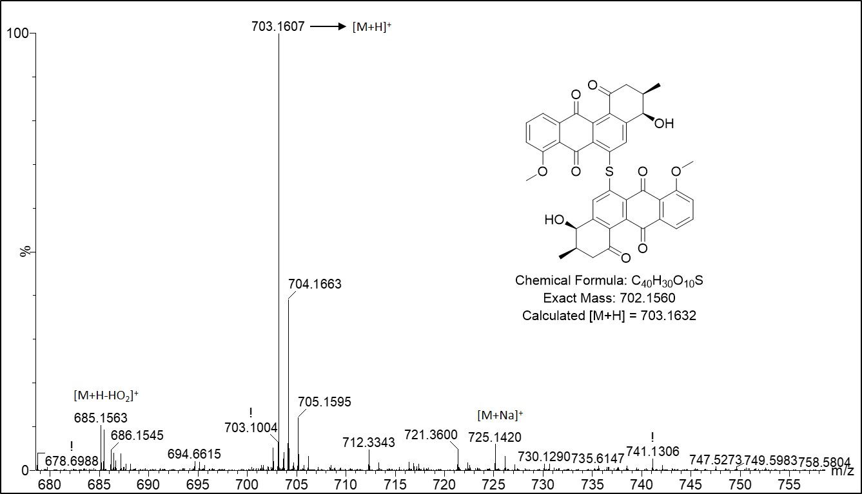
Figure S14 HRESIMS (ES+) spectrum of 1.

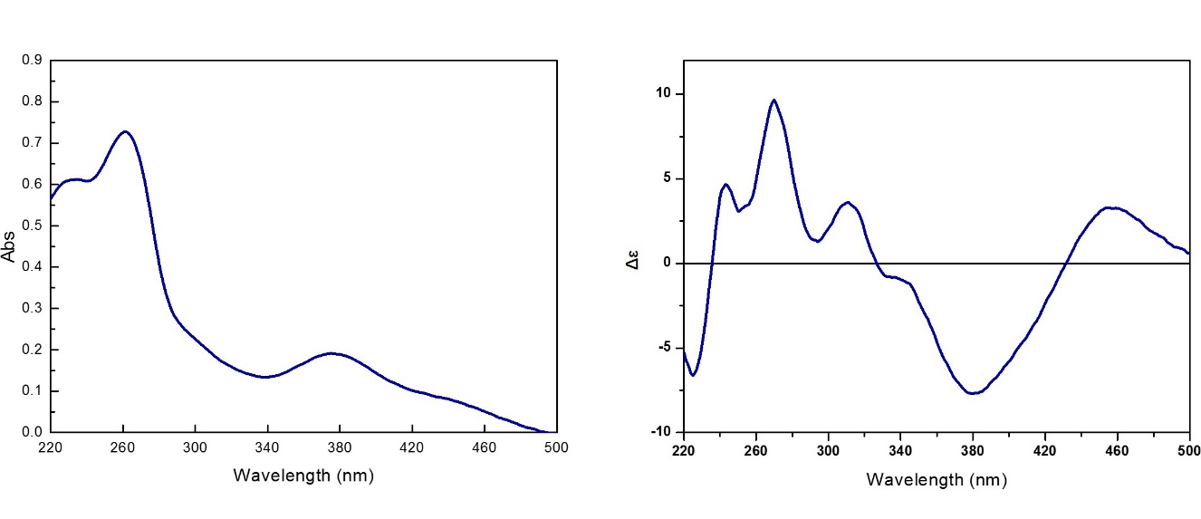
Figure S15 UV and ECD (MeOH) spectra of 1.

Figure S16 ¹H NMR (DMSO-d₆, 600 MHz) spectrum of 2.

Figure S17 ¹³C NMR (DMSO-d₆, 150 MHz) spectrum of 2.

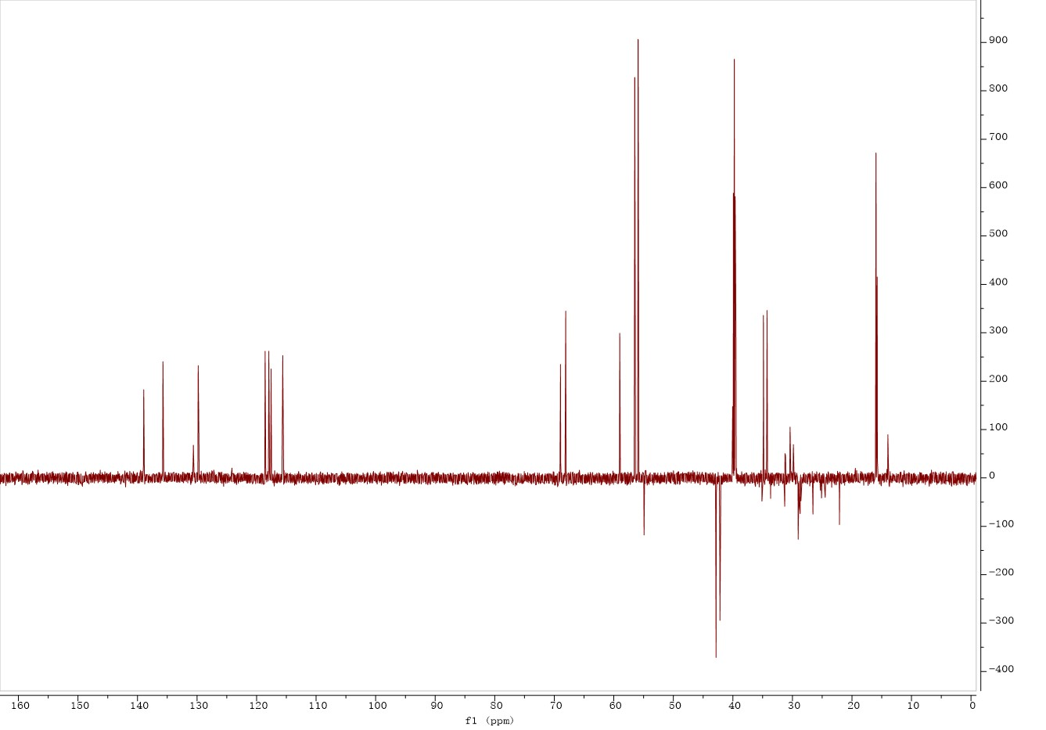
Figure S18 DEPT135 NMR (DMSO-d₆, 150 MHz) spectrum of 2.
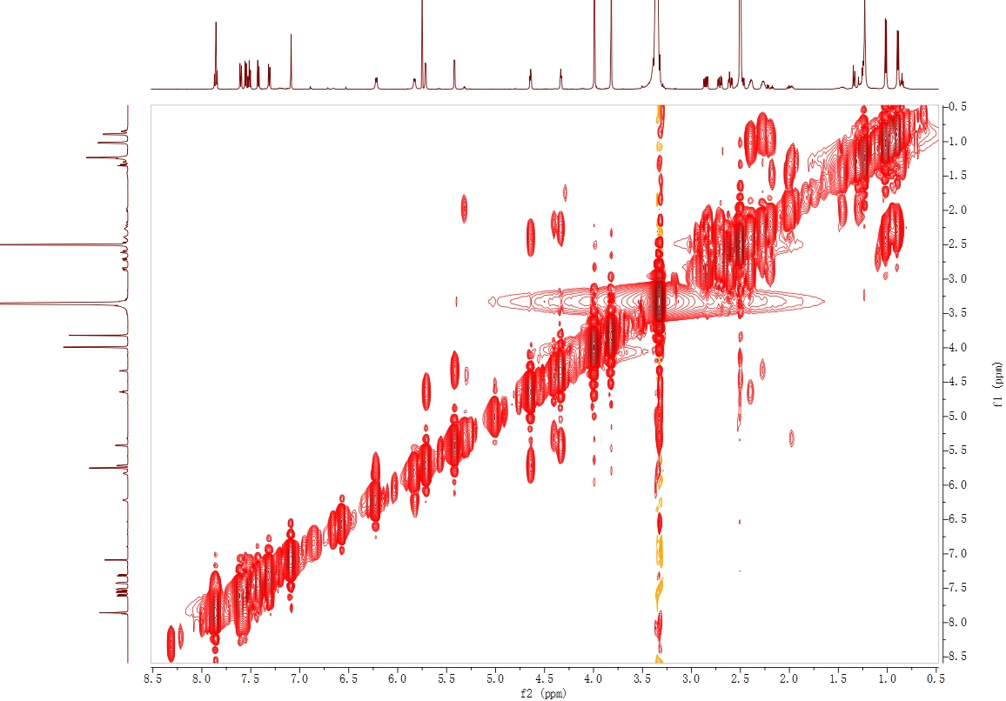
Figure S19 ¹H-¹H COSY NMR (DMSO-d₆, 600 MHz) spectrum of 2.

Figure S20 HSQC NMR (DMSO-d₆, 600 MHz) spectrum of 2.
Figure S21 HMBC NMR (DMSO-d₆, 600 MHz) spectrum of 2.

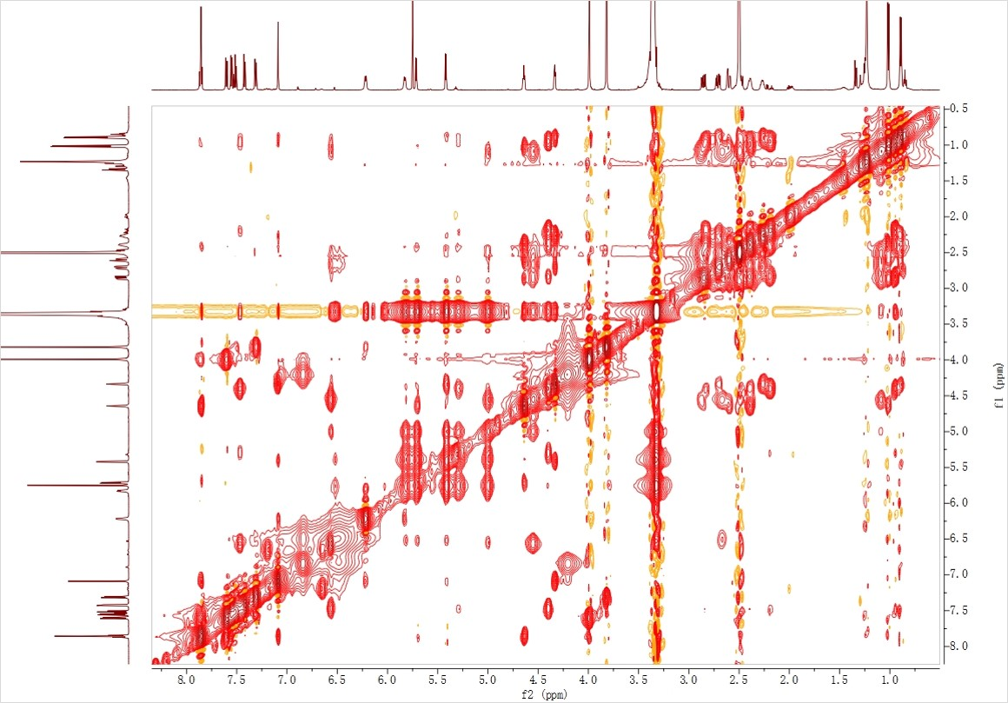

Figure S22 NOESY NMR (DMSO-d₆, 600 MHz) spectrum of 2.

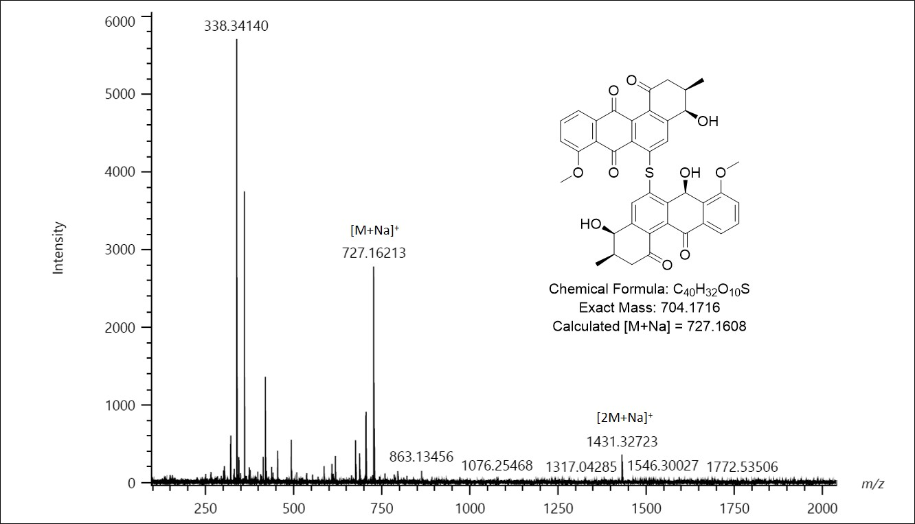
Figure S23 HRESIMS (ES+) spectrum of 2.

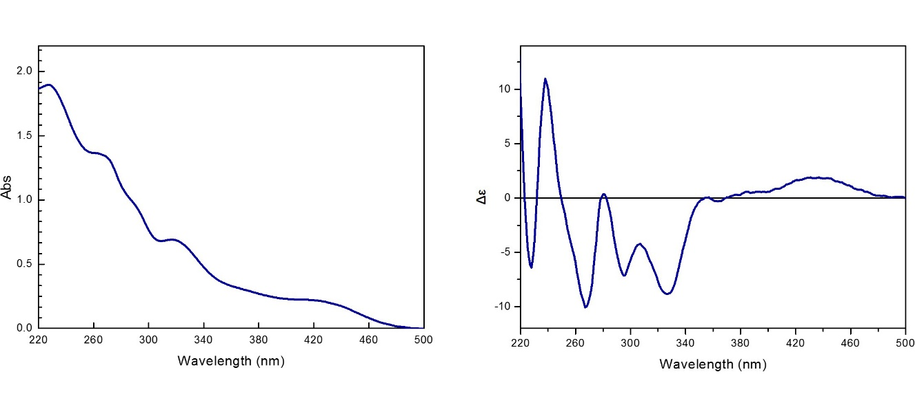
Figure S24 UV and ECD (MeOH) spectra of 2.

Figure S25 ¹H NMR (DMSO-d₆, 600 MHz) spectrum of 3.

Figure S26 ¹³C NMR (DMSO-d₆, 150 MHz) spectrum of 3.
Figure S27 DEPT135 NMR (DMSO-d₆, 150 MHz) spectrum of 3.

Figure S28 ¹H-¹H COSY NMR (DMSO-d₆, 600 MHz) spectrum of 3.
Figure S29 HSQC NMR (DMSO-d₆, 600 MHz) spectrum of 3.

Figure S30 HMBC NMR (DMSO-d₆, 600 MHz) spectrum of 3.
Figure S31 NOESY NMR (DMSO-d₆, 600 MHz) spectrum of 3.

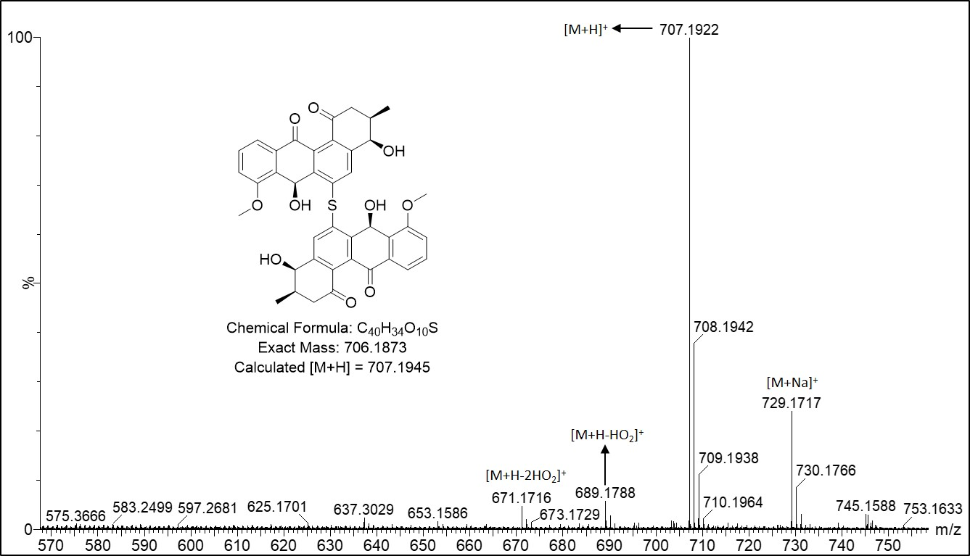
Figure S32 HRESIMS (ES+) spectrum of 3.

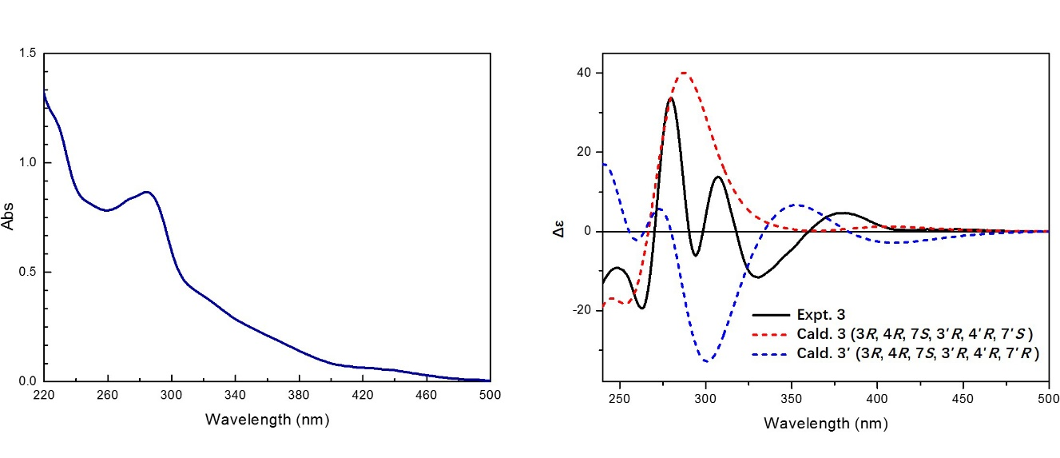
Figure S33 UV and ECD (MeOH) spectra of 3, calcultaed ECD spectra of 3 and diastereomer 3'.

Figure S34 ¹H NMR (DMSO-d₆, 600 MHz) spectrum of 4.

Figure S35 ¹³C NMR (DMSO-d₆, 150 MHz) spectrum of 4.

Figure S36 DEPT135 NMR (DMSO-d₆, 150 MHz) spectrum of 4.
Figure S37 ¹H-¹H COSY NMR (DMSO-d₆, 600 MHz) spectrum of 4.

Figure S38 HSQC NMR (DMSO-d₆, 600 MHz) spectrum of 4.
Figure S39 HMBC NMR (DMSO-d₆, 600 MHz) spectrum of 4.
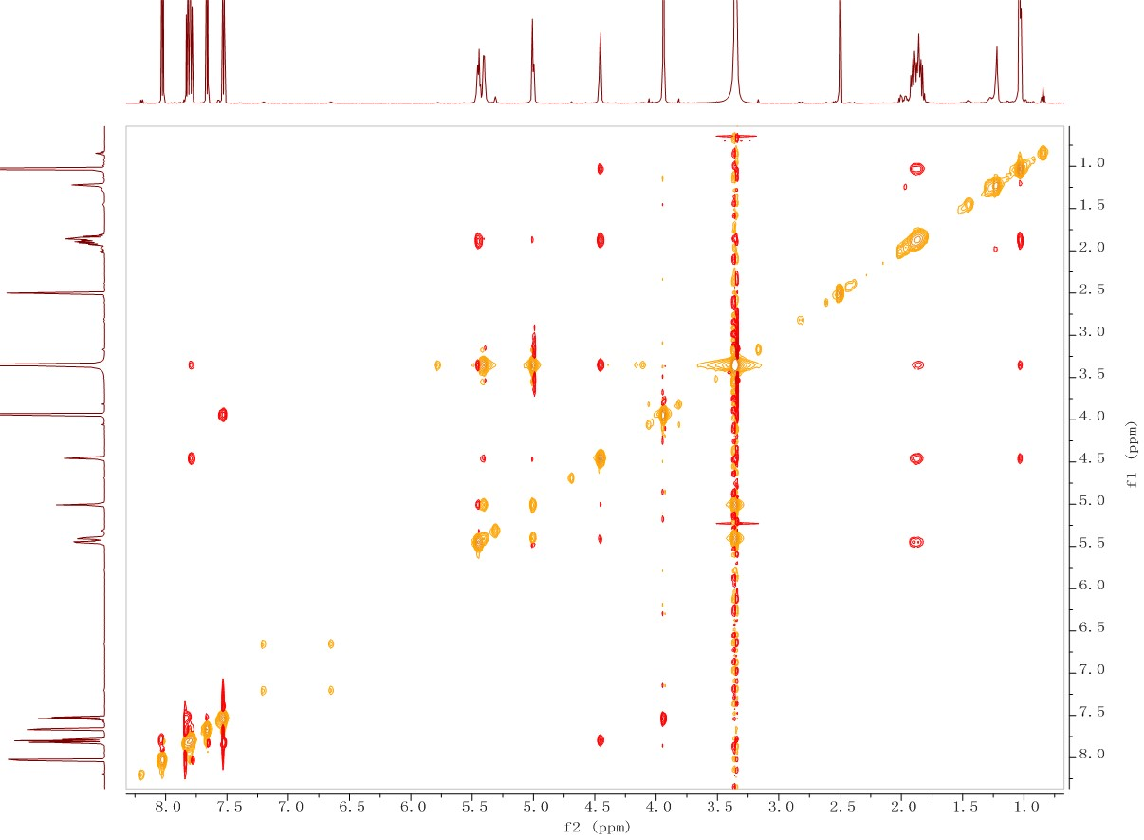
Figure S40 NOESY NMR (DMSO-d₆, 600 MHz) spectrum of 4.
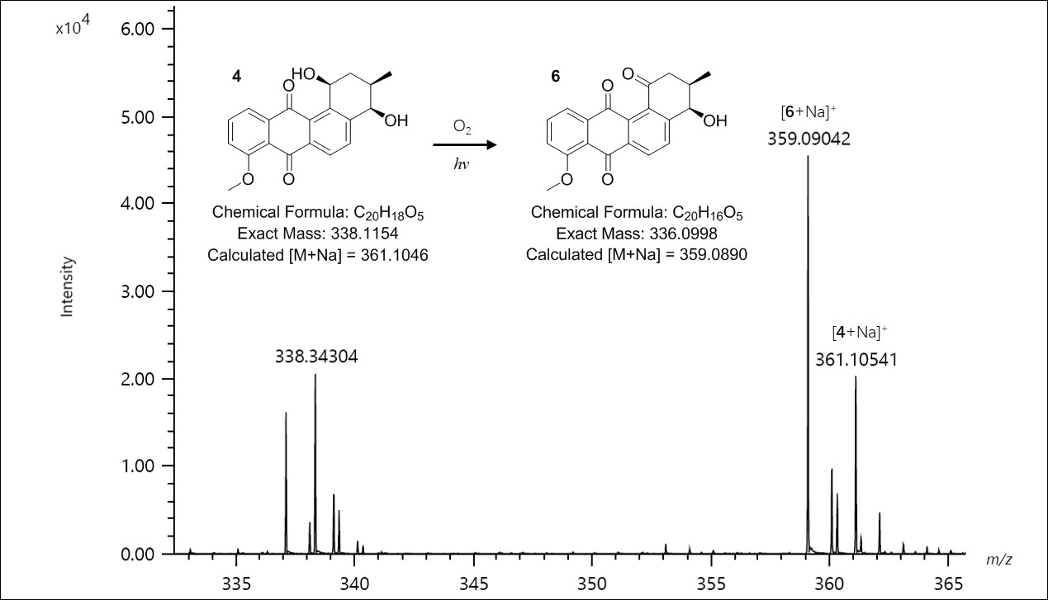
Figure S41 HRESIMS (ES+) spectrum of 4 and oxidized product 6.

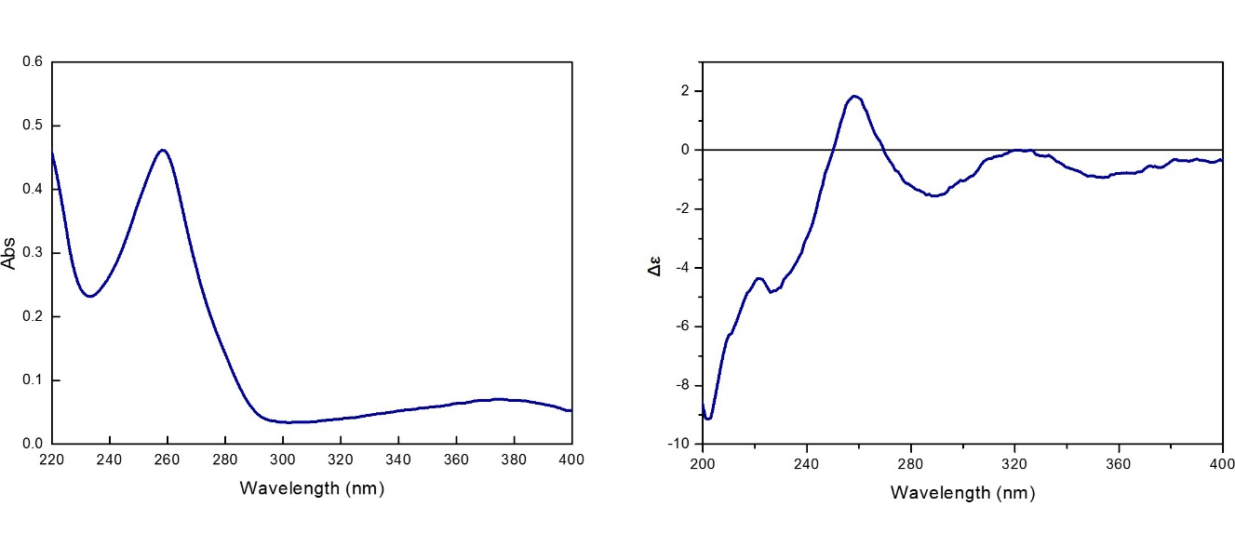 Figure S42 UV and ECD (MeOH) spectra of 4.
Figure S43 ¹H NMR (CDCl₃, 600 MHz) spectrum of 5.

Figure S44 ¹³C NMR (CDCl₃, 150 MHz) spectrum of 5.
Figure S45 DEPT135 NMR (CDCl₃, 150 MHz) spectrum of 5.

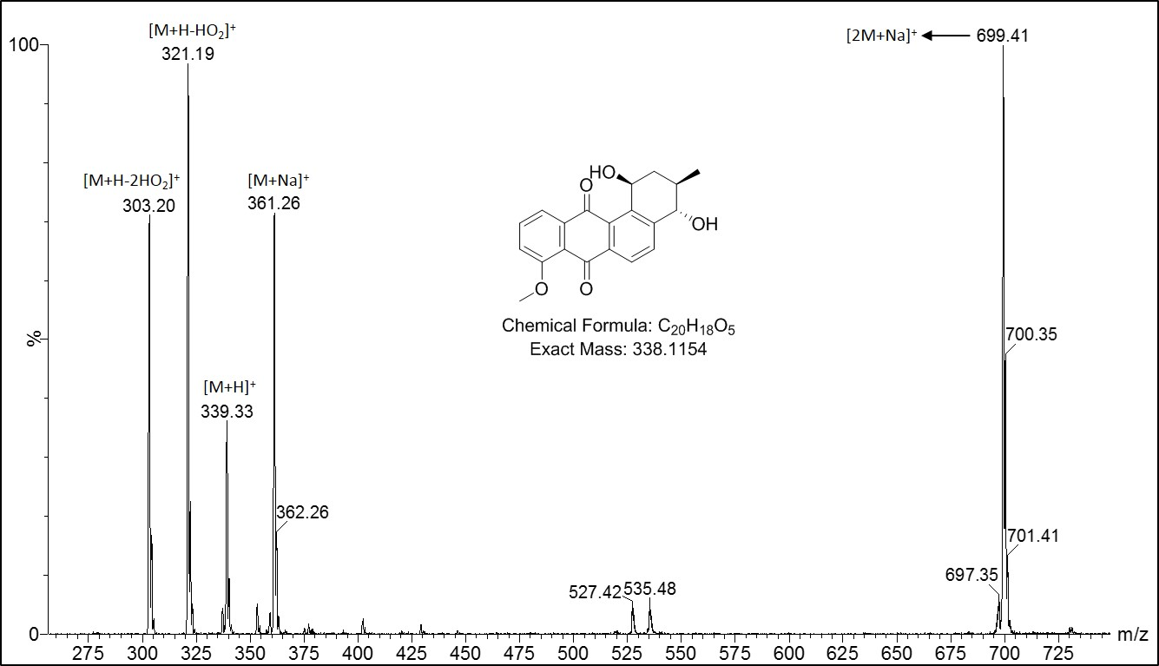
Figure S46 ESIMS (ES+) spectrum of 5.
Figure S47 ¹H NMR (CDCl₃, 600 MHz) spectrum of 6.

Figure S48 ¹³C NMR (CDCl₃, 150 MHz) spectrum of 6.
Figure S49 DEPT135 NMR (CDCl₃, 150 MHz) spectrum of 6.

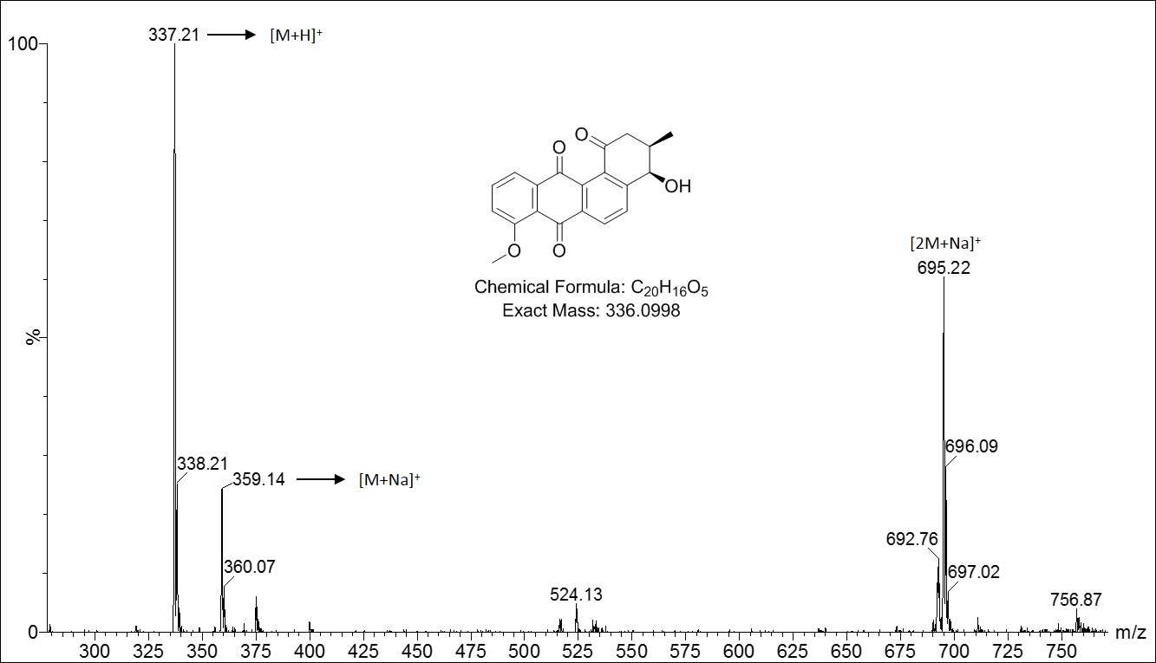
Figure S50 ESIMS (ES+) spectrum of 6.

Figure S51 ¹H NMR (DMSO-d₆, 600 MHz) spectrum of 7.

Figure S52 ¹³C NMR (DMSO-d₆, 150 MHz) spectrum of 7.
Figure S53 DEPT135 NMR (DMSO-d₆, 150 MHz) spectrum of 7.

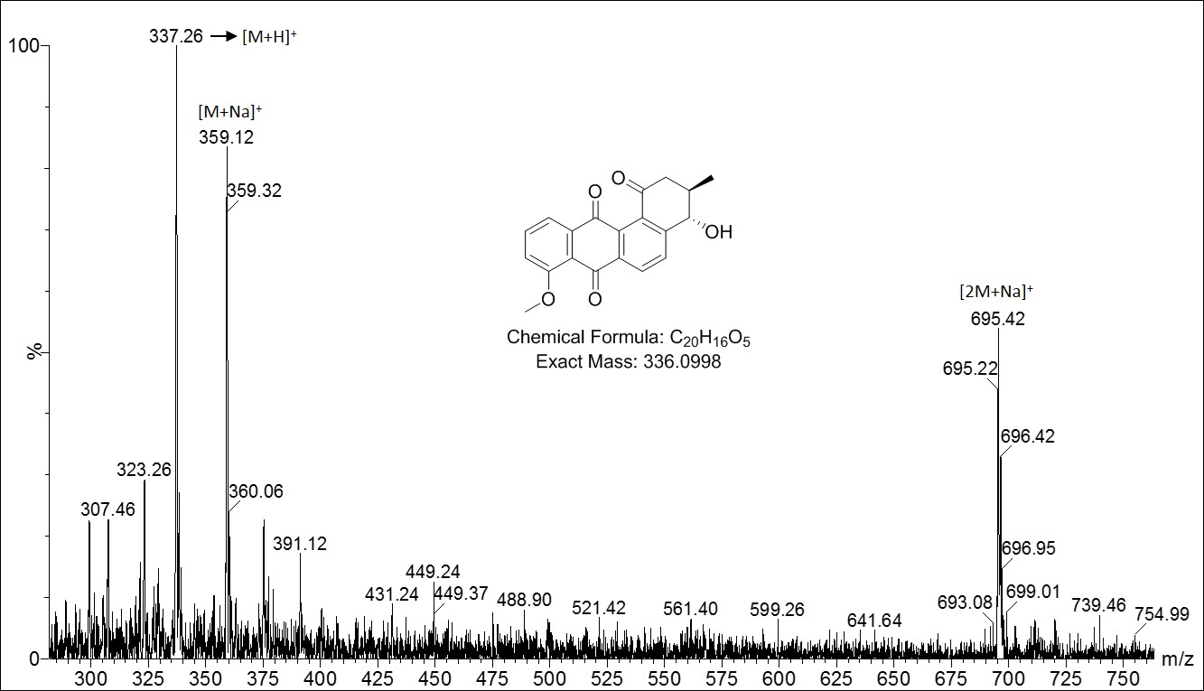
Figure S54 ESIMS (ES+) spectrum of 7.

Table S1 Formula of five selected media.
Ingredient (g) | M1 | M2 | M3 | M4 | M5
Glucose* | / | 10 | / | 20 | /
Glycerol | 15 | / | / | / | /
Soluble starch | 15 | 10 | 10 | 10 | 10
Yeast extract | / | 5 | 4 | 10 | 0.5
Beef extract | / | / | / | 3 | /
Soybean powder | 5 | / | / | / | /
Peptone | 15 | / | 2 | 10 | /
Tryptone | / | 5 | / | / | 1
KH₂PO₄ | / | / | / | 0.5 | /
K₂HPO₄ | / | / | / | / | 1
MgSO₄ | / | / | / | 2 | 1
(NH₄)₂SO₄ | / | / | / | / | 2
CaCO₃ | 2 | 1 | / | 2 | /
Trace salt* | / | / | / | / | 0.1
sea salt | 10 | 10 | 10 | 10 | 10
pH | 7.4 | 7.2-7.4 | 7.0 | 7.0 | 7.0
* (mL): FeSO₄•7H₂O 0.1 g, MnCl₂•4H₂O 0.1 g, ZnSO₄•7H₂O 0.1 g, ddH₂O 100 mL.

Table S2 Cartesian coordinates of the geometry of 1.
1 | S | -2.28800000 | 3.55900000 | 6.53200000 | 42 | C | -1.78300000 | 2.04200000 | 8.80700000
2 | O | -4.29900000 | 4.62300000 | 11.06700000 | 43 | C | -2.33700000 | 1.57600000 | 13.01600000
3 | O | -2.47200000 | 4.25100000 | 9.12400000 | 44 | C | -6.66300000 | -1.57400000 | 2.77700000
4 | O | -3.76400000 | 3.37700000 | 0.37900000 | 45 | C | -3.23900000 | 2.34200000 | 13.64900000
5 | O | -1.94200000 | 5.51600000 | 4.64300000 | 46 | C | -0.11400000 | 6.62200000 | 0.96000000
6 | O | -0.26600000 | 0.38500000 | 11.55700000 | 47 | C | 2.06200000 | -2.68700000 | 6.52000000
7 | O | -3.00700000 | 0.69100000 | 0.59900000 | 48 | C | -0.53900000 | 6.01600000 | -0.15600000
8 | O | -0.03200000 | 6.86200000 | 3.34200000 | 49 | C | 0.85400000 | -2.17900000 | 8.66500000
9 | C | -2.75400000 | 2.83300000 | 10.99600000 | 50 | C | -0.48500000 | 6.28400000 | 2.20200000
10 | C | -2.36700000 | 3.11500000 | 9.63900000 | 51 | C | 0.92200000 | 7.86000000 | 3.20700000
11 | C | -4.05200000 | 1.06500000 | 3.88500000 | 52 | H | -3.81800000 | 1.34000000 | 5.88400000
12 | C | -3.84800000 | 0.71800000 | 1.45200000 | 53 | H | -3.54500000 | -1.29900000 | 4.78000000
13 | C | -3.70000000 | 3.62300000 | 11.67300000 | 54 | H | -0.64700000 | -2.58200000 | 5.64100000
14 | C | -3.59300000 | 1.71400000 | 5.04000000 | 55 | H | -5.37000000 | -0.20800000 | 4.79900000
15 | C | -2.84300000 | 2.84800000 | 5.01900000 | 56 | H | -0.93800000 | 1.17900000 | 5.75400000
16 | O | -3.93700000 | -1.30800000 | 4.03800000 | 57 | H | 0.41300000 | -0.74300000 | 5.69100000
17 | C | -1.72900000 | 2.15000000 | 7.38900000 | 58 | H | -1.82700000 | 4.58300000 | -0.83400000
18 | C | -1.95000000 | 4.80900000 | 3.68000000 | 59 | H | -5.28600000 | 6.29900000 | 11.24400000
19 | O | -0.86600000 | -2.14400000 | 6.32200000 | 60 | H | -4.54700000 | 5.82800000 | 12.58300000
20 | C | -2.59800000 | 3.45500000 | 3.74000000 | 61 | H | -5.88500000 | 5.09000000 | 12.10600000
21 | C | -2.12600000 | 1.77800000 | 11.64800000 | 62 | H | -6.36300000 | 0.49000000 | 2.75800000
22 | C | -1.20900000 | 0.91200000 | 9.47800000 | 63 | H | 1.90400000 | -0.85200000 | 7.49200000
23 | C | -2.97200000 | 3.56600000 | 1.25900000 | 64 | H | -4.53000000 | -1.22500000 | 1.38100000
24 | C | -0.67700000 | -0.13600000 | 8.75000000 | 65 | H | -5.54500000 | -0.18800000 | 0.71200000
25 | O | -0.87400000 | -1.91800000 | 10.26000000 | 66 | H | -4.53200000 | 3.91400000 | 13.51500000
26 | C | -4.82200000 | -0.22300000 | 3.96300000 | 67 | H | -1.85200000 | 0.91100000 | 13.48900000
27 | C | -0.56800000 | -0.02300000 | 7.38000000 | 68 | H | -6.09700000 | -2.37400000 | 2.79800000
28 | C | -1.05900000 | 1.11200000 | 6.69500000 | 69 | H | -7.22000000 | -1.58800000 | 1.97200000
29 | C | -1.19300000 | 0.97100000 | 10.95500000 | 70 | H | -7.23700000 | -1.56000000 | 3.57200000
30 | C | -3.05400000 | 2.81400000 | 2.60100000 | 71 | H | -3.41900000 | 2.16700000 | 14.56500000
31 | C | 0.10800000 | -1.12100000 | 6.56500000 | 72 | H | 0.49500000 | 7.34500000 | 0.86400000
32 | C | -1.48100000 | 4.99900000 | -0.05400000 | 73 | H | 1.43000000 | -3.33300000 | 6.14300000
33 | C | -5.06100000 | 5.52700000 | 11.80500000 | 74 | H | 2.69100000 | -3.15100000 | 7.11100000
34 | C | -5.77500000 | -0.31800000 | 2.76600000 | 75 | H | 2.55600000 | -2.25100000 | 5.79400000
35 | C | 1.29000000 | -1.62400000 | 7.32500000 | 76 | H | -0.20300000 | 6.27800000 | -1.00500000
36 | C | -4.94300000 | -0.33100000 | 1.48500000 | 77 | H | 0.58800000 | -3.12500000 | 8.54000000
37 | C | -1.90700000 | 4.60400000 | 1.20200000 | 78 | H | 1.63200000 | -2.16900000 | 9.27700000
38 | C | -3.70600000 | 1.58900000 | 2.65600000 | 79 | H | 0.67900000 | 8.44400000 | 2.45800000
39 | C | -3.92100000 | 3.37800000 | 13.02400000 | 80 | H | 1.79600000 | 7.45500000 | 3.03500000
40 | C | -0.25600000 | -1.46800000 | 9.31300000 | 81 | H | 0.96100000 | 8.38700000 | 4.03200000
41 | C | -1.40300000 | 5.22300000 | 2.32500000

Table S3 Cartesian coordinates of the geometry of 3.
Conformation 1
∆G = 0.000 kcal/mol P (%) = 39.64%
1 | C | 10.79233100 | -2.75585500 | -7.01658400 | 44 | O | 2.39375900 | -9.97856100 | -3.51041900
2 | C | 11.45393100 | -0.88795000 | -5.25375500 | 45 | O | 3.53013500 | -5.85075500 | -6.52684800
3 | C | 9.80471500 | -0.31978600 | -3.27313200 | 46 | O | 7.02686000 | -1.19664700 | 1.52706700
4 | C | 7.50146300 | -1.63741500 | -3.00394600 | 47 | O | -7.27262200 | 6.60711200 | -0.63984000
5 | C | 6.87612300 | -3.47783000 | -4.79098200 | 48 | O | 0.74167800 | 3.09438900 | -1.88472300
6 | C | 8.50927200 | -4.02908800 | -6.81293900 | 49 | O | -8.88634600 | 6.75742900 | 4.42941200
7 | C | 5.77103600 | -0.96077500 | -0.83901800 | 50 | O | -6.22493800 | -2.67554400 | 6.83411600
8 | C | 3.40902400 | -2.54351300 | -0.64099900 | 51 | C | -9.24820800 | -1.34391000 | 2.13379100
9 | C | 2.89143100 | -4.55822700 | -2.27658700 | 52 | H | 12.09152600 | -3.18679300 | -8.56245700
10 | C | 4.38473300 | -4.79369400 | -4.67279500 | 53 | H | 13.24508600 | 0.10818600 | -5.45534300
11 | C | 1.65686300 | -1.94237000 | 1.28292200 | 54 | H | 7.92508300 | -5.45609100 | -8.18042800
12 | C | -0.57346700 | -3.32111600 | 1.47191800 | 55 | H | 5.13702500 | 1.02006300 | -1.09903400
13 | C | -1.05961100 | -5.39225000 | -0.08663900 | 56 | H | -1.98171200 | -2.83751000 | 2.87506600
14 | C | 0.74197000 | -6.11778800 | -1.89534200 | 57 | H | -4.83305500 | -5.89613000 | -1.29926900
15 | C | -3.57322100 | -6.75519800 | 0.14150000 | 58 | H | -5.29764700 | -10.34298500 | -0.61626000
16 | C | -3.35598200 | -9.58210700 | -0.47387300 | 59 | H | -1.96982500 | -11.79874100 | -3.69858700
17 | C | -2.10476300 | -9.81760800 | -3.09241600 | 60 | H | -3.22547100 | -8.76690500 | -4.50650200
18 | C | 0.54608800 | -8.72487400 | -3.00751400 | 61 | H | -2.01555300 | -0.77318100 | 6.39142200
19 | S | 2.28663400 | 0.62858500 | 3.42271900 | 62 | H | -7.59742600 | 0.56166200 | 8.24336000
20 | C | -0.86217800 | 1.90023300 | 3.54051300 | 63 | H | -10.97830700 | -1.33057000 | 5.80892200
21 | C | -2.60829200 | 0.76194900 | 5.15187500 | 64 | H | -11.96975900 | 2.77784400 | 3.11622400
22 | C | -5.15938600 | 1.43373800 | 5.07587300 | 65 | H | -11.49708800 | 3.12520300 | 6.39625400
23 | C | -5.89794700 | 3.51051300 | 3.60537500 | 66 | H | 2.00920700 | 5.30655300 | 1.08385400
24 | C | -4.15352200 | 4.65760300 | 1.94203100 | 67 | H | -5.85208100 | 10.90907400 | -2.41633600
25 | C | -1.62748700 | 3.84018400 | 1.87890700 | 68 | H | -2.58307200 | 13.60884800 | -4.57034100
26 | C | -7.13639600 | -0.21864800 | 6.36203600 | 69 | H | 1.88265600 | 12.23256300 | -4.69087100
27 | C | -9.58893100 | -0.17992000 | 4.76810400 | 70 | H | 12.66604700 | 3.98087200 | -3.41301800
28 | C | -10.55230800 | 2.55510700 | 4.62917000 | 71 | H | 12.47936900 | 4.25208200 | -0.03772600
29 | C | -8.50156800 | 4.52246500 | 4.13998300 | 72 | H | 14.20068100 | 1.68730900 | -1.43513200
30 | C | -5.06894500 | 6.51414100 | 0.00838400 | 73 | H | 5.12785400 | 9.44061300 | -5.82764800
31 | C | -3.11898300 | 8.15930600 | -1.18404800 | 74 | H | 5.85822500 | 11.02063500 | -2.91117700
32 | C | -0.59419000 | 7.38633500 | -1.17220300 | 75 | H | 7.24664600 | 8.00430100 | -3.60274000
33 | C | 0.24867200 | 4.94001400 | 0.02603000 | 76 | H | -6.15098900 | -7.31648000 | 2.72732500
34 | C | -3.85816500 | 10.38561800 | -2.42688800 | 77 | H | 0.02335400 | -10.38026700 | 1.77794500
35 | C | -2.04236600 | 11.85176900 | -3.63009400 | 78 | H | -1.85853300 | -13.07828200 | 1.09461200
36 | C | 0.49519900 | 11.08222200 | -3.69366800 | 79 | H | -2.86159600 | -10.84718300 | 3.41882100
37 | C | 1.20140800 | 8.83041300 | -2.50833700 | 80 | H | 8.35432400 | 0.06488100 | 1.51323000
38 | O | 10.25825700 | 1.51111800 | -1.50006000 | 81 | H | 2.07449200 | 3.79775500 | -2.92309000
39 | C | 12.52463200 | 2.91531100 | -1.62428500 | 82 | H | -5.70550700 | -3.47705000 | 5.26334700
40 | O | 3.57670600 | 7.82163600 | -2.57935900 | 83 | H | -8.32908100 | -3.20638200 | 2.23067600
41 | C | 5.53441900 | 9.16057300 | -3.79975800 | 84 | H | -8.08982100 | -0.14192800 | 0.89176900
42 | O | -4.63714600 | -6.30452500 | 2.58195900 | 85 | H | -11.09816000 | -1.59242100 | 1.21382700
43 | C | -1.93410900 | -11.05481000 | 1.57099800

Conformation 2
∆G = 0.427 kcal/mol P (%) = 19.39%
1 | C | 12.78153500 | -7.14420500 | -1.67762200 | 44 | O | 1.52399500 | -10.36167400 | -0.71688400
2 | C | 13.20588500 | -4.72021200 | -0.68854600 | 45 | O | 5.44757200 | -8.96449700 | -4.09328000
3 | C | 11.18160700 | -3.04753300 | -0.41767300 | 46 | O | 6.27650600 | -1.32713300 | 1.82397700
4 | C | 8.71894400 | -3.77282900 | -1.13932400 | 47 | O | -7.83912300 | 7.09698600 | 2.72631100
5 | C | 8.33634900 | -6.20707500 | -2.09059100 | 48 | O | -1.92080600 | 5.59486500 | -3.61379500
6 | C | 10.36972400 | -7.89268300 | -2.38398000 | 49 | O | -6.31239700 | 5.53240700 | 7.56823100
7 | C | 6.60262700 | -1.88810500 | -0.78681300 | 50 | O | -2.92182000 | -3.60039600 | 4.84002600
8 | C | 4.04151900 | -2.77787100 | -1.70308600 | 51 | C | -8.09129200 | -1.62078700 | 3.42060900
9 | C | 3.59365400 | -5.33686200 | -2.24777000 | 52 | H | 14.37524400 | -8.44097300 | -1.88201900
10 | C | 5.76480200 | -7.04372900 | -2.86667500 | 53 | H | 15.11228300 | -4.16867500 | -0.13824700
11 | C | 1.99679000 | -1.06895300 | -1.75867000 | 54 | H | 9.98585900 | -9.76320100 | -3.15952400
12 | C | -0.43615000 | -1.93913900 | -2.30188800 | 55 | H | 7.12543000 | -0.14732100 | -1.82333100
13 | C | -0.92202000 | -4.52281600 | -2.48466400 | 56 | H | -1.98964900 | -0.58741400 | -2.41962300
14 | C | 1.09367900 | -6.24562300 | -2.45754000 | 57 | H | -4.88765600 | -3.99715800 | -3.13967600
15 | C | -3.60530500 | -5.50771800 | -2.51022100 | 58 | H | -3.29456300 | -7.04513400 | -6.17441400
16 | C | -3.84059100 | -7.78022700 | -4.30081900 | 59 | H | -2.83478300 | -11.33051500 | -2.35519100
17 | C | -1.95128700 | -9.87730500 | -3.55651300 | 60 | H | -1.28754400 | -10.87988500 | -5.26115500
18 | C | 0.40982700 | -8.98743000 | -2.17075500 | 61 | H | 0.28323000 | -0.97200400 | 2.82954400
19 | S | 2.42055200 | 2.20742100 | -1.06177300 | 62 | H | -3.11170500 | -1.16449200 | 7.73862500
20 | C | -0.23474400 | 2.64812500 | 0.99719200 | 63 | H | -7.32237600 | -2.86385200 | 7.20598600
21 | C | -0.84631200 | 0.74499500 | 2.72072500 | 64 | H | -9.61940700 | 1.58533900 | 6.99843300
22 | C | -2.97899200 | 0.95281400 | 4.25329100 | 65 | H | -7.31714300 | 1.10075800 | 9.35558000
23 | C | -4.36968200 | 3.21250900 | 4.25399300 | 66 | H | 0.81971100 | 7.12345100 | -1.26322500
24 | C | -3.82285100 | 5.09865800 | 2.44768300 | 67 | H | -7.65690100 | 11.88145800 | 2.02983100
25 | C | -1.75569400 | 4.82716400 | 0.80124700 | 68 | H | -6.15085900 | 15.64548200 | -0.46027000
26 | C | -3.87296100 | -1.31048000 | 5.79865100 | 69 | H | -2.49113200 | 15.23714400 | -3.33508900
27 | C | -6.78964400 | -1.26128200 | 5.98689800 | 70 | H | 13.52125200 | 2.20227800 | 1.90933900
28 | C | -7.59040000 | 1.20531600 | 7.29255900 | 71 | H | 14.64067400 | -0.87883700 | 2.77548100
29 | C | -6.17576200 | 3.55933400 | 6.41680300 | 72 | H | 15.10965300 | 0.27653900 | -0.38479600
30 | C | -5.64752300 | 7.22763000 | 2.04511000 | 73 | H | -0.39304500 | 13.55777000 | -6.84459600
31 | C | -4.68975700 | 9.47302800 | 0.63954500 | 74 | H | 1.77299500 | 14.41294200 | -4.37370500
32 | C | -2.58187900 | 9.22040400 | -0.93057500 | 75 | H | 2.63938900 | 12.05340100 | -6.64714700
33 | C | -1.23148100 | 6.72928400 | -1.26574200 | 76 | H | -3.39549600 | -7.41270200 | 0.71034300
34 | C | -6.00333900 | 11.77357000 | 0.80350400 | 77 | H | -7.20389600 | -9.37026700 | -2.56378800
35 | C | -5.17037600 | 13.83315500 | -0.59497400 | 78 | H | -6.66786200 | -10.41979600 | -5.72360400
36 | C | -3.08802900 | 13.61048000 | -2.22186800 | 79 | H | -7.85238000 | -7.31890700 | -5.14619500
37 | C | -1.82770700 | 11.29691200 | -2.41908000 | 80 | H | 7.77698400 | -0.40877600 | 2.32936300
38 | O | 11.39361300 | -0.66036700 | 0.54298800 | 81 | H | -1.17122900 | 6.63565600 | -4.91804800
39 | C | 13.80183300 | 0.25846400 | 1.24045100 | 82 | H | -3.58671100 | -3.88707800 | 3.14747100
40 | O | 0.13470900 | 10.84140200 | -4.03130600 | 83 | H | -7.73792200 | -0.01650500 | 2.14215300
41 | C | 1.06703100 | 12.83361900 | -5.54055100 | 84 | H | -10.15125400 | -1.76557800 | 3.68076500
42 | O | -4.42450600 | -6.06405500 | 0.01846600 | 85 | H | -7.45516500 | -3.35827300 | 2.47112000
43 | C | -6.54520100 | -8.78065500 | -4.44701500
Conformation 3
∆G = 3.188 kcal/mol P (%) = 0.18%
1 | C | 12.73897100 | -6.91448300 | -1.90824500 | 44 | O | 1.28212000 | -10.21095400 | 0.31175900
2 | C | 13.15153100 | -4.35018400 | -1.38387200 | 45 | O | 5.31953600 | -9.35154400 | -3.16733400
3 | C | 11.09528700 | -2.70347400 | -1.12838700 | 46 | O | 6.22459300 | -1.24810200 | 1.70444000
4 | C | 8.60220800 | -3.63150100 | -1.38790700 | 47 | O | -7.63622400 | 7.37154500 | 2.62614100
5 | C | 8.23688600 | -6.19647800 | -1.93266500 | 48 | O | -2.27922300 | 6.00248400 | -3.79689000
6 | C | 10.30421100 | -7.84314600 | -2.20646500 | 49 | O | -6.08982600 | 5.81624000 | 7.44926300
7 | C | 6.42787500 | -1.84894900 | -0.92227800 | 50 | O | -2.76944400 | -3.44661500 | 4.83509200
8 | C | 3.87763500 | -2.84203000 | -1.78398800 | 51 | C | -8.01790800 | -1.43726800 | 3.67878400
9 | C | 3.46357800 | -5.46072600 | -1.98931500 | 52 | H | 14.36246400 | -8.17622300 | -2.09896700
10 | C | 5.64959800 | -7.21753600 | -2.36741400 | 53 | H | 15.07964900 | -3.65460700 | -1.18560400
11 | C | 1.80052900 | -1.18889600 | -1.99330700 | 54 | H | 9.93078100 | -9.81943600 | -2.65486900
12 | C | -0.62309500 | -2.15480100 | -2.40966700 | 55 | H | 6.84568900 | -0.03160300 | -1.82998700
13 | C | -1.06715000 | -4.75026100 | -2.29673100 | 56 | H | -2.20221500 | -0.84852300 | -2.64830700
14 | C | 0.97963600 | -6.41915600 | -2.06401900 | 57 | H | -5.04691700 | -4.40322200 | -2.99832500
15 | C | -3.72247800 | -5.81143600 | -2.23366400 | 58 | H | -3.33219000 | -7.65856500 | -5.74735700
16 | C | -3.87423800 | -8.24151000 | -3.82061100 | 59 | H | -2.79903600 | -11.63958200 | -1.63595800
17 | C | -1.92817400 | -10.21405500 | -2.87694200 | 60 | H | -1.13183700 | -11.26023600 | -4.49622100
18 | C | 0.30166900 | -9.10858900 | -1.43917900 | 61 | H | 0.24299700 | -0.93751000 | 2.51635600
19 | S | 2.16239200 | 2.14972900 | -1.61210200 | 62 | H | -2.77454500 | -0.92615800 | 7.66502400
20 | C | -0.26936100 | 2.68303300 | 0.68250500 | 63 | H | -7.02084700 | -2.62421800 | 7.42828400
21 | C | -0.83173400 | 0.81365800 | 2.45852500 | 64 | H | -9.28310200 | 1.81760900 | 7.37245000
22 | C | -2.84730300 | 1.09458400 | 4.12954600 | 65 | H | -6.75033100 | 1.38653800 | 9.48733200
23 | C | -4.19575100 | 3.38105400 | 4.18738500 | 66 | H | 0.80344400 | 7.02480500 | -1.82326600
24 | C | -3.66802200 | 5.25809800 | 2.36532800 | 67 | H | -7.04014200 | 12.25919300 | 2.45924000
25 | C | -1.69003700 | 4.93828500 | 0.61912100 | 68 | H | -5.14808700 | 16.12347700 | 0.42409100
26 | C | -3.65514200 | -1.12459900 | 5.78086000 | 69 | H | -1.38053700 | 15.65094800 | -2.40702600
27 | C | -6.55080600 | -1.04866600 | 6.14950300 | 70 | H | 13.43000900 | 2.90280200 | -0.01943400
28 | C | -7.23371000 | 1.44746500 | 7.46043100 | 71 | H | 14.74918800 | 0.04784500 | 1.24271900
29 | C | -5.91993400 | 3.78771500 | 6.40247600 | 72 | H | 14.88954800 | 0.65439600 | -2.09696000
30 | C | -5.41841300 | 7.46924900 | 2.03330100 | 73 | H | 2.17935100 | 11.01615700 | -7.10748500
31 | C | -4.30943200 | 9.74868500 | 0.80392500 | 74 | H | -0.74345500 | 9.38891500 | -6.49281100
32 | C | -2.21813300 | 9.46701600 | -0.80523700 | 75 | H | -0.70935800 | 12.77610400 | -6.86249700
33 | C | -1.23186200 | 6.87123200 | -1.44847700 | 76 | H | -3.50947900 | -7.46400400 | 1.12557000
34 | C | -5.39714400 | 12.12710700 | 1.21965000 | 77 | H | -7.20933300 | -9.77380900 | -1.97722300
35 | C | -4.34385500 | 14.25354000 | 0.07683500 | 78 | H | -6.61075000 | -11.07502500 | -5.03003100
36 | C | -2.24499900 | 14.00419600 | -1.51158400 | 79 | H | -7.88707700 | -7.97144800 | -4.73310100
37 | C | -1.19605200 | 11.62158700 | -1.97598900 | 80 | H | 5.95169000 | -2.81925400 | 2.60260900
38 | O | 11.31038400 | -0.19891900 | -0.66976800 | 81 | H | -4.10073800 | 6.05348600 | -3.63060800
39 | C | 13.72884100 | 0.88127800 | -0.37627900 | 82 | H | -3.56265100 | -3.80276700 | 3.21215000
40 | O | 0.87198300 | 11.39447800 | -3.50887900 | 83 | H | -10.05608000 | -1.57846700 | 4.07575100
41 | C | 0.34742800 | 11.12710900 | -6.13649100 | 84 | H | -7.44685000 | -3.18831500 | 2.71150800
42 | O | -4.53921900 | -6.17370800 | 0.32971600 | 85 | H | -7.75162300 | 0.15120600 | 2.35956200
43 | C | -6.54769700 | -9.32952600 | -3.89881500
Conformation 4
∆G = 0.709 kcal/mol P (%) = 12.02%
1 | C | 12.89458200 | -6.99336300 | -1.89200800 | 44 | O | 1.40913600 | -10.29524500 | 0.21667900
2 | C | 13.31645500 | -4.44481200 | -1.30191300 | 45 | O | 5.46926200 | -9.36851600 | -3.22340500
3 | C | 11.26630400 | -2.79716300 | -1.00825000 | 46 | O | 6.39976600 | -1.40050400 | 1.85616700
4 | C | 8.76997700 | -3.70750100 | -1.29645300 | 47 | O | -7.68819800 | 7.14259800 | 2.53313900
5 | C | 8.39537500 | -6.25616000 | -1.90638500 | 48 | O | -2.19572100 | 5.77176700 | -3.74947700
6 | C | 10.45659500 | -7.90383200 | -2.21793600 | 49 | O | -6.21179900 | 5.66251300 | 7.41180200
7 | C | 6.60128100 | -1.92968700 | -0.78614200 | 50 | O | -2.71598400 | -3.55980200 | 4.89480600
8 | C | 4.04885600 | -2.88941400 | -1.67928800 | 51 | C | -7.95289900 | -1.61491200 | 3.60528300
9 | C | 3.62516100 | -5.49975300 | -1.95566000 | 52 | H | 14.51325400 | -8.25658900 | -2.11188100
10 | C | 5.80442700 | -7.25578400 | -2.37071800 | 53 | H | 15.24707800 | -3.76261000 | -1.08235500
11 | C | 1.97921000 | -1.22147600 | -1.85161600 | 54 | H | 10.07547800 | -9.86657800 | -2.71666200
12 | C | -0.44546900 | -2.16574400 | -2.31029100 | 55 | H | 7.02823900 | -0.09034500 | -1.64404200
13 | C | -0.90012200 | -4.76135200 | -2.26891200 | 56 | H | -2.01624300 | -0.84644100 | -2.53032000
14 | C | 1.13732500 | -6.44560600 | -2.06786700 | 57 | H | -4.87488500 | -4.37804700 | -2.98207900
15 | C | -3.56030300 | -5.81113100 | -2.24733300 | 58 | H | -3.15898300 | -7.57289800 | -5.80342800
16 | C | -3.71491200 | -8.20030000 | -3.89468700 | 59 | H | -2.66915300 | -11.65406100 | -1.78496900
17 | C | -1.78399900 | -10.20482500 | -2.98793900 | 60 | H | -0.98538300 | -11.21778900 | -4.62710700
18 | C | 0.44439000 | -9.14563300 | -1.51297400 | 61 | H | 0.36066700 | -0.99698200 | 2.69429600
19 | S | 2.35702900 | 2.10110600 | -1.37382100 | 62 | H | -2.82470400 | -1.05042800 | 7.73295100
20 | C | -0.16956200 | 2.60297000 | 0.82561600 | 63 | H | -7.04355600 | -2.78803200 | 7.38159000
21 | C | -0.74714100 | 0.73248900 | 2.59629200 | 64 | H | -9.35790500 | 1.62400400 | 7.25754800
22 | C | -2.82220600 | 0.98022100 | 4.19913800 | 65 | H | -6.87796700 | 1.23083300 | 9.44182800
23 | C | -4.21073800 | 3.24323900 | 4.20303700 | 66 | H | 0.83560900 | 6.90132800 | -1.76749700
24 | C | -3.67360900 | 5.11296700 | 2.37646200 | 67 | H | -7.24719900 | 12.01985600 | 2.23906700
25 | C | -1.64271200 | 4.81948200 | 0.68793300 | 68 | H | -5.43671200 | 15.87598400 | 0.11566500
26 | C | -3.65147400 | -1.25040800 | 5.82477100 | 69 | H | -1.66610600 | 15.50152300 | -2.60205800
27 | C | -6.55745800 | -1.20788200 | 6.11448300 | 70 | H | 14.92015400 | -0.13034200 | 1.45369500
28 | C | -7.30698500 | 1.28088200 | 7.40243800 | 71 | H | 15.08321400 | 0.56881400 | -1.86648100
29 | C | -5.99537200 | 3.63447100 | 6.37276000 | 72 | H | 13.62236400 | 2.76525000 | 0.26475500
30 | C | -5.46405300 | 7.27637700 | 1.96985900 | 73 | H | 2.54874800 | 14.59500400 | -3.55686600
31 | C | -4.39268600 | 9.55752100 | 0.70617500 | 74 | H | 3.44080100 | 12.36120500 | -5.94523400
32 | C | -2.26012700 | 9.29994600 | -0.83839900 | 75 | H | 0.47782700 | 13.98931800 | -6.17968100
33 | C | -1.20049600 | 6.71647800 | -1.41919200 | 76 | H | -3.36968700 | -7.55007100 | 1.06855100
34 | C | -5.57305400 | 11.90908900 | 1.04133800 | 77 | H | -7.06739400 | -9.76187400 | -2.10814000
35 | C | -4.56358800 | 14.02294000 | -0.14637100 | 78 | H | -6.45859100 | -10.98905700 | -5.18956500
36 | C | -2.42106000 | 13.81587500 | -1.69116600 | 79 | H | -7.72141200 | -7.88747300 | -4.82113600
37 | C | -1.27797200 | 11.45608900 | -2.06458500 | 80 | H | 6.09719900 | -2.99232500 | 2.70709100
38 | O | 11.49115600 | -0.30557900 | -0.48417100 | 81 | H | -4.01883700 | 5.80197200 | -3.60679700
39 | C | 13.91278600 | 0.75287300 | -0.14711000 | 82 | H | -3.45914000 | -3.91379200 | 3.24802500
40 | O | 0.77314600 | 11.06959000 | -3.54638000 | 83 | H | -10.00022200 | -1.76941500 | 3.94654500
41 | C | 1.84488500 | 13.12359700 | -4.86064100 | 84 | H | -7.34173200 | -3.36360600 | 2.65959100
42 | O | -4.39032800 | -6.23480300 | 0.30275100 | 85 | H | -7.66142500 | -0.02789600 | 2.28979200
43 | C | -6.39312400 | -9.27283300 | -4.01444600
Conformation 5
∆G = 0.188 kcal/mol P (%) = 28.76%
1 | C | 12.83584500 | -6.78349000 | -2.22880000 | 44 | O | 1.78759000 | -10.35661000 | -0.55352200
2 | C | 13.22614000 | -4.31360100 | -1.34451700 | 45 | O | 5.44985500 | -8.92409200 | -4.18908000
3 | C | 11.16013200 | -2.70434000 | -1.01181600 | 46 | O | 6.32464300 | -1.06034700 | 1.43431500
4 | C | 8.68923200 | -3.53865100 | -1.56877000 | 47 | O | -8.04247600 | 6.86977100 | 2.54362400
5 | C | 8.34315200 | -6.01534200 | -2.41937000 | 48 | O | -2.59750400 | 5.55255200 | -3.80120200
6 | C | 10.41723900 | -7.63862800 | -2.77280600 | 49 | O | -6.37949100 | 5.61993700 | 7.43267000
7 | C | 6.53004500 | -1.71328600 | -1.16746100 | 50 | O | -2.60947600 | -3.52627600 | 4.99349400
8 | C | 3.95600400 | -2.72276100 | -1.90557600 | 51 | C | -7.93313800 | -1.78636800 | 3.84044700
9 | C | 3.57071300 | -5.31271500 | -2.33867200 | 52 | H | 14.46178600 | -8.03059600 | -2.48222700
10 | C | 5.76542500 | -6.96204400 | -3.02974000 | 53 | H | 15.13881600 | -3.67707400 | -0.92261700
11 | C | 1.85212600 | -1.08652900 | -1.90581400 | 54 | H | 10.06025400 | -9.54635700 | -3.46632700
12 | C | -0.57318000 | -2.05902500 | -2.27823100 | 55 | H | 6.93448500 | 0.00138900 | -2.29622400
13 | C | -0.97758800 | -4.66218300 | -2.34787000 | 56 | H | -2.17769600 | -0.76594000 | -2.35703600
14 | C | 1.09711900 | -6.31353200 | -2.37779800 | 57 | H | -4.98658700 | -4.29200000 | -2.81317700
15 | C | -3.62234400 | -5.73541800 | -2.19775800 | 58 | H | -3.44443100 | -7.39576400 | -5.81696500
16 | C | -3.87084100 | -8.07824700 | -3.89308200 | 59 | H | -2.64287200 | -11.50955200 | -1.86503200
17 | C | -1.87623200 | -10.08358300 | -3.17474600 | 60 | H | -1.28064700 | -11.13859000 | -4.87275700
18 | C | 0.53259300 | -9.06711800 | -1.96945800 | 61 | H | 0.40157100 | -0.85846600 | 2.76312800
19 | S | 2.20092700 | 2.23026900 | -1.37725100 | 62 | H | -2.71450100 | -1.00108600 | 7.81781400
20 | C | -0.32417800 | 2.67490600 | 0.83548600 | 63 | H | -6.88115600 | -2.85911600 | 7.60694400
21 | C | -0.79097800 | 0.81535500 | 2.65090200 | 64 | H | -9.35153200 | 1.45797700 | 7.49149100
22 | C | -2.86319900 | 0.99975500 | 4.26859700 | 65 | H | -6.78080700 | 1.20642900 | 9.59028200
23 | C | -4.34873700 | 3.20077500 | 4.24505400 | 66 | H | 0.40213800 | 6.92589500 | -1.92914000
24 | C | -3.93125700 | 5.04701300 | 2.36377900 | 67 | H | -7.89652200 | 11.73393000 | 2.02768500
25 | C | -1.91195700 | 4.80682200 | 0.65287800 | 68 | H | -6.37009400 | 15.59107400 | -0.30614200
26 | C | -3.58587400 | -1.23925300 | 5.93400600 | 69 | H | -2.63647200 | 15.32157100 | -3.08768200
27 | C | -6.48327500 | -1.28547700 | 6.30150000 | 70 | H | 14.94959800 | 0.76020800 | -1.33450900
28 | C | -7.28490300 | 1.19704900 | 7.56722000 | 71 | H | 13.42915000 | 2.71015900 | 0.98460100
29 | C | -6.10328900 | 3.57427800 | 6.44314100 | 72 | H | 14.72138200 | -0.29128000 | 1.88817600
30 | C | -5.84079600 | 7.09779100 | 1.92345300 | 73 | H | -0.52666800 | 13.73101100 | -6.67149100
31 | C | -4.92540400 | 9.38174500 | 0.54550500 | 74 | H | 1.57585600 | 14.64403800 | -4.16551000
32 | C | -2.81037800 | 9.18377300 | -1.03182500 | 75 | H | 2.55198500 | 12.33207100 | -6.44360800
33 | C | -1.61306700 | 6.64414800 | -1.53040400 | 76 | H | -3.17857600 | -7.50200500 | 1.07785300
34 | C | -6.24055500 | 11.67089100 | 0.80154400 | 77 | H | -7.93337000 | -7.77587900 | -4.54520300
35 | C | -5.38792300 | 13.78508200 | -0.50256100 | 78 | H | -7.08590100 | -9.71050400 | -1.93005700
36 | C | -3.26700000 | 13.63760000 | -2.08380000 | 79 | H | -6.67630300 | -10.85658900 | -5.07508700
37 | C | -1.98633200 | 11.33778700 | -2.37361000 | 80 | H | 7.81892500 | -0.07635400 | 1.82134300
38 | O | 11.33719400 | -0.27966300 | -0.14328300 | 81 | H | -4.41710300 | 5.49476300 | -3.62465000
39 | C | 13.74532600 | 0.75425900 | 0.36902300 | 82 | H | -3.36076000 | -3.89381700 | 3.35331700
40 | O | 0.05796900 | 11.01022400 | -3.87971900 | 83 | H | -7.74870400 | -0.21095400 | 2.49140600
41 | C | 0.93940300 | 13.04771200 | -5.35167400 | 84 | H | -9.96156500 | -2.01777900 | 4.24574700
42 | O | -4.29499900 | -6.22381800 | 0.38745300 | 85 | H | -7.27901300 | -3.52420300 | 2.90387800
43 | C | -6.54418500 | -9.16907100 | -3.86434400
Table S4 Cartesian coordinates of the geometry of 3′.
Conformation A
∆G = 4.794 kcal/mol P (%) = 0.03 %
1 | C | -6.30810300 | -5.68901000 | 1.36252600 | 44 | O | 2.25459300 | -9.43751200 | -3.17505000
2 | C | -6.35634500 | -3.08951200 | 1.86014900 | 45 | O | 1.07816600 | -9.15585300 | 1.96527100
3 | C | -4.10562000 | -1.77738700 | 2.37917700 | 46 | O | 1.28510700 | -2.38507200 | 5.69298700
4 | C | -1.79621200 | -3.10041800 | 2.35211200 | 47 | O | -4.44536000 | 7.83178400 | -2.52629600
5 | C | -1.78647000 | -5.67846300 | 1.75266600 | 48 | O | 2.22398800 | 2.04091800 | -4.08985900
6 | C | -4.03092400 | -7.01073500 | 1.31359000 | 49 | O | -5.50125900 | 8.56938300 | 2.77572800
7 | C | 0.68140300 | -1.88567000 | 3.11487600 | 50 | O | -0.49499900 | 9.45424400 | 7.46294300
8 | C | 2.79419100 | -2.74424900 | 1.35721800 | 51 | C | 0.27695400 | 14.71632800 | 5.62493900
9 | C | 2.76472200 | -5.23932800 | 0.45695400 | 52 | H | -8.08823800 | -6.67139300 | 0.98475100
10 | C | 0.70986300 | -6.95318200 | 1.44581500 | 53 | H | -8.16064000 | -2.09457200 | 1.84514000
11 | C | 4.77158800 | -1.13444400 | 0.58373200 | 54 | H | -3.94091500 | -9.02674100 | 0.87982100
12 | C | 6.67260800 | -2.05321200 | -1.00612200 | 55 | H | 0.47901900 | 0.16720600 | 3.05166400
13 | C | 6.64510200 | -4.53428200 | -1.90590100 | 56 | H | 8.18676500 | -0.79199700 | -1.61460800
14 | C | 4.62354800 | -6.13374300 | -1.23496400 | 57 | H | 10.30819300 | -6.13721600 | -2.37035000
15 | C | 8.79753300 | -5.40862600 | -3.61816900 | 58 | H | 9.74748200 | -8.37076500 | -6.21130500
16 | C | 8.00406900 | -7.58004300 | -5.38394800 | 59 | H | 6.24768200 | -11.32076300 | -4.88993300
17 | C | 6.72640300 | -9.63946500 | -3.76212800 | 60 | H | 8.01312500 | -10.21228100 | -2.21526200
18 | C | 4.31639100 | -8.56300600 | -2.66713000 | 61 | H | 4.26572300 | 5.99271100 | 4.60199400
19 | S | 5.32524900 | 2.00646600 | 1.66500000 | 62 | H | 2.88255300 | 10.21397600 | 5.90334800
20 | C | 2.55776500 | 3.93033100 | 1.51951400 | 63 | H | 1.35812700 | 12.65996600 | 2.27608600
21 | C | 2.68686200 | 5.92366100 | 3.26855900 | 64 | H | -4.08244900 | 12.89211400 | 4.16671700
22 | C | 0.83246200 | 7.79156200 | 3.37168200 | 65 | H | -2.86164000 | 13.12843600 | 1.05244700
23 | C | -1.23808800 | 7.63720100 | 1.72787500 | 66 | H | 0.81275900 | -0.07044500 | -1.33574200
24 | C | -1.33720000 | 5.71357600 | -0.10220800 | 67 | H | -7.59301100 | 4.86594700 | -4.66105600
25 | C | 0.51533300 | 3.81016800 | -0.20831600 | 68 | H | -8.81306000 | 0.70234500 | -6.64162400
26 | C | 0.92482900 | 9.96620100 | 5.23774500 | 69 | H | -5.90570700 | -2.93571200 | -6.39943200
27 | C | 0.06329700 | 12.41225700 | 3.89527900 | 70 | H | -5.69147500 | 4.17112600 | 3.03479000
28 | C | -2.66248500 | 12.10247700 | 2.86260900 | 71 | H | -7.15681500 | 2.00258500 | 0.88887300
29 | C | -3.38950200 | 9.37551300 | 2.36435800 | 72 | H | -7.57534600 | 1.60535000 | 4.25350000
30 | C | -3.36403000 | 5.84865200 | -2.07318100 | 73 | H | -3.76717400 | -5.86104200 | -4.02185200
31 | C | -3.98452100 | 3.46003100 | -3.40214900 | 74 | H | -2.24754400 | -5.33101300 | -7.03595900
32 | C | -2.27634600 | 1.44414300 | -3.30611700 | 75 | H | -0.47118000 | -6.53882000 | -4.38594600
33 | C | 0.33017900 | 1.74368300 | -2.18550500 | 76 | H | 8.66381400 | -2.49339600 | -5.88462300
34 | C | -6.33058100 | 3.23426900 | -4.62324400 | 77 | H | 7.33618100 | -5.37537800 | -8.80901300
35 | C | -6.98641500 | 0.93011700 | -5.69953000 | 78 | H | 4.60082800 | -5.67752800 | -6.84330200
36 | C | -5.33509400 | -1.13726900 | -5.57155000 | 79 | H | 5.64809300 | -8.28406700 | -8.69883900
37 | C | -2.97362900 | -0.89485400 | -4.39017400 | 80 | H | 1.28392900 | -4.20574500 | 5.95151000
38 | O | -3.99131900 | 0.72887300 | 2.86172300 | 81 | H | 1.91225000 | 3.63641700 | -4.94844000
39 | C | -6.23627400 | 2.18569400 | 2.75548400 | 82 | H | -2.12741800 | 8.74277900 | 7.00625600
40 | O | -1.29348400 | -2.80162700 | -4.16506800 | 83 | H | -0.38973100 | 16.44354400 | 4.66018600
41 | C | -2.00182500 | -5.25898900 | -4.95977900 | 84 | H | 2.25497300 | 15.02935800 | 6.21665600
42 | O | 9.95331700 | -3.38310300 | -4.92106000 | 85 | H | -0.86824700 | 14.43264500 | 7.34418500
43 | C | 6.29909000 | -6.67159500 | -7.54652300
Conformation B
∆G = 4.122 kcal/mol P (%) = 0.09%
1 | C | -6.32301000 | -5.72269600 | 1.04504300 | 44 | O | 2.36778500 | -9.49562000 | -3.11717000
2 | C | -6.38128300 | -3.11697900 | 1.50857900 | 45 | O | 1.02476700 | -9.20725800 | 1.98564800
3 | C | -4.14998800 | -1.80778400 | 2.11254400 | 46 | O | 1.07419100 | -2.42460100 | 5.68659400
4 | C | -1.84900400 | -3.14183900 | 2.20804800 | 47 | O | -4.07045100 | 7.88337500 | -2.87761400
5 | C | -1.82311400 | -5.72541900 | 1.63316100 | 48 | O | 2.54004900 | 1.97235100 | -4.03724700
6 | C | -4.05164600 | -7.05381100 | 1.10981600 | 49 | O | -5.49303000 | 8.56849100 | 2.34178600
7 | C | 0.59536800 | -1.93420000 | 3.08094000 | 50 | O | -0.77455900 | 9.32422800 | 7.40088100
8 | C | 2.78173400 | -2.80870000 | 1.42483100 | 51 | C | 0.12614000 | 14.61280300 | 5.71710800
9 | C | 2.77537600 | -5.30173400 | 0.52033600 | 52 | H | -8.08940100 | -6.70265600 | 0.60202400
10 | C | 0.68079400 | -7.00782300 | 1.43737500 | 53 | H | -8.17861900 | -2.11492300 | 1.40172100
11 | C | 4.79895300 | -1.20933300 | 0.73752900 | 54 | H | -3.95076100 | -9.07419000 | 0.69919100
12 | C | 6.74822900 | -2.12911200 | -0.79114700 | 55 | H | 0.40481400 | 0.11922600 | 2.99791600
13 | C | 6.73507900 | -4.60373300 | -1.70975000 | 56 | H | 8.28804500 | -0.87217300 | -1.34078300
14 | C | 4.68745200 | -6.19795600 | -1.11022900 | 57 | H | 10.40857800 | -6.20876000 | -2.08985500
15 | C | 8.92970500 | -5.47205000 | -3.37056500 | 58 | H | 9.94052900 | -8.42351300 | -5.95353600
16 | C | 8.17794500 | -7.63262700 | -5.16801000 | 59 | H | 6.40228200 | -11.37245300 | -4.73984500
17 | C | 6.85348100 | -9.69736400 | -3.59153900 | 60 | H | 8.09717300 | -10.28060900 | -2.01354000
18 | C | 4.41651900 | -8.62255400 | -2.55615400 | 61 | H | 4.13012400 | 5.88486300 | 4.78731900
19 | S | 5.33019000 | 1.91731700 | 1.87049000 | 62 | H | 2.69590700 | 10.09327100 | 6.06572900
20 | C | 2.59094300 | 3.86546900 | 1.58973300 | 63 | H | 1.41240800 | 12.61962200 | 2.40317700
21 | C | 2.63425400 | 5.84312200 | 3.36043700 | 64 | H | -4.13671100 | 12.83756600 | 3.94971000
22 | C | 0.79233400 | 7.72661700 | 3.37160800 | 65 | H | -2.72149800 | 13.13579500 | 0.92636800
23 | C | -1.17287400 | 7.61118300 | 1.60014000 | 66 | H | 0.94991000 | -0.11092100 | -1.35949600
24 | C | -1.18124500 | 5.70093000 | -0.24731800 | 67 | H | -7.17519800 | 4.95824800 | -5.15536500
25 | C | 0.64911100 | 3.77415300 | -0.25258700 | 68 | H | -8.36892600 | 0.80273100 | -7.17004200
26 | C | 0.78178700 | 9.86926300 | 5.27656900 | 69 | H | -5.54990400 | -2.88791100 | -6.74726800
27 | C | 0.01574400 | 12.34459500 | 3.93101500 | 70 | H | -7.09591100 | 1.96665200 | 0.41443100
28 | C | -2.63905600 | 12.06874000 | 2.72199200 | 71 | H | -7.69049500 | 1.62248700 | 3.75859600
29 | C | -3.34772400 | 9.35898600 | 2.11399700 | 72 | H | -5.72921200 | 4.15862900 | 2.60106100
30 | C | -3.07382500 | 5.87612100 | -2.34529700 | 73 | H | -3.61590600 | -5.82509700 | -4.21781400
31 | C | -3.66738600 | 3.49269300 | -3.69587300 | 74 | H | -1.92072900 | -5.38079700 | -7.15091900
32 | C | -2.00571400 | 1.44552300 | -3.49468000 | 75 | H | -0.32125800 | -6.58586100 | -4.39111500
33 | C | 0.54245800 | 1.70823600 | -2.23726800 | 76 | H | 8.85055900 | -2.53664000 | -5.61376100
34 | C | -5.94815600 | 3.30336600 | -5.04017100 | 77 | H | 4.81796600 | -5.71462300 | -6.70652100
35 | C | -6.59090000 | 1.00333900 | -6.13346300 | 78 | H | 5.90944700 | -8.31348300 | -8.54786400
36 | C | -4.98973500 | -1.09423300 | -5.90206500 | 79 | H | 7.60480300 | -5.40724400 | -8.59668100
37 | C | -2.68984000 | -0.88831500 | -4.59792800 | 80 | H | 1.05220500 | -4.24415000 | 5.95189000
38 | O | -4.04495700 | 0.70439700 | 2.56730800 | 81 | H | 2.29911700 | 3.56972100 | -4.91493300
39 | C | -6.27204600 | 2.17221300 | 2.32345500 | 82 | H | -2.37994100 | 8.63472500 | 6.82919100
40 | O | -1.06370600 | -2.82733200 | -4.27004200 | 83 | H | -0.47105400 | 16.36203800 | 4.74653000
41 | C | -1.78770000 | -5.28024900 | -5.06563800 | 84 | H | 2.06296500 | 14.90423000 | 6.44122300
42 | O | 10.11807900 | -3.44020500 | -4.63386700 | 85 | H | -1.12856400 | 14.30054400 | 7.35299700
43 | C | 6.53241600 | -6.70865600 | -7.36958400
Conformation C
∆G = 2.127 kcal/mol P (%) = 2.48%
1 | C | -6.29002800 | -4.56830800 | 1.18398100 | 44 | O | 1.97187600 | -9.63489400 | -2.67039900
2 | C | -6.04436900 | -2.08272200 | 2.06254800 | 45 | O | 0.57867000 | -9.05369700 | 2.31681800
3 | C | -3.69557000 | -1.20218400 | 2.93777000 | 46 | O | 1.51993200 | -2.96368200 | 6.21993000
4 | C | -1.58396600 | -2.81325100 | 2.80755300 | 47 | O | -2.92453100 | 7.80547400 | -3.73669200
5 | C | -1.86355500 | -5.27723000 | 1.88393000 | 48 | O | 3.14471100 | 1.41981100 | -3.85939000
6 | C | -4.22072700 | -6.20286600 | 1.12296300 | 49 | O | -5.61224300 | 8.08206500 | 0.89569600
7 | C | 1.00230800 | -2.03703200 | 3.74353400 | 50 | O | -1.94358700 | 8.25489500 | 7.18669500
8 | C | 2.97766700 | -2.90983200 | 1.84117300 | 51 | C | -1.08801200 | 13.69662600 | 6.49775500
9 | C | 2.73928900 | -5.33871100 | 0.79142400 | 52 | H | -8.14194900 | -5.22031600 | 0.53408800
10 | C | 0.48789800 | -6.85112000 | 1.70433400 | 53 | H | -7.69118400 | -0.84290000 | 2.06524900
11 | C | 4.95266100 | -1.34163600 | 1.00869900 | 54 | H | -4.38565700 | -8.14624100 | 0.44625700
12 | C | 6.67292400 | -2.22011500 | -0.78435100 | 55 | H | 1.06966800 | 0.01392900 | 3.95472800
13 | C | 6.45379400 | -4.62930000 | -1.83173800 | 56 | H | 8.14310000 | -0.95583600 | -1.48081900
14 | C | 4.45051200 | -6.21822900 | -1.06049100 | 57 | H | 10.03525400 | -6.09302800 | -3.02443700
15 | C | 8.30760800 | -5.33823100 | -3.92711500 | 58 | H | 8.83782500 | -8.11714500 | -6.82812800
16 | C | 7.25182900 | -7.40356800 | -5.67770000 | 59 | H | 5.67111000 | -11.21375300 | -5.11048700
17 | C | 6.27799200 | -9.56850600 | -3.99146600 | 60 | H | 7.79683300 | -10.17513000 | -2.68629600
18 | C | 4.02809300 | -8.62709700 | -2.49817900 | 61 | H | 3.73882100 | 5.52456300 | 5.09435900
19 | S | 5.48909400 | 1.79369300 | 2.11141200 | 62 | H | 1.79437000 | 9.36225700 | 6.61813800
20 | C | 2.66858400 | 3.59668400 | 1.66765100 | 63 | H | 0.73603400 | 12.24543000 | 3.15697400
21 | C | 2.40591000 | 5.48519100 | 3.51283800 | 64 | H | -4.93430800 | 11.60834700 | 4.10877800
22 | C | 0.45005300 | 7.24677800 | 3.42384500 | 65 | H | -3.36308500 | 12.83889800 | 1.42620400
23 | C | -1.24221600 | 7.20481800 | 1.38937300 | 66 | H | 1.09727200 | -0.45109900 | -1.30570900
24 | C | -0.91083200 | 5.40103300 | -0.53772400 | 67 | H | -6.00384000 | 5.06696800 | -6.38005900
25 | C | 0.91358500 | 3.47453000 | -0.35784900 | 68 | H | -7.19680800 | 0.96356400 | -8.51259300
26 | C | 0.01477500 | 9.11831500 | 5.54196600 | 69 | H | -4.80641300 | -2.92106300 | -7.56828000
27 | C | -0.80117100 | 11.67543200 | 4.45030100 | 70 | H | -6.88775500 | 2.05888300 | 5.22242800
28 | C | -3.25154600 | 11.36574100 | 2.90510100 | 71 | H | -4.57269300 | 4.54540500 | 5.03115400
29 | C | -3.55793300 | 8.83258900 | 1.58522000 | 72 | H | -6.03413600 | 3.42979800 | 2.20269100
30 | C | -2.33319300 | 5.72058200 | -2.97269300 | 73 | H | -3.76132400 | -5.78821700 | -4.50101500
31 | C | -2.89941000 | 3.36458900 | -4.37380600 | 74 | H | -1.64244900 | -5.84915800 | -7.17916800
32 | C | -1.44905900 | 1.20654200 | -3.87984800 | 75 | H | -0.61658300 | -6.99865300 | -4.14453300
33 | C | 0.93156600 | 1.35147800 | -2.30065900 | 76 | H | 7.66386300 | -2.20348500 | -5.76899600
34 | C | -4.94769900 | 3.32423300 | -6.05658200 | 77 | H | 3.70382500 | -5.35681000 | -6.43955400
35 | C | -5.59676000 | 1.05393900 | -7.20584200 | 78 | H | 4.31780300 | -7.92679000 | -8.53755000
36 | C | -4.23814000 | -1.15442200 | -6.67405800 | 79 | H | 6.05154800 | -5.05475700 | -8.84334700
37 | C | -2.16696100 | -1.09963300 | -5.01657800 | 80 | H | 1.23845600 | -4.78089700 | 6.24784500
38 | O | -3.29102200 | 1.13471700 | 3.88957700 | 81 | H | 3.11265000 | 2.99392300 | -4.80904100
39 | C | -5.32920400 | 2.86056900 | 4.08184200 | 82 | H | -1.49853000 | 6.58039700 | 7.79719600
40 | O | -0.81579400 | -3.17945800 | -4.39083600 | 83 | H | -1.68467800 | 15.51510300 | 5.66383700
41 | C | -1.77502200 | -5.57694700 | -5.11006100 | 84 | H | 0.71456000 | 14.01040200 | 7.50452200
42 | O | 9.14215900 | -3.18232800 | -5.27089100 | 85 | H | -2.51983900 | 13.11488600 | 7.89679700
43 | C | 5.21222600 | -6.37560800 | -7.46626800
Conformation D
∆G = 2.046 kcal/mol P (%) = 2.86%
1 | C | -6.42017400 | -5.54912800 | 1.51535600 | 44 | O | 2.33807600 | -9.23096400 | -4.14059100
2 | C | -6.40859400 | -2.97480400 | 2.13176500 | 45 | O | 0.83160500 | -9.11385200 | 1.03666800
3 | C | -4.11382800 | -1.68003400 | 2.45555400 | 46 | O | 1.47827700 | -2.16732300 | 5.20909100
4 | C | -1.81821700 | -2.98889200 | 2.11074900 | 47 | O | -4.86617900 | 7.84872100 | -2.03340600
5 | C | -1.87845200 | -5.54465900 | 1.42615900 | 48 | O | 1.64102500 | 2.71266800 | -4.63175300
6 | C | -4.16513900 | -6.85834400 | 1.16785800 | 49 | O | -5.31692300 | 8.53874600 | 3.35090700
7 | C | 0.70264300 | -1.75447300 | 2.65776800 | 50 | O | 0.15573200 | 9.38078500 | 7.52360700
8 | C | 2.72708600 | -2.63985400 | 0.81718700 | 51 | C | 0.68771700 | 14.68434700 | 5.71828200
9 | C | 2.62918000 | -5.14179800 | -0.08287700 | 52 | H | -8.23212300 | -6.51942300 | 1.28809000
10 | C | 0.54743700 | -6.84288300 | 0.83502000 | 53 | H | -8.20217200 | -1.98717800 | 2.36065900
11 | C | 4.72699400 | -1.06908500 | 0.01857200 | 54 | H | -4.12168600 | -8.85628500 | 0.65233800
12 | C | 6.60972700 | -2.04438200 | -1.57626600 | 55 | H | 0.47413900 | 0.29242100 | 2.55318700
13 | C | 6.52026500 | -4.53246800 | -2.43118500 | 56 | H | 8.15053500 | -0.80741200 | -2.18532600
14 | C | 4.47419900 | -6.07721000 | -1.74928400 | 57 | H | 10.21899800 | -4.41660500 | -4.10482500
15 | C | 8.49953000 | -5.61063300 | -4.19408400 | 58 | H | 9.79550300 | -8.17153400 | -1.39145200
16 | C | 9.15381600 | -8.31630000 | -3.37236000 | 59 | H | 6.61139300 | -11.01140300 | -5.27549900
17 | C | 6.75127400 | -9.98279900 | -3.47154300 | 60 | H | 6.81136100 | -11.41765600 | -1.95173000
18 | C | 4.29030300 | -8.53923000 | -3.16025800 | 61 | H | 4.58548500 | 5.99742900 | 4.15160800
19 | S | 5.37875100 | 2.07965100 | 1.02936400 | 62 | H | 3.34084500 | 10.20094500 | 5.62596500
20 | C | 2.62095400 | 4.01847000 | 1.16818200 | 63 | H | 1.41591000 | 12.70385400 | 2.23274400
21 | C | 2.89638700 | 5.95787700 | 2.95972400 | 64 | H | -3.78829800 | 12.82217400 | 4.71549300
22 | C | 1.05203800 | 7.81143200 | 3.27752700 | 65 | H | -2.92307300 | 13.16767900 | 1.49607400
23 | C | -1.17433000 | 7.67040300 | 1.84614400 | 66 | H | 0.93764300 | 0.21406000 | -1.92997400
24 | C | -1.42993400 | 5.79665700 | -0.02087200 | 67 | H | -8.20172400 | 4.73848000 | -3.70047000
25 | C | 0.44417600 | 3.94619000 | -0.38378600 | 68 | H | -9.49430500 | 0.54905300 | -5.57764000
26 | C | 1.32463000 | 9.94861900 | 5.16916000 | 69 | H | -6.40760900 | -2.93321300 | -5.86358900
27 | C | 0.30576500 | 12.41116100 | 3.97716200 | 70 | H | -7.33412000 | 1.59032900 | 4.89931900
28 | C | -2.51090900 | 12.09178900 | 3.24037600 | 71 | H | -5.61577100 | 4.21896200 | 3.56472800
29 | C | -3.26285600 | 9.37005900 | 2.74631700 | 72 | H | -7.33191800 | 2.13399900 | 1.52884300
30 | C | -3.67854700 | 5.89765300 | -1.74004000 | 73 | H | -3.75901300 | -5.83279400 | -4.13279500
31 | C | -4.38391700 | 3.49690100 | -3.01019800 | 74 | H | -2.67939100 | -4.97653300 | -7.25758400
32 | C | -2.58671300 | 1.56663000 | -3.21048000 | 75 | H | -0.50075800 | -6.24444900 | -4.95475400
33 | C | 0.13781400 | 2.02611000 | -2.49340500 | 76 | H | 6.82026600 | -4.13099000 | -7.15871700
34 | C | -6.86848600 | 3.17423100 | -3.88396800 | 77 | H | 13.03992100 | -8.32182900 | -4.77390700
35 | C | -7.56168800 | 0.85566600 | -4.90893600 | 78 | H | 10.75465100 | -9.48970300 | -6.97262300
36 | C | -5.81065200 | -1.12348000 | -5.08031700 | 79 | H | 11.71285000 | -11.39864300 | -4.34841500
37 | C | -3.31429000 | -0.78166600 | -4.25086700 | 80 | H | 1.54188900 | -3.98098900 | 5.50576700
38 | O | -3.94686500 | 0.79908800 | 3.04272800 | 81 | H | 0.97986600 | 4.29108400 | -5.30432000
39 | C | -6.19051900 | 2.24373400 | 3.27451300 | 82 | H | -1.50089900 | 8.64072200 | 7.22865400
40 | O | -1.52350900 | -2.59516900 | -4.33733000 | 83 | H | -0.09697400 | 16.42176500 | 4.86715200
41 | C | -2.17008300 | -5.03822600 | -5.22995100 | 84 | H | 2.71607500 | 15.00866700 | 6.09425400
42 | O | 7.57718800 | -5.74488600 | -6.71655600 | 85 | H | -0.25793800 | 14.35653300 | 7.54765500
43 | C | 11.29032900 | -9.44727100 | -4.95844200
Conformation E
∆G = 5.742 kcal/mol P (%) = 0.01%
1 | C | -6.57305700 | -5.29272900 | 1.29542200 | 44 | O | 2.42193900 | -8.96142600 | -4.44389900
2 | C | -6.47481400 | -2.77434700 | 2.10101600 | 45 | O | 0.52263800 | -9.12810500 | 0.65068500
3 | C | -4.14080000 | -1.61176200 | 2.60837900 | 46 | O | 1.42242100 | -2.78180200 | 5.45045200
4 | C | -1.89275200 | -3.00160800 | 2.27054400 | 47 | O | -4.96785600 | 7.85323200 | -1.73848800
5 | C | -2.03483600 | -5.49061200 | 1.37188900 | 48 | O | 1.84624100 | 1.81796000 | -3.83097400
6 | C | -4.36353400 | -6.67310500 | 0.92665800 | 49 | O | -5.25111100 | 8.68503400 | 3.64570500
7 | C | 0.67521600 | -1.95816000 | 2.99695400 | 50 | O | 0.20358600 | 9.72342800 | 7.51030900
8 | C | 2.64671700 | -2.70017200 | 1.03136100 | 51 | C | 0.77824100 | 14.91199500 | 5.40162500
9 | C | 2.51550600 | -5.14893200 | 0.00002800 | 52 | H | -8.41440600 | -6.15970800 | 0.93022800
10 | C | 0.35036500 | -6.83525200 | 0.71208100 | 53 | H | -8.23108500 | -1.72199800 | 2.32957900
11 | C | 4.63988100 | -1.10032800 | 0.28044100 | 54 | H | -4.38528400 | -8.62366300 | 0.25270200
12 | C | 6.52943500 | -2.01952300 | -1.33973200 | 55 | H | 0.56232000 | 0.09548800 | 3.18483100
13 | C | 6.47239400 | -4.49357400 | -2.24483000 | 56 | H | 8.06363900 | -0.75795800 | -1.90927900
14 | C | 4.39650300 | -6.03877800 | -1.64825300 | 57 | H | 10.25378400 | -4.42021800 | -3.71602300
15 | C | 8.53158800 | -5.57013400 | -3.92671200 | 58 | H | 9.65393500 | -8.18399200 | -1.07754700
16 | C | 9.10311000 | -8.30704200 | -3.08744400 | 59 | H | 6.63178400 | -11.04961500 | -5.05691300
17 | C | 6.68461900 | -9.95303000 | -3.28594700 | 60 | H | 6.62774700 | -11.33453300 | -1.71808200
18 | C | 4.25332600 | -8.43749900 | -3.16035300 | 61 | H | 4.58435000 | 6.11662600 | 4.23585200
19 | S | 5.25487000 | 1.99278200 | 1.44919600 | 62 | H | 3.38226500 | 10.39897800 | 5.54859800
20 | C | 2.53317900 | 3.99145000 | 1.41212000 | 63 | H | 1.46464200 | 12.72841700 | 2.03269900
21 | C | 2.86690700 | 6.02680800 | 3.08668400 | 64 | H | -3.73063500 | 13.10251200 | 4.49172400
22 | C | 1.04670800 | 7.90851100 | 3.35112500 | 65 | H | -2.85761200 | 13.14204300 | 1.24931900
23 | C | -1.20213400 | 7.71711500 | 1.96644700 | 66 | H | 0.11593000 | -0.03096800 | -0.90749800
24 | C | -1.50581300 | 5.77553700 | 0.18181300 | 67 | H | -8.17974700 | 4.93163000 | -3.80505100
25 | C | 0.33453000 | 3.87635200 | -0.11034000 | 68 | H | -9.41338400 | 0.90257800 | -6.02811600
26 | C | 1.36035800 | 10.14476000 | 5.12008700 | 69 | H | -6.35137400 | -2.61275100 | -6.36904100
27 | C | 0.35979400 | 12.54865400 | 3.79486400 | 70 | H | -7.32326100 | 1.67977100 | 5.09847500
28 | C | -2.46975800 | 12.22325900 | 3.08571900 | 71 | H | -5.43038100 | 4.28577500 | 3.97017000
29 | C | -3.25044200 | 9.47824600 | 2.84014400 | 72 | H | -7.14125900 | 2.38498300 | 1.76306100
30 | C | -3.76022500 | 5.90238200 | -1.51968900 | 73 | H | -2.62852400 | -4.76800900 | -7.47999600
31 | C | -4.45139800 | 3.56638300 | -2.90278100 | 74 | H | -0.53450100 | -6.08692100 | -5.12629500
32 | C | -2.69496900 | 1.60643800 | -3.08478100 | 75 | H | -3.81952400 | -5.65696900 | -4.40525900
33 | C | -0.07897400 | 1.74634600 | -1.95900500 | 76 | H | 6.24931300 | -6.10722800 | -6.83243700
34 | C | -6.87022200 | 3.34656000 | -3.97933600 | 77 | H | 10.85679000 | -9.44296000 | -6.62372700
35 | C | -7.52982800 | 1.11901600 | -5.20321300 | 78 | H | 11.63865600 | -11.43364200 | -3.99706900
36 | C | -5.79690400 | -0.87919500 | -5.40237300 | 79 | H | 13.04895800 | -8.37785200 | -4.29210300
37 | C | -3.37829200 | -0.62940300 | -4.36549000 | 80 | H | 1.29213900 | -4.61447600 | 5.51871200
38 | O | -3.89252500 | 0.81583700 | 3.35444600 | 81 | H | 1.79067700 | 0.18467200 | -4.67952200
39 | C | -6.07739000 | 2.35507700 | 3.56074400 | 82 | H | -1.49661000 | 9.06750100 | 7.26616100
40 | O | -1.55696200 | -2.44006100 | -4.47977700 | 83 | H | 0.01767900 | 16.60864200 | 4.45215800
41 | C | -2.18714900 | -4.86622300 | -5.43847200 | 84 | H | 2.81226500 | 15.22715200 | 5.75431700
42 | O | 7.91671200 | -5.39039300 | -6.53841600 | 85 | H | -0.16657800 | 14.70700300 | 7.24938700
43 | C | 11.28811500 | -9.46118100 | -4.58366300
Conformation F
∆G = 5.779 kcal/mol P (%) = 0.01%
1 | C | -6.51595000 | -5.31689900 | 1.30389100 | 44 | O | 2.42109200 | -8.96457000 | -4.54032400
2 | C | -6.41132600 | -2.79957900 | 2.11202800 | 45 | O | 0.57532500 | -9.14439800 | 0.57375000
3 | C | -4.07314300 | -1.63553700 | 2.59638500 | 46 | O | 1.52064500 | -2.80672900 | 5.37856900
4 | C | -1.82755500 | -3.02290100 | 2.23314600 | 47 | O | -4.95440000 | 7.83776700 | -1.71735800
5 | C | -1.97693900 | -5.51064800 | 1.33194800 | 48 | O | 1.84322800 | 1.80799900 | -3.89542200
6 | C | -4.30916700 | -6.69459900 | 0.90947700 | 49 | O | -5.17772900 | 8.65323400 | 3.67291100
7 | C | 0.74721800 | -1.97870000 | 2.93465400 | 50 | O | 0.33149000 | 9.69962000 | 7.47452500
8 | C | 2.69853400 | -2.71528800 | 0.94698200 | 51 | C | 0.86682300 | 14.89141700 | 5.36208100
9 | C | 2.55807100 | -5.16213600 | -0.08764600 | 52 | H | -8.36032000 | -6.18503300 | 0.95705200
10 | C | 0.40210700 | -6.85183500 | 0.64363400 | 53 | H | -8.16596500 | -1.74898900 | 2.36042400
11 | C | 4.68228100 | -1.11255700 | 0.17735400 | 54 | H | -4.33619200 | -8.64402600 | 0.23241600
12 | C | 6.55466200 | -2.02721700 | -1.46517700 | 55 | H | 0.63478000 | 0.07452900 | 3.12780600
13 | C | 6.48978400 | -4.49971000 | -2.37404500 | 56 | H | 8.08137500 | -0.76326100 | -2.04939400
14 | C | 4.42180800 | -6.04757600 | -1.75765900 | 57 | H | 10.25423900 | -4.42066000 | -3.88771400
15 | C | 8.53061300 | -5.57148800 | -4.08104900 | 58 | H | 9.69058900 | -8.18940200 | -1.25090900
16 | C | 9.11428900 | -8.30953700 | -3.25382300 | 59 | H | 6.62291400 | -11.05606700 | -5.19338000
17 | C | 6.69472000 | -9.95780200 | -3.42418000 | 60 | H | 6.65620900 | -11.33735600 | -1.85405200
18 | C | 4.26456700 | -8.44337400 | -3.27300800 | 61 | H | 4.66809300 | 6.10041400 | 4.14202800
19 | S | 5.30804900 | 1.97905000 | 1.34451700 | 62 | H | 3.48024400 | 10.38292800 | 5.46807100
20 | C | 2.58519700 | 3.97640800 | 1.34079700 | 63 | H | 1.50675200 | 12.71157900 | 1.98144100
21 | C | 2.93715600 | 6.01035100 | 3.01326700 | 64 | H | -3.65172000 | 13.06815500 | 4.52163500
22 | C | 1.11860800 | 7.89024000 | 3.30151100 | 65 | H | -2.82851200 | 13.12454200 | 1.26675000
23 | C | -1.14682500 | 7.69775500 | 1.94425100 | 66 | H | 0.14194400 | -0.04346700 | -0.95689600
24 | C | -1.46920800 | 5.75896100 | 0.15959700 | 67 | H | -8.18583100 | 4.91821600 | -3.75576400
25 | C | 0.36948900 | 3.86208500 | -0.15691700 | 68 | H | -9.44010000 | 0.89349900 | -5.97526800
26 | C | 1.45288100 | 10.12538900 | 5.06819200 | 69 | H | -6.37877800 | -2.61853100 | -6.35784900
27 | C | 0.42882500 | 12.52855400 | 3.75991700 | 70 | H | -7.23027900 | 1.64430800 | 5.13062600
28 | C | -2.41001400 | 12.19844700 | 3.09275000 | 71 | H | -5.35437800 | 4.25679400 | 3.98873900
29 | C | -3.18789000 | 9.45259100 | 2.84685100 | 72 | H | -7.08882900 | 2.36117800 | 1.79562700
30 | C | -3.74236900 | 5.88770800 | -1.51682000 | 73 | H | -2.66559300 | -4.77227000 | -7.51041100
31 | C | -4.44664400 | 3.55419400 | -2.89761500 | 74 | H | -0.54822000 | -6.09271400 | -5.17896600
32 | C | -2.69060500 | 1.59628800 | -3.10357500 | 75 | H | -3.82617100 | -5.66395500 | -4.42474900
33 | C | -0.06307100 | 1.73496400 | -2.00449600 | 76 | H | 6.21336700 | -6.10074400 | -6.96036900
34 | C | -6.87684300 | 3.33482900 | -3.94846900 | 77 | H | 10.82302300 | -9.43801800 | -6.81421400
35 | C | -7.54776800 | 1.10968000 | -5.17060100 | 78 | H | 11.64063200 | -11.05606700 | -4.20122500
36 | C | -5.81534600 | -0.88652500 | -5.39352200 | 79 | H | 13.04445600 | -8.37492300 | -4.50949500
37 | C | -3.38595800 | -0.63717800 | -4.38202600 | 80 | H | 1.39191600 | -4.63959900 | 5.44464800
38 | O | -3.81919500 | 0.79130100 | 3.34304400 | 81 | H | 1.77848700 | 0.17529900 | -4.74457700
39 | C | -6.00372700 | 2.32661300 | 3.58049700 | 82 | H | -1.37105500 | 9.04135500 | 7.25390000
40 | O | -1.56489700 | -2.44668100 | -4.51883500 | 83 | H | 0.08769900 | 16.58720000 | 4.42616400
41 | C | -2.20420200 | -4.87213900 | -5.47337100 | 84 | H | 2.90536000 | 15.21094000 | 5.68346800
42 | O | 7.88541400 | -5.38722400 | -6.68518000 | 85 | H | -0.04884600 | 14.68253500 | 7.22406100
43 | C | 11.28087300 | -9.45929500 | -4.77997000
Conformation G
∆G = 2.221 kcal/mol P (%) = 2.11%
1 | C | -6.85902300 | -5.42343200 | 1.30789400 | 44 | O | 1.50812100 | -9.28495800 | -3.87695700
2 | C | -6.82861100 | -2.86880400 | 1.99297200 | 45 | O | 0.43013300 | -9.02328600 | 1.29317300
3 | C | -4.52782000 | -1.59955900 | 2.37479100 | 46 | O | 1.00854500 | -2.05241200 | 5.17095600
4 | C | -2.23536200 | -2.91012700 | 2.01093900 | 47 | O | -5.39301900 | 7.18866200 | -1.35161100
5 | C | -2.32118300 | -5.46175800 | 1.30870800 | 48 | O | 1.47009700 | 3.82542500 | -4.71083300
6 | C | -4.61147900 | -6.75049000 | 0.98227600 | 49 | O | -5.40430200 | 8.23058100 | 3.97001900
7 | C | 0.29672900 | -1.69955800 | 2.59349000 | 50 | O | -0.04538900 | 9.06354300 | 7.92854300
8 | C | 2.35218900 | -2.63745300 | 0.80695600 | 51 | C | 0.42005300 | 14.39849000 | 6.25407600
9 | C | 2.18994500 | -5.12317300 | -0.12476200 | 52 | H | -8.67680900 | -6.36864900 | 1.02745600
10 | C | 0.11263700 | -6.79088600 | 0.86872600 | 53 | H | -8.61450400 | -1.87013300 | 2.22766600
11 | C | 4.42895200 | -1.13414200 | 0.05724100 | 54 | H | -4.57813400 | -8.74506100 | 0.45300400
12 | C | 6.20732300 | -2.11495500 | -1.65093600 | 55 | H | 0.09141600 | 0.34515200 | 2.42285100
13 | C | 5.97425700 | -4.54786200 | -2.63161700 | 56 | H | 7.76996100 | -0.91055100 | -2.26901500
14 | C | 3.94472500 | -6.07830000 | -1.87599200 | 57 | H | 9.49511100 | -4.38526700 | -4.65313800
15 | C | 7.74312300 | -5.53159600 | -4.64989100 | 58 | H | 9.25189800 | -8.32061900 | -2.21057600
16 | C | 8.40370200 | -8.30170300 | -4.11844500 | 59 | H | 5.57190500 | -10.71119400 | -5.96341200
17 | C | 5.97146900 | -9.91045900 | -4.08308700 | 60 | H | 6.19707800 | -11.53238700 | -2.78343500
18 | C | 3.58513200 | -8.52347700 | -3.27929800 | 61 | H | 4.47433800 | 5.80797400 | 4.53498800
19 | S | 5.30015100 | 1.91952500 | 1.22576900 | 62 | H | 3.15373800 | 9.95587000 | 6.08792600
20 | C | 2.63160500 | 3.97556700 | 1.37987900 | 63 | H | 1.26851100 | 12.52011600 | 2.73902900
21 | C | 2.82060700 | 5.80263500 | 3.29375000 | 64 | H | -4.00028400 | 12.60086900 | 5.03862200
22 | C | 0.92553900 | 7.59622300 | 3.65389100 | 65 | H | -3.03160200 | 12.83363800 | 1.83226900
23 | C | -1.31495200 | 7.42549700 | 2.23343400 | 66 | H | 1.67077900 | 0.79197700 | -2.50607200
24 | C | -1.50009400 | 5.63666400 | 0.27723800 | 67 | H | -8.33273700 | 3.51736700 | -2.80421600
25 | C | 0.52539100 | 3.99120400 | -0.24952600 | 68 | H | -9.01783000 | -0.72513300 | -4.85098800
26 | C | 1.14648300 | 9.68933900 | 5.60152100 | 69 | H | -5.37672800 | -3.45996900 | -5.87616100
27 | C | 0.11812800 | 12.16640100 | 4.44516100 | 70 | H | -7.59171800 | 1.35991900 | 5.25316000
28 | C | -2.67974200 | 11.82375500 | 3.62816200 | 71 | H | -6.04294400 | 4.15850200 | 4.03588600
29 | C | -3.40661100 | 9.07977000 | 3.22489300 | 72 | H | -7.89806400 | 2.23452300 | 1.97071100
30 | C | -3.87228100 | 5.46317400 | -1.26890900 | 73 | H | 1.30021600 | -4.98570400 | -6.83179200
31 | C | -4.29113000 | 3.02521600 | -2.61904600 | 74 | H | -1.56413900 | -5.92157600 | -5.31396600
32 | C | -2.20940900 | 1.50250000 | -3.19991200 | 75 | H | -1.68416300 | -4.10077600 | -8.21538700
33 | C | 0.42675400 | 2.42471600 | -2.64728900 | 76 | H | 5.96858100 | -3.70324500 | -7.35682000
34 | C | -6.75201500 | 2.26925000 | -3.25398600 | 77 | H | 12.12043400 | -8.26167800 | -5.92475600
35 | C | -7.10824800 | -0.07161300 | -4.40173500 | 78 | H | 9.58988900 | -9.22732500 | -7.94509500
36 | C | -5.04747500 | -1.62519200 | -4.99660000 | 79 | H | 10.77475000 | -11.34055300 | -5.58392700
37 | C | -2.58166400 | -0.81951500 | -4.45115300 | 80 | H | 1.06755700 | -3.85900900 | 5.50952200
38 | O | -4.36354800 | 0.85550100 | 3.05388000 | 81 | H | 0.36989100 | 5.26125900 | -5.04093900
39 | C | -6.60868100 | 2.20692300 | 3.61279000 | 82 | H | -1.68114200 | 8.29019600 | 7.60409000
40 | O | -0.47112800 | -2.13623700 | -5.02215300 | 83 | H | -0.36034500 | 16.14805900 | 5.42436100
41 | C | -0.65256600 | -4.40967900 | -6.42267400 | 84 | H | 2.43253600 | 14.73554200 | 6.69826300
42 | O | 6.55795400 | -5.42001100 | -7.07263000 | 85 | H | -0.57467400 | 14.01094500 | 8.04511100
43 | C | 10.33530000 | -9.34287300 | -6.00158500
Conformation H
∆G = 0.000 kcal/mol P (%) = 90.0%
1 | C | -5.96199000 | -4.86994300 | 4.63734200 | 44 | O | 0.60490900 | -8.65298600 | -2.95971200
2 | C | -5.64502800 | -2.31594200 | 5.26156000 | 45 | O | 0.73763400 | -8.80798900 | 2.37607200
3 | C | -3.27413400 | -1.15560000 | 4.99067400 | 46 | O | 2.70501000 | -1.62986900 | 6.20366300
4 | C | -1.23189800 | -2.56360000 | 4.00967000 | 47 | O | -4.01728500 | 7.68789400 | -2.80290500
5 | C | -1.60988700 | -5.10000100 | 3.35095000 | 48 | O | 3.24175500 | 2.17445300 | -4.25332500
6 | C | -3.95437800 | -6.28568600 | 3.69822000 | 49 | O | -5.79123400 | 7.22269400 | 2.23724500
7 | C | 1.37801900 | -1.41691600 | 3.86206000 | 50 | O | -1.00211400 | 7.90212700 | 7.74672700
8 | C | 2.92784800 | -2.49446700 | 1.69307900 | 51 | C | -1.07382000 | 13.37678400 | 7.03063600
9 | C | 2.42761100 | -4.94516900 | 0.80491500 | 52 | H | -7.82313900 | -5.73820400 | 4.87889400
10 | C | 0.51803100 | -6.52999800 | 2.19220400 | 53 | H | -7.25840300 | -1.24194200 | 5.96171500
11 | C | 4.88263800 | -1.08995500 | 0.53064900 | 54 | H | -4.16186100 | -8.27150000 | 3.17667100
12 | C | 6.31050700 | -2.16039500 | -1.41146600 | 55 | H | 1.15844500 | 0.61981600 | 3.61404800
13 | C | 5.75856900 | -4.56829700 | -2.33209700 | 56 | H | 7.78416200 | -1.02824300 | -2.31266500
14 | C | 3.75552400 | -5.94704500 | -1.27961500 | 57 | H | 9.01048000 | -4.67825800 | -4.73758800
15 | C | 7.11355700 | -5.56197100 | -4.64217000 | 58 | H | 8.53485400 | -8.77862000 | -2.75149000
16 | C | 7.41734300 | -8.43652900 | -4.48255800 | 59 | H | 3.98108400 | -10.18092500 | -6.02613400
17 | C | 4.82037800 | -9.71953000 | -4.17524800 | 60 | H | 5.03086500 | -11.53715700 | -3.16379200
18 | C | 2.84115200 | -8.19714500 | -2.74957500 | 61 | H | 4.26729000 | 5.70623000 | 4.64283100
19 | S | 5.74784100 | 2.04861500 | 1.38063900 | 62 | H | 2.34046700 | 9.47590300 | 6.40777000
20 | C | 2.89291700 | 3.83871200 | 1.30112100 | 63 | H | 0.26342900 | 12.21220700 | 3.36434800
21 | C | 2.74138600 | 5.62415700 | 3.24899400 | 64 | H | -5.01215600 | 10.84622300 | 5.30367700
22 | C | 0.64370700 | 7.19511400 | 3.52123400 | 65 | H | -4.11160600 | 12.28098000 | 2.41932900
23 | C | -1.34002200 | 7.00763100 | 1.78339600 | 66 | H | 1.34761300 | -0.07471900 | -1.90783000
24 | C | -1.10041700 | 5.38150100 | -0.31613400 | 67 | H | -6.71080900 | 4.95688900 | -5.67014600
25 | C | 0.94924200 | 3.70478400 | -0.54852400 | 68 | H | -7.36389300 | 1.18746700 | -8.52154900
26 | C | 0.41616100 | 8.99926900 | 5.73182100 | 69 | H | -4.20263200 | -2.22846800 | -8.61409600
27 | C | -0.92036800 | 11.43141900 | 4.89710400 | 70 | H | -6.26637700 | 3.05327700 | 4.89859100
28 | C | -3.55735100 | 10.82439100 | 3.81273300 | 71 | H | -5.70509200 | 2.09691100 | 8.14006200
29 | C | -3.77597500 | 8.28224700 | 2.49405100 | 72 | H | -4.00042700 | 4.71002300 | 6.78050000
30 | C | -2.90490700 | 5.70064600 | -2.47753600 | 73 | H | 1.47072400 | -5.59852300 | -7.15516300
31 | C | -3.18410600 | 3.53114000 | -4.22703000 | 74 | H | -1.88215000 | -5.57844900 | -6.58882000
32 | C | -1.33257200 | 1.64051900 | -4.28112700 | 75 | H | -0.57882100 | -4.03986100 | -9.35705100
33 | C | 1.05257700 | 1.80850000 | -2.71519000 | 76 | H | 5.05377300 | -3.24239700 | -6.69054800
34 | C | -5.33867000 | 3.41980900 | -5.77193200 | 77 | H | 7.86260700 | -9.08054100 | -8.52015900
35 | C | -5.67767400 | 1.34003200 | -7.33460800 | 78 | H | 9.07369400 | -11.57613300 | -6.58298500
36 | C | -3.87744000 | -0.59994700 | -7.39582000 | 79 | H | 10.78082900 | -8.67541300 | -6.87011600
37 | C | -1.68728800 | -0.45404900 | -5.90830900 | 80 | H | 2.82970900 | -3.41563600 | 6.62393200
38 | O | -2.80383800 | 1.28551500 | 5.58890500 | 81 | H | 3.11167200 | 3.83367100 | -5.03392000
39 | C | -4.82781500 | 2.84668600 | 6.39569800 | 82 | H | -0.27595100 | 6.26095300 | 8.14533300
40 | O | 0.13272600 | -2.25287700 | -5.90879300 | 83 | H | -2.03233900 | 15.11389700 | 6.38092600
41 | C | -0.26789500 | -4.48983600 | -7.33935600 | 84 | H | 0.83011000 | 13.90562600 | 7.70682400
42 | O | 5.72164200 | -4.95085700 | -6.86881900 | 85 | H | -2.14145800 | 12.60276600 | 8.64521200
43 | C | 8.86844800 | -9.50468400 | -6.74382200
Conformation I
∆G = 2.146 kcal/mol P (%) = 2.41%
1 | C | -6.517662000 | -4.240189000 | 1.675246000 | 44 | O | 2.461903000 | -9.124142000 | -4.346604000
2 | C | -6.144156000 | -1.808578000 | 2.655964000 | 45 | O | 0.108227000 | -8.701957000 | 0.518840000
3 | C | -3.683653000 | -0.906500000 | 3.060058000 | 46 | O | 1.951661000 | -2.188800000 | 5.274832000
4 | C | -1.605266000 | -2.416383000 | 2.356720000 | 47 | O | -4.421825000 | 7.866392000 | -2.680341000
5 | C | -2.017675000 | -4.839235000 | 1.380762000 | 48 | O | 1.493847000 | 2.926569000 | -5.005493000
6 | C | -4.474640000 | -5.786435000 | 1.074807000 | 49 | O | -5.668394000 | 8.213284000 | 2.454261000
7 | C | 1.054765000 | -1.509720000 | 2.817172000 | 50 | O | -0.744158000 | 7.950108000 | 7.727106000
8 | C | 2.860502000 | -2.477613000 | 0.812040000 | 51 | C | -0.089691000 | 13.450366000 | 7.394040000
9 | C | 2.546441000 | -4.969026000 | -0.072264000 | 52 | H | -8.449545000 | -4.917176000 | 1.384195000
10 | C | 0.202656000 | -6.405320000 | 0.628565000 | 53 | H | -7.774909000 | -0.627168000 | 3.095494000
11 | C | 4.918028000 | -1.042548000 | -0.080132000 | 54 | H | -4.731210000 | -7.698456000 | 0.341499000
12 | C | 6.775965000 | -2.205071000 | -1.575000000 | 55 | H | 1.045047000 | 0.547560000 | 2.868387000
13 | C | 6.591433000 | -4.746922000 | -2.241582000 | 56 | H | 8.385133000 | -1.092942000 | -2.244787000
14 | C | 4.396594000 | -6.103655000 | -1.603592000 | 57 | H | 10.418383000 | -5.034674000 | -3.562808000
15 | C | 8.636717000 | -6.099657000 | -3.728657000 | 58 | H | 9.537159000 | -8.466604000 | -0.595457000
16 | C | 9.020699000 | -8.764646000 | -2.596362000 | 59 | H | 6.468969000 | -11.610716000 | -4.299920000
17 | C | 6.510664000 | -10.283752000 | -2.695569000 | 60 | H | 6.288973000 | -11.416207000 | -0.952733000
18 | C | 4.192396000 | -8.612859000 | -2.928438000 | 61 | H | 4.452541000 | 5.630847000 | 4.251465000
19 | S | 5.566657000 | 2.195804000 | 0.598750000 | 62 | H | 2.793530000 | 9.203944000 | 6.523356000
20 | C | 2.698534000 | 3.952024000 | 0.976952000 | 63 | H | 1.017917000 | 12.357582000 | 3.628645000
21 | C | 2.808890000 | 5.667766000 | 2.997764000 | 64 | H | -4.325232000 | 11.519701000 | 5.663056000
22 | C | 0.836817000 | 7.343961000 | 3.488635000 | 65 | H | -3.349566000 | 12.946438000 | 2.803585000
23 | C | -1.287260000 | 7.371036000 | 1.901556000 | 66 | H | 1.201995000 | 0.291675000 | -2.338591000
24 | C | -1.374110000 | 5.702188000 | -0.165714000 | 67 | H | -8.201141000 | 4.563426000 | -3.553089000
25 | C | 0.548408000 | 3.920089000 | -0.608931000 | 68 | H | -9.571467000 | 0.257260000 | -5.085128000
26 | C | 0.834102000 | 9.011083000 | 5.811046000 | 69 | H | -6.459738000 | -3.187672000 | -5.452101000
27 | C | -0.212371000 | 11.629900000 | 5.150846000 | 70 | H | -6.247676000 | 1.869722000 | 6.435060000
28 | C | -2.928050000 | 11.381694000 | 4.124319000 | 71 | H | -4.161517000 | 4.521045000 | 5.958561000
29 | C | -3.510093000 | 8.933565000 | 2.733148000 | 72 | H | -6.305358000 | 3.646770000 | 3.504663000
30 | C | -3.503713000 | 5.862357000 | -2.043574000 | 73 | H | -3.630645000 | -6.029801000 | -4.199860000
31 | C | -4.330998000 | 3.382288000 | -3.066450000 | 74 | H | -2.752961000 | -4.973259000 | -7.322664000
32 | C | -2.521294000 | 1.461790000 | -3.281379000 | 75 | H | -0.416846000 | -6.307488000 | -5.208407000
33 | C | 0.236241000 | 2.058502000 | -2.783527000 | 76 | H | 6.351878000 | -6.593115000 | -6.644244000
34 | C | -6.864324000 | 3.002021000 | -3.739095000 | 77 | H | 12.976949000 | -9.172752000 | -3.695564000
35 | C | -7.598906000 | 0.621113000 | -4.582027000 | 78 | H | 10.766935000 | -10.365486000 | -5.948777000
36 | C | -5.834176000 | -1.338731000 | -4.793903000 | 79 | H | 11.398076000 | -12.100862000 | -3.108178000
37 | C | -3.285505000 | -0.931847000 | -4.171368000 | 80 | H | 1.869937000 | -4.019254000 | 5.429873000
38 | O | -3.128971000 | 1.367304000 | 4.080041000 | 81 | H | 0.618837000 | 4.426228000 | -5.611219000
39 | C | -5.095737000 | 2.912319000 | 5.035211000 | 82 | H | -0.212098000 | 6.217683000 | 8.029331000
40 | O | -1.480441000 | -2.727833000 | -4.347053000 | 83 | H | -0.868417000 | 15.317207000 | 6.877415000
41 | C | -2.124037000 | -5.133155000 | -5.334268000 | 84 | H | 1.879501000 | 13.728092000 | 8.031703000
42 | O | 8.118032000 | -6.166670000 | -6.365487000 | 85 | H | -1.190896000 | 12.700837000 | 8.997847000
43 | C | 11.164395000 | -10.187407000 | -3.909700000
Table S5 Secondary metabolites BGCs from S. resea LHW63015 predicted by antiSMASH.
Cluster | Type | Most similar known cluster | Similarity
1 | lanthipeptide-class-i | SF2487 | 4%
2 | RiPP-like, amglyccycl | Cetoniacytone A | 45%
3 | NRPS, T1PKS | Ulleungmycin | 8%
4 | Thiopeptide, RRE-containing | Unknown | /
5 | T2PKS | Lysolipin I | 45%
6 | T1PKS | Vicenistatin | 65%
7 | NRPS, T1PKS | Clarexpoxcin | 21%
8 | Phenazine | Marinophenazine A | 26%
9 | NRPS | Coelichelin | 81%
10 | NRPS, T1PKS | Kedarcidin | 6%
11 | Terpene | Unknown | /
12 | T2PKS | Chlortetracycline | 45%
13 | Redox-cofactor | Unknown | /
14 | Terpene | Unknown | /
15 | T2PKS | Pradimicin-A | 25%
16 | T2PKS | Saccharothrixin D | 65%
17 | NRPS, T1PKS | Unknown | /
18 | NRPS-like | Echosides A-E | 11%
19 | T3PKS | Alkylresorcinol | 100%
20 | Siderophore | Peucechelin | 15%
21 | RiPP-like | SF2768 | 11%
22 | Betalactone | Unknown | /
23 | betalactone, terpene | A-201A | 6%
24 | T1PKS | Carbapenem MM4550 | 6%
25 | Lanthipeptide-Class-I | Unknown | /
26 | Lanthipeptide-Class-I | Unknown | /
27 | Lanthipeptide-Class-I | Unknown | /
28 | T1PKS | Ebelactone | 13%
29 | Terpene | Geosmin | 100%
30 | NRPS | Qinichelins | 44%
31 | T1PKS | Yatakemycin | 6%
32 | Ectoine, Indole | Hydroxysporine | 100%
33 | Lanthipeptide-Class-I | Unknown | /
34 | Terpene | Unknown | /
35 | Thiopeptide, Thioamitides | Unknown | /
36 | NRPS | Tetronasin | 3%
37 | NRPS, T1PKS | Tubulysin A | 11%
38 | Terpene | Frankiamicin | 21%
39 | RiPP-like | Mycotrienin I | 7%
40 | Lanthipeptide-Class-III | Catenulipeptin | 60%
41 | Lanthipeptide-Class-III | Omnipeptin | 4%

Table S6 ¹H (600 MHz) and ¹³C (150 MHz) NMR Data for 5, 6 and 7.
no. | 5 (in CDCl₃) |  | 6 (in CDCl₃) |  | 7 (in DMSO-d6)
 | δ_{C}, type | δ_{H}, (mult, J in Hz) | δ_{C}, type | δ_{H}, (mult, J in Hz) | δ_{C}, type | δ_{H}, (mult, J in Hz)
1 | 66.2, CH | 5.38, t (8.0) | 198.4, C |  | 197.0, C
1-OH |  | 4.97, s
2 | 36.9, CH₂ | 2.39, ddd (13.7, 7.1, 2.9) | 42.4, CH₂ | 2.89, ddd (16.8, 6.3, 1.6) | 44.5, CH₂ | 2.90, dd (16.2, 5.6)
 |  | 1.68, td (12.6, 12.0, 8.6) |  | 2.79, ddd (16.8, 9.0, 1.6) |  | 2.53^{ɑ}, dd (10.8)
3 | 36.2, CH | 1.77, m | 35.0, CH | 2.54, m | 37.8, CH | 2.19, m
3-CH₃ | 18.4, CH₃ | 1.24, d (6.5) | 16.4, CH₃ | 1.19, d (6.8) | 18.2, CH₃ | 1.14, d (6.5)
4 | 75.1, CH | 4.42, d (9.0) | 71.5, CH | 4.79, dd (3.0, 1.5) | 71.6, CH | 4.39, dd (9.3, 6.9)
4-OH |  | ND |  | ND |  | 5.98, d (6.9)
4a | 146.9, C |  | 150.0, C |  | 152.6, C
5 | 133.9, CH | 8.08, d (8.2) | 132.2, CH | 7.72^{ɑ}, d (8.0) | 131.2, CH | 8.02, d (8.2)
6 | 127.5, CH | 8.26, d (8.2) | 130.2, CH | 8.30, d (8.0) | 129.0, CH | 8.22, d (8.2)
6a | 136.9, C |  | 137.6, C |  | 133.7, C
7 | 182.5, C |  | 181.5, C |  | 180.2, C
7a | 120.7, C |  | 120.7, C |  | 120.0, C
8 | 159.9, C |  | 160.0, C |  | 159.5, C
8-OCH₃ | 56.7, CH₃ | 4.05, s | 56.6, CH₃ | 4.03, s | 56.4, CH₃ | 3.94, s
9 | 117.9, CH | 7.33, d (8.4) | 117.4, CH | 7.30, d (8.3) | 118.4, CH | 7.55, d (8.4)
10 | 135.3, CH | 7.71, t (8.1) | 135.7, CH | 7.70^{ɑ}, t (8.2) | 135.8, CH | 7.83, t (8.0)
11 | 120.4, CH | 7.88, d (7.8) | 119.8, CH | 7.74^{ɑ}, d (7.5) | 118.5, CH | 7.56, d (7.3)
11a | 137.2, C |  | 136.2, C |  | 134.8, C
12 | 187.9, C |  | 184.3, C |  | 183.7, C
12a | 130.8, C |  | 134.8, C |  | 133.6, C
12b | 141.9, C |  | 134.6, C |  | 136.8, C
^{ɑ}Overlapping signals. ND, not detected.
Table S7 Analysis on CLF protein sequences from the potential T2PKS BGCs.
Cluster | CLF  (aa) | Top MiBIG Hit by AntiSMASH
 |  | GenBank | Identity | MiBIG | BGC product | PKSII subclass
5 | 394 | RBQ20809 | 66.0% | BGC0001513 | Anthrabenzoxocinone | Pentangular PK
12 | 440 | RBQ20089 | 73.0% | BGC0000208 | Chelocardin | Tetracycline
15 | 412 | RBQ19769 | 54.0% | BGC0000212 | Cinerubin B | Anthracycline
16 | 411 | RBQ19184 | 78.0% | BGC0002672 | Saccharothrixin D | Angucycline

Table S8 Predicted functions of ORFs in the angucycline BGC (spo) and homologous in thioangucycline BGC (tac)
Spo | AA | Putative function | Homolog in Tac | ID/SM [%]^{ɑ}
1 | 203 | TetR family transcriptional regulator | / | /
2 | 248 | Methyltransferase | / | /
3 | 281 | Epimerase/dehydratase | / | /
4 | 168 | Unknown | / | /
5 | 527 | Drug resistance transporter | / | /
6 | 293 | Hydrolase | W | 64.50/75.24
7 | 587 | Biotin carboxylase | / | /
8 | 283 | Oxidoreductase | V | 35.25/42.09
9 | 156 | Unknown | / | /
10 | 415 | LuxR family transcriptional regulator | / | /
11 | 141 | MarR family transcriptional regulator | / | /
12 | 486 | Monooxygenase | G | 65.67/77.64
13 | 108 | Polyketide synthesis cyclase | H | 67.59/75.93
14 | 426 | Beta-ketoacyl synthase | I | 80.75/88.03
15 | 411 | Chain length factor | J | 74.51/79.61
16 | 86 | Acyl carrier protein | K | 57.28/66.99
17 | 268 | Ketoacyl reductase | L | 76.49/84.33
18 | 315 | Cyclase/dehydrase | M | 69.40/77.92
19 | 680 | Monooxygenase | N | 63.94/75.33
20 | 528 | Carboxyl transferase | P | 78.13/85.98
21 | 71 | Carboxylase subunit ε | Q | 40.00/50.00
22 | 327 | Oxidoreductase | / | /
23 | 403 | Drug resistance transporter | R | 55.23/69.59
24 | 277 | Luciferase-like monooxygenase | / | /
25 | 432 | Monooxygenase | / | /
26 | 437 | Monooxygenase | / | /
27 | 542 | Extracellular solute-binding protein | / | /
28 | 551 | ABC transporter ATP-binding protein | / | /
29 | 305 | Binding-protein-dependent transport | / | /
30 | 331 | Binding-protein-dependent transport | / | /
31 | 270 | Reductase/dehydrogenase | A | 45.93/62.22
32 | 432 | Putative oxygenase | / | /
33 | 316 | Ferredoxin | / | /
^{ɑ} ID: identity, SM: similarity.
Table S9 Angucycline BGCs used in this work.
MiBIG/GenBank | Product | MiBIG/GenBank | Product
QMEY01000005 | Spongisulfin | BGC0001384 | Saprolmycin
BGC0000201 | Auricin | BGC0001438 | Warkmycin
BGC0000202 | Azicemicin-aziridine | BGC0001596 | FluostatinMQ
BGC0000203 | BE7585A | BGC0001661 | Mayamycin
BGC0000211 | Chrysomycin | BGC0001769 | Saquayamycin
BGC0000223 | Fluostatin | BGC0001904 | FluostatinM
BGC0000229 | Grincamycin | BGC0002000 | Setomimycin
BGC0000231 | Griseusin | BGC0002012 | Julichrome
BGC0000232 | Hatomarubigin | PTJS01000001 | Lugdunomycin
BGC0000234 | Jadomycin | BGC0002028 | Frigocyclinone
BGC0000235 | Kiamycin | BGC0002070 | SEK90
BGC0000236 | Kinamycin | BGC0002140 | Galtamycin
BGC0000239 | Landomycin | BGC0002361 | Baikalomycin
BGC0000253 | Oviedomycin | BGC0002369 | Maduralactomycin_A
BGC0000262 | Gaudimycin | BGC0002383 | Kinanthraquinone_B
BGC0000263 | Ravidomycin | LIPB01000001 | Thioangucycline
BGC0000267 | SaquayamycinA | BGC0002478 | Rubiginone_A2
BGC0000268 | Sch47554 | BGC0002672 | Saccharothrixin_D
BGC0001072 | Simocyclinone | BGC0002712 | WS-5995_D

