Supplementary materials

Analysis of the greenness to determine risperidone in commercial products using a green stability-indicating HPTLC method

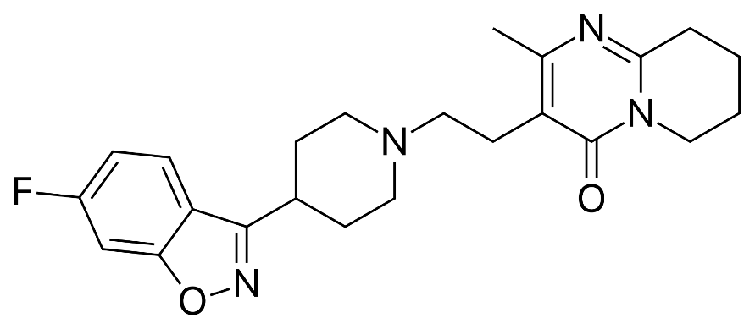

**Figure S1.** Chemical structure of RISP.

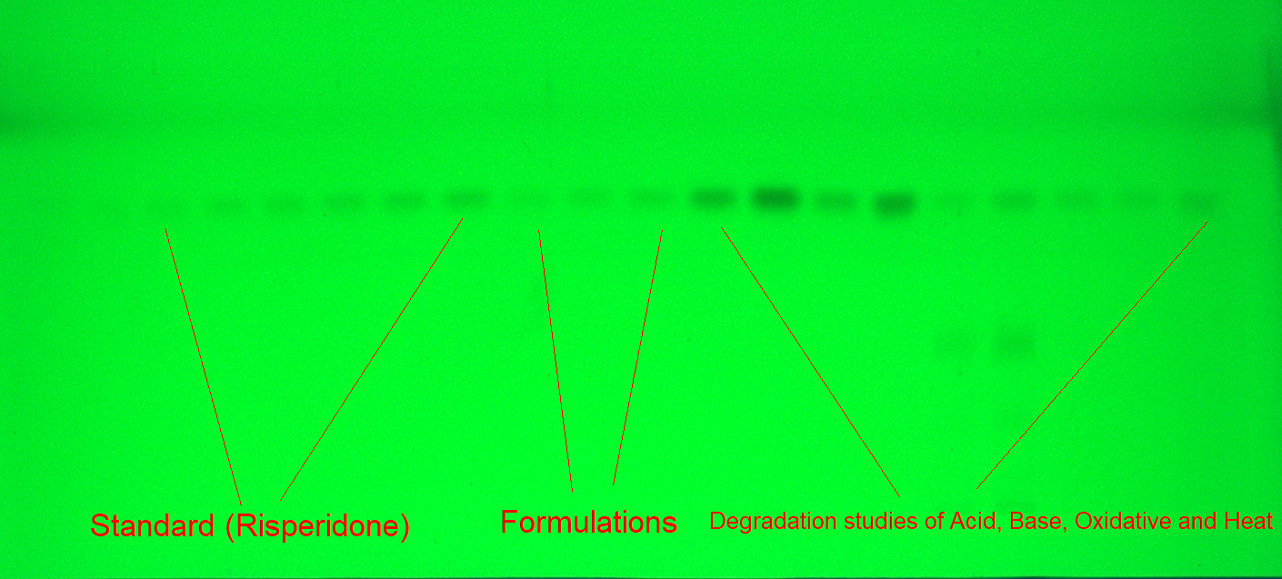

**Figure S2.** The TLC image for reference RISP, marketed products, and forced-degradation samples derived using greener EtOH-EA-NH3 (70:20:10 v/v/v) mobile phase for the current technique.

***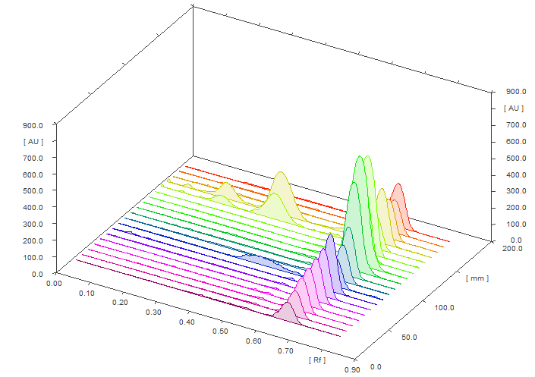* Figure S3.** 3D densitograms of standard RISP and commercial products.