**Experimental Validation and Modeling of Continuous Flow Capillary Reactor for Diels–Alder Reaction of Conjugated Pentadienes with Maleic Anhydride**

Lei Yin1, Tingting Ge1, Cuncun Zuo1, *, Ming Wang1, Guangjun Cui2, Yuchao Li1, Haofei Huang1, *, Liping Zhang3

*1 Research Institute of Clean Chemical Technology, School of Chemistry and Chemical Engineering, Shandong University of Technology, Zibo 255049, P. R. China*

*2 Institute of Zibo Luhua Hongjin New Material Group Co., Ltd. and Clean Chemical Technology, School of Chemistry and Chemical Engineering, Shandong University of Technology, Zibo 255000, People’s Republic of China*

*3 Institute of Zibo Interenergy technology Ltd,.Co. and Clean Chemical Technology, School of Chemistry and Chemical Engineering, Shandong University of Technology, Zibo 255000, People’s Republic of China*

**1. Material supplement**

In our past research [1], 6 isomers of 3/4-MTHPA have been accurately analyzed with the support of 1H-NMR spectra. In this paper, the MTHPA we synthesized was of the simple type and its structure was shown in Fig 1.



Fig 1 MTHPA synthetic formula.

We dissolved 3-MTHPA, 4-MTHPA, and 3/4-MTHPA with deuterated dimethyl sulfoxide and carried out 1H-NMR detection. The spectrum obtained was shown in Fig 2. It can be seen that due to the change of methyl substitution position, the induced force of C=C-H changes, and the hydrogen displacement and hydrogen content become the marks of distinguishing isomers.



Fig 2 1H-NMR diagram of MTHPA.

In the past, we used KBr to compress 3-MTHPA and 4-MTHPA for FT-IR detection, and the results were shown in Fig 3. It can be seen that different functional groups peak at different wavelengths and the infrared spectrum has a clearer distinction between functional groups.



Fig 3 FT-IR diagram of MTHPA.

**2. Experimental supplement**

***2.1 Instrument***

We formed a mature continuous flow capillary reactor D-A reaction to synthesize MTHPA, as shown in Fig 4. The instruments can be briefly introduced as follows: a heat source, MA melting pot, heating pump, advection pump, continuous flow capillary reactor, pressure and temperature controller.

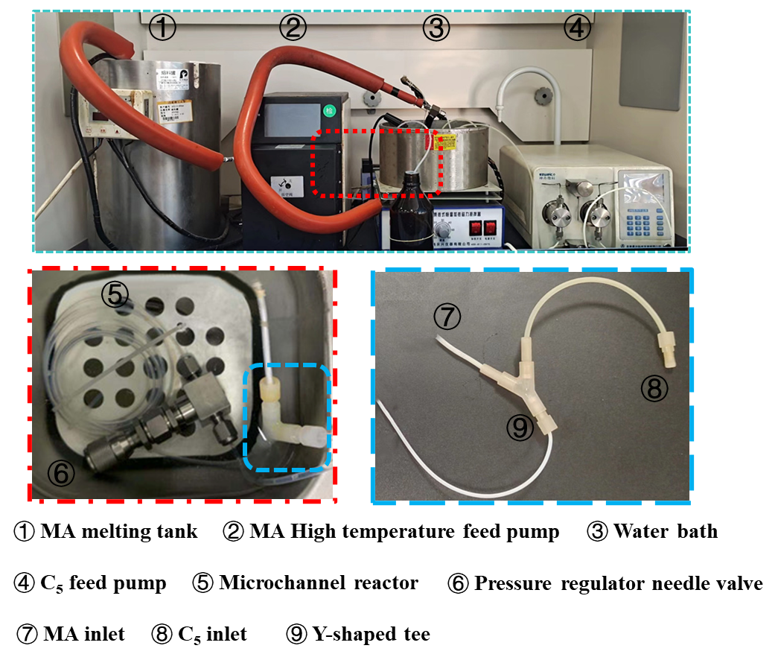

Fig 4 Continuous flow capillary reactor synthesis instrument.

To investigate the effect of microsize on synthesis experiments, we conducted a series of experimental discussions in the kettle reactor. The kettle reactor was shown in Fig 5.

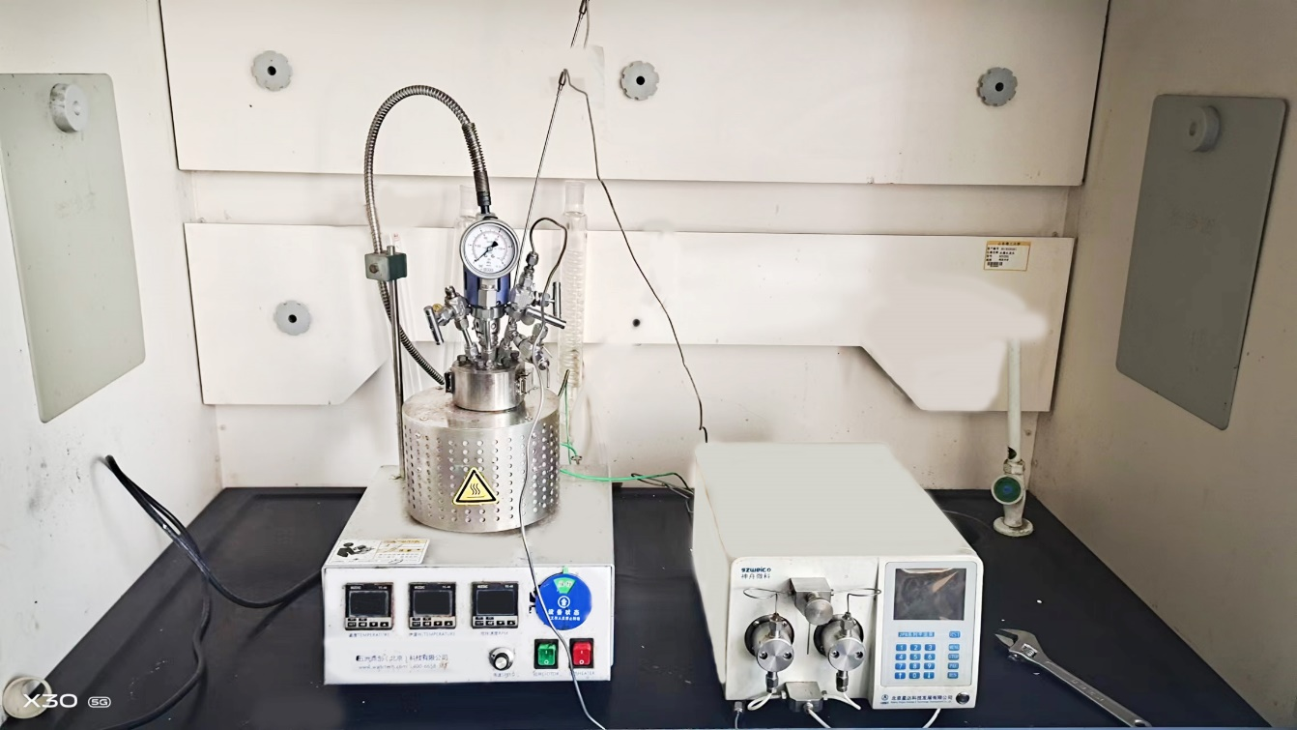

Fig 5 Kettle reaction experimental model.

***2.2 Partial experimental data***

The experimental results were determined by gas chromatography. The reaction amount of MA was different under different conditions. Some experimental data were shown in Fig 6.



Fig 6 Gas chromatography detection spectrum.

In the initial synthesis experiment, we fixed the flow rate of C5 and MA, that is, fixed the molar ratio, and carried out the microchannel D-A reaction at 65 ℃ and 0MPa. It was worth mentioning that the C5 component used was relatively simple and can be regarded as piperylene with a mass fraction of 42%. However, the pure 3-MTHPA after synthesis has a high freezing point and is easy to block the pipeline, so is 4-MTHPA. This is extremely consistent with the theoretical law that the greater the degree of chaos of the system, the lower the freezing point. Therefore, C5 used in our subsequent synthesis was a mixture. In Table 1, we have made statistics on the experimental data of the previous work.

Table 1 D-A reaction experimental data.

|  |  |  |  |  |
| --- | --- | --- | --- | --- |
| Diameter (mm) | 0.5 | 0.8 | 1.2 | 1.6 |
| Conversion (%) | 85.10 | 97.39 | 52.07 | 65.56 |
| 86.03 | 97.98 | 51.67 | 63.27 |
| 85.42 | 84.78 | 70.50 | 58.41 |

The residence time was discussed in a 2.0 mm microtube. The experimental conditions were shown in Table 2. In Figure 7, we can see that with the shortening of residence time, the conversion of MTHPA decreased gradually, while the polymerization amount in the microtubule did not change much.

Table 2 Residence time test conditions.

|  |  |  |  |  |  |
| --- | --- | --- | --- | --- | --- |
| Time (min) | 53 | 30 | 22 | 20 | 17 |
| QC5 (ml/min) | 0.237 | 0.474 | 0.593 | 0.664 | 0.711 |
| QMA (ml/min) | 0.1 | 0.2 | 0.25 | 0.28 | 0.3 |



Fig 7 Effect of residence time on conversion.

Under the same flow rate and tube length, four kinds of microtubules with different diameters were experimentally discussed. The experimental results were shown in Table 3.

Table 3 Effect of pipe diameter on D-A reaction.

|  |  |  |  |  |
| --- | --- | --- | --- | --- |
| Diameter (mm) | 0.5 | 0.8 | 1.2 | 2.0 |
| Conversion (%) | 98.65 | 99.14 | 98.28 | 97.98 |
| Selectivity (%) | 96.54 | 98.32 | 96.75 | 98.48 |

With 0.8mm microtubule as the experimental device, the effect of different flow rates on the reaction was discussed. The experimental results were shown in Table 4.

Table 4 The effect of different flow rates on the reaction.

|  |  |  |  |  |  |
| --- | --- | --- | --- | --- | --- |
| Rates (ml/min) | 0.75Q | Q | 1.25Q | 1.5Q | 2.0Q |
| Conversion (%) | 95.63 | 99.14 | 97.71 | 97.74 | 97.20 |
| Selectivity (%) | 96.31 | 98.32 | 96.33 | 97.10 | 97.12 |

The effect of raw material ratio was discussed in a 0.8mm microtube. The experimental data were shown in Table 5

Table 5 Influence of raw material ratio.

|  |  |  |  |  |  |  |  |  |  |  |
| --- | --- | --- | --- | --- | --- | --- | --- | --- | --- | --- |
| ratio | 1:1 | | 1.04:1 | | 1.07:1 | | 1.1:1 | | 1.13:1 | |
| QC5 (ml/min) | 0.645 | | 0.66 | | 0.679 | | 0.698 | | 0.717 | |
| QMA (ml/min) | 0.27 | | 0.27 | | 0.27 | | 0.27 | | 0.27 | |
| Con (%) | 95.81 | 95.54 | 91.51 | 92.24 | 95.86 | 95.17 | 92.29 | 93.12 | 94.25 | 95.09 |
| S (%) | 96.84 | 96.42 | 96.29 | 96.67 | 95.98 | 96.66 | 96.48 | 97.15 | 95.18 | 96.23 |

**3. Fluid modeling supplement**

***3.1 Response surface modeling***

The results of the model calculations for temperature, residence time, and feedstock ratio were shown in Table 6. The comparison of the f-values in the table with the calculated f-values showed that all models had high significance.

Table 6. Response model calculation results.

|  |  |  |  |  |  |  |
| --- | --- | --- | --- | --- | --- | --- |
| Source | Sum of Squares | df | Mean Square | F Value | p-value Prob > F |  |
| Model | 1097.06002 | 9 | 121.89555777778 | 297.6637980446 | 6.013632183e-011 | significant |
| A-T | 310.6278125 | 1 | 310.6278125 | 758.5399840051 | 9.228608199e-011 |  |
| B-t | 466.3458 | 1 | 466.3458 | 1138.796725334 | 1.234428123e-011 |  |
| C-ratio | 63.2250125 | 1 | 63.2250125 | 154.3928072135 | 2.103759138e-007 |  |
| AB | 17.8929 | 1 | 17.8929 | 43.69370524349 | 6.001499033e-005 |  |
| AC | 1.010025 | 1 | 1.010025 | 2.466438343620 | 0.1473745320177 |  |
| BC | 3.204100000000 | 1 | 3.2041000000002 | 7.824276722648 | 0.01888534200821 |  |
| A2 | 93.60285714285 | 1 | 93.602857142857 | 228.5742193802 | 3.241228269e-008 |  |
| B2 | 50.61602857142 | 1 | 50.616028571428 | 123.6022015993 | 5.970876816e-007 |  |
| C2 | 27.21645714285 | 1 | 27.216457142858 | 66.46143756306 | 9.977337162e-006 |  |
| Residual | 4.0950750000001 | 10 | 0.4095075000000 |  |  |  |
| Lack of Fit | 2.616325000000 | 3 | 0.8721083333333 | 4.12832347140 | 0.0558121951324 | not significant |
| Pure Error | 1.47875 | 7 | 0.21125 |  |  |  |
| Cor Total | 1101.155095 | 19 |  |  |  |  |

A comparison of the responses was shown in Figure 8. The adjusted R2 and predicted R2 for each response indicated that the accuracy of the model was in the acceptable range.



Fig 8. Comparison of responses.

***3.2 Modeling***

The continuous flow capillary reactor model of PTFE can be understood as the combination of a Y-shaped tee and a long coil. The model was also established according to the actual size pipe diameter and pipe length. The coil can be regarded as a helix in the model. Its ring number is 7, the ring radius is 0.05m, the internal channel radius is 0.4mm, and the total length is about 2m. A Y-shaped tee can be formed by combining three cylinders in the model, each cylinder is 0.2m long, and the internal channel radius is 0.4mm. The modeling process was shown in Fig 9.



Fig 9 Microchannel model settings.

The improvement of parameters is the basis of the modeling. Setting relevant parameters in Comsol in advance can simplify the model set. Among them, the dynamic parameters are particularly important, and the specific values were shown in Fig 10.



Fig 10 Parameter setting.

The calculation process needs to consider the complex situation, which requires multiple physical field coupling. In the setting of dilute material transfer, the temperature was set at 65 ℃ and the initial concentration of C5 and MA was set. After coupling, the reaction rate of the material was correlated. The specific settings were shown in Fig 11.



Fig 11 Dilute material transfer setting.

For the setting of the D-A reaction, the "Chemistry" module needs to input the temperature, pressure, molecular weight, and density of each substance, and the most important is the accurate reaction kinetic parameters. Specific settings were shown in Fig 12.



Fig 12 Chemical reaction set.

The setting of fluid is essential. For an incompressible fluid, temperature, pressure, and flow rate are the main parameters. The information entered in Comsol was shown in Fig 13.



Fig 13 Flow setting.

The last step of modeling was to specify the calculated cell size. If it is too large, the calculation is inaccurate, and if it is too small, the boundary cannot mesh. The normal grid size can be selected for this model. The grid model was shown in Figure 14.



Fig 14 Mesh settings.

***3.3 Partial calculation results***

An example of concentration change under MTHPA modeling was given, and the specific values were shown in Table 7.

Table 7 MTHPA calculated concentration.

|  |  |  |  |  |  |
| --- | --- | --- | --- | --- | --- |
| Time (min) | Concentration (mol/m3) | Time (min) | Concentration (mol/m3) | Time (min) | Concentration (mol/m3) |
| 0 | 0 | 0.25362 | 145.6117 | 3.1372 | 205.9577 |
| 1.53E-07 | 2.62E-04 | 0.27086 | 148.7627 | 3.2489 | 206.1014 |
| 3.05E-07 | 5.24E-04 | 0.28811 | 151.6498 | 3.3607 | 206.2302 |
| 6.10E-07 | 0.001048 | 0.30535 | 154.3044 | 3.4724 | 206.3457 |
| 1.22E-06 | 0.002097 | 0.32259 | 156.7534 | 3.5841 | 206.4494 |
| 2.44E-06 | 0.004193 | 0.33983 | 159.0195 | 3.6958 | 206.5425 |
| 4.88E-06 | 0.008387 | 0.35707 | 161.1222 | 3.8076 | 206.6263 |
| 9.77E-06 | 0.016772 | 0.37432 | 163.0783 | 3.9193 | 206.7017 |
| 1.95E-05 | 0.033541 | 0.39156 | 164.9024 | 4.031 | 206.7695 |
| 3.91E-05 | 0.067068 | 0.4088 | 166.6073 | 4.1428 | 206.8306 |
| 7.81E-05 | 0.134082 | 0.42604 | 168.204 | 4.2545 | 206.8856 |
| 1.17E-04 | 0.201055 | 0.44328 | 169.7025 | 4.3662 | 206.9353 |
| 1.56E-04 | 0.267987 | 0.46053 | 171.1112 | 4.478 | 206.9801 |
| 2.34E-04 | 0.401755 | 0.47777 | 172.438 | 4.5897 | 207.0204 |
| 3.13E-04 | 0.535369 | 0.49501 | 173.6896 | 4.7014 | 207.0569 |
| 3.91E-04 | 0.668823 | 0.51225 | 174.8721 | 4.8131 | 207.0898 |
| 5.47E-04 | 0.935244 | 0.54674 | 177.0509 | 4.9249 | 207.1195 |
| 7.03E-04 | 1.201018 | 0.58122 | 179.0117 | 5.0366 | 207.1464 |
| 0.001016 | 1.730631 | 0.61571 | 180.7848 | 5.1483 | 207.1706 |
| 0.001328 | 2.25768 | 0.65019 | 182.3954 | 5.2601 | 207.1925 |
| 0.001641 | 2.78218 | 0.68468 | 183.864 | 5.3718 | 207.2123 |
| 0.001953 | 3.30415 | 0.71916 | 185.2082 | 5.4835 | 207.2302 |
| 0.002578 | 4.340565 | 0.75364 | 186.4424 | 5.5952 | 207.2464 |
| 0.003203 | 5.367072 | 0.78813 | 187.5792 | 5.707 | 207.2611 |
| 0.003828 | 6.383814 | 0.82261 | 188.6291 | 5.8187 | 207.2743 |
| 0.005078 | 8.388553 | 0.8571 | 189.6013 | 5.9304 | 207.2863 |
| 0.006328 | 10.35587 | 0.89158 | 190.5038 | 6.0422 | 207.2971 |
| 0.007578 | 12.28679 | 0.92607 | 191.3433 | 6.1539 | 207.3069 |
| 0.008828 | 14.18233 | 0.96055 | 192.1259 | 6.2656 | 207.3157 |
| 0.010078 | 16.04345 | 0.99503 | 192.8568 | 6.3774 | 207.3237 |
| 0.012578 | 19.6661 | 1.0295 | 193.5408 | 6.4891 | 207.331 |
| 0.015078 | 23.16177 | 1.064 | 194.1818 | 6.6008 | 207.3375 |
| 0.017578 | 26.53702 | 1.0985 | 194.7835 | 6.7125 | 207.3435 |
| 0.020078 | 29.79795 | 1.133 | 195.3492 | 6.8243 | 207.3488 |
| 0.022578 | 32.95027 | 1.1675 | 195.8818 | 6.936 | 207.3537 |
| 0.027578 | 38.95008 | 1.2364 | 196.8577 | 7.0477 | 207.3581 |
| 0.032578 | 44.57515 | 1.3054 | 197.7289 | 7.1595 | 207.3621 |
| 0.037578 | 49.85944 | 1.3744 | 198.5102 | 7.2712 | 207.3657 |
| 0.042578 | 54.83292 | 1.4364 | 199.1463 | 7.3829 | 207.3689 |
| 0.047578 | 59.52217 | 1.4985 | 199.7266 | 7.4946 | 207.3719 |
| 0.052578 | 63.95084 | 1.5606 | 200.2574 | 7.6064 | 207.3745 |
| 0.057578 | 68.14 | 1.6227 | 200.7439 | 7.7181 | 207.3769 |
| 0.062578 | 72.10853 | 1.6847 | 201.191 | 7.8298 | 207.3791 |
| 0.072578 | 79.44963 | 1.7468 | 201.6024 | 7.9416 | 207.3811 |
| 0.081199 | 85.21294 | 1.8089 | 201.9819 | 8.0533 | 207.3829 |
| 0.08982 | 90.51838 | 1.8709 | 202.3325 | 8.165 | 207.3845 |
| 0.098441 | 95.41831 | 1.933 | 202.6569 | 8.2768 | 207.386 |
| 0.10706 | 99.95729 | 1.9951 | 202.9574 | 8.3885 | 207.3873 |
| 0.11568 | 104.1736 | 2.0572 | 203.2362 | 8.5002 | 207.3885 |
| 0.1243 | 108.1004 | 2.1192 | 203.4952 | 8.6119 | 207.3896 |
| 0.13293 | 111.7664 | 2.1813 | 203.736 | 8.7237 | 207.3906 |
| 0.14155 | 115.1968 | 2.2434 | 203.9603 | 8.8354 | 207.3915 |
| 0.15017 | 118.4133 | 2.3054 | 204.1692 | 8.9471 | 207.3923 |
| 0.15879 | 121.4353 | 2.3675 | 204.3642 | 9.0589 | 207.393 |
| 0.16741 | 124.2798 | 2.4296 | 204.5461 | 9.1706 | 207.3937 |
| 0.17603 | 126.962 | 2.5537 | 204.8751 | 9.2823 | 207.3943 |
| 0.18465 | 129.4952 | 2.6779 | 205.1631 | 9.394 | 207.3948 |
| 0.20189 | 134.1617 | 2.802 | 205.4159 | 9.5058 | 207.3953 |
| 0.21914 | 138.361 | 2.9137 | 205.6173 | 9.6175 | 207.3958 |
| 0.23638 | 142.1595 | 3.0255 | 205.797 | 9.7292 | 207.3962 |

**Reference**

[1] Y. Lei, L. HuiYang, G. Tingting, L. Yuchao, Z. Cuncun, W. Ming, C. GuangJun, H. Haofei, G. Lin, Continuous heterogeneous isomerization of 3/4-methyltetrahydrophthalic anhydride (3/4-MTHPA) with acid-and base-modified γ-Al 2 O 3 catalysts, NEW J CHEM (2023).