Supplementary File

Highly Dispersed Palladium Nanoparticles Decorated on Nitrogen Doped Graphene for Enhanced Photoelectrochemical Water Splitting

Mohammed Rafi Shaik 1, Maha Al-Othman 1, Mufsir Kuniyil 1, Abdulrahman Al-Warthan 1, Mohammad Rafe Hatshan 1, Mohamed E. Assal 1, Muhammad Nawaz Tahir 2,3 and Mujeeb Khan 1,*

1Department of Chemistry, College of Science, King Saud University, P.O. 2455, Riyadh 11451, Saudi Arabia

2Chemistry Department, King Fahd University of Petroleum & Minerals, Dhahran 31261, Kingdom of Saudi Arabia.

3 Interdisciplinary Research Center for Hydrogen and Energy Storage (IRC-HES), King Fahd University of Petroleum and & Minerals, Dhahran 31261, Saudi Arabia

**\***Correspondence: kmujeeb@ksu.edu.sa (Muj.K.)

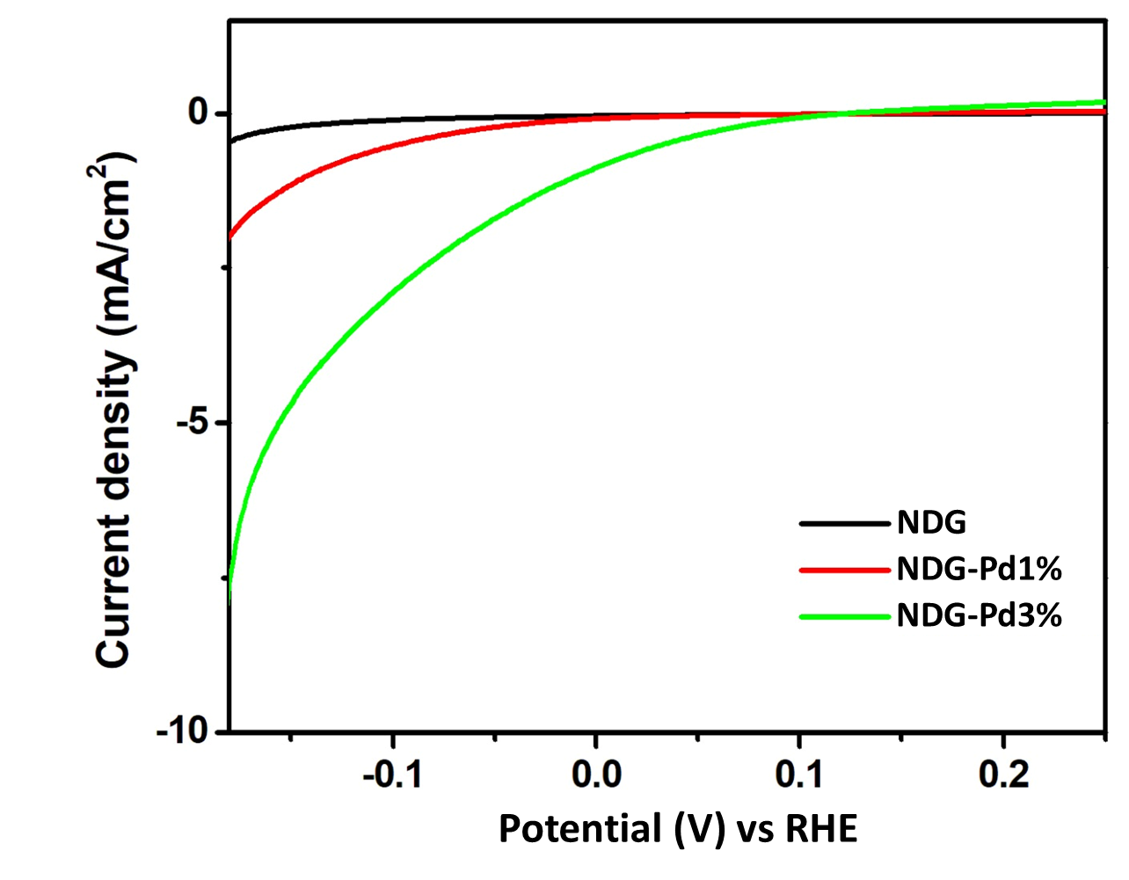

**Figure S1:** Zoomed in LSV plots of NDG, NDG-Pd1% and Pd-NDG3% indicating the respective onset potentials.