Exploring Sustainable Corrosion Inhibition of Copper in Saline Environment: An Examination of Hydroquinazolinones via Experimental and ab initio DFT simulations

Mohammed Oubahou¹, Mohamed Rbaa², Hassane Lgaz^{3,*}, Driss Takky¹, Youssef Naimi¹, Awad A. Alrashdi⁴, Han-seung Lee^{5,*}
“¹Laboratory of Physical Chemistry of Materials, Faculty of Science Ben M’Sik B.P.7955, Hassan II University of Casablanca, Casablanca, Morocco.
²Laboratory of Organic Chemistry, Catalysis and Environment, Department of Chemistry, Faculty of Sciences, Ibn Tofaïl University, PO Box 133, 14000, Kenitra, Morocco.
³Innovative Durable Building and Infrastructure Research Center, Center for Creative Convergence Education, Hanyang University ERICA, 55 Hanyangdaehak-ro, Sangrok-gu, Ansan-si, Gyeonggi-do 15588, South Korea
⁴Chemistry Department, Umm Al-Qura University, Al-Qunfudah University College, Al Qunfudah 21962, 11, Saudi Arabia.
⁵Department of Architectural Engineering, Hanyang University-ERICA, 55 Hanyangdaehak-ro, San-grok-gu, Ansan-si, Gyeonggi-do 15588, Republic of Korea”

*Correspondence: hlgaz@hanyang.ac.kr (H.L.), ercleehs@hanyang.ac.kr (H-s.L.)

S1. Synthesis of compounds

1-((4-hydroxynaphthalen-1-yl)methyl)-2-(p-tolyl)-2,3-dihydroquinazolin-4(1H)-one (DQ-CH3):
Chemical Formula: C26H22N2O2
Molecular Weight: 394.47

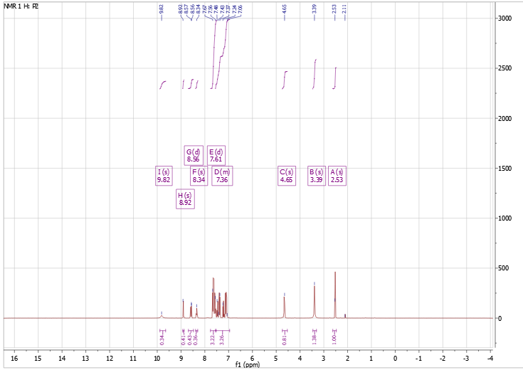
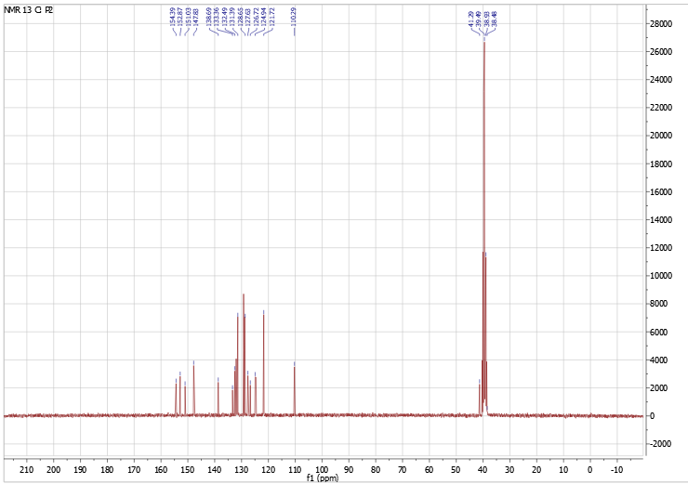
Fig.S1. Spectral ¹³ C and ¹ H NMR for compound DQ-CH₃.

1-((4-hydroxynaphthalen-1-yl)methyl)-2-phenyl-2,3-dihydroquinazolin-4(1H)-one (DQ-H):
Chemical Formula: C25H20N2O2
Molecular Weight: 380,44

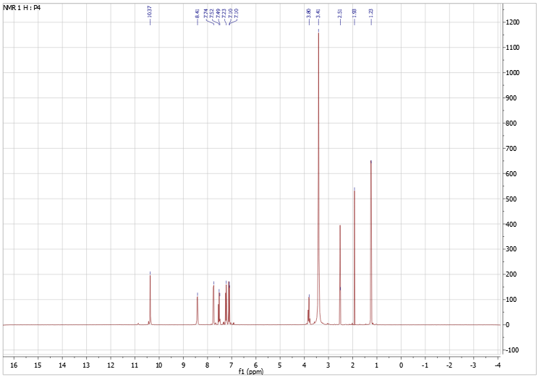
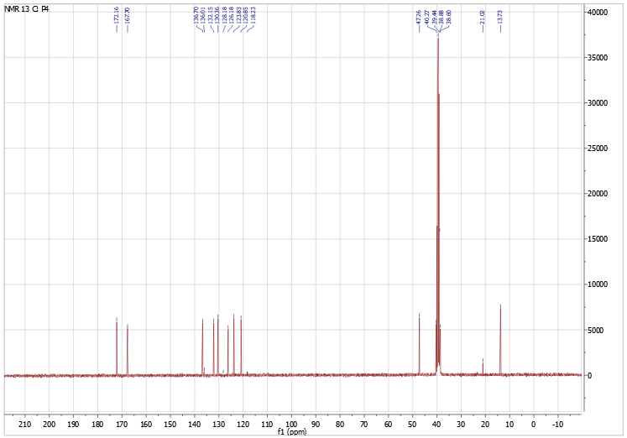
Fig.S2. Spectral ¹³ C and ¹ H NMR for compound DQH.

Table S2. Fukui function indices of DQ-CH₃ and DQ-H compounds obtained by DFT/GGA.
DQ-CH₃ | Fukui(+) | Fukui(-) | DQ-H | Fukui(+) | Fukui(-)
C ( 1) | 0.026 | 0.034 | C ( 1) | 0.034 | 0.026
C ( 2) | 0.025 | 0.034 | C ( 2) | 0.034 | 0.024
C ( 3) | 0.021 | 0.023 | C ( 3) | 0.022 | 0.021
C ( 4) | 0.018 | 0.033 | C ( 4) | 0.031 | 0.017
C ( 5) | 0.013 | 0.012 | C ( 5) | 0.012 | 0.012
C ( 6) | 0.015 | 0.014 | C ( 6) | 0.014 | 0.014
C ( 7) | 0.036 | 0.023 | C ( 7) | 0.022 | 0.036
C ( 8) | 0.028 | 0.024 | C ( 8) | 0.023 | 0.027
C ( 9) | 0.031 | 0.022 | C ( 9) | 0.022 | 0.031
C ( 10) | 0.035 | 0.022 | C ( 10) | 0.021 | 0.034
O ( 11) | 0.018 | 0.039 | O ( 11) | 0.038 | 0.018
C ( 12) | 0.007 | 0.014 | C ( 12) | 0.014 | 0.007
N ( 13) | 0.009 | 0.065 | N ( 13) | 0.066 | 0.009
C ( 14) | 0.023 | 0.023 | C ( 14) | 0.024 | 0.023
C ( 15) | 0.033 | 0.038 | C ( 15) | 0.039 | 0.033
C ( 16) | 0.054 | 0.013 | C ( 16) | 0.014 | 0.054
N ( 17) | 0.030 | 0.015 | N ( 17) | 0.015 | 0.030
C ( 18) | 0.009 | 0.011 | C ( 18) | 0.011 | 0.009
C ( 19) | 0.048 | 0.035 | C ( 19) | 0.035 | 0.048
C ( 20) | 0.033 | 0.069 | C ( 20) | 0.070 | 0.033
C ( 21) | 0.061 | 0.035 | C ( 21) | 0.036 | 0.061
C ( 22) | 0.032 | 0.046 | C ( 22) | 0.047 | 0.032
O ( 23) | 0.067 | 0.031 | O ( 23) | 0.031 | 0.067
C ( 24) | 0.005 | 0.003 | C ( 24) | 0.003 | 0.007
C ( 25) | 0.011 | 0.005 | C ( 25) | 0.005 | 0.012
C ( 26) | 0.009 | 0.009 | C ( 26) | 0.009 | 0.011
C ( 27) | 0.013 | 0.009 | C ( 27) | 0.011 | 0.018
C ( 28) | 0.011 | 0.009 | C ( 28) | 0.009 | 0.013
C ( 29) | 0.010 | 0.009 | C ( 29) | 0.009 | 0.012
C ( 30) | 0.004 | 0.003

Table S3: Comparative chart listing performances of some other quinazolines and quinazolinones acting as corrosion inhibitors of various metals.
Inhibitor structure | Metal/solution | Techniques | Efficiency at max. concentration | Ref.
DQ-Br  DQ-Cl  DQ-Cl’ | Copper/NaCl | EIS, PDP, WL, SEM, FT-IR, UV-vis, DFT, MD | DQ-Br: 97.24%  DQ-Cl: 95.24%  DQ-Cl’: 94.18% | (Oubahou et al., 2023)
PPQ  MPPQ | Mild Steel/1M HCl | Mass loss, PDP EIS, SEM/EDS, XPS, AFM, DFT, MD | PPQ : 95.7%  MPPQ : 95.2% | (W. Chen et al., 2021b)
QZ-H  QZ-OH  QZ-CH₃  QZ-NO₂ | Mild Steel/1M HCl | PDP, EIS, SEM, UV-visible, DFT, MC | QZCH₃: 96.52%  QZ-OH: 93.13%  QZ-NO₂: 90.74%  QZ-H: 85.37% | (Errahmany et al., 2020)
HQ-ZH  HQ-ZNO2  HQ-ZOH | Mild steel/1M HCl | PDP, EIS, SEM, UV-visible, DFT,  Monte Carlo simulations | HQ-ZNO₂: 95.9%  HQ-ZH: 94.4%  HQ- ZOH: 91.4% | (Rbaa, Galai, et al., 2019)
DM  DME | Copper/0.5M H₂SO₄ | PDP, EIS, SEM, AFM, XPS, FT-IR, DFT, MD | DME: 88.1%  DM: 86.0% | (J. Zhang & Zhang, 2021)
BQA  QA  HQA  ThQA  SHQA | COPPER/ HNO3 | Gravimetry, electrochemical | SHQA: 58.9%  ThQA: 52.0%  HQA: 50.4%  QA: 45.0%  BQA: 42.0% | (A. E.-A. S. Fouda et al., 2010)
PDQ | MS/0.1M HCl | EIS, PDP, Quantum chemical | 92.93 % | (Ayati et al., 2011)
Metolazone | Mild steel/HCl | WL, electrochemical, SEM, DFT | 82.8% | (Arrousse et al., 2022)
(1)  (2)  (3) | Carbon steel/2M HCl | WL, PDP, EIS, EDS, SEM | (1): 75.4%  (2): 59.8%  (3): 49.8% | (A. S. Fouda & Hassan, 2013)
HMPB  BHMB | Carbon steel/1M HCl | WL, PDP, EIS, UV-vis, DFT | BHMB : : 86.7%  HMPB : 81.6% | (Faydy et al., 2019)
Q1  Q2  Q3 | MS/0.5M HCl | EIS PDP SEM DFT | Q1 : 95.3%  Q2 : 90.1%  Q3 : 86.2% | (Kumar et al., 2020)
MMDQ  NNDQ | Mild stel/1M HCl | Mass loss, OCP, PDP, EIS, SEM | MMDQ : 92%  NNDQ : 89% | (G. Khan et al., 2017)
Q1A  Q1B  Q1C | Mild steel/H2SO4 | DFT, MD | Q1A: 96%  Q1B: 89%  Q1C: 50% | (Saha et al., 2016)
QZ-H  QZ-Cl | Mild steel/1M HCl | PDP, EIS, DFT | QZ-Cl: 88.62%  QZ-H: 86.20% | (Touir et al., 2024)
QDO  QIM | Mild steel/1M HCl | PDP, EIS, SEM/EDS, UV-vis, FT-IR, DFT | QIM: 97.95%  QDO: 92.59% | (Rbaa & Lakhrissi, 2019)
DHIP1  DHIP2 | Low Alloy Steel/ HCl | Weight loss, Electrochemical, SEM | DHIP1 : 86.3%  DHIP2 : 81.8% | (G. Khan et al., 2018)

