**Supplementary Materials**

**Fig. S1** Chemical structures of secondary metabolites identified in fruits, flowers and leaves of *Forsythia suspensa.*

**Fig. S2** The MS/MS spectrums and fragmentation patterns of forsythoside A in positive mode.

**Fig. S3** The MS/MS spectrums and fragmentation patterns of phillyrin in positive mode.

**Fig. S4** The MS/MS spectrums and fragmentation patterns of forsythenside B in positive mode.

**Fig. S5** The MS/MS spectrums and fragmentation patterns of chlorogenic acid in positive mode.

**Fig. S6** The MS/MS spectrums and fragmentation patterns of rutin in positive mode.

**Table S1** Sample information of fruits, leaves and flowers of *Forsythia suspensa.*

**Table S2** Information of 29 differential metabolites in three parts of *Forsythia suspensa.*

**Fig. S1** Chemical structures of secondary metabolites identified in fruits, flowers and leaves of *Forsythia suspensa.*

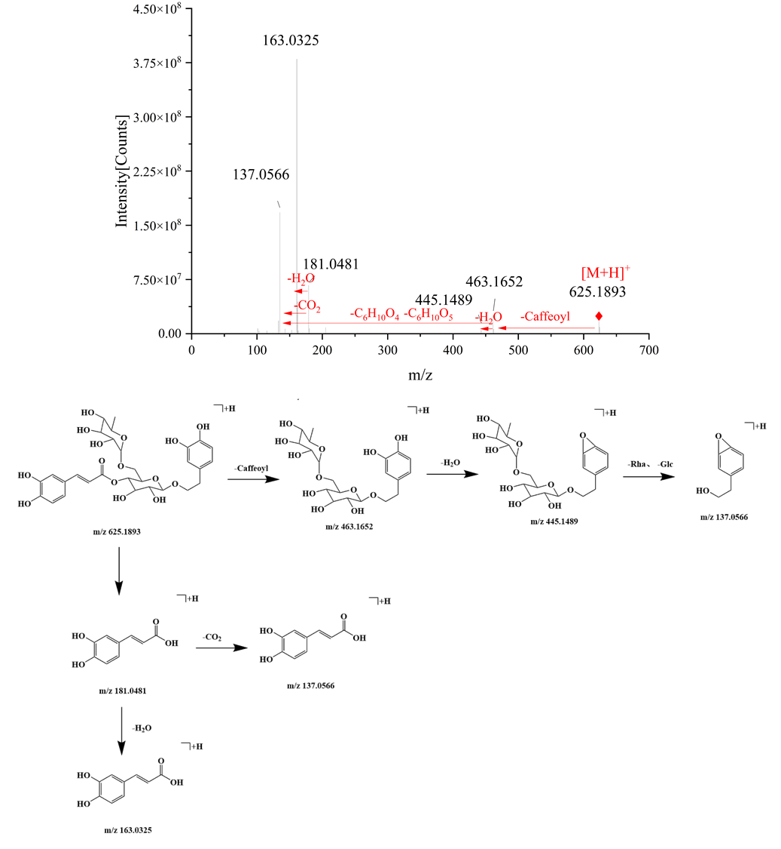

**Fig. S2** The MS/MS spectrums and fragmentation patterns of forsythoside A in positive mode.

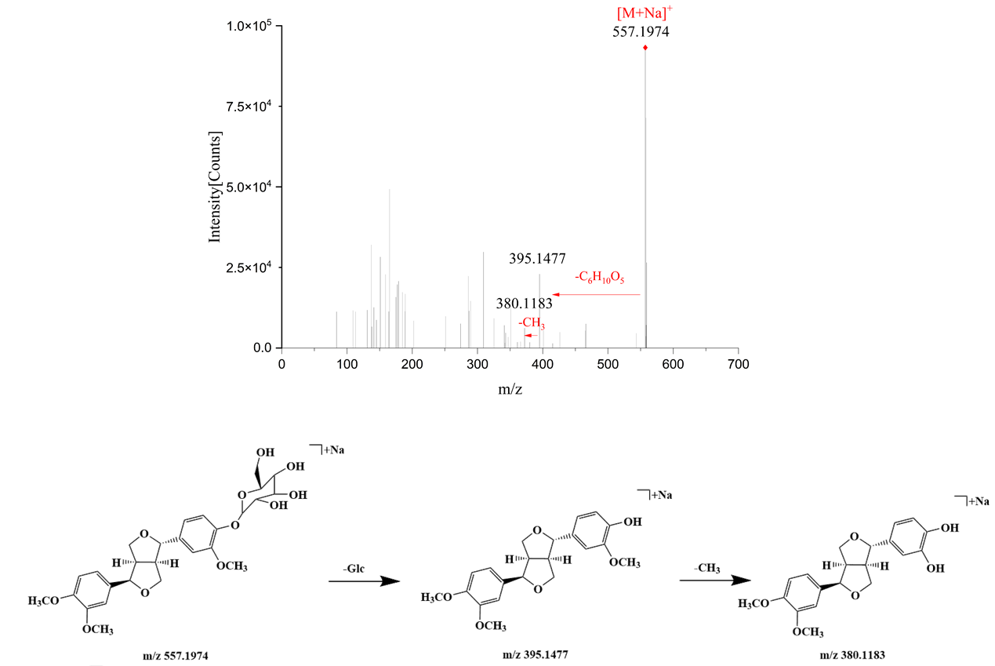

**Fig. S3** The MS/MS spectrums and fragmentation patterns of phillyrin in positive mode.

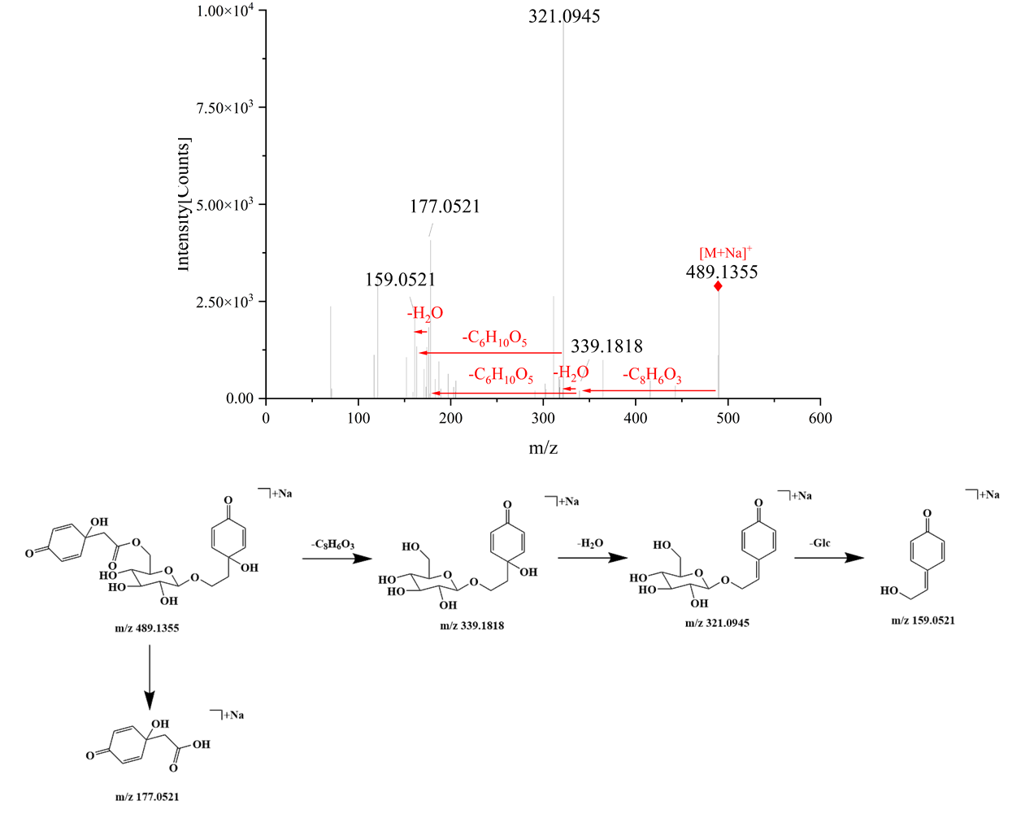

**Fig. S4** The MS/MS spectrums and fragmentation patterns of forsythenside B in positive mode.

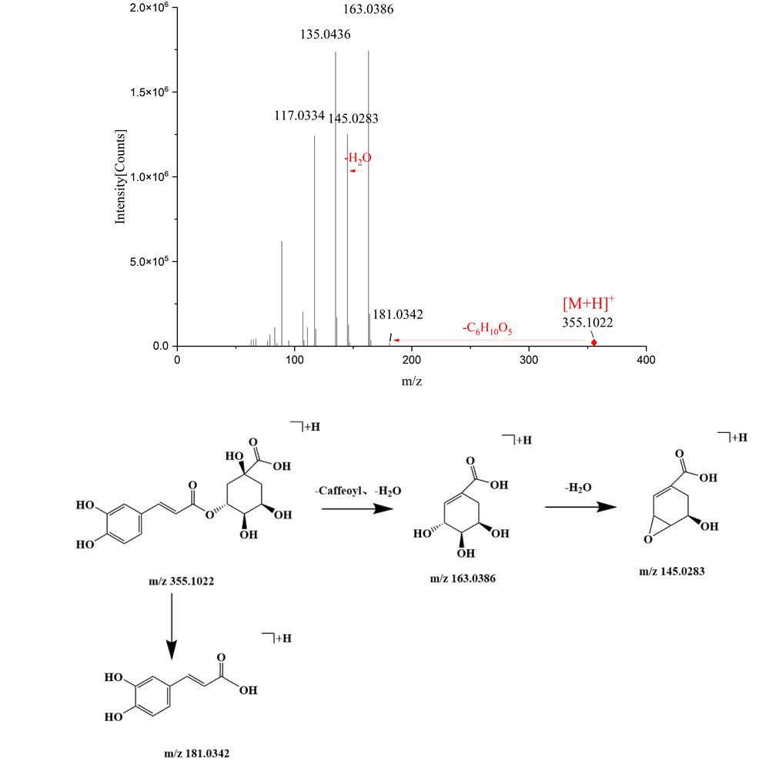

**Fig. S5** The MS/MS spectrums and fragmentation patterns of chlorogenic acid in positive mode.

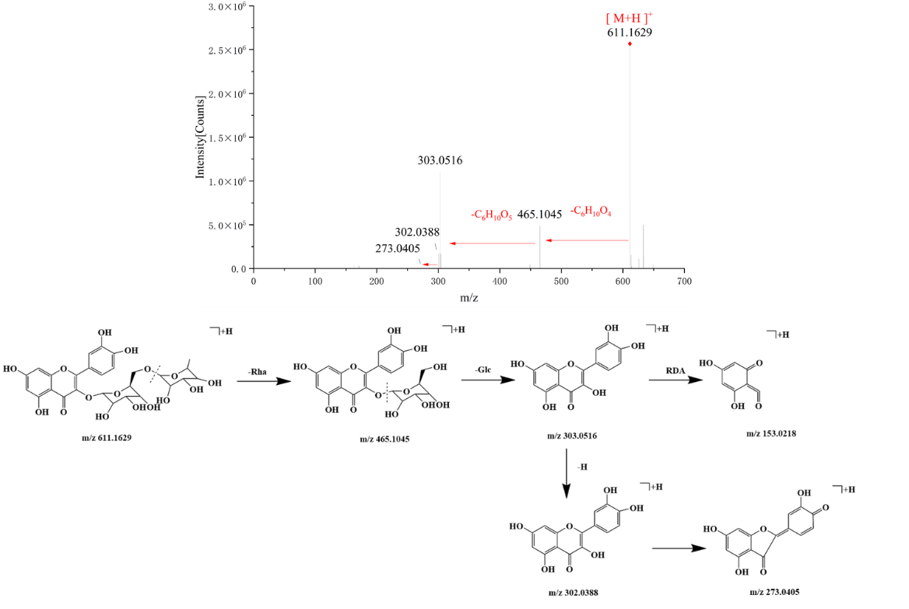

**Fig. S6** The MS/MS spectrums and fragmentation patterns of rutin in positive mode.

**Table S1** Sample information of fruits, leaves and flowers of *Forsythia suspensa.*

|  |  |  |  |  |  |  |  |  |
| --- | --- | --- | --- | --- | --- | --- | --- | --- |
| NO. | Origins | Part | NO. | Origins | Part | Batch. | Origins | Part |
| G1 | Shanxi province, China | Fruits | H1 | Shanxi province, China | Flowers | Y1 | Shanxi province, China | Leaves |
| G2 | Shanxi province, China | Fruits | H2 | Shanxi province, China | Flowers | Y2 | Shanxi province, China | Leaves |
| G3 | Shanxi province, China | Fruits | H3 | Shanxi province, China | Flowers | Y3 | Shanxi province, China | Leaves |
| G4 | Shanxi province, China | Fruits | H4 | Shanxi province, China | Flowers | Y4 | Shanxi province, China | Leaves |
| G5 | Shanxi province, China | Fruits | H5 | Hebei province, China | Flowers | Y5 | Shanxi province, China | Leaves |
| G6 | Shanxi province, China | Fruits | H6 | Hebei province, China | Flowers | Y6 | Hebei province, China | Leaves |
| G7 | Henan province, China | Fruits | H7 | Hebei province, China | Flowers | Y7 | Hebei province, China | Leaves |
| G8 | Henan province, China | Fruits | H8 | Hebei province, China | Flowers | Y8 | Henan province, China | Leaves |
| G9 | Henan province, China | Fruits | H9 | Shanxi province, China | Flowers | Y9 | Henan province, China | Leaves |
| G10 | Henan province, China | Fruits | H10 | Shanxi province, China | Flowers | Y10 | Henan province, China | Leaves |
| G11 | Henan province, China | Fruits | H11 | Hebei province, China | Flowers | Y11 | Henan province, China | Leaves |
| G12 | Henan province, China | Fruits | H12 | Hebei province, China | Flowers | Y12 | Henan province, China | Leaves |
| G13 | Hebei province, China | Fruits | H13 | Shanxi province, China | Flowers |  |  |  |
| G14 | Hebei province, China | Fruits | H14 | Shanxi province, China | Flowers |  |  |  |

**Table S2** Information of 29 differential metabolites in three parts of *Forsythia suspensa.*

|  |  |  |  |  |  |  |  |
| --- | --- | --- | --- | --- | --- | --- | --- |
| No. | Compound | Molecular  formula | VIP values | tR(min) | Molecular ions (*m/z*) | MS/MS fragments (*m/z*) | Classification |
| 1 | Rengynic acid-4-O  -β-D-glucoside | C14H24O9 | 1.549 | 1.586 | [M+Na]+ 359.1311 | 203.0521, 147.0449, 109.0450 | Cyclohexanol |
| 6 | Caffeic acid 2-(1  naphthyl) ethyl ester | C21H18O4 | 2.294 | 2.323 | [M+H]+ 335.1238 | 173.0710, 155.0597, 129.0572 | Organic acids |
| 7 | Galiridoside | C15H22O9 | 1.838 | 2.672 | [M+NH4]+ 364.1601 | 309.0915, 247.1157, 167.0700 | Cyclohexanol |
| 10 | Adoxosidic acid | C16H24O10 | 1.969 | 3.057 | [M+Na]+ 399.1271 | 215.0916, 197.0810, 153.0908, 105.0699 | Terpenes |
| 12 | Vanilloloside | C14H20O8 | 1.560 | 3.448 | [M+Na]+ 339.1054 | 137.0596 | Cyclohexanol |
| 14 | Forsythoside E | C20H30O12 | 1.537 | 4.401 | [M+Na]+ 485.1627 | 317.1080, 155.0547, 137.0594 | Phenylethanoids |
| 15 | Chlorogenic acid | C16H18O9 | 2.242 | 5.142 | [M+H]+ 355.1022 | 163.0387, 145.0281, 135.0439, 117.0334 | Organic acids |
| 16 | Forsythenside B | C22H26O11 | 1.753 | 5.318 | [M+Na]+ 489.1355 | 339.1818, 321.0945, 177.0521, 159.0521 | Cyclohexanol |
| 23 | p-Coumaroyl  quinic acid | C16H18O8 | 2.098 | 7.311 | [M+H]+ 339.1068 | 147.0441, 119.0492, 91.0541 | Organic acids |
| 25 | 7-Epi-12-Hydroxyjasmonic acid glucoside | C18H28O9 | 2.071 | 7.675 | [M+Na]+ 411.16 | 249.0707, 167.0710 | Organic acids |
| 28 | 8-Hydroxypinoresinol 4-glucoside | C26H32O12 | 1.640 | 9.104 | [M+Na]+ 559.1755 | 3731291, 343.1174, 328.0933, 313.1072 | Lignans |
| 30 | Forsythenside A | C22H26O10 | 1.700 | 10.707 | [M+Na]+ 473.141 | 315.1081, 193.0504, 175.0499, 151.0401 | Cyclohexanol |
| 31 | R-suspensaside A | C29H36O16 | 1.840 | 10.93 | [M+Na]+ 663.1881 | 621.1819, 529.1561 , 487.1448, 469.1376, 179.0338, 161.0233,151.0398, 135.0444 | Phenylethanoids |
| 32 | S-suspensaside A | C29H36O16 | 1.853 | 11.18 | [M+Na]+ 663.1884 | 621.1819, 529.1561, 487.1448, 469.1376, 179.0338, 161.0233, 151.0398, 135.0444 | Phenylethanoids |
| 33 | (Z)-3-Hexenylvicianoside | C17H30O10 | 1.665 | 11.468 | [M+Na]+ 417.1729 | 344.0973, 285.1277, 136.0822, 145.0498, 133.0490, 127.0386, 115.0390 | Others |
| 38 | Quercitrin | C21H20O12 | 2.059 | 13.214 | [M+H]+ 465.1026 | 303.0494, 285.0405, 257.0418, 229.0491 | Flavonoids |
| 40 | Forsythoside I | C29H36O15 | 1.985 | 13.701 | [M+H]+ 625.1981 | 463.1725, 445.1332, 317.1076, 207.0651, 181.0154, 163.0163, 137.0432 | Phenylethanoids |
| 41 | Rutin | C27H30O16 | 2.155 | 13.928 | [M+H]+ 611.1629 | 465.1045, 303.0516, 302.0388, 273.0405, 147.0649, 129.0543 | Flavonoids |
| 46 | Kaempferol-3-O  -rutinoside | C27H30O15 | 2.114 | 15.542 | [M+H]+ 595.1669 | 449.1120, 287.0552, 241.0502, 165.0119 | Flavonoids |
| 47 | Forsythoside H | C29H36O15 | 1.604 | 16.196 | [M+NH4]+ 642.2386 | 471.1594, 325.0918, 163.0388 | Phenylethanoids |
| 53 | Kaempferol | C15H10O6 | 2.177 | 17.436 | [M+H]+ 287.0557 | 213.0539, 185.0599, 171.0435, 165.0178, 153.0182, 107.0487 | Flavonoids |
| 54 | Pinoresinol-4-O  -glucoside | C26H32O11 | 2.009 | 17.655 | [M+Na]+ 543.1834 | 381.1204, 153.0521, 138.0628 | Lignans |
| 56 | Epi-pinoresinol-4'-O  -glucoside | C26H32O11 | 2.013 | 21.665 | [M+Na]+ 543.1834 | 381.1199, 153.0520, 138.0628 | Lignans |
| 62 | 2-[4-(3-Hydroxypropyl)-2-methoxyphenoxy]-1,3-propanediol  1-glucoside | C19H30O10 | 2.249 | 25,068 | [M+NH4]+ 436.2177 | 231.0495, 153.1273, 135.1166 | Others |
| 63 | (+)-Pinoresinol monomethyl ether-β-D  -glucoside | C27H34O11 | 1.768 | 27.018 | [M+Na]+ 557.1992 | 395.1447 | Lignans |
| 66 | Phillyrin | C27H34O11 | 1.869 | 28.906 | [M+Na]+ 557.199 | 371.1499, 356.1267 | Lignans |
| 72 | Epipinoresinol | C20H22O6 | 2.229 | 34.143 | [M+H]+ 359.1486 | 341.1379, 311.1275, 205.0851, 151.0387 | Lignans |
| 73 | Matairesinol | C20H22O6 | 1.954 | 35.092 | [M+H]+ 359.1485 | 341.1368, 311.1279, 205.0858, 151.0389 | Lignans |
| 74 | Phillygenin | C21H24O6 | 2.057 | 36.779 | [M+H-H2O]+ 355.1541 | 337.1438, 189.0899 | Lignans |