**Supplementary Material**

**Formation of Ketoprofen Methyl Ester Artifact in GC-MS Analysis of Basic Drugs in Horse Urine using Alkaline Liquid-Liquid Extraction**

Chaksawat Sangawitayakorn1, Pirom Chenprakhon2,

Prapin Wilairat3,*, Rattikan Chantiwas1,*

1Department of Chemistry and Center of Excellence for Innovation in Chemistry, Faculty of Science, Mahidol University, Rama VI Rd., Bangkok 10400, Thailand

2Institute for Innovative Learning, Mahidol University, Nakhon Pathom 73170, Thailand

3Analytical Sciences and National Doping Test Institute (ASNDTI), Mahidol University,

Rama VI Rd., Bangkok 10400, Thailand

*Corresponding author***.***

Email address: prapin***.***wil@mahidol***.***ac***.***th ***(***P***.*** Wilairat***)***, rattikan.cha@mahidol**.**ac***.***th*,* rattikan***.***cha@mahidol***.***edu ***(***R***.*** Chantiwas***).***

Tel.: +66 2 201 5199; Fax: +66 2 354 7151

**Contents:**

**1. Supplementary Material A:** Modification of procedures for the estimation of percent formation of KME artifact

**2. Supplementary Material B:**  Comparison of mass spectra of flunixin methyl ester

**Supplementary Material A**

**Modification of procedures for the estimation of percent formation of KME artifact**

**Modified procedure for alkaline LLE of basic drugs in horse urine**

In the alkaline LLE procedure (see Section 2.5), 20.0 µL of pure methanol was added to the 5.0 mL horse urine sample. After separation of the TBME phase and drying, 200 µL of TBME and 20.0 µL of 0.25 mg mL-1 diphenylamine (dissolved in methanol) were added to the residue for the GC-MS analysis (see Section 2.2).

**Modified procedure for acidic LLE and methylation of NSAIDs in horse urine**

Section 2.6 was followed for the acidic LLE and drying steps using 1.0 mL of the horse urine sample. The dry residue was dissolved in 1500 µL of acetone. Methylation was performed by pipetting 150 $\text{μ}$ L of the acetone solution into a clean 10 mL screw-cap glass test tube and adding 50 $\text{μ}$ L methyl iodide and 50 mg anhydrous potassium carbonate. The tube was screwed tight and heated in a heating block at 60 °C for 30 min. After cooling to room temperature, 20.0 µL of 0.25 mg mL-1 diphenylamine, dissolved in methanol, was added. Then 2 µL of the solution was injected into the GC-MS instrument.

It is noted that the volume of the final solution for injection into GC-MS is the same (i.e., 220 µL) as the volume for the modified alkaline LLE (*vide supra*).

**Supplementary Material B**

**Comparison of mass spectra of flunixin methyl ester**

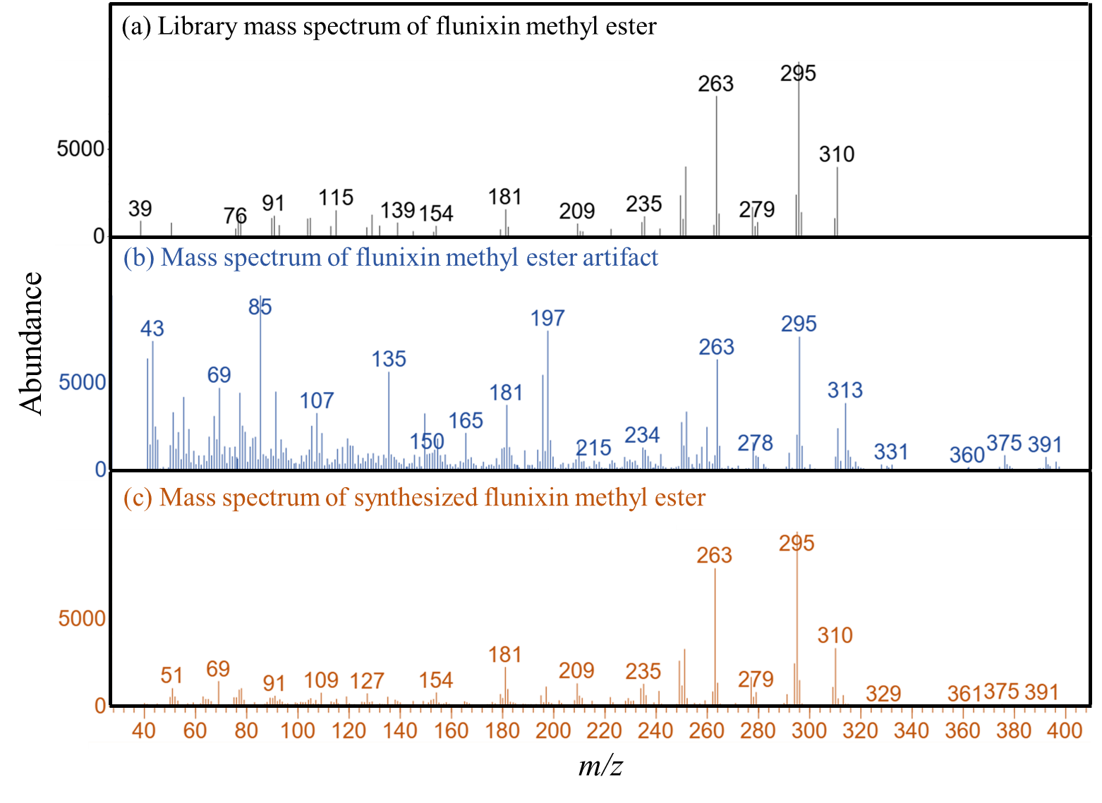

**Fig. S1** Mass spectra of **(a)** library matched mass spectrum of flunixin methyl ester, **(b)** mass spectrum of flunixin methyl ester artifact, RT = 7.36 min and **(c)** mass spectrum of synthesized flunixin methyl ester at RT = 7.36 min.