Supplementary Material

Text S1. Indentification of the intermediates.
The intermediates were analyzed using gas chromatography-mass spectrometry (Agilent7890A/GC-5975C MS). The water sample was pretreated with the following steps: 50 mL water sample was added into a separation funnel, followed by the addition of 5 mL dichloromethane and 1 g sodium chloride for oscillating extraction. The obtained lower extraction liquid was then transferred to 10 mL nitrogen tube after dehydrating with anhydrous sodium sulfate and filtering with glass fiber filter membrane. The above pretreatment was conducted for twice for the water sample, and the extracted solution was then treated with nitrogen blowing and concentrating. In the end, 1 mL dichloromethane was added to the solution for subsequent measurement. The gas chromatographic conditions were as follows: The chromatographic column was an HP-5 quartz capillary column (30 m×250 μm×0.25 μm) with helium as carrier gas at a flow rate of 1 mL min⁻¹. The inlet temperature, injection volume and split ratio were set to be 260℃, 1 μL and 10:1, respectively. The heating was proceeded with an initial column temperature of 40℃ and remained for 3 min. The temperature was then increased to 300℃ with a ramp rate of 15℃ min⁻¹ and maintained for 10 min. Finally, the temperature was heated to 325℃ for 3 min. Mass spectrum was operated with a scanning range of 50~560 m Z⁻¹, ion source of 230℃, electron bombardment source EI of 70 eV and four-stage rod temperature of 150℃.

Text S2. Toxicity detection.
The comprehensive biological toxicity of the water samples during BDE-209 degradation was evaluated by DeltaTox II toxicity detection analyzer (DeltaTox® II, SDIX, USA), which was according to the ISO standard luminescent bacteria toxicity test. The specific steps were as follows: Firstly, 310 μL Micro Tox diluent was added into a test tube filled with Vibrio fischeri freeze-dried powder, and cultured at room temperature for 15 min. The above diluent was then evenly divided into three test tubes, and their initial luminescence (E₀) was recorded with physiological liquid as blank control. Afterwards, the salinity of 1000 μL water sample was adjusted to 3% through the addition of 100 μL Micro Tox osmotic adjustment solution. Finally, 900 μL water sample was added to the above three test tubes on average, and the luminescence (E) was recorded after an exposure time of 5 min. HgCl₂ solution with concentration of 0.08~0.12 mg L⁻¹ was used as a reference to test whether the activity of luminescent bacteria is normal, and the relative luminescence of HgCl₂ solution should be ~50% after 15 min reaction. It also should be noted that the pH of the water sample was adjusted to neutral before the test and the testing temperature was controlled at 20±5℃. The biological toxicity of water samples (T%) can be calculated with the formula shown below.
where E₀ and E represents initial and measured luminescence, respectively.

- (b)

Fig. S1. (a) The degradation rate of BDE-209 in different methods; (b) The apparent rate constants k_{obs} in three different oxidation systems. (Experimental conditions: [Fe³⁺]=[PMS]=[Fe(VI)]=0.1 mmol/L, [BDE-209]=0.5 μmol/L, initial solution pH=7.0, temperature=20±1℃.)

Table S1. The required concentrations of oxidants for complete removal of BDE-209 in different ([BDE-209]=0.5 μmol/L, initial solution pH=7.0, temperature=20±1℃.)
Sole PMS | Sole Fe(VI) | Fe(VI)-PMS combined process
[PMS]=1.0 mmol/L | [Fe(VI)]=0.8 mmol/L | [PMS]=0.1 mmol/L; [Fe(VI)]=0.2 mmol/L

Fig. S2. The apparent rate constants k_{obs} in the free radical quenching experiments. (Experimental conditions: [PMS]=[Fe(VI)]=0.1 mmol/L, [BDE-209]=0.5 μmol/L, [TBA]=[EtOH]=0.005 mmol/L; initial solution pH=7.0, temperature=20±1℃.)

Fig. S3. EPR spectra during ozonation system. (Experimental conditions: [PMS]=[Fe(VI)]=0.1 mmol/L, [BDE-209]=0.5 μmol/L, initial solution pH=7.0, temperature=20±1℃.)

(a) (b)

Fig. S4. Reaction kinetics fitting in different Fe(VI) dosage (a) and PMS dosage (b). (Experimental conditions: [BDE-209]=0.5 μmol/L; [Fe(VI)]=0.01-0.5 mmol/L for (a), 0.1 mmol/L for (b); [PMS]=0.01-0.5 mmol/L for (b), 0.1 mmol/L for (a); initial solution pH=7.0, temperature=20±1℃.)

- (b)
(c)

Fig. S5. Reaction kinetics fitting in different initial solution pH (a), temperature (b) and BDE-209 concentration (c). (Experimental conditions: [Fe(VI)] = [PMS] =0.1 mmol/L; initial solution pH=7.0 for (b) and (c), 3.0-11.0 for (a); temperature=20±1 ℃ for (a) and (c), 10-40 ℃ for (b); [BDE-209]=0.5 μmol/L for (a) and (b), 0.1-5.0 μmol/L for (c).)

Fig. S6. pH values before and after reaction under different initial pH conditions (Experimental conditions: [Fe(VI)] = [PMS] =0.1 mmol/L; initial pH=3.0-11.0; temperature=20±1 ℃; [BDE-209]=0.5 μmol/L.)

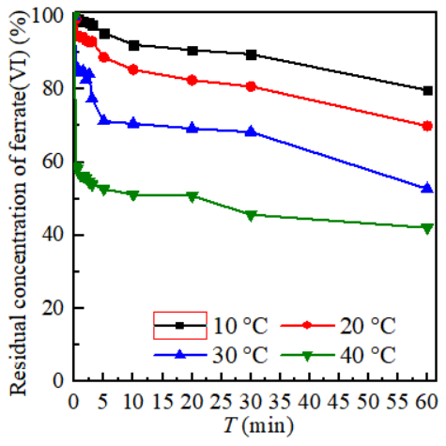

Fig. S7. The variation of ferrate(VI) concentration under different temperature. (Experimental conditions: [Fe(VI)] = [PMS] =0.1 mmol/L; initial pH=7.0; temperature=10-40 ℃.)
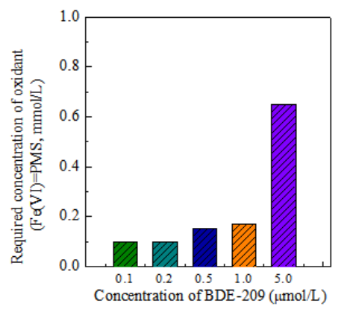

Fig. S8. The required concentration of oxidant. (Experimental conditions: BDE-209=0.1, 0.2, 0.5, 1.0, 5.0 μmol/L; [Fe(VI)] = [PMS]; initial pH=7.0; temperature=10-40 ℃.)

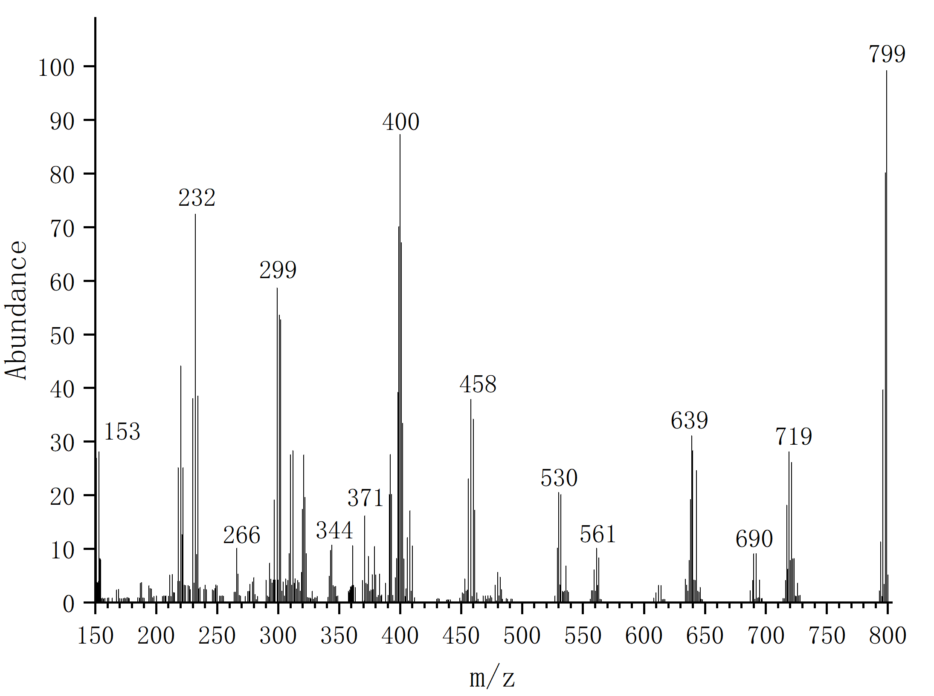
Product A: BDE-209
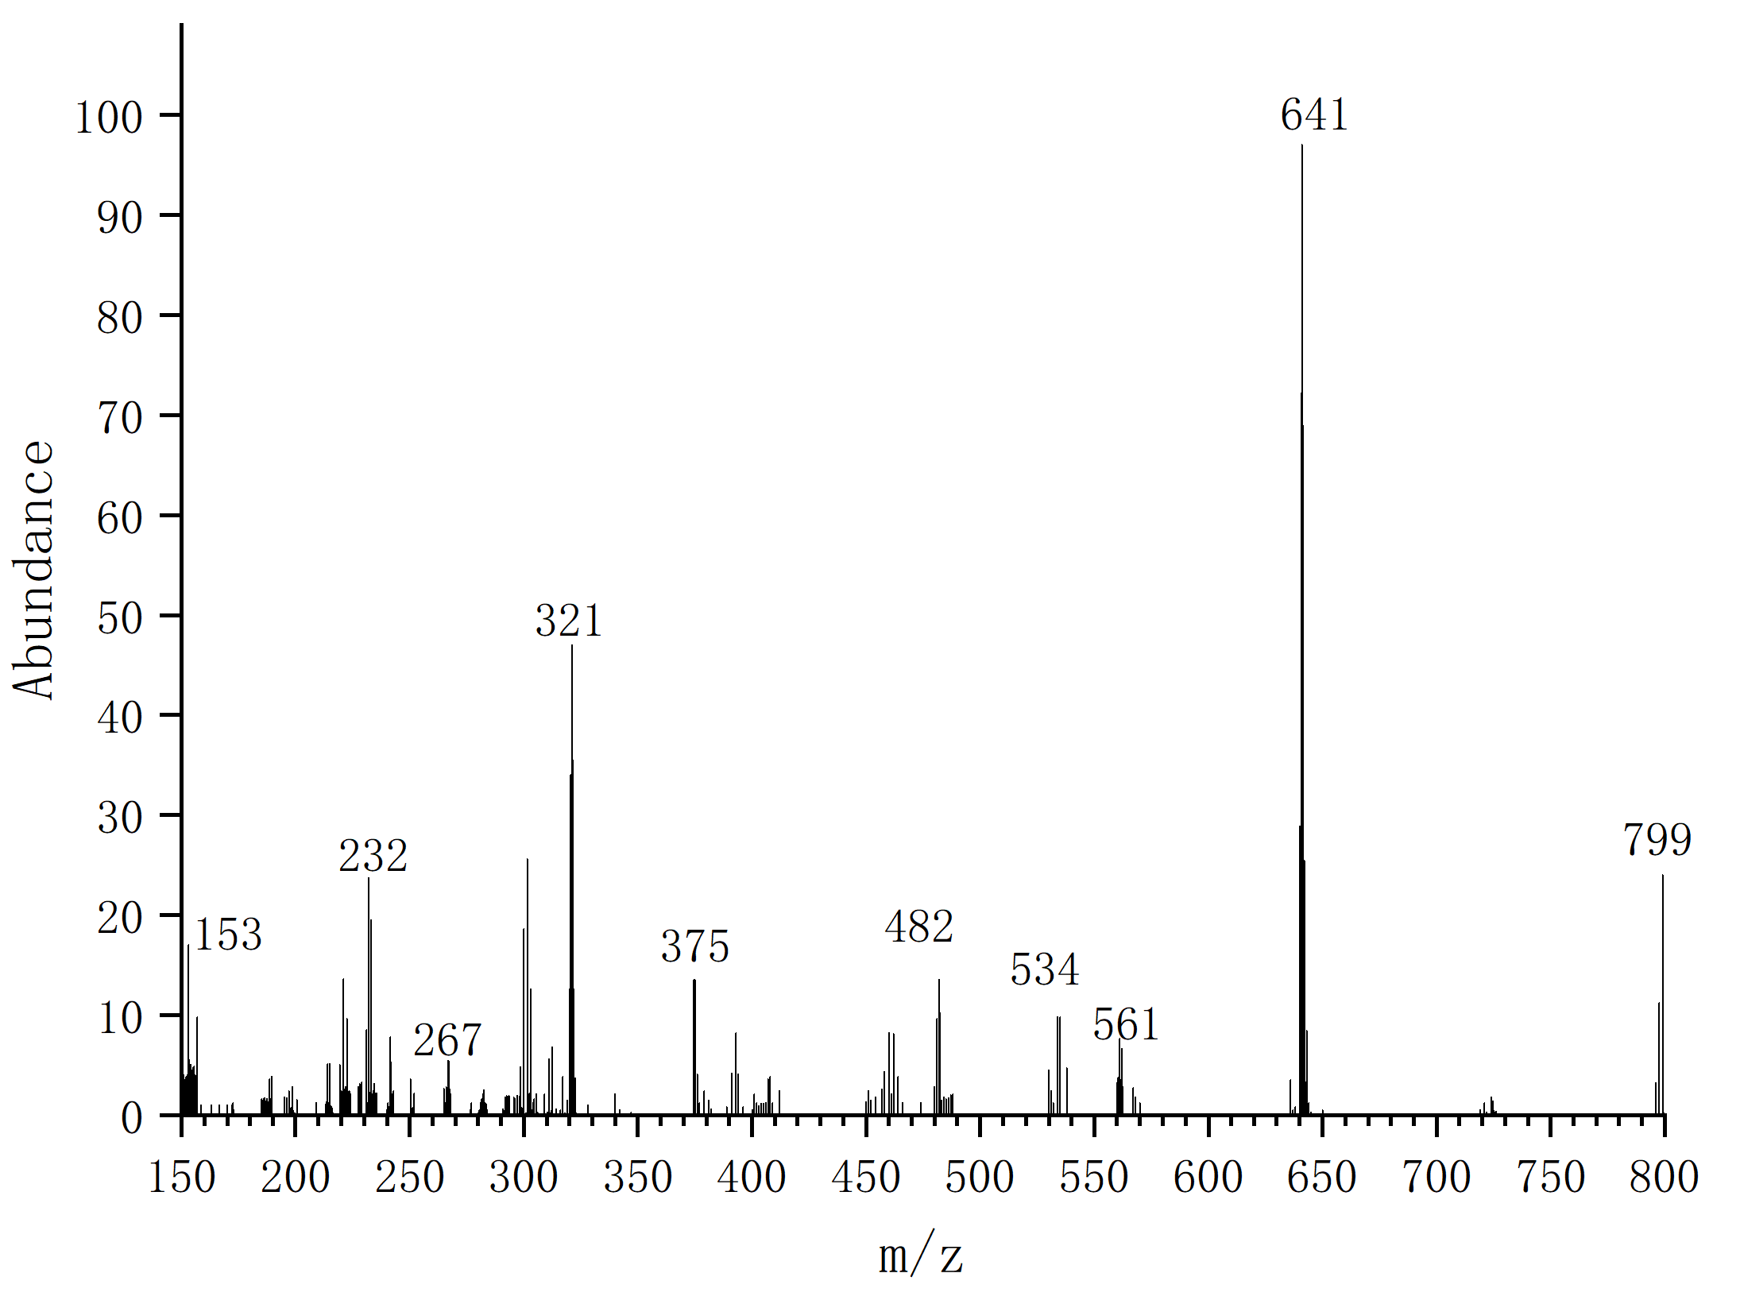
Product B: BDE-203
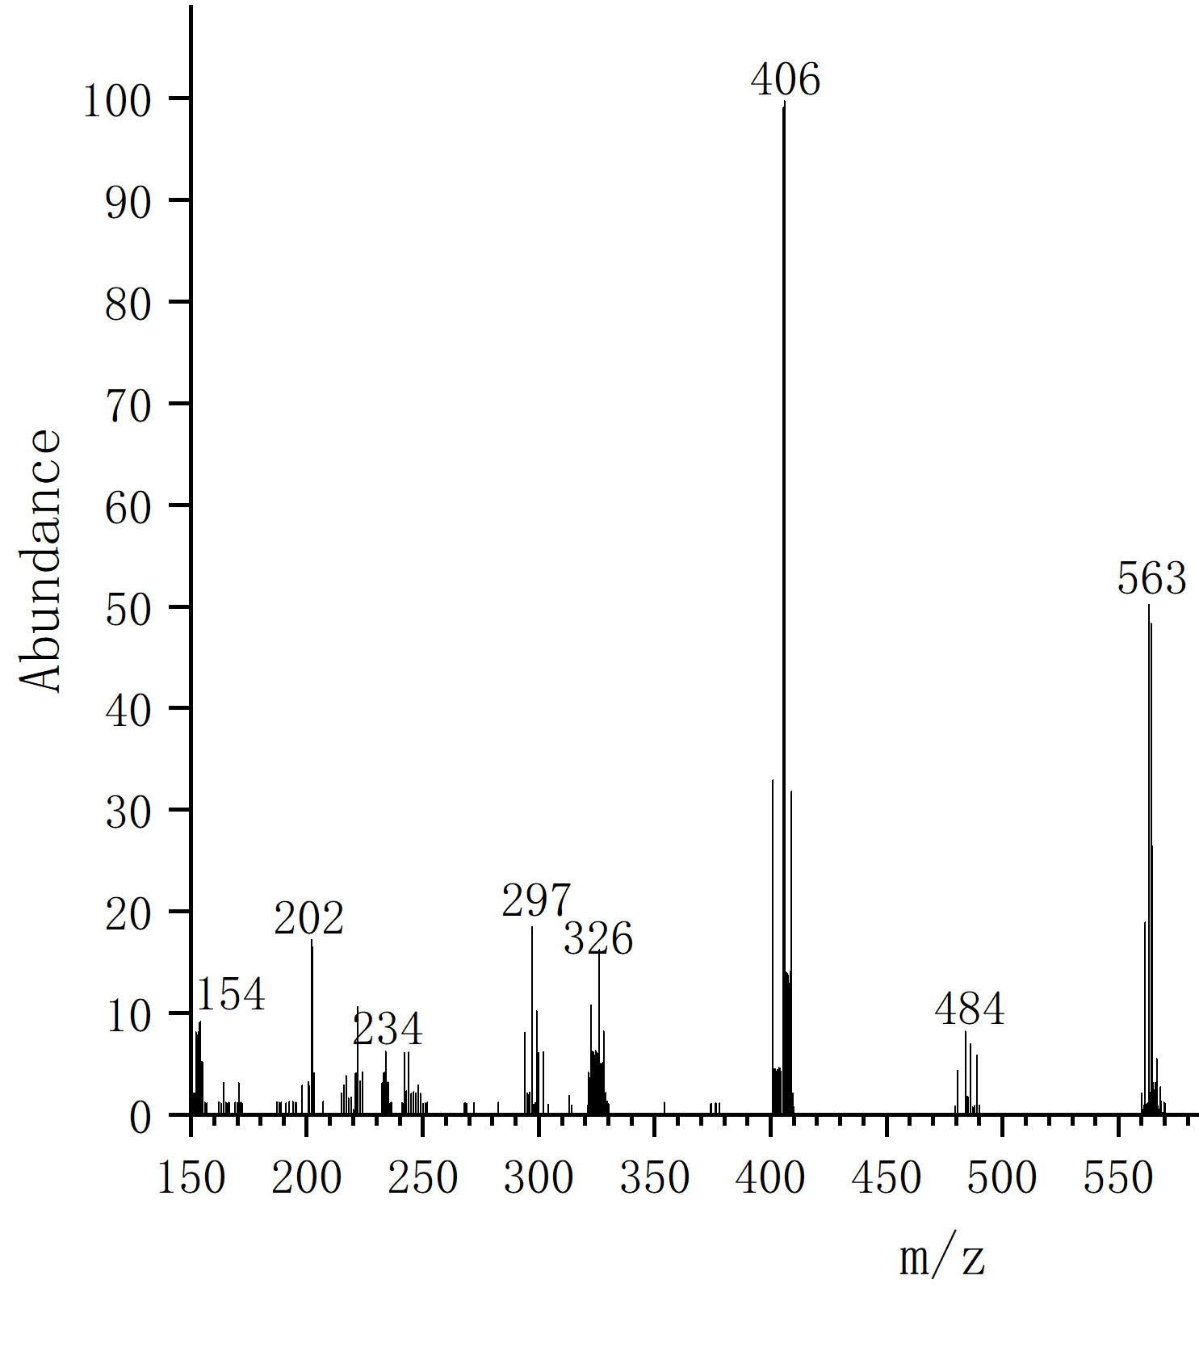
Product C:BDE-99
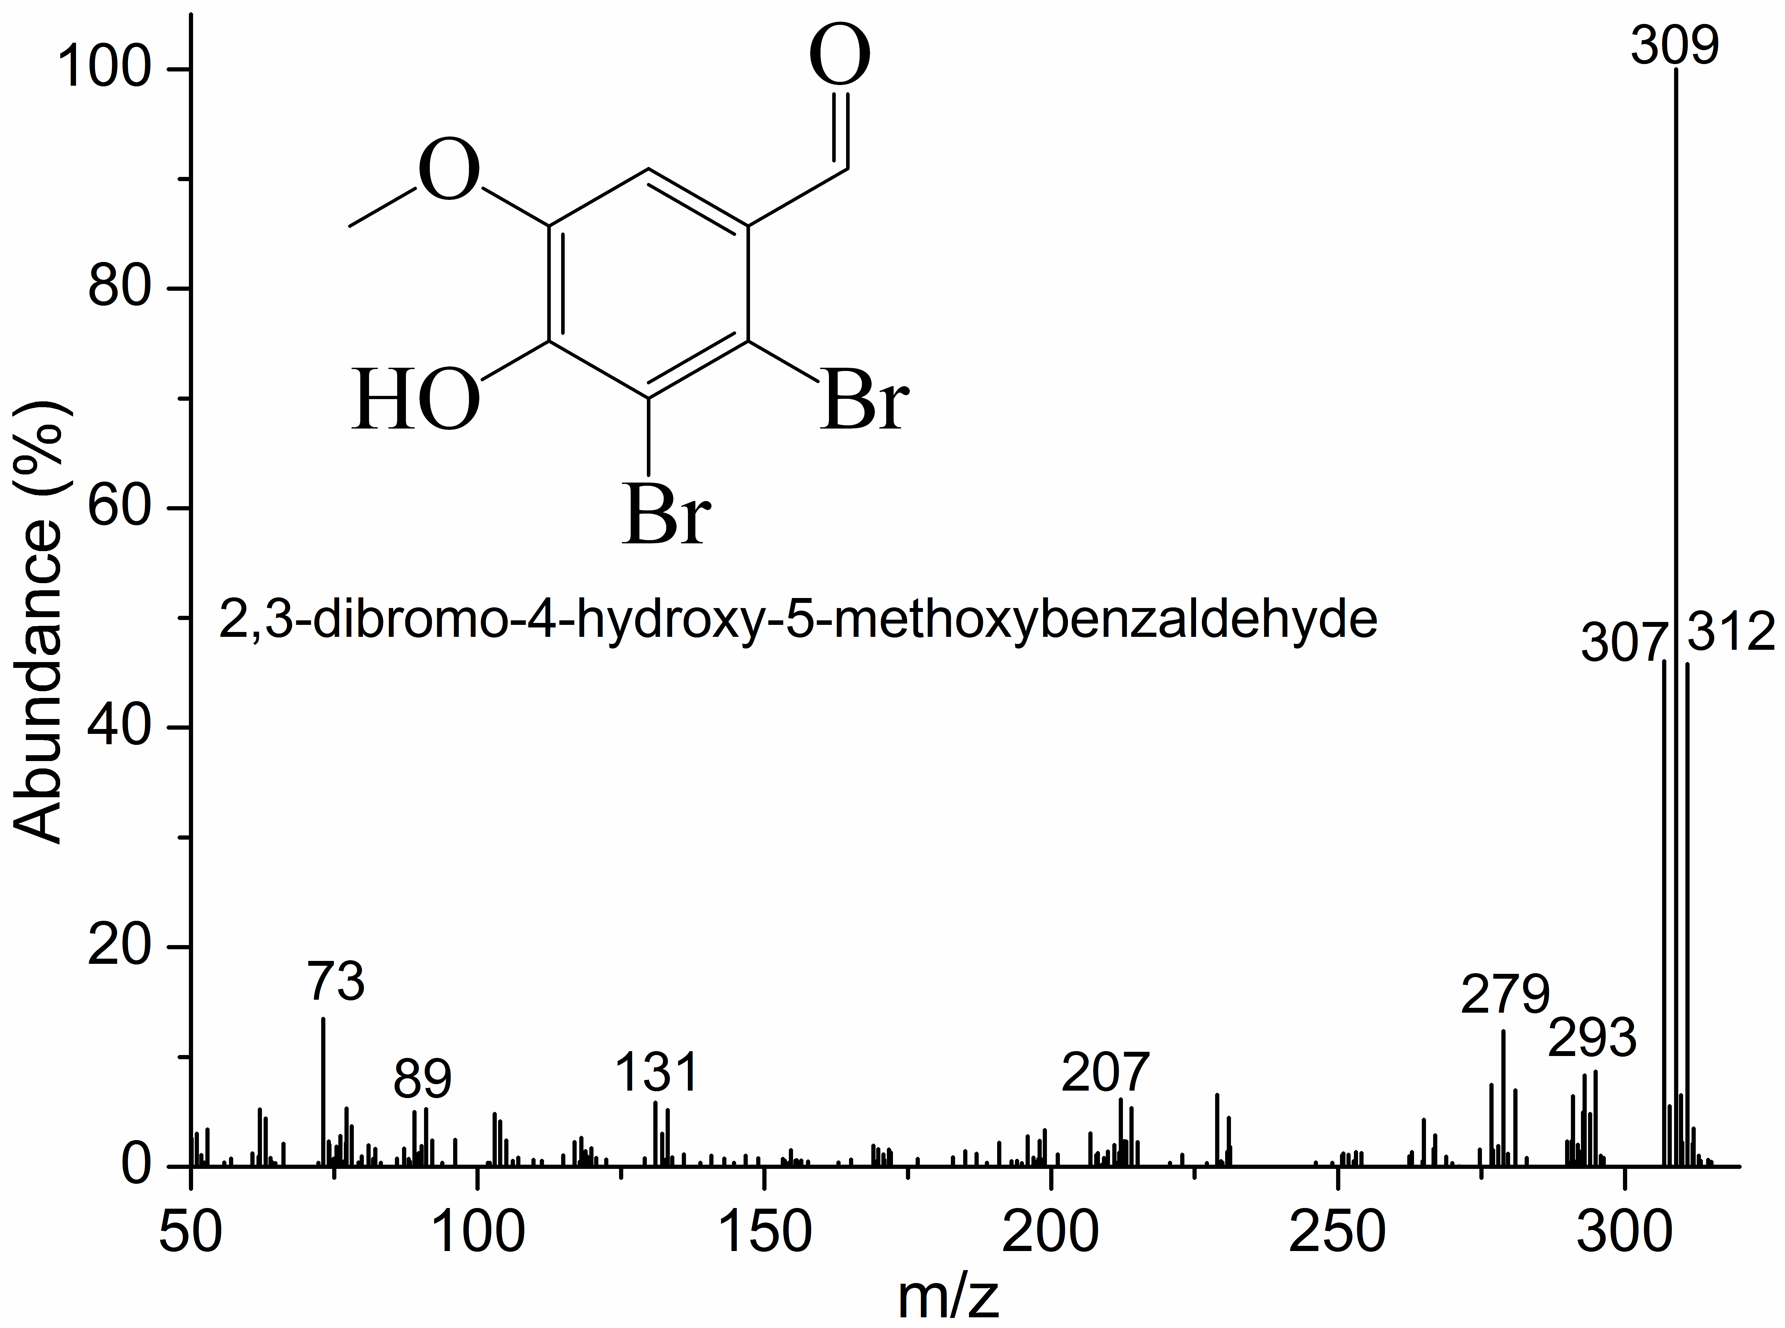
Product D: 2,3-dibromo-4-hydroxy-5-methoxybenzaldehyde

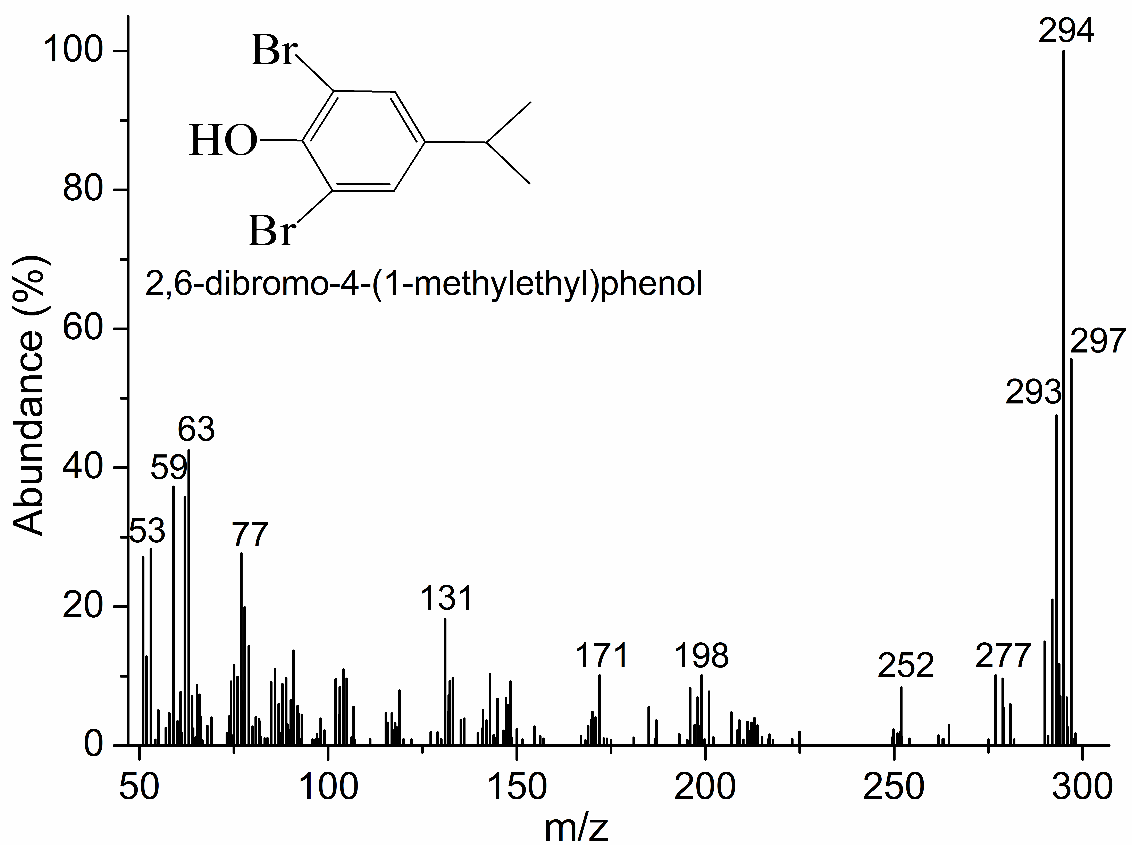
Product E: 2,6-dibromo-4-(1-methylethyl) phenol
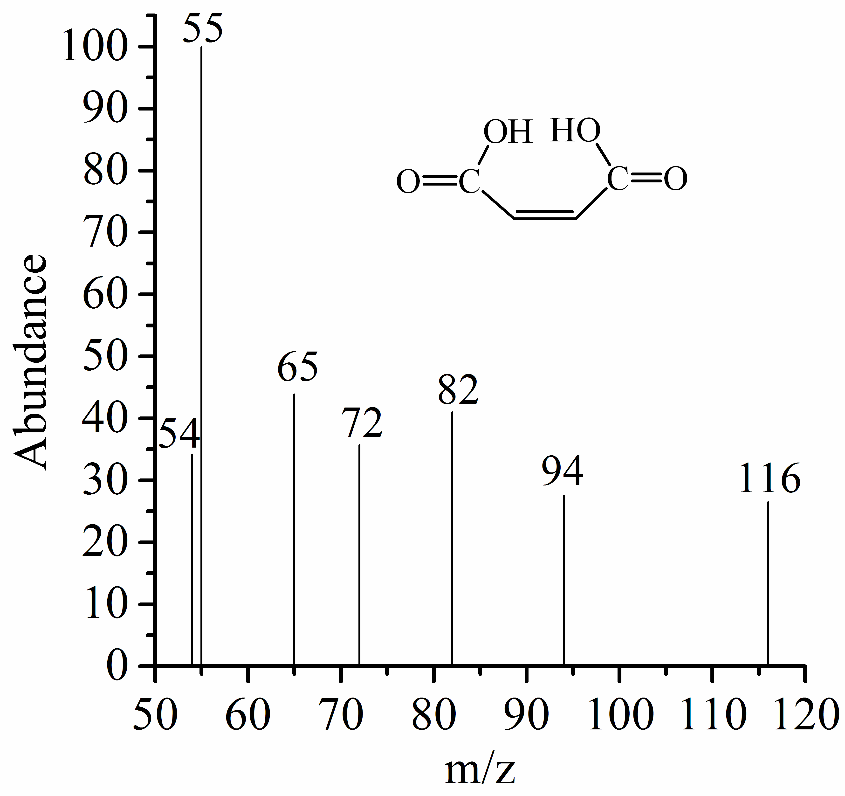
Product F: Maleic acid

Fig. S9. The GC-MS spectrums of determined intermediates

Table S2. Water quality parameters of Maozhou River after filtration
Water quality parameters | pH | UV254 (cm⁻¹) | TOC  (mg/L) | CO₃²⁻ (mg/L) | Cl⁻ (mg/L) | NO₃⁻ (mg/L) | PO₄³⁻ (mg/L) | NH₄⁺ (mg/L)
 | 7.11 | 0.020 | 7.25 | 98 | 18.55 | 13.48 | 4.25 | 1.52

