**Supplementary Information**

Cationic anticancer peptide L-K6 and doxorubicin dual-loaded MSN nanoparticles reverse multidrug resistance



**Suppl Fig. 1** The schematic illustration of MSN@L-K6@DOX preparation

**Suppl Fig.2** The particle hydrodynamic diameter (A) and DOX release (B) of MSN@L-K6@DOX after being dispersed in complete medium containing 10% FBS for 72 h.

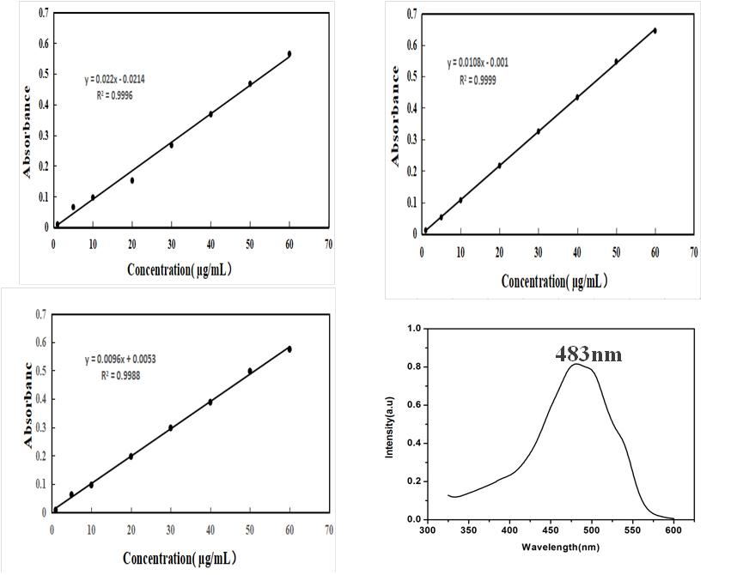

**Suppl Fig.3** DOX standard curve line at pH=（7.4, 6.8, 5.4) and the fluorscence emission spectra of DOX



**Suppl Fig. 4**  Microplate analysis of the cellular DOX uptake in MSNs treated MCF-7/ADR cells.

**Suppl Table 1** IC50 values of MCF-7 and MCF-7/ADR cells after DOX, MSN@DOX and MSN@L-K6@DOX exposure.

|  |  |  |  |
| --- | --- | --- | --- |
| **IC50 (μg/mL)** | **DOX** | **MSN@DOX** | **MSN@L-K6@DOX** |
| MCF-7/ADR |  | | |
| 24h | 244.44±4.96 | 57.41±2.32 | 32.46±1.49 |
| 48h | 240.15±7.48 | 47.18±3.12 | 28.96±1.69 |
| 72h | 243.23±7.93 | 46.87±2.17 | 26.66±1.45 |
| MCF-7 |  | | |
| 4h | 13.24±1.6 | 5.01±0.8 | 3.26±0.2 |
| 24h | 8.01±0.9 | 3.04±0.4 | 0.17±0.03 |