**Supporting Information**

**Chitosan/magnetic biochar composite with enhanced reusability: synergistic effect of functional groups and multilayer structure**

**Yongbo Yua,b, Wanting Liua,b, Yinuo Zhanga, Bolun Zhanga,b, Yiping Jina,b, Siji Chena,b, Shanshan Tanga,b,*, Yingjie Sua,b, Xiaoxiao Yua,b, Guang Chena,b**

a. College of Life Sciences, Jilin Agricultural University, Changchun 130118, China

b. Key Laboratory of Straw Comprehensive Utilization and Black Soil Conservation, Ministry of Education, Jilin Agricultural University, Changchun 130118, China

*Email: [tangshanshan81@163.com](mailto:tangshanshan81@163.com)

1. Reagents

K2Cr2O7, FeCl3·6H2O, FeSO4·7H2O, HCl, H2SO4, Ethanol absolute were procured from Beijing Chemical Works (Beijing, China). Chitosan, NaOH, disodium EDTA were obtained from Sinopharm Group Chemical Reagent Co., Ltd. (Shanghai, China). Diphenylcarbonyldihydrazide was sourced from Aladdin Chemical Co., Ltd. (Shanghai, China). All reagents were of analytical grade (AR) purity and required no further purification.

2. Characterization

The surface structures of the samples were visualized using a Zeiss Merlin scanning electron microscope (ZEISS, Germany) equipped with an energy dispersive spectroscopy (EDS) system (X-max, Oxford Instruments, UK). A transmission electron microscope (TEM) (JEOL JEM-2100F, Japan) was used to observe the structure of the composite material. X-ray diffraction (XRD) patterns were obtained using an Ultima IV diffractometer (Rigaku, Japan). Infrared (IR) spectra were recorded using a Nicolet iS5 Fourier Transform Infrared Spectrometer (FT-IR) (Thermo Fisher Scientific, USA). X-ray photoelectron spectroscopy (XPS) measurements were conducted using an Axis Ultra DLD spectrometer (Kratos Analytical Ltd., UK). Subsequently, N2 adsorption-desorption analysis was performed using an ASAP 2020 Plus instrument (Micromeritics, USA). Magnetic properties were determined using the Vibrating Sample Magnetometer 7404 (VSM) (LakeShore 7404, USA). Concentrations of heavy metals were analyzed using a UV-visible spectrophotometer (Agilent Cary UV-Vis).

3. Adsorption experiments

In the batch adsorption experiments, a certain quantity of MWSBC-0.5 sample was added to a flask containing 100 mL of Cr(VI) solution. The initial concentrations of the utilized adsorbents were 50, 100, and 150 mg L-1. The influence of various parameters such as the initial pH value (ranging from 1 to 7), biochar dosage (ranging from 0.1 to 1 g L-1), and contact duration (ranging from 0 to 24 h) on the adsorption behavior was examined. The pH value was adjusted using either HCl (0.1 M) or NaOH (0.1 M) solutions. During the adsorption kinetics experiments, 1 mL of the suspension was collected at specified intervals and subjected to centrifugation at 12,000 rpm. The resulting supernatant was collected and analyzed. The concentration of Cr(VI) was determined through diphenylcarbodihydrazide spectrophotometry (at 540 nm). All tests were conducted in triplicate.

The adsorption capacity of sample, *Q*e (mg g−1), was calculated through the equation below:

$Q_{e}=\frac{V\left(C_{0}-C_{e}\right)}{m}$ (1)

Where *C*e (mg L-1), *C*0 (mg L-1) and *V* (L) are the equilibrium concentration, initial concentration and volume of the Cr(VI) solution, respectively, and *m* (g) denotes the mass of MWSBC-C.

3.1 Adsorption kinetic

The effect of contact time on the Cr(VI) adsorption capacity of MWSBC-0.5 was investigated by pseudo-first-order, pseudo-second-order, Bangham and intraparticle diffusion kinetic models (Equations 2-5).

$Q_{t}=Q_{e}\left(1-e^{-k_{1 }t}\right)$ (2)

$Q_{t}=\frac{k_{2}Q_{e}^{2}}{\left(1+k_{2}Q_{e}t\right)}$ (3)

$Q_{t}=Q_{e}\left(1-e^{-t^{n}k_{b}}\right)$ (4)

$Q_{t}=k_{1}t^{0.5}+C$ (5)

Where *Q*t (mg g-1) is the adsorption capacity of MWSBC-C to Cr(VI) at different contact time (t, min). *k*1 (min-1), *k*2 (g mg-1 min-1), *k*I (mg g-1 min-1/2), and *k*b (min1/n) denote the rate constants of different kinetic models, respectively. *C* is the intercept.

3.2 Adsorption isotherms

Cr(VI) solutions with different initial concentrations (20, 40, 60, 80 and 100 mg L-1) were used to test the adsorption isotherms at 288K, 303 K and 318K. The sorption isotherm data were investigated using the Langmuir isotherm model (Equation 6) and Freundlich isotherm model (Equation 7) ,which are containing two parameters, and the Sips isotherm model (Equation 8) and the Dubinin-Radushkevich (D-R) isotherm model (Equation 9), which are with three parameters.

$Q_{e}=\frac{Q_{m}K_{L}C_{e}}{1+K_{L}Cⅇ}$ (6)

$Q_{e}=K_{F}C_{e}^{1∕n_{F}}$ (7)

$Q_{e}=\frac{Q_{m}K_{S}C_{e}^{n_{s}}}{1+K_{s}C_{e}^{n_{s}}}$ (8)

$Q_{e}=Q_{m}-R^{e^{{-K}_{DR}ε^{2}}}$ (9)

Where *Q*m (mg g-1) is the maximum adsorption capacity of the sample calculated by the adsorption isotherm model. *K*L(L mg−1), *K*F (mg g−1(L mg−1)1/n), *K*s ((mg L−1)−n) and *K*DR (mol2 kJ-2) denote the adsorption isotherm constants for different models. *n*F is heterogeneity factor, *n*S is the Sips constant, and *ε* (kJ mol-1) is the adsorption potential based on the Polanyi potential theory.

3.3 Adsorption thermodynamics

The thermodynamic changes of Cr(VI) adsorption on MWSBC-C during the adsorption process at 293 K, 303 K and 313 K were investigated. The standard entropy change (Δ*S*, J mol-1 K-1), heat of adsorption (Δ*H*, kJ mol-1) and Gibbs free energy of adsorption (Δ*G*, kJ mol-1) were measured based on the following equations.

$ln\left(\frac{Q_{e}}{C_{e}}\right)=\frac{ΔS}{R}-\frac{ΔH}{RT}$ (10)

Δ*G =* Δ*H − T*Δ*S* (11)

where *T* is the temperature (K), and *R* is the gas constant (8.314 J mol-1 K-1).

3.4 Coexisting cations and ionic strength

Three different cations and anions with concentrations of 0.01 mol L-1 were chosen as model ions (K+ , Zn2+, Mg2+, , and ) and the variation of the adsorption capacity of MWSBC-0.5 in different coexisting ions was investigated. In addition, in the ionic strength experiments, NaCl was the model ion and the concentrations were chosen as 0.001, 0.01, 0.1 and 0.5 mol L-1. The above experiments were carried out at 303 K with the rotational speed set at 160 rpm and the pH value =5 of the prepared Cr(VI).

3.5 Reusability experiments

Reusability experiments were conducted through elution to regenerate the samples. Elutes such as 1 mol L-1 NaOH, 1 mol L-1 HCl, ethanol, and 0.01 mol L-1 EDTA were selected for the MWSBC-0.5 elution process. Subsequently, the eluted sample was thoroughly rinsed with ample amounts of deionized water, passed through an extraction device, dried, and ready for the subsequent cycle. The initial concentration of Cr(VI) was 50 mg L-1, the quantity of biochar was 0.5 g L-1, the temperature was maintained at 303 K, and the pH value remained unadjusted, reflecting the natural pH (pH value = 5) of the solution.

3.6 Removal of low concentration of Cr(VI)

In the low concentration Cr(VI) removal experiments, a 5 mg L-1 concentration of Cr(VI) solution was selected, the adsorbent dosing amount was 0.5 g L-1, the temperature was 303 K, and the pH value was the natural pH (pH value = 5) of the solution without further adjustment.

3.7 Fixed-bed column experiment

In order to simulate the industrial treatment of heavy metals, a simple fixed-bed experiments were conducted. The experimental setup consisted of a glass tube with an inner diameter of 2 cm and a height of 20 cm. The fixed bed experiment was performed at a temperature of 298 K. Approximately 0.3 g of sample was introduced into the glass tube, resulting in a bed height of approximately 4 mm. The adsorbent layer was positioned on a pre-embedded ceramic substrate. The concentration of the Cr(VI) solution used in the experiment was 20 mg L-1, and the flow rate was set at 5 mL min-1, which was regulated using a peristaltic pump. The effluent was assessed at various time intervals, with *C*t/*C*0 values of 10% and 90% serving as indicators of breakthrough and saturation, respectively. The Yoon-Nelson and Adam-Bohart models were employed to analyze the experimental data and elucidate the fixed bed adsorption characteristics.

The nonlinear form of the Yoon-Nelson (Equation 12) and Adam-Bohart (Equation 13) model was expressed as：

$\frac{C_{t}}{C_{0}}=\frac{1}{1+\exp^{k\left(t-A\right)}}$ (12)

$\frac{C_{t}}{C_{0}}=\frac{1}{1+exp⁡[K_{ab}C_{0}\left(\frac{ZN_{0}}{UC_{0}}-t\right)]}$ (13)

where *C*t is the concentration at different time points t, *C*0 is the initial concentration, *k* (mg L-1 min-1) is the rate constant for the Yoon-Nelson model, A (min) is the time required for contaminant penetration to reach 50%. *k*ab (L mg-1 min-1) is the rate constant for the Adam-Bohart model. Z (cm) is the height of the bed, *N*0 (mg L-1) is the adsorption capacity of adsorbent per unit volume of bed, and *U* (cm min-1) is the linear velocity.



**Fig. S1.** Optimization of conditions for different chitosan loadings.

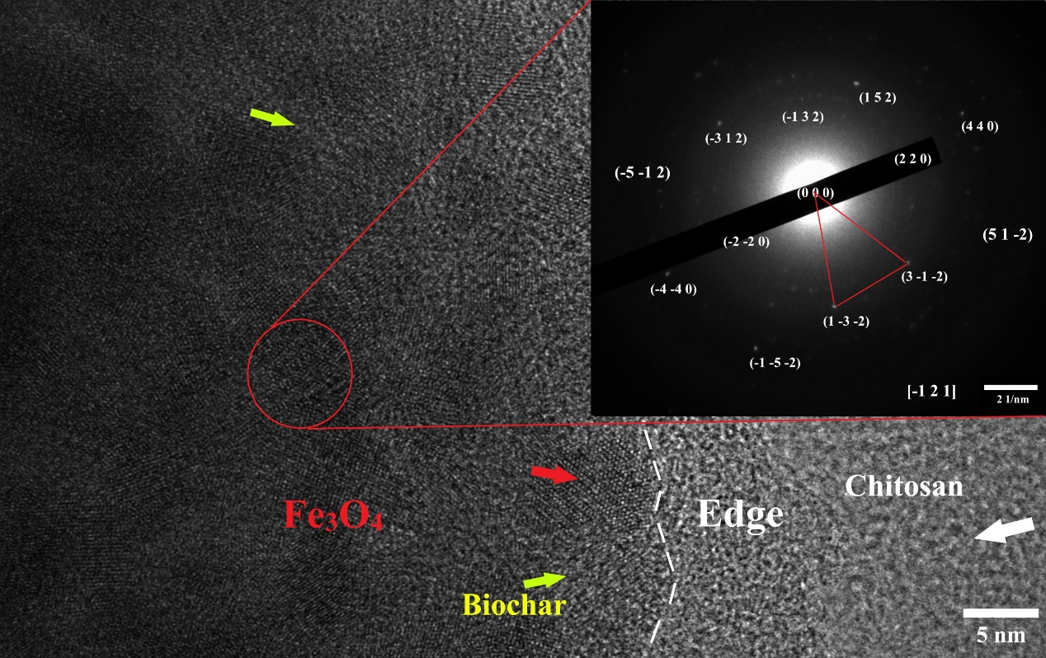

**Fig. S2.** TEM and SAED of MWSBC-0.5



**Fig. S3.** EDS element analysis of WSBC and MWSBC-0.5.

 **Fig. S4.** XPS spectra of MWSBC before and after adsorption of Cr(VI) (a) full spectrum, (b) high-resolution XPS spectrum of Cr2p.



**Fig. S5**. The pHPZC after HCl elution of MWSBC-0.5.

**Table S1** EDS elemental analysis data of WSBC and MWSBC-0.5.

|  |  |  |
| --- | --- | --- |
| Element | At% | |
| WSBC | MWSBC-0.5 |
| C | 92.56 | 77.6 |
| N | - | 3.05 |
| O | 6.24 | 16.5 |
| K | 1.6 | - |
| Fe | - | 2.85 |

**Table S2** N2 adsorption-desorption data of WSBC, MWSBC and MWSBC-0.5.

|  |  |  |  |  |
| --- | --- | --- | --- | --- |
| Adsorbent | *S*BET (m2 g-1) | *V*mic (cm3 g-1) | *V*totol (cm3 g-1) | Pore size (nm) |
| WSBC | 8.80 | 0.0015 | 0.0089 | 4.03 |
| MWSBC | 3.01 | 0.0020 | 0.0022 | 2.89 |
| MWSBC-0.5 | 0.91 | 0.0002 | 0.0002 | 0.90 |

**Table S3** Relative content of each element in XPS of MWSBC and MWSBC-0.5.

|  |  |  |
| --- | --- | --- |
| Element | At % | |
| MWSBC | MWSBC-0.5 |
| C1s | 79.84 | 66.82 |
| O1s | 18.17 | 27.23 |
| Fe2p | 1.03 | 0.29 |
| N1s | 0.68 | 5.66 |

**Table S4** Elemental analysis of MWSBC-0.5.

|  |  |
| --- | --- |
| Element | wt% |
| MWSBC-0.5 |
| C | 46.885  6.567  5.898  0 |
| H |
| N |
| S |

**Table S5** MWSBC-0.5 fixed bed experimental parameters

|  |  |  |  |
| --- | --- | --- | --- |
| Sample | model | Constants | |
|  | 298 K |
| MWSBC-0.5 | Yoon-Nelson | *k* (mg L-1 min-1) | 0.01 |
| *A* (min) | 120 |
| *R*2 | 0.926 |
| Adam-Bohart | *k*ab (L mg-1 min-1) | 8.66 |
| *N*0 (mg L-1) | 104.97 |
| *R*2 | 0.707 |