**Supporting information**

**Highly efficient remediation of chlorpyrifos and malachite green by an SBA-15 incorporated guar gum-grafted-poly (acrylic acid)/cobalt ferrite matrix for water purification**

Mohammad Mehdi Salehia,1, Kimia Rajabi a,1, Fereshteh Hasanzadeh-Afruzia,1,Fatemeh Ganjalia,1, Ali Malekia,*, Ehsan Nazarzadeh Zareb,*

a Catalysts and Organic Synthesis Research Laboratory, Department of Chemistry, Iran University of Science and Technology, Tehran 16846-13114, Iran.

b School of Chemistry, Damghan University, Damghan 36716-45667, Iran

*Corresponding author. E-mail: [maleki@iust.ac.ir](mailto:maleki@iust.ac.ir) (A. Maleki); [ehsan.nazarzadehzare@gmail.com](mailto:ehsan.nazarzadehzare@gmail.com); e.nazarzadeh@du.ac.ir (E.N.Zare)

1These authors contributed equally to this work.

*Author’s ORCIDs:*

*Mohammad Mehdi Salehi: https://orcid.org/0000-0003-3648-1865*

*Fereshteh Hasanzadeh-Afruzi:* [*https://orcid.org/0000-0003-0570-2506*](https://orcid.org/0000-0003-0570-2506)

*Fatemeh Ganjali: https://orcid.org/0000-0002-2594-2761*

*Ali Maleki:* [*https://orcid.org/0000-0001-5490-3350*](https://orcid.org/0000-0001-5490-3350)

|  |  |
| --- | --- |
| **Content** | **Page** |
| **Figure S1.** Calibration curve of chlorpyrifos. | **S2** |
| **Figure S2.** Calibration curve of malachite green. | **S3** |
| Calculation of how to prepare 0.1 M NaOH. | **S4** |
| Calculation of how to prepare 0.1 M HCl. | **S5** |
| Calculation of how to prepare 100 mg/L of the MG. | **S6** |
| Calculation of how to prepare 100 mg/L of the CPF. | **S7** |
| **Table S1.** Zeta potential measurements for the synthesized SBA-15-GG-*g*-PAA/CoFe2O4 mesoporous adsorbent at various pH (4, 5, 6, 7, 8, and 9). | **S8** |

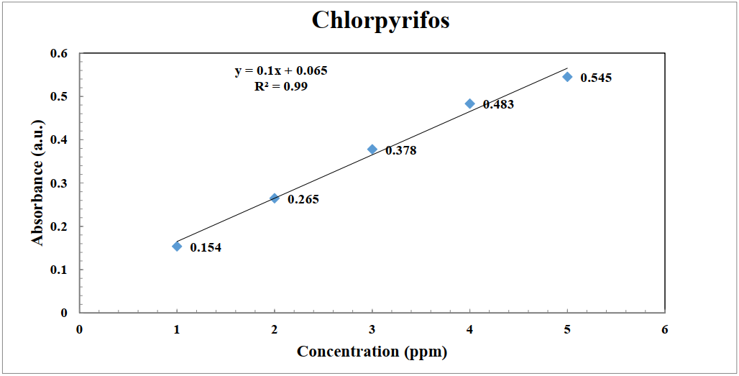**Fig. S1.** Calibration curve of chlorpyrifos.

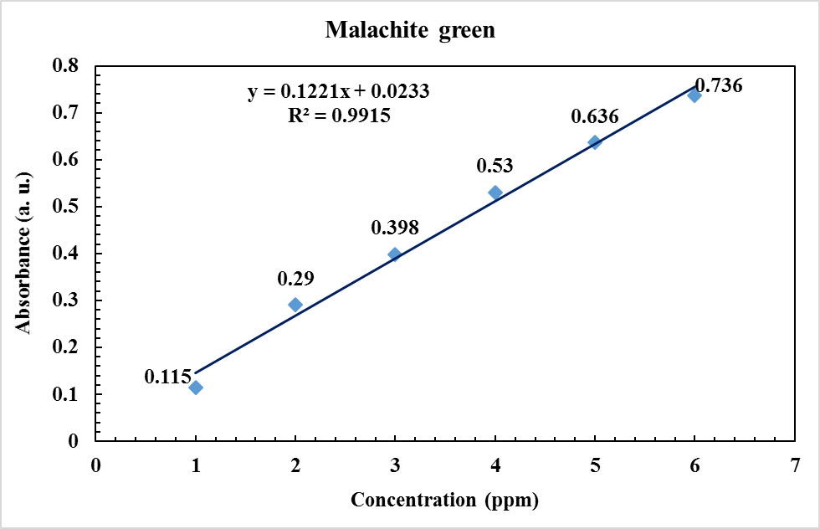

**Fig. S2.** Calibration curve of malachite green.

**Calculation of how to prepare 0.1 M NaOH :**

$g= C_{M}×M ×V \left(L\right)$ (1)

In Eq.1: (*g*) represents the amount of the desired solid substance in grams, which is unknown, (*CM*) represents Molarity, (M) represents the molecular mass of the desired solid, and (*V*) represents the desired volume in liters.

**Preparation of 100 mL solution containing 0.1 M NaOH by Eq. 1:**

$g= C_{M}×M ×V (L)$ 0.1 $×$ 40 $×$ 100/1000= 0.4 g of NaOH

(The M.W. of NaOH is 40 g/mol), Then, we weigh the amount of 0.4 g NaOH and add it to the volume of 100 in a flask.

**Calculation of how to prepare 0.1 M HCl:**

$C_{m}= \frac{10 ad}{M}$ (2)

In Eq. 2, (*a*) represents the percentage of purity, (*d*) represents the density, and (*M*) represents the molecular weight.

Molar: 0.1

Balloon: 100 mL

Density: 1.19 g/mL

Weight percentage: 37%

Molecular mass: 36.5 g/mol

**Preparation of 100 mL of solution containing 0.1 M HCl by Eq. 2:**

Cm = 10 $×$ 37 $×$ 1.19 / 36.45 = 11.97 mL

*Cm1V1* = *Cm2V2*

11.97 *V1*= 0.1 100 = 0.835 mL

**Calculation of how to prepare 100 mg/L of the MG:**

ppm =  106  orMass of solute (g) = $\frac{100 ppm × Mass of solvent (g)}{{10}^{6}}$ (3)

1 ppm = 1 mg so 1000 ppm = 100 mg so 1000 g = 1000000 mg

Mass of solute (g) = $\frac{100 ppm × 1000000 (g)}{{10}^{6}}$ = 100 mg

Then, we weigh the amount of 100 mg of MG and add it to the volume of 100 in a flask.

**Calculation of how to prepare 100 mg/L of the CPF:**

$C_{m}= \frac{10 ad}{M}$ (2)

In Eq. 2, (*a*) represents the percentage of purity, (*d*) represents the density, and (*M*) represents the molecular weight.

Balloon: 100 mL

Density: 1.4 g/mL

Weight percentage: 40.8%

Molecular mass: 350.59 g/mol

**Preparation of 100 mL solution containing 100 mg/L CPF by Eq. 2:**

Cm = 10 $×$ 40.8 $×$ 1.4 / 350.59 = 1.62 mL

*Cm1V1*= *Cm2V2*

1.62 V1 = 100 100 mL = 6.25 mL

**Table S1.** Zeta potential measurements for the synthesized SBA-15-GG-*g*-PAA/CoFe2O4 mesoporous adsorbent at various pH (4, 5, 6, 7, 8, and 9).

|  |  |  |  |  |  |  |
| --- | --- | --- | --- | --- | --- | --- |
| **pH**  **Run** | **4** | **5** | **6** | **7** | **8** | **9** |
| **1** | **-8.1 mV** | **-9.6 mV** | **-12.9 mV** | **-17.1 mV** | **-26.0 mV** | **-27.5 mV** |
| **2** | **-7.6 mV** | **-10.1 mV** | **-14.5 mV** | **-16.8 mV** | **-25.9 mV** | **-26.1 mV** |
| **3** | **-7.2 mV** | **-9.8 mV** | **-13.8 mV** | **-16.7 mV** | **-25.6 mV** | **-25.9 mV** |
| **Average of 3 runs for zeta potential** | **-7.63 mV** | **-9.83 mV** | **-13.73 mV** | **-16.86 mV** | **-25.83 mV** | **-26.5mV** |