**Supplementary File**

**Degradation of ribavirin by Fe2+/PS oxidation technology: performance, mechanism and toxicity control**

Xiaohui Sun a, b, Wei Li c, Zijun Dong a, b, *, Yunhe Hou c, Yuyang Ning c, Chenyu Wang d, *, Guo Lv a

a College of Civil and Transportation Engineering, the Underground Polis Academy, Shenzhen University, Shenzhen, 518060, China

b State Key Laboratory·of Intelligent Geotechnics and Tunnelling(Shenzhen University),Shenzhen, 518060, China

c Shenyang Jianzhu University, College of Municipal and Environmental Engineering, Shenyang 100168, China

d Jiangsu Collaborative Innovation Center of Atmospheric Environment and Equipment Technology (CICAEET), Jiangsu Key Laboratory of Atmospheric Environment Monitoring and Pollution Control, School of Environmental Science and Engineering, Nanjing University of Information Science & Technology, Nanjing 210044, China

*Corresponding author at:

E-mail address: dongzijun@szu.edu.cn (Z. Dong).

E-mail address: wangchenyu@nuist.edu.cn (C. Wang).

**Contents**

**Additional Texts:**

**Text S1.** Detection of the transformation products of ribavirin during Fe2+/PS process.

**Text S2.** The ISO standard luminescent bacteria toxicity test.

**Text S3.** Calculation of reaction stoichiometric efficiency.

**Additional Figures:**

**Fig. S1.** Chromatogram of ribavirin degradation products.

**Fig. S2.** Mass spectrums of four degradation products

**Fig. S3.** Chromatogram of ribavirin in ultra high performance liquid phase.

**Fig. S4.** Chromatograms of TMSO and TMSO2 in ultra-high performance liquid chromatography.

**Fig. S5.** Removal of TOC in the PS/Fe2+ system.

**Fig. S6.** Changes in pH in different pH systems. pHi is the initial pH of the system;pHPS is the pH after the addition of PS; pH is the pHf after one hour of reaction.

**Additional Tables:**

**Table S1.** %RSE in different PS systems.

**Text S1.** Detection of the transformation products of ribavirin during Fe2+/PS process.

LC-MS analysis was performed on an Agilent 1290 Infinity II Ultra-High Performance Liquid Chromatograph (UHPLC) equipped with a Quadrupole Time-of-Flight (QTOF) system (TRIPLETOF 4600, AB SCIEX, USA).The chromatographic separation was carried out using Waters ACQUITY UPLC HSS T3 C18 column (4.6 mm × 150 mm, 5 μm; Waters Corporation, Milford, MA, USA). The UV detection of UHPLC fractions were performed by U3000 3D field DAD detector with wavelength coverages from 200nm to 400nm. The analytical column was maintained at 30°C with an injection volume of 3μL.Gradient elution was performed with a gradient containing pure water (solvent A) and methanol (solvent B).The flow rate was 0.3 ml/min, and gradient elution was as follow: 0-7min, 10-90% B; 7-8min, 90%-90% B; 8-8.1min, 90%-10% B; 8.1-10min, 10%-10% B.Positive ion mode in the range of m/z 50-750 was set for the MS analysis.Other mass spectrometry conditions were source temperature (TEM) 500 ℃, spray voltage (IS) 4500 V, curtain gas (CUR) 35 psi, nebulizer gas (GS1) 50 psi, heating gas (GS2) 50 psi, and collision energy(CE) 10 V.The identification of unknown compound was performed by Compound discover 241, 211, 198, and 147, with mzcloud and mzVault databases.

A syringe was used to draw 1mL of sample from the system, which was filtered using a polyethersulfone membrane into a 2mL brown injection bottle and injected（Same as UHPLC sample preparation）.

**Text S2.** The ISO standard luminescent bacteria toxicity test.

In this study, Vibrio fischeri (Microtox® SOLO reagent) luminescent bacteria were selected for the determination of bioacute toxicity of the samples in the reaction.First, resuscitate the luminescent bacteria: take a bottle of Microto® SOLO reagent and add 300 µL of Microtox dilution solution, mix the reagent 3~4 times with a 300 µL pipette gun, and then leave it for 15 min to form a resuscitation solution.100 µL of recovery solution was placed in the cuvette, then 900 µL of the sample to be tested and 100 µL of Microtox osmolality adjusting solution were added to the cuvette, mixed, and then quickly tested on the machine and readings were recorded. It should be noted that the pH of the sample for toxicity testing needs to be controlled at 6~8. If the pH of the sample is lower than 6, use NaOH solution to adjust the pH to 6.0, if the pH of the sample is higher than 8, use HCl solution to adjust the pH to 8.0, and if it is over-titrated, the sample should be discarded and re-adjusted.

**Text S3.** Calculation of reaction stoichiometric efficiency.

Reaction stoichiometric efficiency (RSE) is the number of moles of RBV degradation over the number of moles of PS consumed, as shown in Eq. (S1).It is a crucial parameter to evaluate the catalyst per formance.

|  |  |
| --- | --- |
| $$\%RSE=\frac{∆n(RBV)}{∆n(PS)}×100$$ | (S1) |

Herein, Δn(RBV) is the number of moles of ribavirin degradation; Δn(PS) is the number of moles of PS consumed.

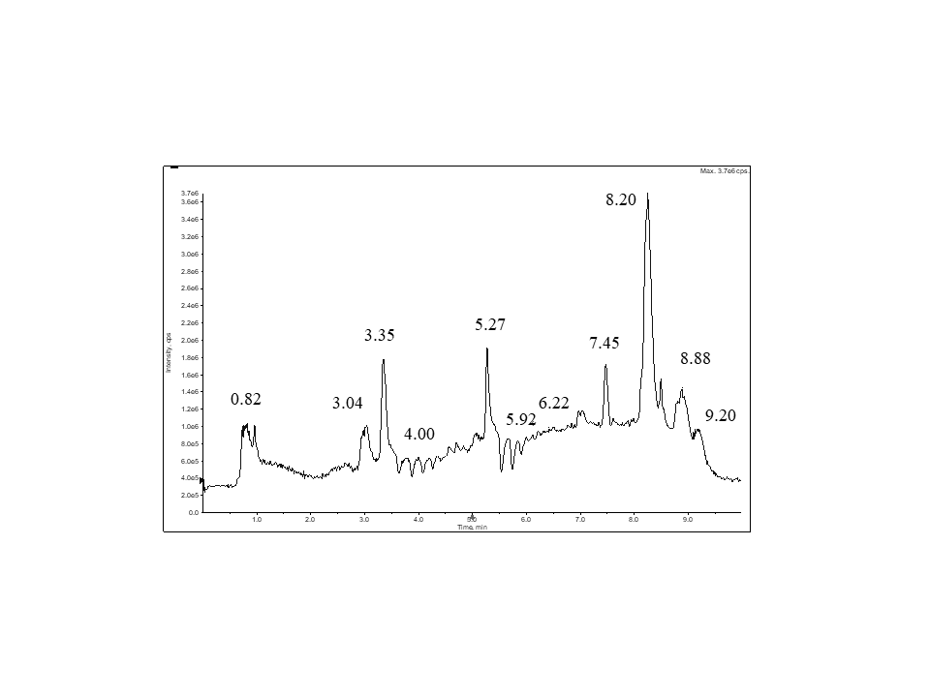

**Fig. S1.** Chromatogram of ribavirin degradation products.

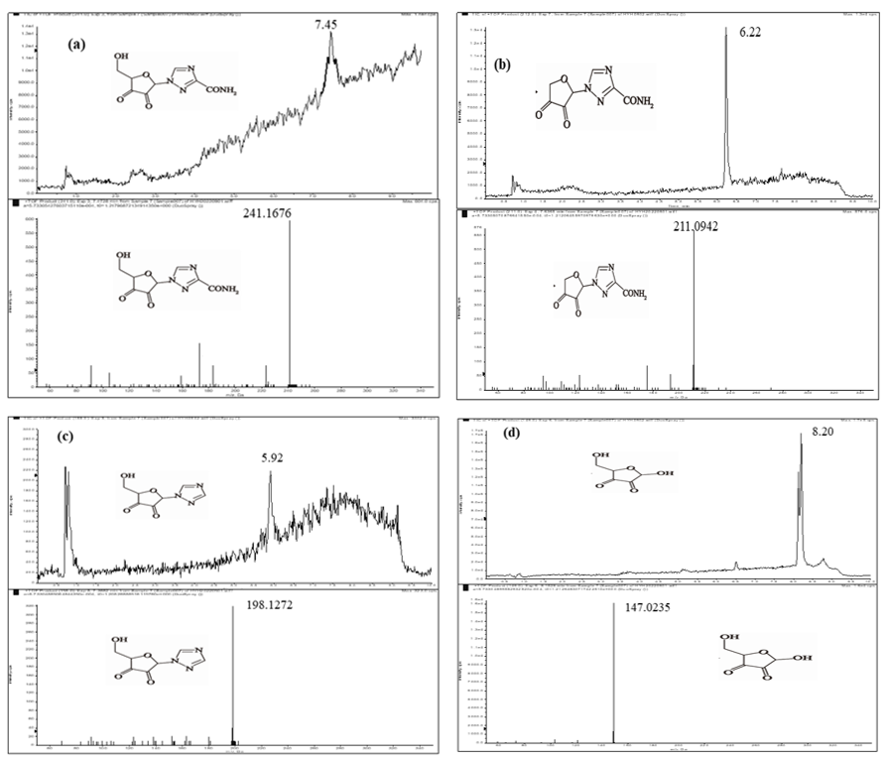

**Fig. S2.** Mass spectrums of four degradation products

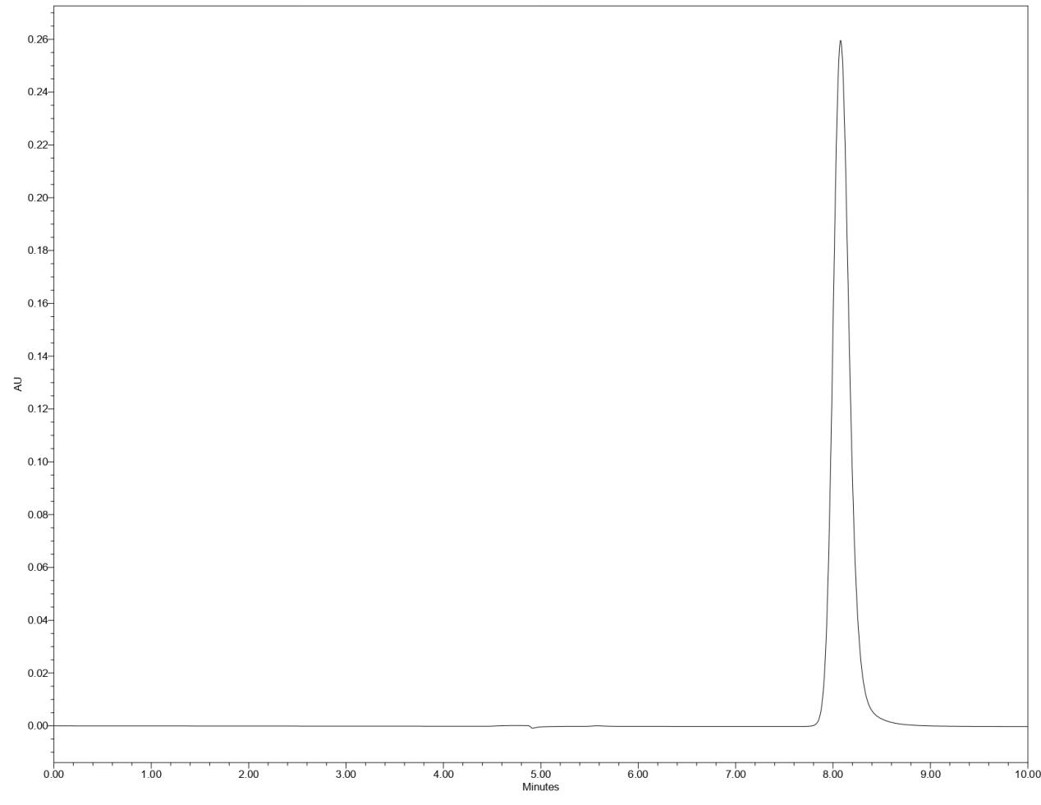

**Fig. S3.** Chromatogram of ribavirin in ultra high performance liquid phase.

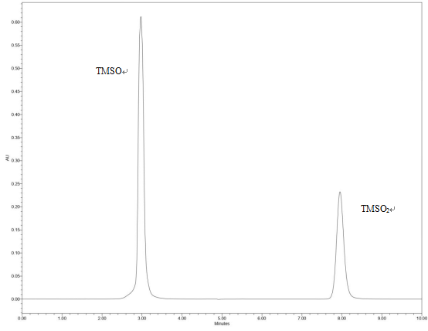

**Fig. S4.** Chromatograms of TMSO and TMSO2 in ultra-high performance liquid chromatography.

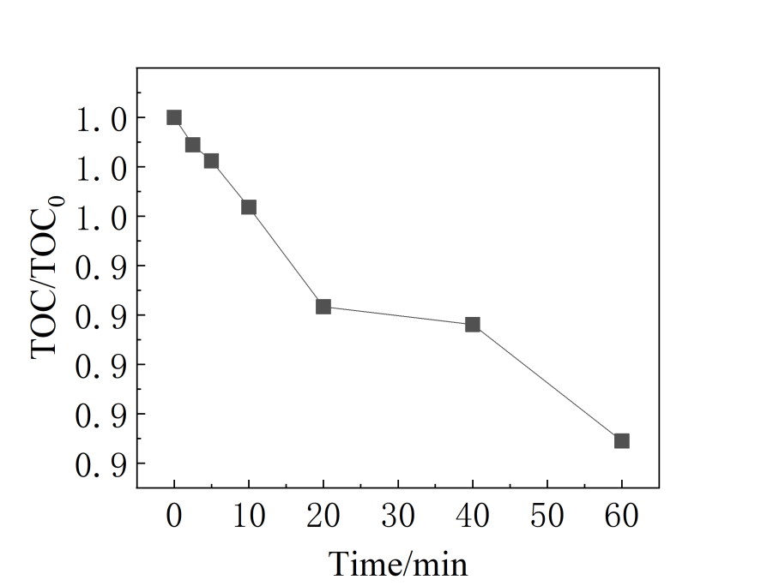

**Fig. S5.** Removal of TOC in the PS/Fe2+ system.

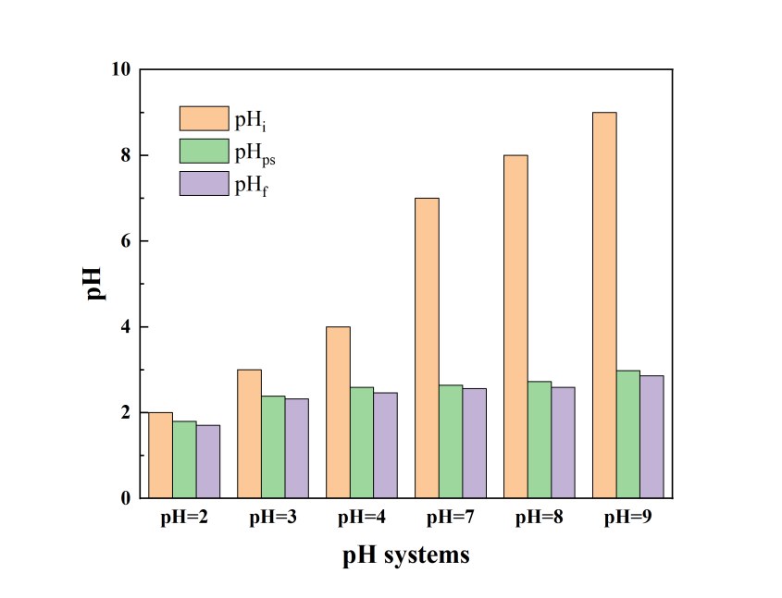

**Fig. S6.** Changes in pH in different pH systems. pHi is the initial pH of the system;pHPS is the pH after the addition of PS; pH is the pHf after one hour of reaction.

**Table S1.** %RSE in different PS systems.

|  |  |  |  |  |
| --- | --- | --- | --- | --- |
| Activation  method | PS/PMS  dosage  (mmol/L) | Pollutants | %RSE | Reference |
| Fe2+ | 1.0 | sulfamethoxazole | 5.55% | (Ayoub and Ghauch, 2014) |
| Fe0 | 1.0 | sulfamethoxazole | 5.20% | (Ayoub and Ghauch, 2014) |
| nZVI/RS500 | 2.0 | monochlorobenzene | 4.10% | (Yang et al., 2020) |
| thermal (T =60 ◦C) | 2.0 | ketoprofen | 1.55% | (Amasha et al., 2018) |
| N, S-doped porous carbons | 8 | tetracycline | 1.50% | (Huo et al., 2020) |
| UV | 0.5 | chloramphenicol | 24% | (Ghauch et al., 2017) |

**Reference**

Amasha, M., Baalbaki, A., Ghauch, A., 2018. A comparative study of the common persulfate activation techniques for the complete degradation of an NSAID: The case of ketoprofen. Chemical Engineering Journal 350, 395–410. https://doi.org/10.1016/j.cej.2018.05.118

Ayoub, G., Ghauch, A., 2014. Assessment of bimetallic and trimetallic iron-based systems for persulfate activation: Application to sulfamethoxazole degradation. Chemical Engineering Journal 256, 280–292. https://doi.org/10.1016/j.cej.2014.07.002

Ghauch, A., Baalbaki, A., Amasha, M., El Asmar, R., Tantawi, O., 2017. Contribution of persulfate in UV-254   nm activated systems for complete degradation of chloramphenicol antibiotic in water. Chemical Engineering Journal 317, 1012–1025. https://doi.org/10.1016/j.cej.2017.02.133

Huo, X., Zhou, P., Zhang, J., Liu, Yunxin, Cheng, X., Liu, Yang, Li, W., Zhang, Y., 2020. N, S-Doped porous carbons for persulfate activation to remove tetracycline: Nonradical mechanism. Journal of Hazardous Materials 391, 122055. https://doi.org/10.1016/j.jhazmat.2020.122055

Yang, L., Chen, Y., Ouyang, D., Yan, J., Qian, L., Han, L., Chen, M., Li, J., Gu, M., 2020. Mechanistic insights into adsorptive and oxidative removal of monochlorobenzene in biochar-supported nanoscale zero-valent iron/persulfate system. Chemical Engineering Journal 400, 125811. https://doi.org/10.1016/j.cej.2020.125811

Wu, X., Zhang, J., Hu, S., Zhang, G., Lan, H., Peng, J., Liu, H., 2022. Evaluation of degradation performance toward antiviral drug ribavirin using advanced oxidation process and its relations to ecotoxicity evolution. Science of The Total Environment 850, 157851. https://doi.org/10.1016/j.scitotenv.2022.157851

Liu, X., Hong, Y., Ding, S., Jin, W., Dong, S., Xiao, R., Chu, W., 2021. Transformation of antiviral ribavirin during ozone/PMS intensified disinfection amid COVID-19 pandemic. Science of The Total Environment 790, 148030. https://doi.org/10.1016/j.scitotenv.2021.148030