**Supporting Information**

**Photothermal-triggered release of alkyl radicals hydrogel via versatile carbon dots chelating Ag+ and its synergistic anti-bacterial and biofilm activities**

*Wen Liua,b,d*, Baizhi Sub, Hua Songb, Xueyun Zhangb, Guodong Renb, Xuewei Wangb, Lili Yanb,d, Sufang Mab, Lihong Lib,d, Lixia Guoc, Shuming Xue, Boye Zhangb, Haipeng Diaob,d*, Zhifang Wua, Sijin Lia, Chengwu Zhangb*

a The First Hospital of Shanxi Medical University, The First Clinical Medical School of Shanxi

Medical University, Taiyuan 030001, P.R. China

b School of Basic Medical Sciences, Shanxi Medical University, Taiyuan 030001, P.R. China

c college of pharmacy, Shanxi Medical University, Taiyuan 030001, P.R. China

d Key Laboratory of Cellular Physiology at Shanxi Medical University, Ministry of Education,

Taiyuan 030001, P. R. China

e Women health center of Shanxi, Taiyuan 030013, P.R. China

* Corresponding authors.

E-mail addresses: [liuwen@sxmu.edu.cn](mailto:liuwen@sxmu.edu.cn) (W. Liu), [diaohp@sxmu.edu.cn](mailto:diaohp@sxmu.edu.cn) (H. Diao)

**Fig.S1-Fig.S10**

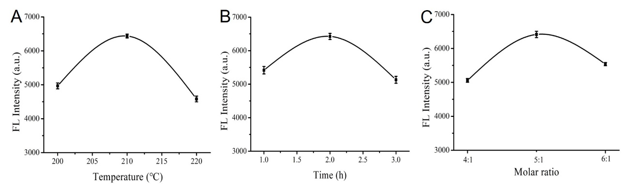

**Fig. S1.** Fluorescence intensity of PTCDs under different synthesis conditions. (A) different reaction temperatures; (B) different reaction times; (C) the molar ratio of different reactants.

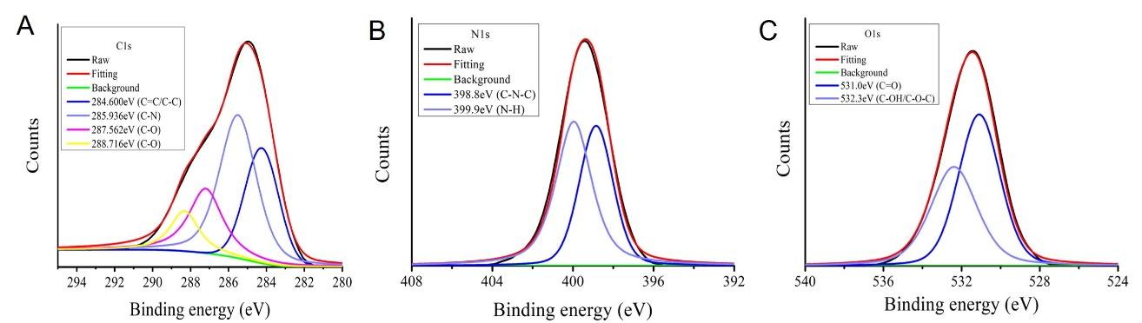

**Fig. S2.** The high resolution C1S XPS spectrum (A), N1S XPS spectrum (B) and O1S XPS spectrum (C).

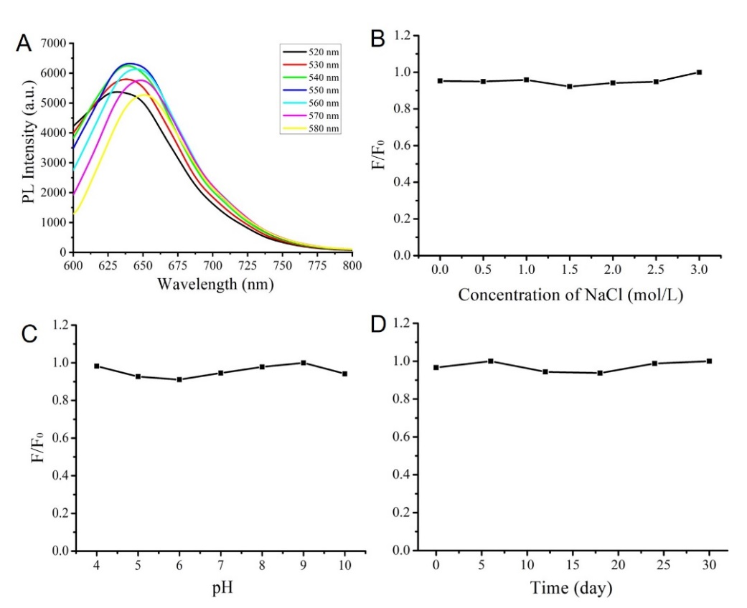

**Fig. S3.** (A) Fluorescence emission spectra of PTCDs at different excitation wavelengths; (B) Effect of ionic strength (NaCl) on fluorescence intensity of PTCDs; (C) Effect of different pH on fluorescence intensity of PTCDs; (D) The time-dependence of fluorescent intensity of PTCDs at the various time.

.

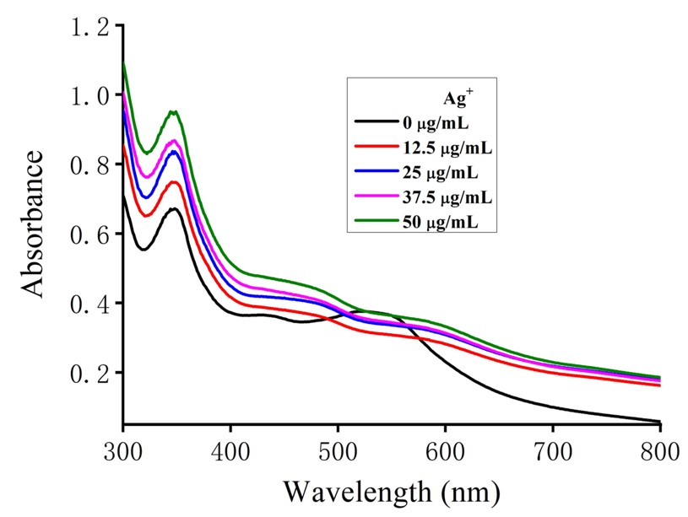

**Fig. S4**. The absorption spectra of PTCDs incubated with different concentrations of Ag+.

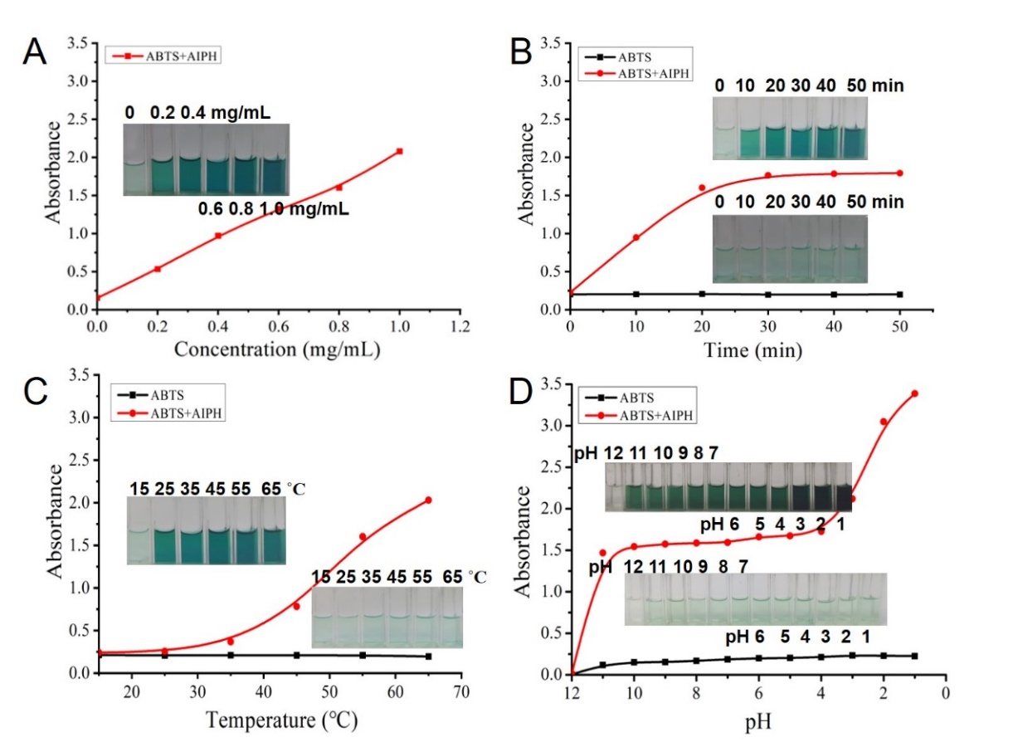

**Fig. S5.** Alkyl radicals produced by AIPH (A) at different concentrations in a water bath for 55 ℃ and (B) at different times in a water bath for 55 ℃ and (C) at different temperatures and (D) at different pH in a water bath for 55 ℃. The insets: the color change of the solution before and after ABTS interacted with the alkyl radical produced by AIPH.

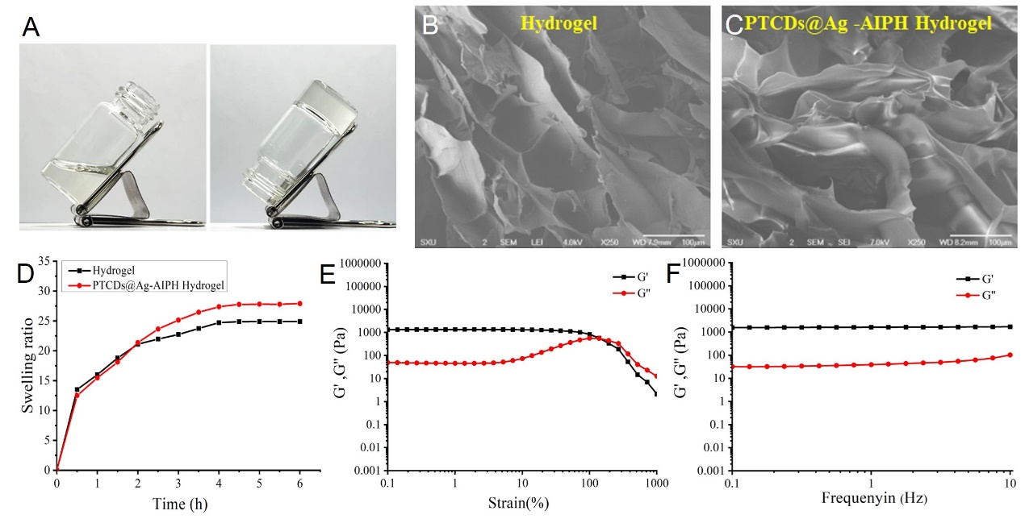

**Fig. S6**. (A) Photographs of hydrogels in the gel and sol states, (B, C) High-resolution SEM of Hydrogel and composite hydrogel (PTCDs@Ag-AIPH Hydrogel), (D) Swelling rates of Hydrogel and PTCDs@Ag-AIPH Hydrogel, (E, F) Rheological properties of PTCDs@Ag-AIPH Hydrogel: strain scan (E), frequency scan (F).

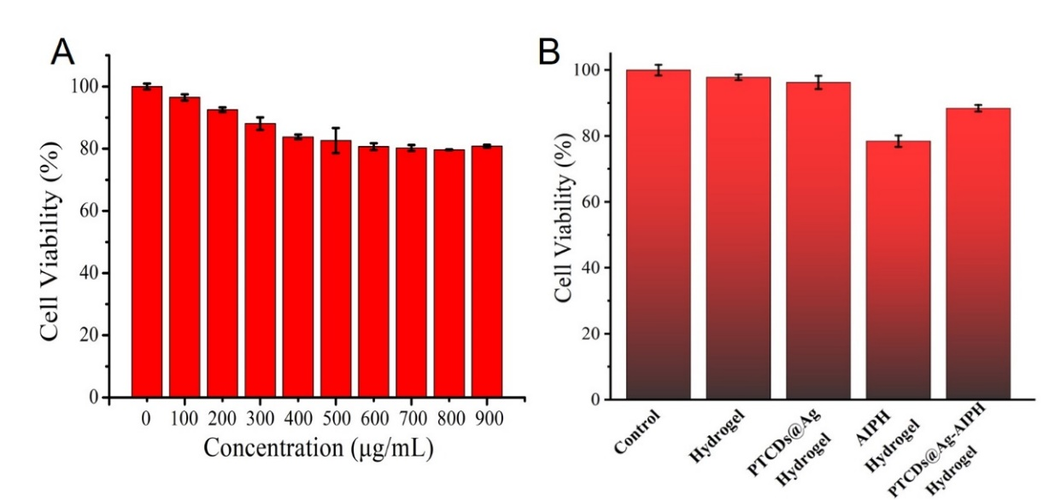

**Fig. S7.** Cytotoxicity tests of PTCDs at different concentrations and Hydrogels.

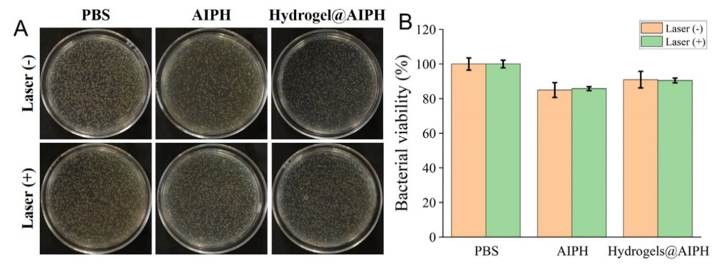

**Fig. S8.** (A) The plate photos of *S. aureus* cocultured with PBS, AIPH and Hydrogel@AIPH under 660 nm laser irradiation or not ([AIPH]=0.80 mg/mL). The final bacteria suspension concentrations were adjusted to 106 CFU·mL−1. (B) The viability rate of the different treatments against *S. aureus*.

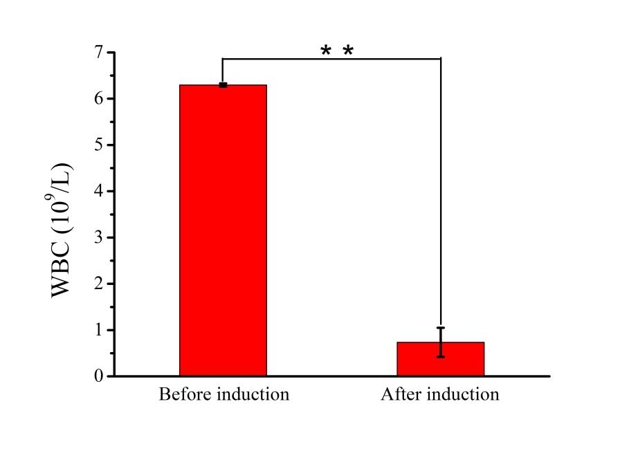

**Fig. S9.** The difference of white blood cell value in mice before and after cyclophosphamide induction (**p<0.01).

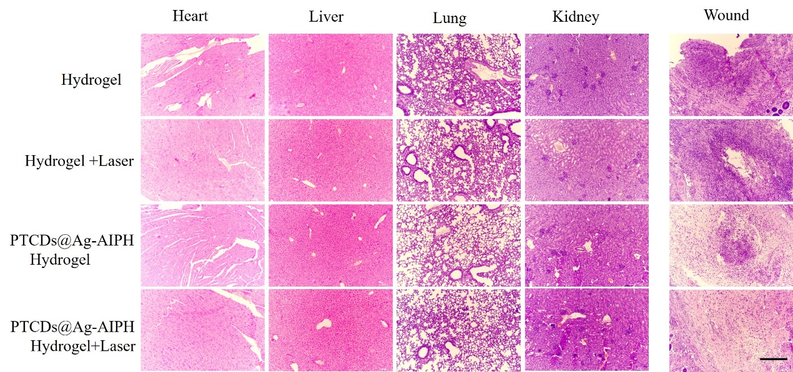

**Fig. S10.** H&E staining analyses of major organs and infected wound tissues in mice with various treatments. Scale bar = 200 μm.