**Supplementary material**

**Preparation of high-efficient KMnO4 modified biochar for**

**heavy metal removal from municipal wastewater**

Fuhua Changa, Haoyu Lib*

1. School of Architectural Engineering, Zhengzhou Business University, Zhengzhou 451200, Henan, China;

b. College of Biological and Chemical Engineering (College of Agricultural Sciences), Panzhihua University, Panzhihua 617000, China)

## Characterization analysis

X-ray diffraction (XRD) is employed to identify the crystallographic structure of the KM/biochar. Scanning electron microscopy (SEM) equipped with dispersive X-ray spectroscopy (EDS) is used to observe and assess the surface microstructures and element distribution of sample. Nitrogen adsorption apparatus is employed to measure the specific surface area and pore structure parameters of the sample. Fourier transform infrared spectroscopy (FT-IR) is employed to investigate chemical function groups of the biochar. X-ray photoelectron spectroscopy (XPS) is used to determine the surface properties of the samples. The atomic absorption spectrophotometer is employed to measure the concentrations of Pb(II).

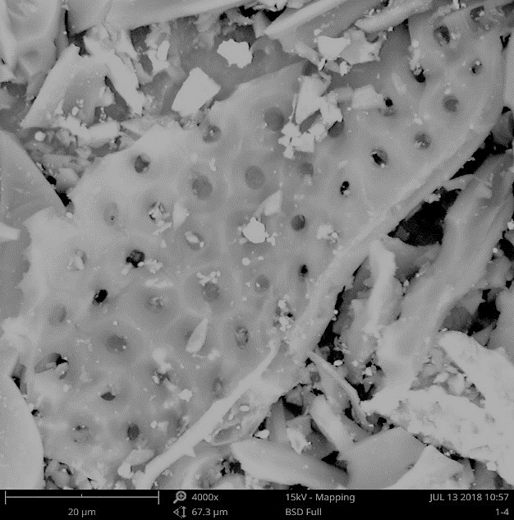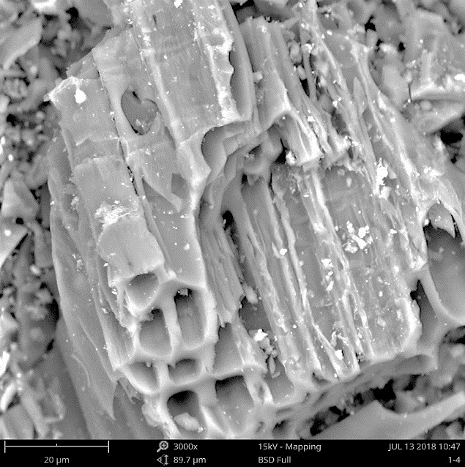

**b**

**a**

**Fig.S1** The surface morphology and micro composition of KM/biochar-1:9(a) and KM/biochar-1:39 (b).

C:\Users\X230\Desktop\Graph1.tif

**Fig.S2** Comparison of Pb(II)adsorption capability of KM/biochars and original biochar

C:\Users\X230\Desktop\Graph1.tif

**Fig.S3** Slope and intercept of ln (Kd) vs. 1/T plot for the Pb(II).

C:\Users\X230\Desktop\Graph3.tif

Fig.S4 The influence of the coexisting ions on Pb(II) removal.

C:\Users\X230\Desktop\Graph1.tif

Fig.S5 Pb(II)removal of the KM/biochar-1:1 after regeneration.

**Table S1** Adsorption kinetic model and corresponding parameters

|  |  |  |
| --- | --- | --- |
| Kinetic models | Equation | Parameters |
| Pseudo-first order | $$q_{t}=q_{t}(1-e^{-{tk}_{1}})$$ | qt is uptake at time (mg/g).  k1 means adsorption rate constant(1/min). |
| Pseudo-second order |  | K2 means rate constant (g/mg min). |
| Intraparticle diffusion |  | K3 (mg/g min1/2) is rate constant  C is a constant. |
| Boyd | $$-Ln\left(1-\frac{q_{t}}{q_{e}}\right)=Bt-Ln(\frac{6}{Π^{2}})$$ | B is the constant of Boyd model. |

**Table S 2** Adsorption isotherm models and corresponding parameters.

|  |  |  |
| --- | --- | --- |
| Isotherms | Equations | Parameters |
| Langmuir | $$q_{e}=\frac{k_{L}q_{m}C_{e}}{1+k_{L}C_{e}}$$ | qm means the adsorption amount (mg/g).  kL (L/mg) is coefficient. |
| Freundlich | $$q_{e}=k_{F}C_{e}^{1/n}$$ | kF is adsorption constant (mg/g). (L/mg)1/n, 1/n is adsorption intensity |
| Temkin | $$q_{e}=B_{T}lnK_{T}+B_{T}lnC_{e}$$ | $B_{T}$ is adsorption heat, J/mol $K_{T}$ is binding equilibrium, L/g |
| Hill | $$qe=\frac{Qm{Ce}^{n}}{{C^{n}+Ce}^{n}}$$ | Qm is the maximum  adsorption capacity (mg/g) , n and C are the number of ions per site  and semi saturated concentration, respectively. |

**Table S3** The maximum adsorption capacity of similar adsorbents for Pb(II) adsorption capacity.

|  |  |  |
| --- | --- | --- |
| Adsorbents | Adsorption  capacity (mg/g) | References |
| KM/biochar | 88.15-144.49 | This study |
| H3PO4 pretreated chicken feather biochar | 78.4 | (Chen et al., 2019) |
| Biochar - manganese oxide nanoparticles | 110.00 | (Wan et al., 2018) |
| MgCl2 modified crayfsh shell biochar | 93.90 | (Zhang et al., 2020) |
| PHF-modified activated carbon | 50.25 | (Yin et al., 2019) |
| MgAl-layered double hydroxides | 147.89 | (Guo et al., 2024) |
| Magnetic DTPA-modified chitosan | 214.63 | (Liu et al., 2024) |
| Biomass-derived porous carbon | 126.4 | (Wang et al., 2019) |
| Bacteria TJ6 immobilized on biochar | 250.10 | (Wang et al., 2024) |
| UV-aged microplastics | 93.49 | (Chang et al., 2024) |
| MnO2-composted mixture biochar | 127.75 | (Liang et al., 2017) |
| MnSO4-peanut shell biochar | 68.00 | (Wan et al., 2018) |

**Referene**

Chang, B., Huang, Z., Yang, X., Yang, T., Fang, X., Zhong, X., Ding, W., Cao, G., Yang, Y., Hu, F., Xu, C., Qiu, L., Lv, J., Du, W. 2024. Adsorption of Pb(II) by UV-aged microplastics and cotransport in homogeneous and heterogeneous porous media. *Journal of Hazardous Materials*, **465**, 133413.

Chen, H., Li, W., Wang, J., Xu, H., Liu, Y., Zhang, Z., Li, Y., Zhang, Y. 2019. Adsorption of cadmium and lead ions by phosphoric acid-modified biochar generated from chicken feather: Selective adsorption and influence of dissolved organic matter. *Bioresource Technology*, **292**, 121948.

Guo, H., Cheng, S., Xing, B., Meng, M., Feng, L., Nie, Y., Zhang, C. 2024. Preparation of three kinds of efficient sludge-derived adsorbents for metal ions and organic wastewater purification. *Arabian Journal of Chemistry*, **17**(4), 105671.

Liang, J., Li, X., Yu, Z., Zeng, G., Luo, Y., Jiang, L., Yang, Z., Qian, Y., Wu, H. 2017. Amorphous MnO2 Modified Biochar Derived from Aerobically Composted Swine Manure for Adsorption of Pb(II) and Cd(II). *Acs Sustainable Chemistry & Engineering*, **5**(6), 5049–5058.

Liu, X., Wang, Y., Wu, X., Wang, Y., Fan, G., Huang, Y., Zhang, L. 2024. Preparation of magnetic DTPA-modified chitosan composite microspheres for enhanced adsorption of Pb(II) from aqueous solution. *International Journal of Biological Macromolecules*, **264**, 130410.

Wan, S., Wu, J., Zhou, S., Wang, R., Gao, B., He, F. 2018. Enhanced lead and cadmium removal using biochar-supported hydrated manganese oxide (HMO) nanoparticles: Behavior and mechanism. *Science of The Total Environment*, **616-617**, 1298-1306.

Wang, A., Zheng, Z., Li, R., Hu, D., Lu, Y., Luo, H., Yan, K. 2019. Biomass-derived porous carbon highly efficient for removal of Pb(II) and Cd(II). *Green Energy & Environment*, **4**(4), 414-423.

Wang, D., Chen, H., Xin, C., Yuan, Y., Sun, Q., Cao, C., Chao, H., Wu, T., Zheng, S. 2024. Insight into adsorption of Pb(II) with wild resistant bacteria TJ6 immobilized on biochar composite: Roles of bacterial cell and biochar. *Separation and Purification Technology*, **331**, 125660.

Yin, W., Zhao, C., Xu, J., Zhang, J., Guo, Z., Shao, Y. 2019. Removal of Cd(II) and Ni(II) from aqueous solutions using activated carbon developed from powder-hydrolyzed-feathers and Trapa natans husks. *Colloids and Surfaces a-Physicochemical and Engineering Aspects*, **560**, 426-433.

Zhang, D., Zhang, K., Hu, X., He, Q., Xue, Y. 2020. Journal Pre-proof Cadmium removal by MgCl 2 modified biochar derived from crayfish shell waste: Batch adsorption, response surface analysis and fixed bed filtration. *Journal of Hazardous Materials*.