Supporting information
Decamethylcyclopentasiloxane-Based Sustainable and Recyclable Polyester Fabric Whitening Using OB-1 Fluorescent Brightener
Yingjie Cai^{1,2}, Tianjie Wang¹, Le Li¹, Xiaolong Huang¹, Md. Nahid Pervez¹, Ai Chen³, Xiaohua Zhao³, Lina Lin^{1,4*}, Xiaorong Xiong^{2*}, Vincenzo Naddeo^{5*}
¹Hubei Provincial Engineering Laboratory for Clean Production and High Value Utilisation of Bio-based Textile Materials, Wuhan Textile University, Wuhan, 430200 China
² School of Computing, Huanggang Normal University, Huanggang, 438000 China
³Technical Quality Department, Hubei Hongxin Chemical Co., Ltd, Wuxue, 435406 China
⁴State Key Laboratory of New Textile Materials and Advanced Processing Technologies, Wuhan Textile University, Wuhan, 430073 China
⁵Sanitary Environmental Engineering Division (SEED), Department of Civil Engineering, University of Salerno, 84084, Fisciano, Italy

*Corresponding authors:
linalin@wtu.edu.cn (L. Lin); xiongxiaorong@hgnu.edu.cn (X. Xiong); vnaddeo@unisa.it (V. Naddeo)

Table S1. L*, a*, and b* values of the whitened polyester fabric treated by various OB-1 mass.
Sample treated by OB-1 mass (%, o.m.f) | L* | a* | b*
0.00125 | 92.62 | -0.33 | 0.04
0.00250 | 92.81 | -0.37 | -0.46
0.00500 | 92.44 | -0.25 | -2.69
0.01250 | 93.28 | -0.48 | -3.87
0.02500 | 93.44 | -0.57 | -4.02
0.03000 | 93.44 | -0.53 | -4.21
0.03750 | 93.65 | -0.71 | -4.82
0.04375 | 93.12 | -0.79 | -4.72
0.05000 | 93.53 | -1.91 | -5.31

Table S2. Selected parameters and their levels
Symbol | Parameter | Unit | Level 1 | Level 2 | Level 3 | Level 4
A | Temperature | ºC | 100 | 110 | 120 | 130
B | Time | min | 40 | 50 | 60 | 70
C | OB-1 mass | %, o.m.f | 0.0250 | 0.0275 | 0.0300 | 0.0325

Table S3. L₁₆ (4^3) orthogonal array-based experimental data with their S/N ratios
Experimental number | A | B | C | Whiteness | S/N ratio (dB)
1 | 100 | 40 | 0.0250 | 74.0 | 37.3880
2 | 100 | 50 | 0.0275 | 73.4 | 37.3174
3 | 100 | 60 | 0.0300 | 72.2 | 37.1728
4 | 100 | 70 | 0.0325 | 72.2 | 37.1706
5 | 110 | 40 | 0.0275 | 83.4 | 38.4248
6 | 110 | 50 | 0.0250 | 84.3 | 38.5194
7 | 110 | 60 | 0.0325 | 83.5 | 38.4387
8 | 110 | 70 | 0.0300 | 85.8 | 38.6737
9 | 120 | 40 | 0.0300 | 90.2 | 39.1060
10 | 120 | 50 | 0.0325 | 91.8 | 39.2609
11 | 120 | 60 | 0.0250 | 93.7 | 39.4307
12 | 120 | 70 | 0.0275 | 97.4 | 39.7703
13 | 130 | 40 | 0.0325 | 104.7 | 40.4007
14 | 130 | 50 | 0.0300 | 108.7 | 40.7271
15 | 130 | 60 | 0.0275 | 107.6 | 40.6346
16 | 130 | 70 | 0.0250 | 106.4 | 40.5410

Table S4. Validation tests.
Conditions | Initial parameters | Prediction | Confirmation experiment
Level | A4B2C3 | A4B4C2 | A4B4C2
Whiteness | 108.7 | 109.1 | 109.9
S/N | 40.727 | 40.779 | 40.816
Improvement in the S/N ratio |  | 0.089

Table S5. Crystallite parameters of PET treated in D5 medium.
Sample | 2θ of peak（°） | d (Å) | FWHM(º) | S (Å) | CI (%)
PET | 17.4 | 5.09 | 2.60 | 30.54 | 28.0
 | 22.8 | 3.90 | 2.31 | 34.76
 | 26.1 | 3.41 | 2.90 | 27.86
PET-OB-1 | 17.4 | 5.09 | 2.61 | 30.45 | 29.9
 | 22.9 | 3.89 | 2.27 | 35.33
 | 26.1 | 3.41 | 2.85 | 28.33

Table S6. Whiteness performance duration of rubbing.
Condition | Whiteness |  | Colorimetric values of the test cotton fabric
 | PET sample | Cotton test fabric | L* | a* | b*
Before rubbing | 108.8 | 70.5 | 94.03 | -0.35 | 3.48
Wet rubbing | 106.7 | 72.2 | 93.74 | -0.44 | 3.71
Dry rubbing | 105.5 | 68.7 | 94.00 | -0.73 | 4.41

Figure S1. Main effects plot for S/N ratios in whiteness.

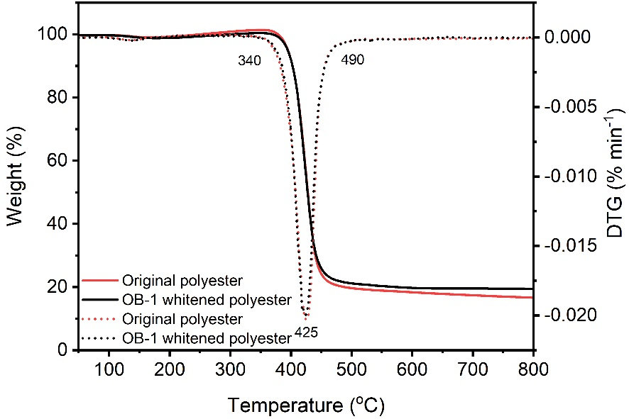
Figure S2. TG and DTG curves of the original and whitened polyester fibers.

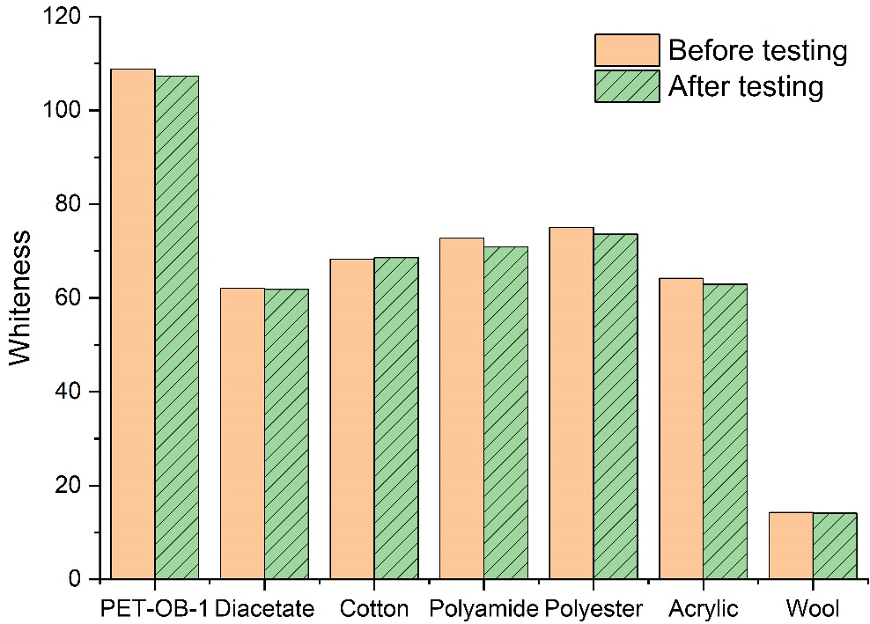
Figure S3. Whiteness of the whitened PET fabric and the multifiber fabric after washing test.

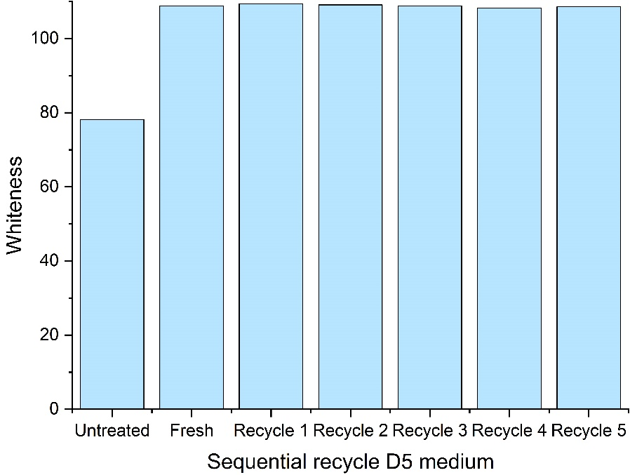
Figure S4. Whiteness of polyester fabric treated with OB-1 in sequential recycle D5 medium.

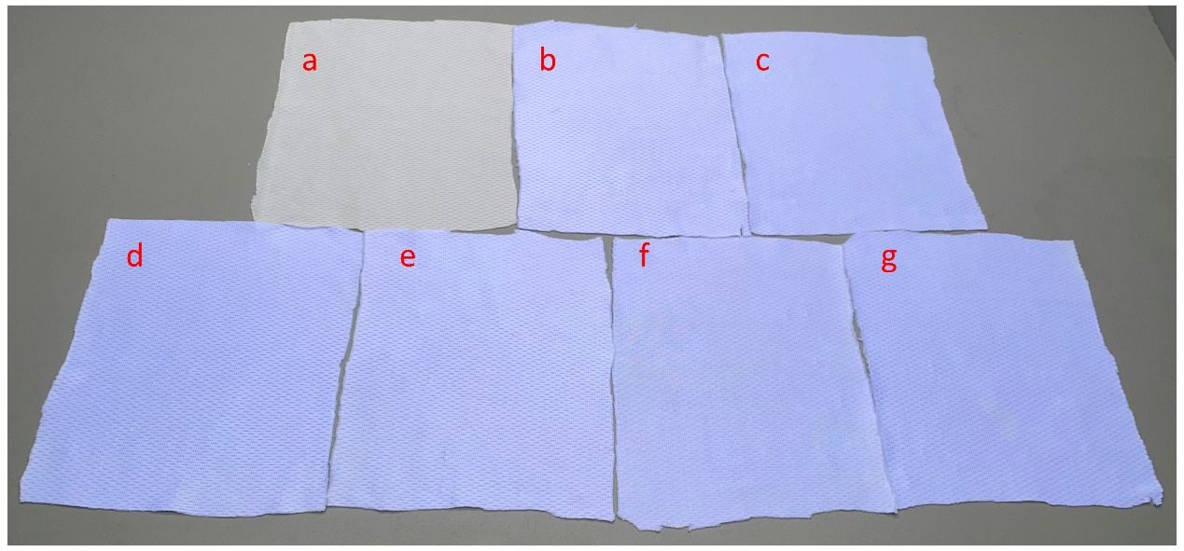
Figure S5. Samples of the untreated and whitened polyester with sequential recycle D5 medium irradiated under the lights of UV and D65

Text S1. Residual plots assessment
ANOVA tests are used to analyze both the model as a whole and each individual parameter separately; the results of these tests lead to the identification of factors that affect the fixation response. In the regression analysis process, the most significant parameter is considered, and with a confidence level of 95%, the coefficients of each parameter are gathered. Figure 1 illustrates the residual plots of the S/N ratios for whiteness.
For the normal probability plot, it is clear that all of the points on the normal probability are grouped together in close proximity to the straight line that represents the mean. This suggests that the data are, on average, distributed in a usual manner (normal). The dots are scattered above and below the straight line near zero in the versus fits plot. This indicates that the error variance is constant and follows a normal distribution. The histogram shows that residuals only reach a variance point for a few observations. As for residual vs. observation, order may be used to assess the potential for inaccuracies in the output findings due to the chosen parameters. The output shows that the residuals lie on a straight line that is almost zero on both sides. In this case, it was safely inferred that the importance of the model equations is independent of the outcomes, and they are consistent with one another. This means that the inquiry may be concluded without spending extra time dissecting the errors.
Figure 1. Residual plots for the S/N ratios of the whiteness (Normal probability plot, versus fits, Histogram, and versus order plot)

Text S2. Fitted plots assessment
The regression analysis may be used to compute the expected values precisely based on the planned experimental circumstances, and the results of this calculation can be compared with the actual data that was acquired. Figure 2 shows the plots fitted for the predicted vs experimental results for the whiteness of polyester fabric.
The figure reveals an excellent match for both the experimental and predicted values of whiteness, with an R² of 98.6% and an adjusted R² of 98.5%, respectively. As a result, there is a high degree of concordance between the values. The accurate capacity of this model to forecast the reaction is noteworthy, as is the case when the difference between the two is 0.1, confirming the variation around the mean of the replies revealed by the model. Finally, a P-value of 0.000 was found for the Pearson correlation between the predicted and experimental whiteness, which was 0.9858. This further proves the robust relationship between the predicted and experimental whiteness of the polyester fabric.

Figure 2. Fitted lines for the experimental S/N ratios (whiteness) and predicted S/N ratios (whiteness)

Text S3. Assessment of interaction plots
An interaction graph analysis is necessary for identifying the behavior of the levels of process parameters in interaction with one another. There are two possible types of interaction behaviors: parallelism and non-parallelism. The interaction effects of the input parameters may be seen in the figure as non-parallel and parallel lines, respectively. Greater parameter dependency is shown in non-parallel lines, whereas only a moderate amount is seen in parallel lines. In this Figure 3, there is significant interaction (three lines intersect with each other) between all of the process variables at varying degrees The whitening time (B) and the OB-1 mass (C) are obviously related because the whitening temperature contributed to the most effect on the whiteness while whitening time and OB-1 mass show little contribution on whiteness improvement (Table 2). Overall, this study demonstrates the significant effect of the selected parameters on the whitening of polyester fabric, and interaction plots are a great tool for analyzing process aspects.
Figure 3. Full interaction plot for S/N ratios in whiteness.

