pH-responsive binding and release of ciprofloxacin hydrochloride *from* micro-, nano-, and functionalized nanocellulose

Hridoy Roy1, Khalide Hasan Parvej2, Mohammad Mozammal Hosen2, Md. Shahinoor Islam1, Shakhawat H. Firoz\*2

1Department of Chemical Engineering, Bangladesh University of Engineering and Technology, Dhaka-1000, Bangladesh

2Department of Chemistry, Bangladesh University of Engineering and Technology, Dhaka-1000, Bangladesh

shfiroz@chem.buet.ac.bd (Corresponding author)

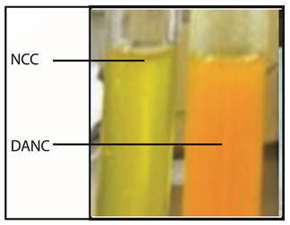

Figure S1: Images of test tubes after conducting 2, 4- dinitrophenylhydrazine (2,4-DNPH) wet chemical test of NCC (greenish-yellow) and DANC (orange ppt)

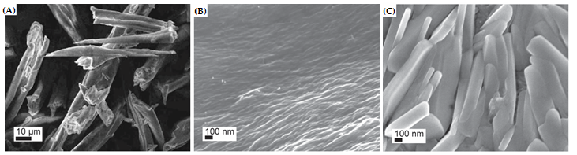

Figure S2: FESEM image of MCC (A), synthesized NCC (B), and DANC (C)