Fig. S1. Various isotherm plots for the adsorption of EDTP, DITP and DPTP on the surface of C1018 carbon steel determined by electrochemical impedance spectroscopy.

 |  | Fukui function
 |  | Electrophilic (f_{k}⁻) | Nucleophilic (f_{k}⁺)
EDTP | 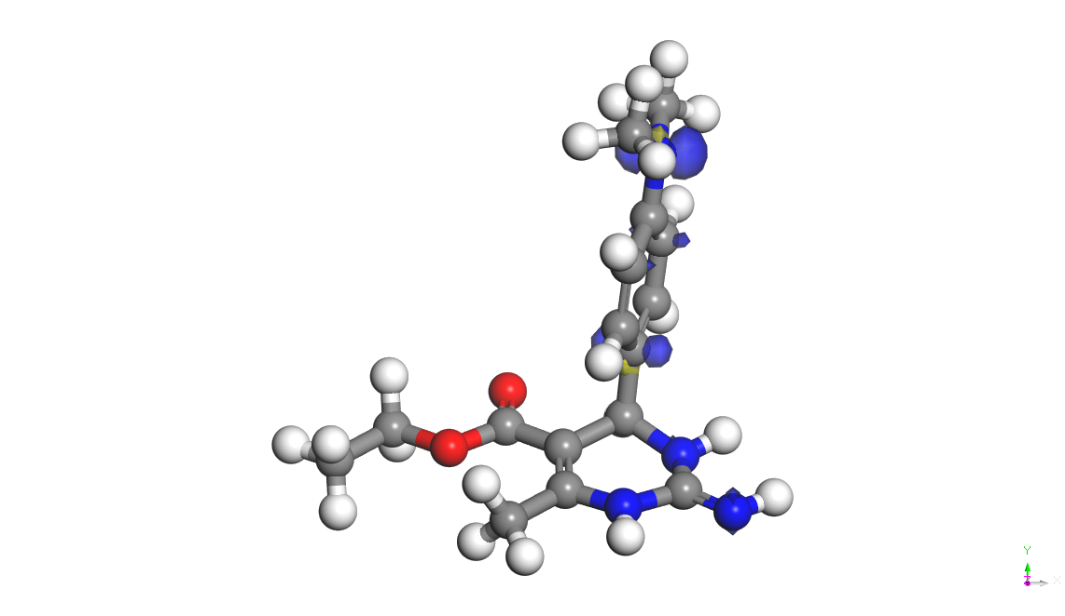 |  | 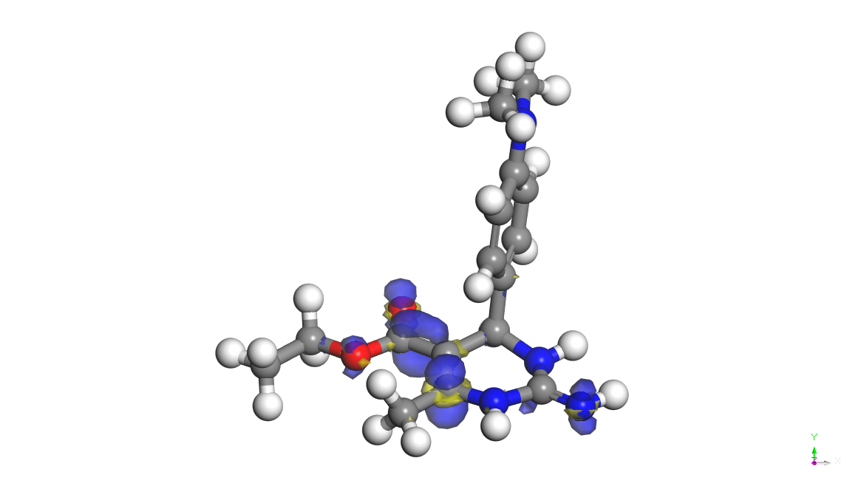
DITP | 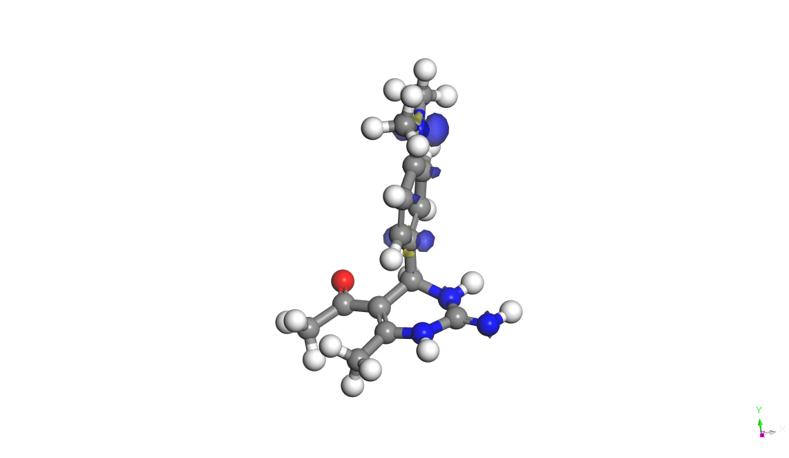 |  | 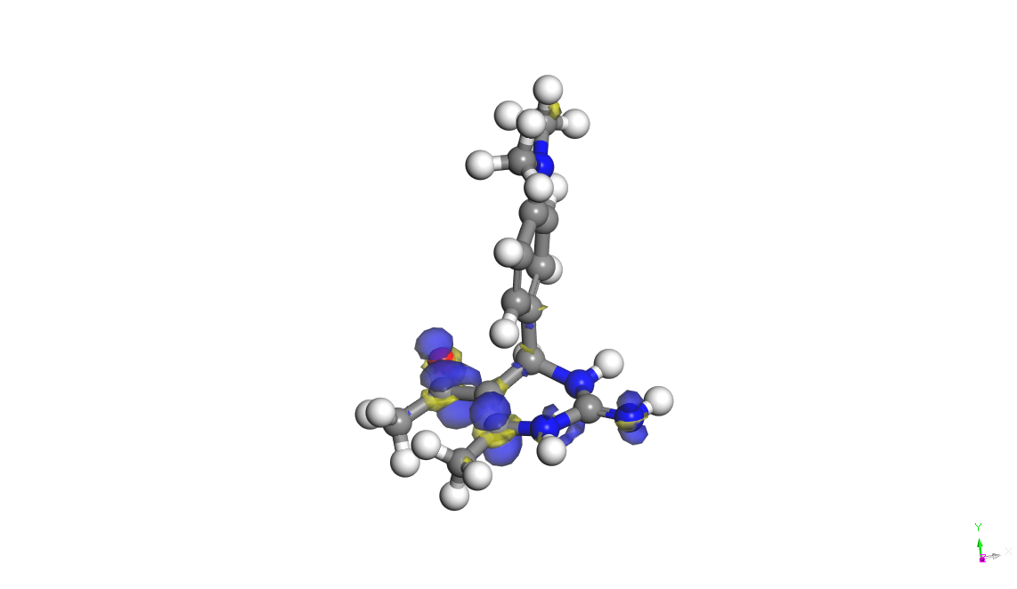
DPTP | 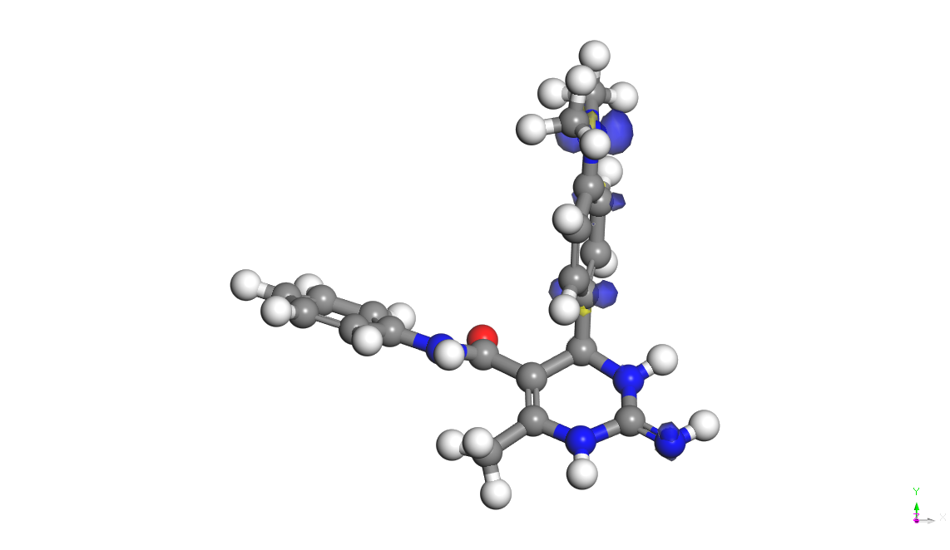 |  | 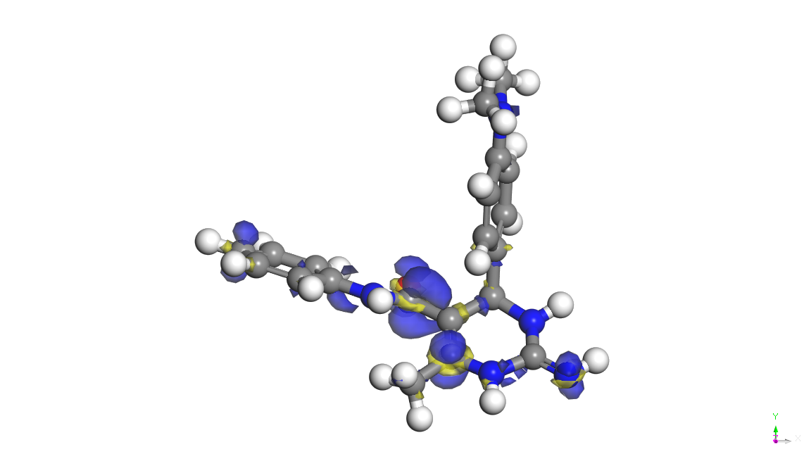

Fig. S2. Visualization of Fukui functions of EDTP, DITP and DPTP.

Table S1
Fukui Indices for EDTP, DITP and DPTP determined by using BLYP/DNP.

Inhibitor | Atom | Mulliken Population Analysis |  | Hirshfeld population analysis
 |  | fk⁻ | fk⁺ | fk⁻ | fk⁺
EDTP | C(1) | 0.046 | 0.006 | 0.059 | 0.017
 | C(2 | 0.017 | 0.004 | 0.038 | 0.011
 | C(3) | 0.019 | 0.018 | 0.037 | 0.019
 | C(4) | 0.058 | -0.023 | 0.076 | -0.016
 | C(5) | 0.040 | 0.009 | 0.051 | 0.013
 | C(6) | 0.020 | -0.012 | 0.037 | -0.007
 | C(7) | -0.007 | -0.013 | 0.007 | 0.007
 | N(8) | 0.012 | 0.003 | 0.018 | 0.015
 | C(9) | -0.008 | 0.012 | 0.007 | 0.032
 | N(10) | 0.009 | 0.010 | 0.012 | 0.037
 | C(11) | -0.007 | 0.039 | 0.003 | 0.054
 | C(12) | 0.011 | 0.131 | 0.014 | 0.114
 | C(13) | -0.006 | -0.031 | 0.007 | 0.028
 | C(14) | 0.006 | 0.099 | 0.002 | 0.083
 | O(15) | 0.002 | 0.107 | 0.004 | 0.105
 | O(16) | 0.006 | 0.018 | 0.007 | 0.029
 | C(17) | -0.010 | -0.031 | 0.003 | 0.011
 | N(18) | 0.090 | 0.007 | 0.108 | 0.012
 | C(19) | -0.040 | -0.014 | 0.026 | 0.006
 | C(20) | -0.039 | -0.012 | 0.026 | 0.006
 | N(21) | 0.060 | 0.086 | 0.053 | 0.081
 | C(22) | -0.005 | -0.014 | 0.004 | 0.008
DITP | C(1) | 0.047 | 0.007 | 0.059 | 0.016
 | C(2 | 0.017 | -0.001 | 0.039 | 0.006
 | C(3) | 0.018 | 0.016 | 0.037 | 0.017
 | C(4) | 0.061 | -0.023 | 0.078 | -0.019
 | C(5) | 0.042 | 0.006 | 0.054 | 0.011
 | C(6) | 0.018 | -0.011 | 0.038 | -0.009
 | C(7) | -0.008 | -0.014 | 0.007 | 0.005
 | N(8) | 0.017 | 0.011 | 0.020 | 0.013
 | C(9) | -0.013 | 0.017 | 0.005 | 0.027
 | N(10) | 0.004 | 0.017 | 0.009 | 0.041
 | C(11) | -0.011 | 0.023 | 0.002 | 0.046
 | C(12) | 0.009 | 0.130 | 0.012 | 0.113
 | C(13) | -0.008 | -0.031 | 0.007 | 0.027
 | C(14) | 0.004 | 0.109 | 0.005 | 0.105
 | O(15) | 0.010 | 0.135 | 0.011 | 0.137
 | N(16) | 0.091 | 0.006 | 0.109 | 0.012
 | C(17) | -0.039 | -0.013 | 0.026 | 0.006
 | C(18) | -0.040 | -0.012 | 0.026 | 0.006
 | N(19) | 0.056 | 0.082 | 0.048 | 0.078
 | C(20) | -0.007 | -0.029 | 0.006 | 0.023
DPTP | C(1) | 0.045 | 0.007 | 0.057 | 0.016
 | C(2 | 0.015 | 0.009 | 0.035 | 0.013
 | C(3) | 0.017 | 0.012 | 0.034 | 0.015
 | C(4) | 0.052 | -0.024 | 0.068 | -0.012
 | C(5) | 0.036 | 0.012 | 0.046 | 0.014
 | C(6) | 0.018 | -0.011 | 0.034 | -0.004
 | C(7) | -0.003 | -0.008 | 0.007 | 0.006
 | N(8) | 0.007 | 0.006 | 0.017 | 0.010
 | C(9) | 0.000 | 0.011 | 0.012 | 0.020
 | N(10) | 0.016 | 0.009 | 0.019 | 0.026
 | C(11) | -0.002 | 0.018 | 0.009 | 0.031
 | C(12) | 0.012 | 0.083 | 0.018 | 0.074
 | C(13) | -0.008 | -0.022 | 0.008 | 0.018
 | C(14) | -0.008 | 0.092 | -0.005 | 0.077
 | O(15) | 0.008 | 0.089 | 0.007 | 0.088
 | N(16) | 0.084 | 0.007 | 0.100 | 0.010
 | C(17) | -0.036 | -0.012 | 0.024 | 0.005
 | C(18) | -0.036 | -0.010 | 0.024 | 0.005
 | N(19) | 0.070 | 0.063 | 0.065 | 0.059
 | N(20) | 0.004 | -0.002 | 0.002 | 0.021
 | C(21) | -0.009 | 0.014 | -0.007 | 0.017
 | C(22) | -0.001 | 0.016 | 0.002 | 0.028
 | C(23) | -0.002 | 0.014 | 0.001 | 0.022
 | C(24) | 0.002 | 0.006 | 0.009 | 0.030
 | C(25) | 0.001 | 0.009 | 0.008 | 0.030
 | C(26) | 0.008 | 0.043 | 0.015 | 0.055

